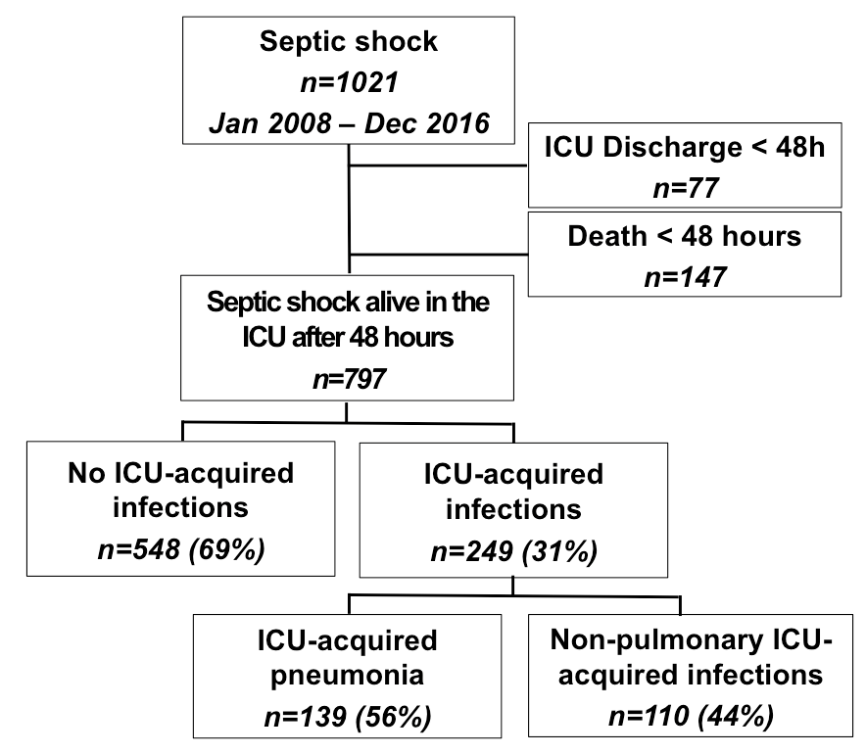

Figure S1: Flow-chart of the study. ICU: Intensive care unit.

