Supplementary Material

Gibberellins Inhibit Nodule Senescence and Stimulate Nodule Meristem Bifurcation in Pea (Pisum sativum L.)
Tatiana A. Serova¹, Anna V. Tsyganova¹, Igor A. Tikhonovich^{1,2}, Viktor E. Tsyganov¹*
¹Laboratory of Molecular and Cellular Biology, Department of Biotechnology, All-Russia Research Institute for Agricultural Microbiology, Pushkin 8, Saint Petersburg, Russia
²Saint-Petersburg State University, Department of Genetics and Biotechnology, Saint Petersburg, Russia
* Correspondence:
Viktor E. Tsyganov
tsyganov@arriam.spb.ru

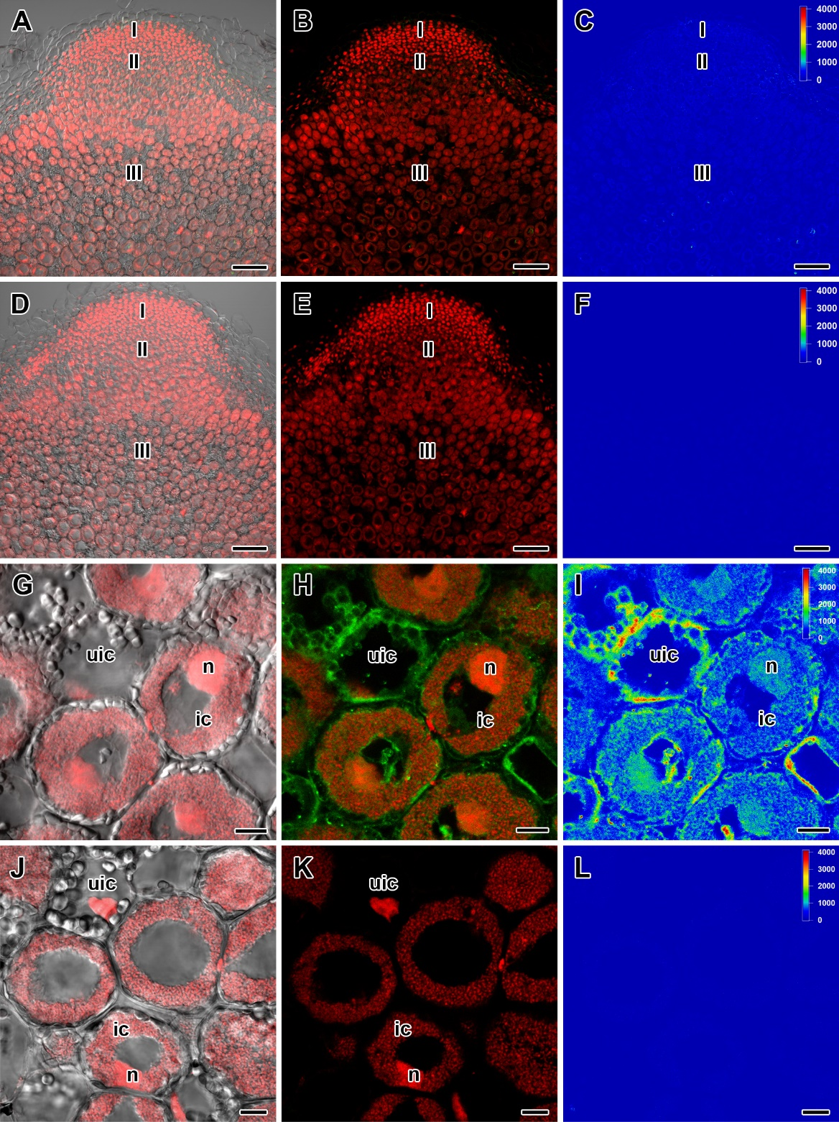
Supplementary Figure 1. The controls show specificity of antibodies to gibberellin (GA₃). To confirm specificity of the anti-GA₃ antibody, slices of wild-type SGE 2-week-old nodules were incubated with GA₃-specific antibodies supplemented with GA₃-BSA conjugate before immunostaining (A–C). Note the absence in fluorescence in the whole nodule. Primary anti-GA₃ antibodies were omitted as a negative control, resulting in the absence of fluorescence (D–F, J–L). The controls show specificity of antibodies to gibberellin (GA₃) in nuclei (G–L). A differential interference contrast microscopy image merged with laser scanning confocal microscopy image in red channel (A, D, G, J). Merged images of laser scanning confocal microscopy in green and red channels (B, E, H, K). Heat map provides a color code of fluorescence signal intensities (C, F, I, L). GA₃ in green, nuclei and bacteria in red. Scale bar = 100 µm (A–F), 10 µm (G–L).
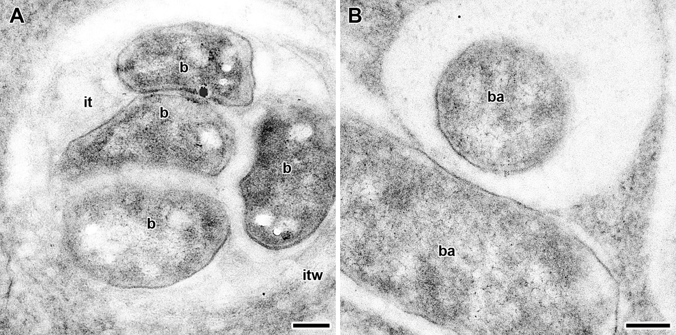
Supplementary Figure 2. Transmission electron micrographs of cells from nodule of wild-type SGE at 2 weeks after inoculation treated as negative control to GA₃ immunogold labeling. Gold particles were absent when cells were treated after the omission of the primary antibody (A), with unspecific secondary antibody (B). It was used secondary goat anti-mouse IgG MAb conjugated to 10 nm diameter colloidal gold. it, infection thread; itw, infection thread wall; b, bacterium; ba, bacteroid. (A) Infection thread, (B) Mature bacteroids. Scale bar = 200 nm.

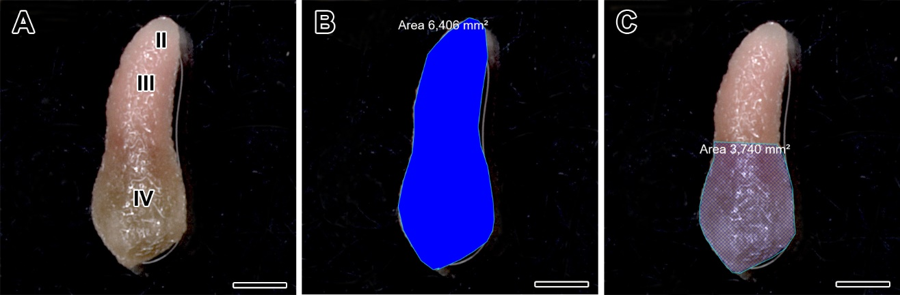
Supplementary Figure 3. Selection and measurement of area of wild-type nodule at 6 weeks after inoculation. General view of nodule (A), selection and measurement of whole nodule area (blue background) (B), selection and measurement of area of senescence zone in nodule (blue mesh background) (C). Areas were selected and measured with AxioVision Rel. 4.8 software (Carl Zeiss). Zones of nodule are designated by Roman numerals: II – infection zone, III – fixation zone, IV – senescence zone. Scale bar = 1 mm.

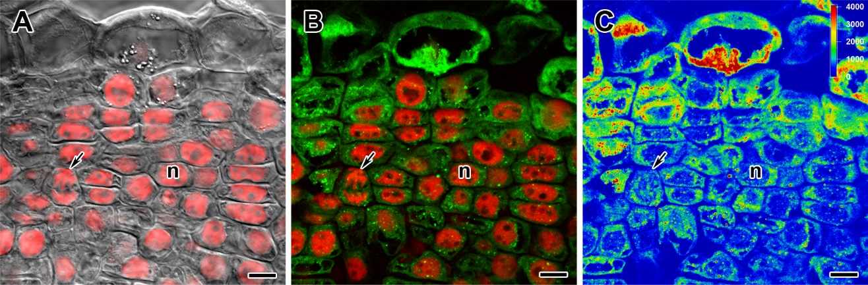
Supplementary Figure 4. Immunolocalization of gibberellin (GA₃) in meristem of nodules of wild-type SGE at 2 weeks after inoculation. n, nucleus. Arrow indicates mitosis. A differential interference contrast microscopy image merged with laser scanning confocal microscopy image in red channel (A). Merged images of laser scanning confocal microscopy in green and red channels (B). Heat map provides color code of fluorescence signal intensities (C). Visualization of GA₃ by the Alexa Fluor 488 conjugated secondary antibody (green), nuclei and bacteria stained with propidium iodide (red). Scale bar = 10 µm.

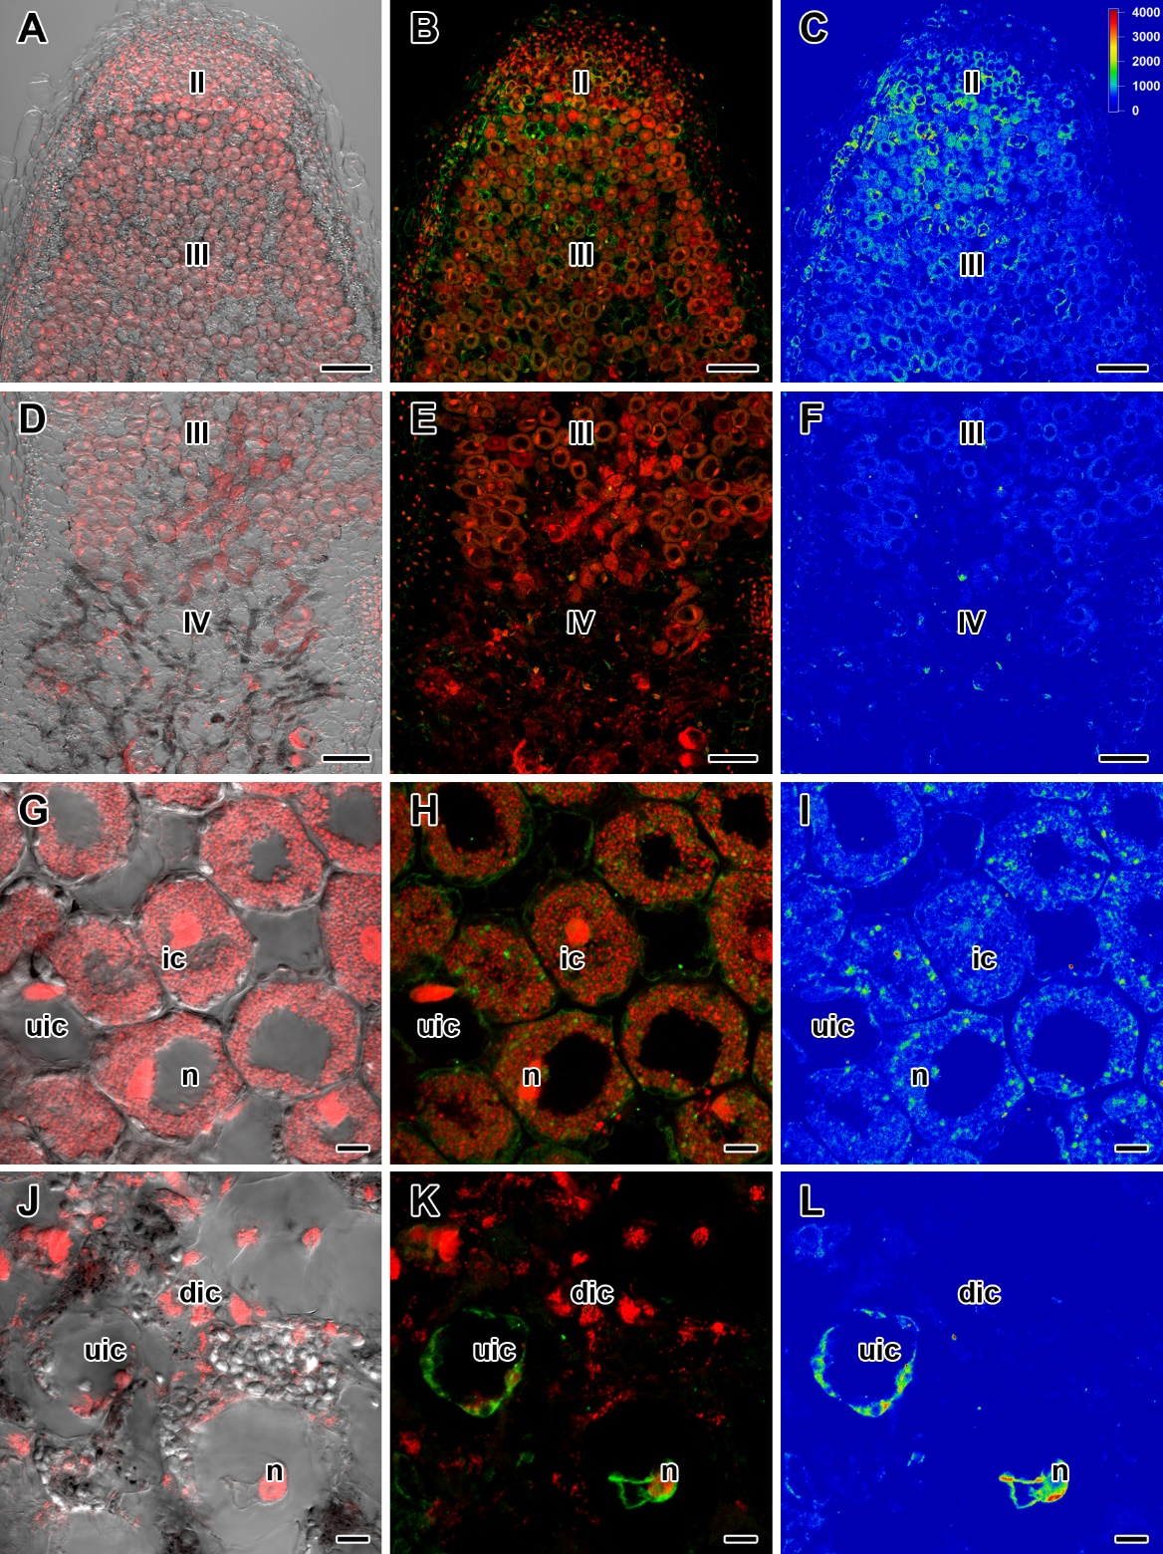
Supplementary Figure 5. Immunolocalization of gibberellin (GA₃) in nodules of wild-type plants (A–F) and cells in central part of nodules (G–L) at 6 weeks after inoculation. Zones of nodule are designated by Roman numerals: II – infection zone, III – fixation zone, IV – senescence zone. ic, infected cell; dic, degrading infected cell; uic, uninfected cell; n, nucleus. A differential interference contrast microscopy image merged with laser scanning confocal microscopy image in red channel (A, D, G, J). Merged images of laser scanning confocal microscopy in green and red channels (B, E, H, K). Heat map provides color code of fluorescence signal intensities (C, F, I, L). Visualization of GA by the Alexa Fluor 488 conjugated secondary antibody (green), nuclei and bacteria stained with propidium iodide (red). Scale bar (A-F) = 100 µm, (G-L) = 10 µm.

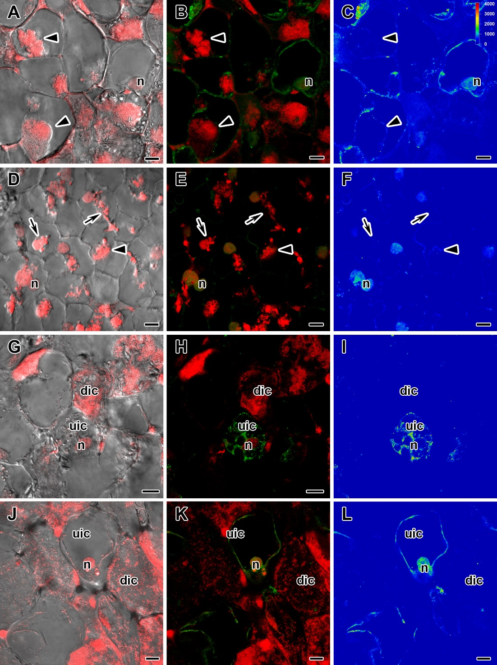
Supplementary Figure 6. Immunolocalization of gibberellin (GA₃) in cells in central part of nodules of pea mutants (SGEFix⁻-1 (sym40) (A–C), SGEFix⁻-2 (sym33) (D–F), SGEFix⁻-3 (sym26) (G–I) and SGEFix⁻-7 (sym27) (J–L)) at 4 weeks after inoculation. dic, degrading infected cell; uic, uninfected cell; n, nucleus. Arrow indicates infection thread, arrowhead indicates infection droplet. A differential interference contrast microscopy image merged with laser scanning confocal microscopy image in red channel (A, D, G, J). Merged images of laser scanning confocal microscopy in green and red channels (B, E, H, K). Heat map provides color code of fluorescence signal intensities (C, F, I, L). Visualization of GA by the Alexa Fluor 488 conjugated secondary antibody (green), nuclei and bacteria stained with propidium iodide (red). Scale bar = 10 µm.

