DAG
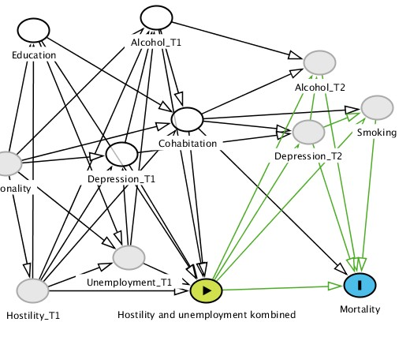

Measured variables

Survey:
Employment status
Hostility
Education

Population registry:
Cohabitation

Hospitalizations related to alcohol abuse and depression 1980-1994 Somatic wards only, 1994-1999 somatic and psychiatric wards. Medications from 1995-1999

Causes of Death registry:
All-cause mortality

1980 1995 1999 2000 2014

