Supplemental information

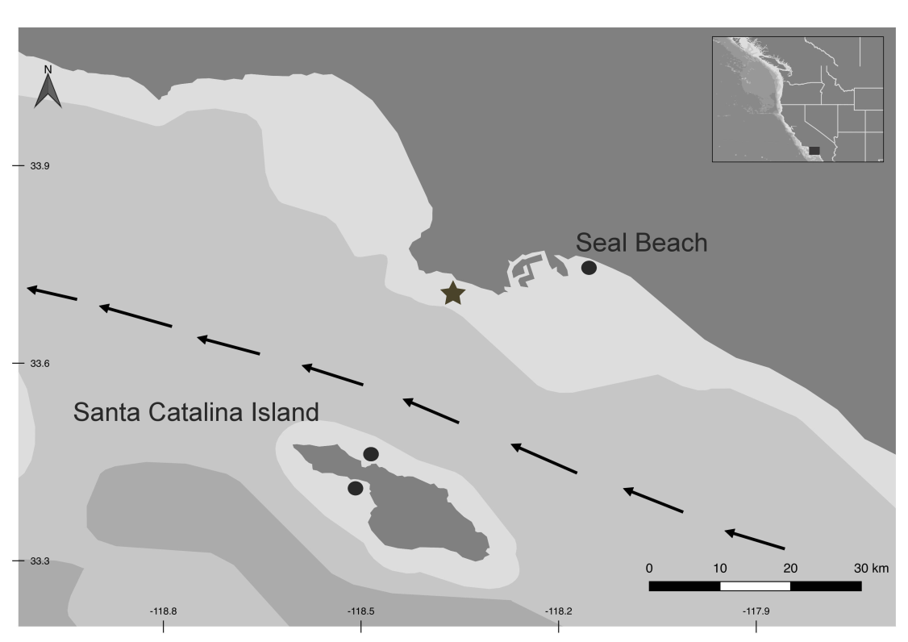
Figure 1. Adult male and female sampling locations.
Stingrays were sampled (black dots) from several areas within southern California (USA). Seal Beach (mainland California) represented our contaminated site and Santa Catalina Island, located ~35 km offshore, represented our reference site (males were sampled from the norther side and females from the southern side). Star indicates the location of the Palos Verdes US Environmental Protection Agency superfund site and relative depth is depicted in shades of grey, with darker colors corresponding to deeper depths. Arrows indicate direction of the California Countercurrent, reducing the environmental transport of contaminants from the mainland to the island.

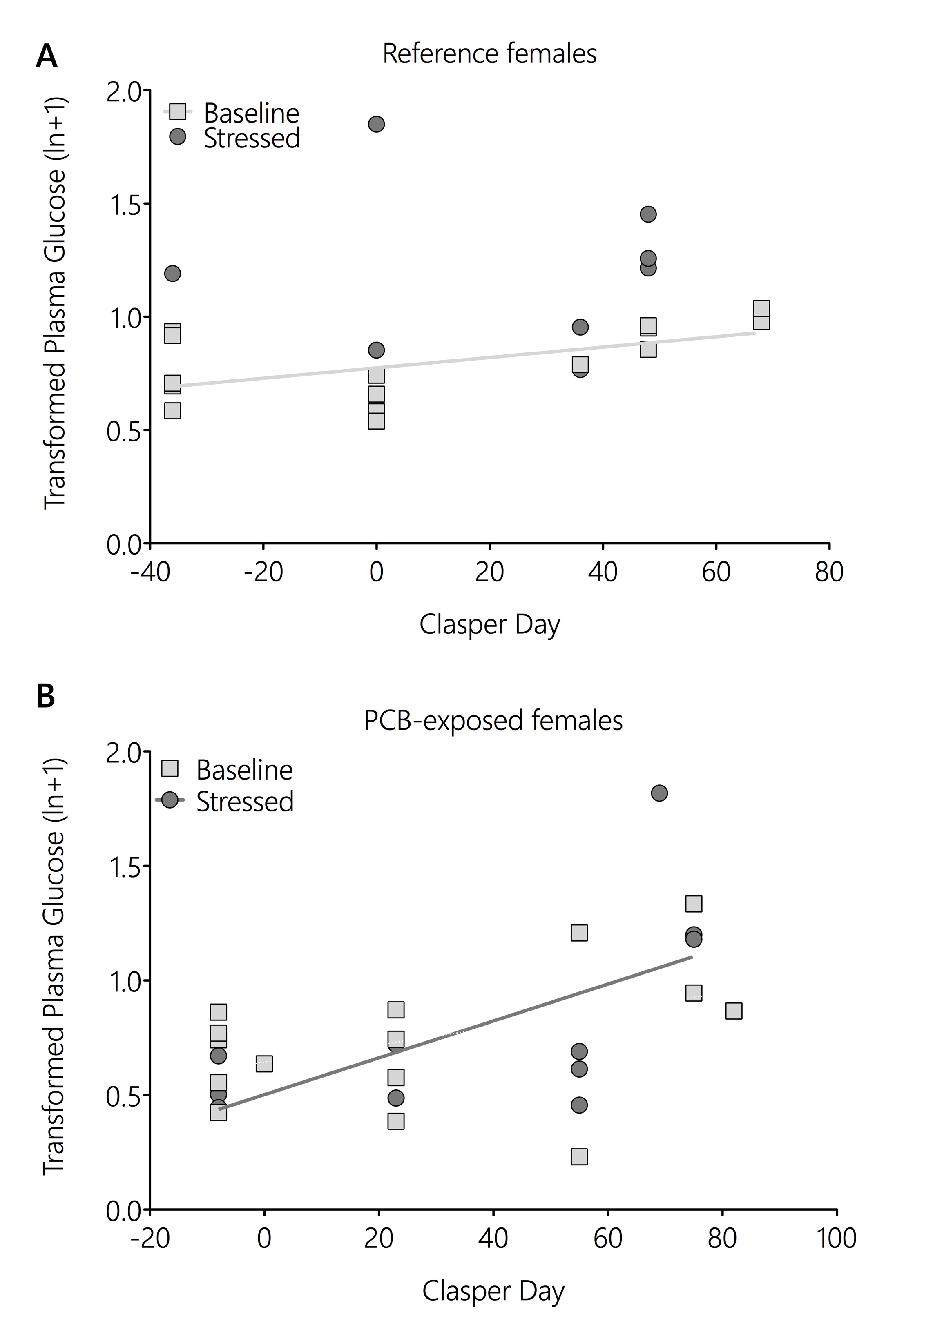
Figure 2. Plasma glucose in baseline (light grey squares) and stressed (dark grey circles) female stingrays were compared for reference (A) and PCB-exposed (B) females over pregnancy based on clasper days. Significant linear regressions are shown in solid lines and glucose values are shown as transformed numbers (natural log (x+1)).

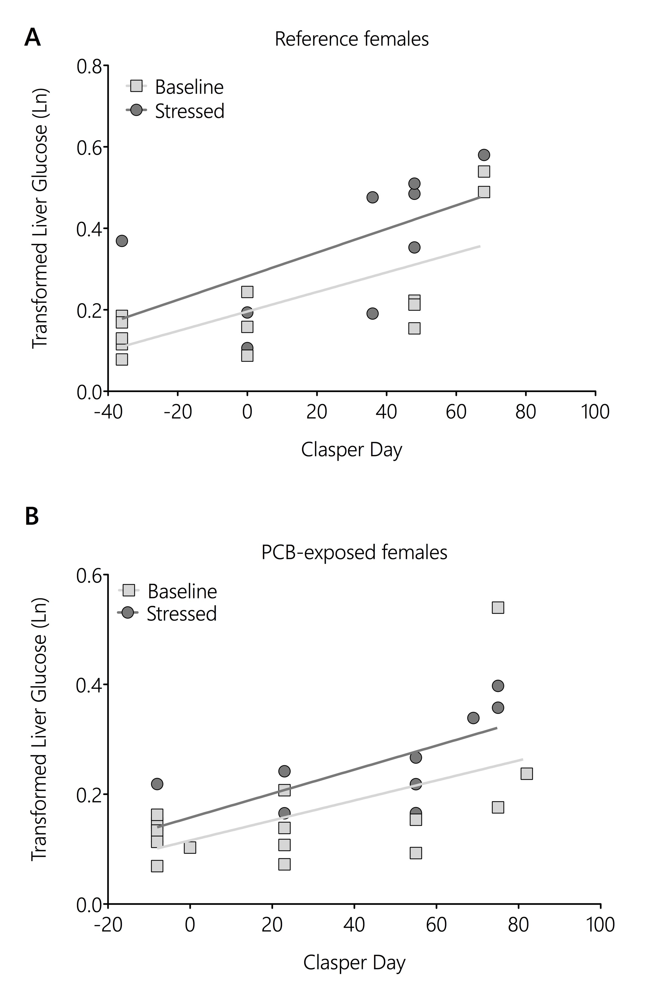
Figure 3. Liver glucose content in baseline (light grey squares) and stressed (dark grey circles) female stingrays were compared for reference (A) and PCB-exposed (B) females over pregnancy based on clasper days. Significant linear regressions are shown in solid lines and glucose values are shown as transformed numbers (natural log).

Table 1. A range of corticosteroids were measured by LCMS following previously published methods (Koren et al., 2012). Only cortisol and 11-dehydrocorticosterone (11-DHC) concentrations were detected in plasma samples, with all other corticosteroids (cortisone, corticosterone, 11-deoxycortisol) were below detection limits. However, detections rates of cortisol and 11-DHC were low in samples (11% and 6%, respectively), and concentrations are reported here for stingrays where plasma levels could be quantified. Stingrays are separated by sex, experimental group (baseline or stressed) and PCB-exposure (site). Concentrations are reported on a nmol/L basis or as below the lower limit of quantitation (< LOQ).
ID | Location | Sex | Experimental group | Cortisol | 11-DHC
Cat65 | Reference | F | Stressed | < LOQ | 0.18
Main123 | PCB-exposed | F | Stressed | < LOQ | 0.21
Main128 | PCB-exposed | F | Stressed | < LOQ | 0.18
Cat45 | Reference | F | Unstressed | 0.37 | < LOQ
Cat47 | Reference | F | Unstressed | 0.33 | < LOQ
Cat50 | Reference | F | Unstressed | 0.30 | < LOQ
Cat51 | Reference | F | Unstressed | 1.41 | < LOQ
Main102 | PCB-exposed | F | Unstressed | 1.57 | < LOQ
Main126 | PCB-exposed | F | Unstressed | < LOQ | 0.27
Main4-11 | PCB-exposed | M | Stressed | 0.36 | < LOQ
Main4-7 | PCB-exposed | M | Stressed | 0.30 | < LOQ
Main4-9 | PCB-exposed | M | Stressed | 22.9 | < LOQ
Cat3 | Reference | M | Unstressed | < LOQ | 0.15
Main4-12 | PCB-exposed | M | Unstressed | 0.55 | < LOQ

Table 2. Baseline values for measured parameters between reference (n = 2) and PCB-exposed males (n = 8) and with tissue type indicated. Values for reference males are given as the range between the two individuals sampled (dashes indicate no data collected) and values for PCB-exposed males are shown as mean ± standard deviation. Plasma hormones and metabolites are reported in pg/mL and mmol/L (mM). respectively. Liver and muscle measurements are in mg metabolite/g gram wet weight of tissue.
 | Reference |  |  |  |  |  | PCB-exposed
 | Plasma |  | Liver |  | Muscle |  |  | Plasma |  | Liver | Muscle
1α-OH-Corticosterone | 165- 195 | - |  |  | - |  |  |  | 1.321 ± 155 | - | -
Glucose | 1.12 – 1.56 | 0.52 – 1.59 |  |  | 0.25 – 0.29 |  |  |  | 1.42 ± 0.56 | 0.23 ± 0.053 | 0.42 ± 0.27
Glycogen | - | 1.66 – 2.98 |  |  | 2.36 – 5.04 |  |  |  | 1.- | 10.98 ± 5.42 | 2.94 ± 0.84
Lactate | 1.27 – 1.52 |  |  | - |  | 1.45 – 1.64 | 1.04 ± 0.42 |  |  | - |  | 2.20 ± 0.13

Koren LZ, Ng ESM, Soma KK & Wynne-Edwards KE (2012) Sample preparation and liquid chromatography-tandem mass spectrometry for multiple steroids in mammalian and avian serum. PLoS One. 7(2):e32496 DOI: 10.1371/journal.pone.0032496.

