Additional file 3

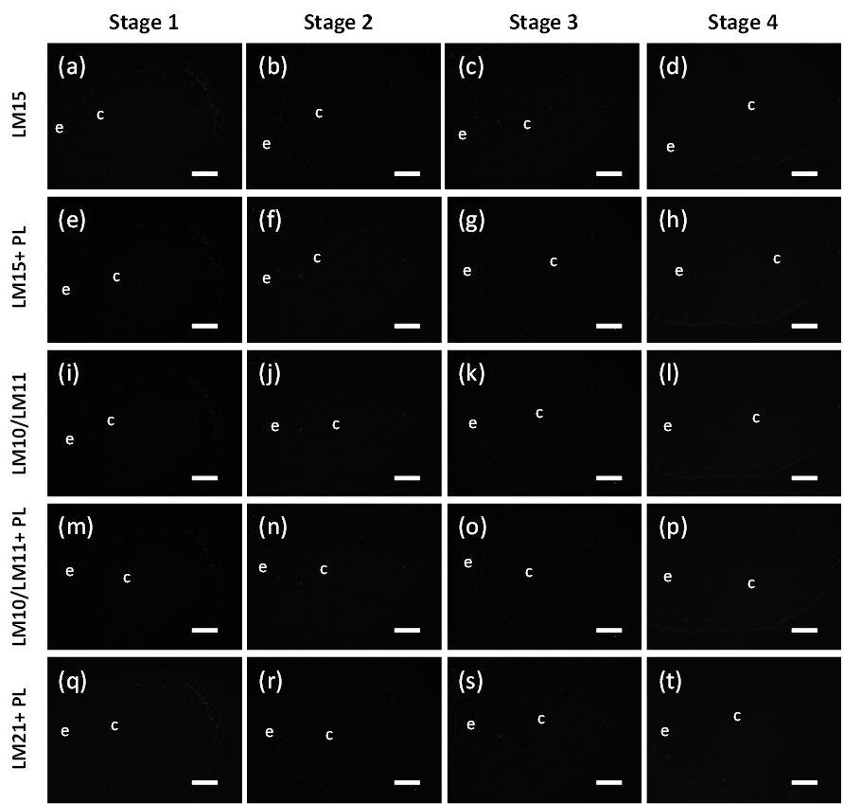
Figure S3. Control immunofluorescence micrographs of transverse sections of celery collenchyma strands at four developmental stages with the omission of the primary antibodies LM15, LM10, LM11 and LM21. LM15 (a-d) are control experiments for sections with LM15 labelling omitted. LM15 + PL (e-h) are control experiments for sections pretreated with pectate lyase, but with LM15 labelling omitted. LM10/LM11 (i-l) are control experiments for sections with LM10 or LM11 labelling omitted. LM10/LM11+ PL (m-p) are control experiments for sections pretreated with pectate lyase, but with LM10 or LM11 labelling omitted. LM21+ PL (q-t) are control experiments for sections pretreated with pectate lyase, but with LM21 labelling omitted. Stage 1 (from 2.6 cm petiole) (a, e, I, m, q); Stage 2 (from 11 cm petiole) (b, f, j, n, r); Stage 3 (from 24 cm petiole) (c, g, k, o, s); Stage 4 (from 40 cm petiole) (d, h, l, p, t). e = epidermis, c = collenchyma cells. Scale = 100 μm.

