Structural and molecular modeling studies of antimelanogenic piper-amide TRPM1 antagonists
J.-Y. Lee^{a,b}, H. Choª, E. Hwang^{c}, S. Y. Kim^{c} and S. Kim ^{a,d,}*
ªCollege of Pharmacy, Seoul National University, 1 Gwanak-ro, Gwanak-gu, Seoul 08826, Korea; ^{b}Chemical Data-Driven Research Center, Korea Research Institute of Chemical Technology, 141 Gajeong-ro, Yuseong-gu, Daejeon 34114, Korea; ^{c}College of Pharmacy, Gachon University, 191 Hambakmoero, Yeonsu-gu, Incheon 21936, Korea; ^{d}Research Institute of Pharmaceutical Sciences, College of Pharmacy, Seoul National University, 1 Gwanak-ro, Gwanak-gu, Seoul 08826, Korea

Contents

Sequence alignments between hTRPM1 and mTRPM7 | S1
Sequence alignment between hTRPV1 and rTRPV1 | S2
Tetrameric hTRPV1 structure and Ramachandran plot of hTRPV1 homology | S3
RMSD plots and MD-refined structures of apo TRPM1, apo TRPV1, NED-180:TRPM1 and NED-180:TRPV1 | S4
Binding models of the selected active compounds with TRPV1 | S5

Sequence alignments between hTRPM1 and mTRPM7
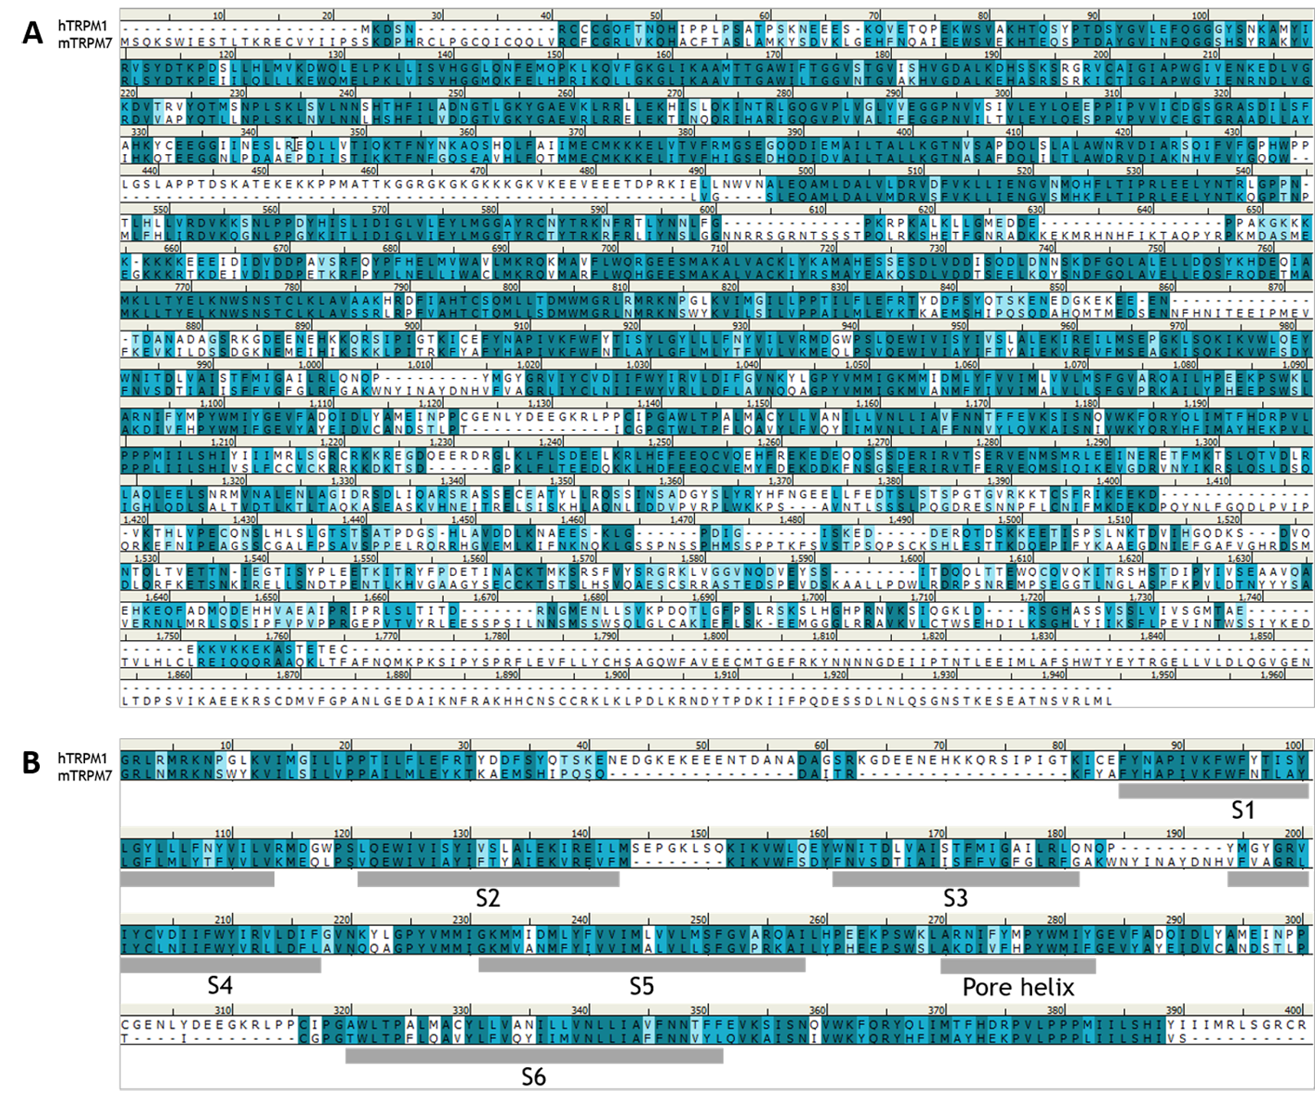
Figure S1. Sequence alignments of (A) full and (B) TM domain between hTRPM1 (Accession number Q7Z4N2) and mTRPM7 (Accession number Q923J1). Residues in the dark cyan shade box are the exactly same, and residues in sky blue shade box are similar property residues.

Sequence alignment between hTRPV1 and rTRPV1
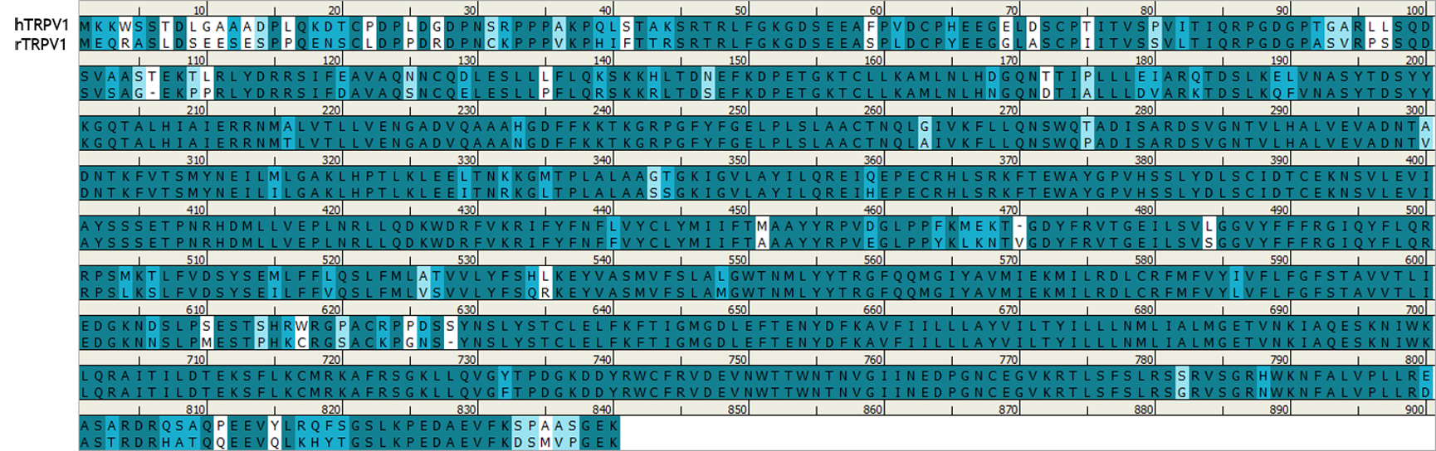
Figure S2. Sequence alignment between hTRPV1 (Accession number Q8NER1) and rTRPV1 (Accession number O35433). Residues in the dark cyan shade box are the exactly same, and residues in sky blue shade box are similar property residues.

Tetrameric hTRPV1 structure and Ramachandran plot of hTRPV1 homology
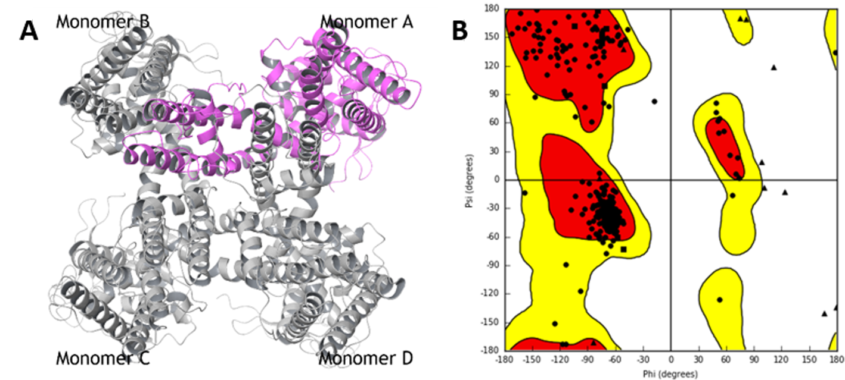
Figure S3. (A) Homology model of tetrameric hTRPV1 structure and (B) Ramachandran plot of hTRPV1 homology model. The hTRPV1 homology model showed that 93.8% (391/417) of all residues were favored regions, and 98.1% (409/417) of all residues were in allowed regions in the plot.

RMSD plots and MD-refined structures of apo TRPM1, apo TRPV1, NED-180:TRPM1 and NED-180:TRPV1
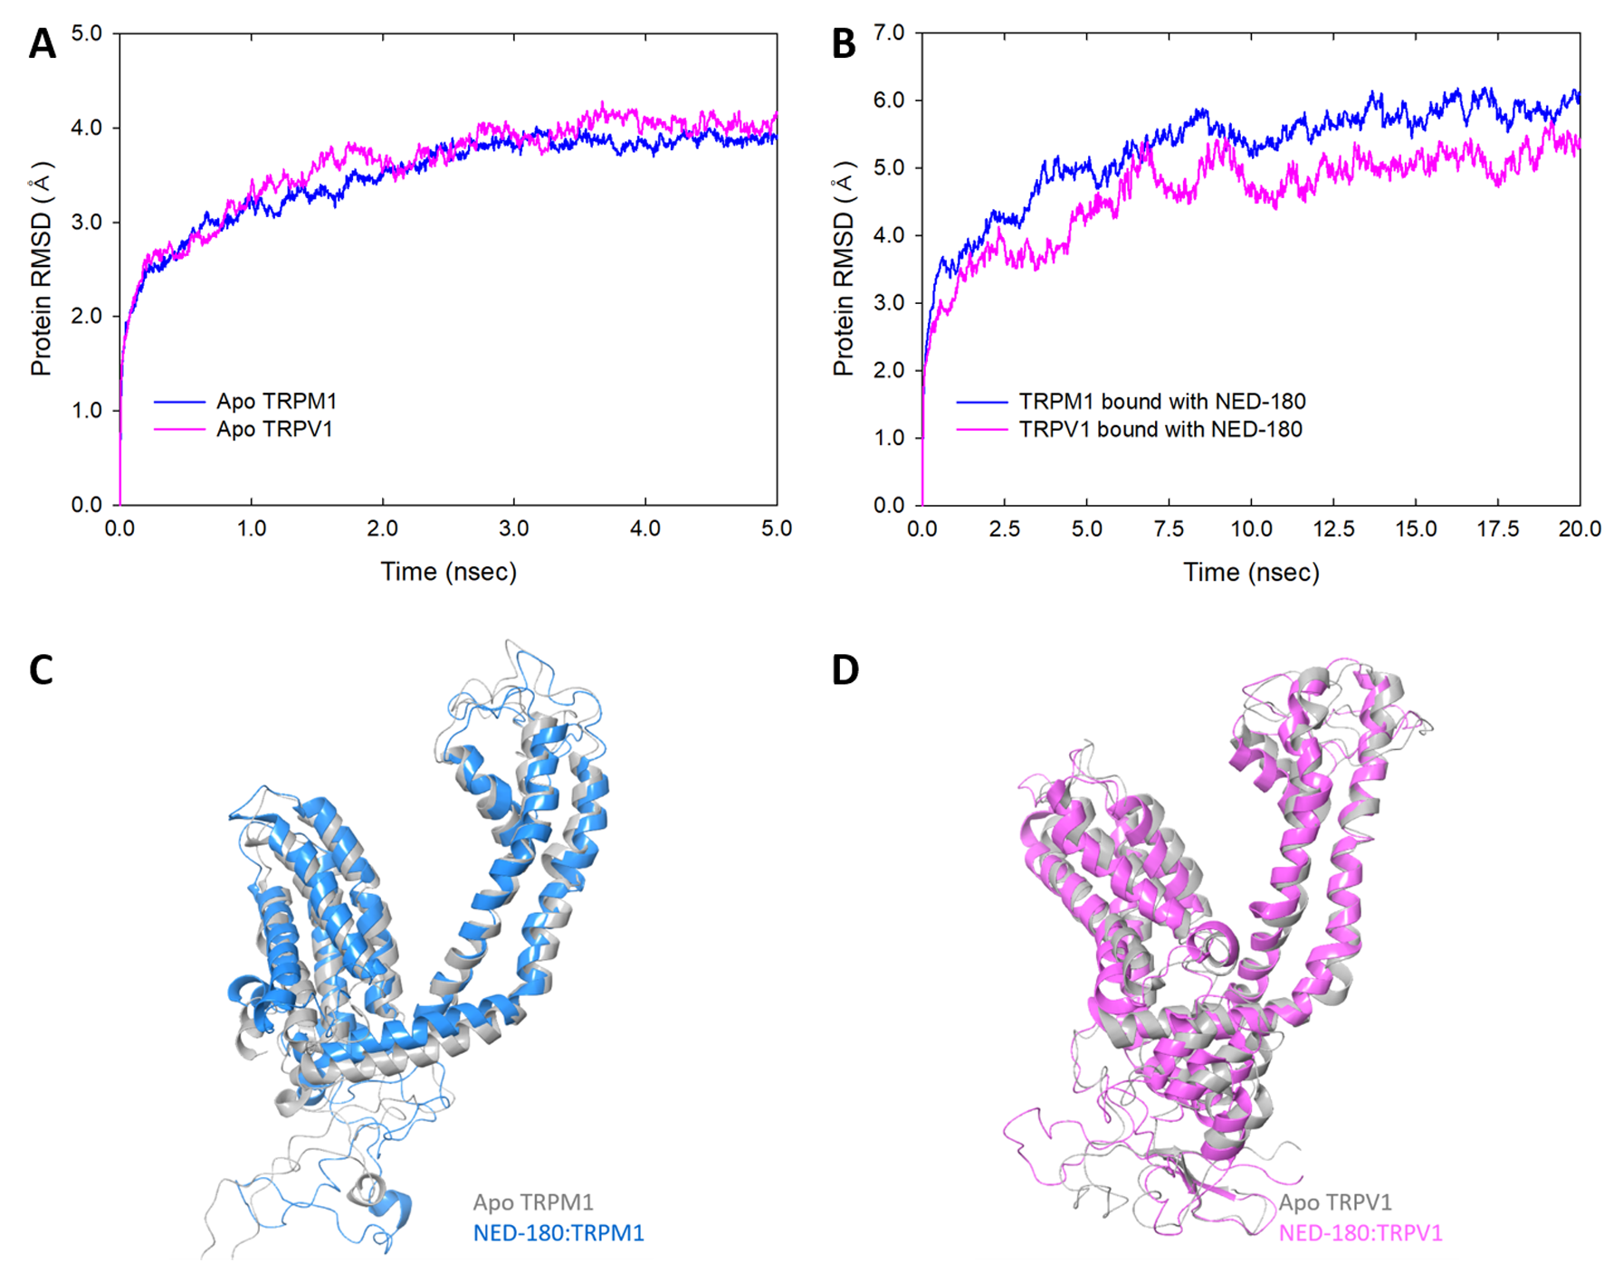
Figure S4. Time evolution of the RMSD of the protein backbone C-α atoms and alignment of refined structures by MD simulations. (A) RMSD plot of ligand-unbound TRPM1 (blue lines) and TRPV1 (pink lines) during 5 ns of the MD simulation. The total energies of the dynamic proteins were stable after approximately 3 ns of total simulation. The RMSD of all structures converged at 4 Å during the 5 ns simulation. (B) RMSD plot of NED-180-bound TRPM1 (blue lines) and TRPV1 (pink lines) during 20 ns of the MD simulation. The total energies of the dynamic ligand-protein complexes were stable after approximately 12.5 ns of total simulation. The RMSD of NED-180:TRPM1 and NED-180:TRPV1 converged at 6 Å and 5 Å, respectively, during the 20 ns simulation. (C) Superimposition of apo TRPM1 (gray ribbon model) and NED-180-bound TRPM1 (blue ribbon model) monomers after MD simulations. (D) Superimposition of apo TRPV1 (gray ribbon model) and NED-180-bound TRPV1 (pink ribbon model) monomers after MD simulations.
Binding models of the selected active compounds with TRPV1
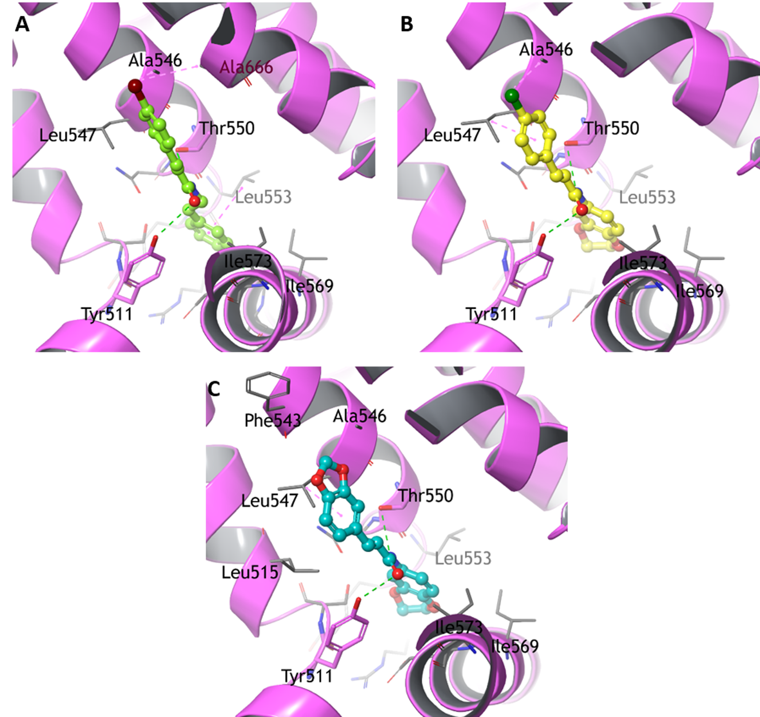
Figure S5. Proposed binding models of (A) NED-134 (yellow-green ball and stick), (B) NED-181 (yellow ball and stick) and (C) NED-182 (cyan ball and stick) with TRPV1 (magenta ribbon model). The hydrogen bonds are shown as green dashed lines and hydrophobic interactions are represented by pink dashed lines.

