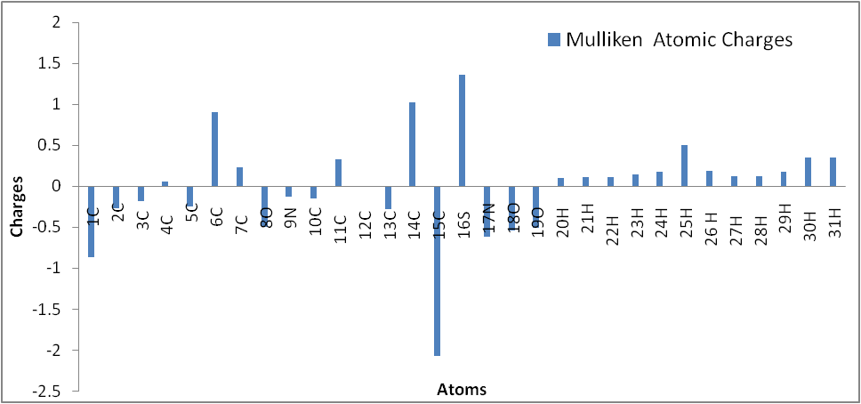
Figure S1 Bar diagram representation of Mulliken atomic charges of sal-snmH

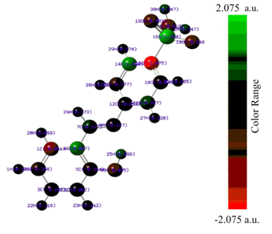
FigureS2 The color range in the scale of positive and negative charge for Mulliken atomic charges of sal-snmH in atomic units (a.u.)
Figure S3 FMOs with energy level three dimensional structures of sal-snmH

