Supplementary Information
Ovary failure perturbs 'hypothalamus-uterus-kidney' axis through ERβ/PTGDS signalling pathway triggered lipid metabolism disorder
Yan-Ru Liu ^{a,1}, Zhi-Shu Tang ^{a,1,2}, Jin-Ao Duan^{c,2}, Lin Chen ª, Jing Sunª, Rui Zhou ª, Zhong-Xing Song ª, Xin-Yi Kong ª, Xin-Bo Shi ª, Yang Lv ª, and Hui-Yuan Zhu ^{b}

ª Shaanxi Province Key Laboratory of New Drugs and Chinese Medicine Foundation Research, Shaanxi Collaborative Innovation Center of Chinese Medicinal Resource Industrialization, Shaanxi University of Chinese Medicine, 712083, Xianyang, P.R. China
^{b} Shaanxi University of Chinese Medicine, 712083, Xianyang, P.R. China
^{c} Key Laboratory for High Technology Research of TCM Formulae and Jiangsu Collaborative Innovation Center of Chinese Medicinal Resources Industrialization，Nanjing University of Chinese Medicine，210023，Nanjing, P.R. China

The authors declare no conflict of interest.
¹ Yan-Ru Liu and Zhi-Shu Tang contributed equally to this work.
² To whom correspondence should be addressed.

corresponding author : Zhi-Shu Tang
Email: tzs6565@163.com.

Updated March 2018

Supplemental Materials and Methods
Table S1 Targeted proteins MRM for Q1-Q3, DP, CE Optimization
Protein | Peptide | Q1* | Q3* | DP | CE | ion type | Lable**
AMBP | DSLLQEFR | 504.2615 | 692.3726 | 67.9 | 27 | +2y5 | light
 |  | 504.2615 | 579.2885 | 67.9 | 27 | +2y4 | light
 |  | 504.2615 | 451.23 | 67.9 | 27 | +2y3 | light
 |  | 504.2615 | 322.1874 | 67.9 | 27 | +2y2 | light
 |  | 504.2615 | 316.1503 | 67.9 | 27 | +2b3 | light
 |  | 509.2656 | 815.4649 | 67.9 | 27 | +2y6 | heavy
 |  | 509.2656 | 702.3809 | 67.9 | 27 | +2y5 | heavy
 |  | 509.2656 | 589.2968 | 67.9 | 27 | +2y4 | heavy
 |  | 509.2656 | 461.2382 | 67.9 | 27 | +2y3 | heavy
 |  | 509.26559 | 332.1956 | 67.9 | 27 | +2y2 | heavy
 |  | 509.2656 | 316.1503 | 67.9 | 27 | +2b3 | heavy
Complement C3 | VHQFFNVGLIQPGSVK | 885.488496 | 898.5356 | 95.7 | 40.7 | +2y9 | light
 |  | 885.4885 | 615.3461 | 95.7 | 40.7 | +2y6 | light
 |  | 885.4885 | 487.2875 | 95.7 | 40.7 | +2y5 | light
 |  | 885.4885 | 365.1932 | 95.7 | 40.7 | +2b3 | light
 |  | 885.4885 | 512.2616 | 95.7 | 40.7 | +2b4 | light
 |  | 885.4885 | 872.4413 | 95.7 | 40.7 | +2b7 | light
 |  | 889.4956 | 906.5498 | 95.7 | 40.7 | +2y9 | heavy
 |  | 889.4956 | 623.3603 | 95.7 | 40.7 | +2y6 | heavy
 |  | 889.4956 | 495.3017 | 95.7 | 40.7 | +2y5 | heavy
 |  | 889.4956 | 365.1932 | 95.7 | 40.7 | +2b3 | heavy
 |  | 889.4956 | 512.2616 | 95.7 | 40.7 | +2b4 | heavy
 |  | 889.4956 | 872.4413 | 95.7 | 40.7 | +2b7 | heavy
 |  | 590.6614 | 898.5356 | 74.2 | 29.7 | +3y9 | light
 |  | 590.6614 | 728.4301 | 74.2 | 29.7 | +3y7 | light
 |  | 590.6614 | 615.3461 | 74.2 | 29.7 | +3y6 | light
 |  | 590.6614 | 487.2875 | 74.2 | 29.7 | +3y5 | light
 |  | 590.6614 | 929.4628 | 74.2 | 29.7 | +3b8 | light
 |  | 593.3328 | 906.5498 | 74.2 | 29.7 | +3y9 | heavy
 |  | 593.3328 | 736.4443 | 74.2 | 29.7 | +3y7 | heavy
 |  | 593.3328 | 623.3603 | 74.2 | 29.7 | +3y6 | heavy
 |  | 593.3328 | 495.3017 | 74.2 | 29.7 | +3y5 | heavy
 |  | 593.3328 | 929.4628 | 74.2 | 29.7 | +3b8 | heavy
Prostaglandin-H2 D-isomerase | DQGLTEEDIVFLPQPDK | 648.658072 | 844.4563 | 78.4 | 32.9 | +3y7 | light
 |  | 648.6581 | 697.3879 | 78.4 | 32.9 | +3y6 | light
 |  | 648.6581 | 584.3039 | 78.4 | 32.9 | +3y5 | light
 |  | 648.6581 | 301.1143 | 78.4 | 32.9 | +3b3 | light
 |  | 651.3295 | 852.4705 | 78.4 | 32.9 | +3y7 | heavy
 |  | 651.3295 | 705.4021 | 78.4 | 32.9 | +3y6 | heavy
 |  | 651.3295 | 592.3181 | 78.4 | 32.9 | +3y5 | heavy
 |  | 651.3295 | 301.1143 | 78.4 | 32.9 | +3b3 | heavy
CAMP(Cathelicidin antimicrobial peptide) | AVDDFNQQSLDTNLYR | ﻿949.947586 | 1109.559 | 100.4 | 43.1 | +2y9 | light
 |  | 949.9476 | 981.5 | 100.4 | 43.1 | +2y8 | light
 |  | 949.9476 | 894.468 | 100.4 | 43.1 | +2y7 | light
 |  | 949.9476 | 781.3839 | 100.4 | 43.1 | +2y6 | light
 |  | 949.9476 | 666.357 | 100.4 | 43.1 | +2y5 | light
 |  | 949.9476 | 338.1823 | 100.4 | 43.1 | +2y2 | light
 |  | 954.9517 | 1119.567 | 100.4 | 43.1 | +2y9 | heavy
 |  | 954.9517 | 991.5083 | 100.4 | 43.1 | +2y8 | heavy
 |  | 954.9517 | 904.4762 | 100.4 | 43.1 | +2y7 | heavy
 |  | 954.9517 | 791.3922 | 100.4 | 43.1 | +2y6 | heavy
 |  | 954.9517 | 676.3652 | 100.4 | 43.1 | +2y5 | heavy
 |  | 954.9517 | 348.1905 | 100.4 | 43.1 | +2y2 | heavy
 |  | 633.6341 | 981.5 | 77.3 | 32.1 | +3y8 | light
 |  | 633.6341 | 894.468 | 77.3 | 32.1 | +3y7 | light
 |  | 633.6341 | 781.3839 | 77.3 | 32.1 | +3y6 | light
 |  | 633.6341 | 666.357 | 77.3 | 32.1 | +3y5 | light
 |  | 633.6341 | 338.1823 | 77.3 | 32.1 | +3y2 | light
 |  | 636.9702 | 991.5083 | 77.3 | 32.1 | +3y8 | heavy
 |  | 636.9702 | 904.4762 | 77.3 | 32.1 | +3y7 | heavy
 |  | 636.970239 | 791.3922 | 77.3 | 32.1 | +3y6 | heavy
 |  | 636.9702 | 676.3652 | 77.3 | 32.1 | +3y5 | heavy
 |  | 636.9702 | 348.1905 | 77.3 | 32.1 | +3y2 | heavy
*Q1 is the peptide precursor ion, and Q3 is the peptide product ion, DP is the declustering potential, and CE is the collision energy.
**Light: target peptide; Heavy: standards.

Table S2 Ovary failure effects phenotypes and protein expression.

Table S2-1 The phenotype, serum biochemistry analysis. (n=6, mean ± s.d.)
Organ/body weight ratio (%) | Kidney% | Liver% | Spleen% | Uterus% | Hypothalamus%
Control_6 week | 0.63±0.030 | 3.12±0.148 | 0.20±0.019 | 0.37±0.070 | 0.06±0.006
OVX_6 week | 0.57±0.028* | 3.07±0.061 | 0.20±0.031 | 0.20±0.031** | 0.04±0.010**
Control_9 week | 0.57±0.038 | 3.37±0.464 | 0.21±0.021 | 0.34±0.073 | 0.04±0.012
OVX_9 week | 0.49±0.040* | 2.61±0.270* | 0.21±0.032 | 0.15±0.039** | 0.02±0.008**
Control_12 week | 0.76±0.038 | 3.58±0.209 | 0.22±0.010 | 0.37±0.111 | 0.04±0.013
OVX_12 week | 0.623±0.035** | 2.80±0.240** | 0.19±0.037 | 0.09±0.019** | 0.02±0.009**
Biochemical kidney  profiles | ALB  (g/L) | UA (µmol/L) | UREA (mmol/L) | GLU (mmol/L) | CREA  (mmol/L)
Control_6 week | 35.00±1.279 | 61.21±4.453 | 7.86±0.951 | 6.99±0.384 | 52.87±1.537
OVX_6 week | 34.73±3.616 | 65.78±9.537 | 6.90±0.643 | 8.84±1.526* | 63.13±1.102**
Control_9 week | 31.87±2.420 | 55.87±6.897 | 6.94±0.532 | 6.92±0.728 | 56.13±3.105
OVX_9 week | 36.40±0.817** | 63.62±8.757 | 8.87±0.695** | 9.09±0.803** | 60.9±2.578*
Control_12 week | 30.02±1.072 | 66.23±6.028 | 6.49±1.053 | 6.81±0.357 | 59.73±3.075
OVX_12 week | 33.32±1.606** | 107.12±33.284* | 8.83±0.972** | 9.21±0.801** | 65.33±3.554*
Biochemical lipid  profiles | TC (mmol/L) | TG (mmol/L) | HDL (mmol/L) | LDL (mmol/L)
Control_6 week | 1.48±0.310 | 0.78±0.145 | 1.25±0.060 | 0.41±0.104
OVX_6 week | 2.38±0.244** | 1.23±0.279** | 0.96±0.091** | 0.50±0.051
Control_9 week | 1.36±0.171 | 0.73±0.140 | 1.55±0.133 | 0.39±0.018
OVX_9 week | 2.01±0.142** | 1.39±0.140** | 1.24±0.277* | 0.58±0.116**
Control_12 week | 1.75±0.365 | 0.61±0.199 | 1.86±0.019 | 0.49±0.072
OVX_12 week | 2.13±0.119* | 1.47±0.409** | 1.47±0.150** | 0.67±0.091**
*p < 0.05, **p < 0.005, ***p < 0.0005 versus control rats. NS, not significant.
Table S2-2 Enrichment list of differentially expressed proteins on cellular component, cellular function, and biochemical process. (cut-off valure 1.5-fold change, p value ˂ 0.05)
No. | Gene name | Abbreviation | Cellular Component | Cellular Function | Biochemical Process (GOID)
1 | Actin, cytoplasmic 1 | Actb | extracellular exosome(GO:0070062),  blood microparticle(GO:0072562),  membrane(GO:0016020),  focal adhesion(GO:0005925),  cytosol(GO:0005829),  MLL5-L complex(GO:0070688),  NuA4 histone acetyltransferase complex(GO:0035267),  cytoplasmic ribonucleoprotein granule(GO:0036464),  myelin sheath(GO:0043209),  cortical cytoskeleton(GO:0030863),  nuclear chromatin(GO:0000790) | ATP binding(GO:0005524),  RNA polymerase II core promoter proximal region sequence-specific DNA binding(GO:0000978),  RNA polymerase II distal enhancer sequence-specific DNA binding (GO:0000980) | substantia nigra development(GO:0021762),  platelet aggregation(GO:0070527),  ATP-dependent chromatin remodeling(GO:0043044)
2 | Adenosine deaminase | Ada | Extracellular space(GO:0005615),  lysosome(GO:0005764),  cytoplasm(GO:0005737),  external side of plasma membrane(GO:0009897),  cell junction(GO:0030054),  cytoplasmic membrane-bounded vesicle lumen(GO:0060205),  neuronal cell body (GO:0043025),  dendrite cytoplasm (GO:0032839), | zinc ion binding (GO:0008270),  purine nucleoside binding (GO:0001883),  adenosine deaminase activity (GO:0004000) | Aging(GO:0007568),  positive regulation of T cell differentiation in thymus(GO:0033089),  liver development(GO:0001889),  adenosine catabolic process(GO:0006154),  negative regulation of mucus secretion(GO:0070256)，  negative regulation of circadian sleep/wake cycle, non-REM sleep(GO:0042323),  germinal center B cell differentiation(GO:0002314),  response to hypoxia(GO:0001666),  negative regulation of mature B cell apoptotic process(GO:0002906),  inosine biosynthetic process(GO:0046103),  dATP catabolic process(GO:0046061),  positive regulation of T cell receptor signaling pathway(GO:0050862),  positive regulation of germinal center formation(GO:0002636),  negative regulation of leukocyte migration(GO:0002686),  histamine secretion(GO:0001821),  T cell activation(GO:0042110),  negative regulation of thymocyte apoptotic process(GO:0070244),  adenosine metabolic process(GO:0046085),  negative regulation of inflammatory response(GO:0050728),  positive regulation of alpha-beta T cell differentiation(GO:0046638),  response to hydrogen peroxide(GO:0042542),  trophectodermal cell differentiation(GO:0001829),  lung alveolus development(GO:0048286),  positive regulation of calcium-mediated signaling(GO:0050850),  positive regulation of heart rate(GO:0010460),  positive regulation of smooth muscle contraction(GO:0045987),  positive regulation of B cell proliferation(GO:0030890),  placenta development(GO:0001890),  response to vitamin E(GO:0033197)
3 | Alpha-2-HS-glycoprotein | Ahsg | extracellular space(GO:0005615),  blood microparticle(GO:0072562),  extracellular matrix(GO:0031012),  protein complex(GO:0043234), | cysteine-type endopeptidase inhibitor activity (GO:0004869),  endopeptidase inhibitor activity (GO:0004866),  receptor signaling protein tyrosine kinase inhibitor activity (GO:0030294),  kinase inhibitor activity (GO:0019210) | negative regulation of endopeptidase activity(GO:0010951),  acute-phase response(GO:0006953),  cellular response to insulin stimulus(GO:0032869),  negative regulation of cell growth(GO:0030308),  negative regulation of protein tyrosine kinase activity(GO:0061099),  cerebral cortex development(GO:0021987),  negative regulation of phosphorylation(GO:0042326),  regulation of inflammatory response(GO:0050727),  protein complex assembly(GO:0006461),  negative regulation of insulin receptor signaling pathway(GO:0046627)
4 | Fructose-bisphosphate aldolase A | Aldoa | cytoplasm(GO:0005737),  mitochondrion(GO:0005739),  I band(GO:0031674),  M band(GO:0031430) | fructose-bisphosphate aldolase activity (GO:0004332) | response to hypoxia(GO:0001666),  glycolytic process(GO:0006096),  response to estrogen(GO:0043627),  protein homotetramerization(GO:0051289),  response to heat(GO:0009408),
5 | Protein AMBP | Ambp | extracellular space(GO:0005615)  extracellular exosome(GO:0070062)  blood microparticle(GO:0072562)  plasma membrane(GO:0005886)  cell surface (GO:0009986)  intracellular membrane-bounded organelle(GO:0043231) | small molecule binding (GO:0036094), serine-type endopeptidase inhibitor activity (GO:0004867),  IgA binding (GO:0019862),  heme binding (GO:0020037),  protein homodimerization activity (GO:0042803) | negative regulation of endopeptidase activity(GO:0010951),  protein catabolic process(GO:0030163),  protein-chromophore linkage(GO:0018298)
6 | Annexin A1 | Anxa1 | extracellular space(GO:0005615),  extracellular exosome(GO:0070062),  nucleus(GO:0005634),  plasma membrane(GO:0005886),  cytoplasm(GO:0005737),  focal adhesion(GO:0005925),  apical plasma membrane(GO:0016324),  lateral plasma membrane(GO:0016328),  extrinsic component of external side of plasma membrane(GO:0031232),  extrinsic component of endosome membrane(GO:0031313),  sarcolemma(GO:0042383),  protein complex(GO:0043234),  basolateral plasma membrane (GO:0016323),  mitochondrial membrane(GO:0031966),  phagocytic cup(GO:0001891),  mast cell granule(GO:0042629),  cornified envelope(GO:0001533),  motile cilium(GO:0031514),  early endosome membrane (GO:0031901),  cytoplasmic vesicle membrane (GO:0030659), | double-stranded DNA-dependent ATPase activity (GO:0033676),  phospholipase A2 inhibitor activity (GO:0019834),  calcium ion binding (GO:0005509), protein homodimerization activity (GO:0042803),  annealing helicase activity (GO:0036310),  structural molecule activity (GO:0005198),  single-stranded DNA binding (GO:0003697),  helicase activity (GO:0004386),  phospholipid binding (GO:0005543),  calcium-dependent phospholipid binding (GO:0005544) | regulation of interleukin-1 production(GO:0032652),  response to organic cyclic compound (GO:0014070),  inflammatory response (GO:0006954),  DNA rewinding(GO:0036292),  cell surface receptor signaling pathway(GO:0007166),  estrous cycle(GO:0044849),  positive regulation of neutrophil apoptotic process(GO:0033031),  negative regulation of interleukin-8 secretion(GO:2000483),  response to corticosteroid(GO:0031960),  positive regulation of T-helper 1 cell differentiation(GO:0045627),  granulocyte chemotaxis(GO:0071621),  DNA strand renaturation(GO:0000733),  regulation of leukocyte migration(GO:0002685),  innate immune response(GO:0045087),  positive regulation of prostaglandin biosynthetic process(GO:0031394),  gliogenesis(GO:0042063),  negative regulation of T-helper 2 cell differentiation(GO:0045629),  response to hormone(GO:0009725),  response to estradiol(GO:0032355),  regulation of cell shape(GO:0008360),  alpha-beta T cell differentiation(GO:0046632),  prolactin secretion(GO:0070459),  response to glucocorticoid(GO:0051384),  response to peptide hormone(GO:0043434),  regulation of hormonesecretion(GO:0046883),  cellular response to glucocorticoid stimulus(GO:0071385),  positive regulation of vesicle fusion(GO:0031340),  peptide cross-linking(GO:0018149),  negative regulation of protein secretion(GO:0050709),  regulation of inflammatory response(GO:0050727),  adaptive immune response(GO:0002250),  actin cytoskeleton reorganization(GO:0031532)  positive regulation of T cell proliferation(GO:0042102),  arachidonic acid secretion(GO:0050482),  positive regulation of interleukin-2 production(GO:0032743),  keratinocyte differentiation(GO:0030216),  G-protein coupled receptor signaling pathway, coupled to cyclic nucleotide second messenger(GO:0007187),  DNA duplex unwinding(GO:0032508),  positive regulation of G1/S transition of mitotic cell cycle(GO:1900087),  response to interleukin-1(GO:0070555),  insulin secretion(GO:0030073),  monocyte chemotaxis(GO:0002548)
7 | ATP synthase subunit beta, mitochondrial | Atp5b | mitochondrion(GO:0005739)  mitochondrial inner membrane (GO:0005743)  mitochondrial proton-transporting ATP synthase complex, catalytic core F(1)  (GO:0000275)  proton-transporting ATP synthase complex, catalytic core F(1) (GO:0045261)  mitochondrial proton-transporting ATP synthase complex(GO:0005753) | ATP binding (GO:0005524),  lipoprotein particle receptor activity (GO:0030228),  calcium ion binding (GO:0005509),  ATPase activity (GO:0016887),  proton-transporting ATP synthase activity, rotational mechanism (GO:0046933) | ATP metabolic process(GO:0046034),  receptor-mediated endocytosis(GO:0006898),  ATP hydrolysis coupled proton transport(GO:0015991),  ATP synthesis coupled proton transport(GO:0015986)
8 | Beta-2-microglobulin | B2m | extracellular space(GO:0005615)  extracellular exosome(GO:0070062)  external side of plasma membrane  (GO:0009897)  focal adhesion(GO:0005925)  Golgi apparatus(GO:0005794)  MHC class I protein complex  (GO:0042612) |  | protein refolding(GO:0042026),  cellular response to lipopolysaccharide(GO:0071222),  positive regulation of T cell cytokine production(GO:0002726),  negative regulation of receptor binding(GO:1900121),  regulation of membrane depolarization(GO:0003254),  antigen processing and presentation of exogenous protein antigen via MHC class Ib, TAP-dependent(GO:0002481),  positive regulation of T cell mediated cytotoxicity(GO:0001916),  positive regulation of receptor-mediated endocytosis(GO:0048260),  T cell differentiation in thymus(GO:0033077)
9 | Complement C3 | C3 | extracellular space(GO:0005615) | endopeptidase inhibitor activity (GO:0004866),  C5L2 anaphylatoxin chemotactic receptor binding (GO:0031715),  lipid binding (GO:0008289),  cofactor binding (GO:0048037) | complement activation, alternative pathway(GO:0006957),  blood coagulation(GO:0007596),  complement activation, classical pathway(GO:0006958),  inflammatory response(GO:0006954),  complement activation(GO:0006956),  tolerance induction(GO:0002507),  positive regulation of ERK1 and ERK2 cascade(GO:0070374),  regulation of triglyceride biosynthetic process(GO:0010866),  response to estradiol(GO:0032355),  positive regulation of developmental growth(GO:0048639),  response to glucocorticoid(GO:0051384),  positive regulation of protein phosphorylation(GO:0001934),  response to estrogen(GO:0043627),  positive regulation of glucose transport(GO:0010828),  positive regulation of lipid storage(GO:0010884),  chemotaxis(GO:0006935),  response to progesterone(GO:0032570),  positive regulation of G-protein coupled receptor protein signaling pathway(GO:0045745),  fatty acid metabolic process(GO:0006631),  response to magnesium ion(GO:0032026),
10 | Cathelicidin antimicrobial peptide | Camp | extracellular space(GO:0005615)  cytoplasm(GO:0005737)  cell projection(GO:0042995) | cysteine-type endopeptidase inhibitor activity (GO:0004869) | positive regulation of cell proliferation(GO:0008284),  cellular response to lipopolysaccharide(GO:0071222),  cellular response to peptidoglycan(GO:0071224),  positive regulation of angiogenesis(GO:0045766),  positive regulation of protein phosphorylation(GO:0001934),  cellular response to tumor necrosis factor(GO:0071356),  cellular response to interleukin-1(GO:0071347)  cellular response to interleukin-6(GO:0071354)
11 | CD44 protein | Cd44 | integral component of membrane  (GO:0016021) | hyaluronic acid binding (GO:0005540) | cell adhesion(GO:0007155)
12 | Cd99 protein | Cd99 | integral component of membrane  (GO:0016021),  focal adhesion(GO:0005925)
13 | Cadherin-1 | Cdh1 | integral component of membrane  (GO:0016021),  extracellular exosome(GO:0070062),  plasma membrane(GO:0005886),  cytoplasm(GO:0005737),  focal adhesion(GO:0005925),  lateral plasma membrane(GO:0016328),  aggresome(GO:0016235),  perinuclear region of cytoplasm (GO:0048471),  flotillin complex(GO:0016600),  cytoplasmic side of plasma membrane  (GO:0009898),  catenin complex(GO:0016342),  apical junction complex(GO:0043296),  endosome(GO:0005768),  cell-cell adherens junction(GO:0005913),  trans-Golgi network(GO:0005802),  lamellipodium(GO:0030027),  cortical actin cytoskeleton(GO:0030864) | calcium ion binding (GO:0005509) | positive regulation of transcription, DNA-templated(GO:0045893),  neuron projection development(GO:0031175),  homophilic cell adhesion via plasma membrane adhesion molecules(GO:0007156),  cellular response to indole-3-methanol(GO:0071681),  response to organic substance(GO:0010033),  single organismal cell-cell adhesion(GO:0016337),  positive regulation of transcription factor import into nucleus(GO:0042993),  negative regulation of cell-cell adhesion(GO:0022408),  synapse assembly(GO:0007416),  establishment of protein localization to plasma membrane(GO:0090002),  pituitary gland development(GO:0021983)
14 | Collagen alpha-1(I) chain | Col1a1 | extracellular space(GO:0005615),  extracellular region(GO:0005576),  collagen type I trimer(GO:0005584),  Golgi apparatus(GO:0005794),  endoplasmic reticulum(GO:0005783),  secretory granule(GO:0030141) | metal ion binding (GO:0046872),  extracellular matrix structural constituent (GO:0005201) | protein transport(GO:0015031),  positive regulation of transcription, DNA-templated(GO:0045893),  positive regulation of cell migration(GO:0030355),  response to corticosteroid(GO:0031960),  response to estradiol(GO:0032355),  collagen biosynthetic process(GO:0032964),  response to cAMP(GO:0051591),  response to mechanical stimulus(GO:0009612),  response to peptide hormone(GO:0043434),  cellular response to tumor necrosis factor(GO:0071356),  osteoblast differentiation(GO:0001649),  bone trabecula formation(GO:0060346),  cellular response to mechanical stimulus(GO:00712600),  skin morphogenesis(GO:0043589),  negative regulation of cell-substrate adhesion(GO:0010812),  cartilage development involved in endochondral bone morphogenesis(GO:0060351),  cellular response to transforming growth factor beta stimulus(GO:0071560),  Ossification(GO:0001503),  response to hydrogen peroxide(GO:0042542),  response to steroid hormone(GO:0048545),  positive regulation of canonical Wnt signaling pathway(GO:0090263),  cellular response to amino acid stimulus(GO:0071230),  protein heterotrimerization(GO:0070208),  response to hyperoxia(GO:0055093),  cellular response to fibroblast growth factor stimulus(GO:0044344),  collagen fibril organization(GO:0030199),  blood vessel development(GO:0001568),  protein localization to nucleus(GO:0034504),  cellular response to epidermal growth factor stimulus(GO:0071364),  endochondral ossificationGO:0001958  positive regulation of epithelial to mesenchymal transition(GO:0010718),  embryonic skeletal system development(GO:0048706),  face morphogenesis(GO:0060325),  Response to nutrient (G0:0007584)
15 | Ceruloplasmin | Cp | extracellular exosome(GO:0070062),  blood microparticle(GO:0072562),  lysosomal membrane(GO:0005765) | copper ion binding (GO:0005507),  ferroxidase activity (GO:0004322) | copper ion transport(GO:0006825),  cellular iron ion homeostasis(GO:0006879)
16 | Protective protein for beta-galactosidase | Ctsa | lysosomal membrane(GO:0005765),  mitochondrion(GO:0005739) | serine-type carboxypeptidase activity (GO:0004185),  glycoprotein binding (GO:0001948) | Proteolysis(GO:0006508),  proteolysis involved in cellular protein catabolic process(GO:0051603),  regulation of protein stability(GO:0031647)
17 | Dihydrolipoamide S-succinyltransferase (E2 component of 2-oxo-glutarate complex), isoform CRA_a | Dlst | extracellular exosome(GO:0070062),  nucleus(GO:0005634),  membrane(GO:0016020),  mitochondrion(GO:0005739),  oxoglutarate dehydrogenase complex  (GO:0045252),  myelin sheath(GO:0043209) | dihydrolipoyllysine-residue succinyltransferase activity (GO:0004149) | tricarboxylic acid cycle(GO:0006099)
18 | Eukaryotic translation initiation factor 4A1 | Eif4a1 | extracellular exosome(GO:0070062),  cytoplasm(GO:0005737),  membrane(GO:0016020) | ATP binding (GO:0005524),  poly(A) RNA binding (GO:0044822),  ATP-dependent RNA helicase activity (GO:0004004),  double-stranded RNA binding (GO:0003725),  translation initiation factor activity (GO:0003743) | regulation of gene expression(GO:0010468),  RNA secondary structure unwinding(GO:0010501),  regulation of translational initiation(GO:0006446),  translational initiation(GO:0006413)
19 | Ac2-120 | F5 | extracellular region(GO:0005576),  Golgi apparatus(GO:0005794),  endoplasmic reticulum(GO:0005783) | serine-type endopeptidase activity (GO:0004252),  copper ion binding (GO:0005507) | Proteolysis(GO:0006508),  blood coagulation(GO:0007596),  blood coagulation, extrinsic pathway(GO:0007598)
20 | Lysosomal alpha-glucosidase | Gaa | Lysosome(GO:0005764),  lysosomal membrane(GO:0005765) | maltose alpha-glucosidase activity (GO:0032450),  alpha-1,4-glucosidase activity (GO:0004558),  carbohydrate binding (GO:0030246) | glycogen catabolic process(GO:0005980)
21 | Gamma-glutamyl hydrolase | Ggh | extracellular space(GO:0005615),  extracellular exosome(GO:0070062),  nucleus(GO:0005634),  lysosome(GO:0005764),  cytosol(GO:0005829),  melanosome(GO:0042470) | gamma-glutamyl-peptidase activity (GO:0034722) | Proteolysis(GO:0006508),  response to ethanol(GO:0045471),  response to insulin(GO:0032868),  glutamine metabolic process(GO:0006541)
22 | Gamma-glutamyltranspeptidase 1 | Ggt1 | extracellular space(GO:0005615),  plasma membrane(GO:0005886),  integral component of plasma membrane  (GO:0005887) | glutathione hydrolase activity (GO:0036374),  gamma-glutamyltransferase activity (GO:0003840) | Aging(GO:0007568),  peptide modification(GO:0031179),  glutathione catabolic process(GO:0006751),  response to lipopolysaccharide(GO:0032496),  response to estradiol(GO:0032355),  glutamate metabolic process(GO:0006536),  glutathione biosynthetic process(GO:0006750),  cellular response to oxidative stress(GO:0034599),  response to tumor necrosis factor(GO:0034612)
23 | Beta-galactosidase | Glb1 | extracellular exosome(GO:0070062),  lysosome(GO:0005764),  Golgi apparatus(GO:0005794) | galactoside binding (GO:0016936),  beta-galactosidase activity (GO:0004565) | galactose catabolic process(GO:0019388),  cellular carbohydrate metabolic process(GO:0044262)
24 | GM2 ganglioside activator | Gm2a | extracellular exosome(GO:0070062),  lysosome(GO:0005764),  cytoplasm(GO:0005737),  mitochondrion(GO:0005739),  cytoplasmic side of plasma membrane  (GO:0009898),  apical cortex(GO:0045179) | beta-N-acetylhexosaminidase activity  (GO:0004563),  phospholipase activator activity (GO:0016004),  lipid transporter activity (GO:0005319),  lipid binding (GO:0008289) | positive regulation of hydrolase activity(GO:0051345),  ganglioside metabolic process(GO:0001573),  ganglioside catabolic process(GO:0006689),  lipid transport(GO:0006869),  learning or memory(GO:0007611),  lipid storage(GO:0019915)
25 | Heat shock 70 kDa protein 1-like | Hspa1l | blood microparticle(GO:0072562),  cytosol(GO:0005829),  mitochondrion(GO:0005739),  zona pellucida receptor complex  (GO:0002199),  mitochondrial matrix(GO:0005759),  COP9 signalosome(GO:0008180),  cell body(GO:0044297) | ATP binding (GO:0005524) | protein refolding(GO:0042026),  positive regulation of protein targeting to mitochondrion(GO:1903955)
26 | Insulin-like growth factor binding protein 7, isoform CRA_b | Igfbp7 | extracellular space(GO:0005615),  extracellular exosome(GO:0070062),  extracellular matrix(GO:0031012) |  | response to organic cyclic compound(GO:0014070),  cell adhesion(GO:0007155),  response to cortisol(GO:0051414),  regulation of cell growth(GO:0001558),  response to heat(GO:0009408),  regulation of steroid biosynthetic process(GO:0050810),  cellular response to hormone  stimulus(GO:0032870),
27 | Ig gamma-2B chain C region | Igh-1a | blood microparticle(GO:0072562),  external side of plasma membrane  (GO:0009897),  immunoglobulin complex, circulating  (GO:0042571) | antigen binding (GO:0003823),  immunoglobulin receptor binding (GO:0034987) | complement activation, classical pathway(GO:0006958),  positive regulation of B cell activation(GO:0050871),  B cell receptor signaling pathway(GO:0050853),  innate immune response(GO:0045087)
28 | Immunoglobulin joining chain | Jchain | extracellular exosome(GO:0070062),  blood microparticle(GO:0072562),  secretory dimeric IgA immunoglobulin complex(GO:0071752),  pentameric IgM immunoglobulin complex(GO:0071756)  monomeric IgA immunoglobulin complex(GO:0071748),  dimeric IgA immunoglobulin complex  (GO:0071750) | immunoglobulin receptor binding (GO:0034987),  peptidoglycan binding (GO:0042834),  phosphatidylcholine binding (GO:0031210),  single-stranded DNA binding (GO:0003697) | innate immune response(GO:0045087),  positive regulation of protein oligomerization(GO:0032461),  adaptive immune response(GO:0002250),  glomerular filtration(GO:0003094),  humoral immune response(GO:0006959)
29 | Leukemia inhibitory factor receptor | Lifr | integral component of membrane  (GO:0016021),  extracellular exosome(GO:0070062),  receptor complex(GO:0043235) | leukemia inhibitory factor receptor activity (GO:0004923),  oncostatin-M receptor activity (GO:0004924) | positive regulation of cell proliferation(GO:0008284)
30 | Lipoprotein lipase | Lpl | extracellular exosome(GO:0070062),  plasma membrane(GO:0005886),  anchored component of membrane (GO:0031225),  extracellular matrix(GO:0031012),  cell surface(GO:0009986),  chylomicron(GO:0042627),  very-low-density lipoprotein particle  (GO:0034361) | triglyceride binding (GO:0017129),  lipoprotein lipase activity (GO:0004465), heparin binding (GO:0008201) | positive regulation of cholesterol storage(GO:0010886),  positive regulation of sequestering of triglyceride(GO:0010890),  lipid catabolic process(GO:0016042),  triglyceride biosynthetic process(GO:0019432)  triglyceride homeostasis(GO:0070328)
31 | Lactoperoxidase (Predicted) | Lpo | extracellular space(GO:0005615),  extracellular exosome(GO:0070062),  cytoplasm(GO:0005737),  basolateral plasma membrane (GO:0016323) | thiocyanate peroxidase activity (GO:0036393),  heme binding (GO:0020037) | response to oxidative stress(GO:0006979)
32 | Protein Lrp1 | Lrp1 | integral component of membrane (GO:0016021),  nucleolus(GO:0005730),  focal adhesion (GO:0005925),  dendrite(GO:0030425),  lysosomal membrane(GO:0005765),  receptor complex(GO:0043235),  neuronal cell body(GO:0043025),  endosome(GO:0005768),  clathrin-coated vesicle(GO:0030136) | poly(A) RNA binding (GO:0044822),  protease binding (GO:0002020),  calcium ion binding (GO:0005509) | Aging(GO:0007568),  cell proliferation(GO:0008283),  lipoprotein metabolic process(GO:0042157),  positive regulation of protein transport(GO:0051222),  cerebral cortex development(GO:0021987),  negative regulation of neuron projection development(GO:0010977),  protein kinase C-activating G-protein coupled receptor signaling pathway(GO:0007205)
33 | Myosin-6 | Myh6 | Nucleoplasm(GO:0005654),  focal adhesion(GO:0005925),  myosin complex(GO:0016459),  stress fiber(GO:0001725),  Z disc(GO:0030018) | ATP binding (GO:0005524),  actin-dependent ATPase activity (GO:0030898),  motor activity (GO:0003774) | ATP metabolic process(GO:0046034),  regulation of heart rate(GO:0002027),  regulation of heart growth(GO:0060420),  adult heart development(GO:0007512),  ventricular cardiac muscle tissue morphogenesis(GO:0055010),  atrial cardiac muscle tissue morphogenesis(GO:0055009),  regulation of ATPase activity(GO:0043462),  cardiac muscle fiber development(GO:0048739),  BMP signaling pathway(GO:0030509),  canonical Wnt signaling pathway(GO:0060070),  cardiac muscle contraction(GO:0060048),  regulation of blood pressure(GO:0008217),  actin filament-based movement(GO:0030048)
34 | Niemann Pick type C2 | Npc2 | extracellular exosome(GO:0070062),  lysosome(GO:0005764) | cholesterol binding (GO:0015485) | intracellular cholesterol transport(GO:0032367),  cholesterol homeostasis(GO:0042632),  cholesterol efflux(GO:0033344)
35 | Plasminogen activator, urokinase | Plau | extracellular space(GO:0005615),  extracellular exosome(GO:0070062),  focal adhesion(GO:0005925),  cell surface(GO:0009986) | serine-type endopeptidase activity (GO:0004252),  kinase activity (GO:0016301) | Fibrinolysis(GO:0042730),  regulation of cell proliferation(GO:0042127),  response to hypoxia(GO:0001666),  regulation of receptor activity(GO:0010469),  regulation of cell adhesion mediated by integrin(GO:0033628)
36 | Plasminogen | Plg | plasma membrane(GO:0005886),  extracellular region(GO:0005576),  intracellular membrane-bounded organelle(GO:0043231),  extrinsic component of plasma membrane (GO:0019897) | serine-type endopeptidase activity (GO:0004252),  endopeptidase activity (GO:0004175) | Fibrinolysis(GO:0042730),  tissue remodeling(GO:0048771),  blood coagulation(GO:0007596),  proteolysis involved in cellular protein catabolic process(GO:0051603),  labyrinthine layer blood vessel development(GO:0060716),  trophoblast giant cell differentiation(GO:0060707)
37 | Anionic trypsin-2 | Prss2 | extracellular space(GO:0005615),  extracellular region(GO:0005576) | serine-type endopeptidase activity (GO:0004252),  calcium ion binding (GO:0005509) | Proteolysis(GO:0006508),  response to nutrient(GO:0007584),  collagen catabolic process(GO:0030574)
38 | Prosaposin | Psap | extracellular exosome(GO:0070062),  lysosome(GO:0005764),  nucleoplasm(GO:0005654),  nucleolus(GO:0005730),  Golgi apparatus(GO:0005794),  mitochondrion(GO:0005739) |  | negative regulation of hydrogen peroxide-induced cell death(GO:1903206),  positive regulation of MAPK cascade(GO:0043410),  sphingolipid metabolic process(GO:0006665),  adenylate cyclase-inhibiting G-protein coupled receptor signaling pathway(GO:0007193),  cellular response to organic substance(GO:0071310),  regulation of lipid metabolic process(GO:0019216)
39 | Prostaglandin-H2 D-isomerase | Ptgds | extracellular space(GO:0005615),  extracellular exosome(GO:0070062),  extracellular region(GO:0005576),  Golgi apparatus(GO:0005794),  perinuclear region of cytoplasm,  (GO:0048471),  rough endoplasmic reticulum,  (GO:0005791),  nuclear envelope(GO:0005635),  nuclear membrane(GO:0031965) | transporter activity (GO:0005215),  prostaglandin-D synthase activity (GO:0004667),  retinoid binding (GO:0005501),  fatty acid binding (GO:0005504) | response to glucocorticoid(GO:0051384),  transport(GO:0006810),  prostaglandin biosynthetic process(GO:0001516)
40 | Regenerating islet-derived protein 3-gamma | Reg3g | Cytoplasm(GO:0005737),  extracellular region(GO:0005576) | carbohydrate binding (GO:0030246) | acute-phase response(GO:0006953),  MyD88-dependent toll-like receptor signaling pathway(GO:0002755)
41 | Lipase | RGD1565682 |  | hydrolase activity, acting on ester bonds (GO:0016788) | lipid catabolic process(GO:0016042)
42 | Pre-eosinophil-associated ribonuclease-2 | Rnase2 |  | nucleic acid binding (GO:0003676),  ribonuclease activity (GO:0004540),  endonuclease activity (GO:0004519) | RNA phosphodiester bond hydrolysis(GO:0090501),  nucleic acid phosphodiester bond hydrolysis(GO:0090305)
43 | RCG23287, isoform CRA_a | Rps27a | Ribosome(GO:0005840) | structural constituent of ribosome (GO:0003735) | Translation(GO:0006412)
44 | Protein S100-A8 | S100a8 | extracellular space(GO:0005615),  extracellular exosome(GO:0070062),  nucleus(GO:0005634),  plasma membrane(GO:0005886),  cytoplasm(GO:0005737),  cytoskeleton(GO:0005856) | zinc ion binding (GO:0008270),  calcium ion binding (GO:0005509),  arachidonic acid binding (GO:0050544), antioxidant activity (GO:0016209) | acute inflammatory response(GO:0002526),  chronic inflammatory response(GO:0002544),  response to lipopolysaccharide(GO:0032496),  inflammatory response(GO:0006954),  inflammatory response(GO:0006954),  innate immune response(GO:0045087),  positive regulation of peptide secretion(GO:0002793),  peptidyl-cysteine S-nitrosylation(GO:0018119),  positive regulation of inflammatory response(GO:0050729),  leukocyte migration involved in inflammatory response(GO:0002523),  activation of cysteine-type endopeptidase activity involved in apoptotic process(GO:0006919),  neutrophil chemotaxis(GO:0030593),  astrocyte development(GO:0014002)
45 | Retinoid-inducible serine carboxypeptidase | Scpep1 | extracellular exosome(GO:0070062),  cytosol(GO:0005829) | serine-type carboxypeptidase activity (GO:0004185) | proteolysis involved in cellular protein catabolic process(GO:0051603),  positive regulation of vasodilation(GO:0045909),  negative regulation of blood pressure(GO:0045776)
46 | Protein Sectm1b | Sectm1b | integral component of membrane  (GO:0016021) | signal transducer activity (GO:0004871) | signal transduction(GO:0007165),  immune response(GO:0006955)
47 | Serine protease inhibitor A3K | Serpina3k | extracellular space(GO:0005615) | serine-type endopeptidase inhibitor activity (GO:0004867) | negative regulation of endopeptidase activity(GO:0010951)
48 | Corticosteroid-binding globulin | Serpina6 | extracellular space(GO:0005615),  extracellular exosome(GO:0070062) | serine-type endopeptidase inhibitor activity (GO:0004867),  steroid binding (GO:0005496) | negative regulation of endopeptidase activity(GO:0010951),  glucocorticoid metabolic process(GO:0008211),  transport(GO:0006810)
49 | Protein Serpinc1 | Serpinc1 | extracellular space(GO:0005615),  extracellular exosome(GO:0070062),  blood microparticle(GO:0072562) | serine-type endopeptidase inhibitor activity (GO:0004867),  heparin binding (GO:0008201) | negative regulation of endopeptidase activity(GO:0010951),  regulation of blood coagulation, intrinsic pathway(GO:2000266),  response to nutrient(GO:0007584),  negative regulation of inflammatory response(GO:0050728)
50 | Protein Sh3bgrl3 | Sh3bgrl3 | extracellular exosome(GO:0070062),  lamellipodium(GO:0030027) | GTPase activator activity (GO:0005096), protein disulfide oxidoreductase activity (GO:0015035),  electron carrier activity (GO:0009055) | regulation of blood vessel endothelial cell migration(GO:0043535),  cell redox homeostasis(GO:0045454)
51 | Neutral and basic amino acid transport protein rBAT | Slc3a1 | extracellular exosome(GO:0070062),  plasma membrane(GO:0005886),  integral component of plasma membrane  (GO:0005887),  mitochondrial inner membrane  (GO:0005743),  vacuolar membrane(GO:0005774)  brush border membrane(GO:0031526) | cation binding (GO:0043169),  protein heterodimerization activity (GO:0046982),  catalytic activity (GO:0003824) | carbohydrate metabolic process(GO:0005975),  amino acid transport(GO:0006865)
52 | Extracellular superoxide dismutase [Cu-Zn] | Sod3 | extracellular space(GO:0005615),  extracellular exosome(GO:0070062),  nucleus(GO:0005634),  cytoplasm(GO:0005737),  extracellular matrix(GO:0031012),  trans-Golgi network(GO:0005802) | zinc ion binding (GO:0008270),  superoxide dismutase activity (GO:0004784),  copper ion binding (GO:0005507) | response to hypoxia(GO:0001666),  response to superoxide(GO:0000303),  response to oxidative stress(GO:0006979),  removal of superoxide radicals(GO:0019430),  response to copper ion(GO:0046688)
53 | Trefoil factor 1 | Tff1 | extracellular space(GO:0005615),  cytoplasm(GO:0005737) |  | negative regulation of cell proliferation(GO:0008285),  cell differentiation(GO:0030154),  response to peptide hormone(GO:0043434),  response to immobilization stress(GO:0035902)
54 | Protein Vnn1 | Vnn1 | extracellular exosome(GO:0070062) | pantetheine hydrolase activity (GO:0017159) | acute inflammatory response(GO:0002526),  positive regulation of T cell differentiation in thymus(GO:0033089),  chronic inflammatory response(GO:0002544),  innate immune response(GO:0045087),  single organismal cell-cell adhesion(GO:0016337),  negative regulation of oxidative stress-induced intrinsic apoptotic signaling pathway(GO:1902176),  central nervous system development(GO:0007417),
55 | Protein Vtn | Vtn | extracellular space(GO:0005615),  cytoplasm(GO:0005737),  extracellular matrix(GO:0031012),  basement membrane(GO:0005604),  rough endoplasmic reticulum lumen  (GO:0048237),  Golgi lumen(GO:0005796) | polysaccharide binding (GO:0030247),  heparin binding (GO:0008201),  scavenger receptor activity(GO:0005044),  identical protein binding (GO:0042802),  collagen binding (GO:0005518) | immune responset(GO:GO:0006955),  protein polymerization(GO:0051258)

Table S3 Supplementary Tables for IPA.
Table S3-1 Top 10 disease and disorders predicted by IPA.
NO | Disease | p-value | Molecules Count | Molecules
1 | Neurological Disease | 3.61E-09-4.26E-03 | 22 | DPP4,PVALB,C3,ACTB,CP,SOD1,PTGDS,GSN,LIFR,HSPA8,COL1A1,CDH1,CTSA,MYH2,ATP5B,GAA,ANXA1,EIF4A1,MYH3,PSAP,AFM,PLAU
2 | Cancer | 8.05E-06-4.07E-03 | 31 | SUSD2,SERPINA6,MYH6,AMBP,CP,HSPA1L,LIFR,ANXA1,AFM,DPP4,C3,LPO,ACTB,KRT5,PTGDS,SOD1,GSN,HSPA8,COL1A1,CTSA,CDH1,CAMP,MYH2,ATP5B,WFDC2,EIF4A1,MYH3,PSAP,RPS27A,PLAU,SLC3A1
3 | Gastrointestinal Disease | 8.05E-06-4.23E-03 | 27 | SUSD2,SERPINA6,MYH6,AMBP,CP,HSPA1L,LIFR,ANXA1,GAA,DPP4,C3,ACTB,PTGDS,SOD1,HSPA8,COL1A1,Glycam1,CDH1,CTSA,CAMP,MYH2,ATP5B,EIF4A1,MYH3,PSAP,SLC3A1,PLAU
4 | Hepatic System Disease | 8.05E-06-4.23E-03 | 25 | SUSD2,SERPINA6,MYH6,AMBP,CP,HSPA1L,LIFR,GAA,ANXA1,DPP4,C3,ACTB,SOD1,HSPA8,COL1A1,CTSA,CDH1,MYH2,CAMP,ATP5B,EIF4A1,MYH3,PSAP,PLAU,SLC3A1
5 | Immunological Disease | 1.17E-05-3.97E-03 | 19 | SERPINA6,DPP4,C3,ACTB,KRT5,SOD1,PTGDS,GSN,HSPA1L,HSPA8,COL1A1,Glycam1,CTSA,CDH1,CAMP,GAA,ANXA1,PSAP,PLAU
6 | Inflammatory Disease | 1.8E-05-  3.97E-03 | 16 | DPP4,C3,KRT5,SOD1,PTGDS,GSN,HSPA1L,HSPA8,COL1A1,CTSA,CDH1,CAMP,GAA,ANXA1,PSAP,PLAU
7 | Cardiovascular Disease | 6.06E-05-4.26E-03 | 10 | DPP4,MYH6,C3,GAA,ANXA1,CP,SOD1,PLAU,PTGDS,GSN
8 | Reproductive System Disease | 1.23E-04-2.98E-03 | 20 | DPP4,SERPINA6,MYH6,C3,LPO,CP,KRT5,PTGDS,SOD1,GSN,LIFR,COL1A1,CDH1,CAMP,WFDC2,ANXA1,EIF4A1,SLC3A1,AFM,PLAU
9 | Metabolic Disease | 1.52E-04-4.26E-03 | 17 | DPP4,C3,ACTB,CP,PTGDS,SOD1,GSN,HSPA1L,COL1A1,Glycam1,CTSA,ANXA1,GAA,PSAP,AFM,PLAU,NPC2
10 | Ophthalmic Disease | 1.76E-04-3.97E-03 | 6 | MYH2,C3,ACTB,CP,SOD1,PLAU
Ingenuity pathway analysis (IPA)
Table S3-2 Top 5 Upstream Regulator predicted by IPA.
Upstream Regulator | p-value of overlap | Predicted Activation
β-estradiol | 1.06E-08 | Inhibited
Methotrexate | 4.52E-08
Nitrofurantoin | 6.80E-08
Butyric acid | 3.08E-07
NFKBIA | 3.39E-07
Table S3-3 Top 5 Molecular and Cellular Functions predicted by IPA.
Name | p-value | Molecules Count | Molecules
Cell Morphology | 3.31E-03 - 8.51E-08 | 20 | PVALB,DPP4,MYH6,C3,ACTB,AMBP,CP,PTGDS,SOD1,GSN,COL1A1,CTSA,CDH1,CAMP,MYH2,GAA,ANXA1,PSAP,PLAU,Tpm3
Energy Production | 2.98E-03 - 1.56E-06 | 8 | HSPA8,MYH6,CAMP,ATP5B,LPO,MYH3,CP,SOD1
Nucleic Acid Metabolism | 2.98E-03 - 1.56E-06 | 6 | HSPA8,MYH6,CAMP,ATP5B,MYH3,SOD1
Small Molecule Biochemistry | 4.09E-03 - 1.56E-06 | 21 | PVALB,SERPINA6,DPP4,MYH6,C3,LPO,AMBP,CP,PTGDS,SOD1,GSN,HSPA1L,HSPA8,CAMP,ATP5B,ANXA1,MYH3,PSAP,PLAU,SLC3A1,NPC2
Lipid Metabolism | 4.09E-03 - 4.41E-06 | 15 | DPP4,SERPINA6,PVALB,C3,CP,PTGDS,SOD1,GSN,HSPA1L,HSPA8,CAMP,ANXA1,PSAP,PLAU,NPC2

Table S3-4 Top 5 Physiological System Development and Function predicted by IPA.
Name | p-value | Molecules Count | Molecules
Organ Morphology | 3.97E-03 - 8.51E-08 | 13 | PVALB,MYH6,C3,CP,SOD1,COL1A1,MYH2,ANXA1,GAA,MYH3,PSAP,PLAU,Tpm3
Skeletal and Muscular System Development and Function | 3.44E-03 - 8.51E-08 | 12 | PVALB,MYH6,C3,MYH2,ANXA1,GAA,MYH3,PSAP,SOD1,PLAU,GSN,Tpm3
Tissue Morphology | 2.98E-03 - 8.51E-08 | 18 | MYH6,C3,AMBP,CP,PTGDS,SOD1,GSN,LIFR,COL1A1,CDH1,MYH2,CAMP,GAA,ANXA1,PSAP,PLAU,Tpm3,NPC2
Hematological System Development and Function | 2.82E-03 - 5.27E-06 | 17 | DPP4,MYH6,C3,ACTB,AMBP,CD300LD,PTGDS,SOD1,GSN,HSPA8,COL1A1,Glycam1,CDH1,CAMP,ANXA1,PLAU,Kng1/Kng1l1
Immune Cell Trafficking | 2.82E-03 - 6.40E-06 | 13 | COL1A1,DPP4,Glycam1,CDH1,CAMP,C3,ANXA1,ACTB,CD300LD,PTGDS,PLAU,SOD1,GSN

Table S3-5 Top 5 Top Toxicity Functions predicted by IPA.
Name | p-value | Overlap (select/identify)
Acute Renal Failure Panel (Rat) | 9.18E-06 | 6.5 % (4/62)
Long-term Renal Injury Anti-oxidative Response Panel (Rat) | 6.66E-04 | 11.1 % (2/18)
Positive Acute Phase Response Proteins | 1.86E-03 | 6.7 % (2/30)
Persistent Renal Ischemia-Reperfusion Injury (Mouse) | 1.86E-03 | 6.7 % (2/30)
Cardiac Hypertrophy | 1.04E-02 | 1.0 % (4/402)
Table S3-6 Canonical Pathways predicted by IPA.
Ingenuity Canonical Pathways | p-value | Ratio | Molecules
Epithelial Adherens Junction Signaling | 1.41758E-07 | 3.42E-02 | CDH1,MYH6,MYH2,ACTB,MYH3
ILK Signaling | 4.12199E-07 | 2.7E-02 | CDH1,MYH6,MYH2,ACTB,MYH3
Agranulocyte Adhesion and Diapedesis | 4.62717E-07 | 2.65E-02 | Glycam1,MYH6,MYH2,ACTB,MYH3
Actin Cytoskeleton Signaling | 8.85013E-07 | 2.31E-02 | MYH6,MYH2,ACTB,MYH3,GSN
Cellular Effects of Sildenafil (Viagra) | 1.63534E-06 | 3.1E-02 | MYH6,MYH2,ACTB,MYH3
Glucocorticoid Receptor Signaling | 3.23569E-06 | 1.82E-02 | HSPA8,ANXA1,ACTB,PLAU,HSPA1L
Tight Junction Signaling | 5.45265E-06 | 2.4E-02 | MYH6,MYH2,ACTB,MYH3
Calcium Signaling | 7.37605E-06 | 2.25E-02 | MYH6,MYH2,MYH3,Tpm3
Hepatic Fibrosis / Hepatic Stellate Cell Activation | 8.60894E-06 | 2.19E-02 | COL1A1,MYH6,MYH2,MYH3
Complement System | 8.60198E-05 | 5.41E-02 | C3,Scgb2b27 (includes others)
Germ Cell-Sertoli Cell Junction Signaling | 0.000221371 | 1.88E-02 | CDH1,ACTB,GSN
Acute Phase Response Signaling | 0.000300729 | 1.78E-02 | C3,AMBP,CP
Unfolded protein response | 0.000328815 | 3.7E-02 | HSPA8,HSPA1L
Remodeling of Epithelial Adherens Junctions | 0.000841472 | 2.94E-02 | CDH1,ACTB
Huntington's Disease Signaling | 0.00171942 | 1.31E-02 | HSPA8,ATP5B,HSPA1L
Regulation of Actin-based Motility by Rho | 0.002961213 | 2.2E-02 | ACTB,GSN
Superoxide Radicals Degradation | 0.00331335 | 1.25E-01 | SOD1
Prostanoid Biosynthesis | 0.004412813 | 1.11E-01 | PTGDS
Glycogen Degradation III | 0.011715316 | 7.69E-02 | GAA
LXR/RXR Activation | 0.011715316 | 1.65E-02 | C3,AMBP
FXR/RXR Activation | 0.014226095 | 1.59E-02 | C3,AMBP
eNOS Signaling | 0.027966597 | 1.41E-02 | HSPA8,HSPA1L
Regulation of eIF4 and p70S6K Signaling | 0.032196516 | 1.37E-02 | EIF4A1,RPS27A
Aldosterone Signaling in Epithelial Cells | 0.03992171 | 1.32E-02 | HSPA8,HSPA1L
Table S3-7 Top 5 Associated Network predicted by IPA.
ID | Top Diseases and Functions | Score | Focus Molecules | Molecules in Network
1 | Cellular Movement, Hematological System Development and Function, Immune Cell Trafficking | 42 | 18 | AMBP,ANXA1,C3,CAMP,CDH1,COL1A1,Collagen type I,Collagen(s),CP,DPP4,elastase,ERK1/2,Fibrin,Fibrinogen,Growth hormone,GSN,HDL,IL12 (complex),Integrin,LDL,LIFR,LOC299282,LPO,Mmp,NPC2,PLAU,Pld,Pro-inflammatory Cytokine,Prss1 (includes others),PTGDS,Secretase gamma,SERPINA6,STAT5a/b,trypsin,WFDC2
2 | Cellular Growth and Proliferation, Hematopoiesis, Cell Death and Survival | 30 | 14 | AMBP,AR,C2,CHUK,CNN3,Cpla2,CTSA,FAS,FNDC5,Glycam1,GSN,HNF4A,HPGDS,ITIH3,K Channel,LIFR,MAPK14,MYH2,MYOD1,PNAD,PODXL,PTGDS,PVALB,Pzp,RPS27A,Scgb1b27 (includes others),Scgb2b27 (includes others),SCPEP1,SUSD2,TGFB1,TNFAIP2,TP53,Tpm3,Tpm4,WISP3
3 | Energy Production, Nucleic Acid Metabolism, Small Molecule Biochemistry | 22 | 11 | ACTB,AFM,Akt,Alpha catenin,Ap1,ATP5B,ATPase,caspase,CD3,Cg,Ck2,Creb,F Actin,HSP,Hsp27,Hsp70,Hsp90,HSPA8,HSPA1L,IgG,IL1,Lh,MAP2K1/2,MYH2,MYH3,MYH6,Myosin,PDGF BB,PI3K (complex),PSAP,Rock,Shc,SOD1,Tgf beta,Wfdc17/Wfdc18
4 | Cell-To-Cell Signaling and Interaction, Carbohydrate Metabolism, Lipid Metabolism | 11 | 7 | AMBP,CALB1,CAMP,CD55,CD300LD,CLCF1,Cpla2,CXCR2,ERK,estrogen receptor,Focal adhesion kinase,FSH,IL36B,IL36G,Insulin,Jnk,JUN/JUNB/JUND,K Channel,Kng1/Kng1l1,LBP,LOC500183,Mac,Mapk,miR-146a-5p (and other miRNAs w/seed GAGAACU),MUC2,NFkB (complex),NFKBIA,P2RX7,P38 MAPK,p85 (pik3r),Pkc(s),PLA2G6,PLC,PTGDS, SLC3A1,Vegf
5 | Cell Cycle, Connective Tissue Disorders, Dermatological Diseases and Conditions | 6 | 4 | BRD8,CCAR2,CHD1L,COPG1,DSP,EIF3D,EIF4A1,EIF4F,EIF4G1,GAA,GPI,IDH2,KIAA1524,KLF5,KRT5,KRT7,Krt10,KRT14,MTBP,MXD1,MYC,NUMBL,PIAS2,PKP1,RPL3,RPL11,RPS14,SERPINF1,SERPINH1,SMO,SUMO3,TCF,TEAD1,TRAP1,VDAC2
6 | Auditory Disease, Cellular Assembly and Organization, Connective Tissue Development and Function | 2 | 1 | COL2A1,INSR,Mug1 (includes others)
Table S3-8 Top Analysis-Ready Molecules predicted by IPA (FC)
GeneName | Abbreviations | FC | p value
Protein AMBP | Ambp↑ | 1.787 | 2.415E-07
Annexin A1 | Anxa1↓ | 0.601 | 9.868E-05
Complement C3 | C3↓ | 0.568 | 4.663E-05
Cathelicidin antimicrobial peptide | Camp↓ | 0.377 | 5.069E-04
Collagen alpha-1(I) chain | Col1a1↓ | 0.562 | 9.670E-06
Leukemia inhibitory factor receptor | Lifr↓ | 0.651 | 9.233E-06
Myosin-6 | Myh6↓ | 0.613 | 4.583E-04
Prostaglandin-H2 D-isomerase | Ptgds↑ | 1.521 | 1.591E-05
Table S3-8 Continued.
Symbol | Score | Functions | Links
Camp | 0.947235 | disruption of cells of other organism, disruption of cells of other organism involved in symbiotic interaction, killing of cells in other organism involved in symbiotic interaction, killing of cells of other organism | http://www.ncbi.nlm.nih.gov/sites/entrez?db=gene&cmd=search&term=316010
Myh6 | 0.677982 | blood circulation, structural molecule activity | http://www.ncbi.nlm.nih.gov/sites/entrez?db=gene&cmd=search&term=29556
Esr2 | 0.665631 | response to estradiol, response to estrogen, vagina development | http://www.ncbi.nlm.nih.gov/sites/entrez?db=gene&cmd=search&term=25149
Lifr | 0.649731 | growth factor binding, muscle cell apoptotic process, negative regulation of muscle cell apoptotic process, organ regeneration, regeneration, regulation of muscle cell apoptotic process | http://www.ncbi.nlm.nih.gov/sites/entrez?db=gene&cmd=search&term=81680
Col1a1 | 0.597373 | cellular response to acid, cellular response to amino acid stimulus, collagen, collagen fibril organization, extracellular matrix, extracellular matrix organization, extracellular matrix part, extracellular matrix structural constituent, extracellular structure organization, fibrillar collagen, growth factor binding, platelet-derived growth factor binding, protein heterotrimerization, proteinaceous extracellular matrix, response to amino acid, response to corticosteroid, response to estradiol, response to estrogen, skin development, structural molecule activity, wound healing | http://www.ncbi.nlm.nih.gov/sites/entrez?db=gene&cmd=search&term=29393
Ptgds | 0.577912 | response to corticosteroid, response to glucocorticoid | http://www.ncbi.nlm.nih.gov/sites/entrez?db=gene&cmd=search&term=25526
Anxa1 | 0.577502 | binding, bridging, enzyme inhibitor activity, lipid localization, lipid transport, protein binding, bridging, response to corticosteroid, response to estradiol, response to estrogen, response to glucocorticoid, skin development, structural molecule activity | http://www.ncbi.nlm.nih.gov/sites/entrez?db=gene&cmd=search&term=25380
C3 | 0.568421 | acylglycerol metabolic process, blood coagulation, blood microparticle, coagulation, glycerolipid metabolic process, hemostasis, neutral lipid metabolic process, positive regulation of endocytosis, regulation of body fluid levels, response to corticosteroid, response to estradiol, response to estrogen, response to glucocorticoid, triglyceride metabolic process, wound healing | http://www.ncbi.nlm.nih.gov/sites/entrez?db=gene&cmd=search&term=24232
Ambp | 0.538466 | blood microparticle, enzyme inhibitor activity | http://www.ncbi.nlm.nih.gov/sites/entrez?db=gene&cmd=search&term=25377

Table S3-9 Network explore of the significant eight genes.
Function | FDR | Genes in network | Genes in genome
response to estrogen | 1.01E-05 | 8 | 248
extracellular matrix | 1.01E-05 | 8 | 262
response to estradiol | 1.01E-05 | 7 | 161
fibrillar collagen | 1.01E-05 | 4 | 12
wound healing | 1.35E-05 | 8 | 287
blood microparticle | 1.35E-05 | 6 | 97
collagen | 0.000131 | 4 | 26
collagen fibril organization | 0.000399 | 4 | 35
regeneration | 0.000403 | 6 | 184
structural molecule activity | 0.000686 | 6 | 205
platelet-derived growth factor binding | 0.000693 | 3 | 11
response to amino acid | 0.000693 | 5 | 110
extracellular matrix part | 0.000732 | 5 | 113
cellular response to amino acid stimulus | 0.000767 | 4 | 47
triglyceride metabolic process | 0.002934 | 4 | 67
proteinaceous extracellular matrix | 0.002934 | 5 | 156
acylglycerol metabolic process | 0.004191 | 4 | 75
neutral lipid metabolic process | 0.004399 | 4 | 77
extracellular matrix structural constituent | 0.004607 | 3 | 23
organ regeneration | 0.008058 | 4 | 92
negative regulation of muscle cell apoptotic process | 0.008552 | 3 | 29
growth factor binding | 0.010201 | 4 | 100
skin development | 0.011398 | 5 | 222
blood coagulation | 0.013091 | 4 | 110
response to corticosteroid | 0.013091 | 5 | 232
hemostasis | 0.013515 | 4 | 112
coagulation | 0.014445 | 4 | 115
regulation of body fluid levels | 0.015354 | 5 | 246
blood circulation | 0.016329 | 5 | 251
regulation of muscle cell apoptotic process | 0.019955 | 3 | 43
lipid localization | 0.024317 | 4 | 136
cellular response to acid | 0.025657 | 4 | 139
muscle cell apoptotic process | 0.026932 | 3 | 49
extracellular matrix organization | 0.038657 | 4 | 157
extracellular structure organization | 0.038657 | 4 | 158
protein binding, bridging | 0.047688 | 3 | 61
lipid transport | 0.053154 | 4 | 174
vagina development | 0.055889 | 2 | 11
SMAD binding | 0.060897 | 3 | 68
binding, bridging | 0.063153 | 3 | 70
protein heterotrimerization | 0.063153 | 2 | 12
killing of cells in other organism involved in symbiotic interaction | 0.069923 | 2 | 13
disruption of cells of other organism involved in symbiotic interaction | 0.069923 | 2 | 13
enzyme inhibitor activity | 0.072136 | 4 | 197
positive regulation of endocytosis | 0.086299 | 3 | 82
killing of cells of other organism | 0.086299 | 2 | 15
glycerolipid metabolic process | 0.086299 | 4 | 211
disruption of cells of other organism | 0.086299 | 2 | 15
response to glucocorticoid | 0.09548 | 4 | 218

Table S3-10 Gene to Gene relationship.
Interactions GENES |  | Weight |  | Group | References
Ambp&C3 (Totally weight: 0.04631)
Ambp | C3 | 0.007278 |  | Co-expression | Jolly-Estrem-2005
Ambp | C3 | 0.005404 |  | Co-expression | Wang-You-2006
Ambp | C3 | 0.00712 |  | Co-expression | Marin-Kuan-Schilter-2006
Ambp | C3 | 0.009222 |  | Co-expression | Römer-Zell-2014 B
Ambp | C3 | 0.017286 |  | Co-expression | Almon-Jusko-2005
Anxa1&Col1a1 (Totally weight:0.057981)
Anxa1 | Col1a1 | 0.032011 |  | Co-expression | Jolly-Estrem-2005
Anxa1 | Col1a1 | 0.01181 |  | Co-expression | Kimpel-McBride-2007
Anxa1 | Col1a1 | 0.014159 |  | Co-expression | Römer-Zell-2014 B
Anxa1&Ptgds: (Totally weight:0.013622)
Anxa1 | Ptgds | 0.006016 | Co-expression |  | Kimpel-McBride-2007
Anxa1 | Ptgds | 0.007606 | Co-expression |  | Wang-You-2006
Ambp | Esr2 | 0.008034 | Co-expression |  | Jolly-Estrem-2005
Ptgds | Col1a1 | 0.004917 | Co-expression |  | Kimpel-McBride-2007
C3 | Col1a1 | 0.011504 | Co-expression |  | Kimpel-McBride-2007
Ambp | Ptgds | 0.023649 | Shared protein domains |  | INTERPRO

Table S4 Differentially expressed features by individual study and from meta-analysis.(cut-off criterion: FC˃ 1.5 (OVX/con), p-value ˂0.05, AUC ˃ 0.75, VIP ˃ 1 ).
 | ID | BAT I | BAT II | BAT III | Combined Tstat | Combined Pval | Combined vip | Combined AUC
1 | 20cooh LTB4 | -1.469 | -1.866 | -1.790 | -83.112 | 1.220E-13 | 1.747 | 0.990
2 | 15-oxoETE | 1.750 | 1.235 | 1.594 | 71.761 | 1.400E-11 | 1.390 | 0.911
3 | 15k PGF2a | 1.703 | -0.072 | 1.751 | 63.377 | 3.630E-10 | 1.412 | 0.981
4 | LXB4 | 1.607 | -0.457 | 1.575 | 53.991 | 1.940E-08 | 1.283 | 0.894
5 | 11bdhk PGF2a | 1.402 | -0.034 | 1.770 | 50.453 | 8.550E-08 | 1.436 | 0.971
6 | 6kPGF1a | 1.556 | 0.232 | -0.233 | 38.183 | 9.265E-06 | 1.658 | 0.829
7 | 5,15-diHETE | -0.665 | -1.555 | -1.084 | -34.280 | 4.054E-05 | 1.366 | 0.924
8 | 8-iso PGF3a | -1.203 | -1.169 | -0.299 | -33.891 | 4.620E-05 | 1.588 | 0.925
9 | 11-HEPE | 1.030 | 1.546 | -1.065 | 33.498 | 5.273E-05 | 1.230 | 0.843
10 | PGB2 | 0.031 | -1.828 | -0.566 | -33.413 | 5.273E-05 | 1.286 | 0.889
11 | 12-HEPE | -0.998 | -1.434 | 0.162 | -30.889 | 1.441E-04 | 1.487 | 0.940
12 | PGF2a | 0.806 | 1.515 | 0.289 | 29.857 | 2.059E-04 | 1.216 | 0.771
13 | dihomo PGJ2 | 0.885 | -1.527 | -1.418 | -29.465 | 2.294E-04 | 1.542 | 1.000
14 | PGFM | 1.006 | 1.388 | -0.877 | 29.314 | 2.314E-04 | 1.348 | 0.870
15 | Arachidonic | -0.837 | 1.784 | -0.485 | 25.986 | 8.576E-04 | 1.015 | 0.869
16 | 15d PGD2 | -0.640 | -0.850 | -1.204 | -24.361 | 1.530E-03 | 1.376 | 0.905
17 | 2,3-dinor TXB2 | -0.627 | -1.263 | -0.332 | -21.719 | 3.817E-03 | 1.186 | 0.979
18 | 5,6-diHETrE | -0.517 | -1.268 | -0.443 | -20.682 | 5.474E-03 | 1.374 | 0.918
19 | PGA2 | 0.392 | -1.618 | 0.006 | -20.446 | 5.935E-03 | 1.000 | 0.750
20 | 20oh PGE2 | -0.845 | -0.243 | -0.292 | -16.965 | 0.020 | 1.172 | 0.854
21 | dhk PGD2 | -0.613 | -0.240 | -0.852 | -16.264 | 0.025 | 1.310 | 0.866
22 | PGJ2 | 0.521 | 0.670 | -1.480 | -14.545 | 0.045 | 1.613 | 0.750

Table S5 The ‘Gene-Metabolite-Phenotype’ network.
Table S5-1 ‘Gene to Gene’ correlation analysis.
 | ERβ  (Uterus) | PTGDS  (Kidney) | PTGDS  (Hypothalamus) | AMBP  (Kidney)
ERβ | 1 | -0.814 | 0.565 | -0.833
PTGDS_Kidney | -0.814 | 1 | -0.835 | 0.751
PTGDS_Ht | 0.565 | -0.835 | 1 | -0.321
AMBP | -0.833 | 0.751 | -0.321 | 1

Table S5-2 ‘Gene to Organic phenotypes’ and ‘Gene to organic function’ correlation analysis.
 | ERβ  (Uterus) | PTGDS  (Kidney) | PTGDS  (Hypothalamus) | AMBP  (Kidney)
Body weight | -0.866 | -0.865 | 0.971 | 0.673
Liver% | 0.696 | 0.775 | -0.802 | -0.686
Kidney% | 0.965 | 0.711 | -0.855 | -0.788
Spleen% | 0.450 | 0.901 | -0.627 | -0.217
Uteru% | 0.723 | 0.912 | -0.980 | -0.606
Hypothalamus % | 0.679 | 0.908 | -0.972 | -0.628
Brain% | 0.691 | 0.919 | -0.942 | -0.497
ALB | -0.567 | -0.744 | 0.737 | 0.374
UREA | -0.546 | -0.207 | 0.095 | 0.174
Glu | -0.564 | 0.016 | 0.401 | 0.879
CREA | -0.654 | -0.120 | 0.315 | 0.697
UA | -0.283 | 0.422 | 0.130 | 0.694
TC | 0.110 | -0.029 | 0.269 | 0.403
TG | -0.415 | -0.574 | 0.666 | 0.396
HDL | 0.700 | 0.833 | -0.916 | -0.597
LDL | -0.210 | -0.538 | 0.650 | 0.520

Table S5-3 ‘Gene to eicosanoids’ analysis.
 | Eicosanoid | ERβ  (Uterus) | PTGDS  (Kidney) | PTGDS  (Hypothalamus) | AMBP  (Kidney)
Urine | PGF2a | -0.512 | -0.718 | 0.558 | 0.047
 | dihomo PDJ2 | 0.104 | 0.670 | -0.555 | -0.027
 | 15k PGD2 | 0.702 | 0.069 | -0.238 | -0.537
 | 11bdhk PGF2a | -0.574 | -0.612 | 0.815 | 0.569
 | PGFM | 0.399 | 0.309 | -0.587 | -0.410
 | PGA2 | 0.335 | 0.618 | -0.669 | -0.272
 | PGB2 | 0.265 | 0.674 | -0.702 | -0.232
 | PGJ2 | 0.552 | 0.572 | -0.821 | -0.766
 | DHA | -0.604 | -0.917 | 0.920 | 0.455
Serum | PGF2a | 0.515 | 0.639 | -0.655 | -0.446
 | 15k PGF2a | 0.405 | 0.533 | -0.598 | -0.397
 | 15k PGE2 | 0.636 | 0.727 | -0.651 | -0.469
 | dhk PGF2a | 0.444 | 0.534 | -0.517 | -0.359
 | dhk PGD2 | 0.616 | 0.566 | -0.634 | -0.531
 | PGA2 | 0.387 | 0.409 | -0.504 | -0.395
 | PGB2 | 0.396 | 0.487 | -0.512 | -0.269
 | 15d PGD2 | 0.507 | 0.629 | -0.638 | -0.366
 | 15d PGJ2 | 0.425 | 0.542 | -0.538 | -0.368
 | Arachidonic | 0.186 | 0.430 | -0.458 | -0.293
 | DHA | 0.641 | 0.730 | -0.626 | -0.453
 | 8-iso PGF3a | 0.347 | 0.456 | -0.585 | -0.362

Table S6 Western blot, Immunohistochemistry and peptide MRM quantification results.(n=3, mean ± SEM)
IHC score | ERα  (Uterus) | ERβ  (Uterus) |  | PTGDS  (Hypothalamus) |  | PTGDS  (Kidney) | AMBP  (Kidney)
Control | 2.6±0.07 | 2.8±0.08 |  | 2.7±0.13 |  | 1.0±0.07 | 1.1±0.06
OVX | 2.2±0.03**,# | 1.6±0.11***,### |  | 2.2±0.07**,### |  | 2.0±0.02***,### | 2.1±0.06***,###
OVX+E2 | 2.5±0.05^{NS} | 2.8±0.04^{NS} |  | 2.7±0.09^{NS} |  | 1.2±0.04^{NS} | 1.5±0.06*
WB assay | ERα/GAPDH  (Uterus) | ERβ/GAPDH  (Uterus) |  | PTGDS/GAPDH  (Hypothalamus) |  | PTGDS/GAPDH  (Kidney) | AMBP/GAPDH  (Kidney)
Control | 0.718±0.080 | 0.490±0.056 |  | 0.455±0.016 |  | 0.336±0.028 | 0.536±0.054
OVX | 0.528±0.030^{NS,NS} | 0.206±0.042**,## |  | 0.244±0.036**,## |  | 0.536±0.023**,## | 0.883±0.127*,#
OVX+E2 | 0.579±0.015^{NS} | 0.525±0.024^{NS} |  | 0.477±0.020^{NS} |  | 0.256±0.040^{NS} | 0.489±0.055^{NS}
qPCR assay for ERα | ERβ  (Kidney) |  | ERβ  (Uterus) |  |  | ERβ  (Hypothalamus)
Control | 0.47±0.099 |  | 22.96±2.909 |  |  | 114.24±9.776
OVX | 0.06±0.027*,## |  | 4.61±0.618^{**,NS} |  |  | 44.14±1.979**,#
OVX+E2 | 0.58±0.031^{NS} |  | 9.31±2.039* |  |  | 76.17±2.864*
qPCR assay for PTGDS | PTGDS  (Kidney) |  | PTGDS  (Uterus) |  |  | PTGDS  (Hypothalamus)
Control | 1.27±0.176 |  | 0.06±0.012 |  |  | 180.14±4.688
OVX | 2.47±0.071**,## |  | 0.5±0.0252***,### |  |  | 39.21±3.761**,###
OVX+E2 | 1.35±0.060^{NS} |  | 0.16±0.009* |  |  | 192.75±18.308^{NS}
MRM | PTGDS/ug  (Urine) |  |  |  | AMBP/ug  (Urine)
Control | 0.056±0.0010 |  |  |  | 0.032±0.0004
OVX | 0.075±0.0020**,## |  |  |  | 0.061±0.0004***,##
OVX+E2 | 0.055±0.0020^{NS} |  |  |  | 0.053±0.0010***
*p < 0.05, **p < 0.005, ***p < 0.0005 versus control rats; #p < 0.05, ##p < 0.005, ###p < 0.0005 versus. NS, not significant.

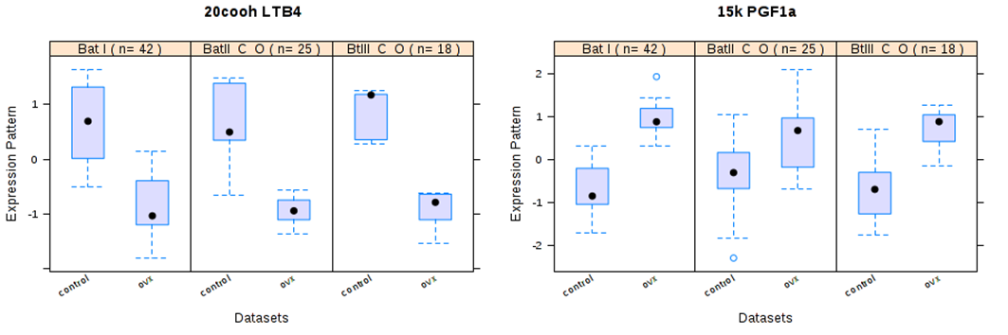
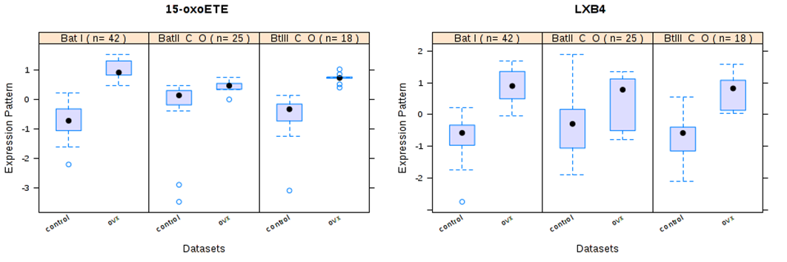
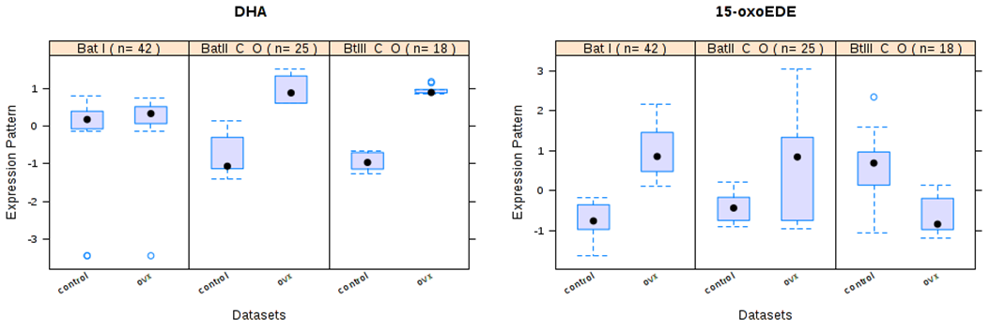
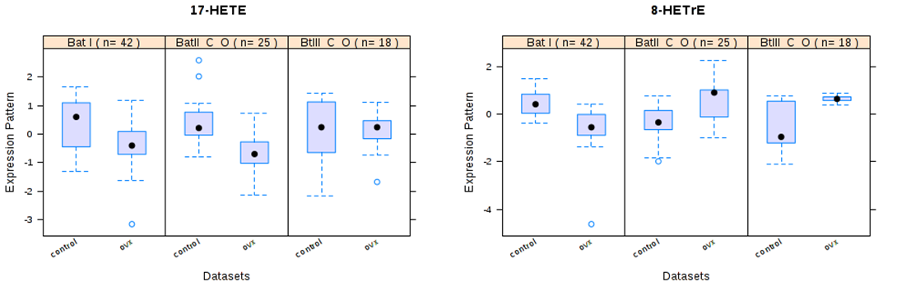
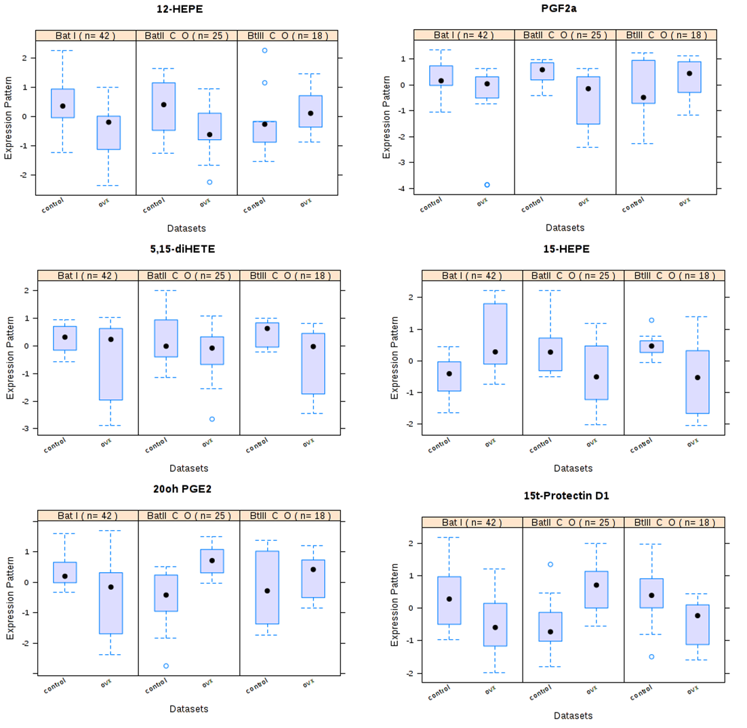
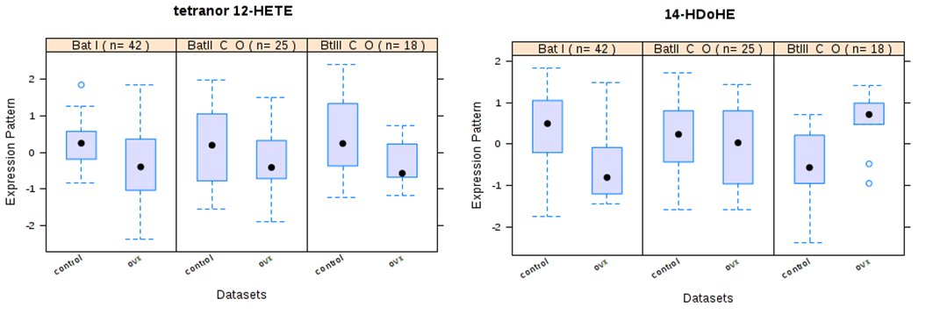
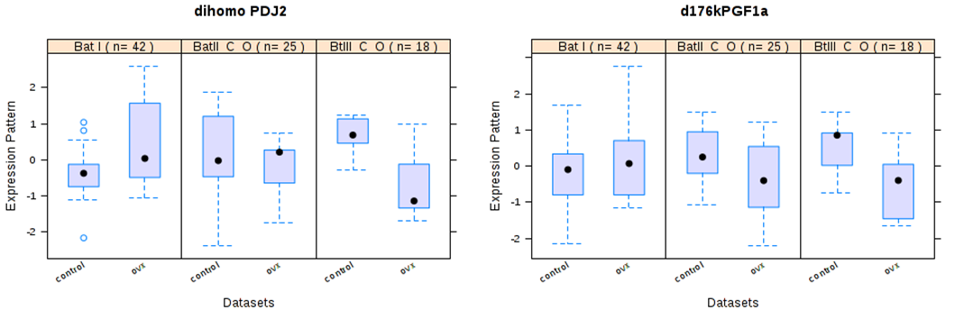
Fig. S1 Box plot of the expression pattern of the selected feature between the two experimental groups across all studies. The expression pattern is on the y-axis, and the group labels are on the x-axis. The median expression for the feature is indicated with a black dot in the center of the boxplot.

