Supplementary Information: Acid-base physiology over tidal periods in the mussel Mytilus edulis: size and temperature are more influential than seawater pH.

Supplementary Methods:

Statistical analysis
Quality control: Haemolymph data were quality checked whereby if a triplicate (or quadruplicate) had a standard deviation greater than the overall dataset standard deviation, the individual data point that was outside the standard deviation was removed from further analysis. For Starcross haemolymph pH 6 of 300 data points were removed, for Starcross haemolymph TCO₂ 26 of 300 data points were removed. For Port Gaverne haemolymph pH 5 of 225 data points were removed, for Port Gaverne haemolymph TCO₂ 14 of 225 data points were removed. These individual points were also removed from corresponding haemolymph pCO₂ and HCO₃⁻, as these were calculated from one or both of the measured pH and TCO₂ parameters.

Transposed mussels: Haemolymph acid-base measurements made in the July sampling event at Port Gaverne (PG). Starcross (SC) mussels were transposed to PG to compare whether the difference in response was due to populations or local environment. Tables S1 to S3 provide the statistical analysis of differences between populations and tide height.

Laboratory experiment – acid-base response to ‘Ocean acidification’ and emersion-recovery: Haemolymph acid-base response during emersion were tested for effects of prior exposure to different pH conditions (control or lowered pH termed “OA”), emersion time (0 to 6 h), air temperature (7, 14, 20 and 28 °C) and mussel size (large or small). Tests were also made of the recovery period when mussels re-immersed back in the respective seawater conditions. Results of the Permanova analysis are provided in Tables S4 to S9.

Supplementary Results:

Laboratory carbonate chemistry data:
The seawater carbonate chemistry parameters for the laboratory-based ‘Ocean Acidification’ emersion-recovery experiments are also summarised in Table S10 below.

Table S1: General Linear Model pH vs. population (SC or PG) and tide height

Analysis of Variance
Source | DF | Adj SS | Adj MS | F-Value | P-Value
Population | 1 | 0.2787 | 0.278727 | 45.32 | 0.000
Tideheight | 22 | 4.5921 | 0.208732 | 33.94 | 0.000
Population*Tideheight | 22 | 0.3771 | 0.017139 | 2.79 | 0.000
Error | 103 | 0.6335 | 0.006151
Total | 148 | 5.8648

Table S2: General Linear Model HCO3 vs. population (SC or PG) and tide height

Analysis of Variance
Source | DF | Adj SS | Adj MS | F-Value | P-Value
Population | 1 | 2.125 | 2.12530 | 36.52 | 0.000
Tideheight | 22 | 12.726 | 0.57844 | 9.94 | 0.000
Population *Tideheight | 22 | 4.489 | 0.20403 | 3.51 | 0.000
Error | 100 | 5.820 | 0.05820
Total | 145 | 25.024

Table S3: General Linear Model pCO₂ vs. population (SC or PG) and tide height

Analysis of Variance
Source | DF | Adj SS | Adj MS | F-Value | P-Value
Population | 1 | 0.5899 | 0.589931 | 73.43 | 0.000
Tideheight | 22 | 4.1131 | 0.186957 | 23.27 | 0.000
Population *Tideheight | 22 | 0.8176 | 0.037165 | 4.63 | 0.000
Error | 100 | 0.8034 | 0.008034
Total | 145 | 6.5967

Table S4: PERMANOVA (Permutational MANOVA) test for haemolymph pH during the emersion experiment
PERMDISP (Distance-based test for homogeneity of multivariate dispersions)
Group factor: timesizetemppH
Number of permutations: 999
Deviations from median
F: 0.63014 df1: 143 df2: 293
P(perm): 0.88

PERMANOVA
Resemblance: D1 Euclidean distance
Sums of squares type: Type III (partial)
Fixed effects sum to zero for mixed terms
Permutation method: Permutation of residuals under a reduced model
Number of permutations: 999

Factors
Name | Abbreviation | Type | Levels
Time | Ti | Fixed | 9
Size | Si | Fixed | 2
Temperature | Te | Fixed | 4
Seawater pH (‘OA’) | OA | Fixed | 2

PERMANOVA table of results
Source | df | SS | MS | Pseudo-F | P(perm) | Unique perms
Ti | 8 | 3.4536 | 0.43171 | 65.339 | 0.001 | 999
Si | 1 | 4.3614 | 4.3614 | 660.1 | 0.001 | 994
Te | 3 | 1.2822 | 0.42739 | 64.686 | 0.001 | 999
OA | 1 | 5.4362E-4 | 5.4362E-4 | 8.2278E-2 | 0.786 | 995
TixSi | 8 | 1.2184 | 0.15229 | 23.05 | 0.001 | 997
TixTe | 24 | 0.78086 | 3.2536E-2 | 4.9244 | 0.001 | 998
TixOA | 8 | 0.29817 | 3.7271E-2 | 5.6411 | 0.001 | 999
SixTe | 3 | 0.53956 | 0.17985 | 27.221 | 0.001 | 997
SixOA | 1 | 8.8391E-2 | 8.8391E-2 | 13.378 | 0.001 | 997
TexOA | 3 | 1.9541E-2 | 6.5137E-3 | 0.98586 | 0.397 | 998
TixSixTe | 24 | 0.46656 | 1.944E-2 | 2.9423 | 0.001 | 997
TixSixOA | 8 | 0.14182 | 1.7728E-2 | 2.6831 | 0.009 | 999
TixTexOA | 24 | 0.66959 | 2.79E-2 | 4.2226 | 0.001 | 998
SixTexOA | 3 | 0.24418 | 8.1394E-2 | 12.319 | 0.001 | 995
TixSixTexOA | 24 | 0.54269 | 2.2612E-2 | 3.4224 | 0.001 | 998
Res | 293 | 1.9359 | 6.6071E-3
Total | 436 | 16.007

Table S5: PERMANOVA (Permutational MANOVA) test for haemolymph pCO₂ during the emersion experiment

PERMDISP (Distance-based test for homogeneity of multivariate dispersions)
Group factor: timesizetemppH
Number of permutations: 999
Deviations from median
F: 0.95319 df1: 143 df2: 293
P(perm): 0.24

PERMANOVA
Resemblance: D1 Euclidean distance
Sums of squares type: Type III (partial)
Fixed effects sum to zero for mixed terms
Permutation method: Permutation of residuals under a reduced model
Number of permutations: 999

Factors
Name | Abbreviation | Type | Levels
Time | Ti | Fixed | 9
Size | Si | Fixed | 2
Temperature | Te | Fixed | 4
Seawater pH (‘OA’) | OA | Fixed | 2

PERMANOVA table of results
Source | df | SS | MS | Pseudo-F | P(perm) | Unique perms
Ti | 8 | 4.7753 | 0.59691 | 34.716 | 0.001 | 998
Si | 1 | 5.8354 | 5.8354 | 339.38 | 0.001 | 998
Te | 3 | 5.6779 | 1.8926 | 110.07 | 0.001 | 998
OA | 1 | 2.0321E-2 | 2.0321E-2 | 1.1819 | 0.283 | 999
TixSi | 8 | 2.0972 | 0.26216 | 15.247 | 0.001 | 998
TixTe | 24 | 2.1173 | 8.8219E-2 | 5.1307 | 0.001 | 997
TixOA | 8 | 0.17284 | 2.1605E-2 | 1.2565 | 0.26 | 998
SixTe | 3 | 2.2269 | 0.7423 | 43.172 | 0.001 | 997
SixOA | 1 | 0.10845 | 0.10845 | 6.3074 | 0.009 | 994
TexOA | 3 | 0.18774 | 6.258E-2 | 3.6396 | 0.017 | 998
TixSixTe | 24 | 1.8661 | 7.7756E-2 | 4.5222 | 0.001 | 997
TixSixOA | 8 | 0.21471 | 2.6838E-2 | 1.5609 | 0.158 | 999
TixTexOA | 24 | 0.83509 | 3.4795E-2 | 2.0237 | 0.004 | 998
SixTexOA | 3 | 0.21581 | 7.1935E-2 | 4.1837 | 0.008 | 999
TixSixTexOA | 24 | 1.0259 | 4.2747E-2 | 2.4861 | 0.001 | 996
Res | 293 | 5.0379 | 1.7194E-2
Total | 436 | 32.191

Table S6: PERMANOVA (Permutational MANOVA) test for haemolymph HCO₃⁻ during the emersion experiment

PERMDISP (Distance-based test for homogeneity of multivariate dispersions)
Group factor: timesizetemppH
Number of permutations: 999
Deviations from median
F: 0.62762 df1: 143 df2: 293
P(perm): 0.891

PERMANOVA
Resemblance: D1 Euclidean distance
Sums of squares type: Type III (partial)
Fixed effects sum to zero for mixed terms
Permutation method: Permutation of residuals under a reduced model
Number of permutations: 999

Factors
Name | Abbreviation | Type | Levels
Time | Ti | Fixed | 9
Size | Si | Fixed | 2
Temperature | Te | Fixed | 4
Seawater pH (‘OA’) | OA | Fixed | 2

PERMANOVA table of results
Source | df | SS | MS | Pseudo-F | P(perm) | Unique perms
Ti | 8 | 6.4758 | 0.80947 | 7.3025 | 0.001 | 999
Si | 1 | 0.67345 | 0.67345 | 6.0754 | 0.019 | 997
Te | 3 | 5.2682 | 1.7561 | 15.842 | 0.001 | 998
OA | 1 | 6.653 | 6.653 | 60.019 | 0.001 | 995
TixSi | 8 | 1.4531 | 0.18164 | 1.6386 | 0.114 | 998
TixTe | 24 | 4.4343 | 0.18476 | 1.6668 | 0.033 | 998
TixOA | 8 | 3.6249 | 0.45311 | 4.0876 | 0.001 | 998
SixTe | 3 | 0.29768 | 9.9227E-2 | 0.89515 | 0.451 | 999
SixOA | 1 | 8.8678E-2 | 8.8678E-2 | 0.79999 | 0.35 | 998
TexOA | 3 | 3.9799 | 1.3266 | 11.968 | 0.001 | 998
TixSixTe | 24 | 4.5601 | 0.19001 | 1.7141 | 0.023 | 997
TixSixOA | 8 | 0.41255 | 5.1569E-2 | 0.46521 | 0.888 | 999
TixTexOA | 24 | 3.8625 | 0.16094 | 1.4519 | 0.089 | 997
SixTexOA | 3 | 1.2081 | 0.40271 | 3.633 | 0.015 | 998
TixSixTexOA | 24 | 5.0987 | 0.21245 | 1.9165 | 0.014 | 999
Res | 293 | 32.479 | 0.11085
Total | 436 | 80.637

Table S7: PERMANOVA (Permutational MANOVA) test for haemolymph pH during the recovery experiment

PERMDISP (Distance-based test for homogeneity of multivariate dispersions)
Group factor: timesizetemppH
Number of permutations: 999
Deviations from median
F: 1.2275 df1: 47 df2: 142
P(perm): 0.207

PERMANOVA
Resemblance: D1 Euclidean distance
Sums of squares type: Type III (partial)
Fixed effects sum to zero for mixed terms
Permutation method: Permutation of residuals under a reduced model
Number of permutations: 999

Factors
Name | Abbreviation | Type | Levels
Time | Ti | Fixed | 3
Size | Si | Fixed | 2
Temperature | Te | Fixed | 4
Seawater pH (‘OA’) | OA | Fixed | 2

PERMANOVA table of results
Source | df | SS | MS | Pseudo-F | P(perm) | Unique perms
Ti | 2 | 2.9698 | 1.4849 | 508.04 | 0.001 | 998
Si | 1 | 0.36419 | 0.36419 | 124.61 | 0.001 | 997
Te | 3 | 4.1536E-2 | 1.3845E-2 | 4.7371 | 0.005 | 999
OA | 1 | 1.8156E-2 | 1.8156E-2 | 6.212 | 0.01 | 997
TixSi | 2 | 0.41723 | 0.20861 | 71.375 | 0.001 | 997
TixTe | 6 | 0.23594 | 3.9323E-2 | 13.454 | 0.001 | 999
TixOA | 2 | 0.19817 | 9.9085E-2 | 33.901 | 0.001 | 998
SixTe | 3 | 8.1532E-2 | 2.7177E-2 | 9.2985 | 0.001 | 998
SixOA | 1 | 1.4979E-3 | 1.4979E-3 | 0.51251 | 0.481 | 998
TexOA | 3 | 8.163E-2 | 2.721E-2 | 9.3096 | 0.001 | 998
TixSixTe | 6 | 4.4144E-2 | 7.3574E-3 | 2.5173 | 0.024 | 999
TixSixOA | 2 | 7.7526E-3 | 3.8763E-3 | 1.3262 | 0.251 | 999
TixTexOA | 6 | 7.0166E-2 | 1.1694E-2 | 4.0011 | 0.001 | 999
SixTexOA | 3 | 1.0122E-2 | 3.3741E-3 | 1.1544 | 0.324 | 998
TixSixTexOA | 6 | 0.10294 | 1.7157E-2 | 5.8702 | 0.001 | 998
Res | 142 | 0.41503 | 2.9228E-3
Total | 189 | 5.055

Table S8: PERMANOVA (Permutational MANOVA) test for haemolymph pCO₂ during the recovery experiment

PERMDISP (Distance-based test for homogeneity of multivariate dispersions)
Group factor: timesizetemppH
Number of permutations: 999
Deviations from median
F: 1.8507 df1: 47 df2: 142
P(perm): 0.029

PERMANOVA
Resemblance: D1 Euclidean distance
Sums of squares type: Type III (partial)
Fixed effects sum to zero for mixed terms
Permutation method: Permutation of residuals under a reduced model
Number of permutations: 999

Factors
Name | Abbreviation | Type | Levels
Time | Ti | Fixed | 3
Size | Si | Fixed | 2
Temperature | Te | Fixed | 4
Seawater pH (‘OA’) | OA | Fixed | 2

PERMANOVA table of results
Source | df | SS | MS | Pseudo-F | P(perm) | Unique perms
Ti | 2 | 4.5581 | 2.2791 | 652.63 | 0.001 | 999
Si | 1 | 0.50212 | 0.50212 | 143.79 | 0.001 | 994
Te | 3 | 1.3763 | 0.45878 | 131.37 | 0.001 | 999
OA | 1 | 6.6083E-2 | 6.6083E-2 | 18.923 | 0.002 | 997
TixSi | 2 | 0.57143 | 0.28572 | 81.817 | 0.001 | 997
TixTe | 6 | 1.27 | 0.21167 | 60.613 | 0.001 | 998
TixOA | 2 | 1.8487E-2 | 9.2433E-3 | 2.6469 | 0.067 | 999
SixTe | 3 | 0.17825 | 5.9417E-2 | 17.015 | 0.001 | 999
SixOA | 1 | 5.4146E-3 | 5.4146E-3 | 1.5505 | 0.215 | 998
TexOA | 3 | 2.4995E-2 | 8.3318E-3 | 2.3859 | 0.078 | 999
TixSixTe | 6 | 0.17633 | 2.9389E-2 | 8.4157 | 0.001 | 999
TixSixOA | 2 | 3.1444E-3 | 1.5722E-3 | 0.45022 | 0.635 | 999
TixTexOA | 6 | 9.3703E-2 | 1.5617E-2 | 4.4721 | 0.001 | 999
SixTexOA | 3 | 2.5572E-2 | 8.5239E-3 | 2.4409 | 0.07 | 999
TixSixTexOA | 6 | 8.4922E-2 | 1.4154E-2 | 4.053 | 0.001 | 999
Res | 142 | 0.49588 | 3.4921E-3
Total | 189 | 9.4823

Table S9: PERMANOVA (Permutational MANOVA) test for haemolymph HCO₃⁻ during the recovery experiment

PERMDISP (Distance-based test for homogeneity of multivariate dispersions)
Group factor: timesizetemppH
Number of permutations: 999
Deviations from median
F: 1.5024 df1: 47 df2: 142
P(perm): 0.073

PERMANOVA
Resemblance: D1 Euclidean distance
Sums of squares type: Type III (partial)
Fixed effects sum to zero for mixed terms
Permutation method: Permutation of residuals under a reduced model
Number of permutations: 999

Factors
Name | Abbreviation | Type | Levels
Time | Ti | Fixed | 3
Size | Si | Fixed | 2
Temperature | Te | Fixed | 4
Seawater pH (‘OA’) | OA | Fixed | 2

PERMANOVA table of results
Source | df | SS | MS | Pseudo-F | P(perm) | Unique perms
Ti | 2 | 33.856 | 16.928 | 198.44 | 0.001 | 999
Si | 1 | 0.35559 | 0.35559 | 4.1685 | 0.035 | 996
Te | 3 | 34.689 | 11.563 | 135.55 | 0.001 | 999
OA | 1 | 1.5091 | 1.5091 | 17.691 | 0.001 | 996
TixSi | 2 | 0.41792 | 0.20896 | 2.4496 | 0.065 | 997
TixTe | 6 | 7.9774 | 1.3296 | 15.586 | 0.001 | 999
TixOA | 2 | 3.1102 | 1.5551 | 18.23 | 0.001 | 998
SixTe | 3 | 0.14621 | 4.8735E-2 | 0.57131 | 0.622 | 999
SixOA | 1 | 0.20648 | 0.20648 | 2.4206 | 0.123 | 999
TexOA | 3 | 2.3251 | 0.77504 | 9.0856 | 0.001 | 999
TixSixTe | 6 | 1.0365 | 0.17275 | 2.0251 | 0.068 | 999
TixSixOA | 2 | 6.2055E-2 | 3.1028E-2 | 0.36373 | 0.711 | 999
TixTexOA | 6 | 4.56 | 0.75999 | 8.9092 | 0.001 | 998
SixTexOA | 3 | 0.35533 | 0.11844 | 1.3885 | 0.249 | 999
TixSixTexOA | 6 | 0.49236 | 8.206E-2 | 0.96197 | 0.45 | 999
Res | 142 | 12.113 | 8.5304E-2
Total | 189 | 103.83

Table S10: Measured seawater conditions for the two pH treatments, pH 8.10 (control) and pH 7.70 (‘OA’), showing mean ± SD, for measured seawater temperature, salinity, pH and dissolved inorganic carbon (DIC), and calculated total alkalinity (TA), pCO2, bicarbonate (HCO₃⁻) and carbonate (CO₃²⁻) ion concentrations. These latter parameters were calculated from measured temperature, salinity, pH and DIC, using CO2sys (1) using K1 and K2 values refitted by Dickson and Millero (2) from Mehrbach et al. (3), and KSO4 determined by Dickson (4)

Experiment | Treatment | Temperature (°C) | Salinity | pH_{NBS} | DIC  (µmol kg⁻¹) | TA  (µmol kg⁻¹) | pCO₂ (µatm) | HCO₃⁻  (µmol kg⁻¹) | CO₃²⁻  (µmol kg⁻¹)
Pre-Emersion | pH 8.10 | 13.2 ± 0.0 | 30.6 ± 0.0 | 8.11 ± 0.00 | 2077 ± 44 | 2287 ± 47 | 342 ± 8 | 1907 ± 40 | 156 ± 3
Pre-Emersion | pH 7.70 | 13.2 ± 0.0 | 30.6 ± 0.0 | 7.70 ± 0.00 | 2145 ± 82 | 2204 ± 84 | 927 ± 30 | 2042 ± 78 | 66 ± 3
Recovery | pH 8.10 | 13.2 ± 0.0 | 30.6 ± 0.0 | 8.11 ± 0.00 | 2084 ± 67 | 2297 ± 72 | 341 ± 11 | 1914 ± 62 | 157 ± 5
Recovery | pH 7.70 | 13.2 ± 0.0 | 30.6 ± 0.0 | 7.70 ± 0.00 | 2144 ± 83 | 2201 ± 84 | 942 ± 32 | 2041 ± 79 | 65 ± 3

Figure S1
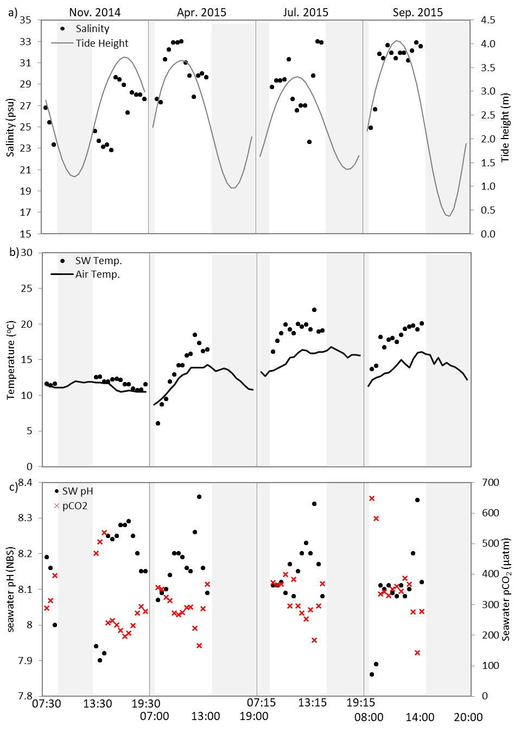

Figure S1: Environmental conditions for Starcross during the sampled tidal cycles in November 2014, April 2015, July 2015 and September 2015 showing: a) Salinity and tidal height (m); b) seawater temperature and air temperature (ºCº); and c) seawater pH_{NBS} and seawater pCO₂ (µatm). Shaded sections represent periods of emersion.

Figure S2
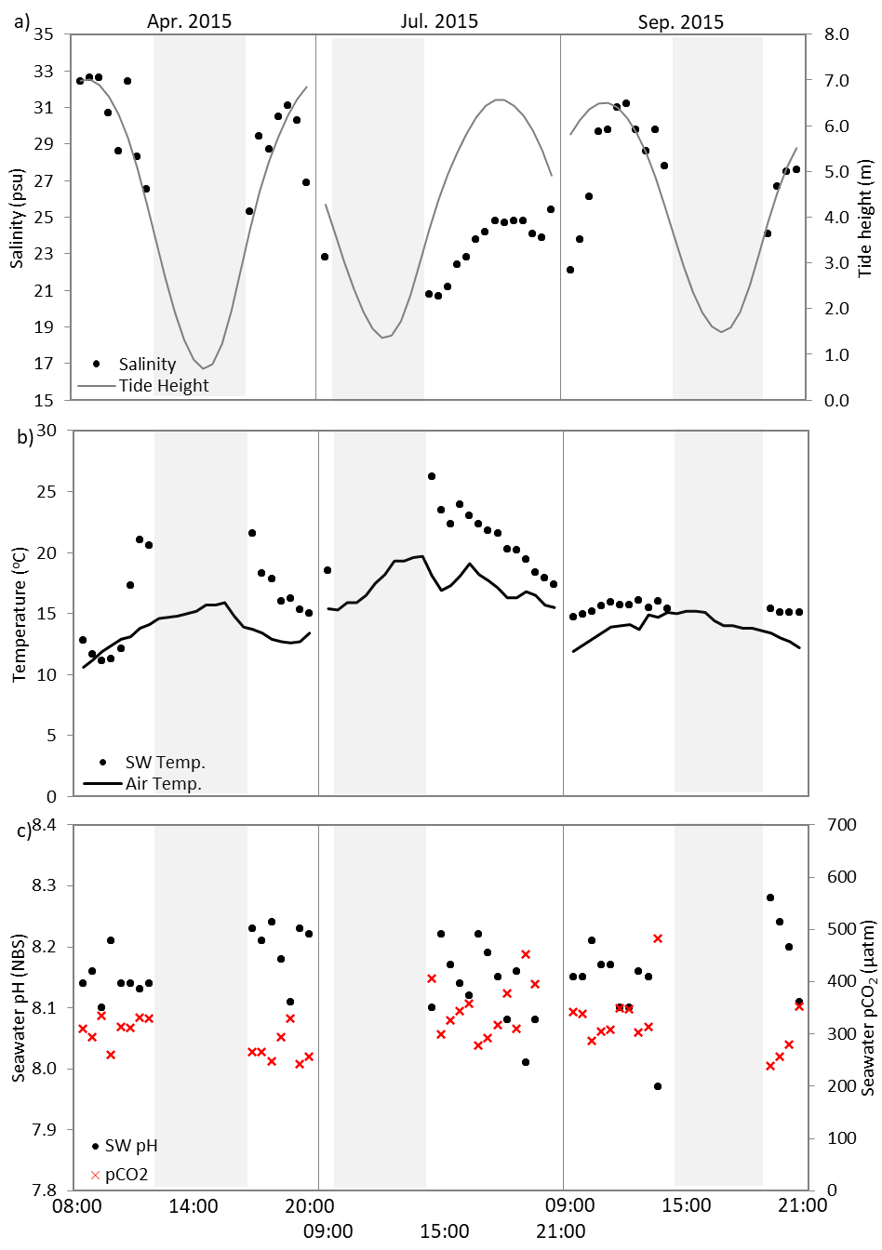

Figure S2: Environmental conditions for Port Gaverne during the sampled tidal cycles in November 2014, April 2015, July 2015 and September 2015 showing: a) Salinity and tidal height (m); b) seawater temperature and air temperature (°C); and c) seawater pH_{NBS} and seawater pCO₂ (µatm). Shaded sections represent periods of emersion.

Additional data table S1 (separate excel file)
All the data generated from this study is provided in an additional excel file entitled “Mangan et al Supplementary meta-data.xls”, which contains a metadata spreadsheet “Metadata”, a spreadsheet containing field data “FieldData”, a spreadsheet containing the acid-base data from the laboratory study “LabDataBiol”, and a spreadsheet containing the carbonate chemistry data from the laboratory study “LabDataChem”.

References

- Pierrot D., Lewis E., Wallace D.W.R. 2006 MS Excel program developed for CO₂ system calculations.
- Dickson A.G., Millero F.J. 1987 A comparison of the equilibrium-constants for the dissociation of carbonic-acid in seawater media. Deep-Sea Research Part a-Oceanographic Research Papers 34(10), 1733-1743. (doi:10.1016/0198-0149(87)90021-5).
- Mehrbach C., Culberso.Ch, Hawley J.E., Pytkowic.Rm. 1973 Measurement of apparent dissociation-constants of carbonic-acid in seawater at atmospheric-pressure. Limnology and Oceanography 18(6), 897-907.
- Dickson A.G. 1990 Standard potential of the reaction - AgCl(s)+1/2H₂(g)=Ag(s)+HCl(aq) and the standard acidity constant of the ion HSO₄⁻ in synthetic sea-water from 273.15-k to 318.15-k. Journal of Chemical Thermodynamics 22(2), 113-127. (doi:10.1016/0021-9614(90)90074-z).

