Supplementary Material

Size distributions of Arctic waterbodies reveal consistent relations in their statistical moments in space and time
S. Muster¹*, W.J. Riley², K. Roth³, M. Langer^{1,4}, F. Cresto Aleina⁵, C.D. Koven², S. Lange¹, A. Bartsch^{6,10}, G. Grosse, G.¹^{, 7} , C. J. Wilson⁸, B. M. Jones⁹, and J. Boike¹^{,3}
¹ Alfred Wegener Institute Helmholtz Centre for Polar and Marine Research, Telegrafenberg A43, 14473 Potsdam, Germany
² Lawrence Berkeley National Laboratory, Berkeley, USA
³ Institute for Environmental Physics, University of Heidelberg, Germany
⁴ Humboldt University of Berlin, Geography Department, Berlin, Germany
⁵ Max Planck Institute for Meteorology, Hamburg, Germany
⁶ Austrian Polar Research Institute, Austria
⁷ Institute for Earth and Environmental Science, University of Potsdam, Germany
⁸ Los Alamos National Laboratory, Los Alamos, USA
⁹ U.S. Geological Survey - Alaska Science Center, Anchorage, USA
¹⁰ b.geos, Korneuburg, Austria
* Correspondence: Corresponding Author: sina.muster@posteo.de

Supplementary Figures and Tables

Supplementary Figures

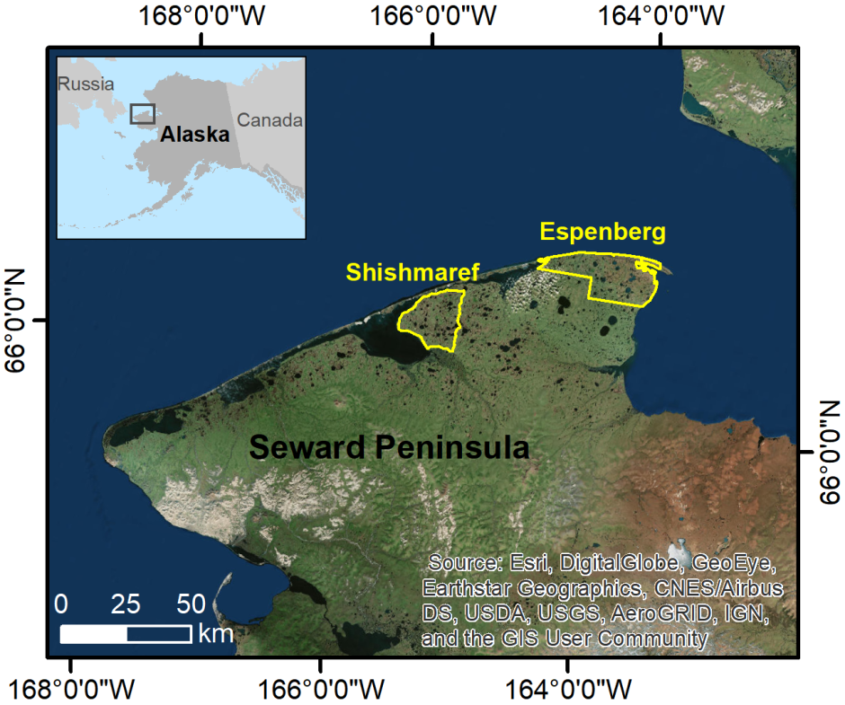
Supplementary Figure 1: Northern Seward Peninsula with location of Shishmaref and Espenberg study areas that were used for change detection analysis. Image source: Esri, DigitalGlobe, GeoEye, Earthstar Geographics, CNES/Airbus, DS, USDA, USGS, AEX, Getmapping, Aerogrid, IGN, IGP, swisstopo, and the GIS User Community. Inset map shows the location of the Seward Peninsula in Alaska.

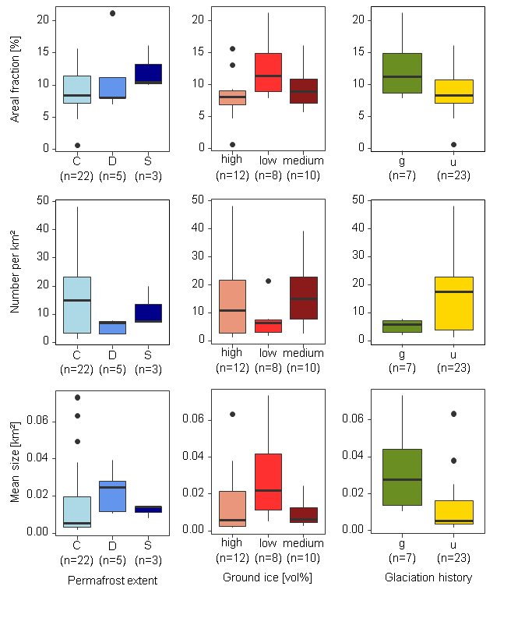
Supplementary Figure 2: Boxplots of distribution statistics and categorical environmental variables. Mean surface area (µ), number per km² and areal fraction are shown for waterbodies of 0.0001 km² to 1 km² in size. Boxplots are grouped according to permafrost extent (C-continuous, D-discontinuous, S-sporadic), ground ice content (high: >40 vol%, medium: >20 to 40 vol%, low: <20 vol%) and glaciation history (g-glaciated and u-unglaciated during the last glacial maximum). Numbers in brackets indicate the number of samples (n) per category.

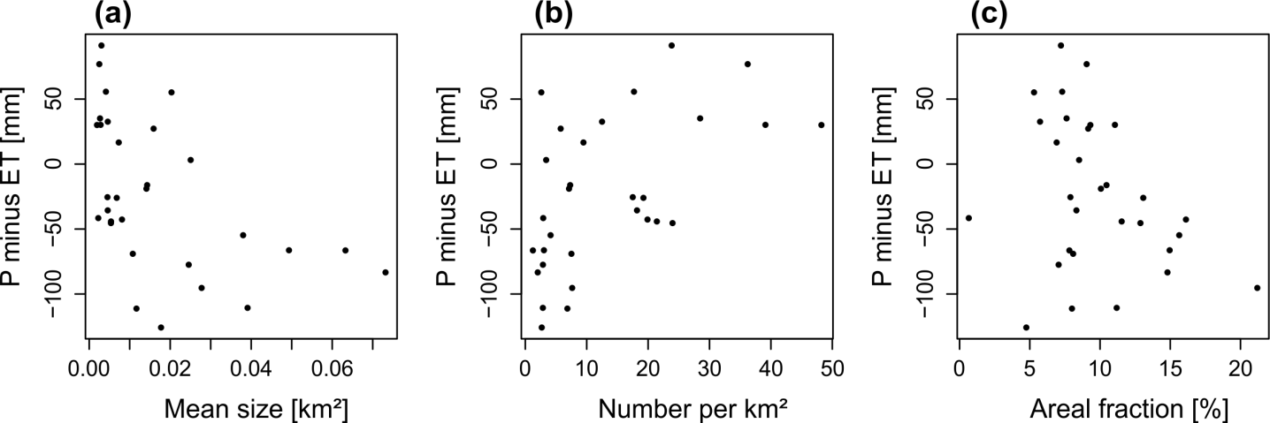

Supplementary Figure 3: Scatterplots of waterbody distribution statistics versus precipitation (P) minus evapotranspiration (ET). Each point represents one study region. Mean waterbody size, number per km², and areal fraction for each study region includes waterbodies of 0.0001 km² to 1 km² in size. P minus ET: precipitation minus evapotranspiration (mm).

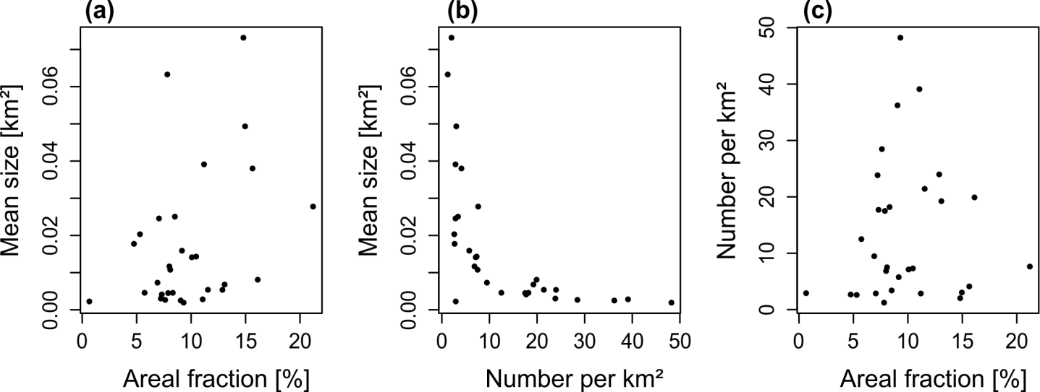
Supplementary Figure 4: Scatterplots of mean waterbody size, areal fraction and number of waterbodies per km². Each point represents one study region. All variables include waterbodies of 0.0001 km² to 1 km² in size

Supplementary Tables

Supplementary Table 1
Location number, map ID, region, ecozone, study region, and coordinates for each waterbody map.
No. refers to the location number of each study region on Figure 1. Map_ID identifies the map vector file that can be downloaded from https://doi.pangaea.de/10.1594/PANGAEA.868349. Latitude (Lat) and longitude (Long) are reported in decimal degrees (WGS84). No. refers to the study region number in Figure 1.
No. | Map ID | Country | Ecozone | Study region | Lat | Long | Extent [km²]
1 | ksl0012010xxxx | USA | Bering Tundra | Kotzebue Sound Lowlands | 66.2 N | 165.8 W | 558.8
2 | yuk00220090812 | USA | Bering Taiga | Yukon-Kuskokwim Delta | 60.9 N | 162.5 W | 575.3
3 | yuk00120090812 | USA | Bering Taiga | Yukon-Kuskokwim Delta | 61.0 N | 162.3 W | 1078.7
4 | wlc00220020801 | USA | Arctic Tundra | Barrow Peninsula | 71.2 N | 156.5 W | 153.8
5 | wlc00120090825 | USA | Arctic Tundra | Barrow Peninsula | 71.0 N | 156.5 W | 1400.2
6 | wlc00320090802 | USA | Arctic Tundra | Barrow Peninsula | 71.2 N | 156.5 W | 297.3
7 | elc00220020801 | USA | Arctic Tundra | Elson Lagoon Coastal Plain | 71.2 N | 156.4 W | 143.2
8 | elc00120090825 | USA | Arctic Tundra | Elson Lagoon Coast Plain | 71.2 N | 156.4 W | 126.0
9 | imc00120040725 | USA | Arctic Tundra | Ikpikpuk Middle Coastal Plain | 70.2 N | 153.3 W | 1309.9
10 | fis00120020715 | USA | Arctic Tundra | Fish-Judy Creek Floodplain | 70.3 N | 151.5 W | 236.8
11 | ycb0012011xxxx | USA | Intermontane Boreal | Yukon-Old Crow Basin | 66.2 N | 145.9 W | 100.0
12 | mdn00120100716 | Canada | Southern Arctic | Mackenzie Delta North | 69.1 N | 135.2 W | 1510.3
13 | mdw00120090921 | Canada | Taiga Plain | Mackenzie Delta West | 68.5 N | 134.7 W | 1614.8
14 | ric00120120925 | Canada | Southern Arctic | Richards Island | 69.5 N | 134.3 W | 587.4
15 | esk00120090727 | Canada | Southern Arctic | Eskimo Lakes | 69.2 N | 133.3 W | 923.4
16 | tuk00120120723 | Canada | Southern Arctic | Tuktoyaktuk Peninsula | 69.9 N | 130.4 W | 477.6
17 | tea00120100901 | Canada | Taiga Shield | Tanzin Upland East Arm | 62.6 N | 115.2 W | 462.9
18 | tbr00120100901 | Canada | Taiga Shield | Tanzin Upland Beaulieu River | 62.8 N | 115.1 W | 694.3
19 | yam00120080824 | Russia | Yamal-Gydan Tundra | Yamal Peninsula South | 70.5 N | 68.4 E | 1294.3
20 | yam00220100820 | Russia | Yamal-Gydan Tundra | Yamal Peninsula North | 72.6 N | 72.4 E | 1006.6
21 | sur00120130802 | Russia | West Siberian Taiga | Surgut | 62.3 N | 74.6 E | 1765.6
22 | arg00120110829 | Russia | Taimyr-Central Siberian Tundra | Arga Island Center Lena Delta | 73.5 N | 123.6 E | 195.9
23 | arg00320110829 | Russia | Taimyr-Central Siberian Tundra | Arga Island North West Lena Delta | 73.0 N | 126.1 E | 223.7
24 | fir00120090906 | Russia | Taimyr-Central Siberian Tundra | First Terrace Lena Delta | 73.3 N | 128.3 E | 150.0
25 | byk00120060709 | Russia | Taimyr-Central Siberian Tundra | Bykovsky Peninsula | 71.8 N | 129.3 E | 170.2
26 | yak0012009xxxx | Russia | East Siberian Taiga | Yakutsk | 62.1 N | 130.3 E | 2035.5
27 | kyt00120070728 | Russia | Northeast Siberian Coastal Tundra | Kytalik | 70.8 N | 147.5 E | 262.3
28 | ind00120090907 | Russia | Northeast Siberian Taiga | Indigirka Lowlands | 68.8 N | 149.8 E | 654.0
29 | che00220090724 | Russia | Northeast Siberian Taiga | Cherskii | 68.6 N | 161.5 E | 340.3
30 | che00120020709 | Russia | Northeast Siberian Taiga | Cherskii-Rodinka | 68.8 N | 161.8 E | 220.8

Supplementary Table 2
Climate characteristics for each region.
Long-term average (1979 to year of image acquisition) of annual air temperature ($MAAT$), precipitation ($P$) and evapotranspiration ($ET$) for the snow-free period. Precipitation (P_{i}) and evapotranspiration (ET_{i}) for the snow-free period during the year of image acquisition, and thawing degree days (TDD) for the year of image acquisition. No. refers to the study region number in Figure 1.
No. | Map ID | Image Date | MAAT  [°C] | P  [mm] | ET  [mm] | P_{i}  [mm] | ET_{i}  [mm] | TDD
1 | ksl0012010xxxx | Summer 2009/2010 | -4.2 | 119.3 | -64.1 | 205.8 | -55.7 | 102
2 | yuk00220090812 | 12 August 2009 | -0.1 | 190.8 | -207.0 | 172.6 | -207.9 | 114
3 | yuk00120090812 | 12 August 2009 | -0.1 | 186.7 | -205.6 | 162.1 | -204.9 | 116
4 | wlc00220020801 | 1 August 2002 | -10.0 | 39.0 | -8.9 | 38.5 | -18.4 | 52
5 | wlc00120090825 | 25 August 2009 | -10.4 | 73.0 | -98.5 | 83.0 | -115.1 | 82
6 | wlc00320090802 | 2009-08-02 | -10.3 | 39.9 | -7.3 | 27.0 | -3.1 | 59
7 | elc00220020801 | 1 August 2002 | -10.0 | 38.9 | -8.9 | 38.1 | -18.3 | 52
8 | elc00120090825 | 25 August 2009 | -10.0 | 64.4 | -8.7 | 53.5 | -11.0 | 82
9 | imc00120040725 | 25 July 2004 | -9.9 | 60.1 | -104.2 | 66.4 | -103.6 | 55
10 | fis00120020715 | 15 July 2002 | -9.5 | 31.3 | -76.7 | 37.6 | -82.4 | 43
11 | ycb0012011xxxx | 2011xxxx | -3.7 | 201.6 | -279.1 | 191.3 | -164.8 | 125
12 | mdn00120100716 | 16 July 2010 | -8.9 | 44.4 | -113.5 | 50.5 | -127.7 | 45
13 | mdw00120090921 | 21 September 2009 | -8.2 | 153.3 | -248.7 | 138.4 | -252.1 | 131
14 | ric00120120925 | 25 September 2012 | -9.2 | 114.3 | -180.6 | 91.0 | -151.1 | 115
15 | esk00120090727 | 27 July 2009 | -9.4 | 56.4 | -139.7 | 28.7 | -144.4 | 57
16 | tuk00120120723 | 23 July 2012 | -9.6 | 35.7 | -8.4 | 23.5 | 5.4 | 58
17 | tea00120100901 | 1 September 2010 | -3.7 | 147.4 | -258.6 | 199.0 | -272.9 | 140
18 | tbr00120100901 | 1 September 2010 | -4.0 | 150.1 | -260.7 | 210.4 | -276.3 | 130
19 | yam00120080824 | 24 August 2008 | -7.7 | 144.9 | -141.7 | 110.0 | -153.4 | 82
20 | yam00220100820 | 20 August 2010 | -9.2 | 115.6 | -99.0 | 149.1 | -88.8 | 79
21 | sur00120130802 | 2 August 2013 | -2.6 | 224.6 | -267.2 | 155.8 | -269.4 | 94
22 | arg00120110829 | 29 August 2011 | -12.2 | 99.7 | -8.4 | 110.2 | -6.0 | 85
23 | arg00320110829 | 29 August 2011 | -13.6 | 115.4 | -141.4 | 116.6 | -163.7 | 97
24 | fir00120090906 | 6 September 2009 | -12.3 | 107.4 | -30.5 | 94.2 | -51.5 | 88
25 | byk00120060709 | 9 July 2006 | -12.1 | 43.4 | -8.3 | 32.5 | -9.0 | 42
26 | yak0012009xxxx | Summer 2009 | -8.5 | 139.1 | -264.9 | 117.8 | -288.7 | 133
27 | kyt00120070728 | 28 July 2007 | -12.9 | 78.5 | -114.1 | 118.8 | -121.4 | 71
28 | ind00120090907 | 7 September 2009 | -12.4 | 135.9 | -202.4 | 126.8 | -203.1 | 110
29 | che00220090724 | 24 July 2009 | -11.1 | 69.3 | -124.1 | 40.1 | -114.8 | 62
30 | che00120020709 | 9 July 2002 | -11.4 | 47.0 | -88.6 | 30.0 | -106.3 | 42

Supplementary Table 3
Permafrost and topography characteristics for each study region.
Permafrost extent (PE: C = continuous, D = discontinuous, S = sporadic), ground ice content, mean elevation (E mean) and range of elevations (E range), mean slope (S mean) and range of slopes (S range). No. refers to the study region number in Figure 1.
No. | Map ID | PE | Ground ice  (vol%) | E  mean  (m) | E  range  (m) | S  mean  (°) | S  range  (°)
1 | ksl0012010xxxx | C | >40 | 19.7 | 45 | 0.4 | 2.3
2 | yuk00220090812 | S | 10-40 | 13.3 | 29 | 0.2 | 2.1
3 | yuk00120090812 | S | 10‒40 | 6.5 | 51 | 0.2 | 4.0
4 | wlc00220020801 | C | 10‒40 | 5.9 | 18 | 0.1 | 1.0
5 | wlc00120090825 | C | 10‒40 | 5.9 | 18 | 0.1 | 1.0
6 | wlc00320090802 | C | 10‒40 | 5.9 | 18 | 0.1 | 1.0
7 | elc00220020801 | C | >40 | 4.0 | 13 | 0.1 | 0.4
8 | elc00120090825 | C | >40 | 6.2 | 13 | 0.2 | 0.5
9 | imc00120040725 | C | <10 | 48.6 | 119 | 0.5 | 3.3
10 | fis00120020715 | C | 10‒40 | 8.5 | 29 | 0.4 | 1.8
11 | ycb0012011xxxx | D | 10‒40 | 137.1 | 17 | 0.3 | 1.9
12 | mdn00120100716 | D | <20% | 2.0 | 29 | 0.1 | 1.7
13 | mdw00120090921 | D | <20% | 1.0 | 0 | 0.0 | 0.0
14 | ric00120120925 | C | >20% | 26.6 | 69 | 0.8 | 2.9
15 | esk00120090727 | C | >20% | 30.5 | 78 | 0.7 | 3.2
16 | tuk00120120723 | C | >20% | 1.2 | 37 | 0.0 | 2.1
17 | tea00120100901 | D | <20% | 157.8 | 6 | 0.0 | 0.2
18 | tbr00120100901 | D | <20% | 182.0 | 143 | 0.4 | 1.4
19 | yam00120080824 | C | 50 | 18.9 | 55 | 0.3 | 1.8
20 | yam00220100820 | C | 30 | 13.7 | 29 | 0.3 | 1.4
21 | sur00120130802 | S | 30 | 81.5 | 57 | 0.5 | 2.8
22 | arg00120110829 | C | 30 | 7.9 | 25 | 0.5 | 1.5
23 | arg00320110829 | C | 50 | 5.3 | 14 | 0.2 | 1.0
24 | fir00120090906 | C | 50 | 1.8 | 2 | 0.1 | 0.2
25 | byk00120060709 | C | No data | 17.5 | 46 | 1.1 | 2.8
26 | yak0012009xxxx | C | 50 | 144.9 | 111 | 0.8 | 5.0
27 | kyt00120070728 | C | 50 | 5.0 | 7 | 0.0 | 0.3
28 | ind00120090907 | C | 50 | 49.2 | 183 | 0.9 | 5.7
29 | che00220090724 | C | 50 | 3.6 | 23 | 0.2 | 2.1
30 | che00120020709 | C | 50 | 81.0 | 227 | 2.1 | 7.2

Supplementary Table 4
Data products and metadata information for environmental variables.
Geocryology includes variables for permafrost extent, ground ice content, and surficial geology.

Variable | Data product | Data repository | Reference
Geocryology Alaska | Permafrost characteristics of Alaska | http://catalog.northslope.org/catalog/entries/3587 | Jorgenson et al. (2008)
Geocryology Canada | National Ecological Framework | http://sis.agr.gc.ca/cansis/nsdb/ecostrat/index.html | Ecological Stratification Working Group (1995); Marshall & Schut (1999)
Geocryology Russia | Land Resources Russia | http://webarchive.iiasa.ac.at/Research/FOR/russia_cd/download.htm | Stolbovoi & McCallum (2002)
Extent of last glacial maximum | Deglaciation of North America | http http://geoscan.nrcan.gc.ca/geoscan-index.html | Dyke et al. (2003)
Elevation, Slope | GTOPO30 | https://lta.cr.usgs.gov/GTOPO30
Air temperature | ERA-INTERIM  (175.128 ERA-ID) | http://apps.ecmwf.int/datasets/ | Berrisford et al. (2011)
Total precipitation | ERA-INTERIM  (175.128 ERA-ID) | http://apps.ecmwf.int/datasets/ | Berrisford et al. (2011)
Surface latent heat flux | ERA-INTERIM  (169.128 ERA-ID) | http://apps.ecmwf.int/datasets/ | Berrisford et al. (2011)

References
Berrisford, P., D. Dee, P. Poli, R. Brugge, K. Fielding, M. Fuentes, P. Kallberg, S. Kobayashi, S. Uppala, and A. Simmons (2011). The ERA-Interim archive Version 2.0. ERA Report Series 1, ECMWF, Shinfield Park, Reading, UK, 13177.
Dyke, A. S., A. Moore, and L. Robertson (2003). Deglaciation of North America, Geological Survey of Canada Ottawa. Open File 1574, doi:10.4095/214399.
Ecological Stratification Working Group (1995). A National Ecological Framework for Canada (Report and national map at 1:7,500,000 scale). Agriculture and Agri-Food Canada, Research Branch, Centre for Land and Biological Resources Research and Environment Canada, State of the Environment Directorate, Ecozone Analysis Branch, Ottawa/Hull.
Jorgenson, M., K. Yoshikawa, M. Kanevskiy, Y. Shur, V. Romanovsky, S. Marchenko, G. Grosse, J. Brown, and B. Jones (2008). Permafrost characteristics of Alaska. Proceedings of the Ninth International Conference on Permafrost, University of Alaska: Fairbanks.
Marshall, I. B., and P. Schut (1999). A national ecological framework for Canada. Eastern Cereal and Oilseed Research Centre (ECORC), Research Branch, Agriculture and Agri-Food Canada.
Stolbovoi, V., and I. McCallum (2002). Land Resources of Russia, edited. International Institute for Applied Systems Analysis and the Russian Academy of Science, Laxenburg, Austria.

