Supplementary Information
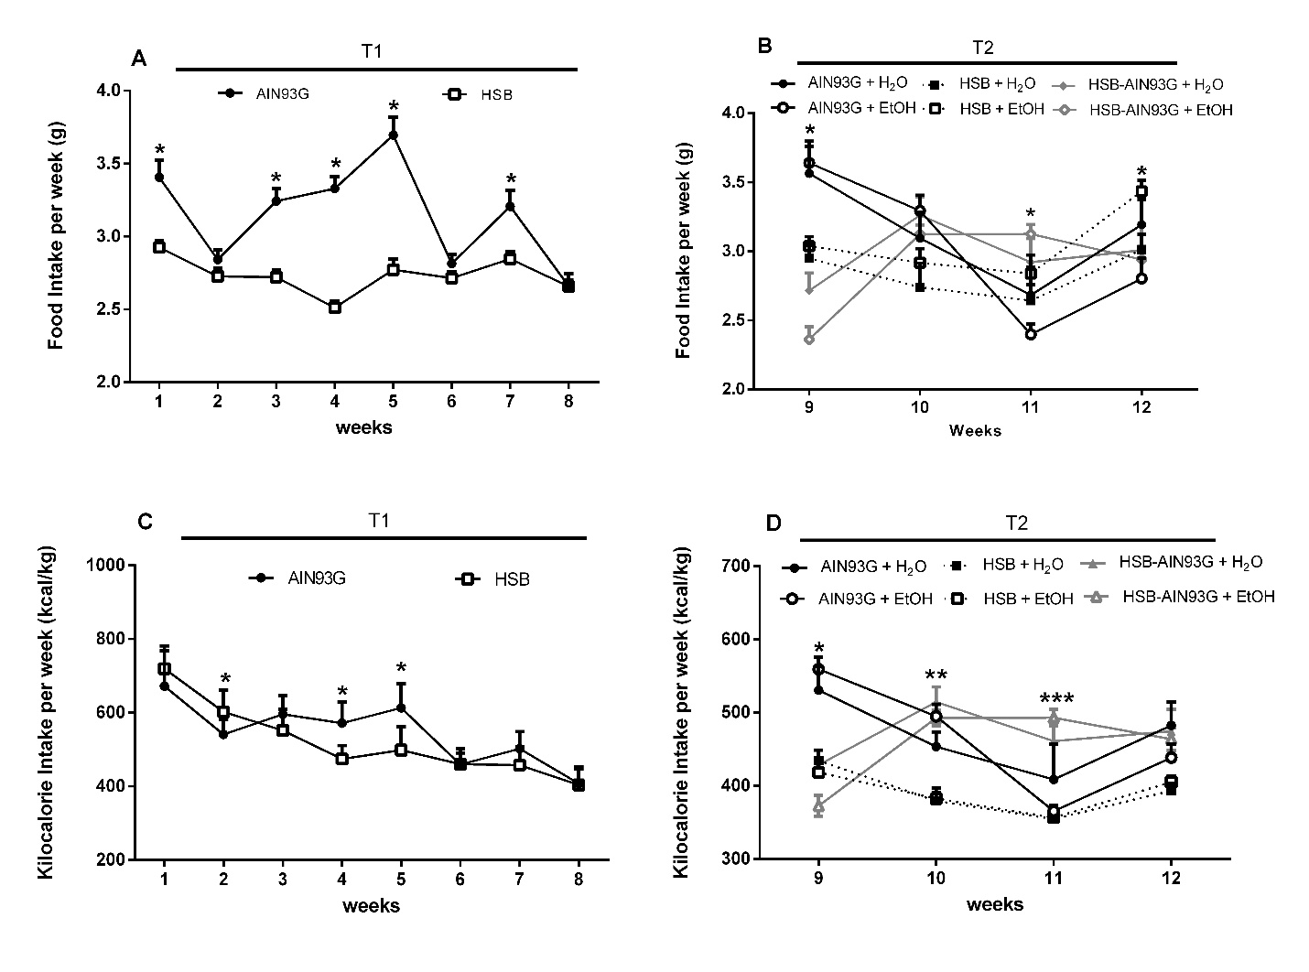

S1. Food and kilocalorie intake. Average food intake per week (g) during T1 (A) and T2 (B). Average kilocalorie intake per week (kcal/kg) during T1 (C) and T2 (D). In (A), weeks 1, 3, 4, 5 and 7: *p < 0.05 for AIN93G vs HSB. In (B), week 9: *p < 0.05 for AIN93G + H2O vs HSB + H2O and HSB-AIN93G + H2O, for AIN93G + EtOH vs HSB + EtOH and HSB-AIN93G + EtOH, for HSB + EtOH vs HSB-AIN93G + EtOH; week 11: *p < 0.05 for AIN93G + EtOH vs HSB-AIN93G + EtOH; week 12: *p < 0.05 for AIN93G + EtOH vs HSB + EtOH. In (C), *p < 0.05 for AIN93G vs HSB. In (D), week 9: *p < 0.05 for AIN93G + H2O and AIN93G + EtOH vs HSB + H2O, HSB + EtOH, HSB-AIN93G + H2O, and HSB-AIN93G + EtOH; week 10: **p < 0.05 for HSB + EtOH and HSB-AIN93G + EtOH vs AIN93G + EtOH; and for HSB-AIN93G + H2O vs HSB + H2O; week 11: ***p < 0.05 for HSB-AIN93G + EtOH vs HSB + EtOH; and for AIN93G + EtOH vs HSB-AIN93G + H2O. Two-way repeated measures ANOVA followed by Tukey post hoc test were used to determine statistically significant differences between the groups. Results are expressed as mean ± SEM. The amount of food ingested (in grams) was calculated by weighting the food pellets. Kilocalories intake was measured by calculating the average weekly food consumption (in grams), multiplying by the caloric value of each diet (AIN93G: 1g = 4kcal; HSB: 1g = 5kcal), and dividing by the mouse’s body weight (kg) obtained at the beginning of that experimental week (Wednesday). The graphs show the kilocalories ingested through the consumption of food only. Kilocalories ingested through the consumption of alcohol were not taken into account, since no evidence of a caloric deficit was found in our model.

