**Appendix**

Contents

[Supplemental Figure 1. Network of hip fracture trials 7](#_Toc512004814)

[Supplemental Figure 2. Network of nonvertebral fracture trials 8](#_Toc512004815)

[Supplemental Figure 3. Network of vertebral fracture trials 9](#_Toc512004816)

[Supplemental table 1: Description of the included trials 10](#_Toc512004817)

[Supplemental table 2. Risk of Bias Assessment 20](#_Toc512004818)

[References 30](#_Toc512004819)

[Direct Comparisons 37](#_Toc512004820)

[A. Hip fracture 37](#_Toc512004821)

[1. Teriparatide compared with Placebo 37](#_Toc512004822)

[2. Denosumab compared with Placebo 38](#_Toc512004823)

[3. Raloxifene compared with Placebo 39](#_Toc512004824)

[4. Zoledronate compared with Placebo 40](#_Toc512004825)

[5. Risedronate compared with Placebo 41](#_Toc512004826)

[6. Ibandronate compared with Placebo 42](#_Toc512004827)

[7. Alendronate compared with Placebo 43](#_Toc512004828)

[8. Vitamin D compared with Placebo 44](#_Toc512004829)

[9. Vitamin D+Calcium compared with Placebo 45](#_Toc512004830)

[10. Calcium compared with Placebo 46](#_Toc512004831)

[11. Bazedoxifene compared with Placebo 47](#_Toc512004832)

[12. Hormone therapy compared with Placebo 48](#_Toc512004833)

[13. Tibolone compared with Placebo 49](#_Toc512004834)

[14. Strontium ranelate compared with Placebo 50](#_Toc512004835)

[15. Lasofoxifene compared with Placebo 51](#_Toc512004836)

[16. Calcitonin compared with Placebo 52](#_Toc512004837)

[17. Romosozumab compared with Placebo 53](#_Toc512004838)

[18. Abaloparatide compared with Placebo 54](#_Toc512004839)

[19. Zoledronate compared with Teriparatide 55](#_Toc512004840)

[20. Risedronate compared with Teriparatide 56](#_Toc512004841)

[21. Ibandronate compared with Denosumab 57](#_Toc512004842)

[22. Alendronate compared with Raloxifene 58](#_Toc512004843)

[23. Tibolone compared with Raloxifene 59](#_Toc512004844)

[24. Vitamin D+Calcium compared with Vitamin D 60](#_Toc512004845)

[25. Calcium compared with Vitamin D+Calcium 61](#_Toc512004846)

[26. Hormone therapy compared with Vitamin D+Calcium 62](#_Toc512004847)

[27. Hormone therapy compared with Calcium 63](#_Toc512004848)

[28. Romosozumab compared with Alendronate 64](#_Toc512004849)

[B. Nonvertebral Fracture 65](#_Toc512004850)

[1. Teriparatide compared with Placebo 65](#_Toc512004851)

[2. Denosumab compared with Placebo 66](#_Toc512004852)

[3. Raloxifene compared with Placebo 67](#_Toc512004853)

[4. Zoledronate compared with Placebo 68](#_Toc512004854)

[5. Risedronate compared with Placebo 69](#_Toc512004855)

[6. Ibandronate compared with Placebo 70](#_Toc512004856)

[7. Alendronate compared with Placebo 71](#_Toc512004857)

[8. Strontium ranelate compared with Placebo 72](#_Toc512004858)

[9. Vitamin D+Calcium compared with Placebo 73](#_Toc512004859)

[10. Bazedoxifene compared with Placebo 74](#_Toc512004860)

[11. Tibolone compared with Placebo 75](#_Toc512004861)

[12. Hormone therapy compared with Placebo 76](#_Toc512004862)

[13. Calcitonin compared with Placebo 77](#_Toc512004863)

[14. Lasofoxifene compared with Placebo 78](#_Toc512004864)

[15. Vitamin D compared with Placebo 79](#_Toc512004865)

[16. Calcium compared with Placebo 80](#_Toc512004866)

[17. PTH 1-84 compared with Placebo 81](#_Toc512004867)

[19. Abaloparatide compared with Placebo 83](#_Toc512004868)

[20. Zoledronate compared with Teriparatide 84](#_Toc512004869)

[21. Risedronate compared with Teriparatide 85](#_Toc512004870)

[22. Alendronate compared with Teriparatide 86](#_Toc512004871)

[23. Calcitonin compared with Teriparatide 87](#_Toc512004872)

[24. Ibandronate compared with Denosumab 88](#_Toc512004873)

[25. Alendronate compared with Denosumab 89](#_Toc512004874)

[26. Alendronate compared with Raloxifene 90](#_Toc512004875)

[27. Bazedoxifene compared with Raloxifene 91](#_Toc512004876)

[28. Calcitonin compared with Raloxifene 92](#_Toc512004877)

[29. Alendronate compared with Risedronate 93](#_Toc512004878)

[30. Alendronate compared with Ibandronate 94](#_Toc512004879)

[31. Hormone therapy compared with Alendronate 95](#_Toc512004880)

[32. Hormone therapy compared with Vitamin D+Calcium 96](#_Toc512004881)

[33. Calcium compared with Vitamin D+Calcium 97](#_Toc512004882)

[34. Vitamin D compared with Hormone therapy 98](#_Toc512004883)

[35. Calcium compared with Hormone therapy 99](#_Toc512004884)

[36. Vitamin D compared with Calcitonin 100](#_Toc512004885)

[37. Romosozumab compared with Alendronate 101](#_Toc512004886)

[38. Abaloparatide compared with Teriparatide 102](#_Toc512004887)

[C. Vertebral Fracture 103](#_Toc512004888)

[1. Teriparatide compared with Placebo 103](#_Toc512004889)

[2. Denosumab compared with Placebo 104](#_Toc512004890)

[3. Raloxifene compared with Placebo 105](#_Toc512004891)

[4. Zoledronate compared with Placebo 106](#_Toc512004892)

[5. Risedronate compared with Placebo 107](#_Toc512004893)

[6. Ibandronate compared with Placebo 108](#_Toc512004894)

[7. Alendronate compared with Placebo 109](#_Toc512004895)

[8. Vitamin D+Calcium compared with Placebo 110](#_Toc512004896)

[9. Calcium compared with Placebo 111](#_Toc512004897)

[10. Bazedoxifene compared with Placebo 112](#_Toc512004898)

[11. Lasofoxifene compared with Placebo 113](#_Toc512004899)

[12. Hormone therapy compared with Placebo 114](#_Toc512004900)

[13. Calcitonin compared with Placebo 115](#_Toc512004901)

[14. Tibolone compared with Placebo 116](#_Toc512004902)

[15. Strontium ranelate compared with Placebo 117](#_Toc512004903)

[16. PTH 1-84 compared with Placebo 118](#_Toc512004904)

[17. Vitamin D compared with Placebo 119](#_Toc512004905)

[18. Romosozumab compared with Placebo 120](#_Toc512004906)

[19. Abaloparatide compared with Placebo 121](#_Toc512004907)

[20. Zoledronate compared with Teriparatide 122](#_Toc512004908)

[21. Risedronate compared with Teriparatide 123](#_Toc512004909)

[22. Alendronate compared with Teriparatide 124](#_Toc512004910)

[23. Ibandronate compared with Denosumab 125](#_Toc512004911)

[24. Alendronate compared with Denosumab 126](#_Toc512004912)

[25. Alendronate compared with Raloxifene 127](#_Toc512004913)

[26. Hormone therapy compared with Raloxifene 128](#_Toc512004914)

[27. Alendronate compared with Risedronate 129](#_Toc512004915)

[28. Alendronate compared with Ibandronate 130](#_Toc512004916)

[29. Hormone therapy compared with Alendronate 131](#_Toc512004917)

[30. Calcitonin compared with Alendronate 132](#_Toc512004918)

[31. Calcitonin compared with Hormone therapy 133](#_Toc512004919)

[32. Vitamin D compared with Hormone therapy 134](#_Toc512004920)

[33. Vitamin D compared with Calcitonin 135](#_Toc512004921)

[34. Romosozumab compared with Alendronate 136](#_Toc512004922)

[35. Abaloparatide compared with Alendronate 137](#_Toc512004923)

[Sensitivity analyses based on dosage and route 138](#_Toc512004924)

[Zoledronate: Nonvertebral Fracture 138](#_Toc512004925)

[Zoledronate compared with Placebo using 5 mg single dose 138](#_Toc512004926)

[Zoledronate compared with Placebo using other doses 139](#_Toc512004927)

[Zoledronate: vertebral fractures 140](#_Toc512004928)

[Zoledronate compared with Placebo using 5 mg single dose 140](#_Toc512004929)

[Calcitonin: Vertebral Fracture 141](#_Toc512004930)

[Calcitonin compared with Placebo using the intranasal route 141](#_Toc512004931)

[Calcitonin compared with Placebo using the injectable route 142](#_Toc512004932)

[Calcitonin compared with Placebo using the oral route 143](#_Toc512004933)

[Search strategies 144](#_Toc512004934)

|  |  |
| --- | --- |
| Code | Intervention |
| 1 | Placebo |
| 2 | Teriparatide |
| 3 | Denosumab |
| 4 | Raloxifene |
| 5 | Zoledronate |
| 6 | Risedronate |
| 7 | Ibandronate |
| 8 | Alendronate |
| 9 | Vitamin D |
| 10 | Vitamin D+Calcium |
| 11 | Calcium |
| 12 | Bazedoxifene |
| 13 | Hormone therapy |
| 14 | Tibolone |
| 15 | Strontium ranelate |
| 16 | Lasofoxifene |
| 17 | Calcitonin |
| 18 | Romosozumab |
| 19 | Abaloparatide |

# S**upplemental Figure 1. Network of hip fracture trials**

**Z:\TES osteoporosis in women\SR in efficacy\7. Output\Manuscript\Manuscript Figures and tables\Bubbles\network_hip.wmf**

# S**upplemental Figure 2. Network of nonvertebral fracture trials**

|  |  |
| --- | --- |
| Code | Intervention |
| 1 | Placebo |
| 2 | Teriparatide |
| 3 | Denosumab |
| 4 | Raloxifene |
| 5 | Zoledronate |
| 6 | Risedronate |
| 7 | Ibandronate |
| 8 | Alendronate |
| 9 | Strontium ranelate |
| 10 | Vitamin D+Calcium |
| 11 | Bazedoxifene |
| 12 | Tibolone |
| 13 | Hormone therapy |
| 14 | Calcitonin |
| 15 | Lasofoxifene |
| 16 | Vitamin D |
| 17 | Calcium |
| 18 | PTH 1-84 |
| 19 | Romosozumab |
| 20 | Abaloparatide |

**Z:\TES osteoporosis in women\SR in efficacy\7. Output\Manuscript\Manuscript Figures and tables\Bubbles\network_nonvert.wmf**

# S**upplemental Figure 3. Network of vertebral fracture trials**

|  |  |
| --- | --- |
| Code | Intervention |
| 1 | Placebo |
| 2 | Teriparatide |
| 3 | Denosumab |
| 4 | Raloxifene |
| 5 | Zoledronate |
| 6 | Risedronate |
| 7 | Ibandronate |
| 8 | Alendronate |
| 9 | Vitmin D+Calcium |
| 10 | Calcium |
| 11 | Bazedoxifene |
| 12 | Lasofoxifene |
| 13 | Hormone therapy |
| 14 | Calcitonin |
| 15 | Tibolone |
| 16 | Strontium ranelate |
| 17 | PTH 1-84 |
| 18 | Vitamin D |
| 19 | Romosozumab |
| 20 | Abaloparatide |

**Z:\TES osteoporosis in women\SR in efficacy\7. Output\Manuscript\Manuscript Figures and tables\Bubbles\network_vert.wmf**

# Supplemental table 1: Description of the included trials

|  |  |  |  |  |  |  |  |  |  |  |
| --- | --- | --- | --- | --- | --- | --- | --- | --- | --- | --- |
| **Author, Year** | **Patients description** | **Baseline BMD status** | **Age (yrs)** | **Race / Ethnicity** | **N** | **Interventions** | **Intervention duration** | **calcium** | **vit D** | **Country** |
| Alexandersen, 1999(1) | Healthy postmenopausal women with low BMD | Osteoporosis and osteopenia | 65 | NR | 50 | HRT (17β-estradiol 50 µg/day, patch + norethisterone acetate oral 1 mg/day) vs. placebo | 24 months | Both arms | Both arms | Denmark |
| Bai, 2013(2) | Postmenopausal women with Osteoposis | Osteoporosis | 56.8 | 100% asian | 483 | zoledronate 5 mg/ year vs. placebo | 24 months | Both arms | Both arms | China |
| Bischoff,2003(3) | Women aged ≥60 years with the ability to walk 3 m with or without a walking aid | NR | 84.6 | NR | 122 | vitamin D3 800 IU vs. placebo | 3 months | Both arms | No | Switzerland |
| black, 1996(4) | Women aged 55-81 years with existing vertebral fractures, with at least 2 years of menopause and low femoral-neck BMD | Osteopenia or Osteoporosis | 55-81 | 97% white, 1% asian, 1% black | 2027 | alendronate 5mg/day for 24 months and then increased to 10 mg/day vs. placebo | 36 months | Both arms | Both arms | USA |
| black, 2007(5) | Women aged 65-89 years with osteoporosis | Osteoporosis | 73 | NR | 7765 | zoledronate, 5mg / year vs. placebo | 24 months | Both arms | Both arms | Multiple countries |
| Blair, 2009(6) | Postmenopausal women with osteoporosis | Osteoporosis | 68.7 | 100% asian | 329 | calcitonin (salmon calcitonin) intranasal 200 IU/day vs. teriparatide 20 µg/day | 6 months | Both arms | Both arms | Multiple countries |
| Bock, 2012(7) | Women aged 60-75 years with menopause for >5 years with osteoporosis | Osteoporosis | NR | NR | 70 | ibandronate 150 mg/month vs. placebo | 12 months | Both arms | Both arms | Germany |
| Body, 2002(8) | Ambulatory postmenopausal women aged 30-85 years | Osteoporosis | 65.5 | 82% white | 146 | alendronate 10 mg/day vs. teriparatide 40 µg/day | 14 months | Both arms | Both arms | Multiple countries |
| Bolton-Smith, 2007(9) | Healthy women ≥60 years | Normal BMD | 68.3 | NR | 123 | vitamin D 400 IU + calcium 1 g/day vs. placebo | 24 months | No | No | UK |
| Bone, 1997(10) | Women aged 60-85 years with osteoporosis | Osteoporosis and osteopenia | 71 | 97% white | 359 | alendronate 1, 2.5 or 5 mg / day vs. placebo | 24 months | Both arms | Both arms | USA |
| Bone, 2008(11) | Ambulatory postmenopausal women with osteopenia | Osteopenia | 59.4 | 83% white | 332 | denosumab, 60 mg/6 months vs. placebo | 24 month | Both arms | Both arms | Multiple countries |
| Bush, 1996(12) | Healthy postmenopause women aged 45-64 years | Normal BMD | 56 | 88.7% white | 875 | HRT (CEE 0.625 mg/day only, or cyclic or continuous CEE 0.625 mg/day + MPA 10 mg/day [day 1 to 12], or CEE 0.625 mg/day + MPA 2.5 mg/day, or CEE 0.625 mg/day + micronized progesterone) vs. placebo | 36 months | NR | NR | USA |
| Cauley, 2003(13) | Postmenopausal women with an intact uterus | NR | 63.3 | 84% white, 7% black, %% hispanic, 0.3% native american, 2% asian/Pacific Islander | 16608 | estrogen + progestin vs. placebo | 18 months | NR | NR | USA |
| Chapuy, 1992/1994(14, 15) | Healthy women living in nursing homes or apartment houses | NR | 84 | NR | 3270 | vitamin D3 800 IU/day + tricalcium phosphate 1.2 g/day vs. placebo | 18 months | No | No | France |
| Chapuy, 2002(16) | Ambulatory women with life expectancy of at least 24 months | NR | NR | NR | 583 | vitamin D3 800 IU/day + elemental calcium 1.2 g/day as a fixed combination or separate vs. placebo | 24 months | No | No | France |
| Chesnut, 2000(17) | Postmenopausal women for at least 1 year with osteoporosis | Osteoporosis | 68.3 | white, asian, or hispanic | 1255 | calcitonin (salmon calcitonin) intranasal 100, 200, or 400 IU/day vs. placebo | 60 months | Both arms | Both arms | Multiple countries |
| Chesnut, 2004(18) | Women aged 55-80 years and ≥5 years postmenopausal with osteoporosis | Osteoporosis | 69 | NR | 2946 | ibandronate 2.5 mg/day or 20 mg in 4 doses/month vs. placebo | 36 months | Both arms | Both arms | Multiple countries |
| Clemmesen, 1997(19) | Healthy women with at least 1 year of menopause with osteoporosis | Osteoporosis | 68 | NR | 132 | risedronate 2.5 mg/day vs. placebo | 24 months | Both arms | No | Multiple countries |
| Cosman, 2009(20) | Women aged ≥50 years with osteoporosis | Osteoporosis | 68.4 | NR | 99 | alendronate 70 total mg/week vs. raloxifene 60 mg/day | 18 months | Both arms | Both arms | USA |
| Cosman, 2011(21) | Postmenopausal women with osteoporosis | Osteoporosis | 45-89 | 97.9% white | 275 | teriparatide 20 µg/day + injectable placebo vs. zoledronate 5 mg/once | 12 months | Both arms | Both arms | Multiple countries |
| Cosman, 2016(22) | Postmenopausal ambulatory women aged 55-90 years | Osteoporosis | 70.9 | 39.6% hispanic, 60.4% non-hipanic | 7180 | romosozumab sc 210 mg/month vs. placebo | 12 months | Both arms | Both arms | Multiple countries |
| Cummings, 1998(23) | Women aged 55-80 years without a vertebral fracture, with at least 2 years of menopause and BMD of 0.68 g/cm2 | Osteopenia and osteoporosis | 68 | 97% white | 4432 | alendronate 5 mg/day vs. placebo | 50.4 months | Those with Ca intakes < than 1000 mg | Those with Ca intakes < than 1000 mg | USA |
| Cummings, 2008(24) | Women aged 60-85 years with osteoporosis | Osteoporosis | 68.25 | NR | 4534 | tibolone 1.25 mg/day vs. placebo | 34 months | Both arms | Both arms | Multiple countries |
| Cummings, 2009(25) | Women aged 60-90 years with osteoporosis | Osteoporosis | 72.3 | NR | 7868 | denosumab 60 mg/6 months vs. placebo | 36 months | Both arms | Both arms | Multiple countries |
| Cummings, 2010(26) | Postmenopausal women (59 to 80 years of age) | Osteoporosis | 67 | 74.1% white, 18.4% asian | 8556 | lasofoxifene 0.25 mg/day vs. placebo | 60 months | Both arms | Both arms | Multiple countries |
| Dursun, 2001(27) | Postmenopausal women with BMD of -2 SD or less (lumbar spine or femoral neck) | Osteoporosis and osteopenia | 60.3 | NR | 101 | alendronate 10 mg/day vs. calcitonin (salmon calcitonin) intranasal 100 IU/day vs. placebo | 12 months | Yes | No | Turkey |
| Ensrud, 2008(28) | Women aged ≥55 years with documented heart disease or at high risk fo coronary events | Normal BMD | 68 | 84% white | 10101 | raloxifene 60 mg/day vs. placebo | 67.2 months (median) | NR | NR | Multiple countries |
| Ettinger, 1999(29) | Women with at least 2 years of menopause and had no severe or long-term disabling condition but osteoporosis | Osteoporosis | 67 | 95.7% white | 7705 | raloxifene 60 or 120 mg/day vs. placebo | 36 months | Both arms | Both arms | Multiple countries |
| Fogelman, 2000(30) | Women up to 80 years of age with at least 1 year of menopause and BMD -2 or less (lumbar spine) | Osteoporosis and osteopenia | 65 | NR | 359 | risedronate 5 mg/day vs. placebo | 24 months | Both arms | No | Multiple countries |
| Fogelman, 2008(31) | Postmenopausal women for a minimum of 1 year | Osteoporosis and osteopenia | 58.8 | NR | 180 | teriparatide 100 µg/day vs. placebo | 17.4 months (teriparatide), 18.2 months (placebo) | Both arms | Both arms | Multiple countries |
| Gallagher, 2001(32) | Women aged 65-77 years with normal BMD | Normal BMD | 71.7 | NR | 367 | HRT (conjugated estrogen 0.625 mg/d + MPA 2.5 mg/d) vs. vitamin D (calcitrol 0.5 µg/day) vs. placebo | 36 months | All arms | No | USA |
| Garay Lillo, 1997(33) | Ambulatory women aged 65-85 years | NR | NR | NR | 4185 | vitamin D 16,000 IU/week vs. placebo | 24 months | Both arms | No | Spain |
| Gennari, 1985(34) | Postmenopausal women with vertebral atraumatic compressions | Osteoporosis | 58.7 | NR | 45 | calcitonin (salmon calcitonin) 100 IU/day or 100IU/interdaily vs. control | 12 months | All arms | No | Italy |
| Greenspan, 1998(35) | Healthy, ambulatory, community-dwelling women aged ≥65 years | None specified | 70 | NR | 120 | alendronate 5mg (10 for the last 12 months) / day vs. placebo | 30 months | If dietary intake less than 1000 mg/d Ca | Those with low Vit. D | USA |
| Greenspan, 2002(36) | Ambulatory women aged ≥65 years living in long-term care facilities | Osteoporosis and osteopenia | 78.5 | 97% white | 327 | alendronate 10 mg/day vs. placebo | 24 months | If dietary calcium intake less than 1500 mg | Both arms | USA |
| Greenspan, 2007(37) | Postmenopausal women aged 45-54 years with osteoporosis | Osteoporosis | 64.4 | NR | 2679 | teriparatide 100 µg/day vs. placebo | 18 months | Both arms according to the patients’ needs | Both arms | Multiple countries |
| Greenspan, 2015(38) | Postmenopausal frail women aged ≥65 years who resided in a nursing home or assisted-living facility | Osteoporosis | 85.5 | NR | 181 | zoledronate 5 mg/once vs. placebo | 24 months | Both arms | Both arms | USA |
| Grey, 2009(39) | Postmenopausal women for at least 5 years with BMD between -1 and -2 (lumbar spine of total hip) | Osteopenia | 63.5 | NR | 50 | zoledronate, 5mg/once vs. placebo | 24 months | No | No | New Zealand |
| Grey, 2014(40) | Postmenopausal women for at least 5 years with BMD between -1 and -2.5 (lumbar spine of total hip) | Osteopenia | 65.3 | NR | 180 | zoledronate 1 mg, 2.5 mg or 5 mg/once vs. placebo | 24 months | No | No | New Zealand |
| Gruber, 1984(41) | Postmenopausal white women aged 51-71 years with osteoporosis | Osteoporosis | 65.4 | 100% white | 45 | calcitonin (synthetic salmon calcitonin) im or sc 100 IU/day vs. control | 24 months | Both arms | Both arms | USA |
| Hadji, 2012(42) | Women aged ≥45 years with 2 years of menopause and a history of back pain for ≥2 months | Osteoporosis | NR | 0.7% african american, 18% hispanic, 80.4% white, 0.4% asian, 0.4% native american | 710 | risedronate 35 mg/week vs teriparatide 20 µg/day | 18 months | Both arms | Both arms | USA |
| Harris, 1999(43) | Ambulatory women aged ≤85 years with at least 1 vertebral fracture | Osteoporosis | 69 | 96% white | 1641 | risedronate 5 mg/day vs. placebo | 36 months | Both arms | Those with low Vit. D | USA |
| Harwood, 2004(44) | Postmenopausal elderly women after hip fracture | Osteoporosis | 81.3 | NR | 150 | vitamin D (ergocalciferol) iv 300,000 IU/day + calcium carbonate 1 g/day vs. vitamin D 300,000 IU/day vs. control | 12 months | No | No | UK |
| Henriksen, 2016(45) | Postmenopausal ambulatory women aged 55-85 years | Osteoporosis | 66.8 | 66.5% white, 1.5% black, 19.2% hispanic, 12.8% asian | 4665 | calcitonin (salmon calcitonin) oral 0.8 mg/day vs. placebo | 36 months | Both arms | Both arms | Multiple countries |
| Hizmetli, 1998(46) | Postmenopausal women with osteoporosis | Osteoporosis | 58 | NR | 107 | calcitonin (salmon calcitonin) intranasal 50 or 100 IU/day vs. placebo | 24 months | Both arms | Both arms | Turkey |
| Hooper, 2005(47) | Early postmenopausal (6-36 months) women with osteoporosis | Osteoporosis | 53 | 98% white | 383 | Risedronate 2.5 or 5 mg/day vs. placebo | 24 months | Both arms | No | Australia |
| Hulley, 1998(48) | Posmenopause women aged 55-80 years for at least 1 year with established coronary disease | NR | 67 | 89% white | 2763 | HRT (CEE 0.625 mg/day + MPA 2.5 mg/day) vs. placebo | 36 months | NR | NR | USA |
| Ishida, 2004(49) | Ambulatory women aged 50-75 with osteoporosis | Osteoporosis | 69.5 | NR | 264 | HRT (estrogen 0.625mg/day + MPA 2.5mg/d) vs. calcitonin (eel calcitonin) 20 IU/week vs. vitamin D 1 µg/d vs. placebo | 24 months | NR | No | Japan |
| Itabashi, 2011(50) | Postmenopausal women aged ≤85 years with an intact uterus | Osteoporosis | 63 | asian | 425 | bazedoxifene 20 mg, 40 mg/day vs. placebo | 26 months | Both arms | Both arms | Japan |
| Iwamoto, 2008(51) | Postmenopausal women with osteoporosis | Osteoporosis | 69.4 | asian | 122 | alendronate 5 mg/day vs. raloxifene, 60 mg/day | 12 months | Instructed to take | No | Japan |
| Iwamoto, 2011(52) | Postmenopausal osteoporotic women with mild to moderate back pain | Osteoporosis | 79.8 | NR | 194 | alendronate 35 mg/week vs. calcitonin (as elcatonin, an eel calcitonin derivative) im 20 IU/week | 6 months | No | No | Japan |
| Jackson, 2006(53) | Postmenopausal women aged 50-79 years | NR | 62.4 | 83% white, 9.2% black, 4.2% hispanic, 0.4% american indian, 2% asian | 36282 | calcium carbonate 1 g/day + vitamin D3 400 IU/day vs. placebo | 84 months | No | No | USA |
| Jacobsen, 2012(54) | Postmenopausal women aged ≥70 years | NR | 73.7 | NR | 318 | tibolone 1.25 mg/day vs. raloxifene 60 mg/day vs. placebo | 24 months | No | No | The Netherlands |
| Koh, 2016(55) | Postmenopausal women aged 60-90 years | Osteoporosis | 66.5 | 100% asian | 135 | denosumab sc 60 mg single dose vs. placebo | 6 months | Both arms | Both arms | Korea |
| Komulainen, 1998(56) | Early postmenopausal women (6 to 24 months) | Osteoporosis | 52.5 | NR | 348 | HRT (Estradiol valerate 2 mg + cyproterone acetate 1 mg) vs. calcium 93 mg + vitamin D 300 IU/day vs. placebo | 60 months | Both arms | Both arms | Finland |
| Lees, 2001(57) | Postmenopausal women for at least 6 months and were non-hysterectomized | Normal BMD | 55.6 | NR | 579 | HRT (17β-estradiol 1 or 2 mg/day [day 1 to 28] + dydrogesterone 5, 10, or 20 mg/day [day 15 to 28]) vs. placebo | 24 months | Both arms | No | UK and Canada |
| Liberman, 1995(58) | Women aged 45-80 years with ≥5 years with menopause with osteoporosis | Osteoporosis | 64 | 87.4% white, 0.4% black; 12.2% other | 994 | alendronate 5, 10 or 20 mg/day vs. placebo | 36 months | Both arms | No | Multiple countries |
| Lindsay, 1990(59) | Postmenopausal women with osteoporosis | Osteoporosis | 62 | NR | 50 | HRT (CCE 0.625 mg/d, women with intact uterus received MPA 5-10 mg/day) vs. placebo | 24 months | Both arms | No | USA |
| Luckey, 2004(60) | Postmenopausal women aged >40 years with osteoporosis | Osteoporosis | 64.2 | 92% white | 456 | alendronate 70 mg/week vs. raloxifene 60 mg/day | 12 months | Both arms | No | USA |
| Lufkin, 1992(61) | Ambulatory postmenopausal women with osteoporosis | Osteoporosis | 64.7 | NR | 75 | HRT (Estradiol 0.1 mg/day + MPA 10 mg/day) vs. placebo | 12 months | No | No | USA |
| Lufkin, 1998(62) | Ambulatory postmenopausal women aged 45-75 years | Osteoporosis | 68.4 | NR | 143 | raloxifene 60 or 120 mg/day vs. no treatment | 12 months | Both arms | Both arms | USA |
| Macdonald, 2013(63) | Healthy postmenopausal women aged 60-70 years | Normal BMD | 64.6 | NR | 305 | vitamin D 400 or 1000 IU/day vs. placebo | 12 months | Both arms | No | UK |
| McClung, 2001(64) | Ambulatory postmenopausal women over the age of 70 | Osteoporosis | 79 | 98% white | 9331 | risedronate 2.5 or 5 mg/day vs. placebo | 24 months | Both arms | Those with low vitamin D | Multiple countries |
| McClung, 2004(65) | Healthy women >6 months postmenopause; aged <60 years | Normal BMD, Osteopenia and Osteoporosis | 55 | NR | 612 | HRT (CEE 0.625 mg/day + MPA 5 mg/day or 17β-estradiol 1-2 mg/day + norethisterone acetate 1 mg/day) vs. placebo | 72 months | No | No | Multiple countries |
| McClung, 2005(66) | Postmenopausal women aged 45-84 years with osteoporosis | Osteoporosis | 45-84 | NR | 203 | alendronate 10 mg/day + injectable placebo vs. teriparatide 20 µg/day + oral placebo | NR | Both arms | Both arms | Multiple countries |
| McClung, 2006(67) | Postmenopausal women aged ≤80 years with osteopenia or osteoporosis | Osteoporosis and osteopenia | 63 | 85% white 11% hispanic 3% black | 365 | denosumab every 3 months (6, 14 or 30 mg) or every 6 months (14, 60, 100 or 210 mg) vs. placebo | 12 months | Both arms | Both arms | USA |
| McClung, 2009(68) | Ambulatory postmenopausal women aged 45-60 years | Osteopenia | 53.5 | NR | 160 | ibandronate 150 mg/month vs. placebo | 12 months | Both arms | Both arms | USA |
| Meunier, 2004/2009(69, 70) | Postmenopausal women aged ≥50 years with at least 1 vertebral fracture and a lumbar lumbar BMD ≤0.84 g/cm2 | Osteoporosis | 69.3 | 100% white | 1649 | strontium ranelate 2 g/day vs. placebo | 48 months | Both arms | Both arms | Multiple countries |
| Miller, 2008(71) | Ambulatory postmenopausal women with osteoporosis | Osteoporosis | 65.6 | 82% white | 1760 | alendronate 70 mg/week vs. ibandronate 150 mg/month | 12 months | Both arms | Both arms | Multiple countries |
| Miller, 2016a(72) | Postmenopausal ambulatory women aged ≥50 years who received oral bisphosphonate therapy for ≥2 years | Osteoporosis | 69 | 96.9% white, 1.4% asian, 0.2% black or african american, 1.6% other | 643 | denosumab sc 60 mg single dose + iv placebo vs. zoledronate iv 5 mg single dose + sc placebo | 12 months | Both arms | Both arms | Multiple countries |
| Miller, 2016b(73) | Postmenopausal women aged 49-86 years | Osteoporosis | 68.8 | 79.7% white, 16.1% asian, 3% black or african american, 1.3% other | 2463 | teriparatide 20 µg//day vs. abaloparatide 80 µg/day vs. placebo | 18 months | Both arms | Both arms | Multiple countries |
| Morii, 2003(74) | Postmenopausal women aged ≤80 years with osteoporosis | Osteoporosis | 64.7 | 100% asian | 202 | raloxifene 60 or 120 mg / day vs. placebo | 12 months | Both arms | Both arms | Japan |
| Mortensen, 1998(75) | Postmenopausal women for 6-60 months with normal BMD | Normal BMD | 51.6 | 100% white | 111 | risedronate 5 mg/day or 5 mg/day the first two week each month vs. placebo | 24 months | Both arms | Both arms | USA and Denmark |
| Mosekilde, 2000(76) | Women aged 45-58 years with intact uterus and 3 to 24 months from last menstruation with perimenopausal symptoms | Normal BMD | 49.8 | NR | 1006 | HRT (oestradiol 2 mg/day [day 1-12], norethisterone acetate 1 mg/day [day 13-22], oestradiol 1 mg/day [day 23-28]) vs. placebo | 60 months | No | No | Denamark |
| Muscoso, 2004(77) | Postmenopausal women with osteoporosis | Osteoporosis | 68 | NR | 1200 | alendronate 10 mg/day vs. risedronate 5 mg/day vs. raloxifene 60 mg/day | 24 months | Both arms | Both arms | Italy |
| Nachtigall, 1979(78) | Postmenopausal women | NR | 55 | NR | 168 | HRT (conjugated estrogen 2.5 mg/day + MPA 10 mg/day) vs. placebo | 120 months | No | No | USA |
| Nakamura, 2012a(79) | Ambulatory postmenopausal women aged ≤80 years | Osteoporosis | 65.1 | 100% asian | 212 | denosumab 14, 60, 100 mg/6 months vs. placebo | 12 months | Both arms | Both arms | Japan |
| Nakamura, 2012b(80) | Healthy postmenopausal women aged 65-95 years with 1-5 vertebral fractures with low BMD | Osteoporosis | 75.3 | 100% asian | 549 | teriparatide sc 56.5 µg/week vs. placebo | 18 months | Both arms | Both arms | Japan |
| Nakamura, 2014(81) | Postmenopausal women aged ≥50 years with 1 to 4 prevalent vertebral fractures | Osteoporosis | 69.5 | 100% asian | 898 | denosumab 60 mg/6 months vs. placebo | 24 months | Both arms | Both arms | Japan |
| Neer, 2001(82) | Ambulatory postmenopausal women for at least 5 years with osteoporosis | Osteoporosis | 70 | 98% white | 1637 | teriparatide 20 or 40 µg/day vs. placebo | 18 months | Both arms | Both arms | Multiple countries |
| Overgaard, 1992(83) | Healthy women aged 68-72 years with bone mineral content on average 30% below the mean value for healthy premenopausal women (distal forearm) | Osteoporosis | 68-72 | NR | 308 | calcitonin (salmon calcitonin) intranasal 50, 100, or 200 IU/day vs. placebo | 24 months | Both arms | No | Denmark |
| Panico, 2011(84) | Postmenopausal women with back pain, osteoporosis, and 2 vertebral fractures | Osteoporosis | 62.6 | NR | 81 | alendronate 70 mg/week vs. teriparatide 20 µg/day | 18 months | Both arms | Both arms | Italy |
| Pfeifer, 2000(85) | Ambulatory healthy women aged ≥70 years with 25-hydroxycholecalciferol serum level below 50 nmol/l | NR | 74.8 | NR | 148 | vitamin D 800 IU/day vs. control | 12 months | Both arms | No | Germany |
| Pols, 1999(86) | Postmenopausal women for 3 years aged 85 years with osteoporosis. | Osteoporosis and osteopenia | 62.8 | 94% white | 1908 | alendronate 10 mg/day vs. placebo | 12 months | Both arms | No | Multiple countries |
| Porthouse, 2005(87) | Postmenopausal women aged ≥70 years with risk factor for hip fracture | NR | 76.8 | NR | 3314 | calcium carbonate 1 g/day + vitamin D3 1600 IU/day vs. control | 18 months | No | No | UK |
| Prince, 2006(88) | Postmenopausal women ≥70 years | Osteoporosis | 75.2 | NR | 1460 | calcium carbonate 1.2 g/day vs. placebo | 60 months | No | NR | Australia |
| Radford, 2014(89) | Healthy postmenopausal women | Normal BMD | 74.1 | NR | 1471 | calcium 1 g/day vs. placebo | 60 months | No | No | New Zealand |
| Recker, 1999(90) | Healthy white women aged >65 years and spinal BMD 0.9 g/cm2 or less | Osteopenia or Osteoporosis | 73 | 100% white | 128 | HRT (CEE 0.3 mg/day + MPA 2.5 mg/day) vs. placebo | 42 months | Both arms | Both arms | USA |
| Recker, 2004(91) | Postmenopausal women with BMD T score -2 to -5 and one to four prevalent vertebral fractures | Osteoporosis | 67 | NR | 2862 | ibandronate 0.5 or 1 mg/3 months vs. placebo | 36 months | Both arms | Both arms | NR |
| Recker, 2007(92) | Ambulatory postmenopausal women aged 50-80 years | Osteoporosis | 65.6 | 87% white | 1423 | alendronate 10 mg/day vs. raloxifene 60 mg/day | 10.8 months | Both arms | Both arms | USA |
| Recknor , 2013(93) | Postmenopausal women with low bone density treated previously with oral biphosphonate therapy | Osteopenia and Osteoporosis | 67.2 | 85.5% white | 833 | denosumab 60 mg/6 months vs. ibandronate 150 mg/month | 12 months | Both arms | Both arms | Multiple countries |
| Reginster, 2000(94) | Ambulatory women aged ≤85 years with ≥2 vertebral fracture | Osteoporosis | 71 | NR | 814 | risedronate 5 mg/day vs. placebo | 36 months | Both arms | Those with low Vit. D | Multiple countries |
| Reginster, 2005/2008(95, 96) | Ambulatory postmenopausal women aged ≥74 years with osteoporosis | Osteoporosis | 76.47 | NR | 5091 | strontium ranelate 2g/day vs. placebo | 36 and 60 months | Both arms | Both arms | Multiple countries |
| Reid, 2002(97) | Postmenopausal women aged 45-80 years | Osteoporosis and osteopenia | 64 | 99.4% white | 351 | zoledronate, 0.25, 0.5, or 1mg every three months; or 2 mg infusion twice; or one 4mg infusion vs. placebo | 12 months | Both arms | No | Multiple countries |
| Reid, 2004(98) | Postmenopausal women aged 40-60 | Normal BMD or Osteopenia | 53 | 95% white | 461 | raloxifene 60 or 150 mg/day vs. placebo | 36 months | Both arms | NR | Multiple countries |
| Rico, 1995(99) | Postmenopausal women with osteoporosis | Osteoporosis | 69.2 | NR | 72 | calcitonin (salmon calcitonin) im 100 IU/day vs. control | 24 months | Both arms | No | Spain |
| Rogers, 2009(100) | Women aged >50 years with menopause for >5 years with BMD T-score between -1 to -2.5 | Osteopenia | 63.4 | NR | 51 | lasofoxifene 0.25 mg/day vs. placebo | 24 months | Both arms | Both arms | UK |
| Saag, 2017 (101) | Ambulatory postmenopausal women 55 to 90 years | Osteoporosis | 74 | 32% hispanic | 4093 | Monthly sc romosozumab (210 mg) vs. weekly oral alendronate | 12 months | Both arms | Both arms | Multiple countries |
| Salovaara, 2010(102) | Women aged ≥65 years | NR | 67.4 | NR | 3195 | vitamin D (cholecalciferol) 800 IU/day + calcium carbonate 1 g/day vs. control group | 36 months | Optional | Optional | Finland |
| Silverman, 2008/2012(103, 104) | Healthy postmenopausal women aged 55-85 with osteoporosis. At least 2 years of menopause | Osteoporosis | 66.4 | 87% white | 7492 | bazedoxifene 20 or 40 mg/day vs. raloxifene 60 mg/day vs. placebo | 36 months for raloxifene arm, 60 months for the rest. | Both arms | Both arms | Multiple countries |
| Tanko, 2004(105) | Healthy postmenopausal women aged 55-85. At least 5 years of menopause | Normal BMD | 55-85 | 100% white | 277 | calcitonin (salmon calcitonin) oral 0.15, 0.4, 1, or 2.5 mg/day or 1 mg/interdaily vs. placebo | 36 months | Both arms | Both arms | Denmark and Belgium |
| Tierney, 2009(106) | Women aged ≥60 years with last menstrual cycle ≥12 months before | NR | 74.7 | 93% white, 4.2% black, 2.8% asian | 142 | HRT (17β-estradiol micronized 1 mg/day + norethindrone 0.35 mg/3 days per week) vs. placebo | 24 months | NR | NR | Canada |
| Ushiroyama, 2001(107) | Postmenopausal Japanese women for at least 6 months with osteopenia or osteoporosis | Osteopenia and osteoporosis | 52.5 | NR | 151 | calcitonin im 10 IU twice a month vs. vitamin D (1ɑ-hydroxycholecalciferol) 1 µg/day vs. control | 24 months | No | No | Japan |
| Vickers, 2007(108) | Postmenopausal (no menstrual period for 12 months) women aged 50-69 years | NR | 62.8 | NR | 6026 | HRT (estrogen 0.625 mg/ day or estrogen 2.5 mg/day + Progesterone 5 mg/day) vs. placebo | 11.9 months | No | No | Japan |
| Weiss, 1999(109) | Postmenopausal women aged ≥45 years, who had undergone hyesterectomy without oophorectomies | NR | 51.2 | 83.4% white, 6.9% black, 5.1% hispanic | 175 | HRT (17β-E2 transdermal system of 0.025,0.05,0.06, and 0.1 mg/day) vs. placebo | 24 months | Both arms | No | USA |
| Wimalawansa, 1998(110) | Postmenopausal white women with osteoporosis | Osteoporosis | 64.9 | 100% white | 36 | HRT (premarin 0.625 mg/day + norgestrel 150 µg for 12 days each month) vs. control | 48 months | Both arms | Both arms | NR |
| Yan, 2009(111) | Ambulatory postmenopausal women with osteoporosis aged ≤85 years | Osteoporosis | 65 | 100% asian | 560 | alendronate 70 mg/week vs. placebo | 12 months | Both arms | Both arms | China |

# Supplemental table 2. Risk of Bias Assessment

|  |  |  |  |  |  |  |  |  |  |  |  |  |
| --- | --- | --- | --- | --- | --- | --- | --- | --- | --- | --- | --- | --- |
| **Author, year** | **Lost follow-up** | **Length of follow-up (mo)** | **Baseline imbalance** | **Allocation concealment** | **Blinding** | | | | | **Funding** | **Fracture assessment** | **Overall RoB** |
| **CG** | **OA** | **DC** | **DA** | **P** |
| Alexandersen, 1999(1) | 28% | 22 | No | Probably Yes | Yes | Yes | NR | NR | Yes | Not reported or unclear | Medical records or radiologic reports | Low |
| Bai, 2013(2) | 0% | 24 | No | NR or unclear | NR | NR | NR | NR | NR | Only not for profit source | Documented by medical personnel | High |
| Bischoff,2003(3) | 27% | 3 | No | NR or unclear | Yes | NR | NR | NR | Yes | Includes for-profit and non-for –profit sources | NR | High |
| Black, 1996(4) | 4% | 36 | No | Probably Yes | Yes | NR | NR | NR | Yes | Not reported or unclear | Medical records or radiologic reports | Low |
| Black, 2007(5) | NR | 36 | No | Probably Yes | Yes | NR | NR | NR | Yes | Includes for-profit source | Documented by medical personnel | Low |
| Blair, 2009(6) | NR | 6 | NR | Probably No | NR | NR | NR | NR | NR | Includes for-profit source | Documented by medical personnel | High |
| Bock, 2012(7) | 2% | 12 | No | Probably Yes | Yes | NR | NR | NR | Yes | Only not-for-profit source. | Documented by medical personnel | Low |
| Body, 2002(8) | 0.50% | 14 | No | NR or unclear | Yes | NR | NR | NR | Yes | Includes for-profit source | Documented by medical personnel | High |
| Bolton-Smith, 2007(9) | 13.80% | 24 | No | Probably Yes | Yes | NR | NR | NR | Yes | Only not-for-profit source. | NR | Low |
| Bone, 1997(10) | NR | 24 | No | NR or unclear | Yes | NR | NR | NR | Yes | Includes for-profit source | Documented by medical personnel | High |
| Bone, 2008(11) | 14% | 24 | No | NR or unclear | Yes | NR | NR | NR | Yes | Includes for-profit source | Documented by medical personnel | High |
| Bush, 1996(12) | 27.10% | 36 | No | NR or unclear | Yes | NR | NR | NR | Yes | Only not-for-profit source | NR | High |
| Cauley, 2003(13) | NR | 18 | No | NR or unclear | Yes | NR | NR | NR | Yes | Includes for-profit source | By semiannual questionnaire | High |
| Chapuy, 1992/1994(14, 15) | 46% | 18 | No | NR or unclear | NR | NR | NR | NR | Yes | Only not-for-profit source. | Medical records or radiologic reports | High |
| Chapuy, 2002(16) | 4.40% | 24 | No | NR or unclear | Yes | NR | NR | NR | Yes | Includes for-profit source | Medical records or radiologic reports | High |
| Chesnut, 2000(17) | 59.30% | 60 | No | Probably Yes | Yes | NR | NR | NR | Yes | Includes for-profit source | Medical records or radiologic reports | Low |
| Chesnut, 2004(18) | NR | 36 | No | Probably Yes | Yes | NR | NR | NR | Yes | Includes for-profit source | Documented by medical personnel | Low |
| Clemmesen, 1997(19) | 27% | 36 | No | Probably No | Yes | Yes | NR | NR | Yes | Not reported or unclear | Documented by medical personnel | High |
| Cosman, 2009(20) | 15.60% | 18 | No | Probably Yes | No | NR | NR | NR | No | Includes for-profit source | NR | Unclear |
| Cosman, 2011(21) | 0% | 12 | No | Probably Yes | Yes | NR | NR | NR | Yes | Includes for- profit source | Documented by medical personnel | Low |
| Cosman, 2016(22) | 0.6% | 12 | No | Probably Yes | Yes | No | NR | NR | Yes | Includes for-profit source | Documented by medical personnel | Low |
| Cummings, 1998(23) | 4% | 50.4 | No | Probably Yes | Yes | Yes | Yes | Yes | Yes | Includes for-profit source | Documented by medical personnel | Low |
| Cummings, 2008(24) | 9.90% | 34 | No | Probably No | Yes | NR | Yes | NR | Yes | Includes for-profit source | Documented by medical personnel | High |
| Cummings, 2009(25) | NR | 36 | No | NR or unclear | NR | NR | NR | NR | NR | Includes for-profit source | Medical records or radiologic reports | High |
| Cummings, 2010(26) | NR | 60 | No | Probably No | NR | NR | NR | NR | NR | Not reported or unclear | Vertebral fractures by medical personnel, non-vertebral by self report | High |
| Dursun, 2001(27) | NR | 12 | No | NR or unclear | NR | NR | NR | NR | NR | Not reported or unclear | Lateral and anteroposterior X-rays for vertebral fractures | High |
| Ensrud, 2008(28) | NR | 67.2 | No | Probably Yes | Yes | Yes | Yes | Yes | Yes | Includes for-profit source | Documented by medical personnel | Low |
| Ettinger, 1999(29) | NR | 36 | No | Probably Yes | Yes | Yes | NR | NR | Yes | Includes for-profit source | Vertebral fractures by medical personnel, non-vertebral not specified | Low |
| Fogelman, 2000(30) | 34% | 24 | No | NR or unclear | Yes | NR | NR | NR | Yes | Includes for-profit source | Documented by medical personnel | High |
| Fogelman, 2008(31) | NR | 18 | No | NR or unclear | Yes | NR | NR | NR | Yes | Includes for-profit source | Vertebral fractures by medical personnel, non-vertebral by self report | High |
| Gallagher, 2001(32) | 14.40% | 36 | Yes, increased vertebral fractures in Vitamin D arm | Probably No | Yes | NR | NR | NR | Yes | Includes for-profit source | Documented by medical personnel | High |
| Garay Lillo, 1997(33) | 43.70% | 24 | NR | NR or unclear | NR | NR | NR | NR | NR | Not reported or unclear | NR | High |
| Gennari, 1985(34) | 45.10% | 12 | No | NR or unclear | NR | NR | NR | NR | NR | Not reported or unclear | Documented by medical personnel | High |
| Greenspan, 1998(35) | 25% | 30 | Yes, the mean intertrochanteric BMD was slightly higher in the placebo group than in the alendronate group | NR or unclear | Yes | NR | NR | NR | Yes | Includes for-profit source | NR | High |
| Greenspan, 2002(36) | NR | 24 | No | Probably Yes | Yes | NR | NR | NR | Yes | Includes for-profit source | NR | Low |
| Greenspan, 2007(37) | 0% | 18 | No | Probably Yes | Yes | Yes | NR | NR | NR | Includes for-profit source | Documented by medical personnel | Unclear |
| Greenspan, 2015(38) | 7.2% | 24 | No | NR or unclear | Yes | Yes | Yes | Yes | Yes | Only not-for-profit source | Documented by medical personnel | High |
| Grey, 2009(39) | 2% | 24 | No | Probably Yes | Yes | Yes | Yes | NR | Yes | Only not-for-profit source | NR | Low |
| Grey, 2014(40) | 7% | 24 | No | Probably Yes | Yes | NR | NR | NR | Yes | Includes For profit source | NR | Low |
| Gruber, 1984(41) | 11.10% | 24 | Yes, treatment group had less years with menopause and more number of vertebral fractures | Probably No | NR | NR | NR | NR | NR | Includes For profit source | Documented by medical personnel | High |
| Hadji, 2012(42) | 25.60% | 18 | No | NR or unclear | Yes | NR | NR | NR | Yes | Includes for-profit source. | Documented by medical personnel | High |
| Harris, 1999(43) | 2.10% | 36 | No | Probably Yes | Yes | NR | NR | NR | Yes | Includes for-profit source | Documented by medical personnel | Low |
| Harwood, 2004(44) | 31.30% | 12 | No | Probably Yes | NR | NR | NR | NR | NR | Not reported or unclear | NR | Unclear |
| Henriksen, 2016(45) | 10.1% | 36 | No | Probably Yes | Yes | Yes | Yes | NR | Yes | Includes for-profit source | Documented by medical personnel | Low |
| Hizmetli, 1998(46) | 24.30% | 24 | No | NR or unclear | NR | NR | NR | NR | NR | Not reported or unclear | Documented by medical personnel | High |
| Hooper, 2005(47) | 22.20% | 24 | No | Probably Yes | Yes | NR | NR | NR | Yes | Includes for-profit source | Documented by medical personnel | Low |
| Hulley, 1998(48) | 5.60% | 49 | No | Probably Yes | Yes | NR | NR | NR | Yes | Includes for-profit source | NR | Low |
| Ishida, 2004(49) | 6.40% | 24 | No | NR or unclear | NR | NR | NR | NR | NR | Not reported or unclear | Documented by medical personnel | High |
| Itabashi, 2011(50) | 0.47% | 24 | No | NR or unclear | Yes | NR | NR | NR | Yes | Includes for-profit source | Vertebral fractures by medical personnel, non-vertebral by self report | High |
| Iwamoto, 2008(51) | 16.30% | 12 | No | NR or unclear | NR | NR | NR | NR | NR | Not reported or unclear | Documented by medical personnel | High |
| Iwamoto, 2011(52) | 0% | 6 | Yes, women in the Calcitonin group were significantly older and thinner. | NR or unclear | Yes | NR | NR | NR | NR | Only not for profit source | Documented by medical personnel | High |
| Jackson, 2006(53) | 7% | 24 | No | NR or unclear | Yes | NR | NR | NR | Yes | Includes for-profit source | Documented by medical personnel | High |
| Jacobsen, 2012(54) | 59.8% (79% dropped from the Tibolone arm due to the results of the Long-Term Intervention on Fractures with Tibolone study (higher risk of CVAs) | 24 | No | Probably Yes | Yes | NR | NR | NR | Yes | Only not for profit source | NR | Low |
| Koh, 2016(55) | 4.4% | 6 | No | NR or unclear | Yes | Yes | Yes | NR | Yes | Includes for-profit source | Documented by medical personnel | Unclear |
| Komulainen, 1998(56) | 5% | 60 | No | Probably Yes | NR | NR | NR | NR | NR | Not reported or unclear | Documented by medical personnel | Unclear |
| Lees, 2001(57) | 38.20% | 24 | No | Probably Yes | Yes | NR | NR | NR | Yes | Includes for-profit source | NR | Low |
| Liberman, 1995(58) | NR | 36 | No | NR or unclear | Yes | Yes | NR | NR | Yes | Includes for-profit source | Vertebral fractures by medical personnel, non-vertebral not specified | High |
| Lindsay, 1990(59) | 20% | 24 | No | NR or unclear | NR | NR | NR | NR | NR | Not reported or unclear | NR | High |
| Luckey, 2004(60) | 18.40% | 12 | No | Probably Yes | Yes | NR | NR | NR | Yes | Includes for-profit source | NR | Low |
| Lufkin, 1992(61) | 9.30% | 12 | No | NR or unclear | Yes | NR | NR | NR | Yes | Includes for-profit source | Documented by medical personnel | High |
| Lufkin, 1998(62) | NR | 12 | No | Probably Yes | Yes | NR | NR | NR | Yes | Includes for-profit source | Vertebral fractures by medical personnel, non-vertebral not specified | Low |
| Macdonald, 2013(63) | >30% | 12 | No | NR or unclear | Yes | NR | NR | NR | Yes | Only not for profit source | Documented by Self report | High |
| McClung, 2001(64) | NR | 28 | No | NR or unclear | NR | NR | NR | NR | NR | Includes for-profit source | Documented by medical personnel | High |
| McClung, 2004(65) | 28.70% | 72 | No | NR or unclear | Yes | NR | NR | NR | Yes | Includes for-profit source | NR | High |
| McClung, 2005(66) | NR | 18 | No | NR or unclear | Yes | NR | NR | NR | Yes | Includes for-profit source | Documented by medical personnel | High |
| McClung, 2006(67) | NR | 12 | No | Probably Yes | Yes | NR | NR | NR | Yes | Includes for-profit source | NR | Low |
| McClung, 2009(68) | NR | 12 | No | NR or unclear | Yes | NR | NR | NR | Yes | Includes for-profit source | Vertebral fractures by medical personnel, non-vertebral by self report | High |
| Meunier, 2004/2009(69, 70) | 12.6%/20.5% | 36/48 | No | Probably No | Yes | NR | NR | NR | Yes | Only not-for-profit source/Not reported or unclear | Documented by medical personnel/Vertebral fractures by radiographs. non-vertebral fractures by radiographs and medical reports | High |
| Miller, 2008(71) | 12% | 12 | No | NR or unclear | Yes | NR | NR | NR | Yes | Includes for-profit source | NR | High |
| Miller, 2016a(72) | 0.0% | 6 | No | NR or unclear | Yes | Yes | Yes | Yes | Yes | Includes for-profit source | Documented by medical personnel | Unclear |
| Miller, 2016b(73) | 22.8% | 18 | No | Probably Yes | No | Yes | Yes | NR | No | Includes for-profit source | Documented by medical personnel | High |
| Morii, 2003(74) | NR | 12 | Yes, Placebo had lower lumbar spine BMD; P = 0.004 | Probably Yes | Yes | Yes | NR | NR | Yes | Includes for-profit source | Vertebral fractures by medical personnel, non-vertebral not specified | Low |
| Mortensen, 1998(75) | NR | 36 | No | NR or unclear | Yes | NR | NR | NR | Yes | Includes for-profit source | Documented by medical personnel | High |
| Mosekilde, 2000(76) | 10.80% | 60 | No | Probably Yes | NR | NR | NR | NR | NR | Only not-for-profit source | Documented by medical personnel | Unclear |
| Muscoso, 2004(77) | NR | 24 | No | NR or unclear | NR | NR | NR | NR | NR | Not reported or unclear | NR | High |
| Nachtigall, 1979(78) | NR | 120 | NR | Probably No | Yes | NR | NR | NR | Yes | Not reported or unclear | NR | High |
| Nakamura, 2012a(79) | 8% | 12 | No | Probably Yes | Yes | NR | NR | NR | Yes | Includes for-profit source. | Documented by medical personnel | Low |
| Nakamura, 2012b(80) | 23.50% | 18 | No | NR or unclear | Yes | Yes | NR | NR | Yes | Includes for-profit source | Medical records or radiologic reports | High |
| Nakamura, 2014(81) | 17.9% | 24 | No | NR or unclear | Yes | Yes | Yes | Yes | Yes | Includes for-profit source | Documented by medical personnel | High |
| Neer, 2001(82) | NR, Base-line and follow-up radiographs available for 81% | 21 | No | NR or unclear | NR | NR | NR | Yes | NR | Includes for-profit source | Documented by medical personnel | High |
| Overgaard, 1992(83) | 15% | 24 | No | Probably Yes | Yes | NR | NR | NR | Yes | Only not-for-profit source | Documented by medical personnel | Low |
| Panico, 2011(84) | 3.70% | 18 | No | NR or unclear | NR | NR | NR | NR | NR | Not reported or unclear | NR | High |
| Pfeifer, 2000(85) | 7.40% | 12 | No | Probably Yes | Yes | NR | NR | NR | Yes | Includes for-profit source | Documented by medical personnel | Low |
| Pols, 1999(86) | 11% | 12 | No | NR or unclear | Yes | NR | NR | NR | Yes | Includes for-profit source | Documented by medical personnel | High |
| Porthouse, 2005(87) | 17.80% | 18 | No | Probably Yes | NR | NR | NR | NR | NR | Includes for-profit source | Documented by medical personnel | Unclear |
| Prince, 2006(88) | 0% | 60 | No | Probably Yes | Yes | Yes | NR | NR | Yes | Only not-for-profit source | Documented by medical personnel | Low |
| Radford, 2014(89) | 10% | 60 | No | Probably Yes | Yes | NR | NR | NR | Yes | Only not for profit source | Documented by Self report | Low |
| Recker, 1999(90) | 16.40% | 42 | No | Probably Yes | Yes | NR | NR | NR | Yes | Only not for profit source | NR | Low |
| Recker, 2004(91) | 1.10% | 36 | No | Probably Yes | Yes | Yes | NR | NR | Yes | Includes for-profit source | Documented by medical personnel | Low |
| Recker, 2007(92) | 1.90% | 10 | No | Probably Yes | Yes | NR | NR | NR | Yes | Includes for-profit source | Documented by medical personnel | Low |
| Recknor , 2013(93) | 9.50% | 12 | No | Probably Yes | NR | NR | NR | NR | NR | Includes for-profit source | NR | Unclear |
| Reginster, 2000(94) | NR, 58% completed 3 study | 36 | No | NR or unclear | Yes | NR | NR | NR | Yes | Includes for-profit source | Vertebral fractures by medical personnel, non-vertebral not specified | High |
| Reginster, 2005/2008(95, 96) | 0.03% | 36 and 60 | No | NR or unclear | Yes | NR | NR | NR | Yes | Not reported or unclear | Vertebral fractures by medical personnel, non-vertebral not specified | High |
| Reid, 2002(97) | 10% | 12 | No | NR or unclear | Yes | NR | NR | NR | Yes | Includes for-profit source | Vertebral fractures by medical personnel, non-vertebral not specified | High |
| Reid, 2004(98) | 3.9% | 36 | No | Probably Yes | Yes | NR | NR | NR | Yes | Includes for-profit source | Documented by medical personnel | Low |
| Rico, 1995(99) | 5.6% | 24 | No | NR or unclear | NR | NR | NR | NR | NR | Not reported or unclear | Documented by medical personnel | High |
| Rogers, 2009(100) | 0.0% | 24 | No | Probably Yes | NR | NR | NR | NR | NR | Includes for-profit source | NR | Unclear |
| Saag, 2017 (101) |  | 12 | No | Probably Yes | Yes | NR | NR | NR | Yes | Includes for-profit source | Documented by medical personnel | Low |
| Salovaara, 2010(102) | 1.8% | 36 | No | Probably Yes | No | NR | NR | NR | No | Includes for-profit source | Medical records or radiologic reports | Unclear |
| Silverman, 2008/2012(103, 104) | >10% | 36 (Raloxifene arm), 60 (Bazedoxifene and Placebo arm) | No | Probably Yes | Yes | Yes | NR | Yes | Yes | Includes for-profit source | Documented by medical personnel | Low |
| Tanko, 2004(105) | 9.4% | 3 | No | NR or unclear | Yes | NR | NR | NR | Yes | Includes for-profit source | NR | High |
| Tierney, 2009(106) | 9.9% | 24 | No | Probably Yes | Yes | Yes | Yes | Yes | Yes | Only not-for-profit source | NR | Low |
| Ushiroyama, 2001(107) | NR | 24 | No | NR or unclear | NR | NR | NR | NR | NR | Not reported or unclear | NR | High |
| Vickers, 2007(108) | NR | 11.9 | No | Probably Yes | NR | NR | NR | NR | NR | Only not-for-profit source | NR | Low |
| Weiss, 1999(109) | 3.0% | 24 | No | Probably No | Yes | NR | NR | NR | Yes | Includes for-profit source | NR | Unclear |
| Wimalawansa, 1998(110) | 19.4% | 48 | No | Probably Yes | NR | Yes | NR | NR | NR | Not reported or unclear | Documented by medical personnel | Unclear |
| Yan, 2009(111) | 17.0% | 12 | No | Probably Yes | Yes | NR | NR | NR | Yes | Includes for-profit source | NR | Low |

Abbreviations: CG (care giver), OA (outcome assessor), DC (data collector), DA (data analyst), P (patient), NR (not reported)

# Supplemental table 3. Quality of evidence of network estimates (interventions compared to placebo)

|  |  |  |  |  |  |  |  |  |  |  |  |  |  |  |  |  |  |  |
| --- | --- | --- | --- | --- | --- | --- | --- | --- | --- | --- | --- | --- | --- | --- | --- | --- | --- | --- |
| **Hip** | | | | | | | | | | | | | | | | | | |
| Abaloparatide | Romosozumab | Calcitonin | Lasofoxifene | Strontium ranelate | Tibolone | Hormone therapy | Bazedoxifene | Calcium | Vitamin D + Calcium | Vitamin D | Alendronate | Ibandronate | Risedronate | Zoledronate | Raloxifene | Denosumab | Teriparatide | |
| 0.24 (0.01,4.84) | 0.44 (0.24,0.79) | 0.48 (0.21,1.10) | 0.83 (0.55,1.26) | 0.89 (0.67,1.18) | 0.69 (0.32,1.51) | 0.72 (0.53,0.98) | 0.93 (0.37,2.33) | 1.39 (0.90,2.15) | 0.81 (0.71,0.93) | 0.69 (0.43,1.09) | 0.61 (0.42,0.90) | 0.62 (0.29,1.36) | 0.73 (0.58,0.92) | 0.60 (0.45,0.81) | 0.91 (0.71,1.17) | 0.56 (0.35,0.90) | 0.64 (0.25,1.68) | |
| **L\*\*** | **H** | **L\*†** | **L\*\*** | **L\*\*** | **L\*\*** | **M†** | **L\*\*** | **VL\*\*†** | **M†** | **L\*†** | **H** | **M\*** | **H** | **H** | **M\*** | **H** | **L\*\*** | |
| **Nonvertebral** | | | | | | | | | | | | | | | | | | |
| Abaloparatide | Romosozumab | PTH 1-84 | Calcium | Vitamin D | Lasofoxifene | Calcitonin | Hormone therapy | Tibolone | Bazedoxifene | Vitamin D + Calcium | Strontium ranelate | Alendronate | Ibandronate | Risedronate | Zoledronate | Raloxifene | Denosumab | Teriparatide |
| 0.51 (0.29,0.87) | 0.67 (0.53,0.86) | 0.98 (0.71,1.35) | 0.77 (0.56,1.05) | 0.44 (0.23,0.85) | 0.84 (0.72,0.99) | 0.84 (0.68,1.05) | 0.78 (0.68,0.89) | 0.73 (0.58,0.94) | 0.90 (0.72,1.11) | 0.93 (0.85,1.01) | 0.90 (0.78,1.04) | 0.84 (0.74,0.94) | 1.06 (0.83,1.36) | 0.78 (0.68,0.89) | 0.79 (0.67,0.94) | 0.94 (0.85,1.05) | 0.80 (0.67,0.96) | 0.62 (0.47,0.80) |
| **H** | **H** | **M\*** | **L\*†** | **M†** | **M\*** | **L\*†** | **M†** | **M†** | **M\*** | **L\*†** | **M\*** | **H** | **M\*** | **H** | **H** | **M\*** | **H** | **H** |
| **Vertebral** | | | | | | | | | | | | | | | | | | |
| Abaloparatide | Romosozumab | Vitamin D | PTH 1-84 | Strontium ranelate | Tibolone | Calcitonin | Hormone therapy | Lasofoxifene | Bazedoxifene | Calcium | Vitamin D + Calcium | Alendronate | Ibandronate | Risedronate | Zoledronate | Raloxifene | Denosumab | Teriparatide |
| 0.14 (0.05,0.42) | 0.33 (0.22,0.49) | 0.85 (0.46,1.59) | 0.41 (0.22,0.77) | 0.60 (0.46,0.78) | 0.56 (0.36,0.87) | 0.65 (0.50,0.85) | 0.65 (0.46,0.92) | 0.67 (0.46,0.98) | 0.61 (0.41,0.90) | 0.70 (0.48,1.04) | 0.88 (0.61,1.27) | 0.57 (0.45,0.71) | 0.67 (0.48,0.93) | 0.61 (0.48,0.78) | 0.38 (0.25,0.58) | 0.59 (0.46,0.76) | 0.32 (0.22,0.45) | 0.27 (0.19,0.38) |
| **H** | **H** | **L\*\*** | **H** | **H** | **M†** | **M†** | **M†** | **H** | **H** | **L\*†** | **L\*†** | **H** | **H** | **H** | **H** | **H** | **H** | **H** |

Quality of evidence (also called certainty in evidence) is categorized as: VL: very low, L: low, M: moderate, H: high. The network is judged to have adequate consistency and transitivity. There was no concern about indirectness of fracture outcomes. There was no clear and reliable evidence of publication bias.

\* Serious concern about imprecision

\*\* Very serious concern about imprecision

† Serious concern about risk of bias

# References

1. **Alexandersen P, Riis BJ, Christiansen C** 1999 Monofluorophosphate combined with hormone replacement therapy induces a synergistic effect on bone mass by dissociating bone formation and resorption in postmenopausal women: a randomized study. The Journal of clinical endocrinology and metabolism 84:3013-3020

2. **Bai H, Jing D, Guo A, Yin S** 2013 Randomized controlled trial of zoledronic acid for treatment of osteoporosis in women. Journal of International Medical Research 41:697–704

3. **Bischoff HA, Stahelin HB, Dick W, Akos R, Knecht M, Salis C, Nebiker M, Theiler R, Pfeifer M, Begerow B, Lew RA, Conzelmann M** 2003 Effects of vitamin D and calcium supplementation on falls: a randomized controlled trial. Journal of bone and mineral research : the official journal of the American Society for Bone and Mineral Research 18:343-351

4. **Black DM, Cummings SR, Karpf DB, Cauley JA, Thompson DE, Nevitt MC, Bauer DC, Genant HK, Haskell WL, Marcus R, Ott SM, Torner JC, Quandt SA, Reiss TF, Ensrud KE** 1996 Randomised trial of effect of alendronate on risk of fracture in women with existing vertebral fractures. Fracture Intervention Trial Research Group. Lancet 348:1535-1541

5. **Black DM, Delmas PD, Eastell R, Reid IR, Boonen S, Cauley JA, Cosman F, Lakatos P, Leung PC, Man Z, Mautalen C, Mesenbrink P, Hu H, Caminis J, Tong K, Rosario-Jansen T, Krasnow J, Hue TF, Sellmeyer D, Eriksen EF, Cummings SR** 2007 Once-yearly zoledronic acid for treatment of postmenopausal osteoporosis. The New England journal of medicine 356:1809-1822

6. **Blair JM, Dai KR, Chen DC, Zhang ZL, Zhang KQ, Wang BQ, He L, Liu B, Xu HZ, Hu YL, Cao YP, Thiebaud D, Yu M, Luo TH** 2009 Comparison of the effects of teriparatide and calcitonin in the treatment of postmenopausal Chinese women with osteoporosis. Bone 44:S68–S98

7. **Bock O, Borst H, Beller G, Armbrecht G, Degner C, Martus P, Roth HJ, Felsenberg D** 2012 Impact of oral ibandronate 150 mg once monthly on bone structure and density in post-menopausal osteoporosis or osteopenia derived from in vivo mu CT. Bone 50:317-324

8. **Body JJ, Gaich GA, Scheele WH, Kulkarni PM, Miller PD, Peretz A, Dore RK, Correa-Rotter R, Papaioannou A, Cumming DC, Hodsman AB** 2002 A Randomized double-blind trial to compare the efficacy of teriparatide [recombinant human parathyroid hormone (1-34)] with alendronate in postmenopausal women with osteoporosis. Journal of Clinical Endocrinology & Metabolism 87:4528-4535

9. **Bolton-Smith C, McMurdo ME, Paterson CR, Mole PA, Harvey JM, Fenton ST, Prynne CJ, Mishra GD, Shearer MJ** 2007 Two-year randomized controlled trial of vitamin K1 (phylloquinone) and vitamin D3 plus calcium on the bone health of older women. Journal of bone and mineral research : the official journal of the American Society for Bone and Mineral Research 22:509-519

10. **Bone HG, Downs RW, Jr., Tucci JR, Harris ST, Weinstein RS, Licata AA, McClung MR, Kimmel DB, Gertz BJ, Hale E, Polvino WJ** 1997 Dose-response relationships for alendronate treatment in osteoporotic elderly women. Alendronate Elderly Osteoporosis Study Centers. The Journal of clinical endocrinology and metabolism 82:265-274

11. **Bone HG, Bolognese MA, Yuen CK, Kendler DL, Wang H, Liu Y, San Martin J** 2008 Effects of denosumab on bone mineral density and bone turnover in postmenopausal women. The Journal of clinical endocrinology and metabolism 93:2149-2157

12. **Bush TL, Wells HB, James MK, BarrettConnor E, Marcus R, Greendale G, Hunsberger S, McGowan J** 1996 Effects of hormone therapy on bone mineral density - Results from the postmenopausal estrogen/progestin interventions (PEPI) trial. Jama-Journal of the American Medical Association 276:1389-1396

13. **Cauley JA, Robbins J, Chen Z, Cummings SR, Jackson RD, LaCroix AZ, LeBoff M, Lewis CE, McGowan J, Neuner J, Pettinger M, Stefanick ML, Wactawski-Wende J, Watts NB, Investigators WsHI** 2003 Effect of Estrogen Plus Progestin on Risk of Fracture and Bone Mineral Density. JAMA 290:1729-1738

14. **Chapuy MC, Arlot ME, Duboeuf F, Brun J, Crouzet B, Arnaud S, Delmas PD, Meunier PJ** 1992 Vitamin-D(3) and Calcium to Prevent Hip-Fractures in Elderly Women. New England Journal of Medicine 327:1637-1642

15. **Chapuy MC, Arlot ME, Delmas PD, Meunier PJ** 1994 Effect of calcium and cholecalciferol treatment for three years on hip fractures in elderly women. BMJ 308:1081-1082

16. **Chapuy MC, Pamphile R, Paris E, Kempf C, Schlichting M, Arnaud S, Garnero P, Meunier PJ** 2002 Combined calcium and vitamin D3 supplementation in elderly women: confirmation of reversal of secondary hyperparathyroidism and hip fracture risk: the Decalyos II study. Osteoporosis international : a journal established as result of cooperation between the European Foundation for Osteoporosis and the National Osteoporosis Foundation of the USA 13:257-264

17. **Chesnut CH, 3rd, Silverman S, Andriano K, Genant H, Gimona A, Harris S, Kiel D, LeBoff M, Maricic M, Miller P, Moniz C, Peacock M, Richardson P, Watts N, Baylink D** 2000 A randomized trial of nasal spray salmon calcitonin in postmenopausal women with established osteoporosis: the prevent recurrence of osteoporotic fractures study. PROOF Study Group. The American journal of medicine 109:267-276

18. **Chesnut CH, 3rd, Skag A, Christiansen C, Recker R, Stakkestad JA, Hoiseth A, Felsenberg D, Huss H, Gilbride J, Schimmer RC, Delmas PD** 2004 Effects of oral ibandronate administered daily or intermittently on fracture risk in postmenopausal osteoporosis. Journal of bone and mineral research : the official journal of the American Society for Bone and Mineral Research 19:1241-1249

19. **Clemmesen B, Ravn P, Zegels B, Taquet AN, Christiansen C, Reginster JY** 1997 A 2-year phase II study with 1-year of follow-up of risedronate (NE-58095) in postmenopausal osteoporosis. Osteoporosis international : a journal established as result of cooperation between the European Foundation for Osteoporosis and the National Osteoporosis Foundation of the USA 7:488-495

20. **Cosman F, Wermers RA, Recknor C, Mauck KF, Xie L, Glass EV, Krege JH** 2009 Effects of teriparatide in postmenopausal women with osteoporosis on prior alendronate or raloxifene: differences between stopping and continuing the antiresorptive agent. The Journal of clinical endocrinology and metabolism 94:3772-3780

21. **Cosman F, Eriksen EF, Recknor C, Miller PD, Guanabens N, Kasperk C, Papanastasiou P, Readie A, Rao H, Gasser JA, Bucci-Rechtweg C, Boonen S** 2011 Effects of intravenous zoledronic acid plus subcutaneous teriparatide [rhPTH(1-34)] in postmenopausal osteoporosis. Journal of bone and mineral research : the official journal of the American Society for Bone and Mineral Research 26:503-511

22. **Cosman F, Crittenden DB, Adachi JD, Binkley N, Czerwinski E, Ferrari S, Hofbauer LC, Lau E, Lewiecki EM, Miyauchi A, Zerbini CAF, Milmont CE, Chen L, Maddox J, Meisner PD, Libanati C, Grauer A** 2016 Romosozumab treatment in postmenopausal women with osteoporosis. New England Journal of Medicine 375:1532-1543

23. **Cummings SR, Black DM, Thompson DE, Applegate WB, Barrett-Connor E, Musliner TA, Palermo L, Prineas R, Rubin SM, Scott JC, Vogt T, Wallace R, Yates AJ, LaCroix AZ** 1998 Effect of alendronate on risk of fracture in women with low bone density but without vertebral fractures: results from the Fracture Intervention Trial. JAMA 280:2077-2082

24. **Cummings SR, Ettinger B, Delmas PD, Kenemans P, Stathopoulos V, Verweij P, Mol-Arts M, Kloosterboer L, Mosca L, Christiansen C, Bilezikian J, Kerzberg EM, Johnson S, Zanchetta J, Grobbee DE, Seifert W, Eastell R** 2008 The effects of tibolone in older postmenopausal women. The New England journal of medicine 359:697-708

25. **Cummings SR, San Martin J, McClung MR, Siris ES, Eastell R, Reid IR, Delmas P, Zoog HB, Austin M, Wang A, Kutilek S, Adami S, Zanchetta J, Libanati C, Siddhanti S, Christiansen C** 2009 Denosumab for prevention of fractures in postmenopausal women with osteoporosis. The New England journal of medicine 361:756-765

26. **Cummings SR, Ensrud K, Delmas PD, LaCroix AZ, Vukicevic S, Reid DM, Goldstein S, Sriram U, Lee A, Thompson J, Armstrong RA, Thompson DD, Powles T, Zanchetta J, Kendler D, Neven P, Eastell R** 2010 Lasofoxifene in postmenopausal women with osteoporosis. The New England journal of medicine 362:686-696

27. **Dursun N, Dursun E, Yalcin S** 2001 Comparison of alendronate, calcitonin and calcium treatments in postmenopausal osteoporosis. International journal of clinical practice 55:505-509

28. **Ensrud KE, Stock JL, Barrett-Connor E, Grady D, Mosca L, Khaw KT, Zhao Q, Agnusdei D, Cauley JA** 2008 Effects of raloxifene on fracture risk in postmenopausal women: the Raloxifene Use for the Heart Trial. Journal of bone and mineral research : the official journal of the American Society for Bone and Mineral Research 23:112-120

29. **Ettinger B, Black DM, Mitlak BH, Knickerbocker RK, Nickelsen T, Genant HK, Christiansen C, Delmas PD, Zanchetta JR, Stakkestad J, Gluer CC, Krueger K, Cohen FJ, Eckert S, Ensrud KE, Avioli LV, Lips P, Cummings SR** 1999 Reduction of vertebral fracture risk in postmenopausal women with osteoporosis treated with raloxifene: results from a 3-year randomized clinical trial. Multiple Outcomes of Raloxifene Evaluation (MORE) Investigators. JAMA 282:637-645

30. **Fogelman I, Ribot C, Smith R, Ethgen D, Sod E, Reginster JY** 2000 Risedronate reverses bone loss in postmenopausal women with low bone mass: results from a multinational, double-blind, placebo-controlled trial. BMD-MN Study Group. The Journal of clinical endocrinology and metabolism 85:1895-1900

31. **Fogelman I, Fordham JN, Fraser WD, Spector TD, Christiansen C, Morris SA, Fox J** 2008 Parathyroid hormone(1-84) treatment of postmenopausal women with low bone mass receiving hormone replacement therapy. Calcified tissue international 83:85-92

32. **Gallagher JC, Fowler SE, Detter JR, Sherman SS** 2001 Combination treatment with estrogen and calcitriol in the prevention of age-related bone loss. The Journal of clinical endocrinology and metabolism 86:3618-3628

33. **Garay Lillo J, Parreno J, González Y, JA. G, Geminis** 1997 A prospective, multicentric, randomised study to evaluate the effect of tricalcium phosphate versus tricalcium phosphate plus 25(OH) Vitamin D on the risk of fractures in older women. Geriátrika 13:24–28

34. **Gennari C, Chierichetti SM, Bigazzi S, Fusi S, Gonnelli S, Ferrara R, Zacchei F** 1985 Comparative effects on bone mineral content of calcium and calcium plus salmon calcitonin given in two different regimens in postmenopausal osteoporosis. Current Therapeutic Research: Clinical and Experimental 38:455-464

35. **Greenspan SL, Parker RA, Ferguson L, Rosen HN, Maitland-Ramsey L, Karpf DB** 1998 Early Changes in Biochemical Markers of Bone Turnover Predict the Long-Term Response to Alendronate Therapy in Representative Elderly Women: A Randomized Clinical Trial. Journal of bone and mineral research 13:1431-1438

36. **Greenspan SL, Schneider DL, McClung MR, Miller PD, Schnitzer TJ, Bonin R, Smith E, DeLucca P, Gormley GJ, Melton ME** 2002 Alendronate improves bone mineral density in elderly women with osteoporosis residing in long-term care facilities - A randomized, double-blind, placebo-controlled trial. Annals of internal medicine 136:742-746

37. **Greenspan SL, Bone HG, Ettinger MP, Hanley DA, Lindsay R, Zanchetta JR, Blosch CM, Mathisen AL, Morris SA, Marriott TB** 2007 Effect of recombinant human parathyroid hormone (1-84) on vertebral fracture and bone mineral density in postmenopausal women with osteoporosis - A randomized trial. Annals of internal medicine 146:326-339

38. **Greenspan SL, Perera S, Ferchak MA, Nace DA, Resnick NM** 2015 Efficacy and safety of single-dose zoledronic acid for osteoporosis in frail elderly women a randomized clinical trial. JAMA Internal Medicine 175:913-921

39. **Grey A, Bolland MJ, Wattie D, Horne A, Gamble G, Reid IR** 2009 The Antiresorptive Effects of a Single Dose of Zoledronate Persist for Two Years: A Randomized, Placebo-Controlled Trial in Osteopenic Postmenopausal Women. Journal of Clinical Endocrinology & Metabolism 94:538-544

40. **Grey A, Bolland M, Mihov B, Wong S, Horne A, Gamble G, Reid IR** 2014 Duration of Antiresorptive Effects of Low-Dose Zoledronate in Osteopenic Postmenopausal Women: A Randomized, Placebo-Controlled Trial. Journal of bone and mineral research 29:166-172

41. **Gruber HE, Ivey JL, Baylink DJ, Matthews M, Nelp WB, Sisom K, Chesnut CH** 1984 Long-Term Calcitonin Therapy in Postmenopausal Osteoporosis. Metabolism-Clinical and Experimental 33:295-303

42. **Hadji P, Zanchetta JR, Russo L, Recknor CP, Saag KG, McKiernan FE, Silverman SL, Alam J, Burge RT, Krege JH, Lakshmanan MC, Masica DN, Mitlak BH, Stock JL** 2012 The effect of teriparatide compared with risedronate on reduction of back pain in postmenopausal women with osteoporotic vertebral fractures. Osteoporosis International 23:2141-2150

43. **Harris ST, Watts NB, Genant HK, McKeever CD, Hangartner T, Keller M, Chesnut CH, 3rd, Brown J, Eriksen EF, Hoseyni MS, Axelrod DW, Miller PD** 1999 Effects of risedronate treatment on vertebral and nonvertebral fractures in women with postmenopausal osteoporosis: a randomized controlled trial. Vertebral Efficacy With Risedronate Therapy (VERT) Study Group. JAMA 282:1344-1352

44. **Harwood RH, Sahota O, Gaynor K, Masud T, Hosking DJ** 2004 A randomised, controlled comparison of different calcium and vitamin D supplementation regimens in elderly women after hip fracture: The Nottingham Neck of Femur (NONOF) Study. Age and ageing 33:45-51

45. **Henriksen K, Byrjalsen I, Andersen JR, Bihlet AR, Russo LA, Alexandersen P, Valter I, Qvist P, Lau E, Riis BJ, Christiansen C, Karsdal MA, Investigators SMC** 2016 A randomized, double-blind, multicenter, placebo-controlled study to evaluate the efficacy and safety of oral salmon calcitonin in the treatment of osteoporosis in postmenopausal women taking calcium and vitamin D. Bone 91:122-129

46. **Hizmetli S, Elden H, Kaptanoglu E, Nacitarhan V, Kocagil S** 1998 The effect of different doses of calcitonin on bone mineral density and fracture risk in postmenopausal osteoporosis. International journal of clinical practice 52:453-455

47. **Hooper MJ, Ebeling PR, Roberts AP, Graham JJ, Nicholson GC, D'Emden M, Ernst TF, Wenderoth D** 2005 Risedronate prevents bone loss in early postmenopausal women: a prospective randomized, placebo-controlled trial. Climacteric : the journal of the International Menopause Society 8:251-262

48. **Hulley S, Grady D, Bush T, Furberg C, Herrington D, Riggs B, Vittinghoff E** 1998 Randomized trial of estrogen plus progestin for secondary prevention of coronary heart disease in postmenopausal women. Heart and Estrogen/progestin Replacement Study (HERS) Research Group. JAMA 280:605-613

49. **Ishida Y, Kawai S** 2004 Comparative efficacy of hormone replacement therapy, etidronate, calcitonin, alfacalcidol, and vitamin K in postmenopausal women with osteoporosis: The Yamaguchi Osteoporosis Prevention Study. The American journal of medicine 117:549-555

50. **Itabashi A, Yoh K, Chines AA, Miki T, Takada M, Sato H, Gorai I, Sugimoto T, Mizunuma H, Ochi H, Constantine GD, Ohta H** 2011 Effects of bazedoxifene on bone mineral density, bone turnover, and safety in postmenopausal Japanese women with osteoporosis. Journal of bone and mineral research : the official journal of the American Society for Bone and Mineral Research 26:519-529

51. **Iwamoto J, Sato Y, Uzawa M, Takeda T, Matsumoto H** 2008 Comparison of effects of alendronate and raloxifene on lumbar bone mineral density, bone turnover, and lipid metabolism in elderly women with osteoporosis. Yonsei medical journal 49:119-128

52. **Iwamoto J, Makita K, Sato Y, Takeda T, Matsumoto H** 2011 Alendronate is more effective than elcatonin in improving pain and quality of life in postmenopausal women with osteoporosis. Osteoporosis International 22:2735-2742

53. **Jackson RD, LaCroix AZ, Gass M, Wallace RB, Robbins J, Lewis CE, Bassford T, Beresford SAA, Black HR, Blanchette P, Bonds DE, Brunner RL, Brzyski RG, Caan B, Cauley JA, Chlebowski RT, Cummings SR, Granek I, Hays J, Heiss G, Hendrix SL, Howard BV, Hsia J, Hubbell FA, Johnson KC, Judd H, Kotchen JM, Kuller LH, Langer RD, Lasser NL, Limacher MC, Ludlam S, Manson JE, Margolis KL, McGowan J, Ockene JK, O'Sullivan MJ, Phillips L, Prentice RL, Sarto GE, Stefanick ML, Van Horn L, Wactawski-Wende J, Whitlock E, Anderson GL, Assaf AR, Barad D, Investigat WHI** 2006 Calcium plus vitamin D supplementation and the risk of fractures. New England Journal of Medicine 354:669-683

54. **Jacobsen DE, Melis RJF, Verhaar HJJ, Rikkert MGMO** 2012 Raloxifene and Tibolone in Elderly Women: A Randomized, Double-Blind, Double-Dummy, Placebo-Controlled Trial. Journal of the American Medical Directors Association 13:189.e181-189.e187

55. **Koh JM, Chung DJ, Chung YS, Kang MI, Kim IJ, Min YK, Oh HJ, Park IH, Lee YS, Kravitz B, Waterhouse B, Nino A, Fitzpatrick LA** 2016 Assessment of denosumab in Korean postmenopausal women with osteoporosis: Randomized, double-blind, placebo-controlled trial with open-label extension. Yonsei Medical Journal 57:905-914

56. **Komulainen MH, Kroger H, Tuppurainen MT, Heikkinen AM, Alhava E, Honkanen R, Saarikoski S** 1998 HRT and Vit D in prevention of non-vertebral fractures in postmenopausal women; a 5 year randomized trial. Maturitas 31:45-54

57. **Lees B, Stevenson JC** 2001 The prevention of osteoporosis using sequential low-dose hormone replacement therapy with estradiol-17 beta and dydrogesterone. Osteoporosis International 12:251-258

58. **Liberman UA, Weiss SR, Broll J, Minne HW, Quan H, Bell NH, Rodriguezportales J, Downs RW, Dequeker J, Favus M, Seeman E, Recker RR, Capizzi T, Santora AC, Lombardi A, Shah RV, Hirsch LJ, Karpf DB** 1995 Effect of Oral Alendronate on Bone-Mineral Density and the Incidence of Fractures in Postmenopausal Osteoporosis. New England Journal of Medicine 333:1437-1443

59. **Lindsay R, Tohme JF** 1990 Estrogen-Treatment of Patients with Established Postmenopausal Osteoporosis. Obstetrics and Gynecology 76:290-295

60. **Luckey M, Kagan R, Greenspan S, Bone H, Kiel RDP, Simon J, Sackarowitz J, Palmisano J, Chen E, Petruschke RA, de Papp AE** 2004 Once-weekly alendronate 70 mg and raloxifene 60 mg daily in the treatment of postmenopausal osteoporosis. Menopause-the Journal of the North American Menopause Society 11:405-415

61. **Lufkin EG, Wahner HW, Ofallon WM, Hodgson SF, Kotowicz MA, Lane AW, Judd HL, Caplan RH, Riggs BL** 1992 Treatment of Postmenopausal Osteoporosis with Transdermal Estrogen. Annals of internal medicine 117:1-9

62. **Lufkin EG, Whitaker MD, Nickelsen T, Argueta R, Caplan RH, Knickerbocker RK, Riggs BL** 1998 Treatment of established postmenopausal osteoporosis with raloxifene: A randomized. Journal of bone and mineral research 13:1747-1754

63. **Macdonald HM, Wood AD, Aucott LS, Black AJ, Fraser WD, Mavroeidi A, Reid DM, Secombes KR, Simpson WG, Thies F** 2013 Hip Bone Loss Is Attenuated With 1000 IU but Not 400 IU Daily Vitamin D3: A 1-Year Double-Blind RCT in Postmenopausal Women. Journal of bone and mineral research 28:2202-2213

64. **McClung MR, Geusens P, Miller PD, Zippel H, Bensen WG, Roux C, Adami S, Fogelman I, Diamond T, Eastell R, Meunier PJ, Reginster JY, Wasnich RD, Greenwald M, Kaufman J, Chestnut CH, Grp HIPS** 2001 Effect of risedronate on the risk of hip fracture in elderly women. New England Journal of Medicine 344:333-340

65. **McClung MR, Wasnich RD, Hosking DJ, Christiansen C, Ravn P, Wu M, Mantz AM, Yates J, Ross PD, Santora AC, Grp ES** 2004 Prevention of postmenopausal bone loss: Six-year results from the early postmenopausal intervention cohort study. Journal of Clinical Endocrinology & Metabolism 89:4879-4885

66. **McClung MR, San Martin J, Miller PD, Civitelli R, Bandeira F, Omizo M, Donley DW, Dalsky GP, Eriksen EF** 2005 Opposite bone remodeling effects of teriparatide and alendronate in increasing bone mass. Archives of internal medicine 165:1762-1768

67. **McClung MR, Lewiecki EM, Cohen SB, Bolognese MA, Woodson GC, Moffett AH, Peacock M, Miller PD, Lederman SN, Chesnut CH, Lain D, Kivitz AJ, Holloway DL, Zhang C, Peterson MC, Bekker PJ, Grp ABLS** 2006 Denosumab in postmenopausal women with low bone mineral density. New England Journal of Medicine 354:821-831

68. **McClung MR, Bolognese MA, Sedarati F, Recker RR, Miller PD** 2009 Efficacy and safety of monthly oral ibandronate in the prevention of postmenopausal bone loss. Bone 44:418-422

69. **Meunier PJ, Roux C, Seeman E, Ortolani S, Badurski JE, Spector TD, Cannata J, Balogh A, Lemmel EM, Pors-Nielsen S, Rizzoli R, Genant HK, Reginster JY** 2004 The effects of strontium ranelate on the risk of vertebral fracture in women with postmenopausal osteoporosis. The New England journal of medicine 350:459-468

70. **Meunier PJ, Roux C, Ortolani S, Diaz-Curiel M, Compston J, Marquis P, Cormier C, Isaia G, Badurski J, Wark JD, Collette J, Reginster JY** 2009 Effects of long-term strontium ranelate treatment on vertebral fracture risk in postmenopausal women with osteoporosis. Osteoporosis international : a journal established as result of cooperation between the European Foundation for Osteoporosis and the National Osteoporosis Foundation of the USA 20:1663-1673

71. **Miller PD, Epstein S, Sedarati F, Reginster JY** 2008 Once-monthly oral ibandronate compared with weekly oral alendronate in postmenopausal osteoporosis: results from the head-to-head MOTION study. Current Medical Research and Opinion 24:207-213

72. **Miller PD, Pannacciulli N, Brown JP, Czerwinski E, Nedergaard BS, Bolognese MA, Malouf J, Bone HG, Reginster JY, Singer A, Wang C, Wagman RB, Cummings SR** 2016 Denosumab or zoledronic acid in postmenopausal women with osteoporosis previously treated with oral bisphosphonates. Journal of Clinical Endocrinology and Metabolism 101:3163-3170

73. **Miller PD, Hattersley G, Riis BJ, Williams GC, Lau E, Russo LA, Alexandersen P, Zerbini CA, Hu MY, Harris AG, Fitzpatrick LA, Cosman F, Christiansen C, Investigators AS** 2016 Effect of Abaloparatide vs Placebo on New Vertebral Fractures in Postmenopausal Women With Osteoporosis: A Randomized Clinical Trial. JAMA 316:722-733

74. **Morii H, Ohashi Y, Taketani Y, Fukunaga M, Nakamura T, Itabashi A, Sarkar S, Harper K** 2003 Effect of raloxifene on bone mineral density and biochemical markers of bone turnover in Japanese postmenopausal women with osteoporosis: results from a randomized placebo-controlled trial. Osteoporosis International 14:793-800

75. **Mortensen L, Charles P, Bekker PJ, Digennaro J, Johnston CC** 1998 Risedronate increases bone mass in an early postmenopausal population: Two years of treatment plus one year of follow-up. Journal of Clinical Endocrinology & Metabolism 83:396-402

76. **Mosekilde L, Beck-Nielsen H, Sorensen OH, Nielsen SP, Charles P, Vestergaard P, Hermann AP, Gram J, Hansen TB, Abrahamsen B, Ebbesen EN, Stilgren L, Jensen LB, Brot C, Hansen B, Tofteng CL, Eiken P, Kolthoff N** 2000 Hormonal replacement therapy reduces forearm fracture incidence in recent postmenopausal women - results of the Danish Osteoporosis Prevention Study. Maturitas 36:181-193

77. **Muscoso E, Puglisi N, Mamazza C, Lo Giudice F, Testai M, Abbate S, Santangelo A, Panebianco P, Maugeri D** 2004 Antiresorption therapy and reduction in fracture susceptibility in the osteoporotic elderly patient: open study. European review for medical and pharmacological sciences 8:97-102

78. **Nachtigall LE, Nachtigall RH, Nachtigall RD, Beckman EM** 1979 Estrogen replacement therapy I: a 10-year prospective study in the relationship to osteoporosis. Obstetrics and Gynecology 53:277-281

79. **Nakamura T, Matsumoto T, Sugimoto T, Shiraki M** 2012 Dose-response study of denosumab on bone mineral density and bone turnover markers in Japanese postmenopausal women with osteoporosis. Osteoporosis international : a journal established as result of cooperation between the European Foundation for Osteoporosis and the National Osteoporosis Foundation of the USA 23:1131-1140

80. **Nakamura T, Sugimoto T, Nakano T, Kishimoto H, Ito M, Fukunaga M, Hagino H, Sone T, Yoshikawa H, Nishizawa Y, Fujita T, Shiraki M** 2012 Randomized Teriparatide [human parathyroid hormone (PTH) 1-34] Once-Weekly Efficacy Research (TOWER) trial for examining the reduction in new vertebral fractures in subjects with primary osteoporosis and high fracture risk. The Journal of clinical endocrinology and metabolism 97:3097-3106

81. **Nakamura T, Matsumoto T, Sugimoto T, Hosoi T, Miki T, Gorai I, Yoshikawa H, Tanaka Y, Tanaka S, Sone T, Nakano T, Ito M, Matsui S, Yoneda T, Takami H, Watanabe K, Osakabe T, Shiraki M, Fukunaga M** 2014 Clinical Trials Express: fracture risk reduction with denosumab in Japanese postmenopausal women and men with osteoporosis: denosumab fracture intervention randomized placebo controlled trial (DIRECT). J Clin Endocrinol Metab 99:2599-2607

82. **Neer RM, Arnaud CD, Zanchetta JR, Prince R, Gaich GA, Reginster JY, Hodsman AB, Eriksen EF, Ish-Shalom S, Genant HK, Wang O, Mitlak BH** 2001 Effect of parathyroid hormone (1-34) on fractures and bone mineral density in postmenopausal women with osteoporosis. The New England journal of medicine 344:1434-1441

83. **Overgaard K, Hansen MA, Jensen SB, Christiansen C** 1992 Effect of salcatonin given intranasally on bone mass and fracture rates in established osteoporosis: a dose-response study. BMJ 305:556-561

84. **Panico A, Lupoli GA, Marciello F, Lupoli R, Cacciapuoti M, Martinelli A, Granieri L, Iacono D, Lupoli G** 2011 Teriparatide vs. Alendronate as a treatment for osteoporosis: Changes in biochemical markers of bone turnover, BMD and quality of life. Medical Science Monitor 17:Cr442-Cr448

85. **Pfeifer M, Begerow B, Minne HW, Abrams C, Nachtigall D, Hansen C** 2000 Effects of a short-term vitamin D and calcium supplementation on body sway and secondary hyperparathyroidism in elderly women. Journal of bone and mineral research 15:1113-1118

86. **Pols HAP, Felsenberg D, Hanley DA, Stepan J, Munoz-Torres M, Wilkin TJ, Qin-sheng G, Galich AM, Vandormael K, Yates AJ, Stych B, Grp FITS** 1999 Multinational, placebo-controlled, randomized trial of the effects of alendronate on bone density and fracture risk in postmenopausal women with low bone mass: Results of the FOSIT study. Osteoporosis International 9:461-468

87. **Porthouse J, Cockayne S, King C, Saxon L, Steele E, Aspray T, Baverstock M, Birks Y, Dumville J, Francis RM, Iglesias C, Puffer S, Sutcliffe A, Watt I, Torgerson DJ** 2005 Randomised controlled trial of supplementation with calcium and cholecalciferol (vitamin D) for prevention of fractures in primary care. British Medical Journal 330:1003-1006

88. **Prince RL, Devine A, Dhaliwal SS, Dick IM** 2006 Effects of calcium supplementation on clinical fracture and bone structure - Results of a 5-year, double-blind, placebo-controlled trial in elderly women. Archives of internal medicine 166:869-875

89. **Radford LT, Bolland MJ, Mason B, Horne A, Gamble GD, Grey A, Reid IR** 2014 The Auckland calcium study: 5-year post-trial follow-up. Osteoporosis International 25:297-304

90. **Recker RR, Davies KM, Dowd RM, Heaney RP** 1999 The effect of low-dose continuous estrogen and progesterone therapy with calcium and vitamin D on bone in elderly women - A randomized, controlled trial. Annals of internal medicine 130:897-904

91. **Recker R, Stakkestad JA, Chesnut CH, Christiansen C, Skag A, Hoiseth A, Ettinger M, Mahoney P, Schimmer RC, Delmas DP** 2004 Insufficiently dosed intravenous ibandronate injections are associated with suboptimal antifracture efficacy in postmenopausal osteoporosis. Bone 34:890-899

92. **Recker RR, Kendler D, Recknor CP, Rooney TW, Lewiecki EM, Utian WH, Cauley JA, Lorraine J, Qu YM, Kulkarni PM, Gaich CL, Wong M, Plouffe L, Stock JL** 2007 Comparative effects of raloxifene and alendronate on fracture outcomes in postmenopausal women with low bone mass. Bone 40:843-851

93. **Recknor C, Czerwinski E, Bone HG, Bonnick SL, Binkley N, Palacios S, Moffett A, Siddhanti S, Ferreira I, Ghelani P, Wagman RB, Hall JW, Bolognese MA, Benhamou CL** 2013 Denosumab Compared With Ibandronate in Postmenopausal Women Previously Treated With Bisphosphonate Therapy A Randomized Open-Label Trial. Obstetrics and Gynecology 121:1291-1299

94. **Reginster JY, Minne HW, Sorensen OH, Hooper M, Roux C, Brandi ML, Lund B, Ethgen D, Pack S, Roumagnac I, Eastell R, Risedronate VE** 2000 Randomized trial of the effects of risedronate on vertebral fractures in women with established postmenopausal osteoporosis. Osteoporosis International 11:83-91

95. **Reginster JY, Seeman E, De Vernejoul MC, Adami S, Compston J, Phenekos C, Devogelaer JP, Curiel MD, Sawicki A, Goemaere S, Sorensen OH, Felsenberg D, Meunier PJ** 2005 Strontium ranelate reduces the risk of nonvertebral fractures in postmenopausal women with osteoporosis: Treatment of Peripheral Osteoporosis (TROPOS) study. The Journal of clinical endocrinology and metabolism 90:2816-2822

96. **Reginster JY, Felsenberg D, Boonen S, Diez-Perez A, Rizzoli R, Brandi ML, Spector TD, Brixen K, Goemaere S, Cormier C, Balogh A, Delmas PD, Meunier PJ** 2008 Effects of long-term strontium ranelate treatment on the risk of nonvertebral and vertebral fractures in postmenopausal osteoporosis: Results of a five-year, randomized, placebo-controlled trial. Arthritis and Rheumatism 58:1687-1695

97. **Reid IR, Brown JP, Burckhardt P, Horowitz Z, Richardson P, Trechsel U, Widmer A, Devogelaer J, Kaufman J, Jaeger P, Body J, Meunier PJ** 2002 Intravenous zoledronic acid in postmenopausal women with low bone mineral density. New England Journal of Medicine 346:653-661

98. **Reid IR, Eastell R, Fogelman I, Adachi JD, Rosen A, Netelenbos C, Watts NB, Seeman E, Ciaccia AV, Draper MW** 2004 A comparison of the effects of raloxifene and conjugated equine estrogen on bone and lipids in healthy postmenopausal women. Archives of internal medicine 164:871-879

99. **Rico H, Revilla M, Hernandez ER, Villa LF, Debuergo MA** 1995 Total and Regional Bone-Mineral Content and Fracture Rate in Postmenopausal Osteoporosis Treated with Salmon-Calcitonin - a Prospective-Study. Calcified tissue international 56:181-185

100. **Rogers A, Glover SJ, Eastell R** 2009 A randomised, double-blinded, placebo-controlled, trial to determine the individual response in bone turnover markers to lasofoxifene therapy. Bone 45:1044-1052

101. **Saag KG, Petersen J, Brandi ML, Karaplis AC, Lorentzon M, Thomas T, Maddox J, Fan M, Meisner PD, Grauer A** 2017 Romosozumab or Alendronate for Fracture Prevention in Women with Osteoporosis. N Engl J Med 377:1417-1427

102. **Salovaara K, Tuppurainen M, Karkkainen M, Rikkonen T, Sandini L, Sirola J, Honkanen R, Alhava E, Kroger H** 2010 Effect of vitamin D(3) and calcium on fracture risk in 65- to 71-year-old women: a population-based 3-year randomized, controlled trial--the OSTPRE-FPS. Journal of bone and mineral research : the official journal of the American Society for Bone and Mineral Research 25:1487-1495

103. **Silverman SL, Christiansen C, Genant HK, Vukicevic S, Zanchetta JR, de Villiers TJ, Constantine GD, Chines AA** 2008 Efficacy of bazedoxifene in reducing new vertebral fracture risk in postmenopausal women with osteoporosis: results from a 3-year, randomized, placebo-, and active-controlled clinical trial. Journal of bone and mineral research : the official journal of the American Society for Bone and Mineral Research 23:1923-1934

104. **Silverman SL, Chines AA, Kendler DL, Kung AW, Teglbjaerg CS, Felsenberg D, Mairon N, Constantine GD, Adachi JD** 2012 Sustained efficacy and safety of bazedoxifene in preventing fractures in postmenopausal women with osteoporosis: results of a 5-year, randomized, placebo-controlled study. Osteoporosis international : a journal established as result of cooperation between the European Foundation for Osteoporosis and the National Osteoporosis Foundation of the USA 23:351-363

105. **Tanko LB, Bagger YZ, Alexandersen P, Devogelaer JP, Reginster JY, Chick R, Olson M, Benmammar H, Mindeholm L, Azria M, Christiansen C** 2004 Safety and efficacy of a novel salmon calcitonin (sCT) technology-based oral formulation in healthy postmenopausal women: acute and 3-month effects on biomarkers of bone turnover. Journal of bone and mineral research : the official journal of the American Society for Bone and Mineral Research 19:1531-1538

106. **Tierney MC, Oh P, Moineddin R, Greenblatt EM, Snow WG, Fisher RH, Iazzetta J, Hyslop PS, MacLusky NJ** 2009 A randomized double-blind trial of the effects of hormone therapy on delayed verbal recall in older women. Psychoneuroendocrinology 34:1065-1074

107. **Ushiroyama T, Ikeda A, Sakai M, Higashiyama T, Ueki M** 2001 Effects of the combined use of calcitonin and 1 alpha-hydroxycholecalciferol on vertebral bone loss and bone turnover in women with postmenopausal osteopenia and osteoporosis: a prospective study of long-term and continuous administration with low dose calcitonin. Maturitas 40:229-238

108. **Vickers MR, MacLennan AH, Lawton B, Ford D, Martin J, Meredith SK, DeStavola BL, Rose S, Dowell A, Wikes HC, Darbyshire JH, Meade TW** 2007 Main morbidities recorded in the women's international study of long duration oestrogen after menopause (WISDOM): a randomised controlled trial of hormone replacement therapy in postmenopausal women. British Medical Journal 335:239-+

109. **Weiss SR, Ellman H, Dolker M, Grp TEI** 1999 A randomized controlled trial of four doses of transdermal estradiol for preventing postmenopausal bone loss. Obstetrics and Gynecology 94:330-336

110. **Wimalawansa SJ** 1998 A four-year randomized controlled trial of hormone replacement and bisphosphonate, alone or in combination, in women with postmenopausal osteoporosis. American Journal of Medicine 104:219-226

111. **Yan YX, Wang W, Zhu HM, Li M, Liu JL, Luo BY, Xie HB, Zhang GJ, Li FB** 2009 The efficacy and tolerability of once-weekly alendronate 70 mg on bone mineral density and bone turnover markers in postmenopausal Chinese women with osteoporosis. Journal of Bone and Mineral Metabolism 27:471-478

# Direct Comparisons

## Hip fracture

### Teriparatide compared with Placebo

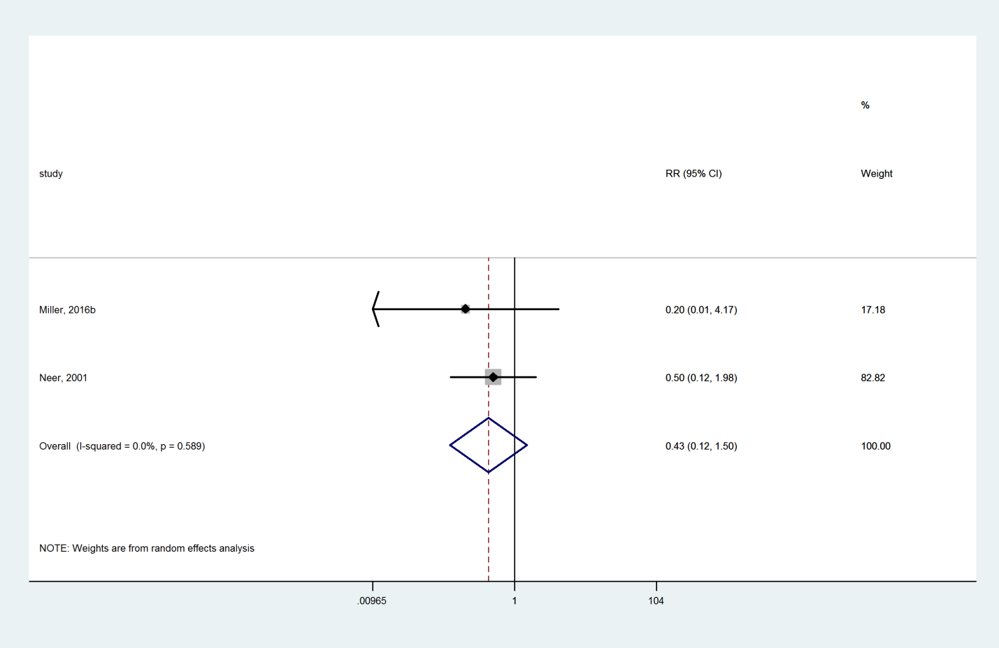

### Denosumab compared with Placebo

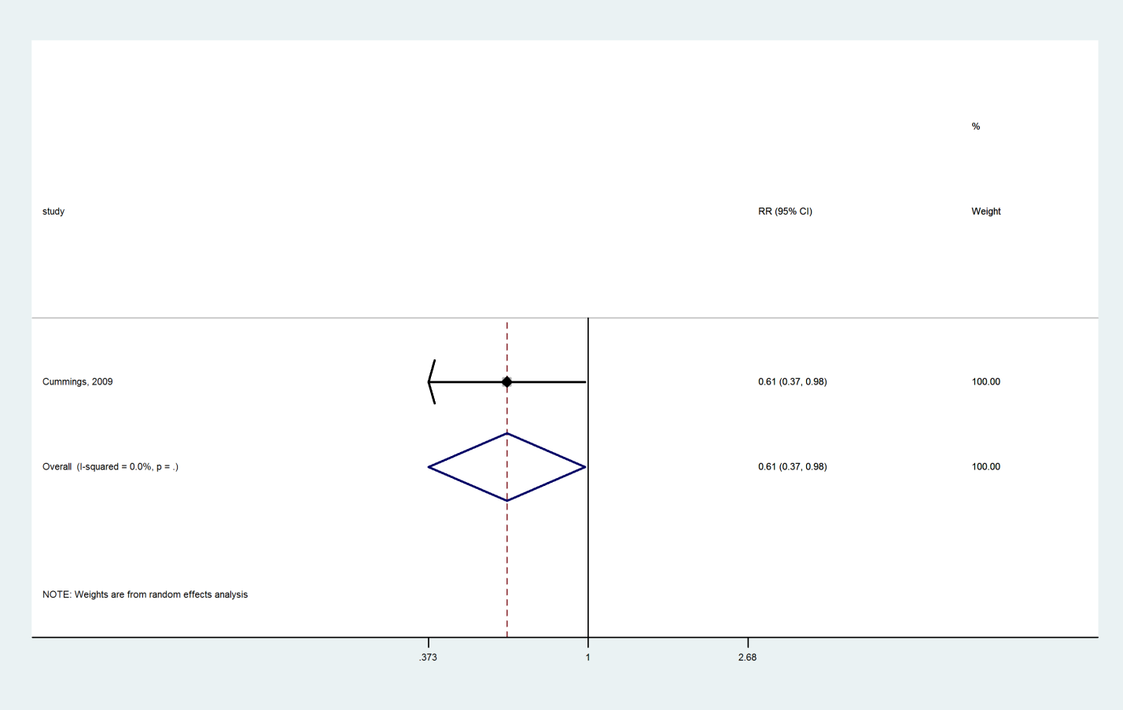

### Raloxifene compared with Placebo

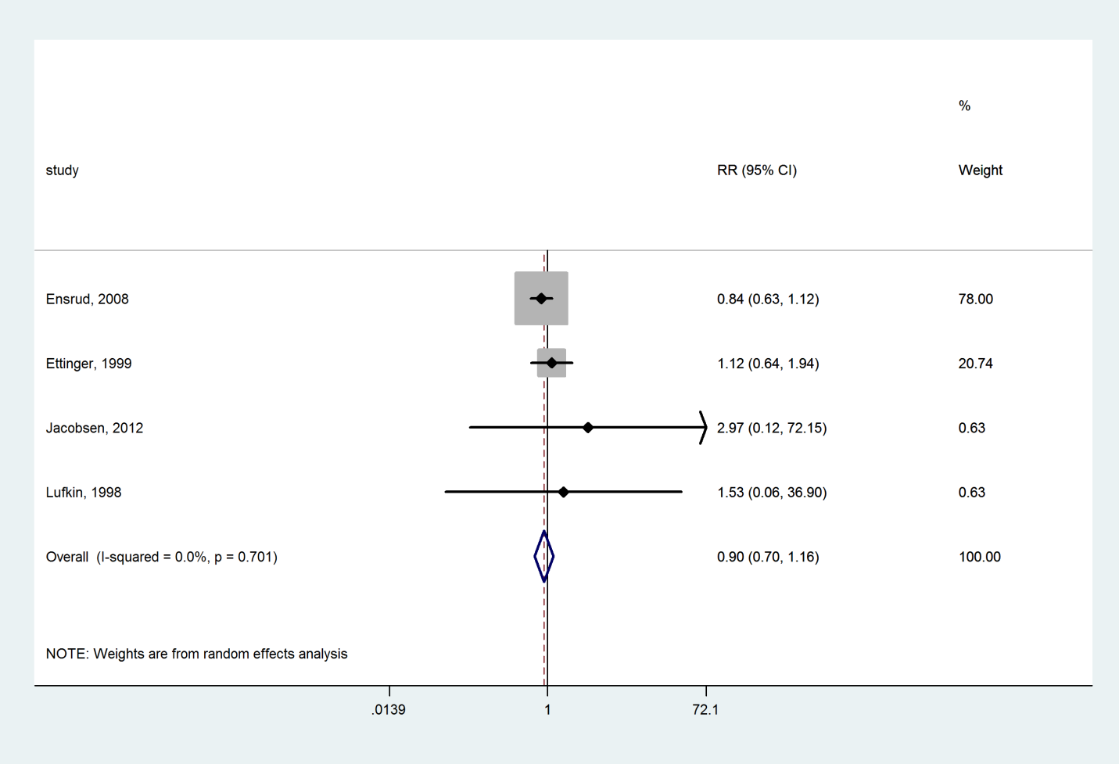

### Zoledronate compared with Placebo

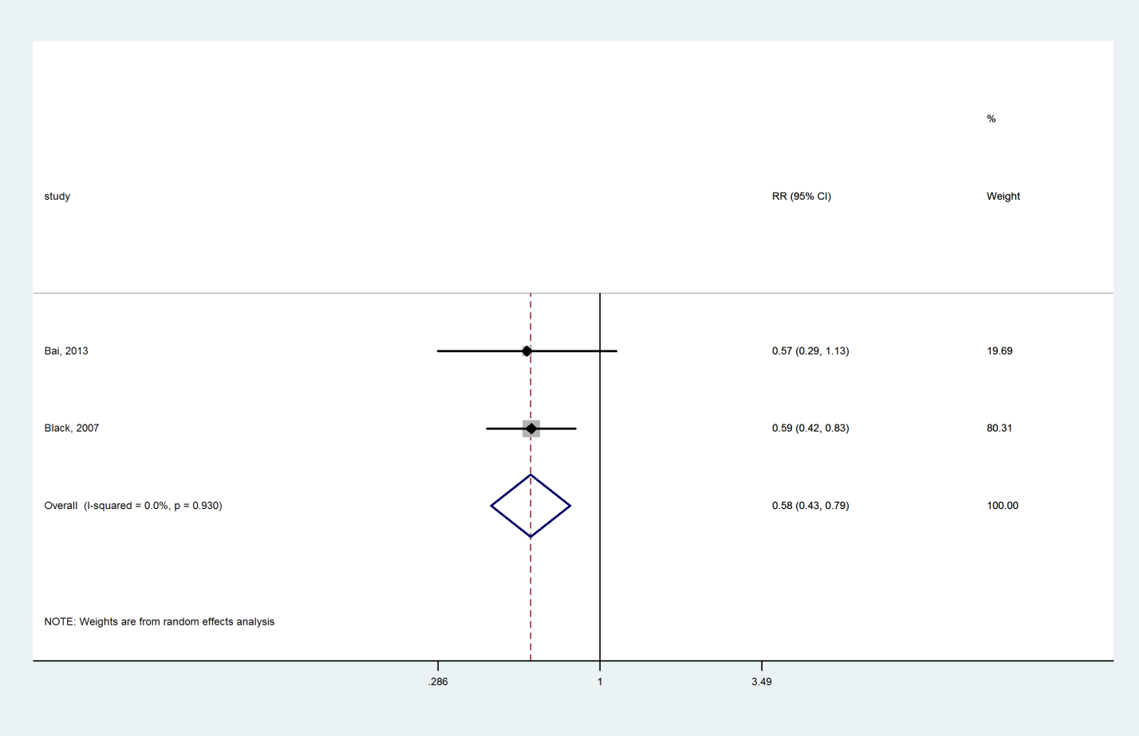

### Risedronate compared with Placebo

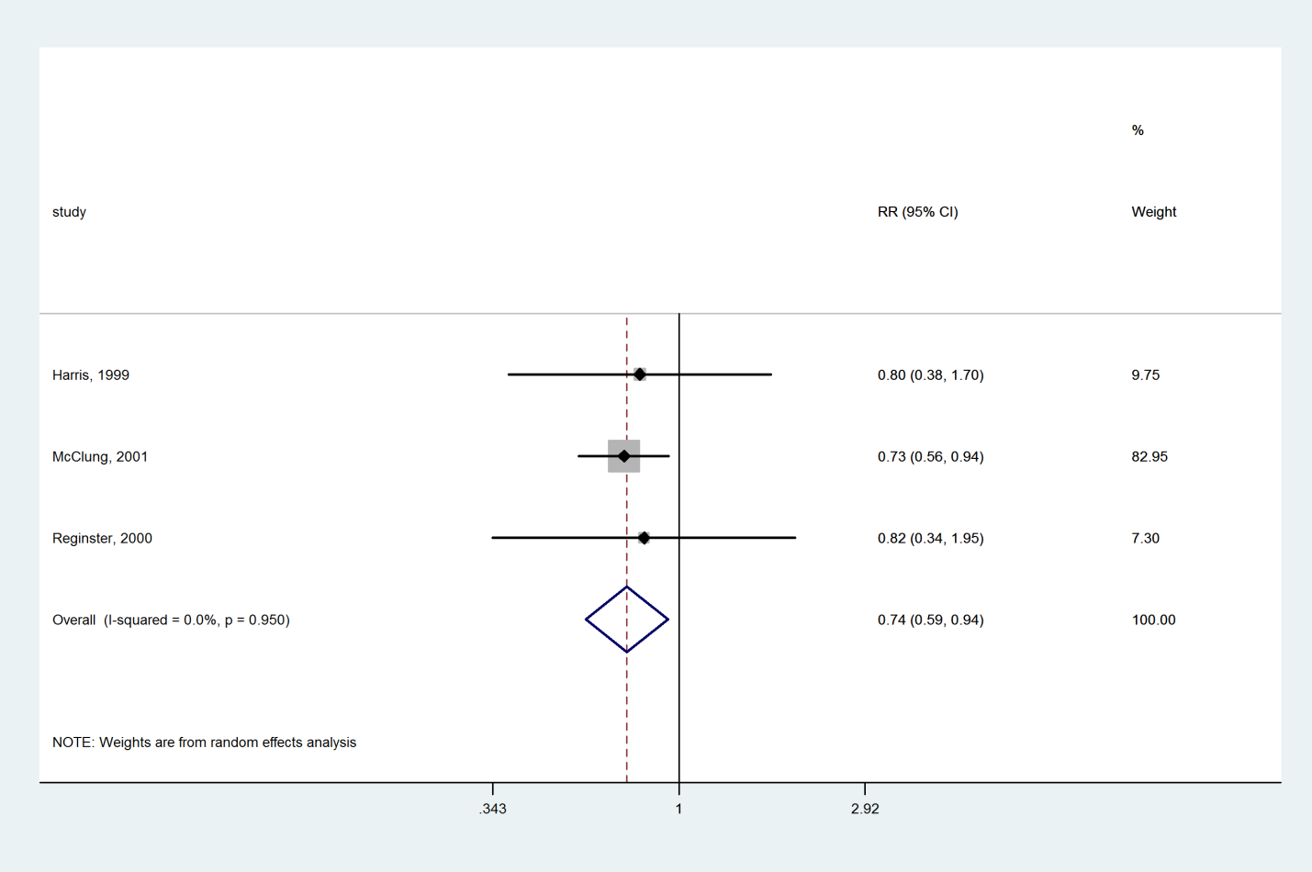

### Ibandronate compared with Placebo

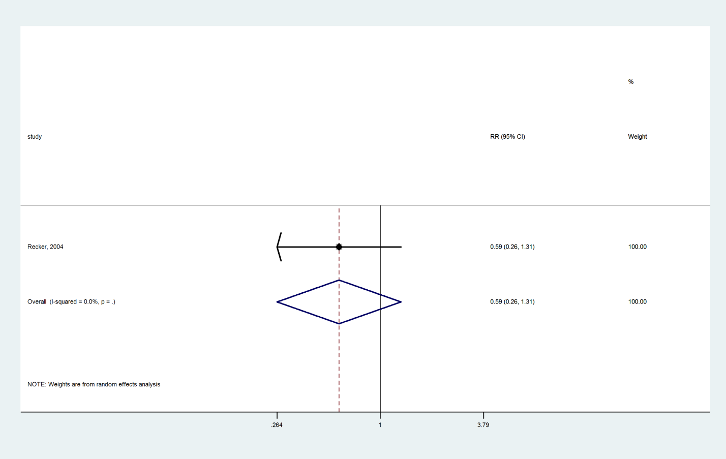

### Alendronate compared with Placebo

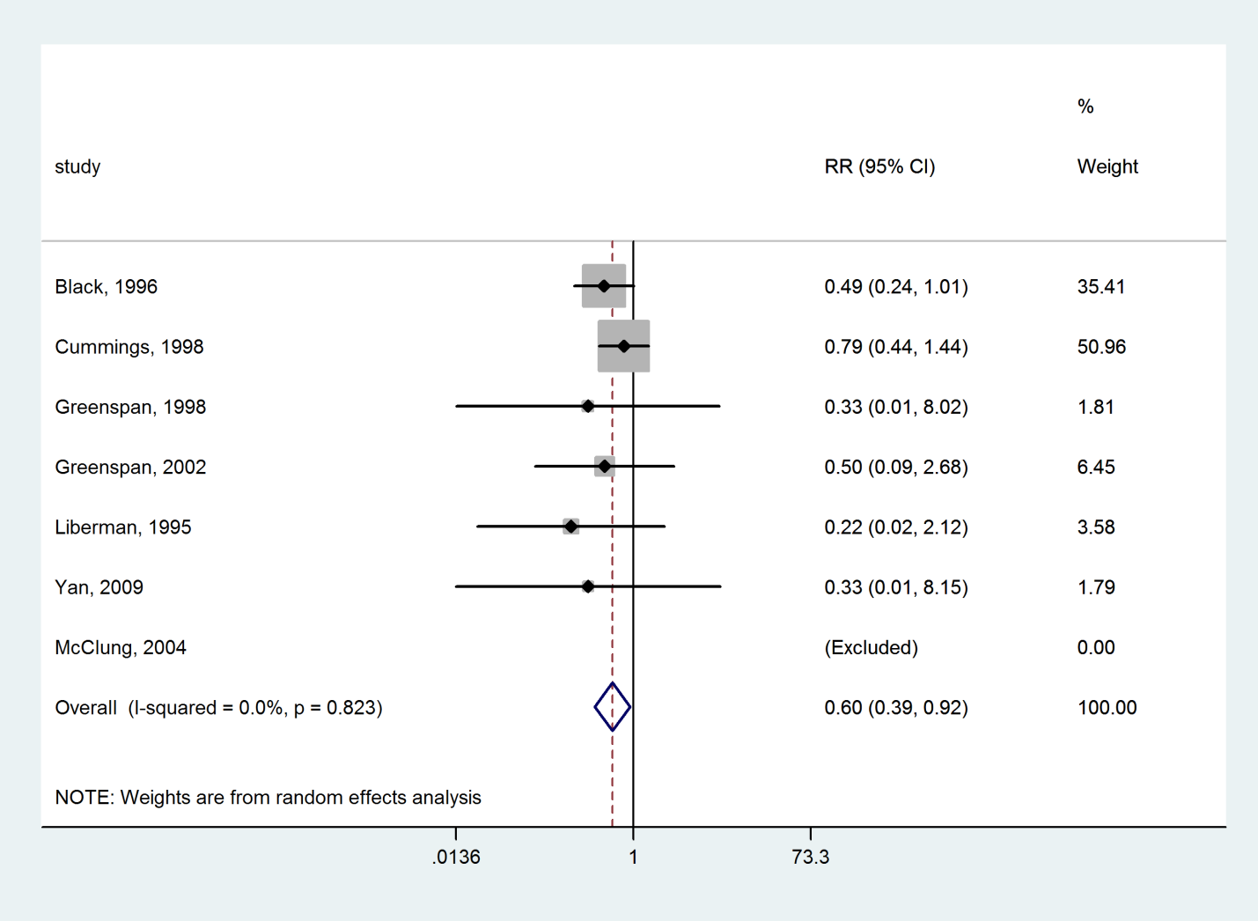

### Vitamin D compared with Placebo

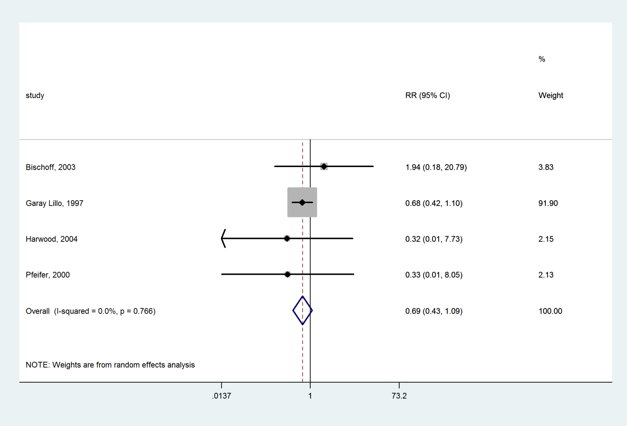

### Vitamin D+Calcium compared with Placebo

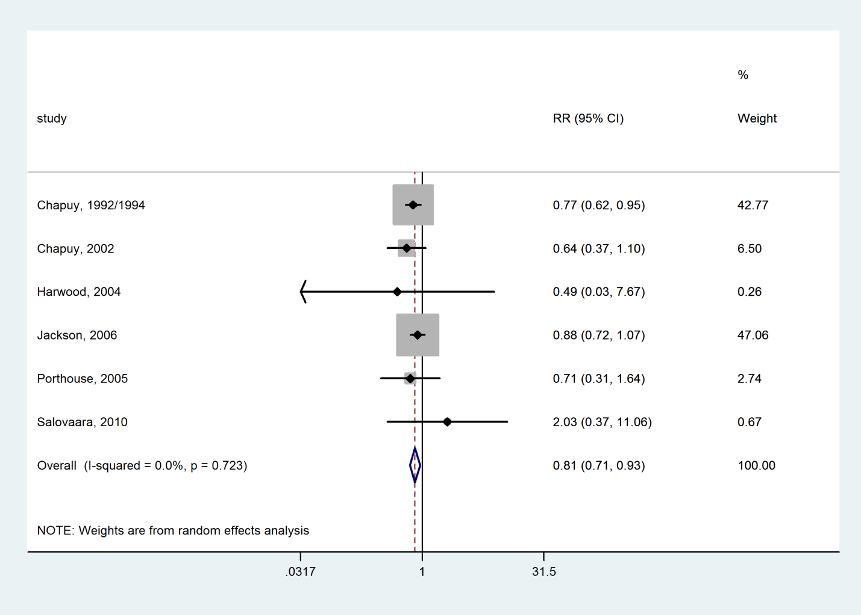

### Calcium compared with Placebo

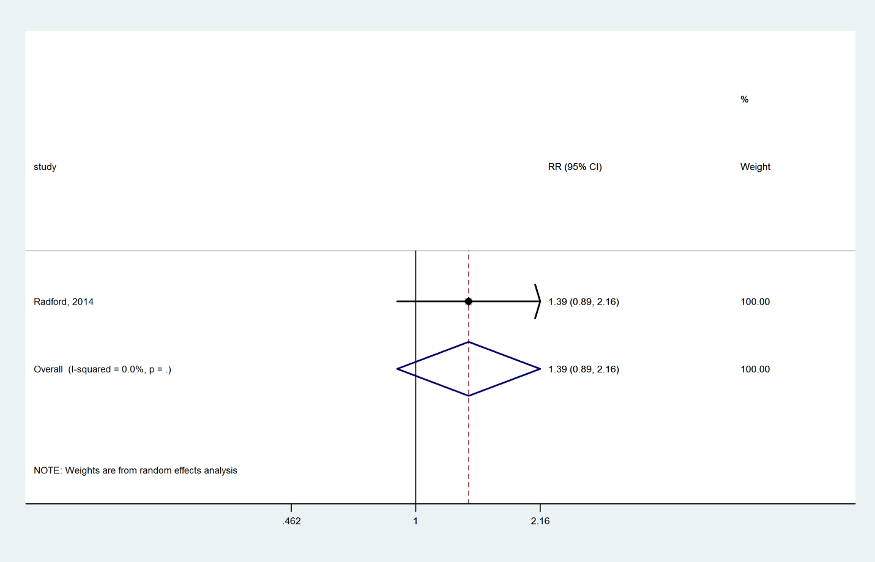

### Bazedoxifene compared with Placebo

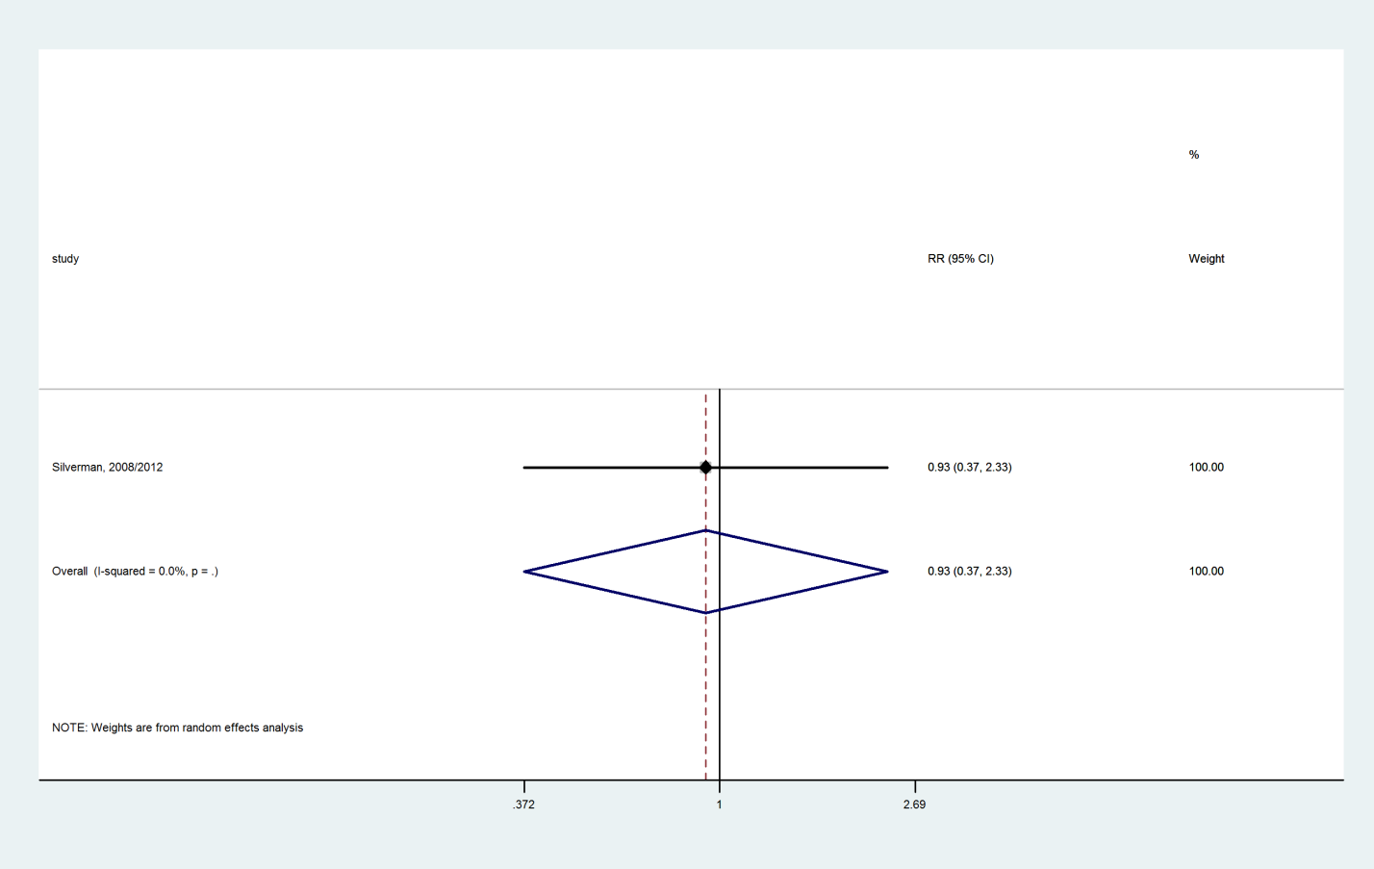

### Hormone therapy compared with Placebo

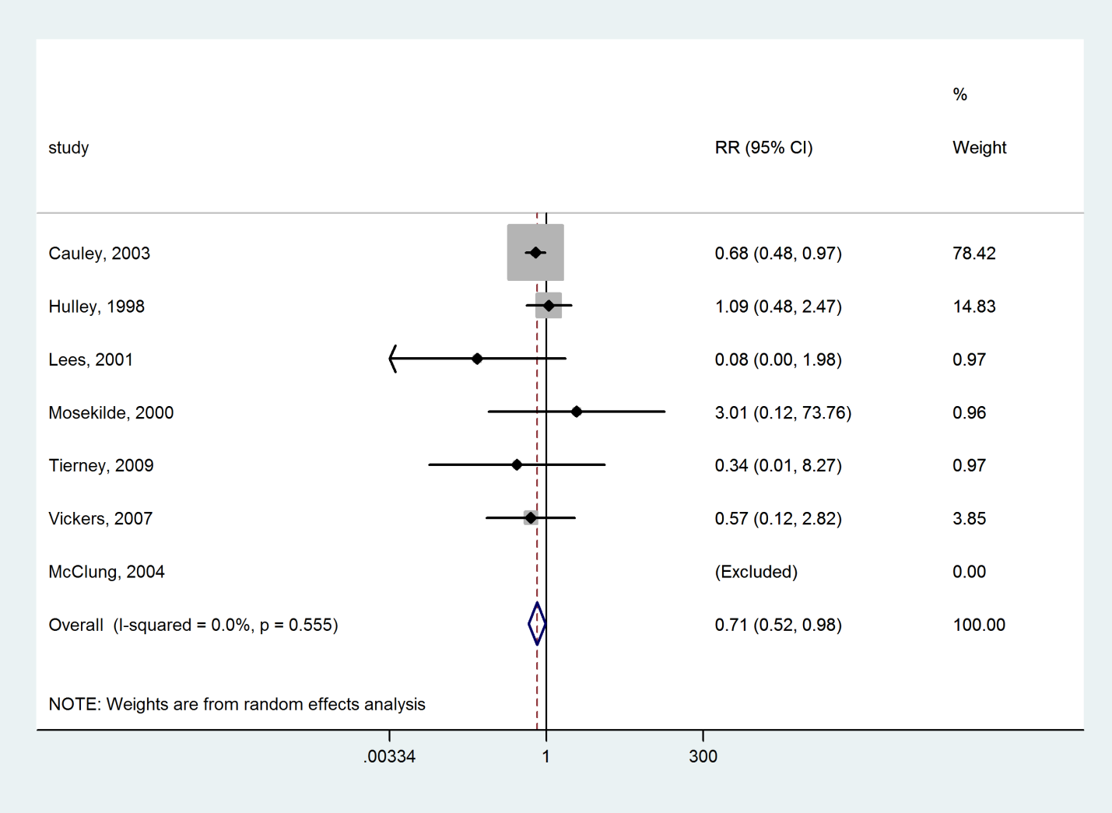

### Tibolone compared with Placebo

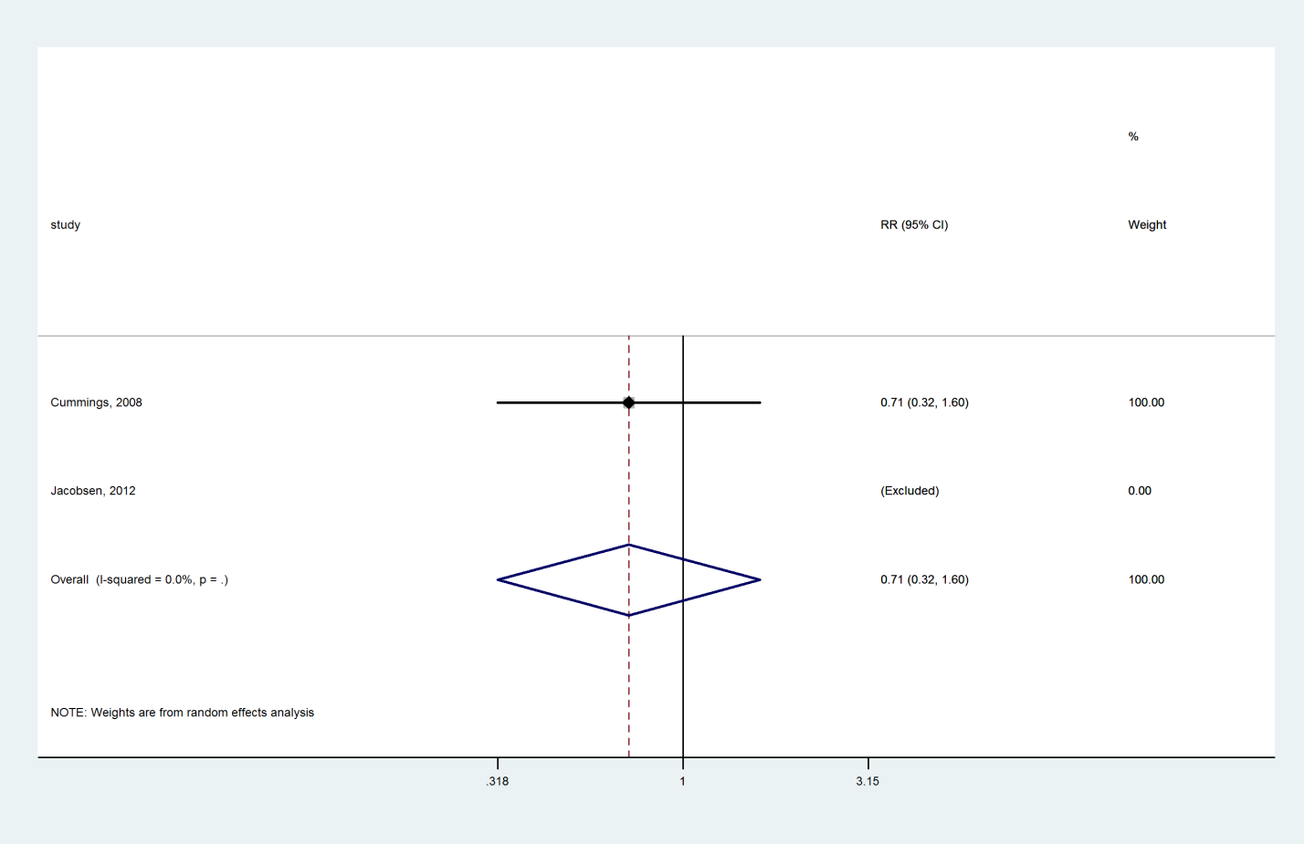

### Strontium ranelate compared with Placebo

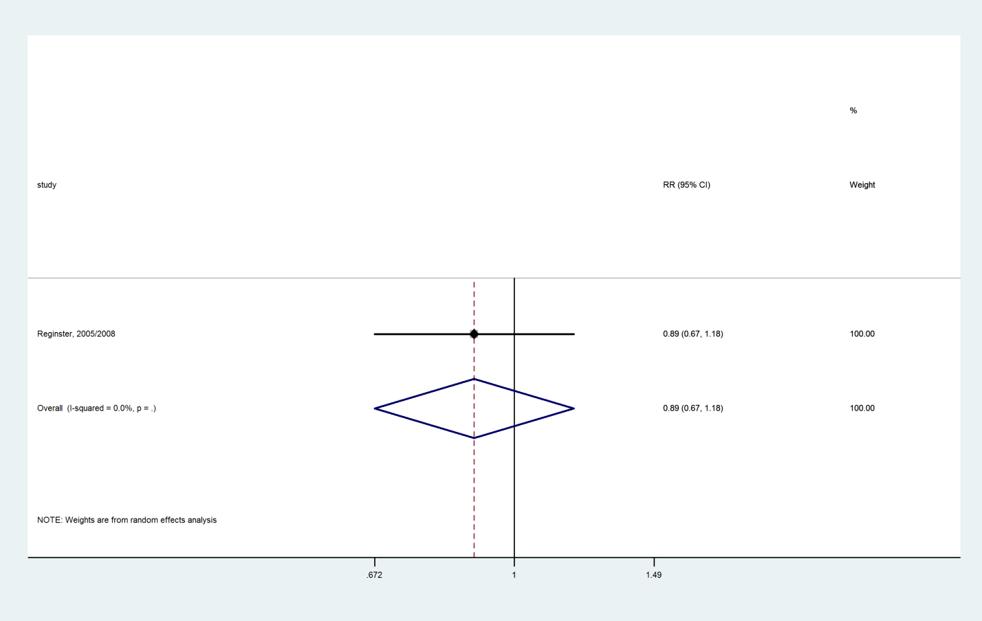

### Lasofoxifene compared with Placebo

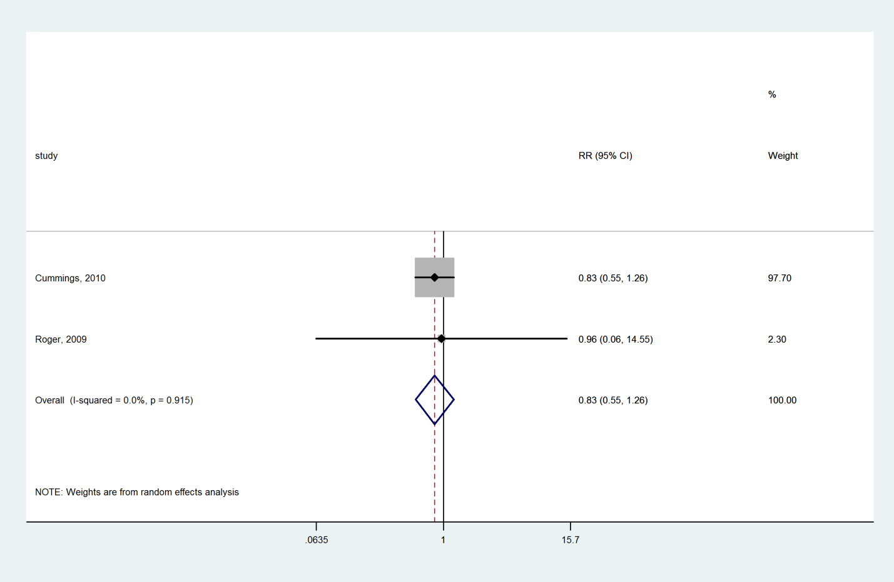

### Calcitonin compared with Placebo

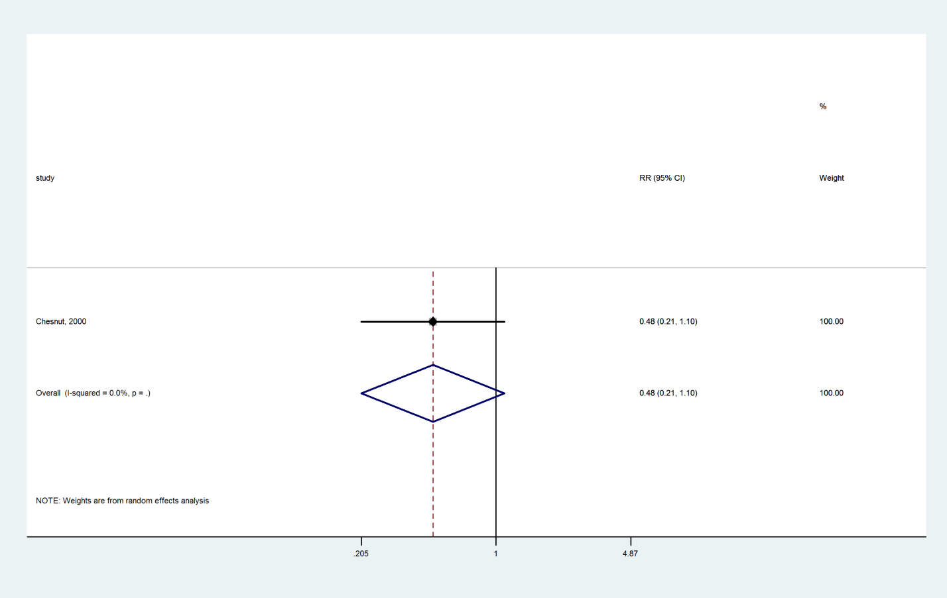

### Romosozumab compared with Placebo

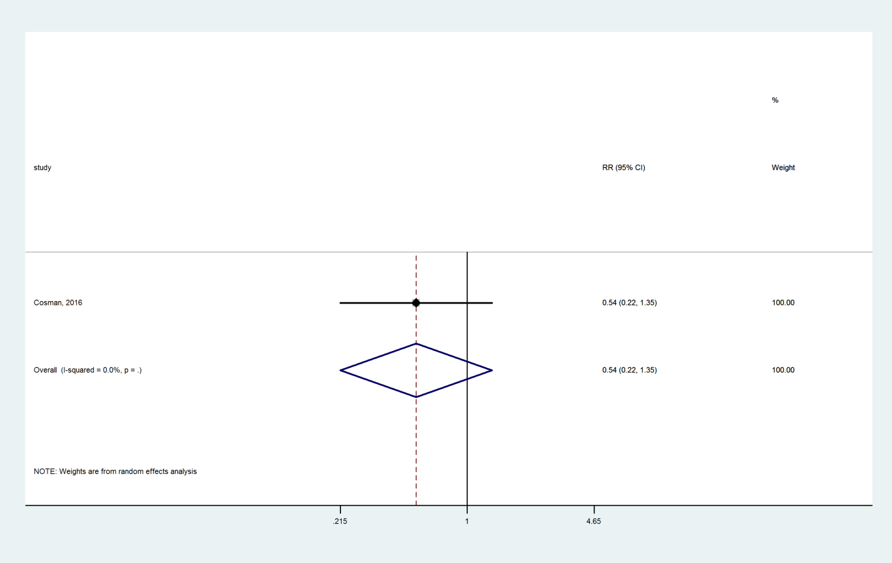

### Abaloparatide compared with Placebo

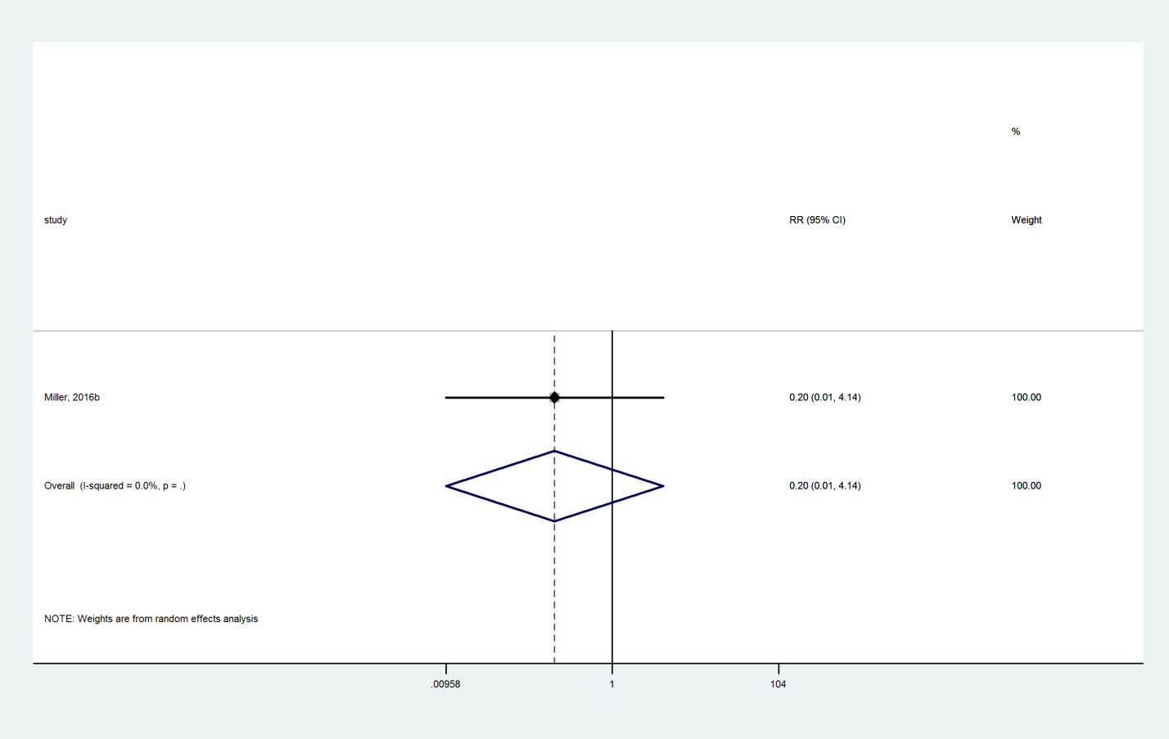

### Zoledronate compared with Teriparatide

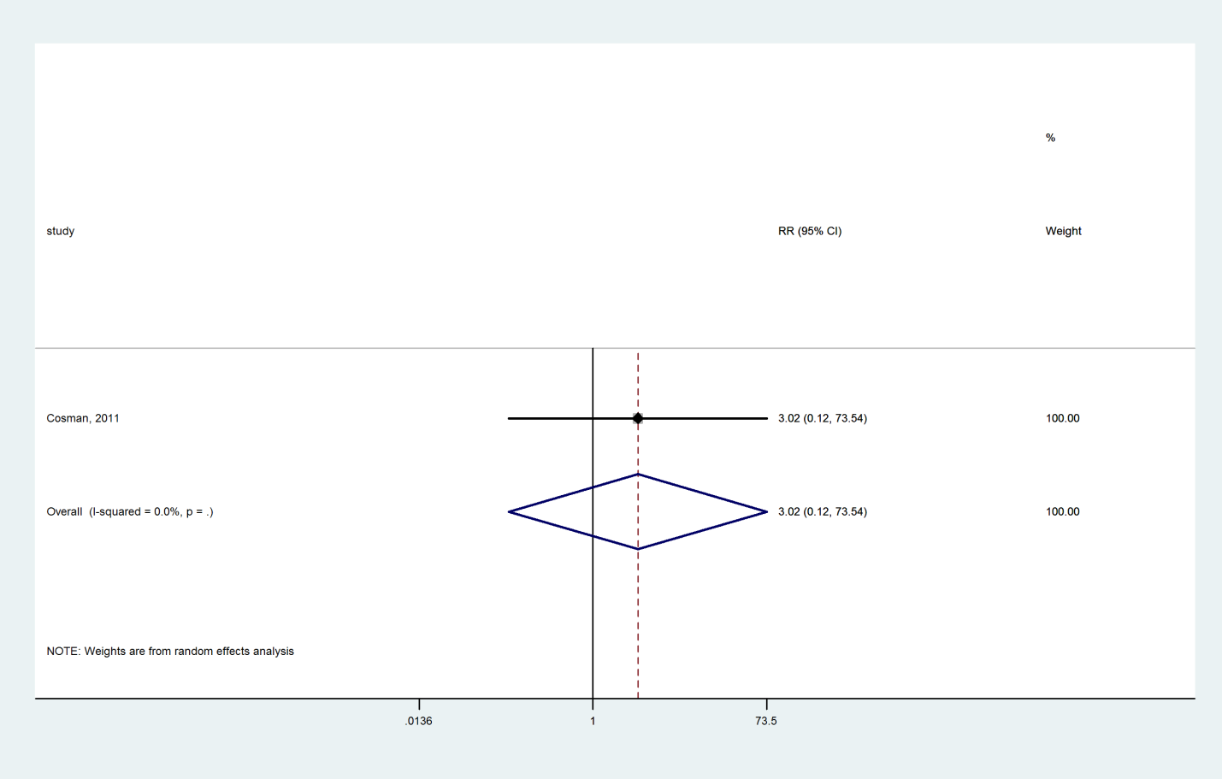

### Risedronate compared with Teriparatide

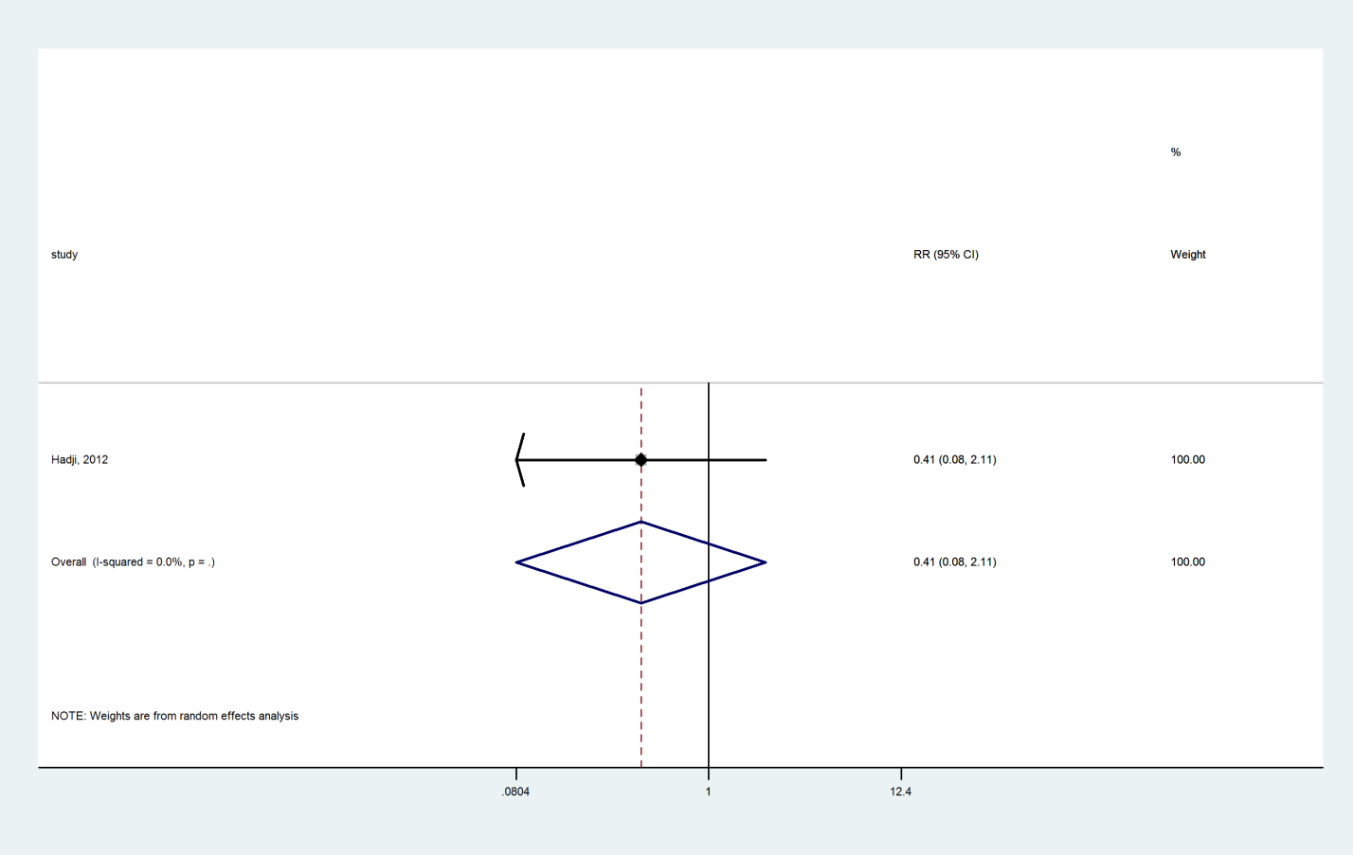

### Ibandronate compared with Denosumab

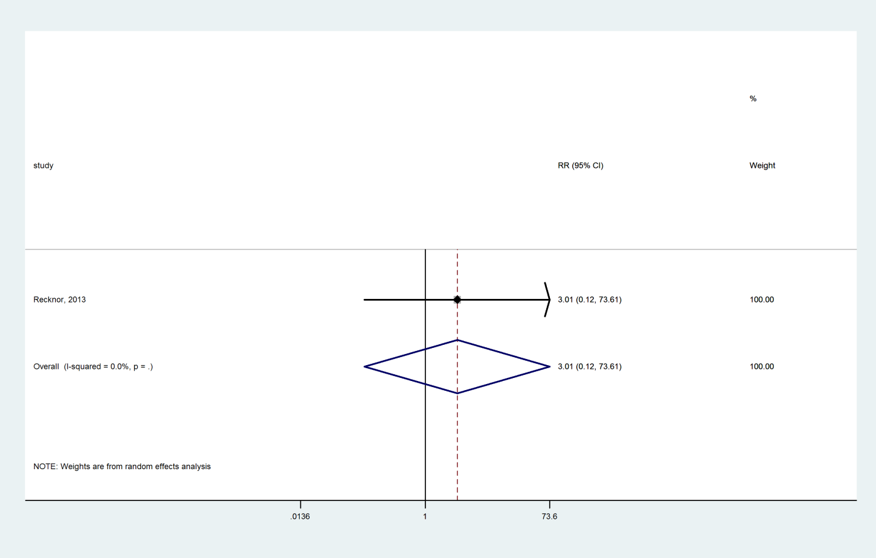

### Alendronate compared with Raloxifene

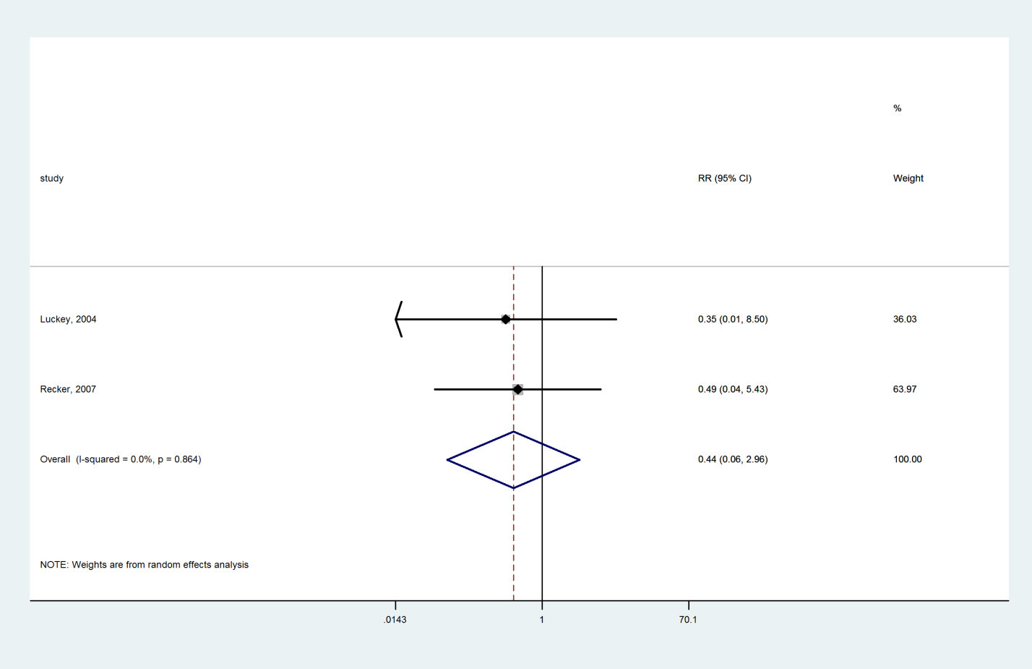

### Tibolone compared with Raloxifene

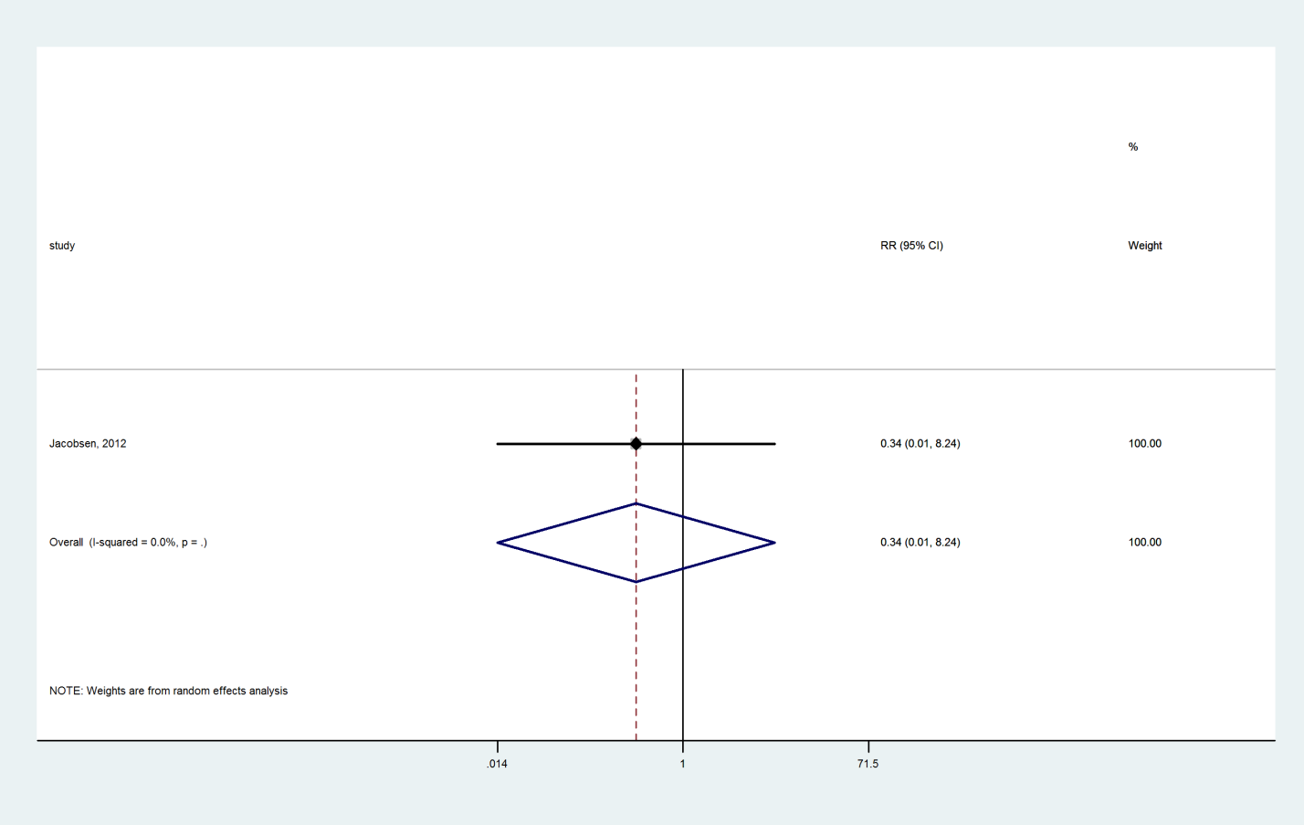

### Vitamin D+Calcium compared with Vitamin D

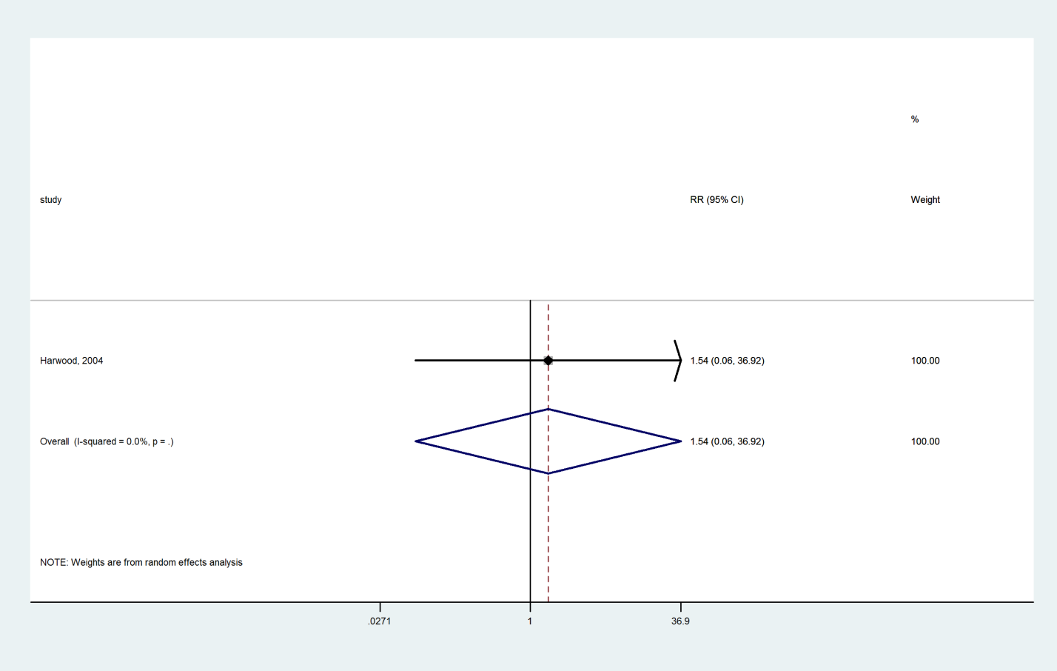

### Calcium compared with Vitamin D+Calcium

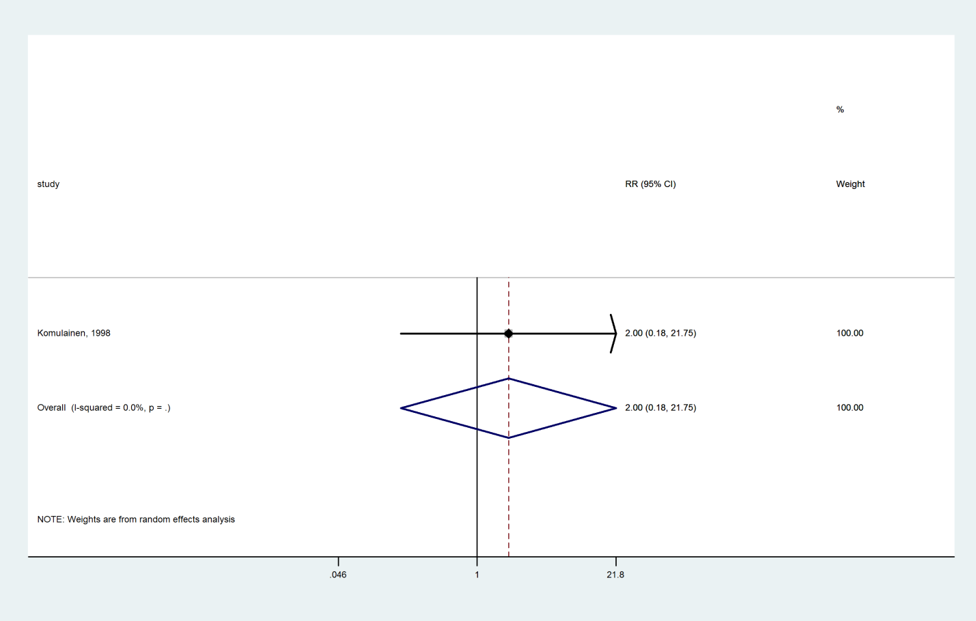

### Hormone therapy compared with Vitamin D+Calcium

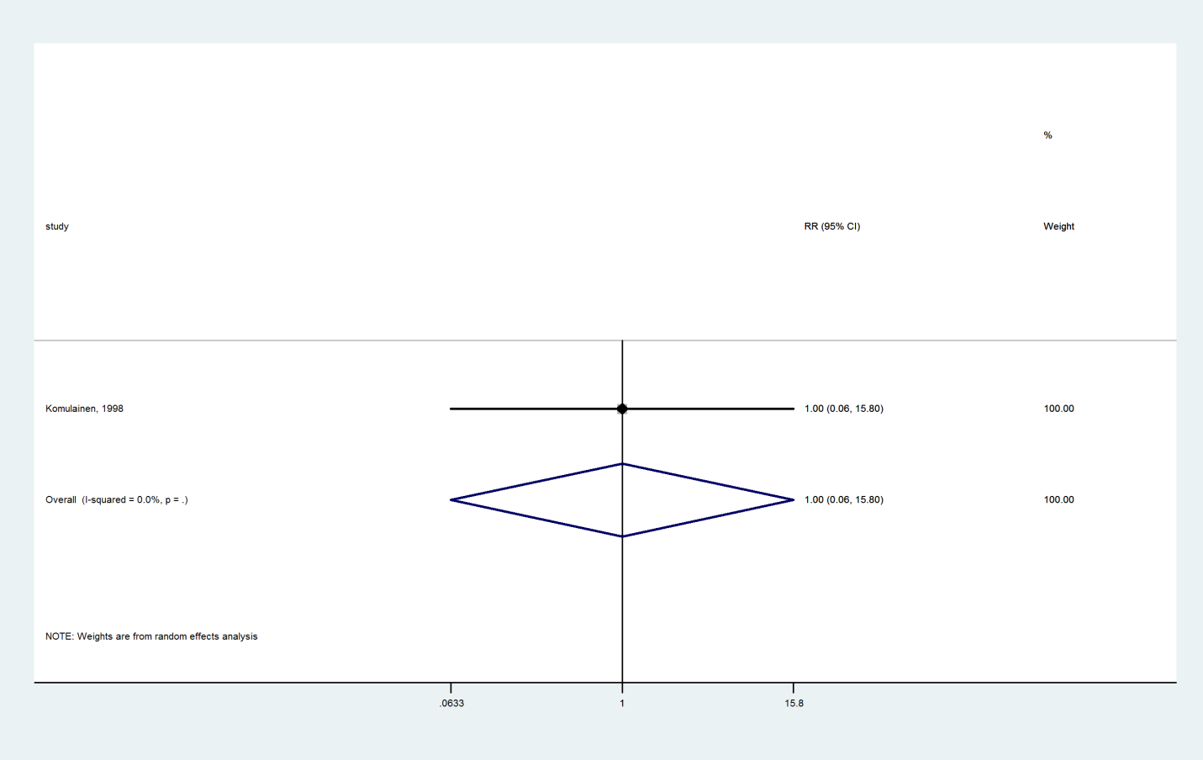

### Hormone therapy compared with Calcium

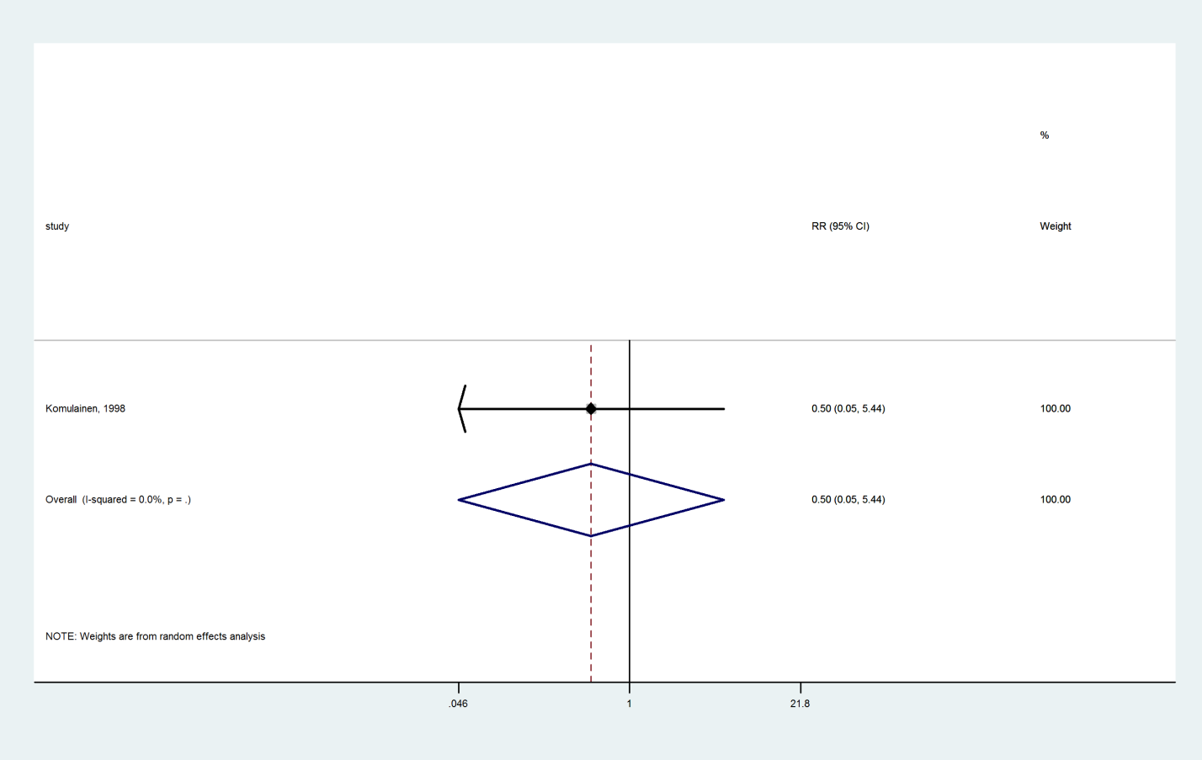

### Romosozumab compared with Alendronate

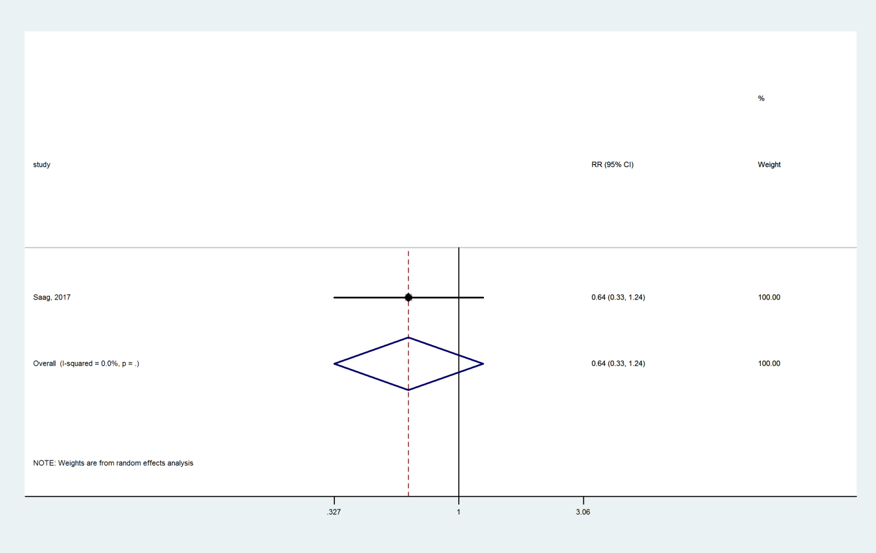

## Nonvertebral Fracture

### Teriparatide compared with Placebo

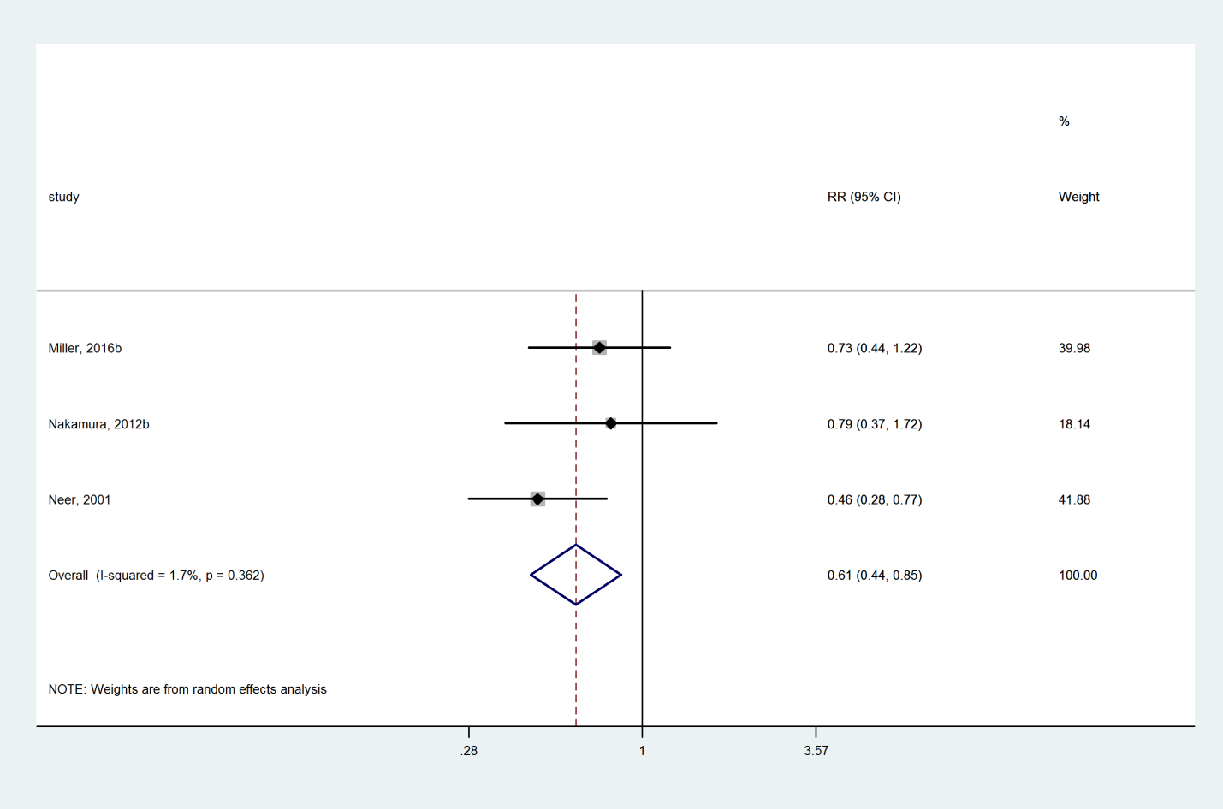

### Denosumab compared with Placebo

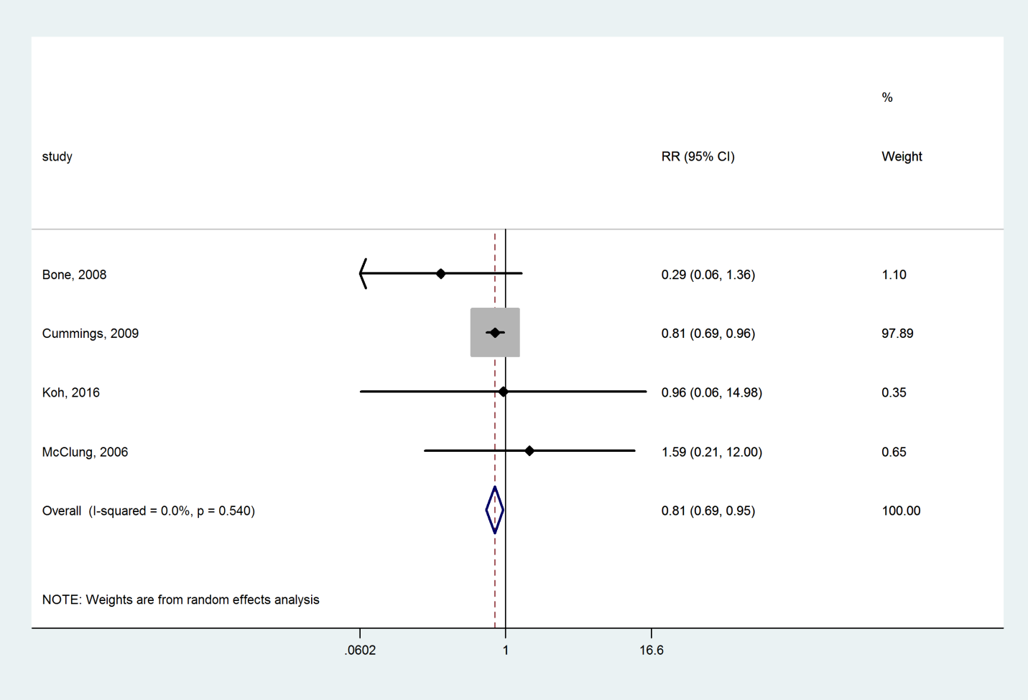

### Raloxifene compared with Placebo

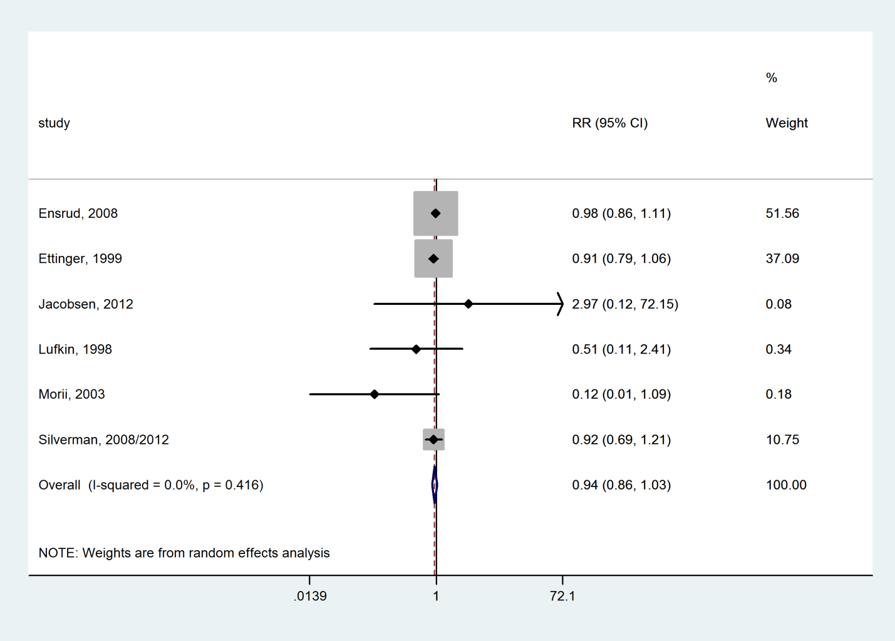

### Zoledronate compared with Placebo

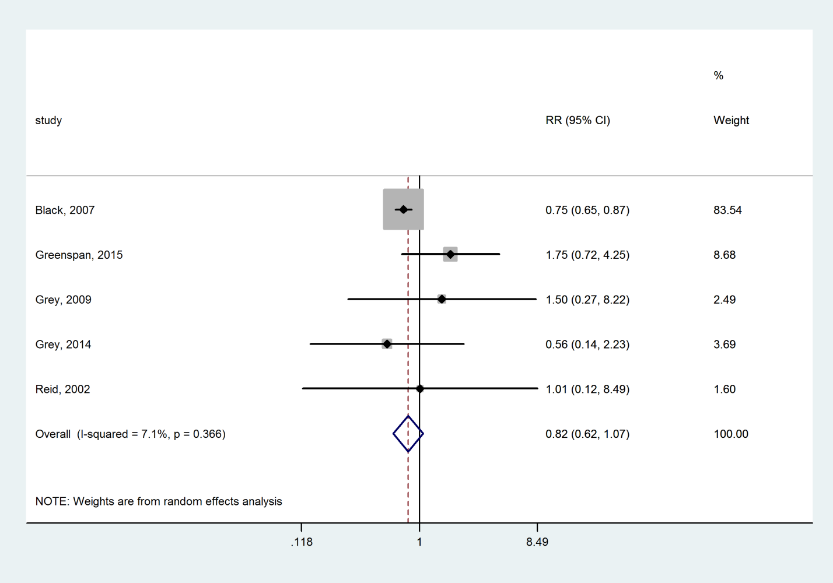

### Risedronate compared with Placebo

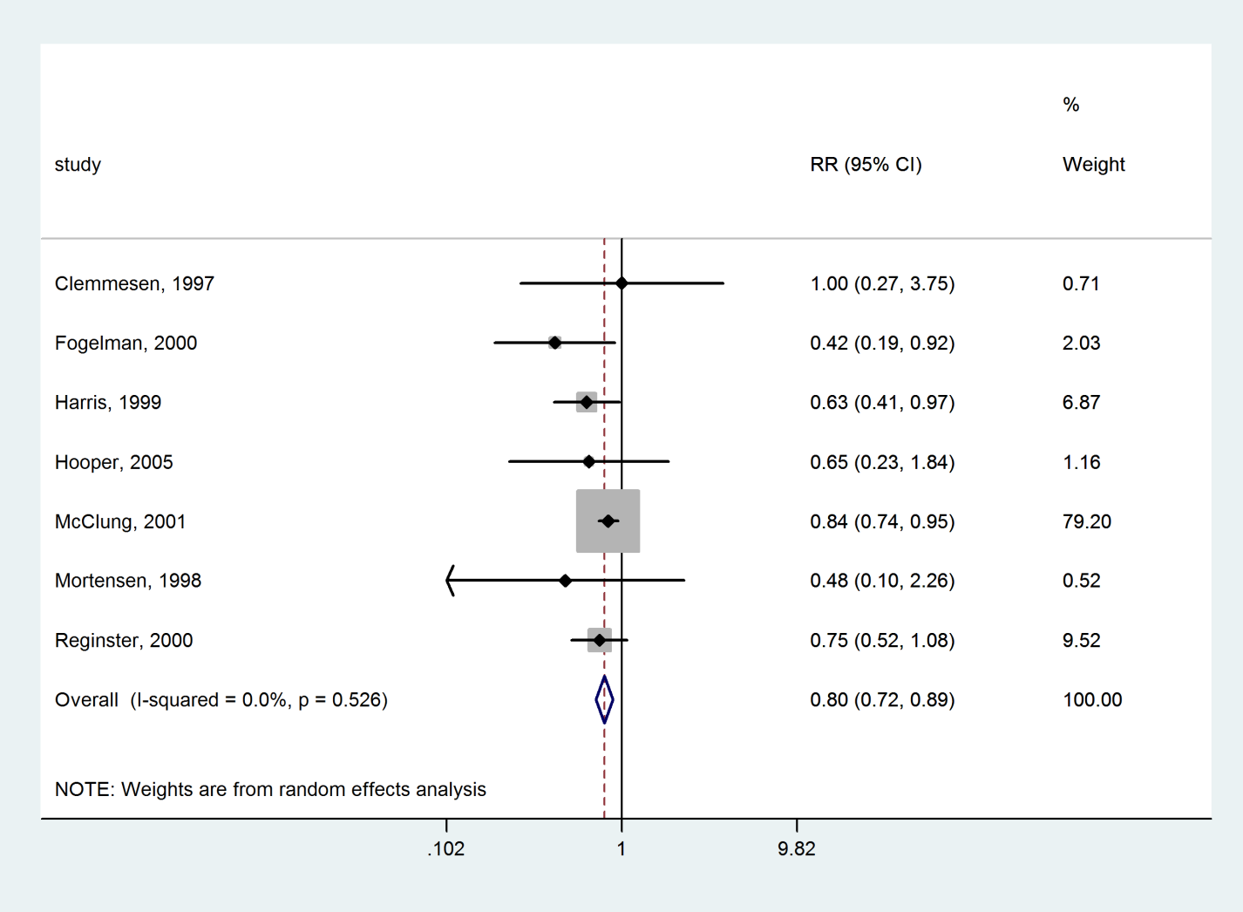

### Ibandronate compared with Placebo

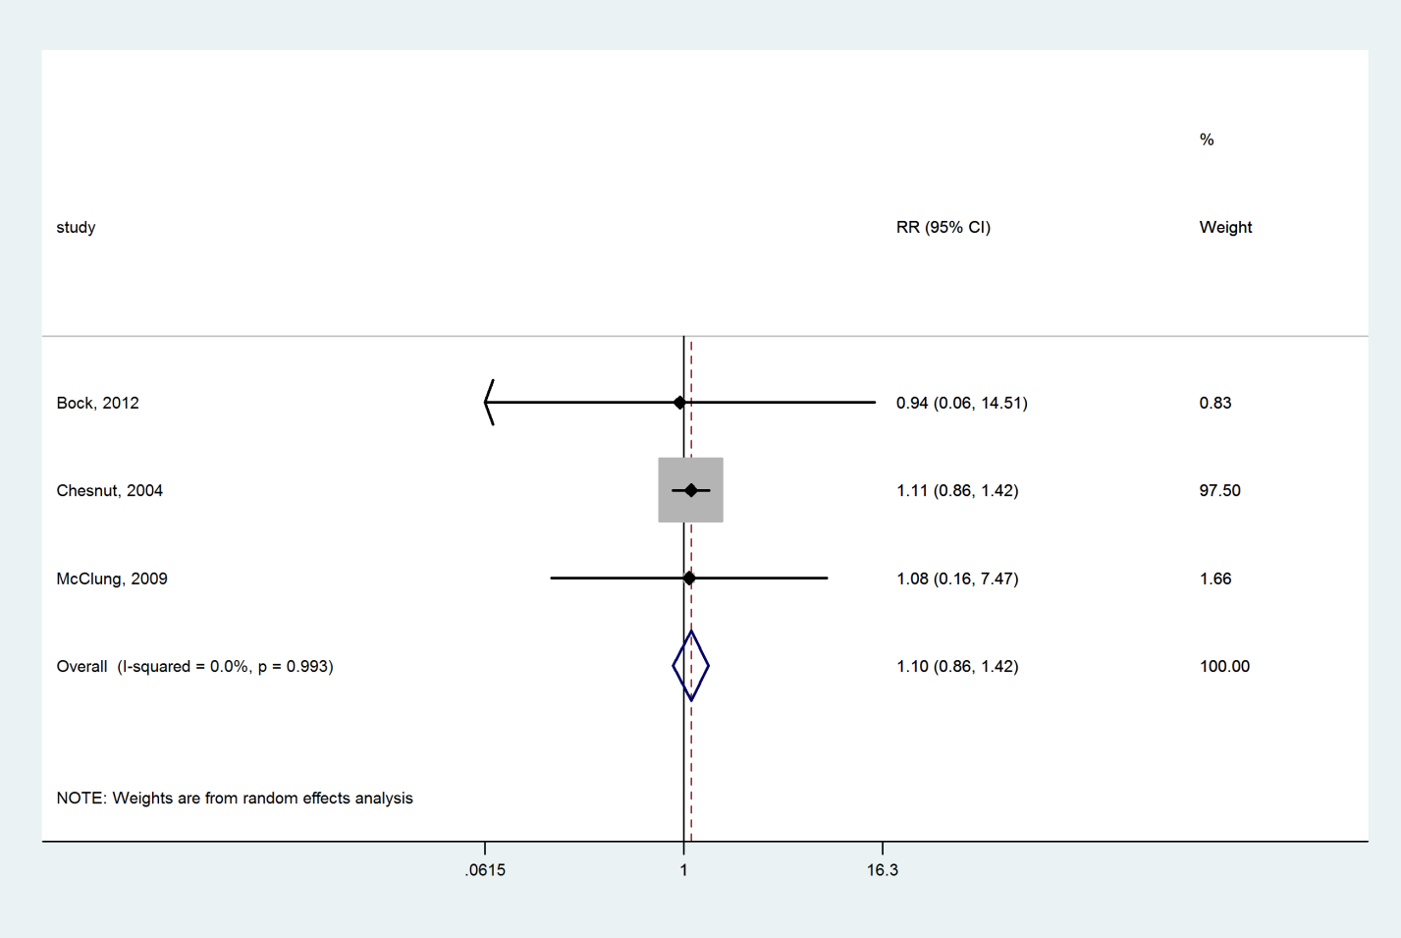

### Alendronate compared with Placebo

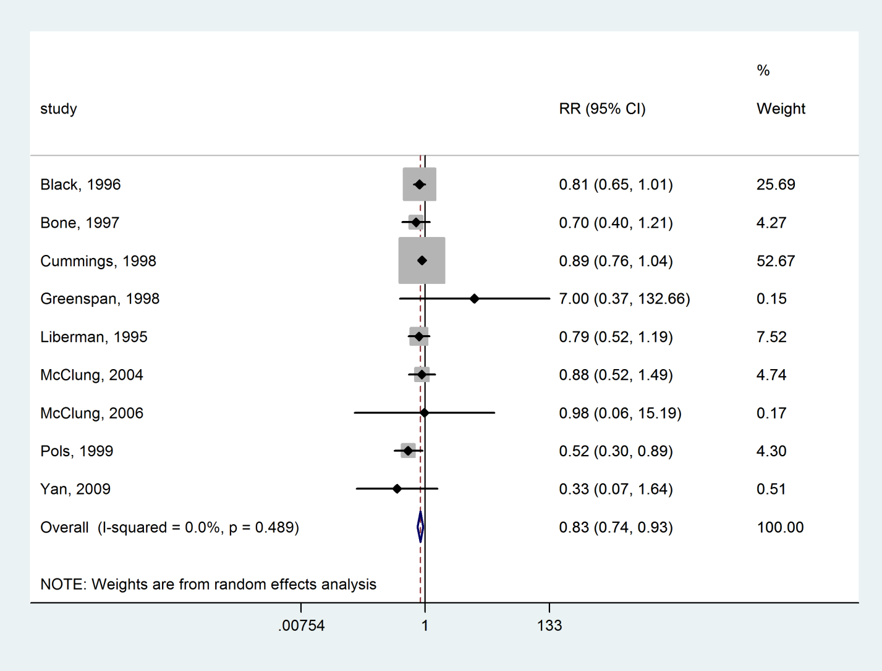

### Strontium ranelate compared with Placebo

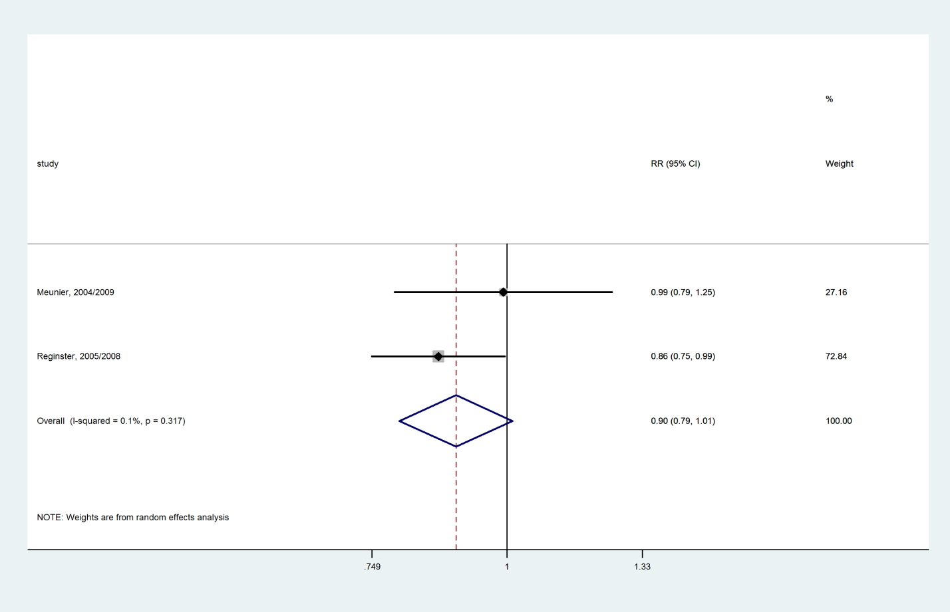

### Vitamin D+Calcium compared with Placebo

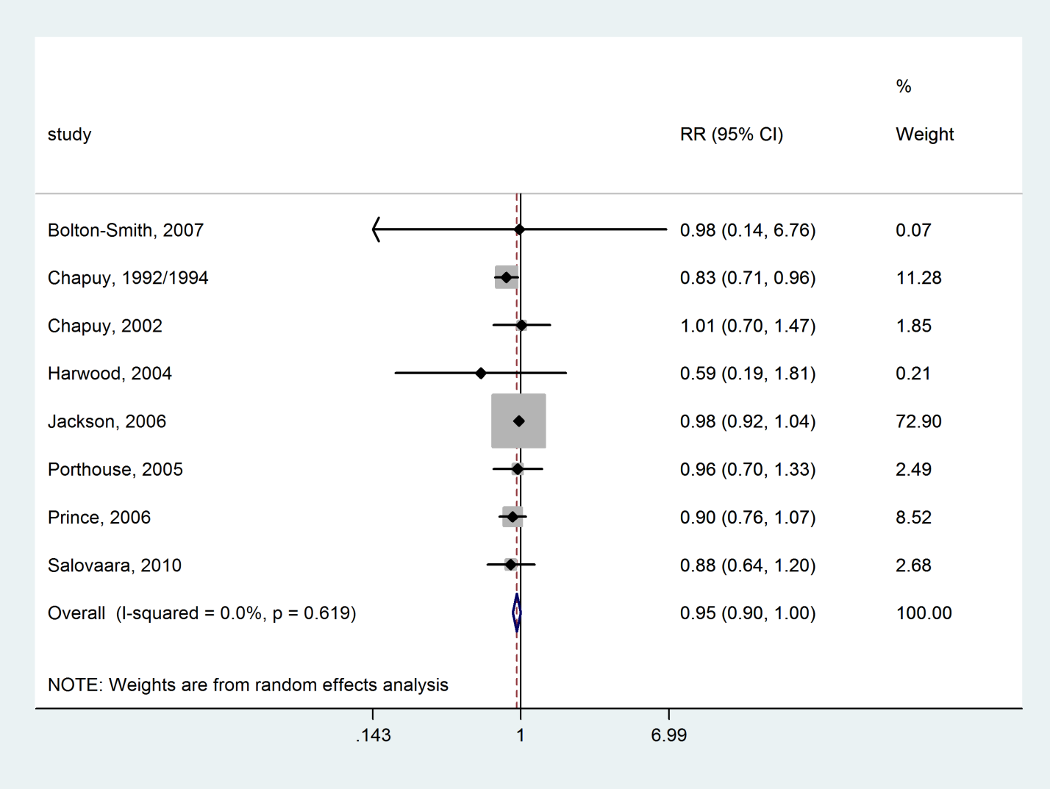

### Bazedoxifene compared with Placebo

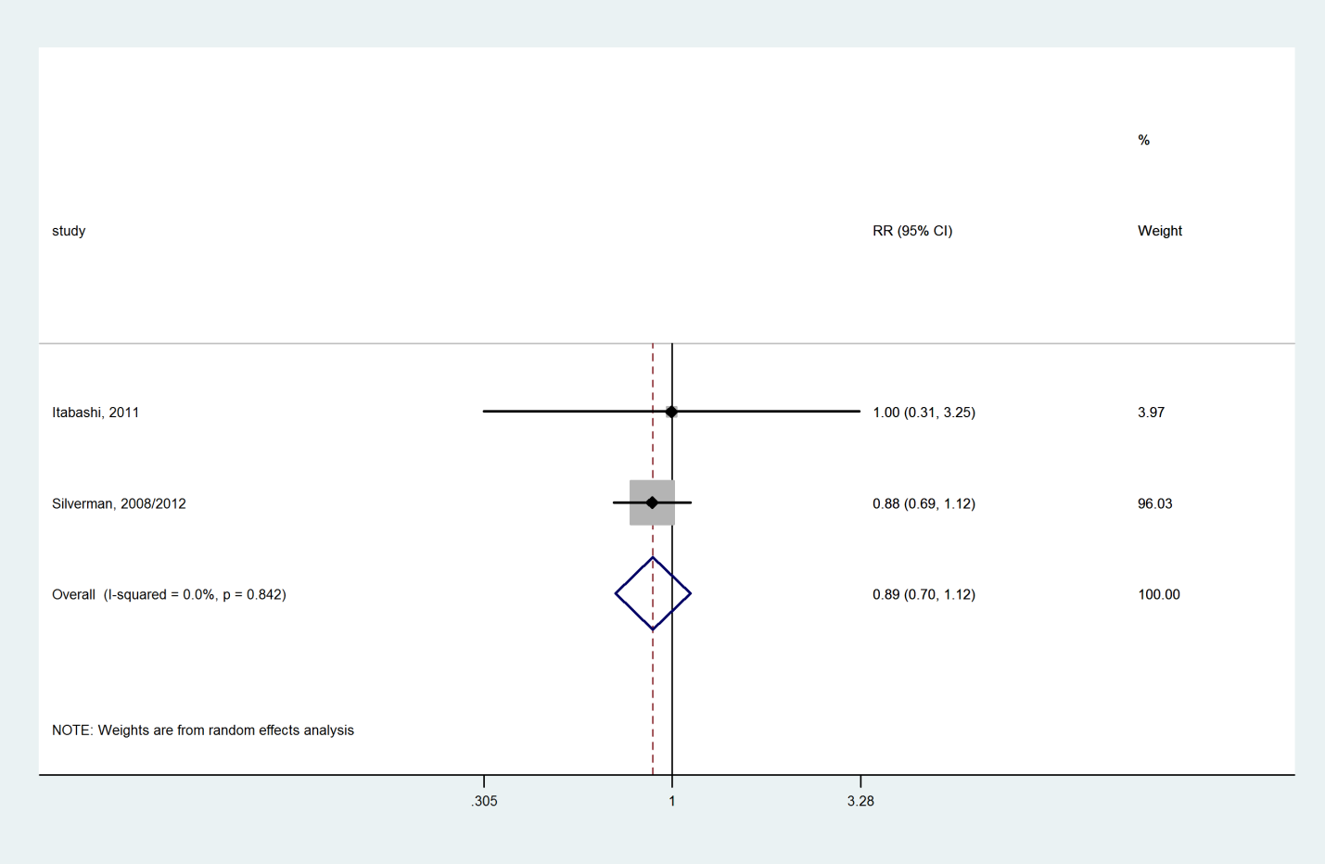

### Tibolone compared with Placebo

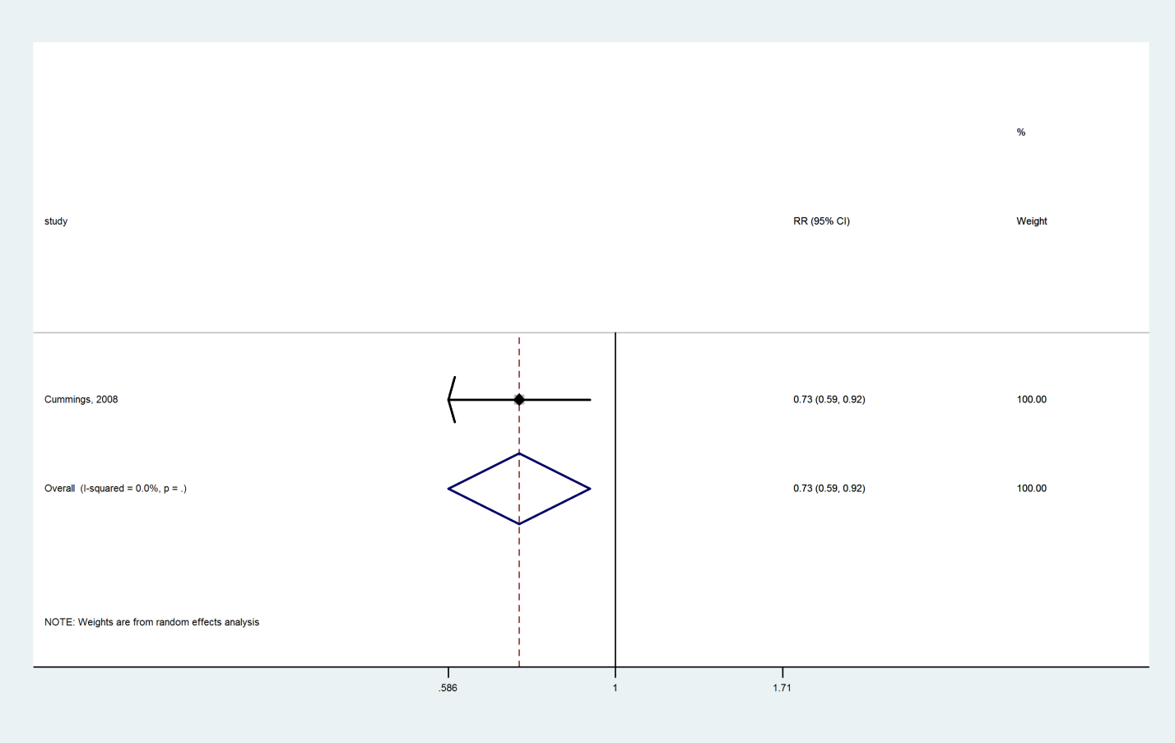

### Hormone therapy compared with Placebo



### Calcitonin compared with Placebo

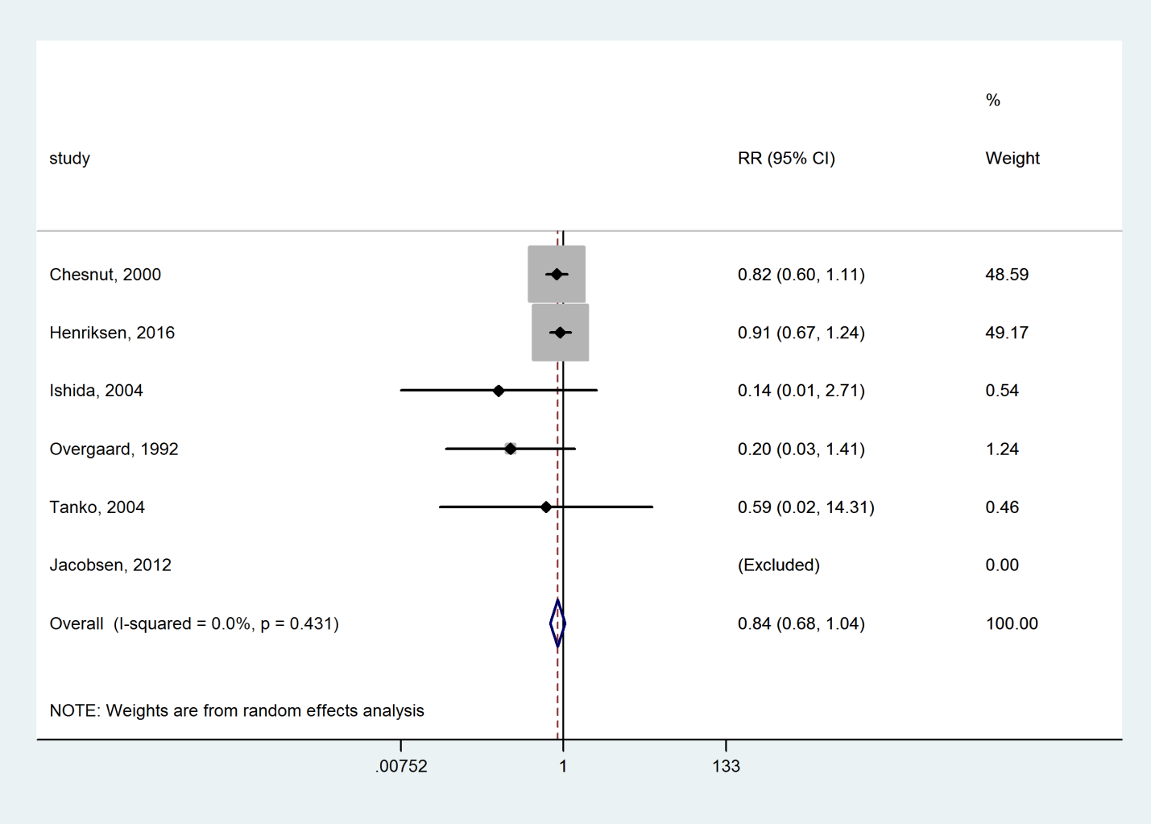

### Lasofoxifene compared with Placebo

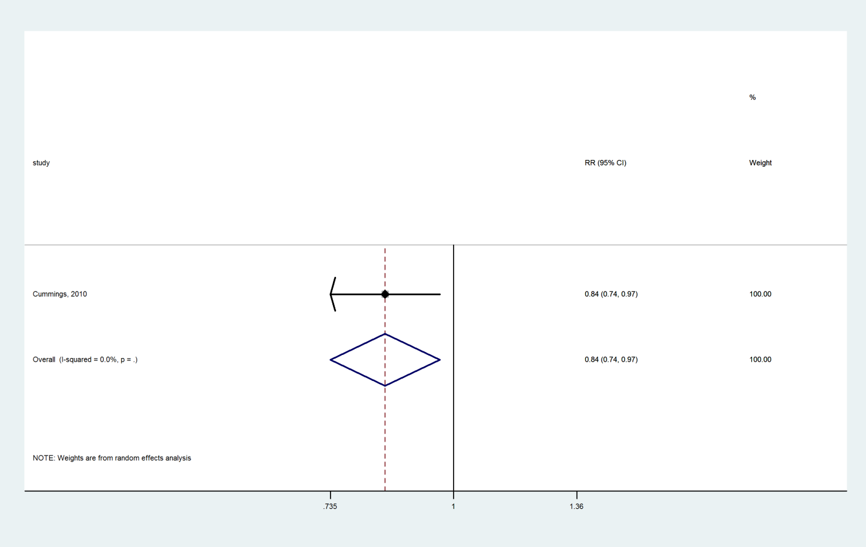

### Vitamin D compared with Placebo

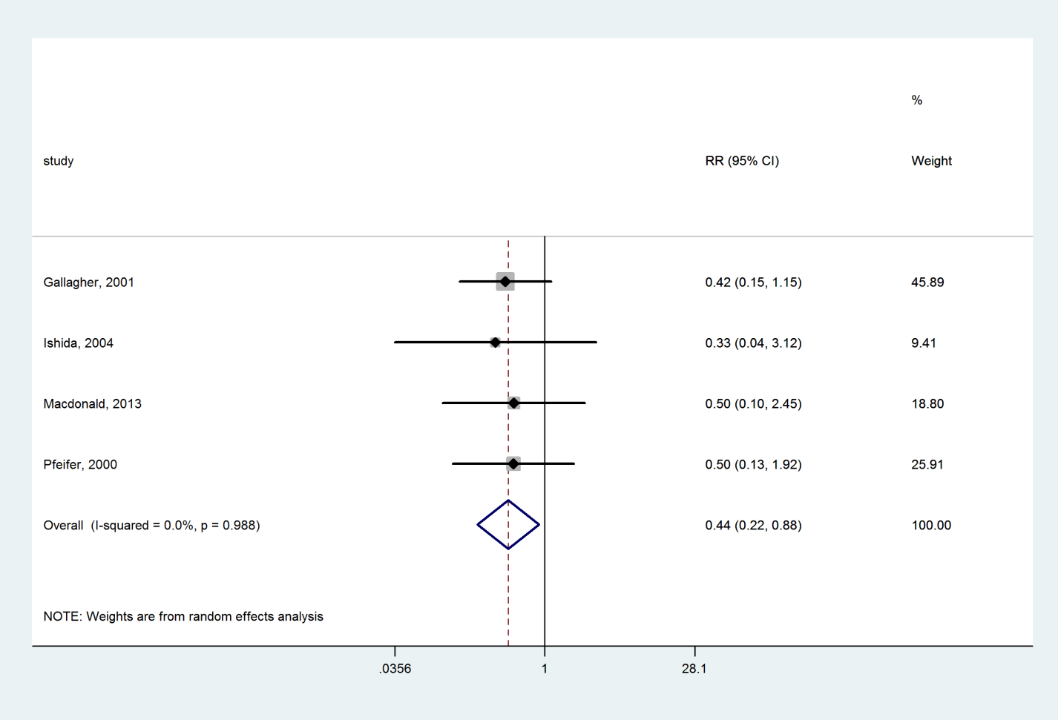

### Calcium compared with Placebo

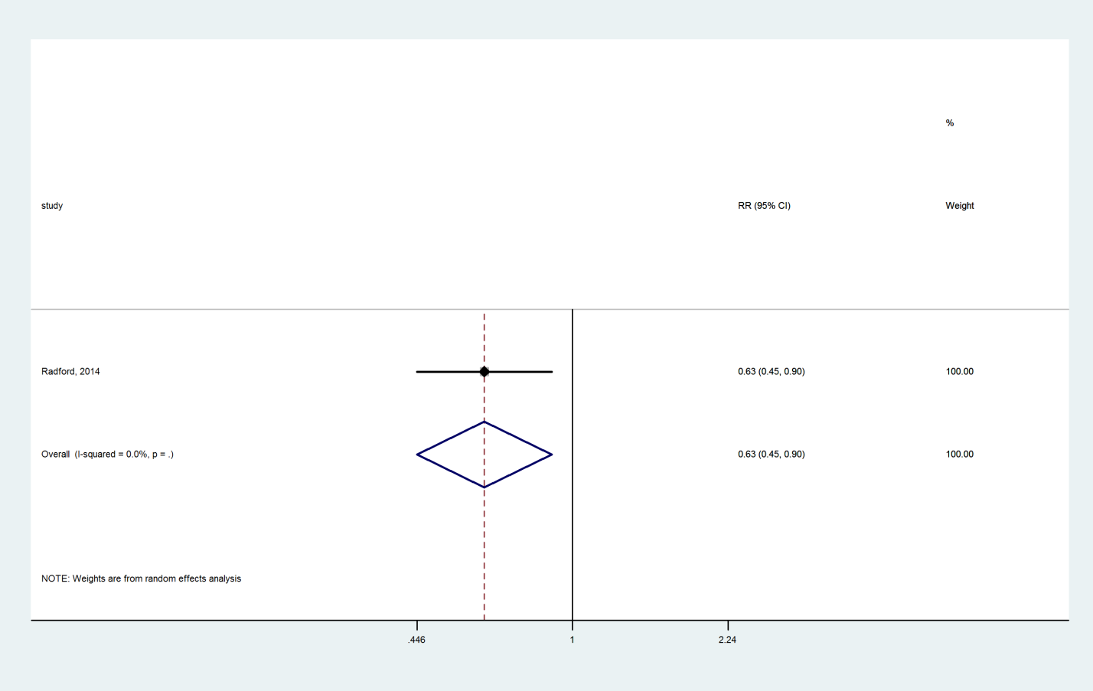

### PTH 1-84 compared with Placebo

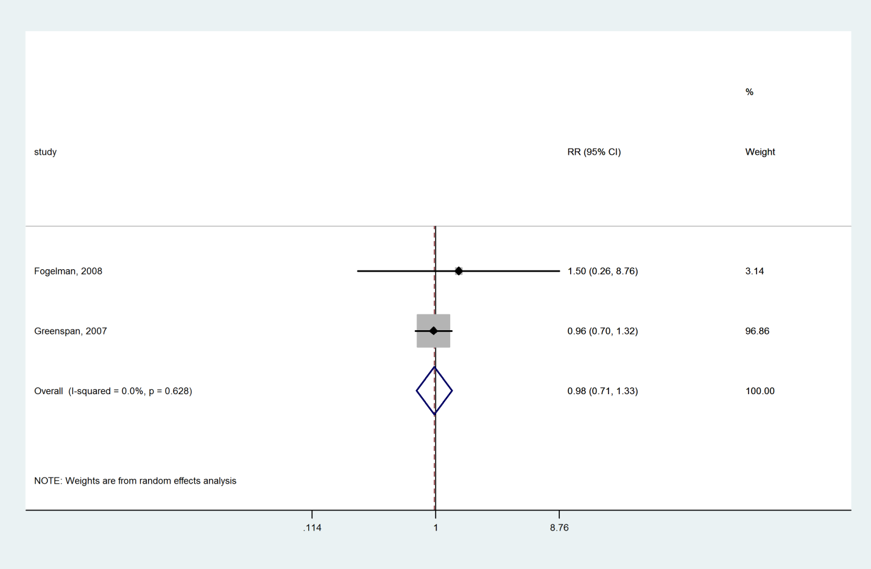

1. **Romosozumab compared with Placebo**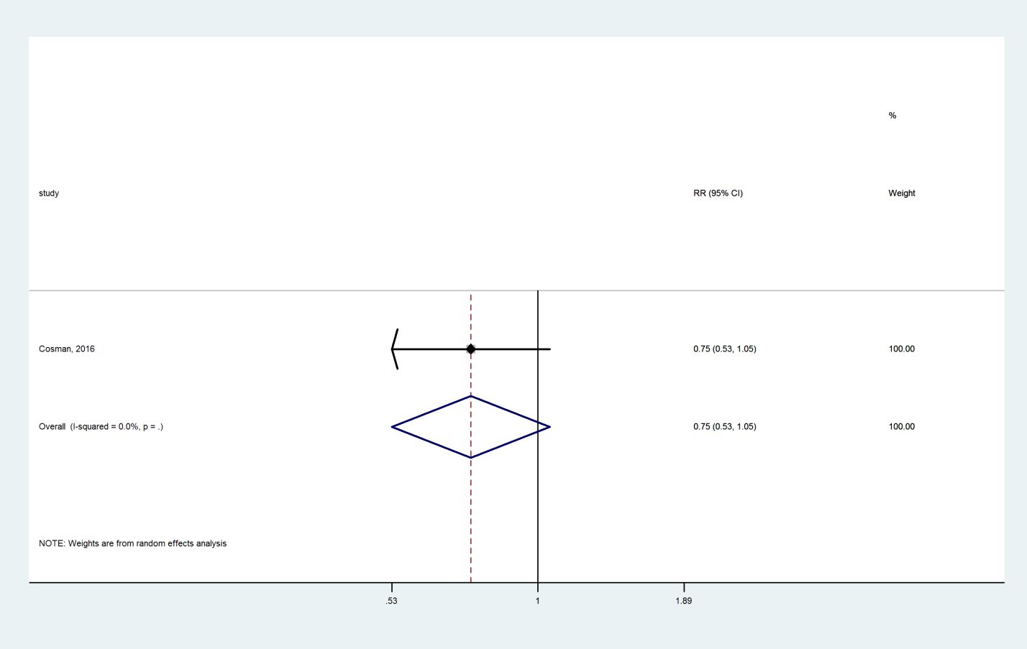

### Abaloparatide compared with Placebo

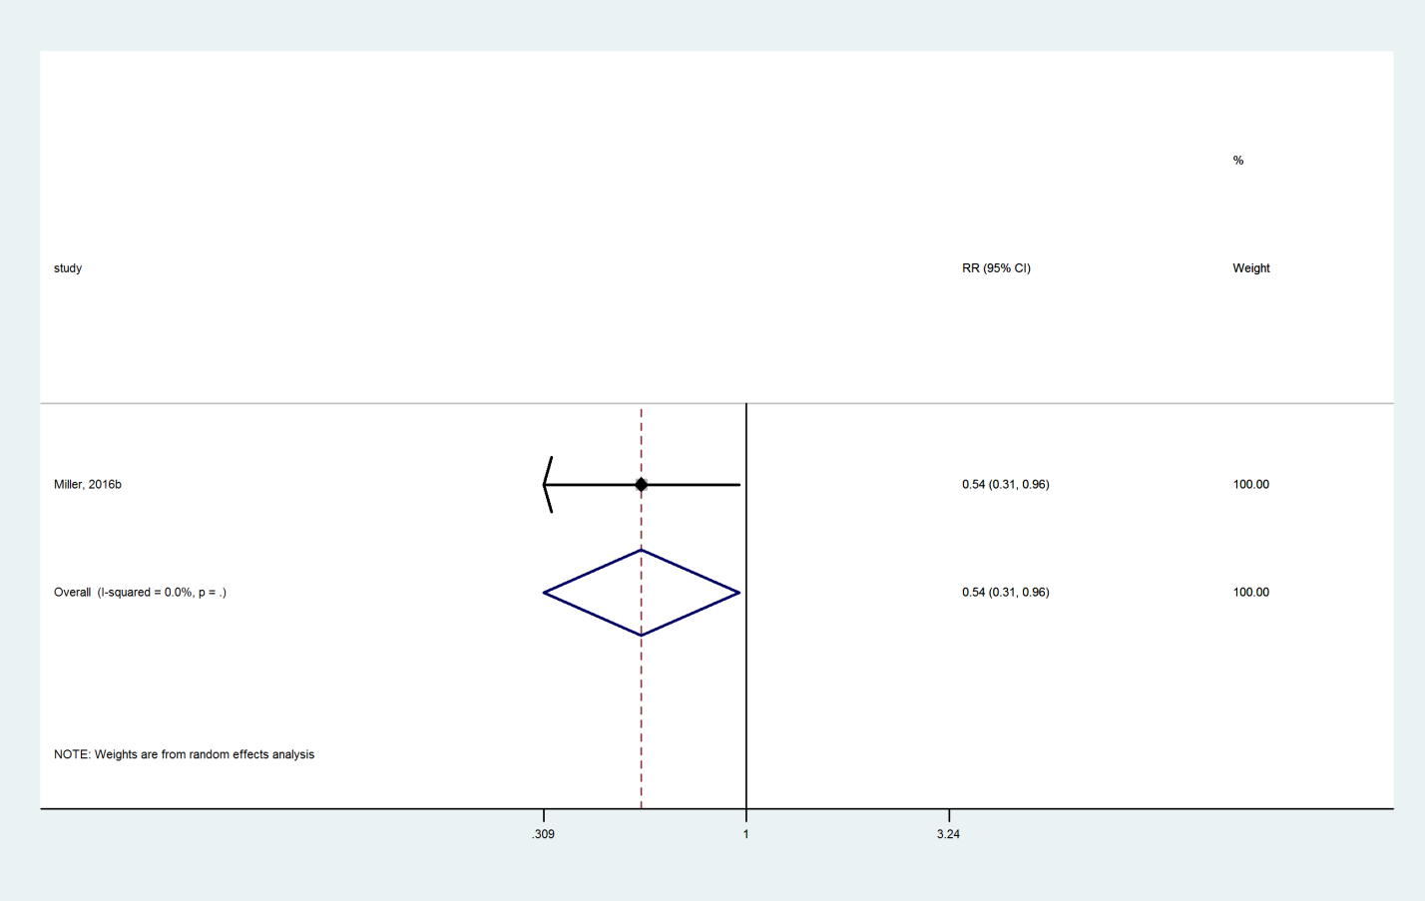

### Zoledronate compared with Teriparatide

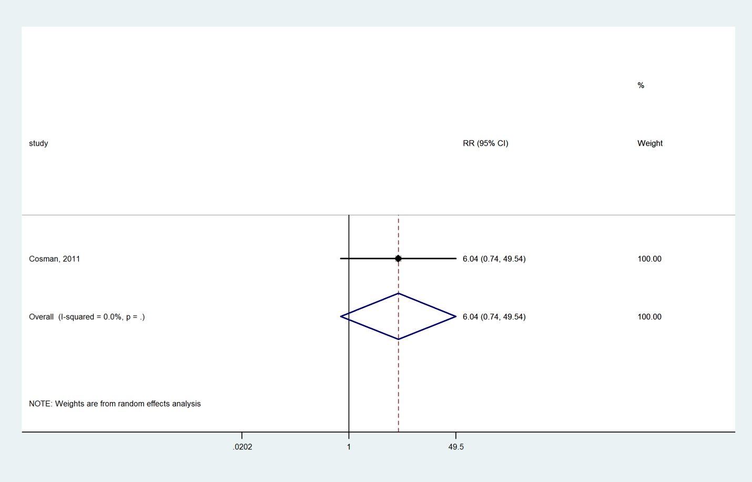

### Risedronate compared with Teriparatide

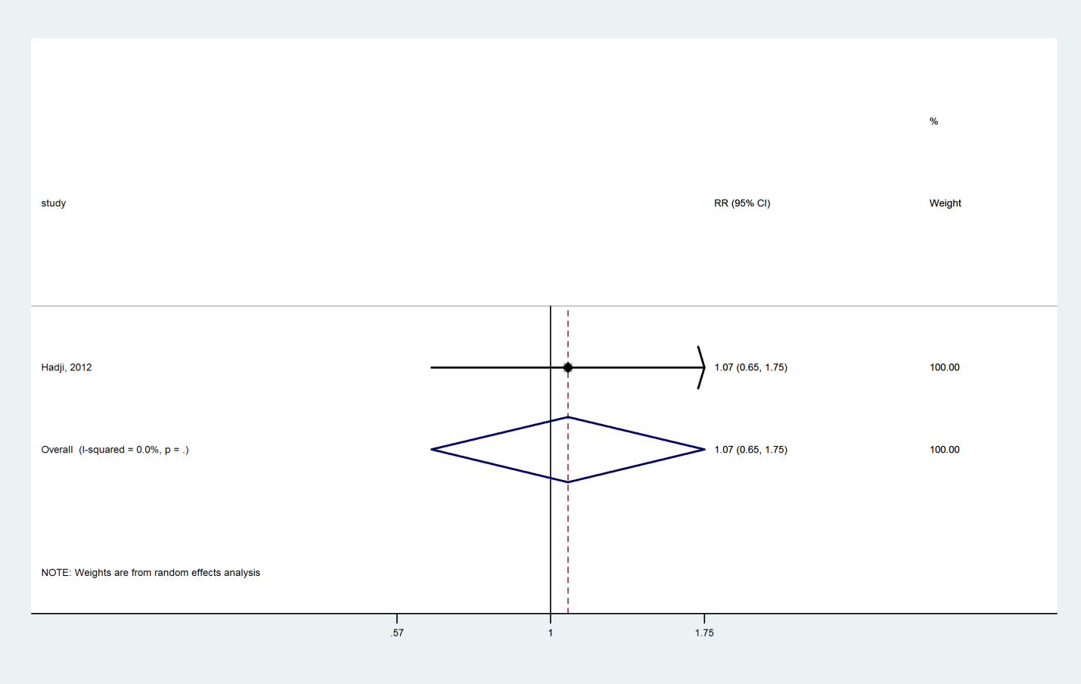

### Alendronate compared with Teriparatide

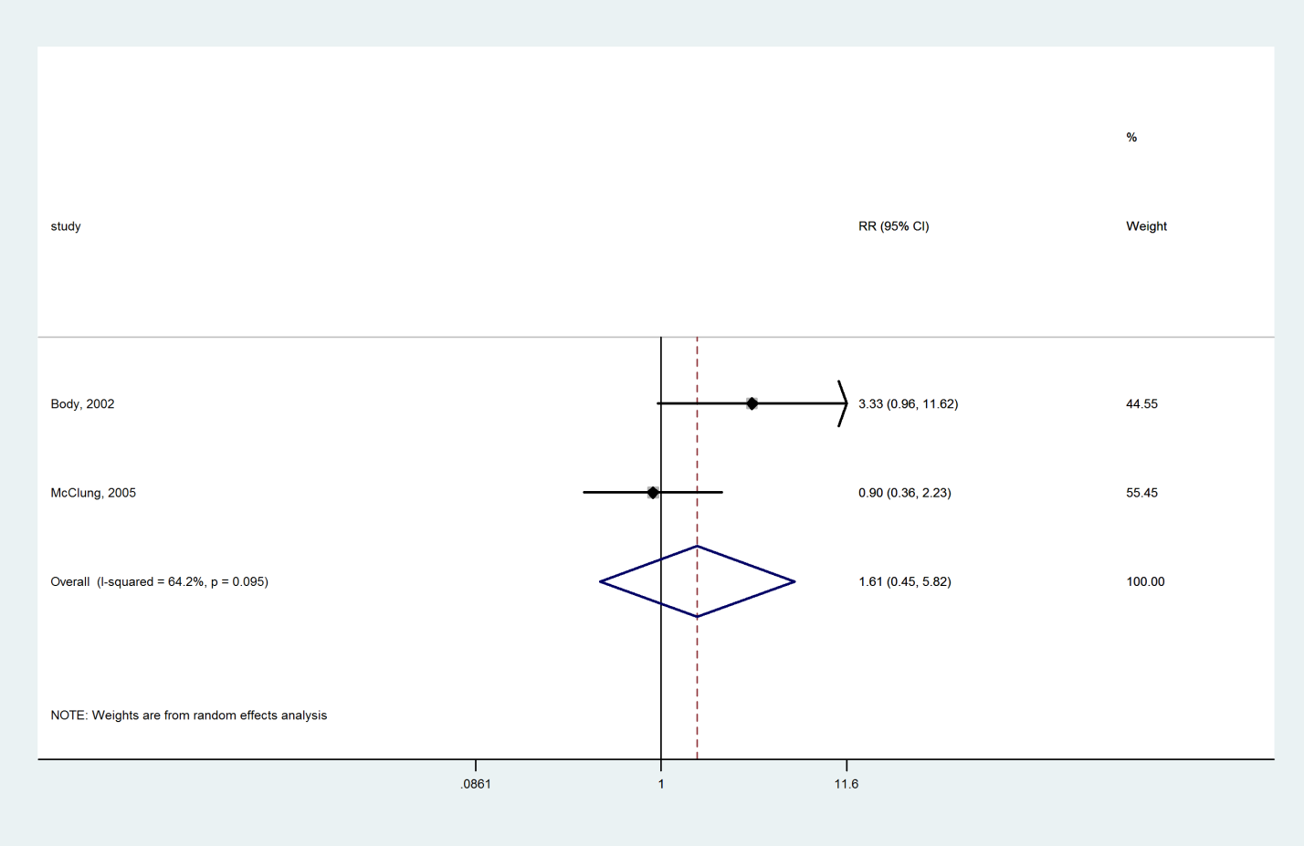

### Calcitonin compared with Teriparatide

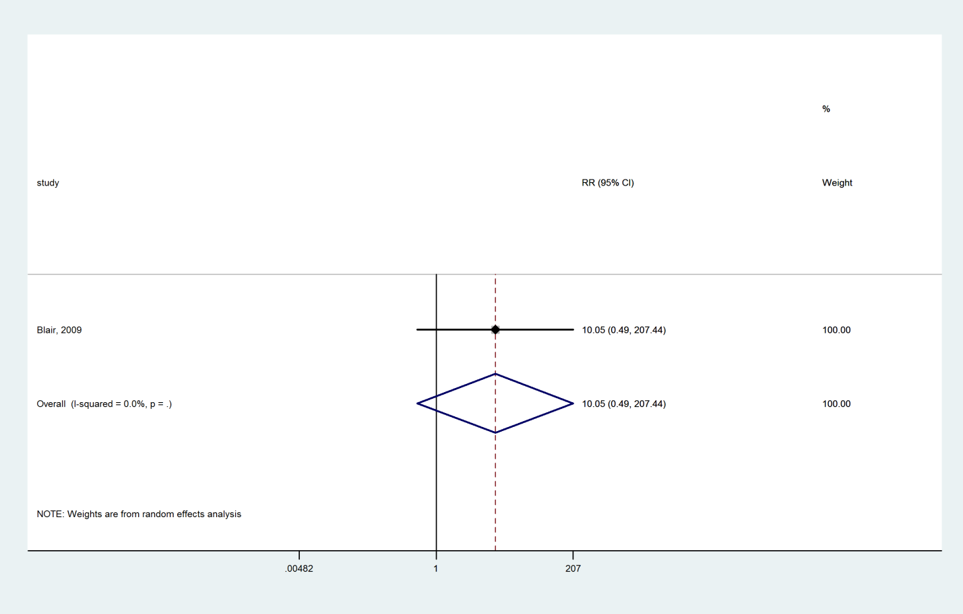

### Ibandronate compared with Denosumab

Y:\TES osteoporosis in women\SR in efficacy\6. Analysis\Direct and Indirect with STATA\2017-08\Direct\Graph_Nonvert_direct\trt7_trt3.wmf

### Alendronate compared with Denosumab

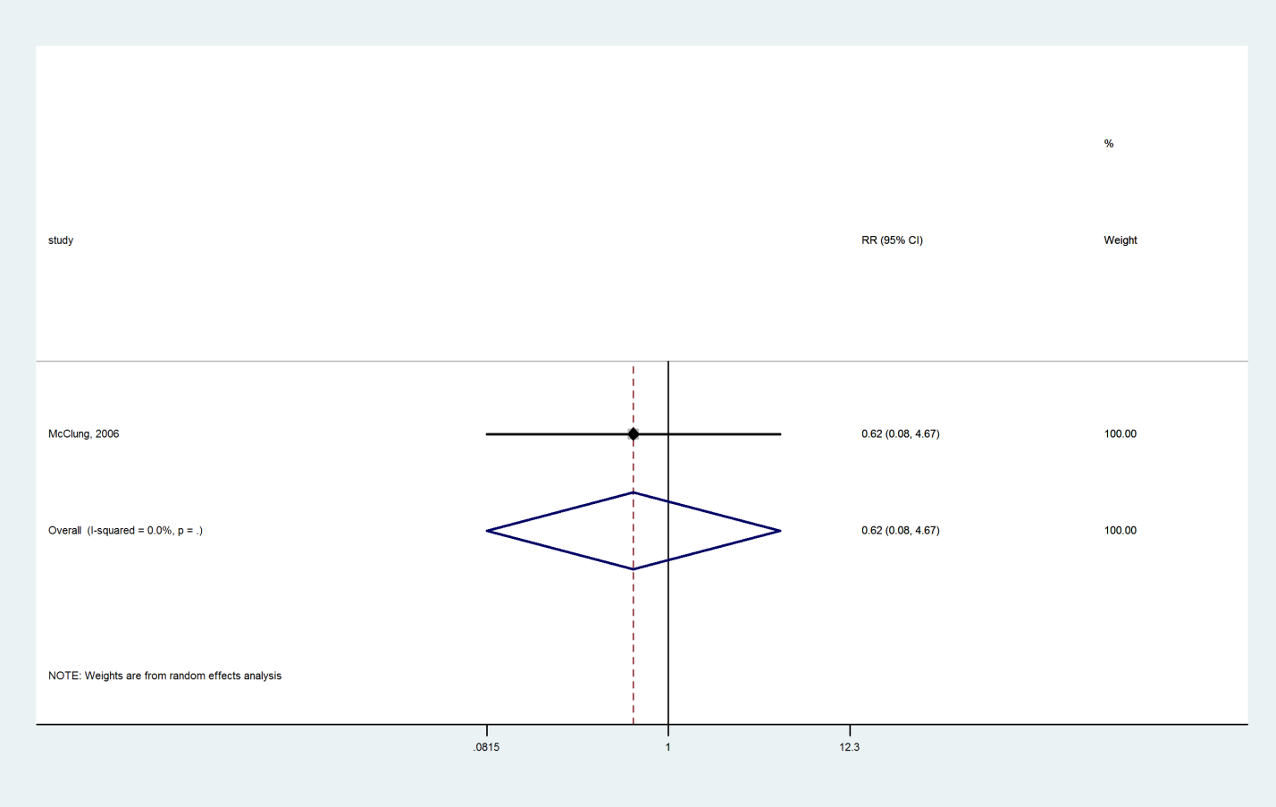

### Alendronate compared with Raloxifene

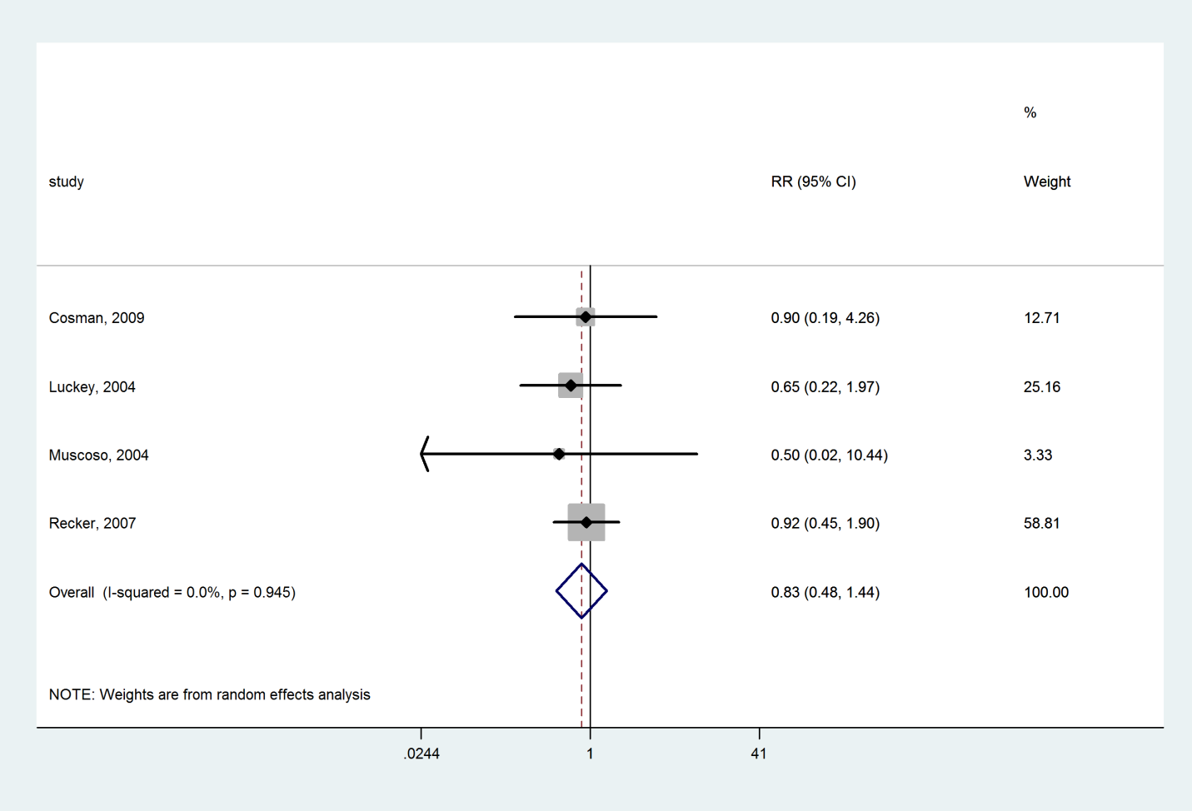

### Bazedoxifene compared with Raloxifene

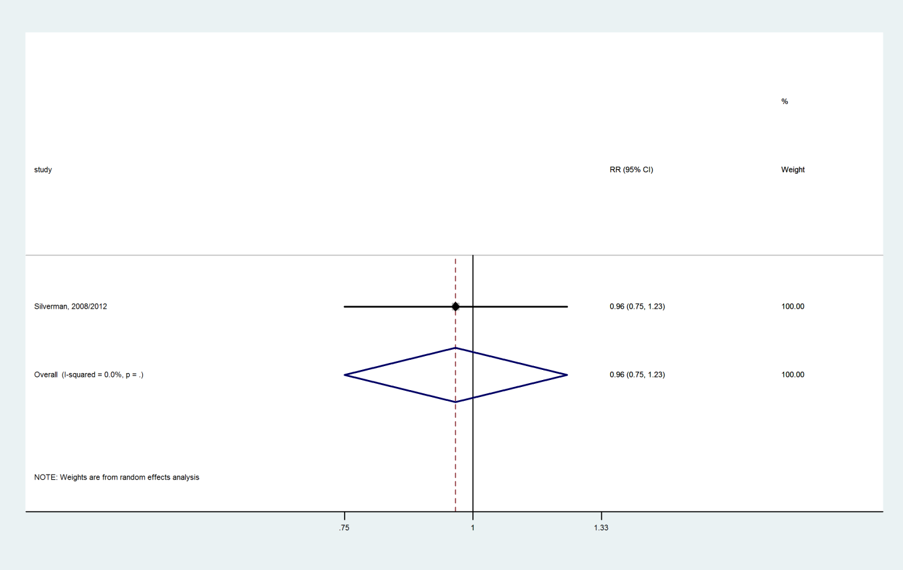

### Calcitonin compared with Raloxifene



### Alendronate compared with Risedronate

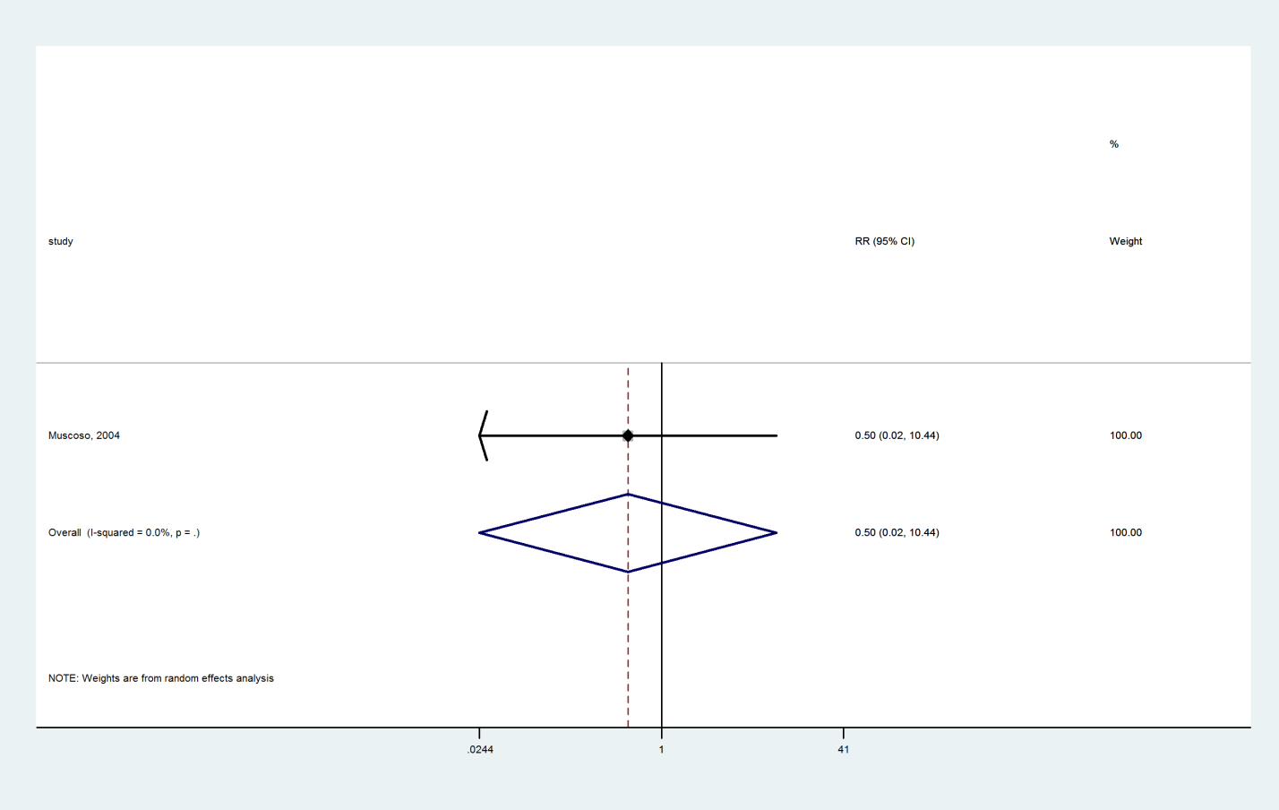

### Alendronate compared with Ibandronate

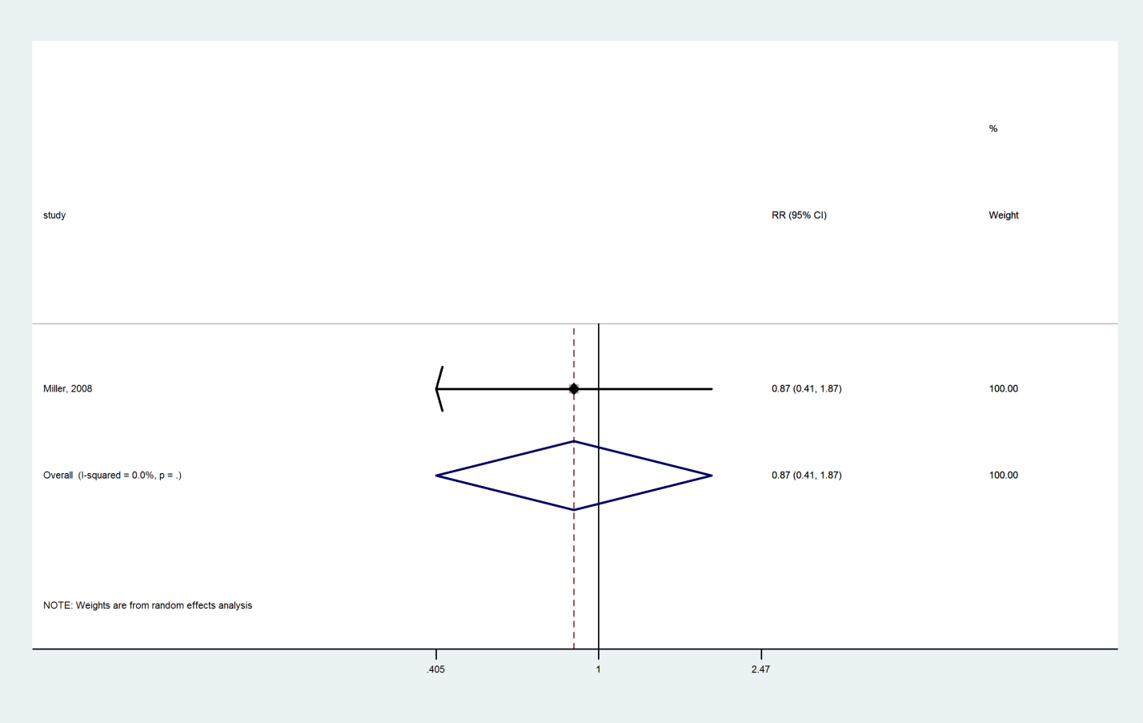

### Hormone therapy compared with Alendronate

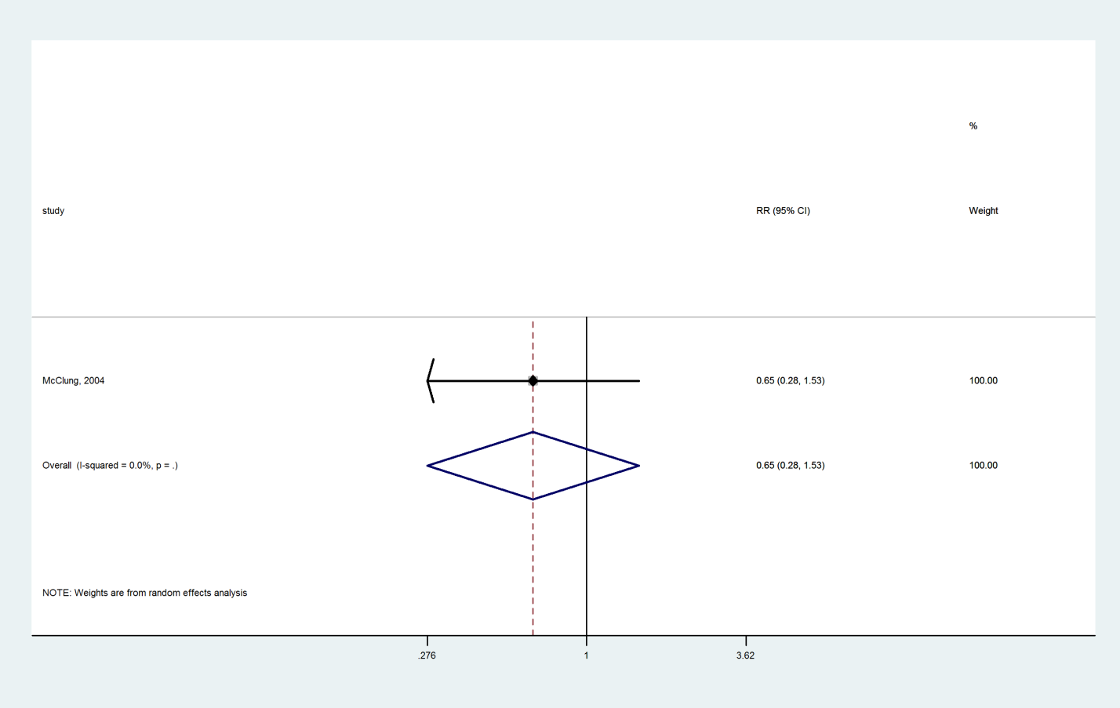

### Hormone therapy compared with Vitamin D+Calcium

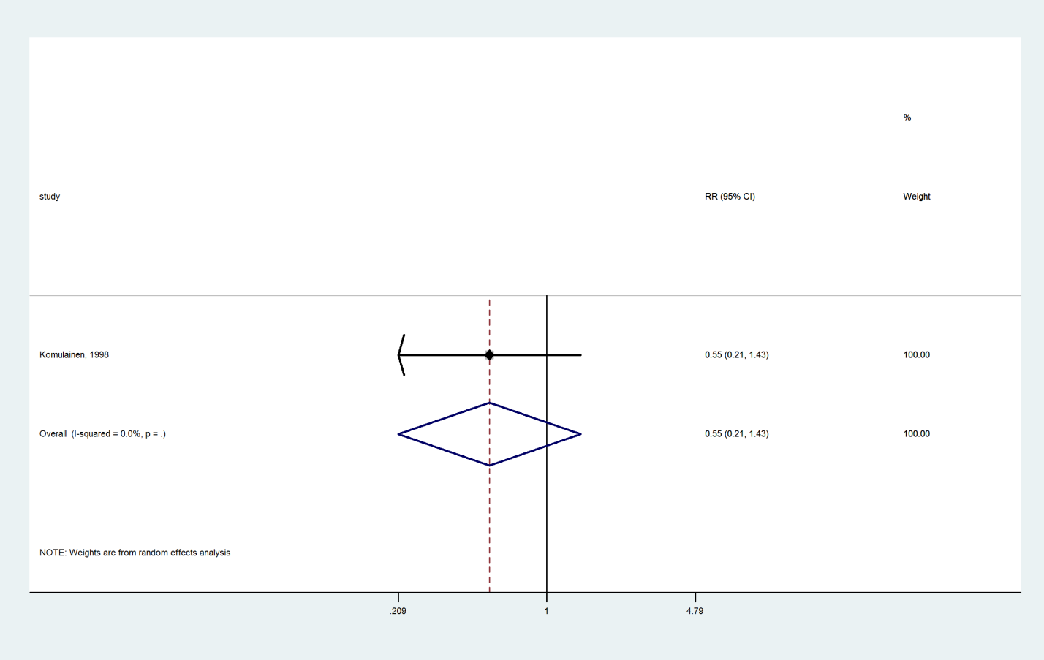

### Calcium compared with Vitamin D+Calcium

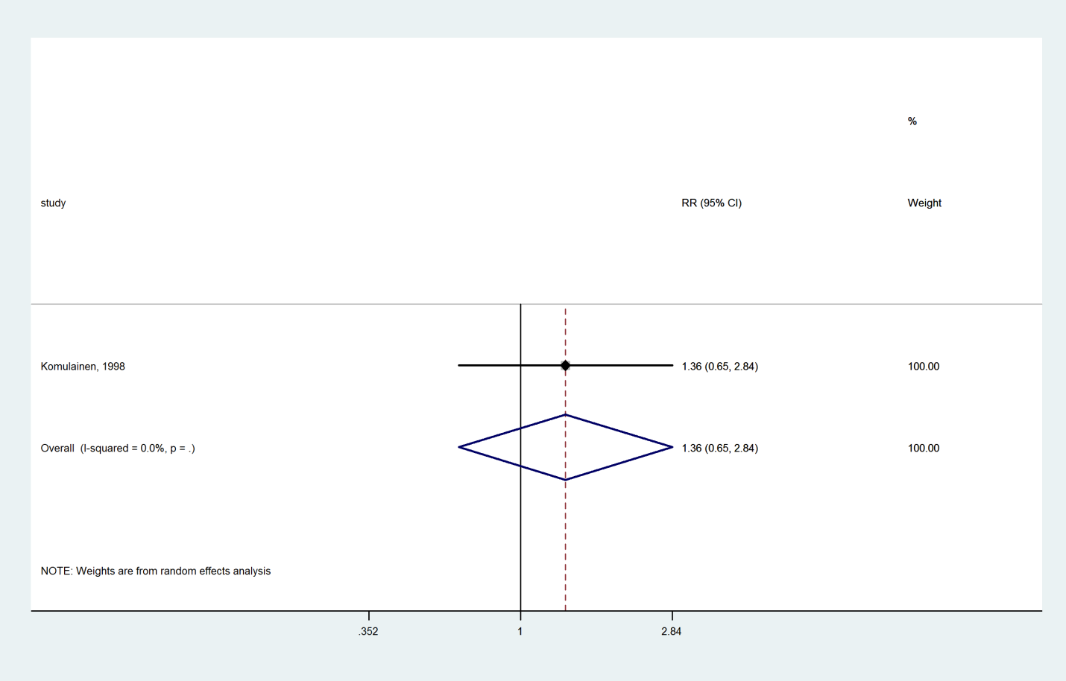

### Vitamin D compared with Hormone therapy

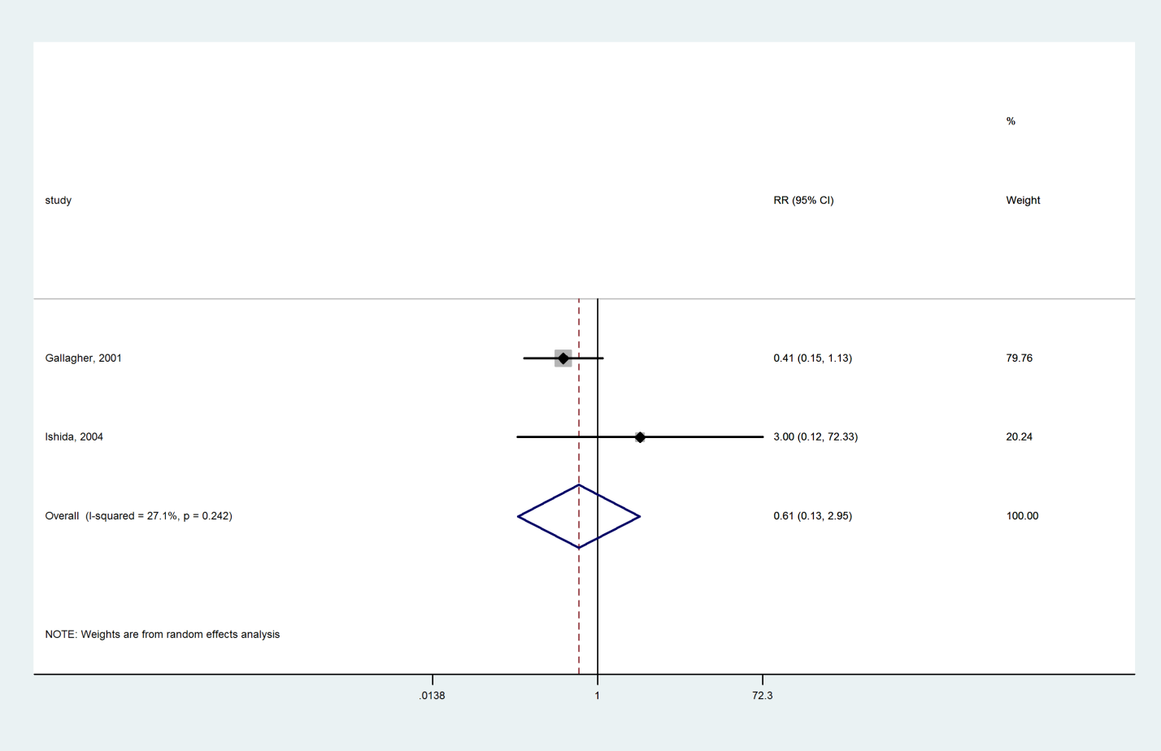

### Calcium compared with Hormone therapy

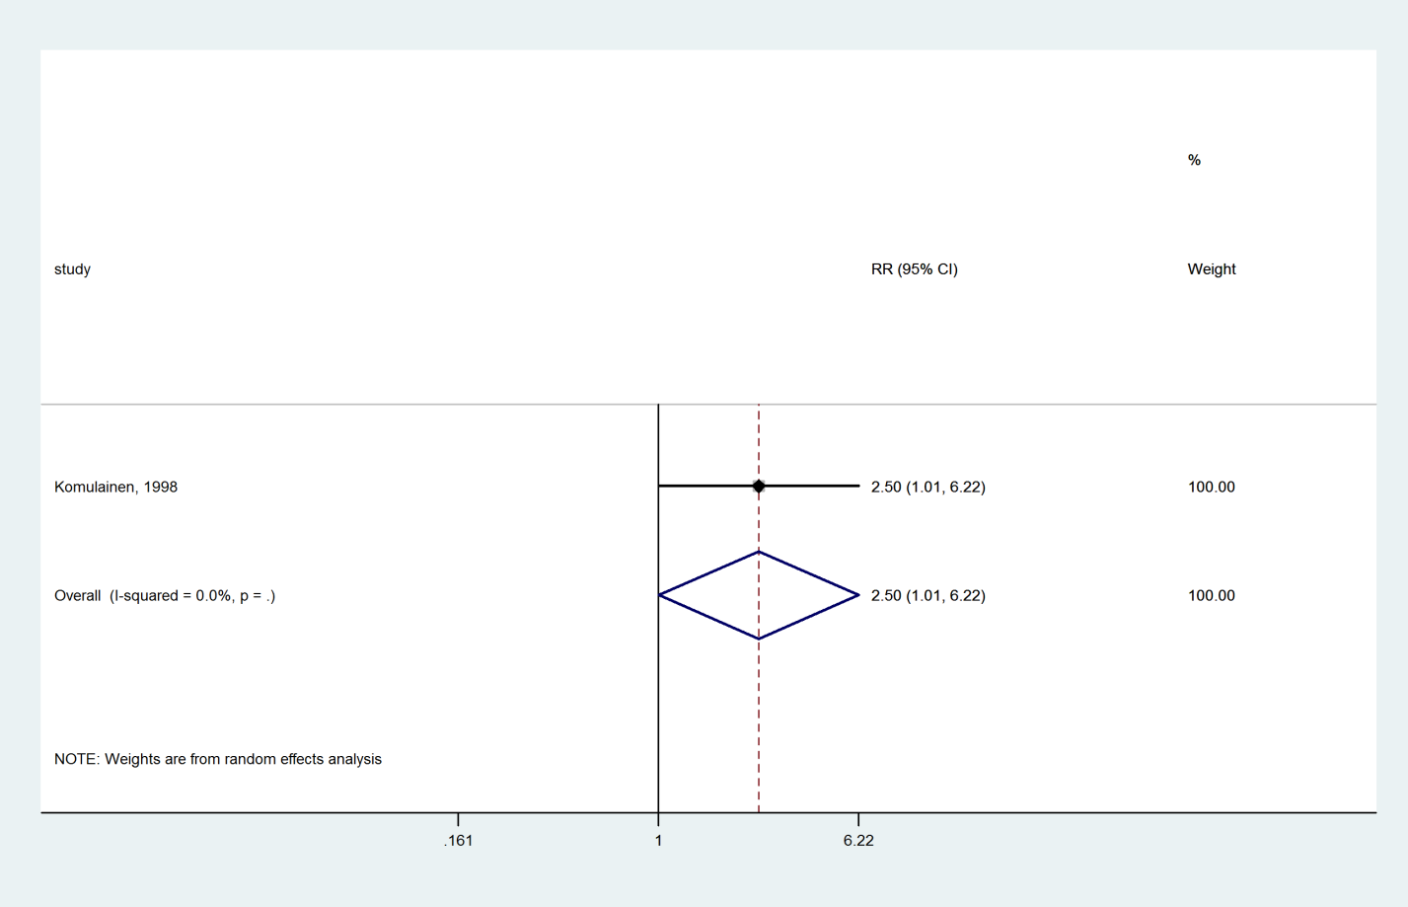

### Vitamin D compared with Calcitonin

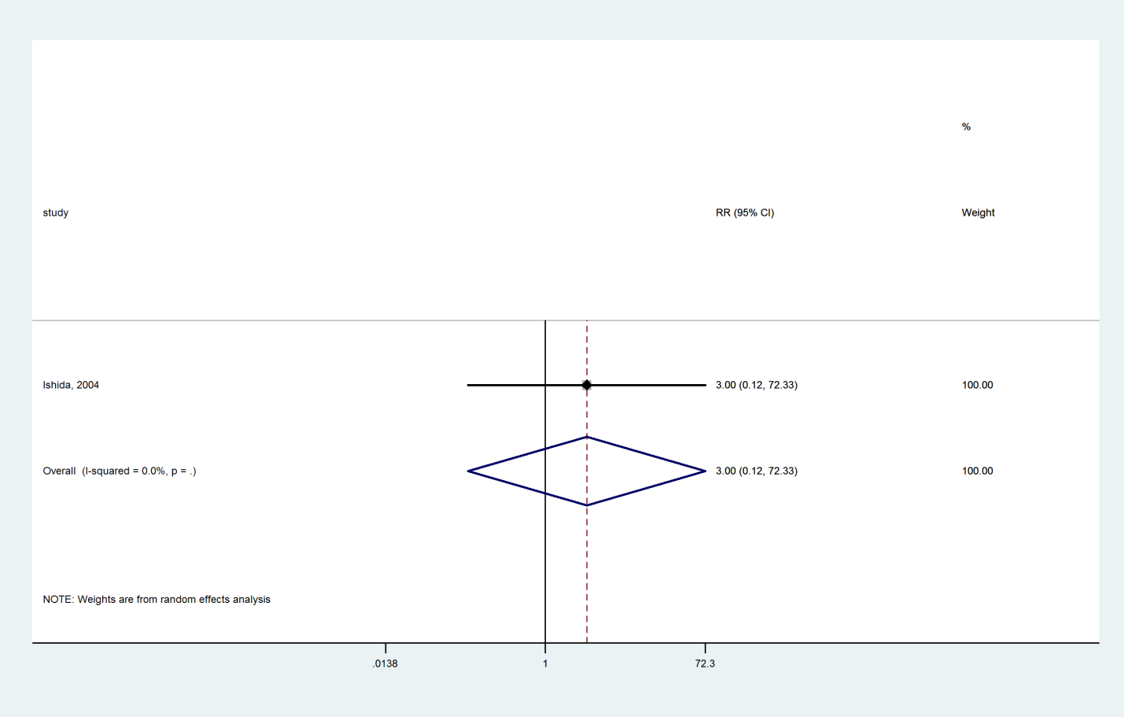

### Romosozumab compared with Alendronate

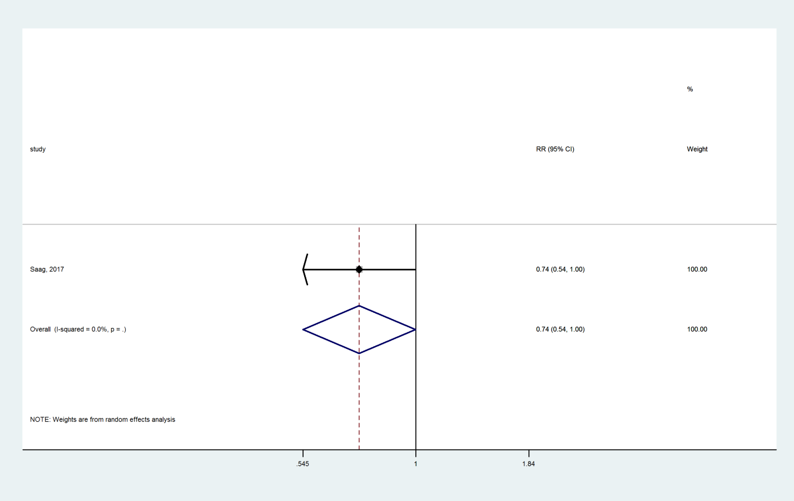

### Abaloparatide compared with Teriparatide

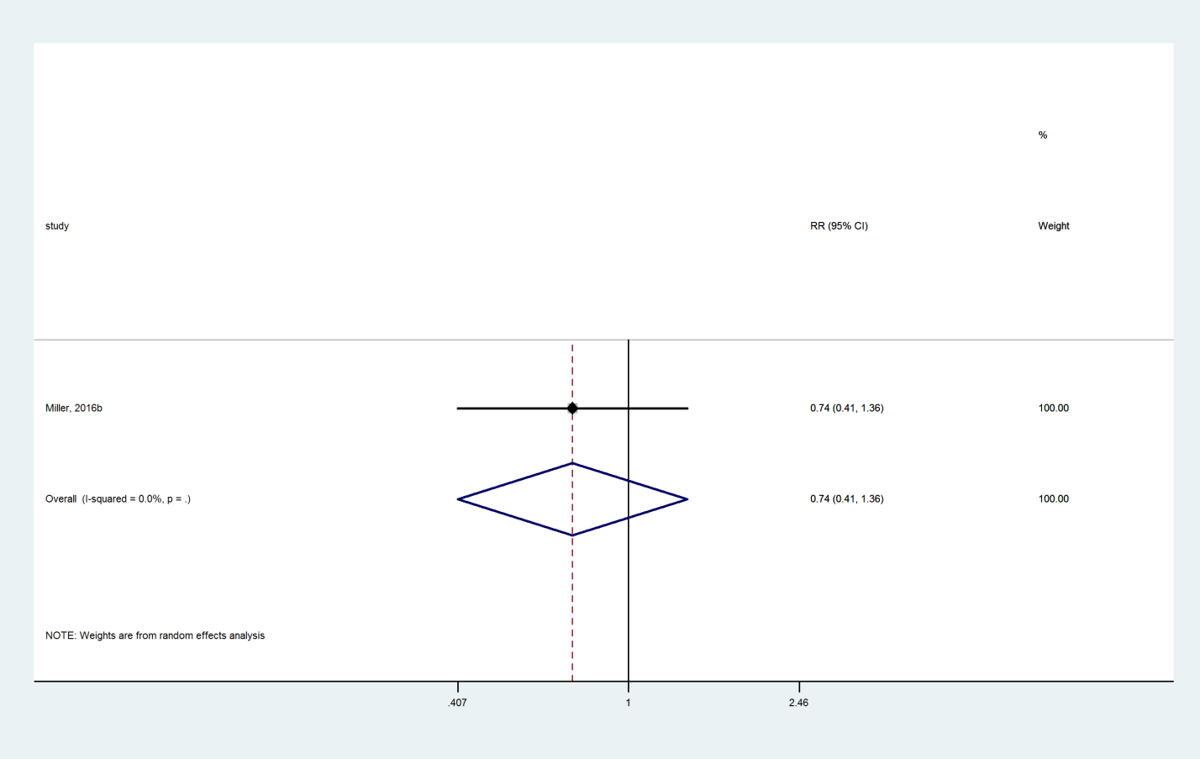

## Vertebral Fracture

### Teriparatide compared with Placebo

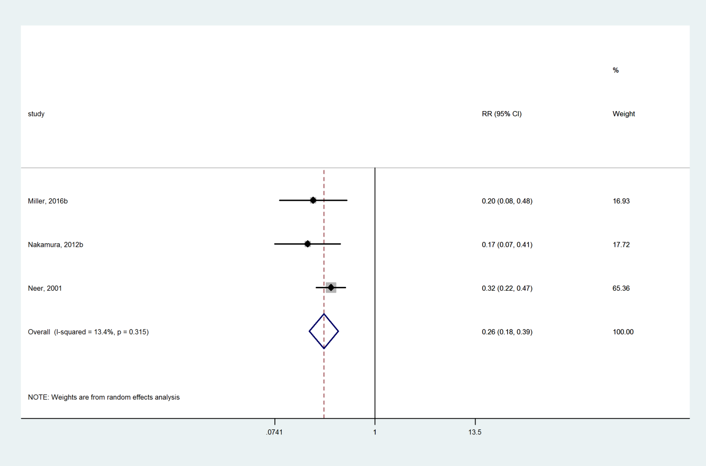

### Denosumab compared with Placebo

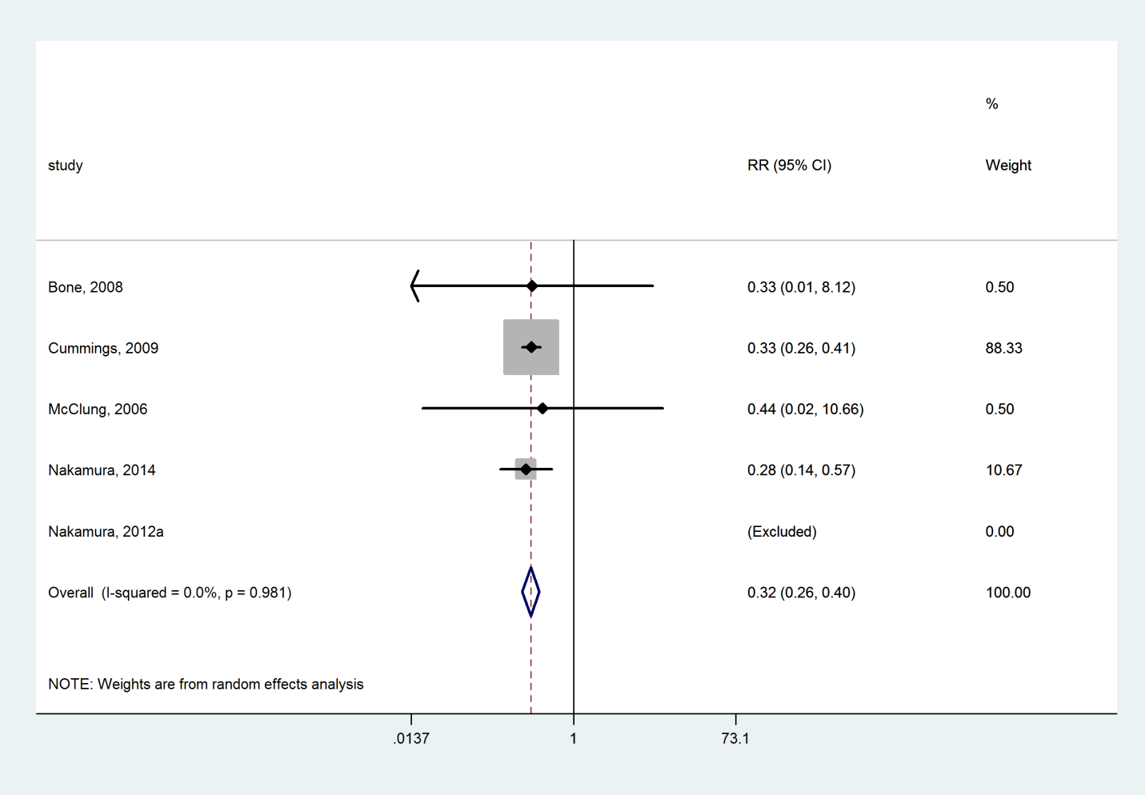

### Raloxifene compared with Placebo

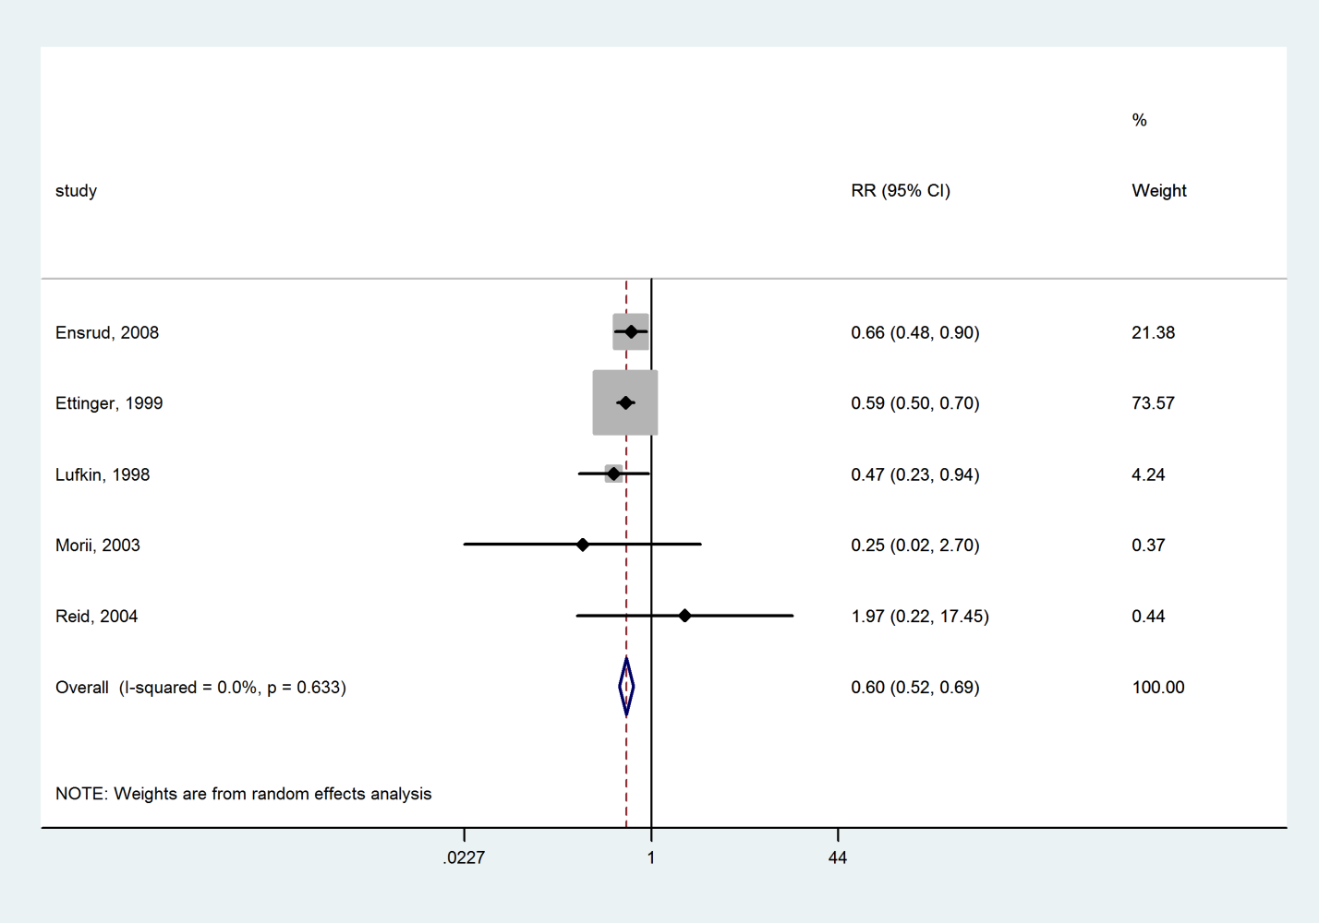

### Zoledronate compared with Placebo

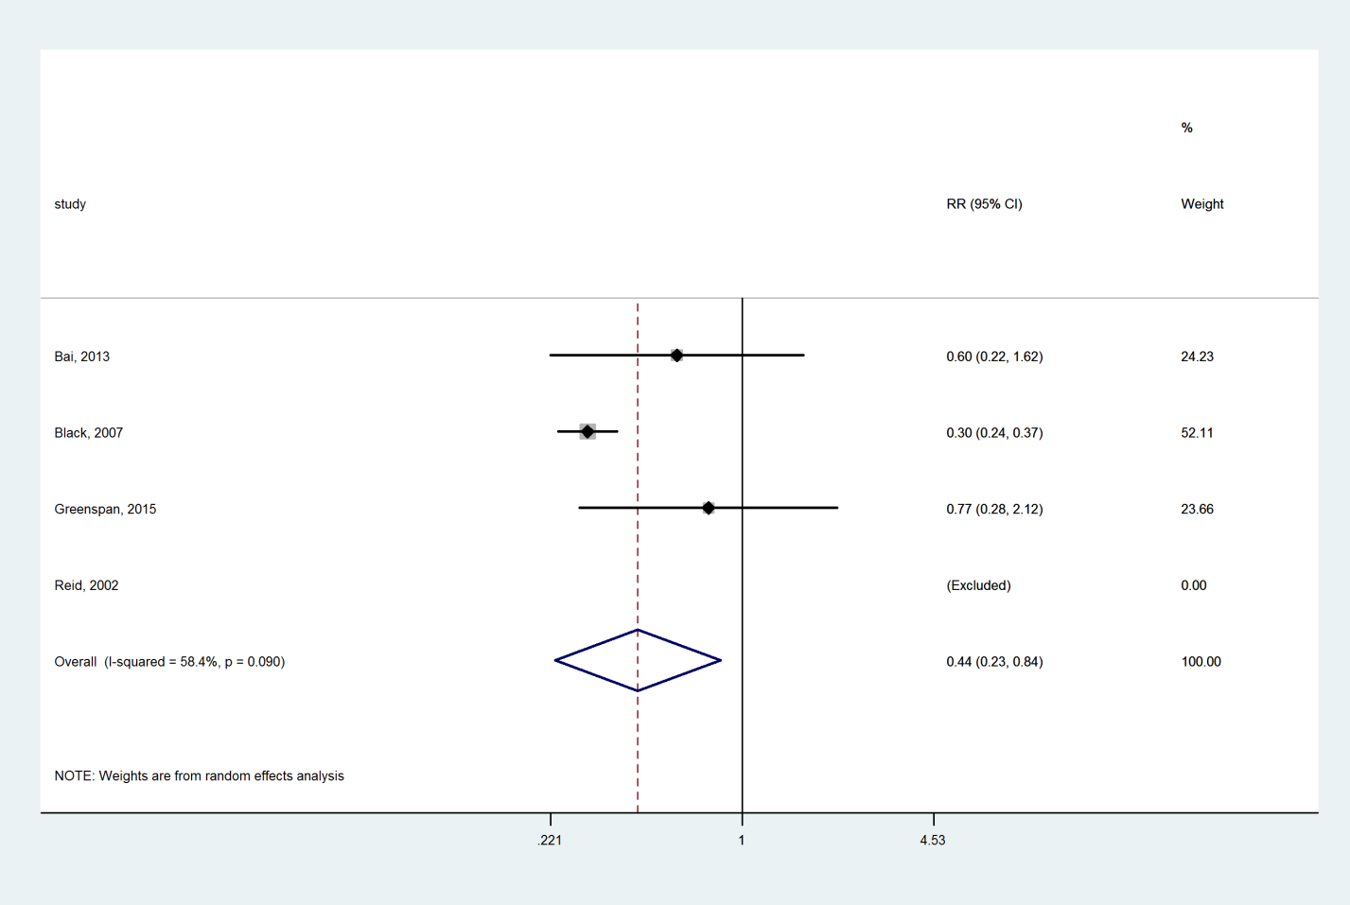

### Risedronate compared with Placebo

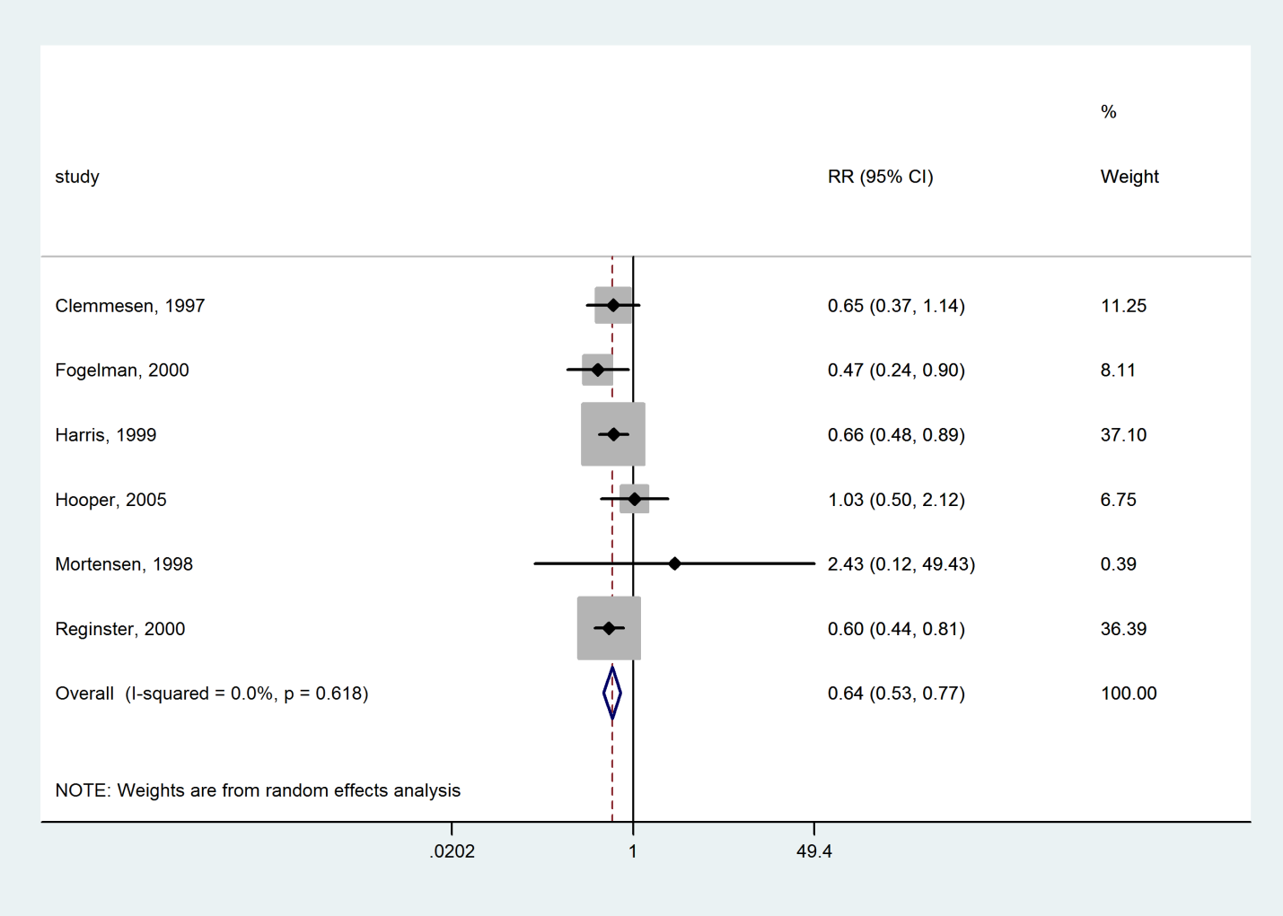

### Ibandronate compared with Placebo

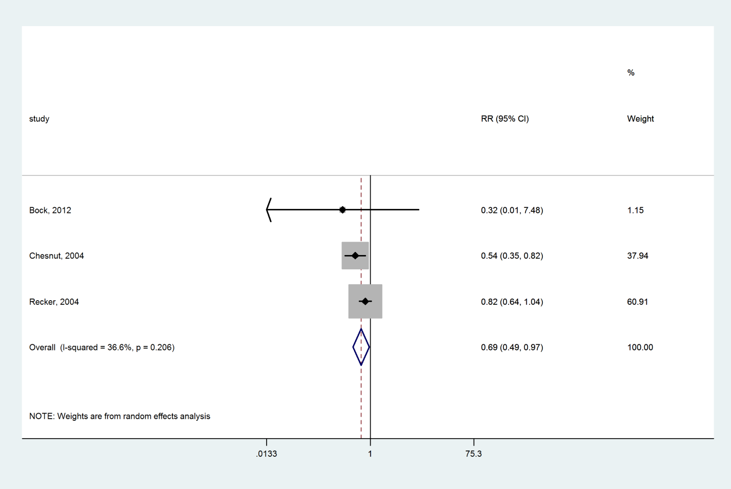

### Alendronate compared with Placebo

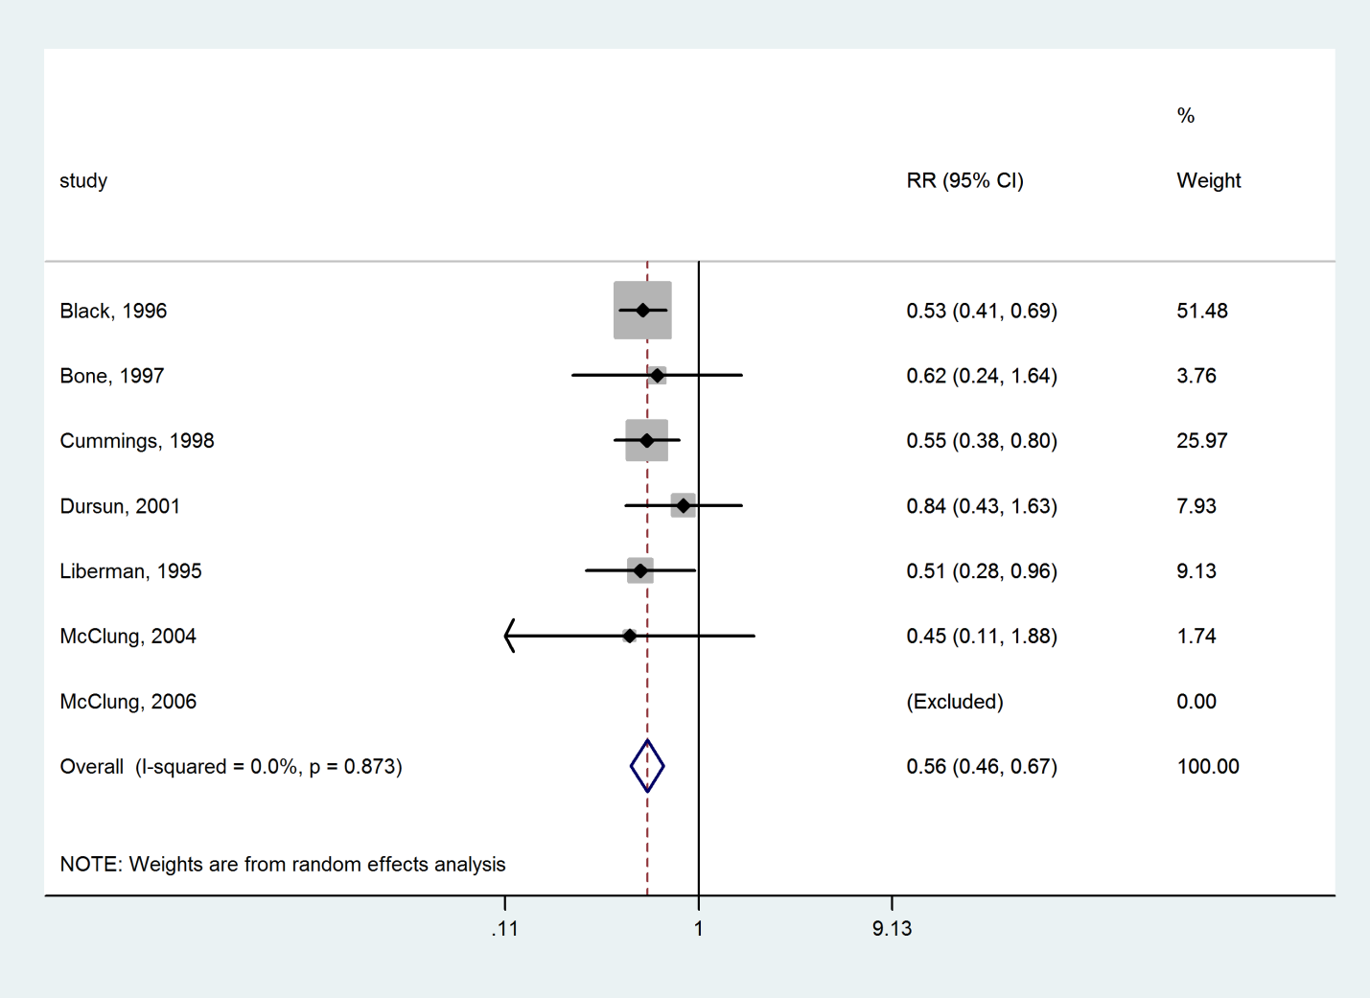

### Vitamin D+Calcium compared with Placebo

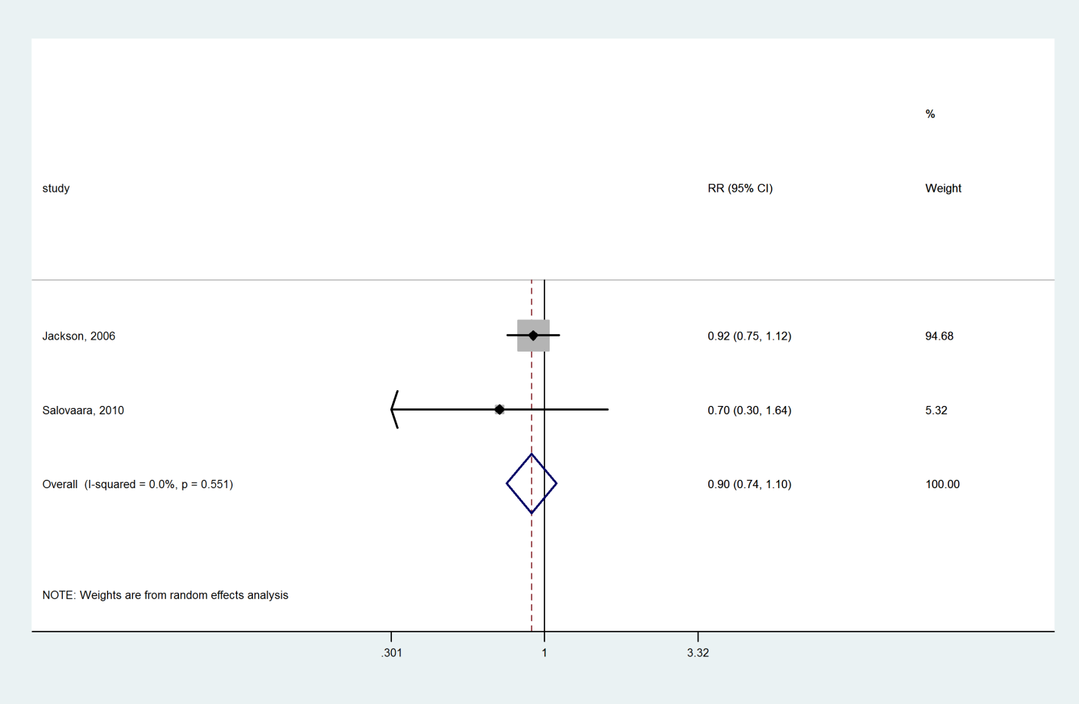

### Calcium compared with Placebo

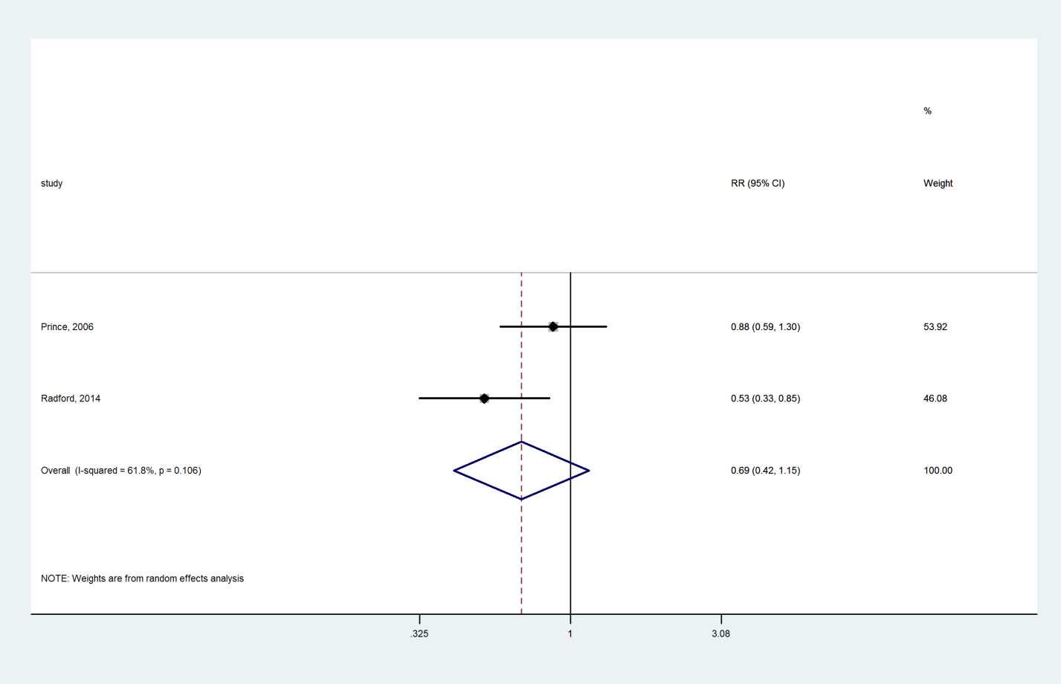

### Bazedoxifene compared with Placebo

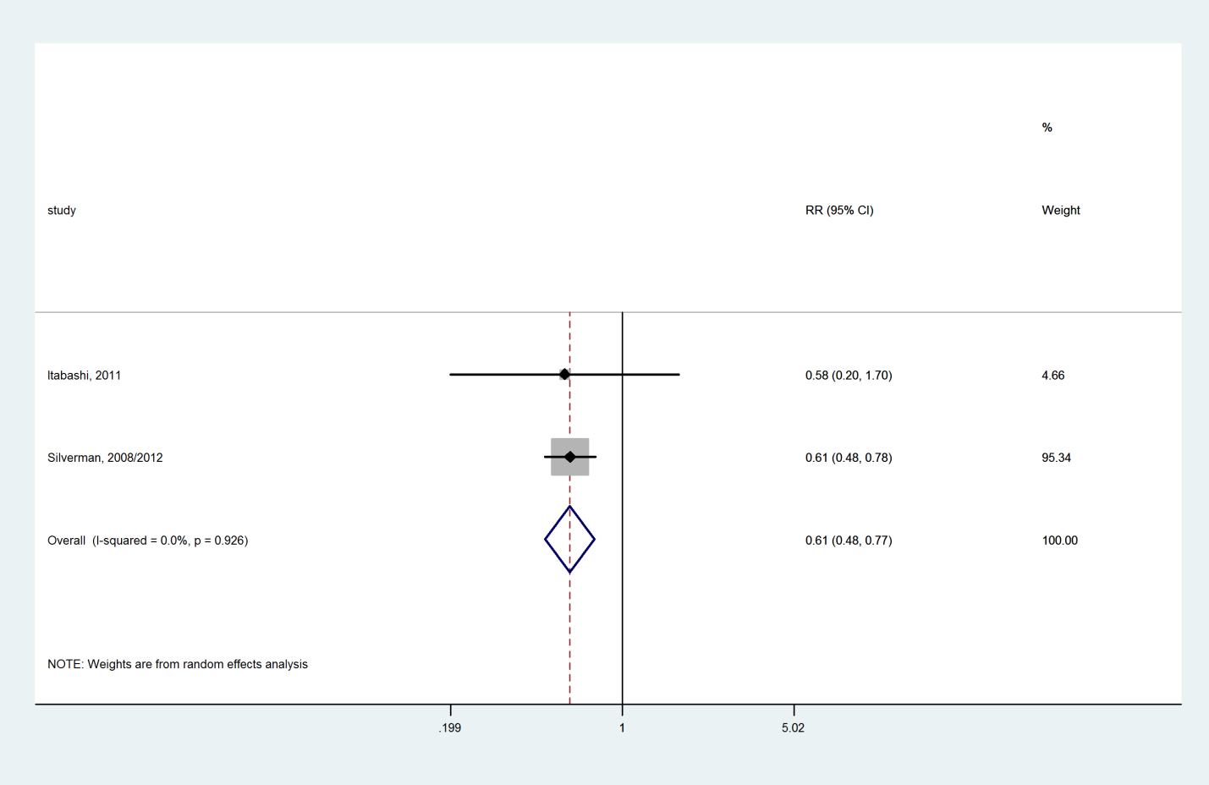

### Lasofoxifene compared with Placebo

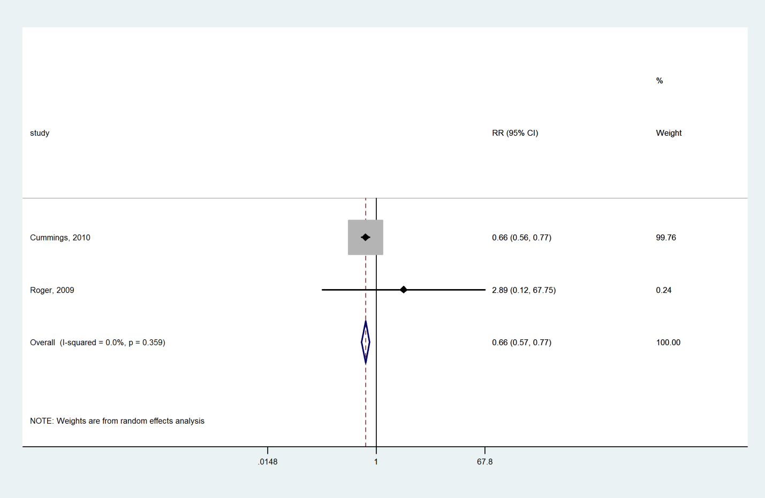

### Hormone therapy compared with Placebo

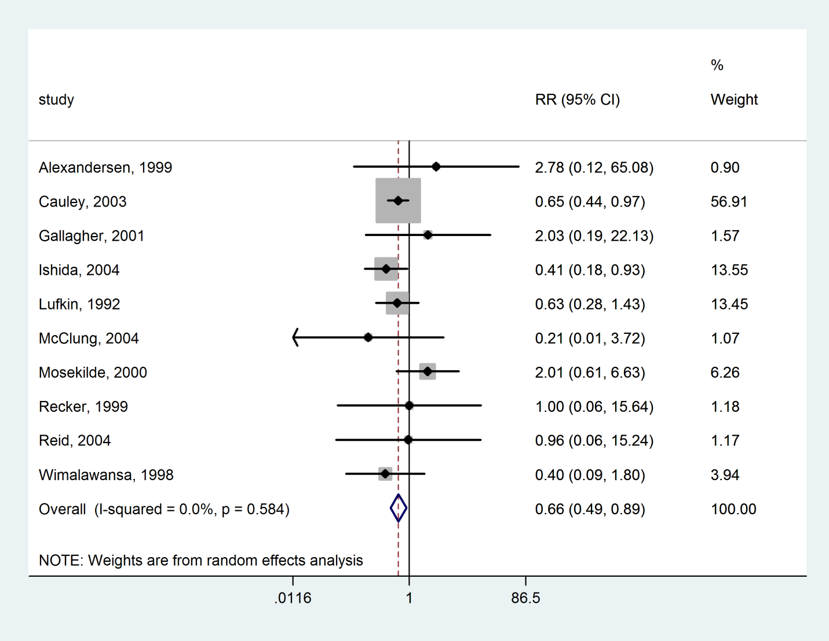

### Calcitonin compared with Placebo

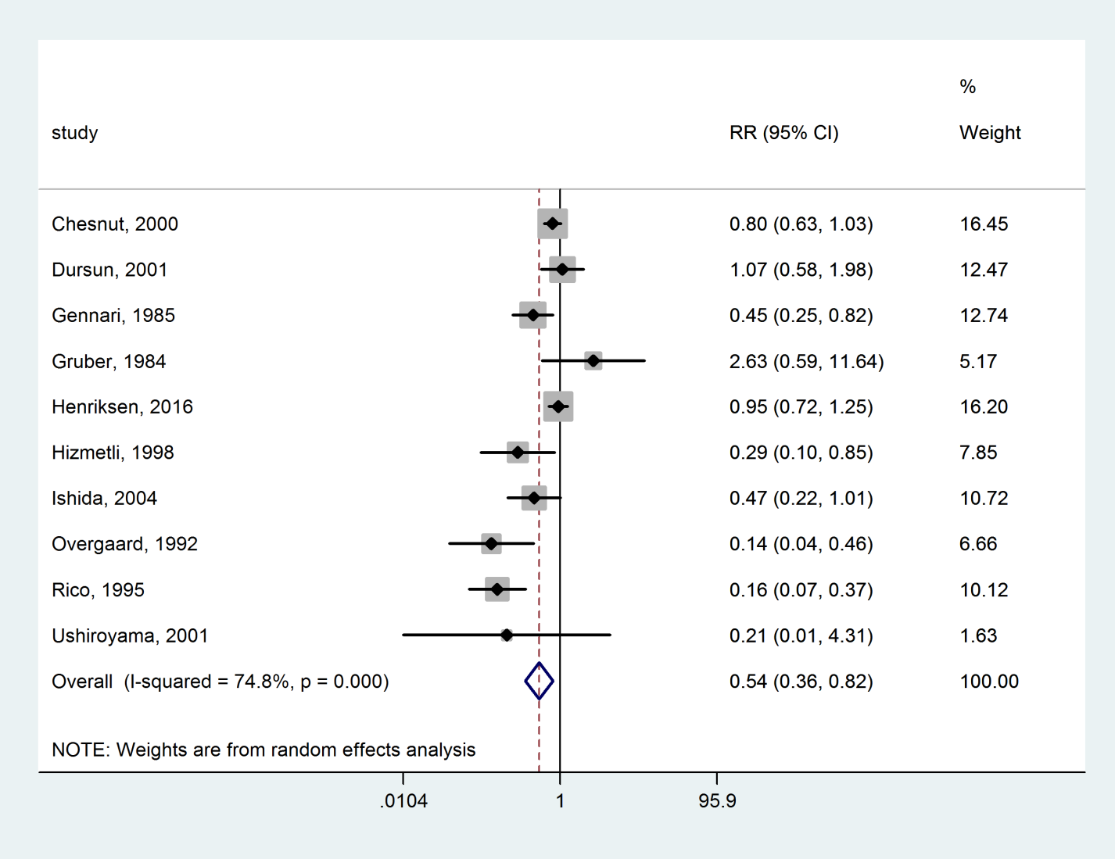

### Tibolone compared with Placebo

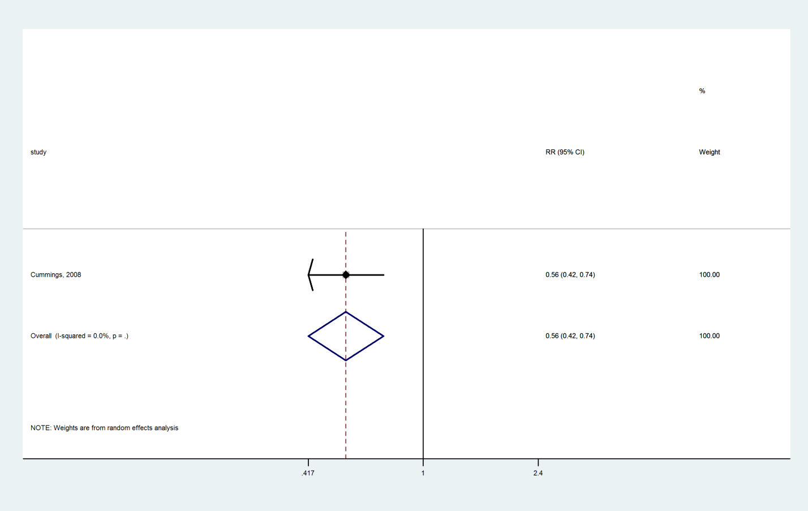

### Strontium ranelate compared with Placebo

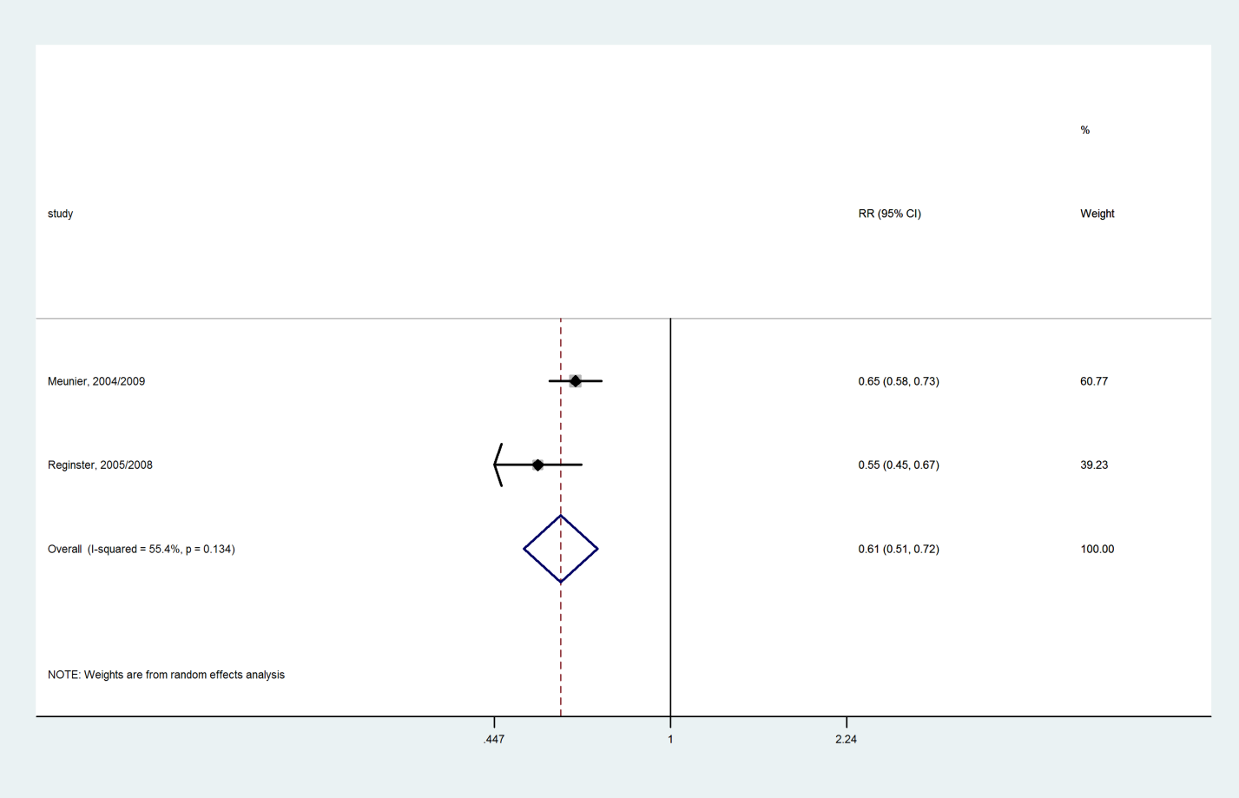

### PTH 1-84 compared with Placebo

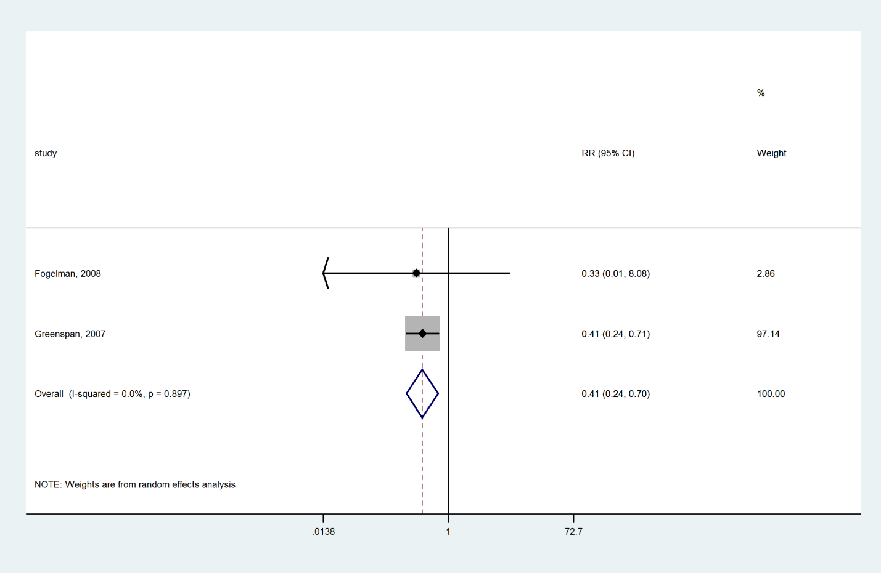

### Vitamin D compared with Placebo

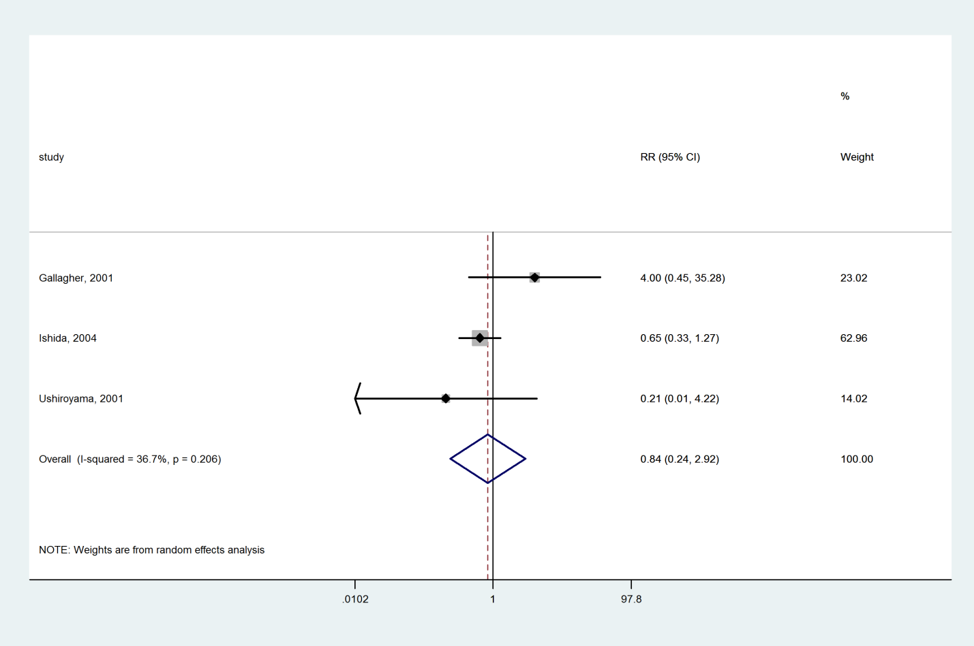

### Romosozumab compared with Placebo

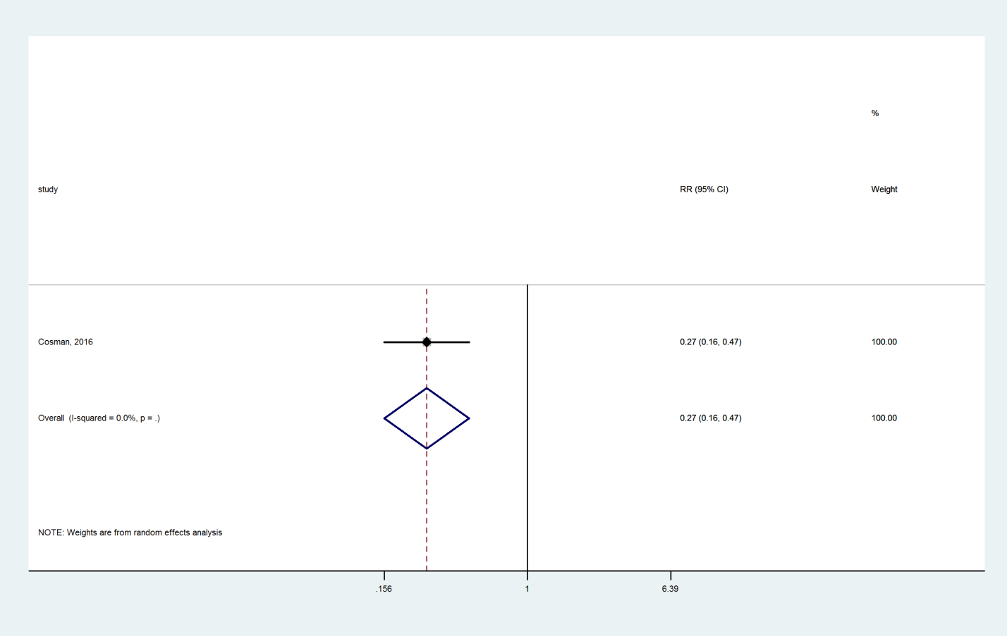

### Abaloparatide compared with Placebo

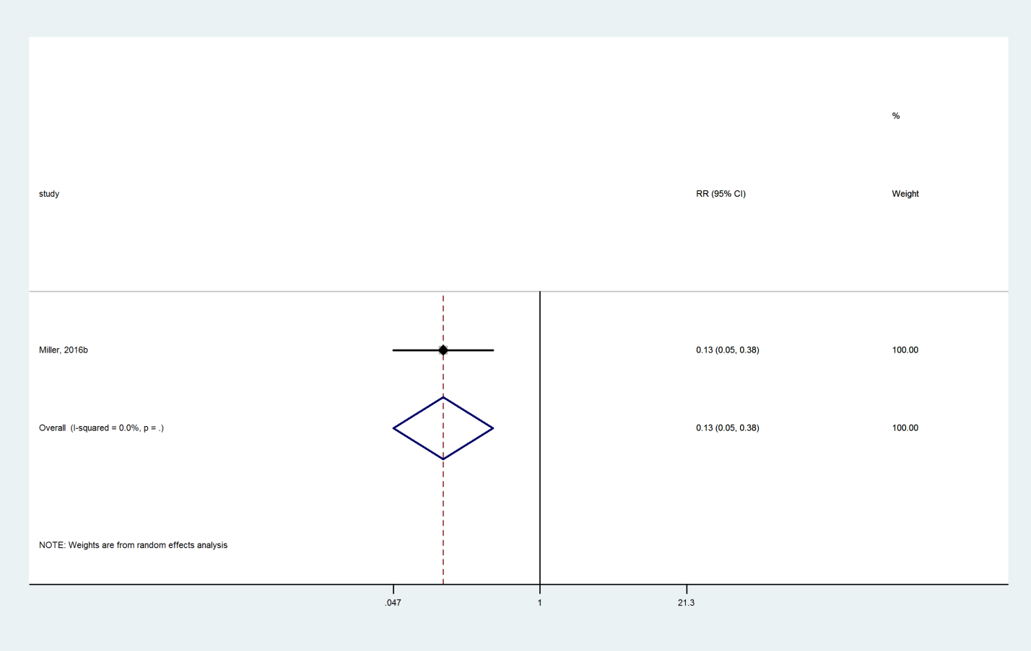

### Zoledronate compared with Teriparatide



### Risedronate compared with Teriparatide

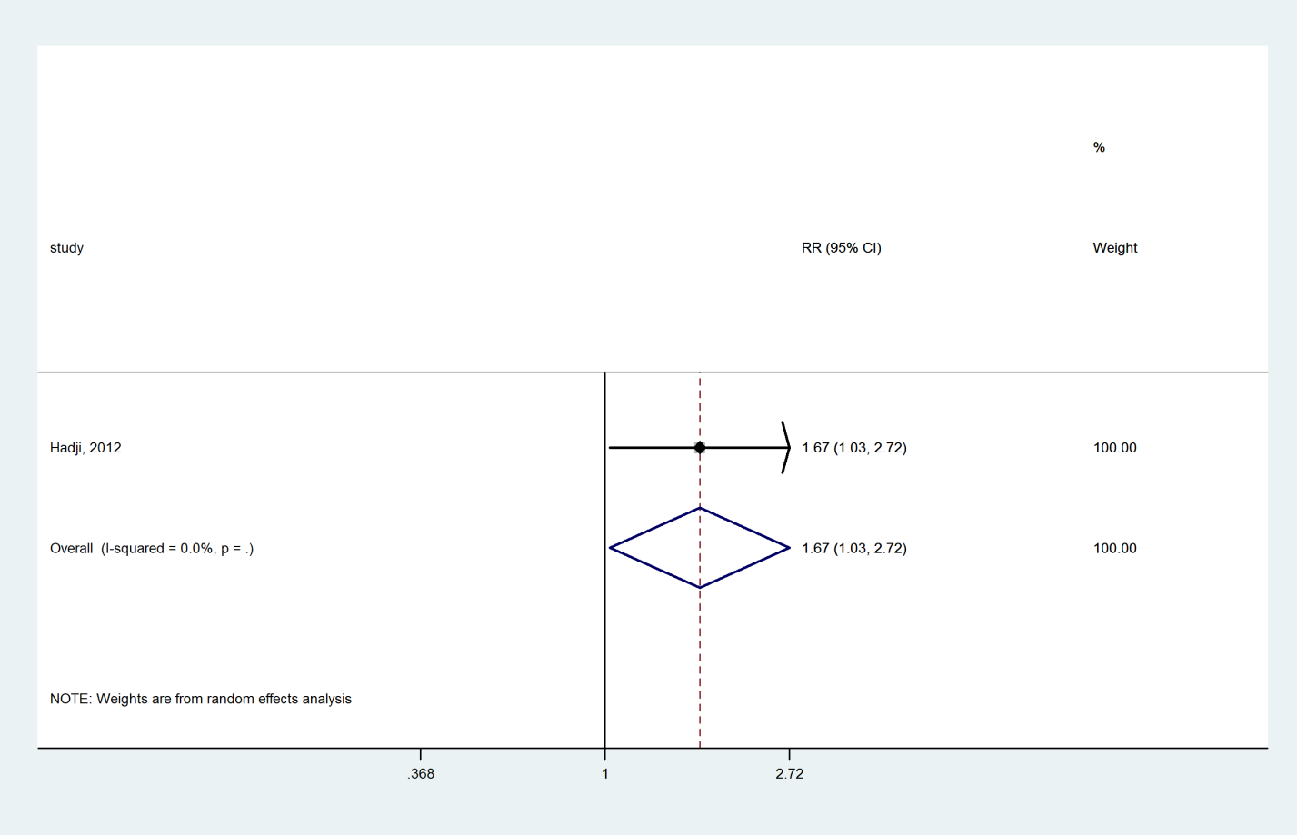

### Alendronate compared with Teriparatide

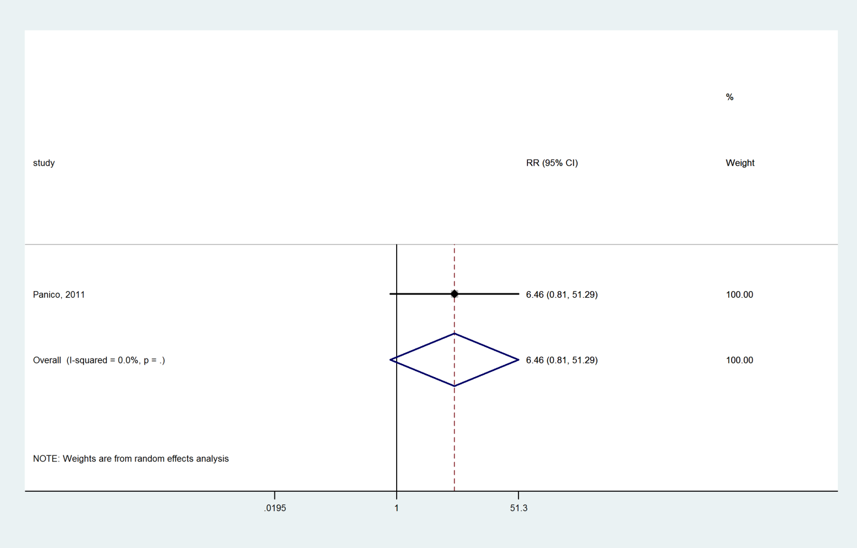

### Ibandronate compared with Denosumab

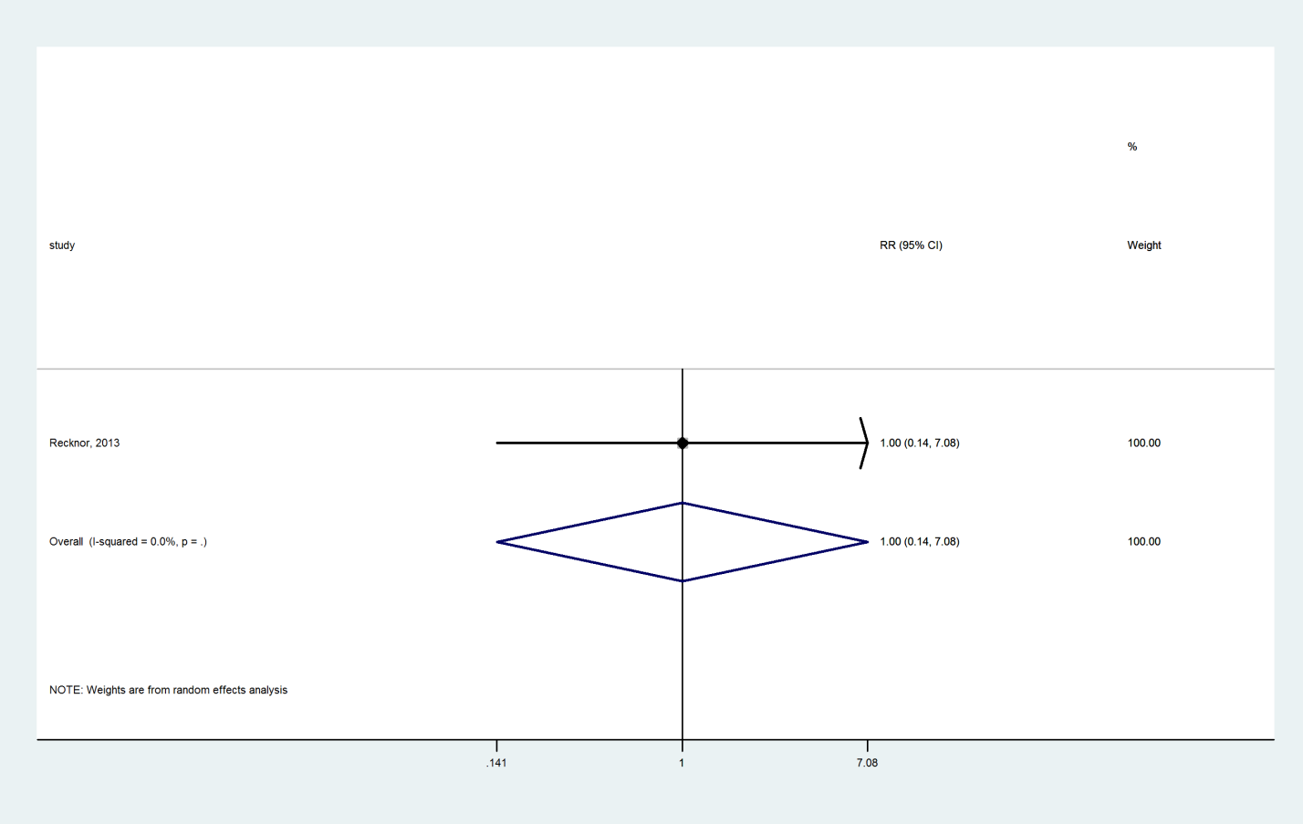

### Alendronate compared with Denosumab

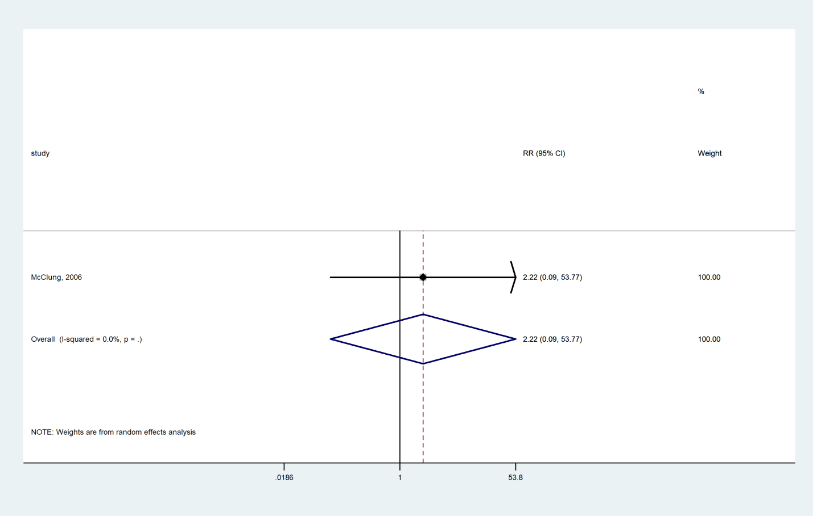

### Alendronate compared with Raloxifene

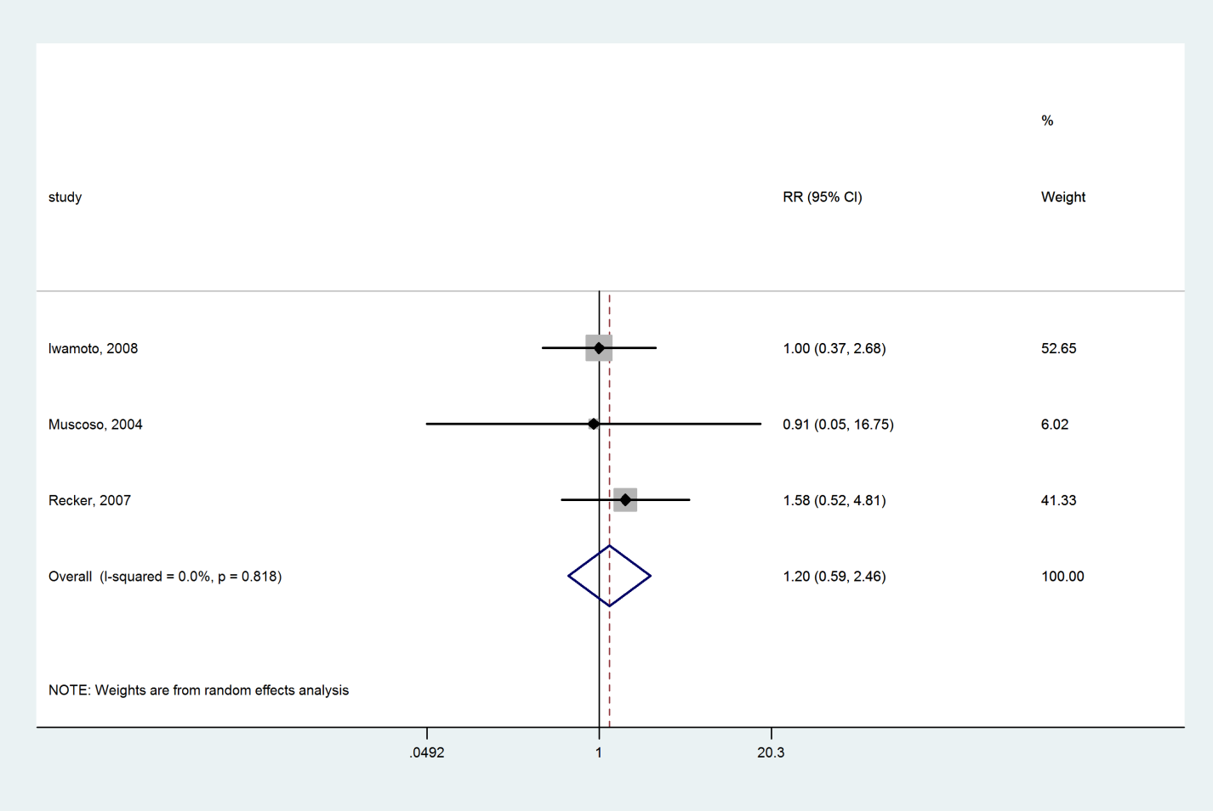

### Hormone therapy compared with Raloxifene

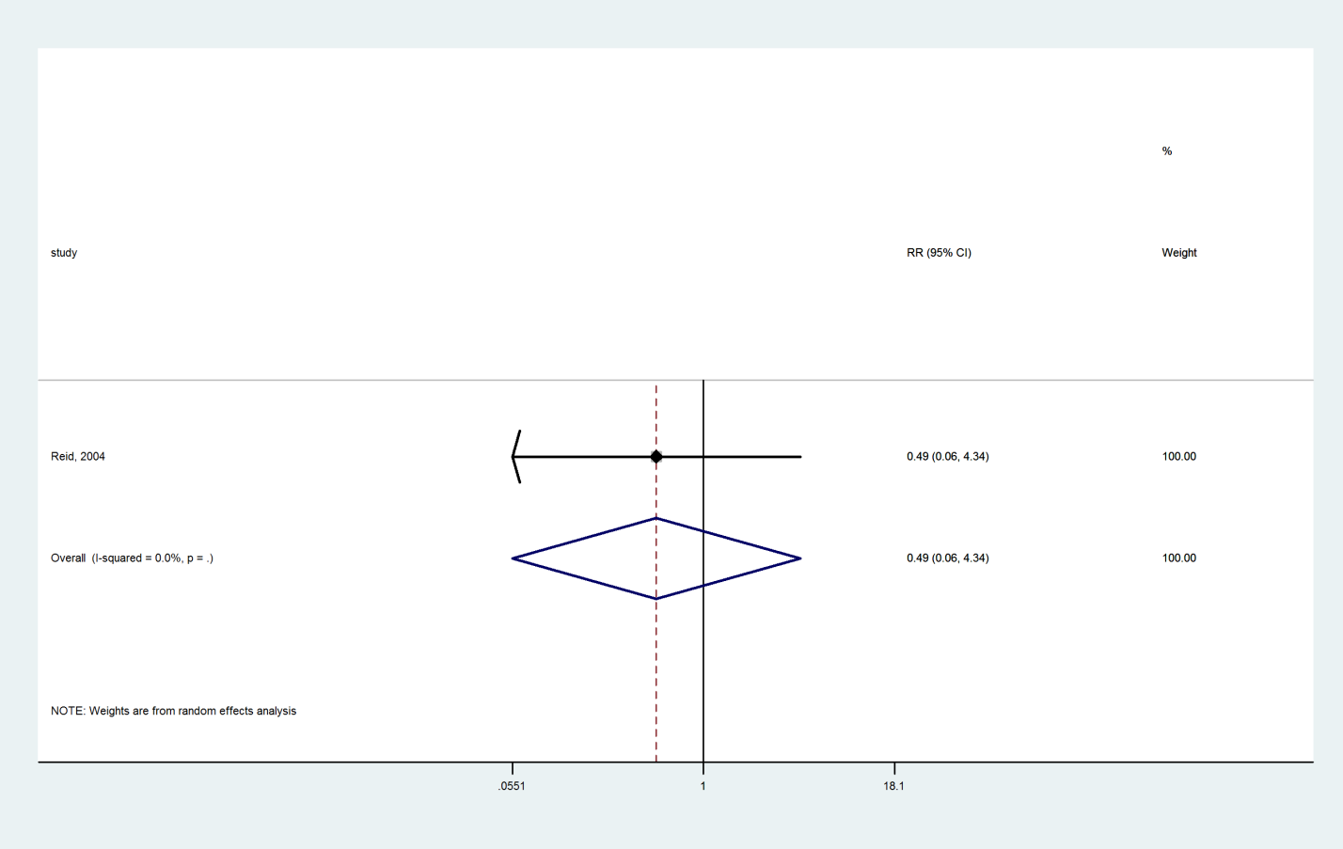

### Alendronate compared with Risedronate

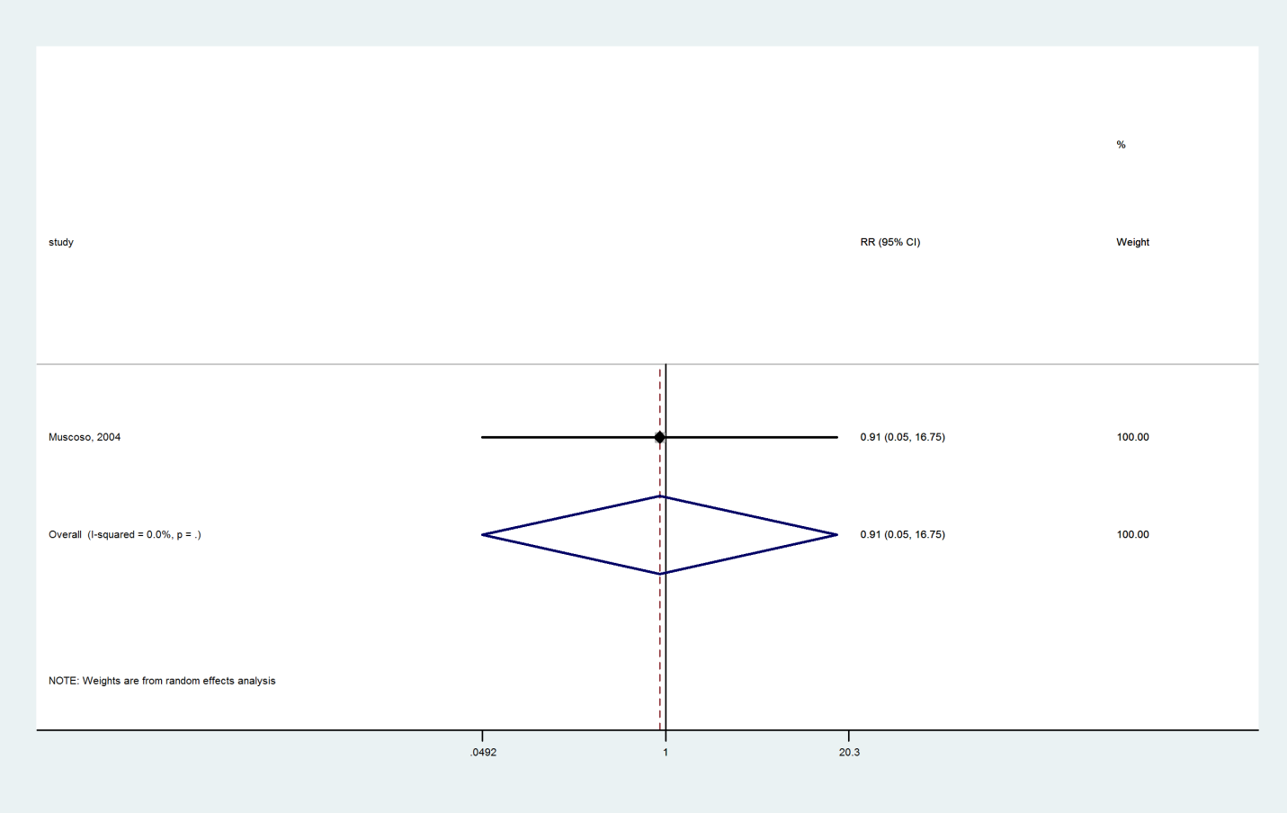

### Alendronate compared with Ibandronate

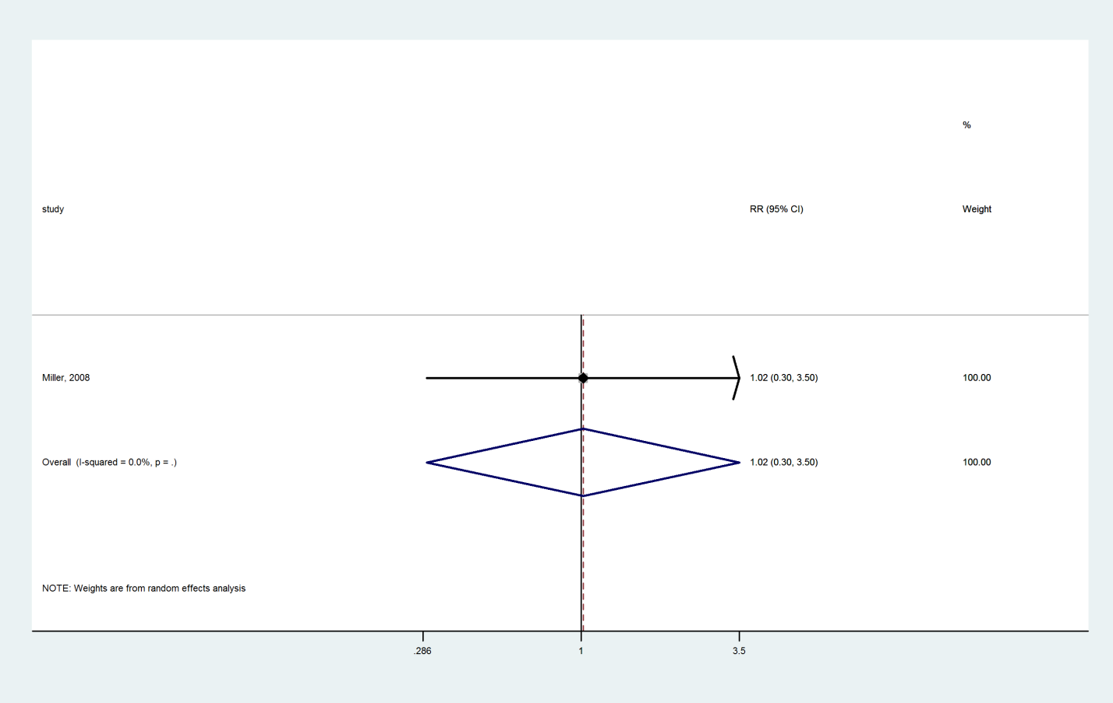

### Hormone therapy compared with Alendronate

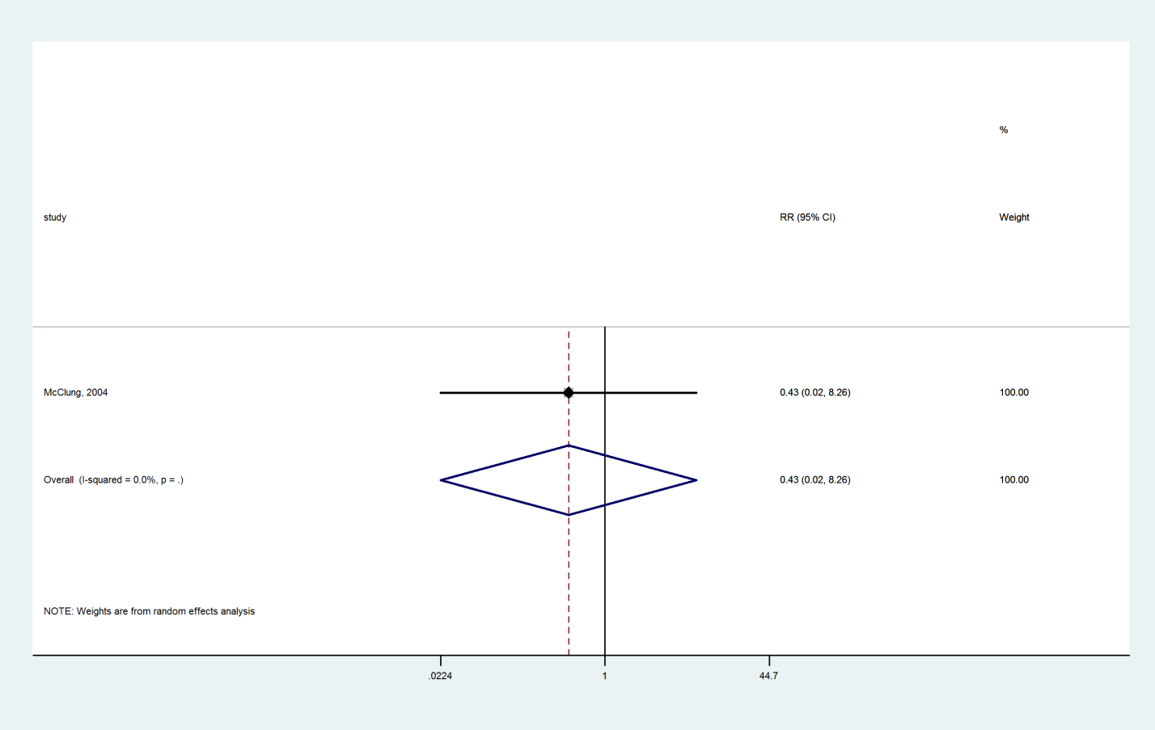

### Calcitonin compared with Alendronate

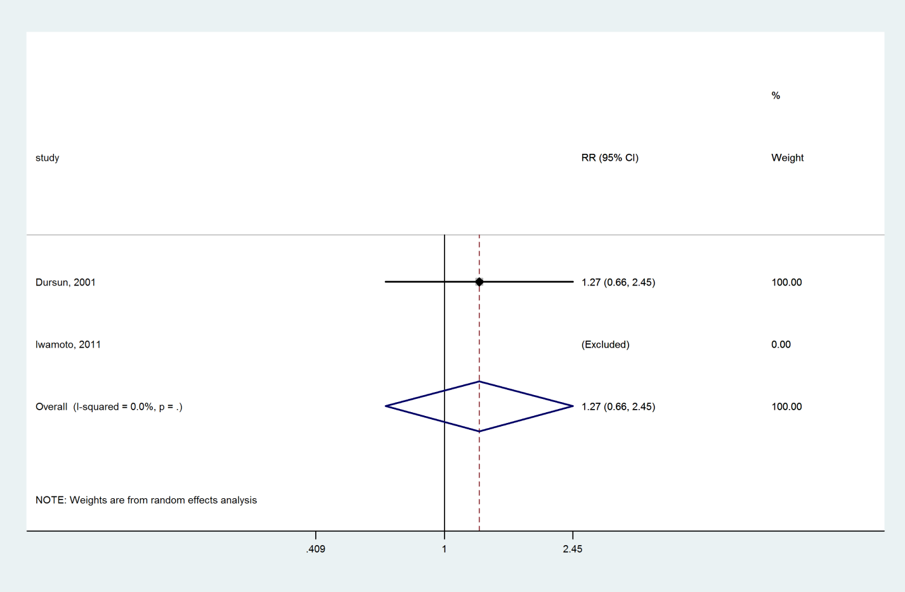

### Calcitonin compared with Hormone therapy

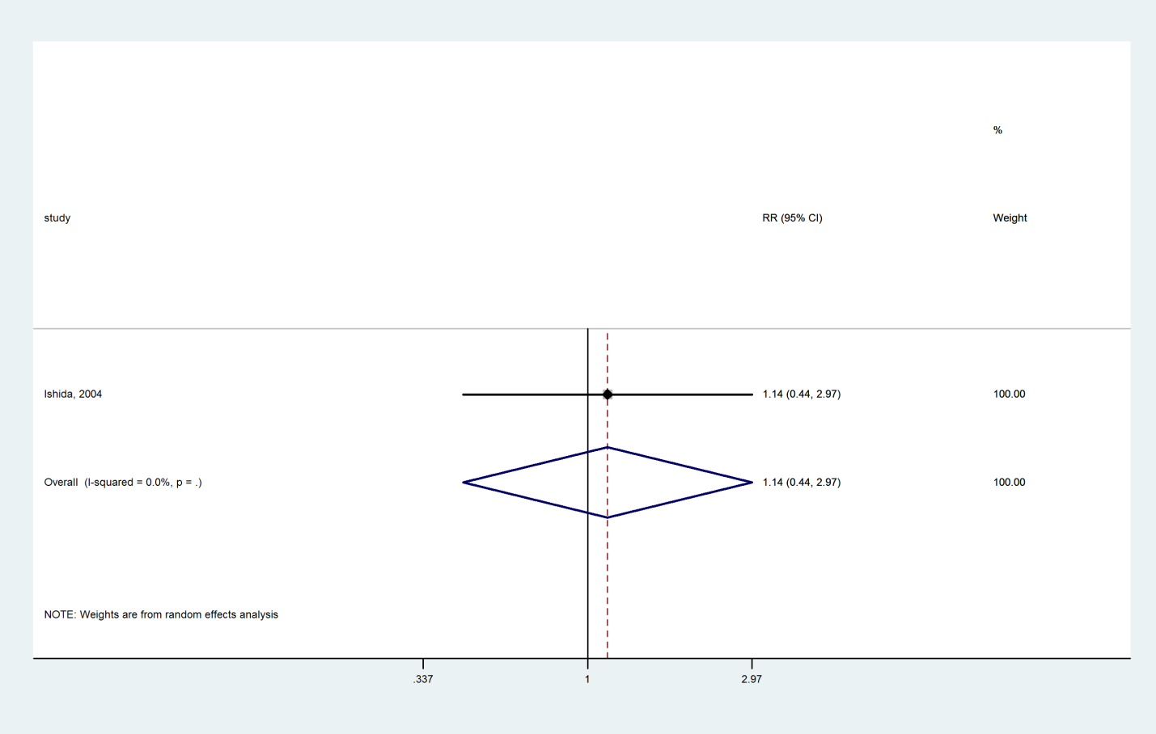

### Vitamin D compared with Hormone therapy

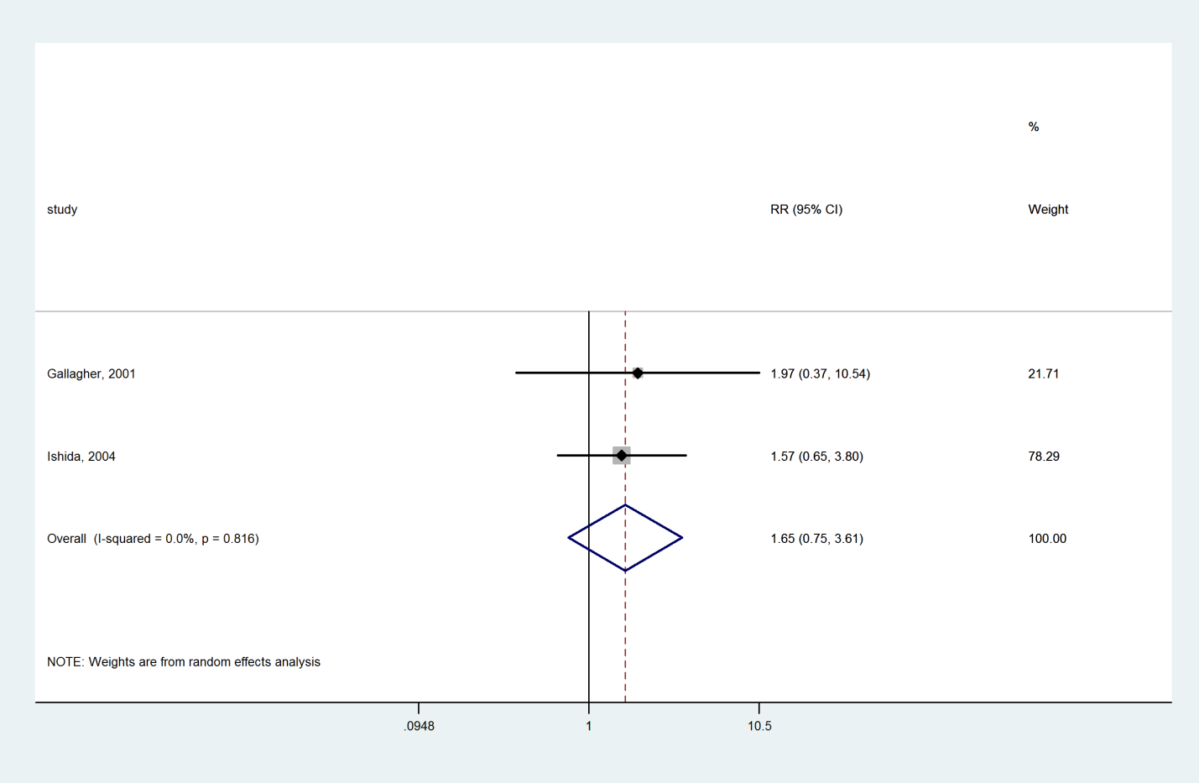

### Vitamin D compared with Calcitonin

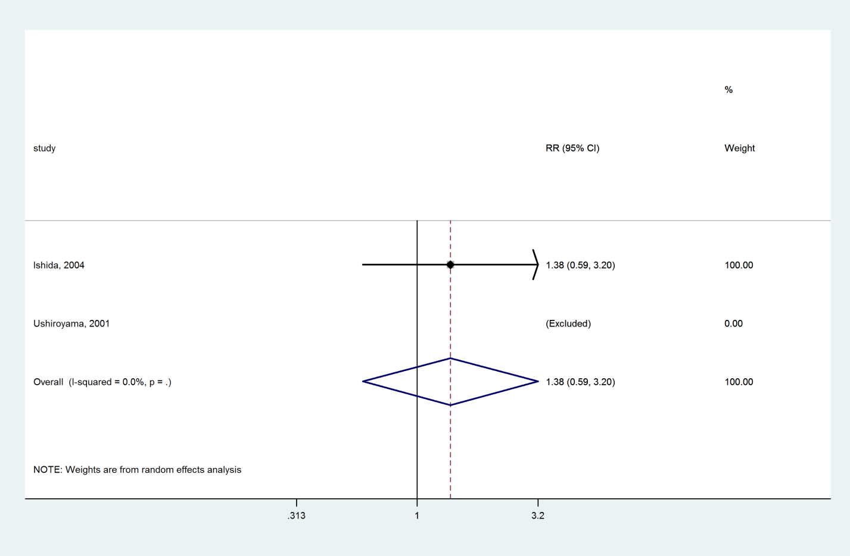

### Romosozumab compared with Alendronate

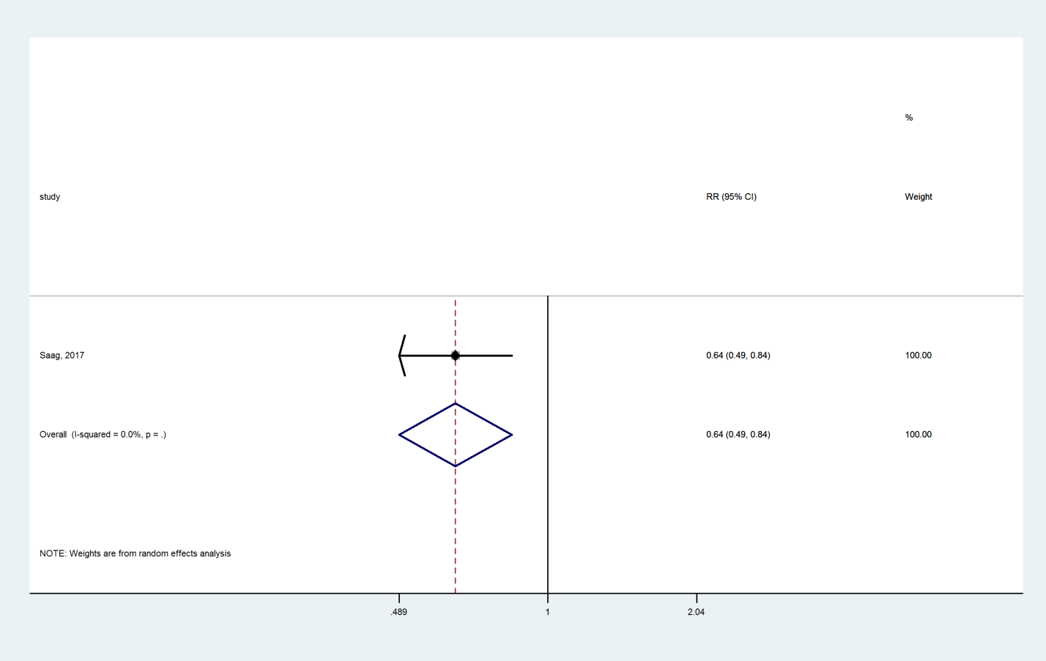

### Abaloparatide compared with Alendronate

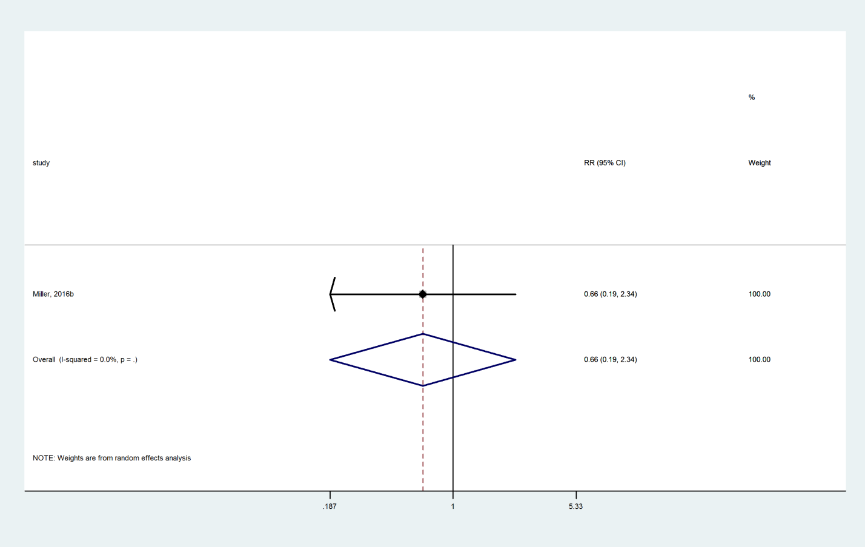

# Sensitivity analyses based on dosage and route

## Zoledronate: Nonvertebral Fracture

### Zoledronate compared with Placebo using 5 mg single dose

Y:\TES osteoporosis in women\SR in efficacy\6. Analysis\Direct and Indirect with STATA\2017-08\Direct\trt2_trt1_nonvert_5mg.wmf

### Zoledronate compared with Placebo using other doses

Y:\TES osteoporosis in women\SR in efficacy\6. Analysis\Direct and Indirect with STATA\2017-08\Direct\trt2_trt1_nonvert_otherdose.wmf

## Zoledronate: vertebral fractures

### Zoledronate compared with Placebo using 5 mg single dose

Y:\TES osteoporosis in women\SR in efficacy\6. Analysis\Direct and Indirect with STATA\2017-08\Direct\trt2_trt1_vert_5mg.wmf

## Calcitonin: Vertebral Fracture

### Calcitonin compared with Placebo using the intranasal route

Y:\TES osteoporosis in women\SR in efficacy\6. Analysis\Direct and Indirect with STATA\2017-08\Direct\trt2_trt1_intranasal.wmf

### Calcitonin compared with Placebo using the injectable route

Y:\TES osteoporosis in women\SR in efficacy\6. Analysis\Direct and Indirect with STATA\2017-08\Direct\trt2_trt1_nvert_intran_inject.wmf

### Calcitonin compared with Placebo using the oral route

Y:\TES osteoporosis in women\SR in efficacy\6. Analysis\Direct and Indirect with STATA\2017-08\Direct\trt2_trt1_oral.wmf

# Search strategies

|  |  |  |  |
| --- | --- | --- | --- |
| **Ovid MEDLINE(R) In-Process & Other Non-Indexed Citations and Ovid MEDLINE(R)** 1946 to Present | | | |
| 1 | exp osteoporosis/ or osteopenia/ or osteoporo\*.mp. or osteopeni\*.mp. or osteopaen\*.mp. or fragil\*.mp. [mp=title, abstract, original title, name of substance word, subject heading word, keyword heading word, protocol supplementary concept word, rare disease supplementary concept word, unique identifier] |  |  |
| 2 | exp fractures, bone/ |  |  |
| 3 | 1 and 2 |  |  |
| 4 | exp bone density conservation agents/ or exp calcium/ or exp selective estrogen receptor modulators/ or exp vitamin d/ |  |  |
| 5 | (alendronate or etidronate).mp. or ibandronate/ or pamidronate.mp. or residronate.mp. or zolendronate.mp. or bisphosphonate.mp. or disphosphonate.mp. or calcitonin.mp. [mp=title, abstract, original title, name of substance word, subject heading word, keyword heading word, protocol supplementary concept word, rare disease supplementary concept word, unique identifier] |  |  |
| 6 | (raloxifen\* or tamoxifen\* or teriparatide or abaloparatide or romosozumab or bazedoxifene or lasofoxifene or denosumab or pth).mp. [mp=title, abstract, original title, name of substance word, subject heading word, keyword heading word, protocol supplementary concept word, rare disease supplementary concept word, unique identifier] |  |  |
| 7 | randomized controlled trial.pt. |  |  |
| 8 | controlled clinical trial.pt. |  |  |
| 9 | randomized controlled trials/ |  |  |
| 10 | random allocation.sh. |  |  |
| 11 | double blind method.sh. |  |  |
| 12 | single-blind method.sh. |  |  |
| 13 | clinical trial$.pt. |  |  |
| 14 | exp clinical trials/ |  |  |
| 15 | (clinic$ adj25 trial$1).ti,ab. |  |  |
| 16 | ((singl$ or doubl$ or trebl$ or tripl$) adj (blind$ or mask$)).ti,ab. |  |  |
| 17 | placebos.sh. or placebo$.ti,ab. |  |  |
| 18 | random$.ti,ab. |  |  |
| 19 | research design.sh. |  |  |
| 20 | exp evaluation studies/ |  |  |
| 21 | follow up studies.sh. |  |  |
| 22 | prospective studies.sh. |  |  |
| 23 | or/7-22 |  |  |
| 24 | 3 and (4 or 5 or 6) |  |  |
| 25 | 2 and bone density/de and (4 or 5 or 6) |  |  |
| 26 | 24 or 25 |  |  |
| 27 | 26 and ((placebo\* or systematic\*).mp. or comparative study/) [mp=title, abstract, original title, name of substance word, subject heading word, keyword heading word, protocol supplementary concept word, rare disease supplementary concept word, unique identifier] |  |  |
| 28 | 26 and 23 |  |  |
| 29 | 27 or 28 |  |  |
| 30 | exp Menopause/ |  |  |
| 31 | limit 29 to (("all aged (65 and over)" or "aged (80 and over)") and female) |  |  |
| 32 | 29 and 30 |  |  |
| 33 | 31 or 32 |  |  |
| 34 | osteoporotic fractures/ and (4 or 5 or 6) and 23 |  |  |
| 35 | 33 or 34 |  |  |
| 36 | limit 35 to yr="2012 - 2015" |  |  |
| 37 | ..l/ 35 yr="2011" |  |  |
| 38 | 36 or 37 |  |  |
| 39 | 38 and (2012\* or 2013\* or 2014\* or 2015).em. |  |  |

4 duplicates removed

|  |  |  |  |
| --- | --- | --- | --- |
| **Ovid MEDLINE(R) In-Process & Other Non-Indexed Citations and Ovid MEDLINE(R)** 1946 to Present | | | |
| 1 | exp osteoporosis/ or osteopenia/ or osteoporo\*.mp. or osteopeni\*.mp. or osteopaen\*.mp. or fragil\*.mp. [mp=title, abstract, original title, name of substance word, subject heading word, keyword heading word, protocol supplementary concept word, rare disease supplementary concept word, unique identifier] |  |  |
| 2 | exp fractures, bone/ |  |  |
| 3 | randomized controlled trial.pt. |  |  |
| 4 | controlled clinical trial.pt. |  |  |
| 5 | randomized controlled trials/ |  |  |
| 6 | random allocation.sh. |  |  |
| 7 | double blind method.sh. |  |  |
| 8 | single-blind method.sh. |  |  |
| 9 | clinical trial$.pt. |  |  |
| 10 | exp clinical trials/ |  |  |
| 11 | (clinic$ adj25 trial$1).ti,ab. |  |  |
| 12 | ((singl$ or doubl$ or trebl$ or tripl$) adj (blind$ or mask$)).ti,ab. |  |  |
| 13 | placebos.sh. or placebo$.ti,ab. |  |  |
| 14 | random$.ti,ab. |  |  |
| 15 | research design.sh. |  |  |
| 16 | exp evaluation studies/ |  |  |
| 17 | follow up studies.sh. |  |  |
| 18 | prospective studies.sh. |  |  |
| 19 | or/3-18 |  |  |
| 20 | exp Menopause/ |  |  |
| 21 | (1 and 2) or osteoporotic fractures/ |  |  |
| 22 | exp Calcium Compounds/ |  |  |
| 23 | exp Vitamin D/ |  |  |
| 24 | Calcitonin/ |  |  |
| 25 | exp Estrogens/ |  |  |
| 26 | (bazedoxifene or lasofoxifene or tibolone).mp. or parathyroid hormone/ [mp=title, abstract, original title, name of substance word, subject heading word, keyword heading word, protocol supplementary concept word, rare disease supplementary concept word, unique identifier] |  |  |
| 27 | strontium ranelate.mp. |  |  |
| 28 | 21 and (22 or 23 or 24 or 25 or 26 or 27) |  |  |
| 29 | exp menopause/ |  |  |
| 30 | 28 and 29 |  |  |
| 31 | limit 28 to (("all aged (65 and over)" or "aged (80 and over)") and female) |  |  |
| 32 | 30 or 31 |  |  |
| 33 | 19 and 32 |  |  |
| 34 | limit 33 to yr="2004 - 2015" |  |  |
| 35 | exp hormone replacement therapy/ and 21 |  |  |
| 36 | 29 and 35 |  |  |
| 37 | limit 35 to (("all aged (65 and over)" or "aged (80 and over)") and female) |  |  |
| 38 | 19 and (36 or 37) |  |  |
| 39 | limit 38 to yr="2004 - 2015" |  |  |

|  |  |  |  |
| --- | --- | --- | --- |
| **Embase** 1988 to 2015 Week 12 | | | |
| 1 | fragility fracture/ |  |  |
| 2 | osteoporosis/ or involutional osteoporosis/ or postmenopause osteoporosis/ or primary osteoporosis/ or secondary osteoporosis/ or senile osteoporosis/ |  |  |
| 3 | exp fracture/ |  |  |
| 4 | (2 or metabolic bone disease/) and 3 |  |  |
| 5 | 1 or 4 |  |  |
| 6 | exp bisphosphonic acid derivative/ |  |  |
| 7 | exp selective estrogen receptor modulator/ |  |  |
| 8 | denosumab/ |  |  |
| 9 | "parathyroid hormone[1-34]"/ |  |  |
| 10 | hormone substitution/ or estrogen therapy/ |  |  |
| 11 | exp estrogen/ |  |  |
| 12 | exp calcitonin/ |  |  |
| 13 | bazedoxifene/ |  |  |
| 14 | lasofoxifene/ |  |  |
| 15 | strontium ranelate/ |  |  |
| 16 | tibolone/ |  |  |
| 17 | 6 or 7 or 8 or 9 or 10 or 11 or 12 |  |  |
| 18 | 5 and 17 and (randomized controlled trial/ or meta-analysis/ or systematic review/ or random\*.mp.) [mp=title, abstract, subject headings, heading word, drug trade name, original title, device manufacturer, drug manufacturer, device trade name, keyword] |  |  |
| 19 | menopause/ or postmenopause/ |  |  |
| 20 | 18 and 19 and female/ |  |  |
| 21 | ..l/ 20 yr=2011-2015 |  |  |
| 22 | 21 and (201148\* or 2012\* or 2013\* or 2014\* or 2015).em. |  |  |
| 23 | exp calcium/ or exp vitamin d/ or calcium intake/ |  |  |
| 24 | 12 or 23 |  |  |
| 25 | 19 and 24 and (randomized controlled trial/ or random\*.mp. or meta-analysis/ or systematic review/) [mp=title, abstract, subject headings, heading word, drug trade name, original title, device manufacturer, drug manufacturer, device trade name, keyword] |  |  |
| 26 | 5 and 25 and female/ |  |  |
| 27 | limit 26 to yr="2007 - 2015" |  |  |
| 28 | 27 and (200736\* or 200737\* or 200738\* or 200739\* or 20074\* or 20075\* or 2008\* or 2009\* or 201\*).em. |  |  |
| 29 | 12 or 13 or 14 or 15 or 16 |  |  |
| 30 | 5 and 29 and (randomized controlled trial/ or random\*.mp. or meta-analysis/ or systematic review/) [mp=title, abstract, subject headings, heading word, drug trade name, original title, device manufacturer, drug manufacturer, device trade name, keyword] |  |  |
| 31 | 30 and 19 |  |  |
| 32 | 31 and female/ |  |  |
| 33 | ..l/ 32 yr=2004-2015 |  |  |
| 34 | 22 or 28 or 33 |  |  |

|  |  |  |  |
| --- | --- | --- | --- |
| **#** | **Query** | **Limiters/Expanders** | **Last Run Via** |
| S21 | S3 AND S11 AND S20 | Limiters - Published Date: 20040101-20150317 Search modes - Boolean/Phrase | Interface - EBSCOhost Research Databases Search Screen - Advanced Search Database - CINAHL with Full Text |
| S20 | S18 OR S19 | Search modes - Boolean/Phrase | Interface - EBSCOhost Research Databases Search Screen - Advanced Search Database - CINAHL with Full Text |
| S19 | (MH "Parathyroid Hormones+") OR (MH "Teriparatide") | Limiters - Published Date: 20070801-20150317 Search modes - Boolean/Phrase | Interface - EBSCOhost Research Databases Search Screen - Advanced Search Database - CINAHL with Full Text |
| S18 | "strontium ranelate" | Limiters - Published Date: 20070801-20150317 Search modes - Boolean/Phrase | Interface - EBSCOhost Research Databases Search Screen - Advanced Search Database - CINAHL with Full Text |
| S17 | S3 AND S11 AND S16 | Limiters - Published Date: 20070801-20150317 Search modes - Boolean/Phrase | Interface - EBSCOhost Research Databases Search Screen - Advanced Search Database - CINAHL with Full Text |
| S16 | S13 OR S14 OR S15 | Search modes - Boolean/Phrase | Interface - EBSCOhost Research Databases Search Screen - Advanced Search Database - CINAHL with Full Text |
| S15 | (MH "Calcitonin") | Limiters - Published Date: 20111101-20150317 Search modes - Boolean/Phrase | Interface - EBSCOhost Research Databases Search Screen - Advanced Search Database - CINAHL with Full Text |
| S14 | (MH "Calcium") OR (MH "Calcium, Dietary") | Limiters - Published Date: 20111101-20150317 Search modes - Boolean/Phrase | Interface - EBSCOhost Research Databases Search Screen - Advanced Search Database - CINAHL with Full Text |
| S13 | (MH "Vitamin D+") OR (MH "Ergocalciferols") OR (MH "Cholecalciferol") OR (MH "Calcitriol") | Limiters - Published Date: 20111101-20150317 Search modes - Boolean/Phrase | Interface - EBSCOhost Research Databases Search Screen - Advanced Search Database - CINAHL with Full Text |
| S12 | S10 AND S11 | Limiters - Published Date: 20111101-20150317 Search modes - Boolean/Phrase | Interface - EBSCOhost Research Databases Search Screen - Advanced Search Database - CINAHL with Full Text |
| S11 | (MH "Menopause+") OR (MH "Postmenopause") OR (MH "Postmenopausal Disorders") | Search modes - Boolean/Phrase | Interface - EBSCOhost Research Databases Search Screen - Advanced Search Database - CINAHL with Full Text |
| S10 | S3 AND S9 | Search modes - Boolean/Phrase | Interface - EBSCOhost Research Databases Search Screen - Advanced Search Database - CINAHL with Full Text |
| S9 | S4 OR S5 OR S6 OR S7 OR S8 | Search modes - Boolean/Phrase | Interface - EBSCOhost Research Databases Search Screen - Advanced Search Database - CINAHL with Full Text |
| S8 | (MH "Hormone Replacement Therapy+") OR (MH "Estrogens+") OR (MH "Estrogens, Conjugated") | Search modes - Boolean/Phrase | Interface - EBSCOhost Research Databases Search Screen - Advanced Search Database - CINAHL with Full Text |
| S7 | "denosumab" | Search modes - Boolean/Phrase | Interface - EBSCOhost Research Databases Search Screen - Advanced Search Database - CINAHL with Full Text |
| S6 | (MH "Teriparatide") | Search modes - Boolean/Phrase | Interface - EBSCOhost Research Databases Search Screen - Advanced Search Database - CINAHL with Full Text |
| S5 | (MH "Selective Estrogen Receptor Modulators+") | Search modes - Boolean/Phrase | Interface - EBSCOhost Research Databases Search Screen - Advanced Search Database - CINAHL with Full Text |
| S4 | (MH "Diphosphonates+") | Search modes - Boolean/Phrase | Interface - EBSCOhost Research Databases Search Screen - Advanced Search Database - CINAHL with Full Text |
| S3 | S1 AND S2 | Search modes - Boolean/Phrase | Interface - EBSCOhost Research Databases Search Screen - Advanced Search Database - CINAHL with Full Text |
| S2 | (MH "Fractures+") | Search modes - Boolean/Phrase | Interface - EBSCOhost Research Databases Search Screen - Advanced Search Database - CINAHL with Full Text |
| S1 | (MH "Osteoporosis+") | Search modes - Boolean/Phrase | Interface - EBSCOhost Research Databases Search Screen - Advanced Search Database - CINAHL with Full Text |

Web of Science

(osteoporo\* OR “bone density” OR “bone loss” OR osteopaen\* OR osteopenia\* OR bmd OR “bone mineral density” OR fragility) AND fractur\* AND (elderly OR menopaus\* OR postmenopaus\*) AND (randomized OR randomized OR RCT\* OR meta-analysis OR systematic\*)

AND

(bisphosphon\* OR diphosphon\* OR alendron\* OR etidron\* OR ibandron\* OR pamidronat\* OR residronat\* OR zolendron\* OR SERMS OR raloxifen\* OR tamoxifen\* OR denosumab OR estrogen\* OR oestrogen\*) Limit to 2012-2015

OR

(“vitamin d\*” OR dihydrotachysterol OR calcitriol OR cholecalciferol OR colecalciferol OR alfacalcidol OR hydroxyvitamin\* OR dihydroxyvitamin\*) Limit to 2007-2015

OR

(bazedoxifen\* OR lasofoxafen\* OR pth OR “parathyroid hormone” OR “1-84” OR “1-48” OR teriparatide OR “strontium ranulate”) Limit to 2004-2015

2017 update

|  |  |  |  |  |  |  |  |  |  |  |  |  |  |  |  |  |  |  |  |  |  |  |  |  |  |  |  |  |  |  |  |  |  |  |  |  |  |  |  |  |  |  |  |  |  |  |  |  |  |  |  |  |  |  |  |  |  |  |  |  |  |  |  |  |  |  |  |  |  |  |  |  |  |  |  |  |  |  |  |  |  |  |  |  |  |  |  |  |  |  |  |  |  |  |  |  |  |  |  |  |  |  |  |  |  |  |  |  |  |  |  |  |  |  |  |  |  |  |  |  |  |  |  |  |  |  |  |  |  |  |  |  |  |  |  |  |  |  |  |  |  |  |  |  |  |  |  |  |  |  |  |  |  |  |  |  |  |  |  |  |  |  |  |  |  |  |  |  |  |  |  |  |  |  |  |  |  |  |  |  |  |  |  |  |  |  |  |  |  |  |  |  |  |  |  |  |  |  |  |  |  |  |  |  |  |  |  |  |  |  |  |  |  |  |  |  |  |  |  |  |  |  |  |  |  |  |  |  |  |  |  |  |  |  |  |  |  |  |  |  |  |  |  |  |  |  |  |  |  |  |  |  |  |  |  |  |  |  |  |  |  |  |  |  |
| --- | --- | --- | --- | --- | --- | --- | --- | --- | --- | --- | --- | --- | --- | --- | --- | --- | --- | --- | --- | --- | --- | --- | --- | --- | --- | --- | --- | --- | --- | --- | --- | --- | --- | --- | --- | --- | --- | --- | --- | --- | --- | --- | --- | --- | --- | --- | --- | --- | --- | --- | --- | --- | --- | --- | --- | --- | --- | --- | --- | --- | --- | --- | --- | --- | --- | --- | --- | --- | --- | --- | --- | --- | --- | --- | --- | --- | --- | --- | --- | --- | --- | --- | --- | --- | --- | --- | --- | --- | --- | --- | --- | --- | --- | --- | --- | --- | --- | --- | --- | --- | --- | --- | --- | --- | --- | --- | --- | --- | --- | --- | --- | --- | --- | --- | --- | --- | --- | --- | --- | --- | --- | --- | --- | --- | --- | --- | --- | --- | --- | --- | --- | --- | --- | --- | --- | --- | --- | --- | --- | --- | --- | --- | --- | --- | --- | --- | --- | --- | --- | --- | --- | --- | --- | --- | --- | --- | --- | --- | --- | --- | --- | --- | --- | --- | --- | --- | --- | --- | --- | --- | --- | --- | --- | --- | --- | --- | --- | --- | --- | --- | --- | --- | --- | --- | --- | --- | --- | --- | --- | --- | --- | --- | --- | --- | --- | --- | --- | --- | --- | --- | --- | --- | --- | --- | --- | --- | --- | --- | --- | --- | --- | --- | --- | --- | --- | --- | --- | --- | --- | --- | --- | --- | --- | --- | --- | --- | --- | --- | --- | --- | --- | --- | --- | --- | --- | --- | --- | --- | --- | --- | --- | --- | --- | --- | --- | --- | --- | --- | --- | --- | --- | --- | --- | --- | --- | --- | --- | --- | --- | --- | --- | --- | --- | --- |
| **Ovid MEDLINE(R) Epub Ahead of Print, In-Process & Other Non-Indexed Citations, Ovid MEDLINE(R) Daily and Ovid MEDLINE(R) <1946 to Present>**   |  |  |  |  | | --- | --- | --- | --- | |  |  |  |  | | 1 exp osteoporosis/ or osteopenia/ or osteoporo\*.mp. or osteopeni\*.mp. or osteopaen  \*.mp. or fragil\*.mp. | | | | | | |  | | 2 | exp fractures, bone/ |  |  |  |  |  | | 3 | 1 and 2 |  |  |  |  |  | | 4 | exp bone density conservation agents/ or exp calcium/ or exp selective estrogen receptor modulators/ or exp vitamin d/ |  |  |  |  |  | | 5 | (alendronate or etidronate).mp. or ibandronate/ or pamidronate.mp. or residronate.mp. or zolendronate.mp. or bisphosphonate.mp. or disphosphonate.mp. or calcitonin.mp. |  |  |  |  |  | | 6 | (raloxifen\* or tamoxifen\* or teriparatide or bazedoxifene or lasofoxifene or denosumab or pth).mp. |  |  |  |  |  | | 7 | randomized controlled trial.pt. |  |  |  |  |  | | 8 | controlled clinical trial.pt. |  |  |  |  |  | | 9 | randomized controlled trials/ |  |  |  |  |  | | 10 | random allocation.sh. |  |  |  |  |  | | 11 | double blind method.sh. |  |  |  |  |  | | 12 | single-blind method.sh. |  |  |  |  |  | | 13 | clinical trial$.pt. |  |  |  |  |  | | 14 | (clinic$ adj25 trial$1).ti,ab. |  |  |  |  |  | | 15 | ((singl$ or doubl$ or trebl$ or tripl$) adj (blind$ or mask$)).ti,ab. |  |  |  |  |  | | 16 | placebos.sh. or placebo$.ti,ab. |  |  |  |  |  | | 17 | random$.ti,ab. |  |  |  |  |  | | 18 | research design.sh. |  |  |  |  |  | | 19 | exp evaluation studies/ |  |  |  |  |  | | 20 | follow up studies.sh. |  |  |  |  |  | | 21 | prospective studies.sh. |  |  |  |  |  | | 22 | or/7-21 |  |  |  |  |  | | 23 | 3 and (4 or 5 or 6) |  |  |  |  |  | | 24 | 2 and bone density/de and (4 or 5 or 6) |  |  |  |  |  | | 25 | 23 or 24 |  |  |  |  |  | | 26 | 25 and ((placebo\* or systematic\*).mp. or comparative study/) |  |  |  |  |  | | 27 | 22 and 25 |  |  |  |  |  | | 28 | 26 or 27 |  |  |  |  |  | | 29 | exp menopause/ |  |  |  |  |  | | 30 | limit 28 to (("all aged (65 and over)" or "aged (80 and over)") and female) |  |  |  |  |  | | 31 | 28 and 29 |  |  |  |  |  | | 32 | 30 or 31 |  |  |  |  |  | | 33 | osteoporotic fractures/ and (4 or 5 or 6) and 22 |  |  |  |  |  | | 34 | 32 or 33 |  |  |  |  |  | | 35 | 34 and (201504\* or 201505\* or 201506\* or 201507\* or 201508\* or 201509\* or 20151\* or 2016\* or 2017\*).dc. |  |  |  |  |  | | 36 | remove duplicates from 35 |  |  |  |  |  | |  |  |  |  |  |  |  | |

CENTRAL 44 same as above strategy

**Ovid MEDLINE(R) Epub Ahead of Print, In-Process & Other Non-Indexed Citations, Ovid MEDLINE(R) Daily and Ovid MEDLINE(R) <1946 to Present>**

|  |  |  |  |  |  |  |
| --- | --- | --- | --- | --- | --- | --- |
|  | | | | | | |
| 1 | exp osteoporosis/ or osteopenia/ or osteoporo\*.mp. or osteopeni\*.mp. or osteopaen\*.mp. or fragil\*.mp. |  |  |  |  |  |
| 2 | exp fractures, bone/ |  |  |  |  |  |
| 3 | randomized controlled trial.pt. |  |  |  |  |  |
| 4 | controlled clinical trial.pt. |  |  |  |  |  |
| 5 | randomized controlled trials/ |  |  |  |  |  |
| 6 | random allocation.sh. |  |  |  |  |  |
| 7 | double blind method.sh. |  |  |  |  |  |
| 8 | single-blind method.sh. |  |  |  |  |  |
| 9 | clinical trial$.pt. |  |  |  |  |  |
| 10 | (clinic$ adj25 trial$1).ti,ab. |  |  |  |  |  |
| 11 | ((singl$ or doubl$ or trebl$ or tripl$) adj (blind$ or mask$)).ti,ab. |  |  |  |  |  |
| 12 | placebos.sh. or placebo$.ti,ab. |  |  |  |  |  |
| 13 | random$.ti,ab. |  |  |  |  |  |
| 14 | research design.sh. |  |  |  |  |  |
| 15 | exp evaluation studies/ | 234194 | Advanced |  |  |  |
| 16 | follow up studies.sh. | 593252 | Advanced |  |  |  |
| 17 | prospective studies.sh. | 464599 | Advanced |  |  |  |
| 18 | or/3-17 | 2758673 | Advanced |  |  |  |
| 19 | exp menopause/ or menopaus\*.mp. or postmenopaus\*.mp. [mp=title, abstract, original title, name of substance word, subject heading word, keyword heading word, protocol supplementary concept word, rare disease supplementary concept word, unique identifier, synonyms] | 101127 | Advanced |  |  |  |
| 20 | (1 and 2) or osteoporotic fractures/ | 21321 | Advanced |  |  |  |
| 21 | exp calcium compounds/ | 69384 | Advanced |  |  |  |
| 22 | exp vitamin d/ | 52571 | Advanced |  |  |  |
| 23 | calcitonin/ | 15364 | Advanced |  |  |  |
| 24 | exp estrogens/ | 155934 | Advanced |  |  |  |
| 25 | (bazedoxifene or lasofoxifene or tibolone).mp. or parathyroid hormone/ | 28414 | Advanced |  |  |  |
| 26 | strontium ranelate.mp. | 739 | Advanced |  |  |  |
| 27 | 20 and (21 or 22 or 23 or 24 or 25 or 26 or ex hormone replacement therapy/) | 2990 | Advanced |  |  |  |
| 28 | ((vitamin adj1 d\*) or calcitonin\* or estrogen\* or oestrogen\* or estradiol\* or oestradiol\* or calcium\*).mp. [mp=title, abstract, original title, name of substance word, subject heading word, keyword heading word, protocol supplementary concept word, rare disease supplementary concept word, unique identifier, synonyms] | 868766 | Advanced |  |  |  |
| 29 | 20 and 28 | 4957 | Advanced |  |  |  |
| 30 | 27 or 29 | 5294 | Advanced |  |  |  |
| 31 | 19 and 30 | 2370 | Advanced |  |  |  |
| 32 | limit 30 to (("all aged (65 and over)" or "aged (80 and over)") and female) | 2466 | Advanced |  |  |  |
| 33 | (31 or 32) and 18 | 1344 | Advanced |  |  |  |
| 34 | 33 and (201504\* or 201505\* or 201506\* or 201507\* or 201508\* or 201509\* or 20151\* or 2016\* or 2017\*).dc. | 87 | Advanced |  |  |  |
| 35 | remove duplicates from 34 | 70 |  |  |  |  |

CENTRAL 26, strategy same as above.

**Embase <1988 to 2017 Week 27>**

|  |  |  |  |  |  |  |
| --- | --- | --- | --- | --- | --- | --- |
|  | | | | | | |
| 1 | fragility fracture/ |  |  |  |  |  |
| 2 | osteoporosis/ or involutional osteoporosis/ or postmenopause osteoporosis/ or primary osteoporosis/ or secondary osteoporosis/ or senile osteoporosis/ |  |  |  |  |  |
| 3 | exp fracture/ |  |  |  |  |  |
| 4 | (2 or metabolic bone disease/) and 3 |  |  |  |  |  |
| 5 | 1 or 4 |  |  |  |  |  |
| 6 | exp bisphosphonic acid derivative/ |  |  |  |  |  |
| 7 | exp selective estrogen receptor modulator/ |  |  |  |  |  |
| 8 | denosumab/ |  |  |  |  |  |
| 9 | "parathyroid hormone[1-34]"/ |  |  |  |  |  |
| 10 | hormone substitution/ or estrogen therapy/ |  |  |  |  |  |
| 11 | hormone substitution/ or estrogen therapy/ |  |  |  |  |  |
| 12 | exp calcitonin/ |  |  |  |  |  |
| 13 | bazedoxifene/ |  |  |  |  |  |
| 14 | lasofoxifene/ |  |  |  |  |  |
| 15 | strontium ranelate/ |  |  |  |  |  |
| 16 | tibolone/ |  |  |  |  |  |
| 17 | or/6-16 |  |  |  |  |  |
| 18 | 5 and 17 and (randomized controlled trial/ or meta-analysis/ or systematic review/ or random\*.mp.) |  |  |  |  |  |
| 19 | menopause/ or postmenopause/ |  |  |  |  |  |
| 20 | 18 and (19 or female/) |  |  |  |  |  |
| 21 | 20 and (201504\* or 201505\* or 201506\* or 201507\* or 201508\* or 201509\* or 20151\* or 2016\* or 2017\*).dc. |  |  |  |  |  |
| 22 | limit 20 to (female and adult <18 to 64 years>) |  |  |  |  |  |
| 23 | 22 and (201504\* or 201505\* or 201506\* or 201507\* or 201508\* or 201509\* or 20151\* or 2016\* or 2017\*).dc. |  |  |  |  |  |
| 24 | 21 or 23 |  |  |  |  |  |
| 25 | remove duplicates from 24 |  |  |  |  |  |

WEB of Science

|  |  |  |  |  |  |
| --- | --- | --- | --- | --- | --- |
| # 6 |  | #5 AND #1  *Indexes=SCI-EXPANDED, ESCI Timespan=2015-2017* |  |  |  |
|  | | | | | |
| # 5 |  | #4 OR #3 OR #2  *Indexes=SCI-EXPANDED, ESCI Timespan=2015-2017* |  |  |  |
|  | | | | | |
| # 4 |  | TS=(bazedoxifen\* OR lasofoxafen\* OR pth OR “parathyroid hormone” OR “1-84” OR “1-48” OR teriparatide OR “strontium ranulate”)  *Indexes=SCI-EXPANDED, ESCI Timespan=2015-2017* |  |  |  |
|  | | | | | |
| # 3 |  | TS=(“vitamin d\*” OR dihydrotachysterol OR calcitriol OR cholecalciferol OR colecalciferol OR alfacalcidol OR hydroxyvitamin\* OR dihydroxyvitamin\*)  *Indexes=SCI-EXPANDED, ESCI Timespan=2015-2017* |  |  |  |
|  | | | | | |
| # 2 |  | TS=(bisphosphon\* OR diphosphon\* OR alendron\* OR etidron\* OR ibandron\* OR pamidronat\* OR residronat\* OR zolendron\* OR SERMS OR raloxifen\* OR tamoxifen\* OR denosumab OR estrogen\* OR oestrogen\*)  *Indexes=SCI-EXPANDED, ESCI Timespan=2015-2017* |  |  |  |
|  | | | | | |
| # 1 |  | TS=((osteoporo\* OR bone density OR bone loss OR osteopaen\* OR osteopenia\* OR bmd OR bone mineral density OR fragility) AND fractur\* AND (elderly OR menopaus\* OR postmenopaus\*) AND (randomized OR randomized OR RCT\* OR meta-analysis OR systematic\*))  *Indexes=SCI-EXPANDED, ESCI Timespan=2015-2017* |  |  |  |

CINAHL

|  |  |
| --- | --- |
| **#** | **Query** |
| S23 | S12 OR S17 OR S21 |
| S22 | S12 OR S17 OR S21 |
| S21 | S3 AND S11 AND S20 |
| S20 | S18 OR S19 |
| S19 | (MH "Parathyroid Hormones+") OR (MH "Teriparatide") |
| S18 | "strontium ranelate" |
| S17 | S3 AND S11 AND S16 |
| S16 | S13 OR S14 OR S15 |
| S15 | (MH "Calcitonin") |
| S14 | (MH "Calcium") OR (MH "Calcium, Dietary") |
| S13 | (MH "Vitamin D+") OR (MH "Ergocalciferols") OR (MH "Cholecalciferol") OR (MH "Calcitriol") |
| S12 | S10 AND S11 |
| S11 | (MH "Menopause+") OR (MH "Postmenopause") OR (MH "Postmenopausal Disorders") |
| S10 | S3 AND S9 |
| S9 | S4 OR S5 OR S6 OR S7 OR S8 |
| S8 | (MH "Hormone Replacement Therapy+") OR (MH "Estrogens+") OR (MH "Estrogens, Conjugated") |
| S7 | "denosumab" |
| S6 | (MH "Teriparatide") |
| S5 | (MH "Selective Estrogen Receptor Modulators+") |
| S4 | (MH "Diphosphonates+") |
| S3 | S1 AND S2 |
| S2 | (MH "Fractures+") |
| S1 | (MH "Osteoporosis+") |