Table S1a: Radial Distribution Function and Coordination Number (CN) Calculation between cation (polar) and anion.
System | r_{peak} | g (r) | r _{min} | CN | System | r_{peak} | g (r) | r _{min} | CN | System | r_{peak} | g (r) | r _{min} | CN
S1a | 3.65 | 2.462 | 4.75 | 1.65 | S1b | 3.65 | 2.470 | 4.75 | 1.65 | S1c | 3.65 | 2.458 | 4.75 | 1.64
S2a | 3.85 | 1.987 | 4.75 | 1.15 | S2b | 3.85 | 1.985 | 4.75 | 1.15 | S2c | 3.85 | 1.953 | 4.75 | 1.12
S3a | 3.85 | 1.469 | 4.65 | 0.50 | S3b | 3.85 | 1.460 | 4.65 | 0.50 | S3c | 3.85 | 1.457 | 4.65 | 0.50
S4a | 3.95 | 1.318 | 4.55 | 0.16 | S4b | 3.95 | 1.319 | 4.55 | 0.16 | S4c | 3.95 | 1.317 | 4.55 | 0.16

Table S1b: Radial Distribution Function and Coordination Number (CN) Calculation between cation (non-polar) and cation (non-polar).
System | r_{peak} | g (r) | r _{min} | CN | System | r_{peak} | g (r) | r _{min} | CN | System | r_{peak} | g (r) | r _{min} | CN
S1a | 4.05 | 1.425 | 6.05 | 2.52 | S1b | 4.05 | 1.420 | 6.05 | 2.50 | S1c | 4.05 | 1.415 | 6.05 | 2.50
S2a | 4.05 | 1.327 | 6.05 | 1.85 | S2b | 4.05 | 1.326 | 6.05 | 1.85 | S2c | 4.05 | 1.319 | 6.05 | 1.83
S3a | 4.15 | 1.089 | 6.05 | 0.92 | S3b | 4.15 | 1.080 | 6.05 | 0.91 | S3c | 4.15 | 1.076 | 6.05 | 0.90
S4a | 4.15 | 0.825 | 5.85 | 0.23 | S4b | 4.15 | 0.820 | 5.95 | 0.25 | S4c | 4.15 | 0.811 | 5.85 | 0.23

Table S1c: Radial Distribution Function and Coordination Number (CN) Calculation between Water and anion.
System | r_{peak} | g (r) | r _{min} | CN | System | r_{peak} | g (r) | r _{min} | CN | System | r_{peak} | g (r) | r _{min} | CN
S2a | 3.55 | 4.130 | 4.35 | 3.33 | S2b | 3.55 | 4.127 | 4.35 | 3.33 | S2c | 3.55 | 4.080 | 4.35 | 3.38
S3a | 3.45 | 2.973 | 4.25 | 5.73 | S3b | 3.45 | 2.962 | 4.25 | 5.70 | S3c | 3.45 | 2.950 | 4.25 | 5.68
S4a | 3.45 | 2.449 | 4.25 | 7.08 | S4b | 3.45 | 2.450 | 4.25 | 7.08 | S4c | 3.45 | 2.401 | 4.25 | 6.95

Table S1d: Radial Distribution Function and Coordination Number (CN) Calculation between Water and cation (polar).
System | r_{peak} | g (r) | r _{min} | CN | System | r_{peak} | g (r) | r _{min} | CN | System | r_{peak} | g (r) | r _{min} | CN
S2a | 3.35 | 1.74 | 4.25 | 1.85 | S2b | 3.35 | 1.74 | 4.25 | 1.85 | S2c | 3.35 | 1.71 | 4.25 | 1.87
S3a | 3.35 | 1.21 | 4.15 | 2.94 | S3b | 3.35 | 1.20 | 4.15 | 2.93 | S3c | 3.35 | 1.20 | 4.15 | 2.91
S4a | 3.35 | 0.96 | 4.05 | 3.17 | S4b | 3.35 | 0.96 | 4.05 | 3.17 | S4c | 3.35 | 0.94 | 4.05 | 3.12

Table S1e: Radial Distribution Function and Coordination Number (CN) Calculation between Water-Water.
System | r_{peak} | g (r) | r _{min} | CN | System | r_{peak} | g (r) | r _{min} | CN | System | r_{peak} | g (r) | r _{min} | CN
S2a | 2.75 | 3.438 | 4.75 | 3.27 | S2b | 2.75 | 3.442 | 4.75 | 3.27 | S2c | 2.75 | 3.415 | 4.75 | 3.33
S3a | 2.85 | 3.008 | 4.65 | 7.15 | S3b | 2.85 | 3.005 | 4.65 | 7.13 | S3c | 2.85 | 2.998 | 4.65 | 7.10
S4a | 2.85 | 2.551 | 4.15 | 7.06 | S4b | 2.85 | 2.550 | 4.15 | 7.05 | S4c | 2.85 | 2.537 | 4.15 | 7.02
S5 | 2.85 | 2.327 | 4.05 | 7.21 | S5 | 2.85 | 2.327 | 4.05 | 7.21 | S5 | 2.85 | 2.327 | 4.05 | 7.21

Table S1f: Radial Distribution Function and Coordination Number (CN) Calculation between Cellulose and anion.
System | r_{peak} | g (r) | r _{min} | CN | System | r_{peak} | g (r) | r _{min} | CN | System | r_{peak} | g (r) | r _{min} | CN
S1a | 2.65 | 4.564 | 3.35 | 1.02 | S1b | 2.65 | 4.511 | 3.35 | 1.00 | S1c | 2.65 | 4.682 | 3.35 | 1.05
S2a | 2.65 | 4.721 | 3.35 | 0.84 | S2b | 2.65 | 4.783 | 3.35 | 0.85 | S2c | 2.65 | 4.870 | 3.35 | 0.87
S3a | 2.65 | 3.870 | 3.35 | 0.47 | S3b | 2.65 | 4.104 | 3.35 | 0.45 | S3c | 2.65 | 4.304 | 3.35 | 0.47
S4a | 2.65 | 2.705 | 3.35 | 0.11 | S4b | 2.65 | 2.722 | 3.35 | 0.11 | S4c | 2.65 | 3.881 | 3.35 | 0.16

Table S1g: Radial Distribution Function and Coordination Number (CN) Calculation between Cellulose and cation (polar).
System | r_{peak} | g (r) | r _{min} | CN | System | r_{peak} | g (r) | r _{min} | CN | System | r_{peak} | g (r) | r _{min} | CN
S1a | 3.25 | 1.056 | 4.15 | 0.53 | S1b | 3.35 | 1.027 | 4.15 | 0.52 | S1c | 3.25 | 1.076 | 4.15 | 0.55
S2a | 3.35 | 1.037 | 4.15 | 0.41 | S2b | 3.35 | 1.039 | 4.15 | 0.41 | S2c | 3.35 | 1.087 | 4.15 | 0.45
S3a | 3.35 | 0.805 | 4.05 | 0.18 | S3b | 3.35 | 0.856 | 4.05 | 0.19 | S3c | 3.35 | 0.897 | 4.05 | 0.20
S4a | 3.35 | 0.506 | 4.05 | 0.04 | S4b | 3.35 | 0.517 | 4.05 | 0.04 | S4c | 3.35 | 0.734 | 4.05 | 0.06

Table S1h: Radial Distribution Function and Coordination Number (CN) Calculation between Cellulose and Water.
System | r_{peak} | g (r) | r _{min} | CN | System | r_{peak} | g (r) | r _{min} | CN | System | r_{peak} | g (r) | r _{min} | CN
S2a | 2.85 | 0.841 | 3.75 | 0.55 | S2b | 2.85 | 0.848 | 3.75 | 0.56 | S2c | 2.85 | 0.931 | 3.75 | 0.63
S3a | 2.85 | 0.977 | 3.75 | 1.37 | S3b | 2.85 | 1.019 | 3.75 | 1.44 | S3c | 2.85 | 1.081 | 3.75 | 1.54
S4a | 2.85 | 0.699 | 3.75 | 1.44 | S4b | 2.85 | 0.721 | 3.75 | 1.48 | S4c | 2.85 | 0.894 | 3.75 | 1.86
S5 | 2.85 | 0.715 | 3.75 | 1.76 | S5 | 2.85 | 0.715 | 3.75 | 1.76 | S5 | 2.85 | 0.715 | 3.75 | 1.76

Figure S1. Three distinct rotameric conformers of the glucose hydroxymethyl group (C6-OH) based on the omega dihedral angle (O5-C5-C6-O6), are presented i.e. gauche-gauche (gg ~-60◦), gauche-trans (gt ~ +60◦) and trans-gauche (tg ~ ± 180◦).

Figure S2. Root-mean-square deviation (RMSD) of cellulose (I_{β}) with reference to the minimized crystal structure for five MD trajectories. The trajectories correspond to the simulations on five systems are: 100% EmimAc (red), 80% EmimAc (green), 50% EmimAc (blue), 20% EmimAc (cyan) and 100% Water (black) for (a) 300K and (b) set b at 433K and (c) set c at 433K.
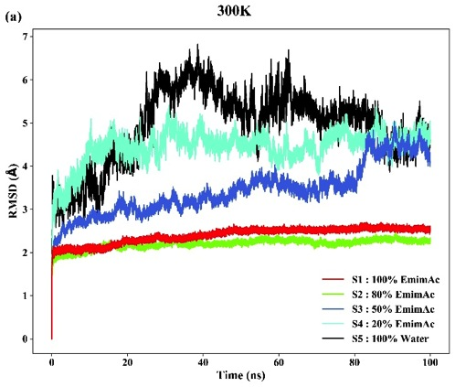
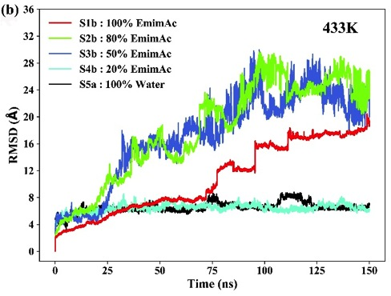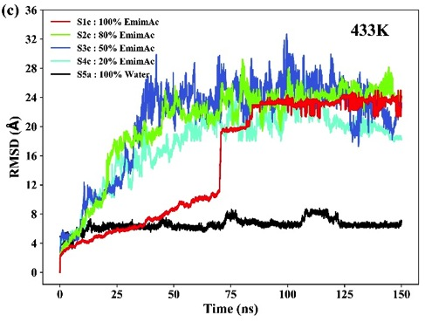

Figure S3. Final snapshots of the cellulose structures after 100 ns MD simulation in 100% EmimAc (S1), 80% EmimAc (S2), 50% EmimAc (S3), 20% EmimAc (S4) and 100% Water (S5) systems at 300K. The cellulose chains mostly remain in an aggregated bunch form that suggests no dissolution.

Figure S4. Radius of gyration (Rg) of cellulose (I_{β}) correspond to the simulations on five systems are: 100% EmimAc (red), 80% EmimAc (green), 50% EmimAc (blue), 20% EmimAc (cyan) and 100% Water (black) for (a) 300K and (b) set b at 433K and (c) set c at 433K.
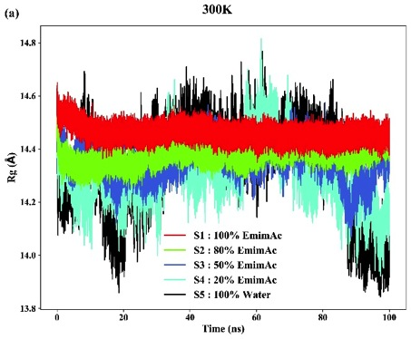
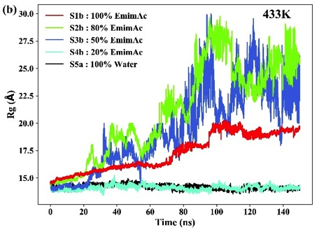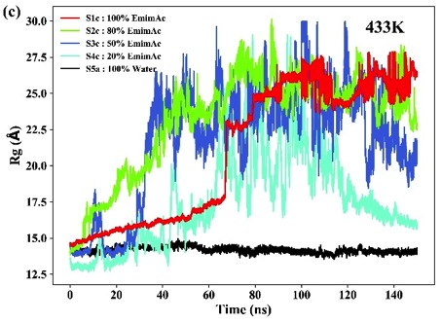

Figure S5. The major intrachain (O3−H3...O5 and O2−H2...O6) and interchain (O6−H6...O2 and O6−H6...O3) hydrogen bonds between two octamer glucan chains are presented. The carbon, oxygen and hydrogen atoms are colored in green, red and white respectively.

Figure S6. Number of cellulose hydrogen bonds as present in simulation trajectory for 100% EmimAc (S1a) (red), 80% EmimAc (S2a) (green), 50% EmimAc (S3a) (blue), 20% EmimAc (S4a) (cyan) and 100% Water (S5a) (black) systems at 300K: I(A) intrachain hydrogen bond, I(B) interchain hydrogen bond; set b at 433K: II(A) intrachain hydrogen bond, II(B) interchain hydrogen bond; set c at 433K: III(A) intrachain hydrogen bond, III(B) interchain hydrogen bond.

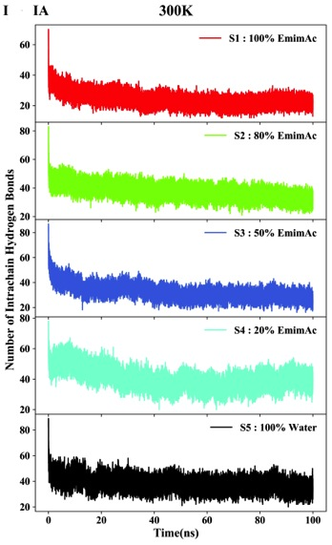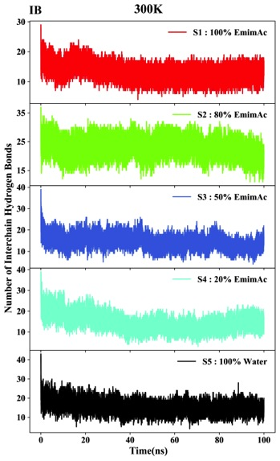

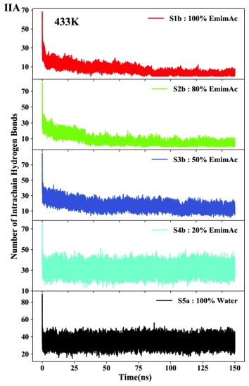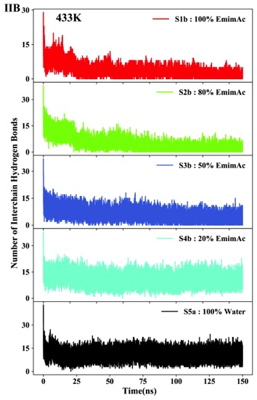
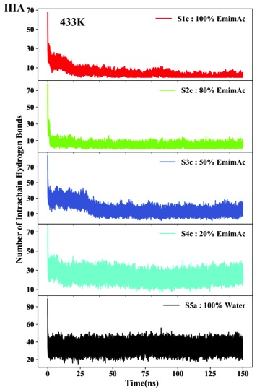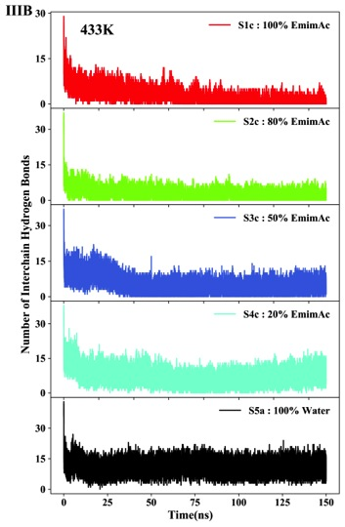

Figure S7. Histogram plot of the average number of hydrogen bonds between cellulose hydroxyl groups and cations (green), anions (red) and water (pink) are represented in the 100% EmimAc, 80% EmimAc, 50% EmimAc, 20% EmimAc and 100% Water systems: (a) at 300K, (b) set b at 433K and (c) set c at 433K.
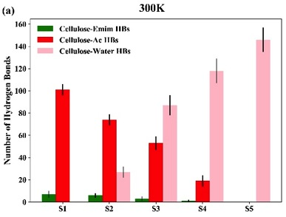
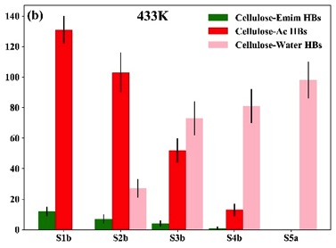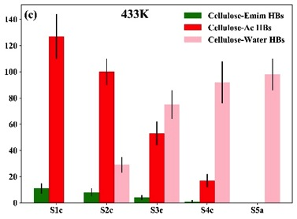

Figure S8. Average lifetime (ps) of different cellulose-acetate hydrogen bonds obtained from MD trajectories of set b at 433K: I(A) 100% EmimAc (S1b), I(B) 80% EmimAc (S2b), I(C) 50% EmimAc (S3b), I(D) 20% EmimAc (S4b); and set c at 433K: II(A) 100% EmimAc (S1c), II(B) 80% EmimAc (S2c), II(C) 50% EmimAc (S3c), II(D) 20% EmimAc (S4c).
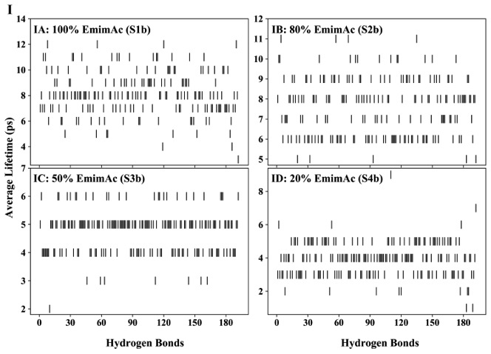
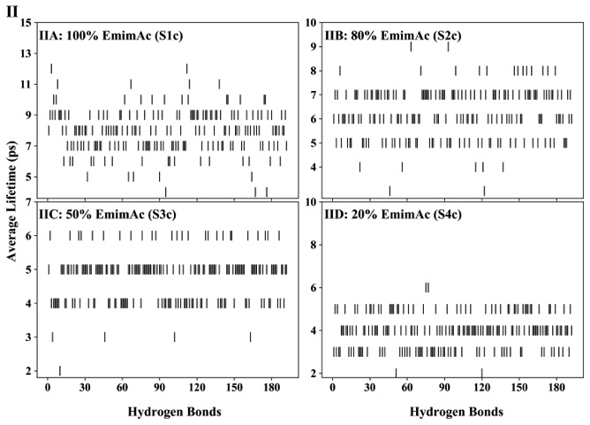

Figure S9. Average lifetime (ps) of different cellulose-water hydrogen bonds obtained from MD trajectories of set b at 433K: I(A) 80% EmimAc (S2b), I(B) 50% EmimAc (S3b), I(C) 20% EmimAc (S4b), I(D) 100% Water (S5a); and set c at 433K: II(A) 80% EmimAc (S2c), II(B) 50% EmimAc (S3c), II(C) 20% EmimAc (S4c), II(D) 100% Water (S5a).
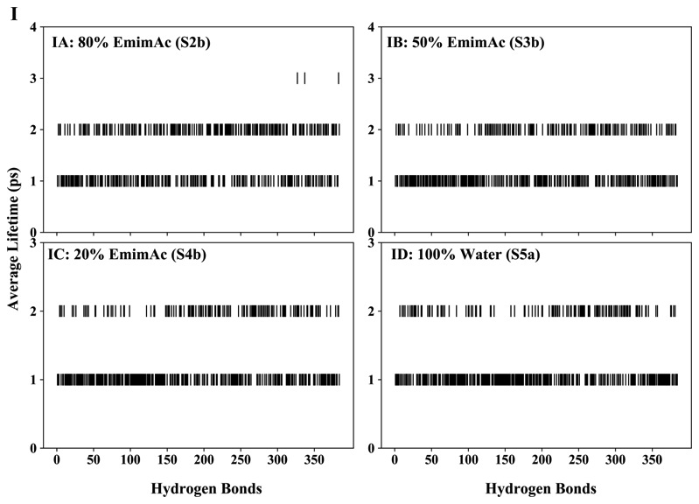
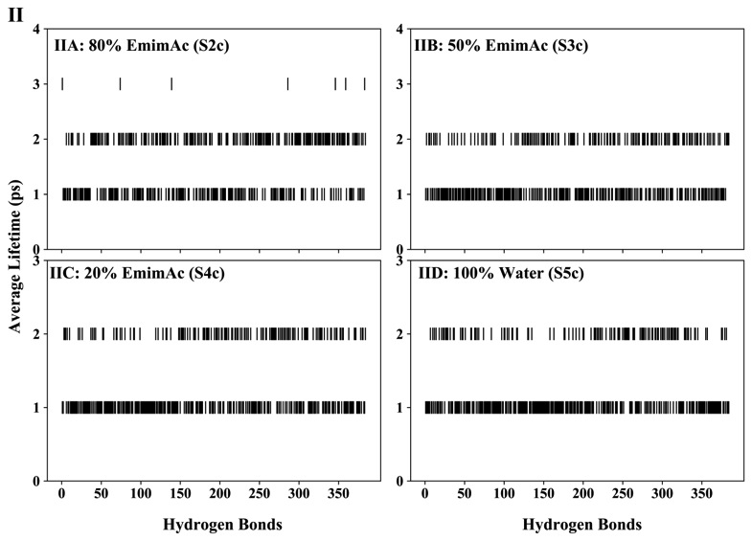
Figure S10. Radial distribution function (RDF) obtained from MD trajectories of 100% EmimAc (red), 80% EmimAc (green), 50% EmimAc (blue) and 20% EmimAc (cyan) systems for set b at 433K: I(A) cation-anion polar interaction, I(B) cation-cation nonpolar interaction; and set c at 433K: II(A) cation-anion polar interaction, II(B) cation-cation nonpolar interaction.
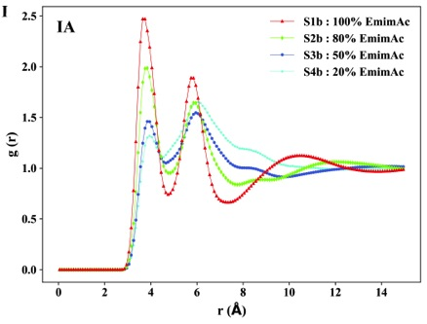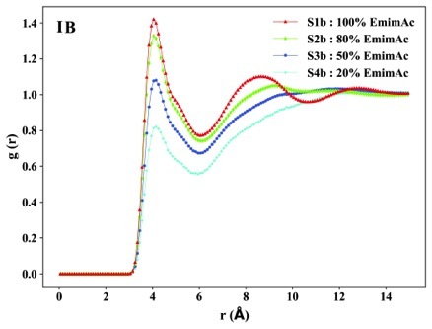
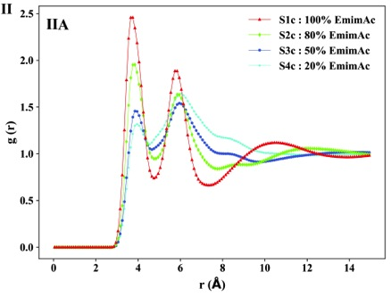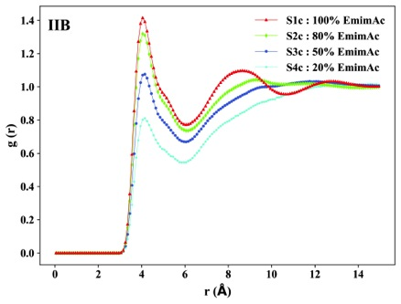

Figure S11. Radial distribution function (RDF) obtained from MD trajectories of 80% EmimAc (green), 50% EmimAc (blue), 20% EmimAc (cyan) and 100% Water (black) systems for set b at 433K: I(A) water-anion, I(B) water-cation and I(C) water -water interactions; and set c at 433K: II(A) water-anion, II(B) water-cation and II(C) water -water interactions.
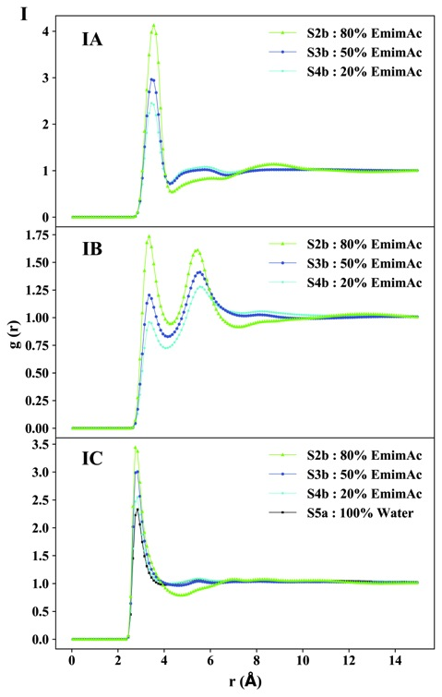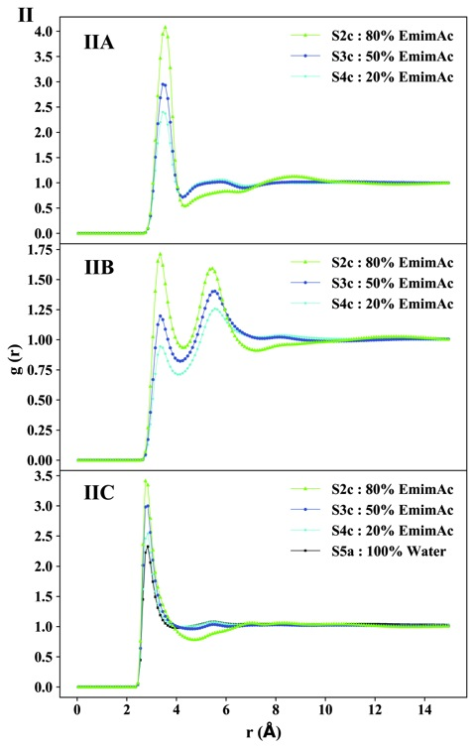

Figure S12. Radial distribution function (RDF) of cellulose (O2, O3, O6) interacting with specific regions of anion (C2), cation (C4) and water (O) molecules in 100% EmimAc (red), 80% EmimAc (green), 50% EmimAc (blue), 20% EmimAc (cyan) and 100% Water (black) systems for set b at 433K: I(A) cellulose-anion, I(B) cellulose-cation and I(C) cellulose-water interaction; and set c at 433K: II(A) cellulose-anion, II(B) cellulose-cation and II(C) cellulose-water interaction.
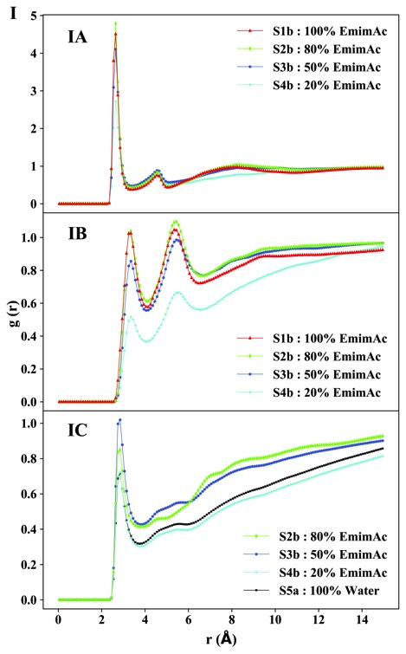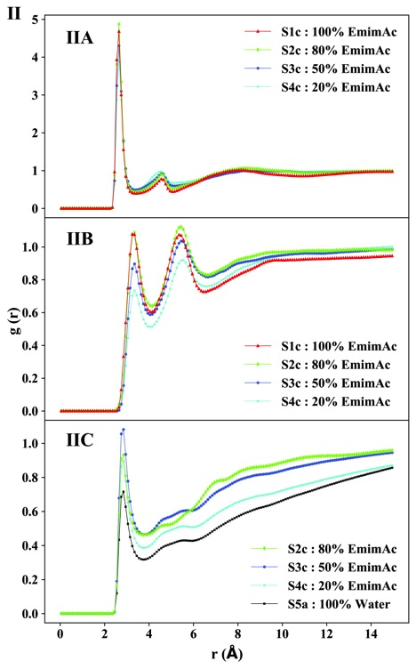

Figure S13: The Cellulose-solvent electrostatic interaction energy has been calculated from MD trajectories of 100% EmimAc (red), 80% EmimAc (green), 50% EmimAc (blue), 20% EmimAc (cyan) and 100% Water (black) systems for set b at 433K: I(A) cellulose-cation, I(B) cellulose-anion and I(C) cellulose-water interactions; and set c at 433K: II(A) cellulose-cation, II(B) cellulose-anion and II(C) cellulose -water interactions.
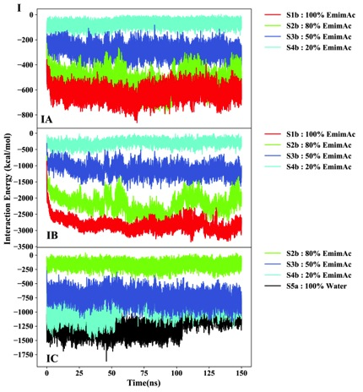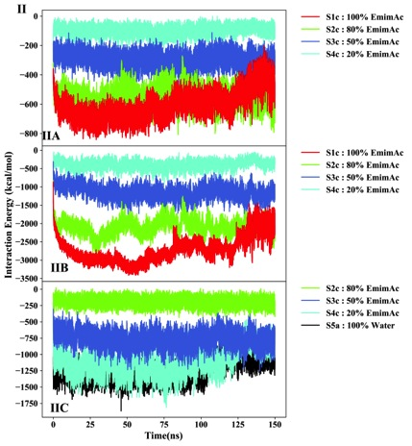

Figure S14: The correlated motion of the cellulose chains is framed in different solvent systems from MD trajectories of 100% EmimAc, 80% EmimAc and 50% EmimAc systems for : I(A) 100% EmimAc (S1) at 300K; II(A) 100% EmimAc (S1) at 300K; set b at 433K: I(B) 100% EmimAc (S1b), I(C) 80% EmimAc (S2b) and I(D) 50% EmimAc (S3b) systems; set c at 433K: II(B) 100% EmimAc (S1c), II(C) 80% EmimAc (S2c) and II(D) 50% EmimAc (S3c) systems.
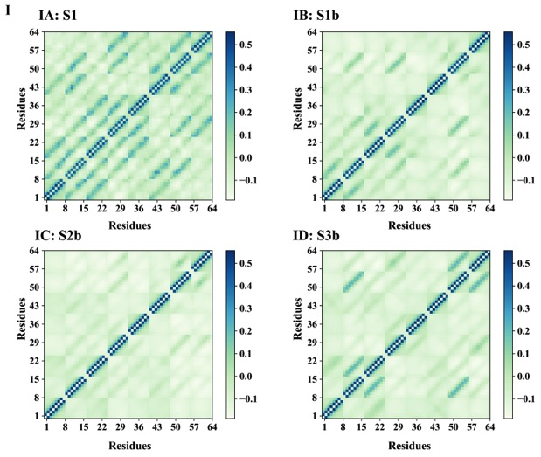
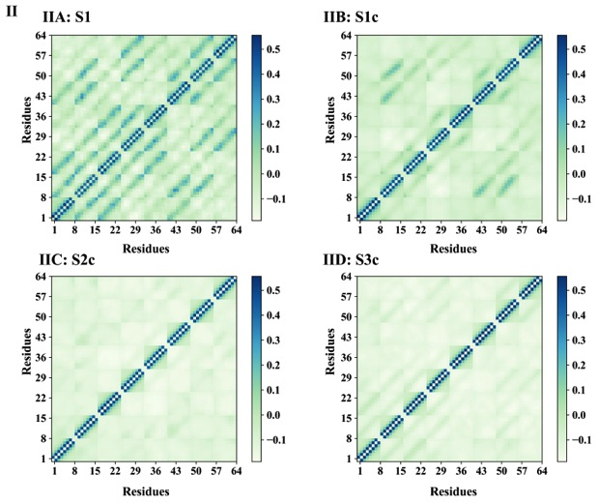
Figure S15. Distribution of the omega (ω) dihedral angles of the glucose residues in the cellulose chains in 100% EmimAc, 80% EmimAc, 50% EmimAc, 20% EmimAc and 100% Water systems: (a) at 300K, (b) set b at 433K and (c) set c at 433K. The histograms of the rotameric conformers obtained from the MD simulation were divided based on the range of normal distribution as gg = (−120◦ to 0◦), gt = (0◦ to 120◦), tg = (−180◦ to −120◦) and (120◦ to 180◦) for simplicity.
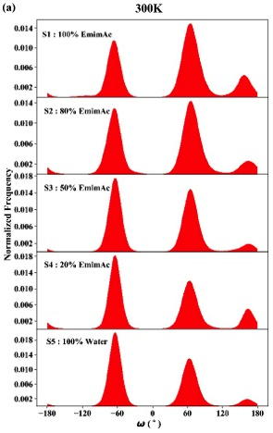
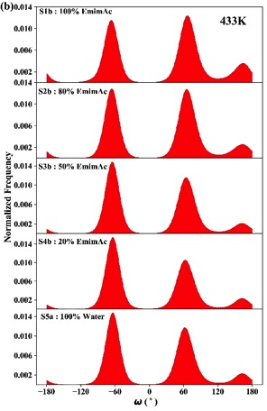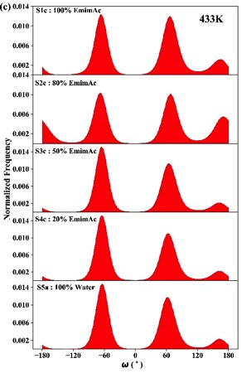

Figure S16. Snapshots of the simulation boxes, displaying the last 100ps ensemble of the system trajectories which show gradual disappearance of nanostructured water-clusters and even distribution of water molecules from (A) 50% EmimAc (S3a) to (B) 20% EmimAc (S4a). Thus, with the rising water concentration the systems transform more into an aqueous like system than IL-water mixture. The oxygen and hydrogen atoms in water molecules are colored in red and white respectively. The rest of the solvents are denoted in sea-green for easy discrimination.

