Supporting Information for

Odd-even Effect of the Number of Free Valence Electrons on the Electronic Structure Properties of Gold-Thiolate Clusters

Yanle Liª, Chunyan Liu,^{b,*} Vytor Oliveira^{c}, Dieter Cremer^{c}, Zijia Chenª,
and Jing Ma^{a,*}

ªKey Laboratory of Mesoscopic Chemistry of MOE, School of Chemistry and Chemical Engineering, Nanjing University, Nanjing, Jiangsu, People’s Republic of China; ^{b}College of Chemistry and Chemical Engineering, Hunan University, Changsha, Hunan, People’s Republic of China; ^{c}Computational and Theoretical Chemistry Group (CATCO), Department of Chemistry, Southern Methodist University, Dallas, Texas, USA

Contents
Figure S1. The search algorithm of thirty studied clusters.........................................S2

Table S1. The charge data of S and H atoms of Au_{m}(SR)_{n} (m, n = 5 -12)…………..S3

Table S2. The PCA result of charge data (in a.u.)…………………………………...S4

Table S3. The Clustering Analysis result…………..…………………………..…....S4

Figure S2. The bond length and bond strength order of the Au−S and Au−Au in the four kinds of Au_{m}(SH)_{n} (m, n = 5 - 12): (a) twisted clusters, (b) Rings attached to two central Au₃/Au₄, (c) Interlocked rings and (d) Other structures.……………….…...S5

The search algorithm of thirty studied clusters:
The genetic algorithm and basin-hopping algorithm are combined to search the minimum geometry more efficiently. The basin-hopping algorithm converts the rough potential energy surface into a serials of basins and explores the whole potential energy surface through Monte Carlo random moves which are accepted with certain probability based on the Metropolis criterion. Usually, the search based on the basin-hopping algorithm is easily restrained in some deep valleys of the PES, i.e. the local minima, which results in the wrong global minimum. To avoid this mistake, the genetic algorithm is introduced, and the local minimums from the basin-hopping are used as the initial individuals in the genetic algorithm. Genetic algorithm is an evolution algorithm based on the “survival of the fitness” principle.

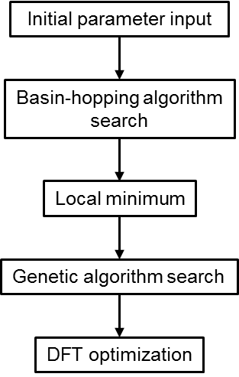
Figure S1. The scheme of the search algorithm of thirty studied clusters.

Table S1. The charge data of S and H atoms of Au_{m}(SR)_{n} (m, n = 5 -12).

m | n | m-n | Charge variance of S/|e|² | Average charge of H/|e| | Average charge of H/|e|² | Energy gap/eV | with of without Au₄
6 | 6 | 0 | 0.0000 | 0.1952 | 0.0000 | 5.76 | 0
7 | 7 | 0 | 0.0000 | 0.1959 | 0.0000 | 5.7 | 0
8 | 8 | 0 | 0.0001 | 0.1949 | 0.0000 | 5.41 | 0
9 | 9 | 0 | 0.0001 | 0.1967 | 0.0000 | 5.48 | 0
10 | 10 | 0 | 0.0003 | 0.1946 | 0.0000 | 3.45 | 0
11 | 11 | 0 | 0.0002 | 0.1948 | 0.0000 | 4.28 | 0
12 | 12 | 0 | 0.0000 | 0.1947 | 0.0000 | 4.85 | 0
7 | 6 | 1 | 0.0001 | 0.1950 | 0.0000 | 3.49 | 0
8 | 7 | 1 | 0.0001 | 0.1951 | 0.0000 | 3.43 | 0
9 | 8 | 1 | 0.0002 | 0.1934 | 0.0000 | 3.04 | 0
10 | 9 | 1 | 0.0012 | 0.1927 | 0.0000 | 3.2 | 0
11 | 10 | 1 | 0.0009 | 0.1944 | 0.0000 | 3.45 | 0
12 | 11 | 1 | 0.0007 | 0.1946 | 0.0000 | 3.64 | 0
8 | 6 | 2 | 0.0000 | 0.1951 | 0.0000 | 4.76 | 1
9 | 7 | 2 | 0.0001 | 0.1950 | 0.0000 | 4.74 | 1
10 | 8 | 2 | 0.0000 | 0.1945 | 0.0000 | 4.78 | 1
11 | 9 | 2 | 0.0003 | 0.1924 | 0.0000 | 3.09 | 1
12 | 10 | 2 | 0.0001 | 0.1951 | 0.0000 | 3.68 | 1
8 | 5 | 3 | 0.0003 | 0.1937 | 0.0000 | 3.35 | 0
9 | 6 | 3 | 0.0003 | 0.1955 | 0.0000 | 2.78 | 1
10 | 7 | 3 | 0.0003 | 0.1951 | 0.0000 | 2.61 | 1
11 | 8 | 3 | 0.0005 | 0.1954 | 0.0000 | 2.64 | 1
12 | 9 | 3 | 0.0001 | 0.1950 | 0.0000 | 3.19 | 0
9 | 5 | 4 | 0.0000 | 0.1933 | 0.0000 | 3.02 | 1
10 | 6 | 4 | 0.0000 | 0.1940 | 0.0000 | 3.65 | 1
11 | 7 | 4 | 0.0000 | 0.1942 | 0.0000 | 3.84 | 1
12 | 8 | 4 | 0.0000 | 0.1944 | 0.0000 | 3.98 | 1
11 | 6 | 5 | 0.0002 | 0.1937 | 0.0000 | 2.3 | 1
12 | 7 | 5 | 0.0006 | 0.1949 | 0.0000 | 2.32 | 1
12 | 6 | 6 | 0.0002 | 0.1929 | 0.0000 | 3.14 | 1

Table S2. The PCA result of charge data (in e.).
Charge data | Average charge of Au | Charge variance of Au | Average charge of S | Charge variance of S | Average charge of H | Charge variance of H
PCA parameter | 0.0014 | 0.0006 | 0.0003 | 0.0001 | 0.0000 | 0.0000

Table S3.The Clustering Analysis result.
H-L energy gap | m – n > 2 | with or without Au₄
86.7% | 73.3% | 76.7%

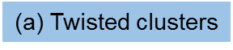
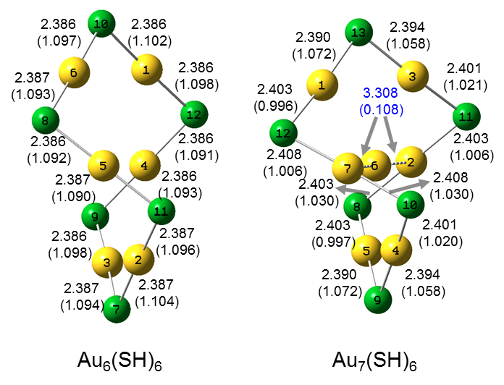

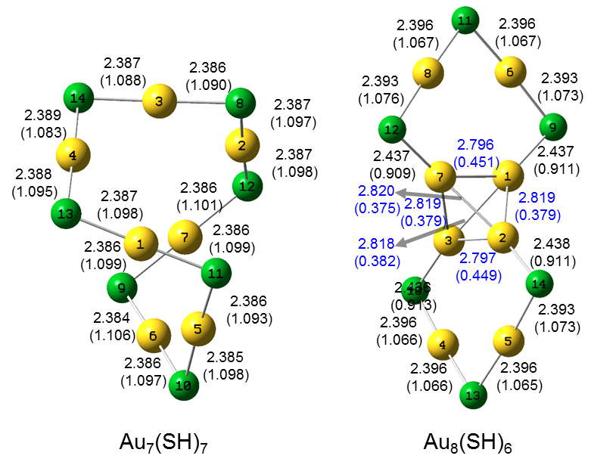
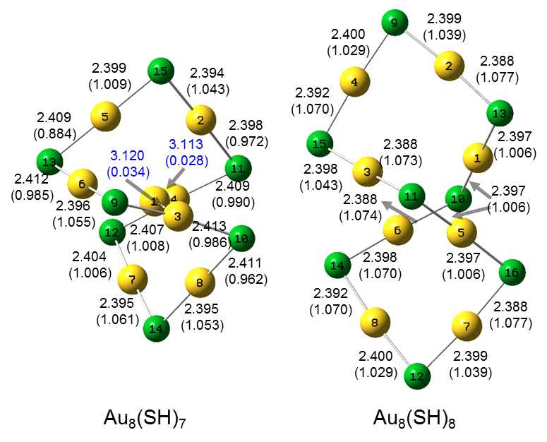

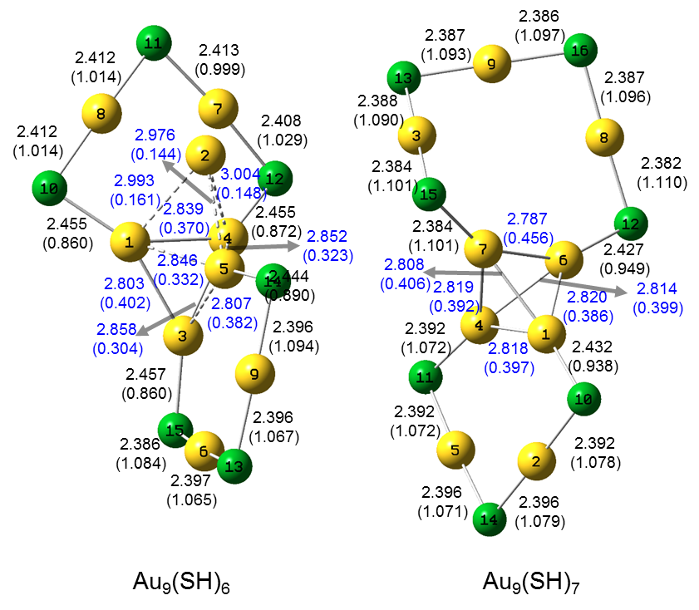
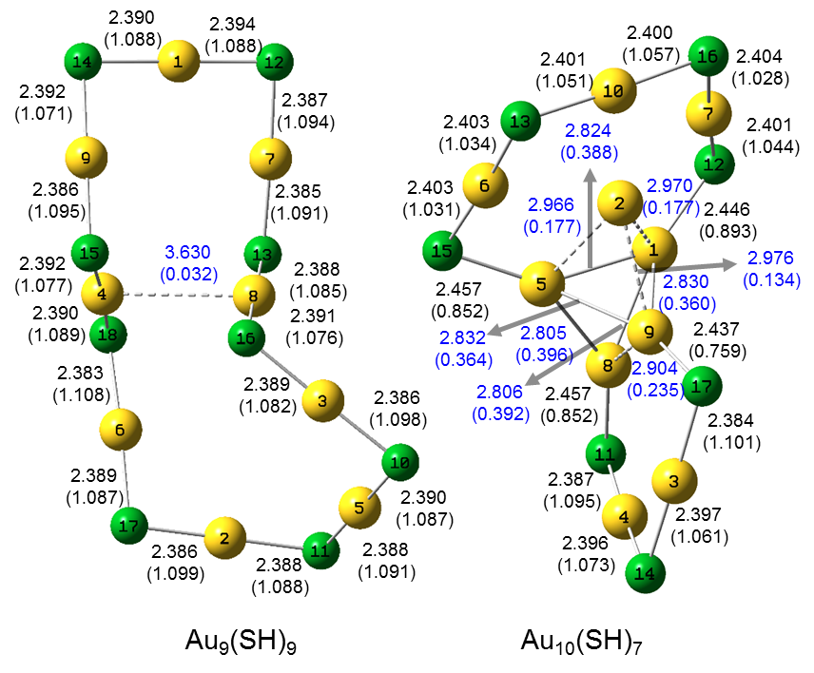
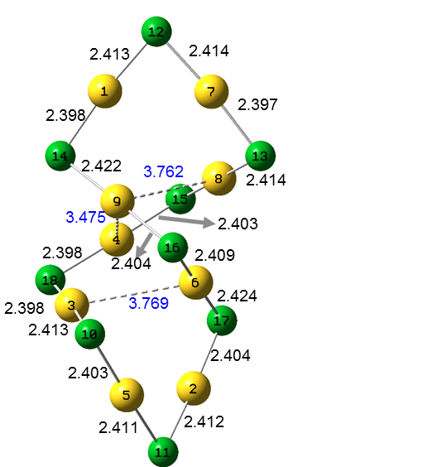
Au₉(SR)₉(M06-2X)
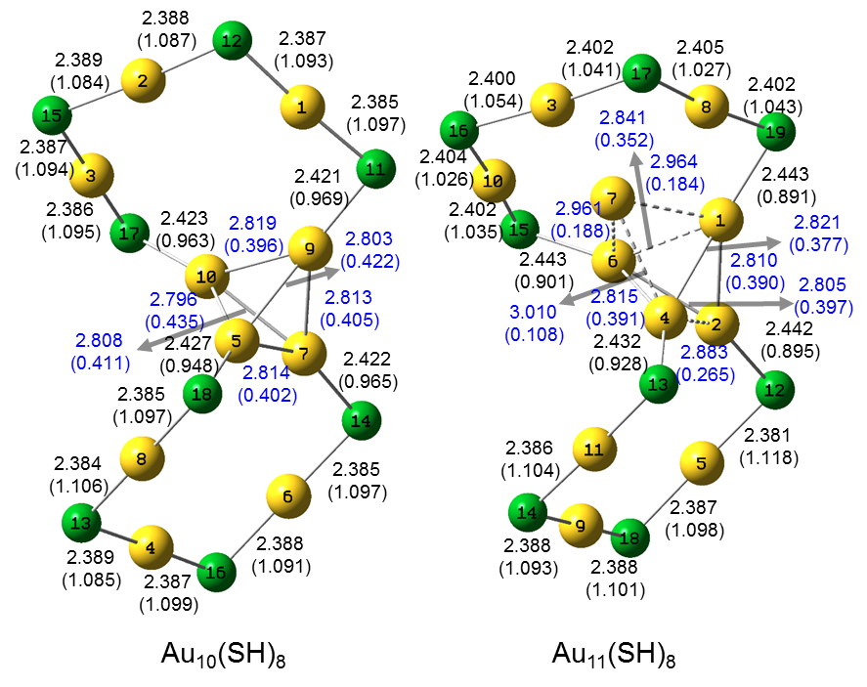

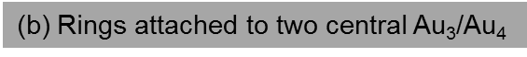
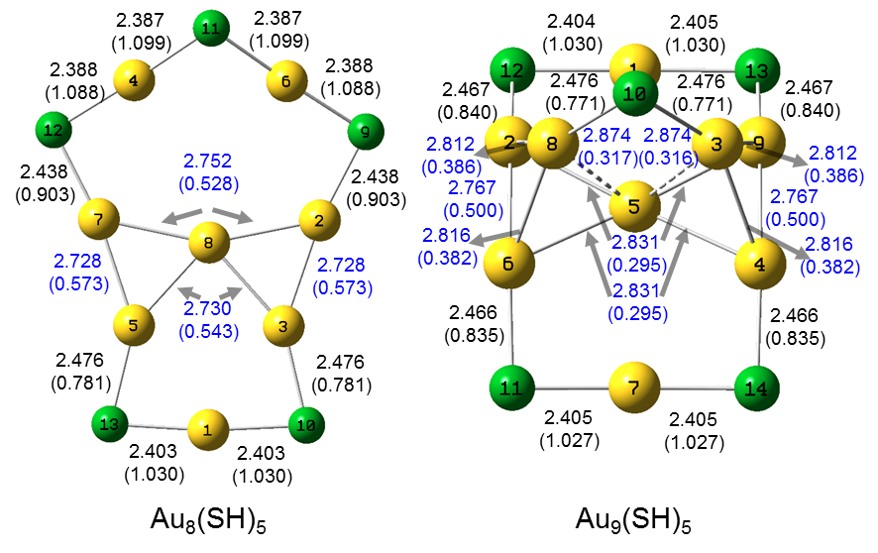

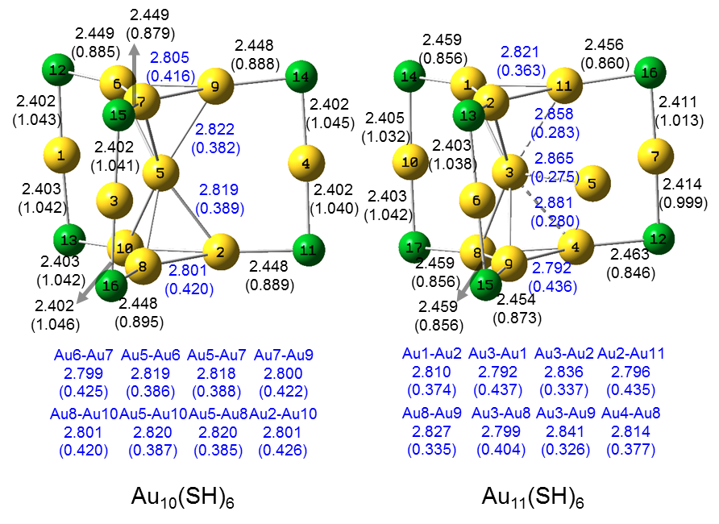
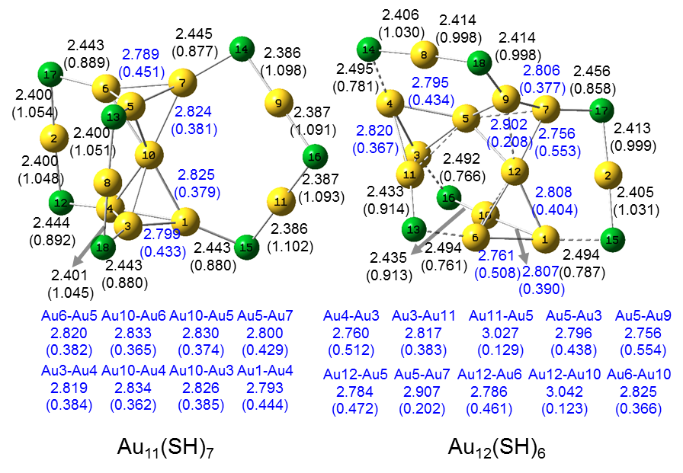

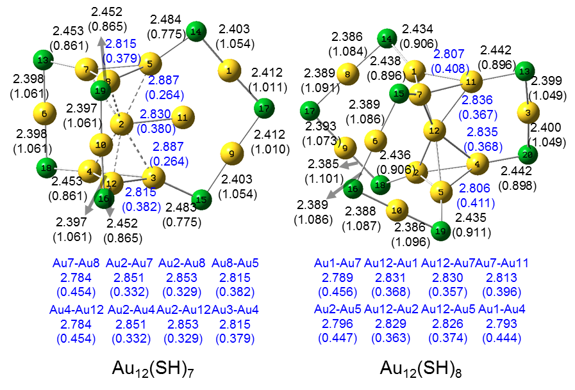

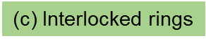
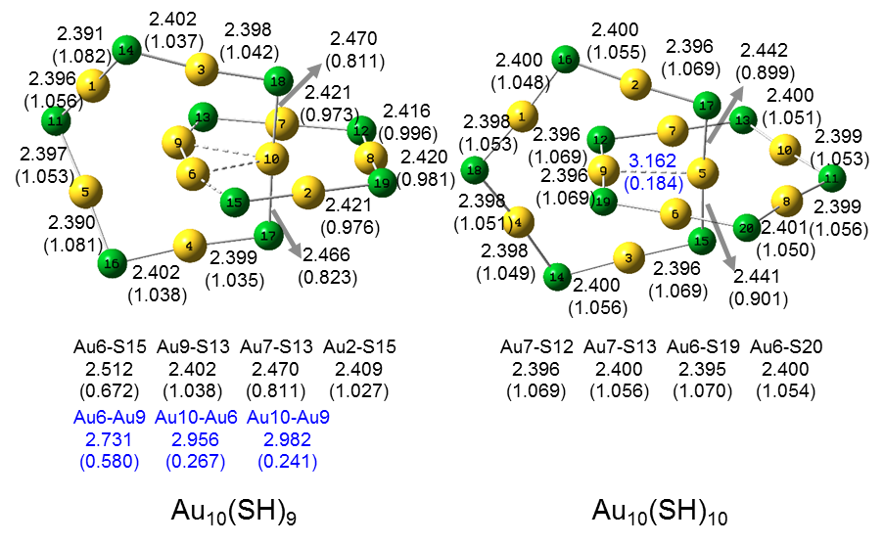

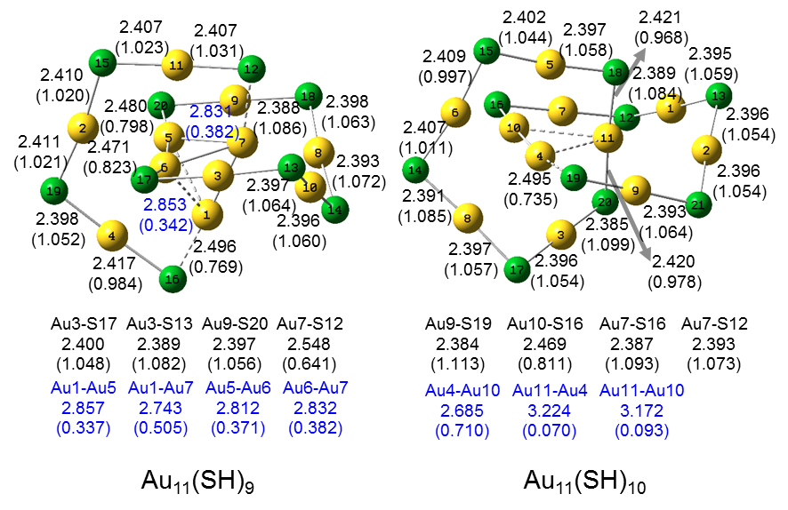

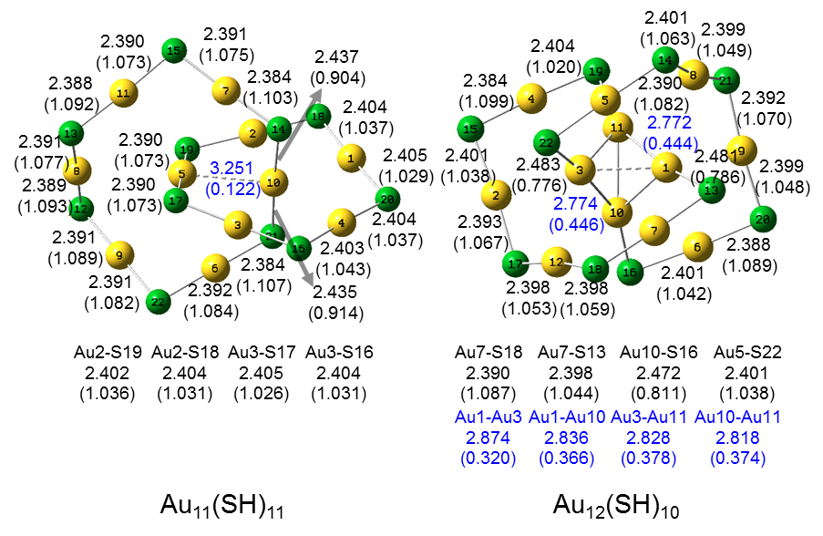

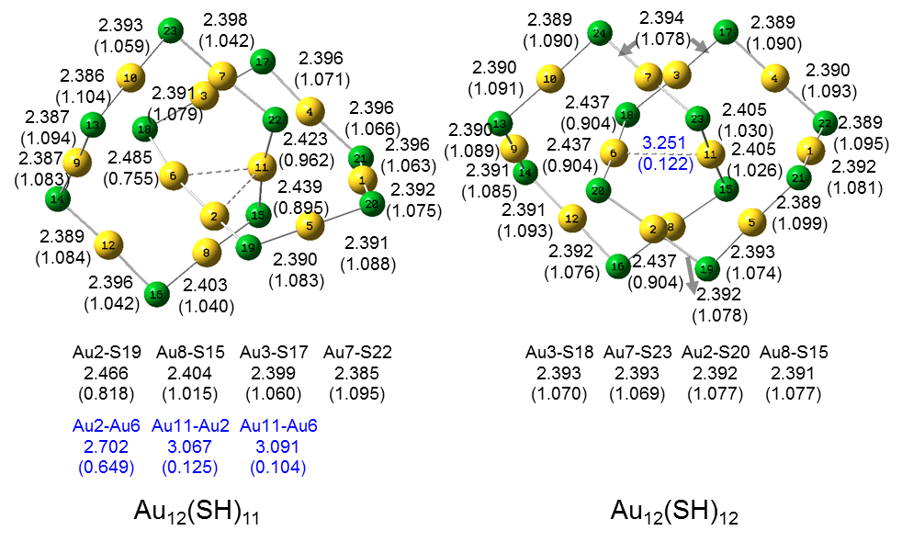

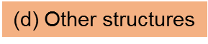
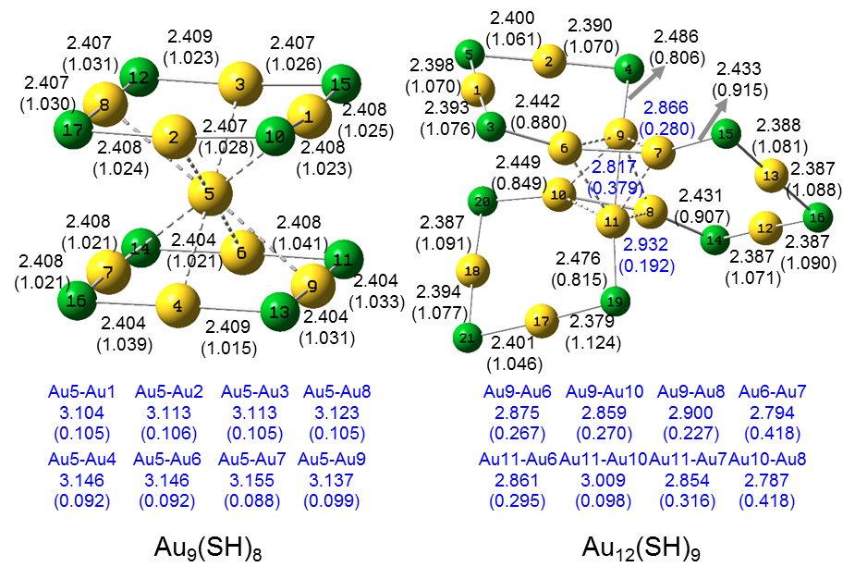
Figure S2. The bond length (Å, black) and bond strength order (arbitrary unit, blue, in parenthesis) of the Au−S and Au−Au in the four kinds of Au_{m}(SH)_{n} (m, n = 5 - 12): (a) twisted clusters, (b) Rings attached to two central Au3/Au4, (c) Interlocked rings and (d) Other structures.

