Supplementary Material
Marine CO₂ Patterns in the Northern Salish Sea
Wiley Evans*, Katie Pocock, Alex Hare, Carrie Weekes, Burke Hales, Jennifer Jackson, Helen Gurney-Smith, Jeremy T. Mathis, Simone R. Alin, and Richard A. Feely
*Correspondence to: wiley.evans@hakai.org: 250-914-4055

Supplemental Text 1: A number of ancillary datasets were utilized in this study. Hourly wind speed, wind direction, and sea surface temperature data were provided by Environment Canada from weather buoy 46131 (http://www.meds-sdmm.dfo-mpo.gc.ca/isdm-gdsi/waves-vagues/data-donnees/data-donnees-eng.asp?medsid=C46131). Composite (day and night averaged) Advanced Very High Resolution Radiometer (AVHRR) local area coverage (LAC) 1.1 km sea surface temperature data from the NOAA Polar Orbiting Environmental Satellite (POES) were provided by NOAA CoastWatch (http://coastwatch.pfel.noaa.gov/data.html#). Hakai Institute oceanographic station QU39 CTD data were obtained through the institute’s data portal (hecate.hakai.org) and processed using standard CTD data handling protocols. Atmospheric xCO₂ from the Representative Concentration Pathway (RCP) 8.5 (Riahi et al., 2011) acquired from the RCP Database Version 2.0 (http://www.iiasa.ac.at/web-apps/tnt/RcpDb/dsd?Action=htmlpage&page=welcome) and converted to pCO₂ assuming 1 atm of pressure.

Supplemental Text 2: The pattern of NSS along-axis cumulative wind stress, as determined using daily mean wind speed and direction from Environment Canada weather buoy 46131 (Figure 1), showed rapid growth at the start of the year due to the occurrence of strong winter storms with southeasterly winds, with an inflection when wind stress became predominantly negative that is associated with the occurrence of northwesterly winds through the summer months (Supplemental Figure 5). A second inflection occurred in the fall when wind stress transitioned to mainly positive values associated with southeasterly winds. Spring and fall transitions defined based on these inflection points (Huyer et al., 1979; Pierce et al., 2006) were used to delineate summertime winds that then allowed for the rate of energy transfer from the wind to be calculated (Supplemental Figure 6). Using CTD data collected at oceanographic station QU39 (Figure 1), the potential energy needed to mix the upper water column can be expressed relative to the density gradient between the surface ocean and a reference layer (Hauri et al., 2013). For this calculation, reference layers of 10 m and 20 m were used because during the summertime high-CO₂ events, seawater with a 21 kg m⁻³ density anomaly ($σ_{t}$) reached the surface, and this density layer has typically been found near 20 m and meaning that vertical mixing extended to at least this depth. This layer surfaced when the energy imparted on the upper ocean from the wind surpassed the potential energy needed to mix the upper water column (Figure 7).

Supplemental Table 1: Data source, number of measurements, timing and collection method, observing period, and digital object identifiers for CO₂ system datasets presented in this study.
Data Source | Number of Measurements | Timing / Data Collection Method | Observing Period | Digital Object Identifier
QIFS SUPERCO₂/BoL | 246825 | year-round / flow-through analyzer | Dec. 18 2014 - Jun. 1 2018 | http://dx.doi.org/10.21966/1.437736  http://dx.doi.org/10.21966/1.614670  http://dx.doi.org/10.21966/1.715729
Sentry Shoal SeaFET | 82413 | seasonal / in situ probe at 1 m | Jul. 19 2016 - Dec. 1 2016; Jul. 25 2017 - Oct. 24 2017 | http://dx.doi.org/10.21966/1.715693
NOAA WCOA2016 | 65 | single research cruise with CTD-Rosette | Jun. 5 2016 - Jun. 6 2016 | http://dx.doi.org/10.21966/1.715784
Hakai Institute station QU39 | 662 | year-round / full water column discrete samples collected by Niskin bottles with messengers | Jan. 19 2016 - Dec. 11 2017 | http://dx.doi.org/10.21966/1.715738
Pacific Salmon Foundation (PSF) | 399 | seasonal / surface and 20 m discrete samples collected by Niskin bottles with messengers | Jul. 26 2016 - Oct. 19 2017 | http://dx.doi.org/10.21966/1.715740
Sawmill Bay Shellfish | 90 | seasonal / surface discrete samples collected by hand | May 9 2016 - Dec. 13 2016 | http://dx.doi.org/10.21966/1.715756
Mac’s Oysters, LTD. (MO) | 28 | seasonal / surface discrete samples collected by hand | Jul. 5 2017 - Sep. 4 2017 | http://dx.doi.org/10.21966/1.715756
Fanny Bay Oysters (FBO) | 57 | year-round / surface discrete samples collected by hand | Apr. 18 2017 - Nov. 29 2017 | http://dx.doi.org/10.21966/1.715756
Deep Bay Field Station (DB) | 90 | year-round / surface discrete samples collected by hand | Jan. 13 2017 - Mar. 24 2018 | http://dx.doi.org/10.21966/1.715756

Supplemental Table 2: Uncertainties for various CO₂ system parameters computed at mean temperature (11.61°C), salinity (26.26), pCO₂ (441 µatm), pH_{T} (7.99), Alk_{inorganic} (1851 µmol kg⁻¹), TCO₂ (1736 µmol kg⁻¹) using a MATLAB CO2SYS error propagation routine that includes uncertainty in the carbonic acid dissociation constants (Orr et al., 2018). Uncertainties for CO₂ system parameters computed for BoL and SeaFET inputs used factory reported temperature (0.002°C) and salinity (0.001; based on conductivity uncertainty at mean temperature) for both SBE 45 and SBE 37 sensors. Uncertainties for CO₂ system parameters computed from discrete TCO₂ and pCO₂ measurements used with factory reported uncertainty in the NIST traceable thermometer (0.2°C) and uncertainty in YSI probe salinity based on the standard deviation (0.11) about a mean difference of 0.01 for 85 measurements of CRMs with known salinity.
Input parameters | pCO₂ (µatm) | Alk_{inorganic}  (µmol kg⁻¹) | TCO₂  (µmol kg⁻¹) | $$Ω_{arag}$$ | pH_{T}
Continuous pCO₂- Alk_{inorganic} (S) | 6.61 | 22.47@ | 20.42 | 0.031 | 0.009
Continuous pH_{T}- Alk_{inorganic} (S) | 15.03 | 22.47@ | 22.04 | 0.039 | 0.014&
Discrete TCO₂-pCO₂ | 6.61 | 6.13 | 5.2 | 0.023 | 0.008
@RMSE of Alk_{inorganic} (S) relationship
&from Miller et al. (2018)

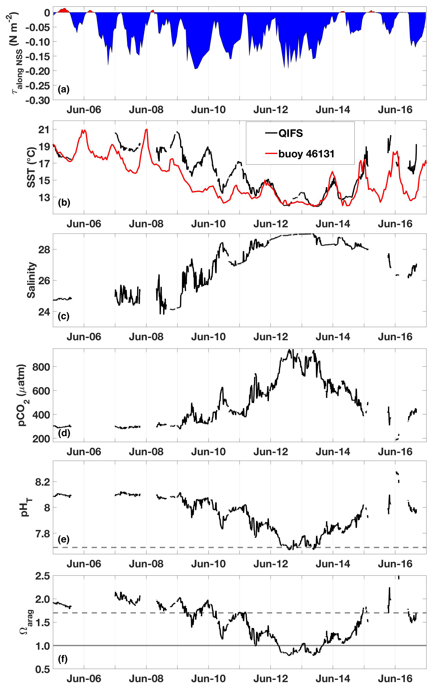
Supplemental Figure 1: Observations made during the June 2015 high-CO₂ event, including: (a) along-axis wind stress ($τ_{along NSS};$N m⁻²) from buoy 46131, (b) SST (°C) from QIFS and buoy 46131, (c) salinity, (d) seawater pCO₂ (µatm), (e) pH_{T}, and (f) $Ω_{arag}$. All QIFS data are black while buoy 46131 data are red. The horizontal line in panel (e) marks pH_{T} = 7.69, and the horizontal lines in panel (f) mark $Ω_{arag}$ = 1 (solid gray) and $Ω_{arag}$ = 1.7 (dashed gray).
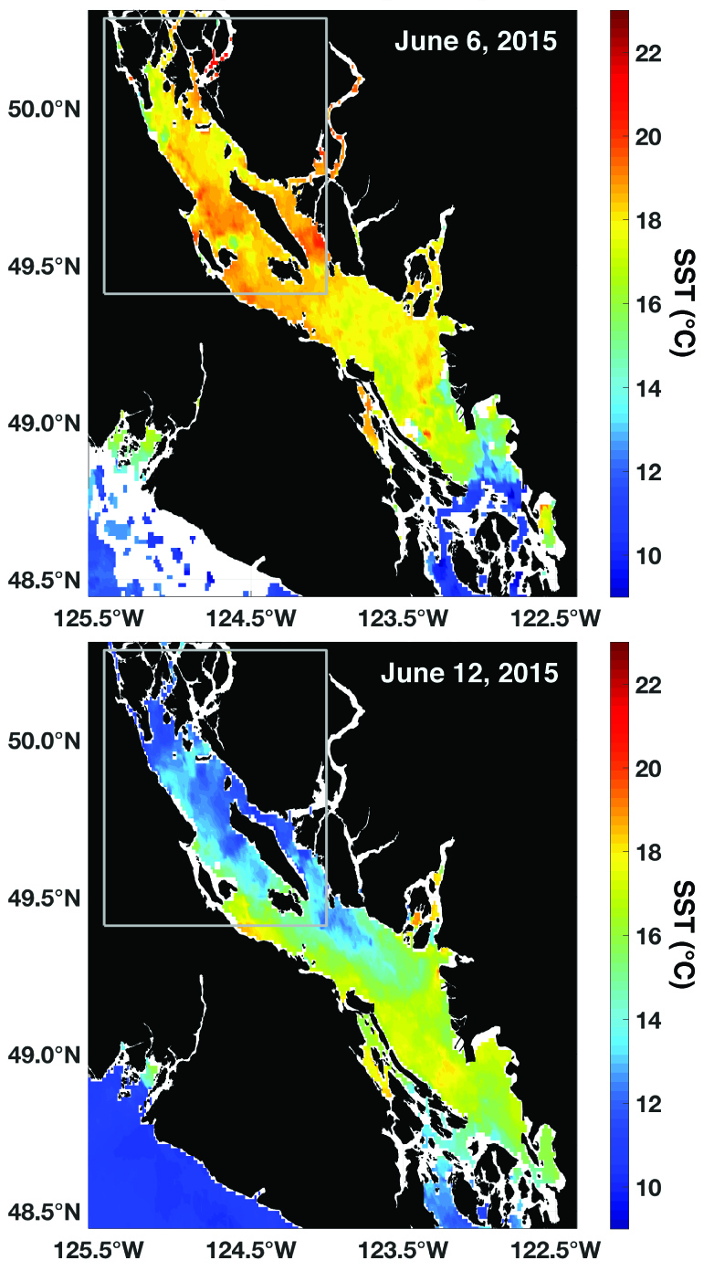
Supplemental Figure 2: NOAA Polar Operational Environmental Satellite (POES) Advanced Very High Resolution Radiometer (AVHRR) daily average (night and day passes) SST (°C) at the start (top) and peak (bottom) of the June 2015 high-CO₂ events. The gray box marks the NSS as outlined in Figure 1.
Supplemental Figure 3: Annual mean (red), minima, and maxima (both black) anthropogenic CO₂ inventories estimated for the NSS. The blue dot marks the 2008 value (36 µmol kg⁻¹) reported for Puget Sound by Feely et al. (2010).

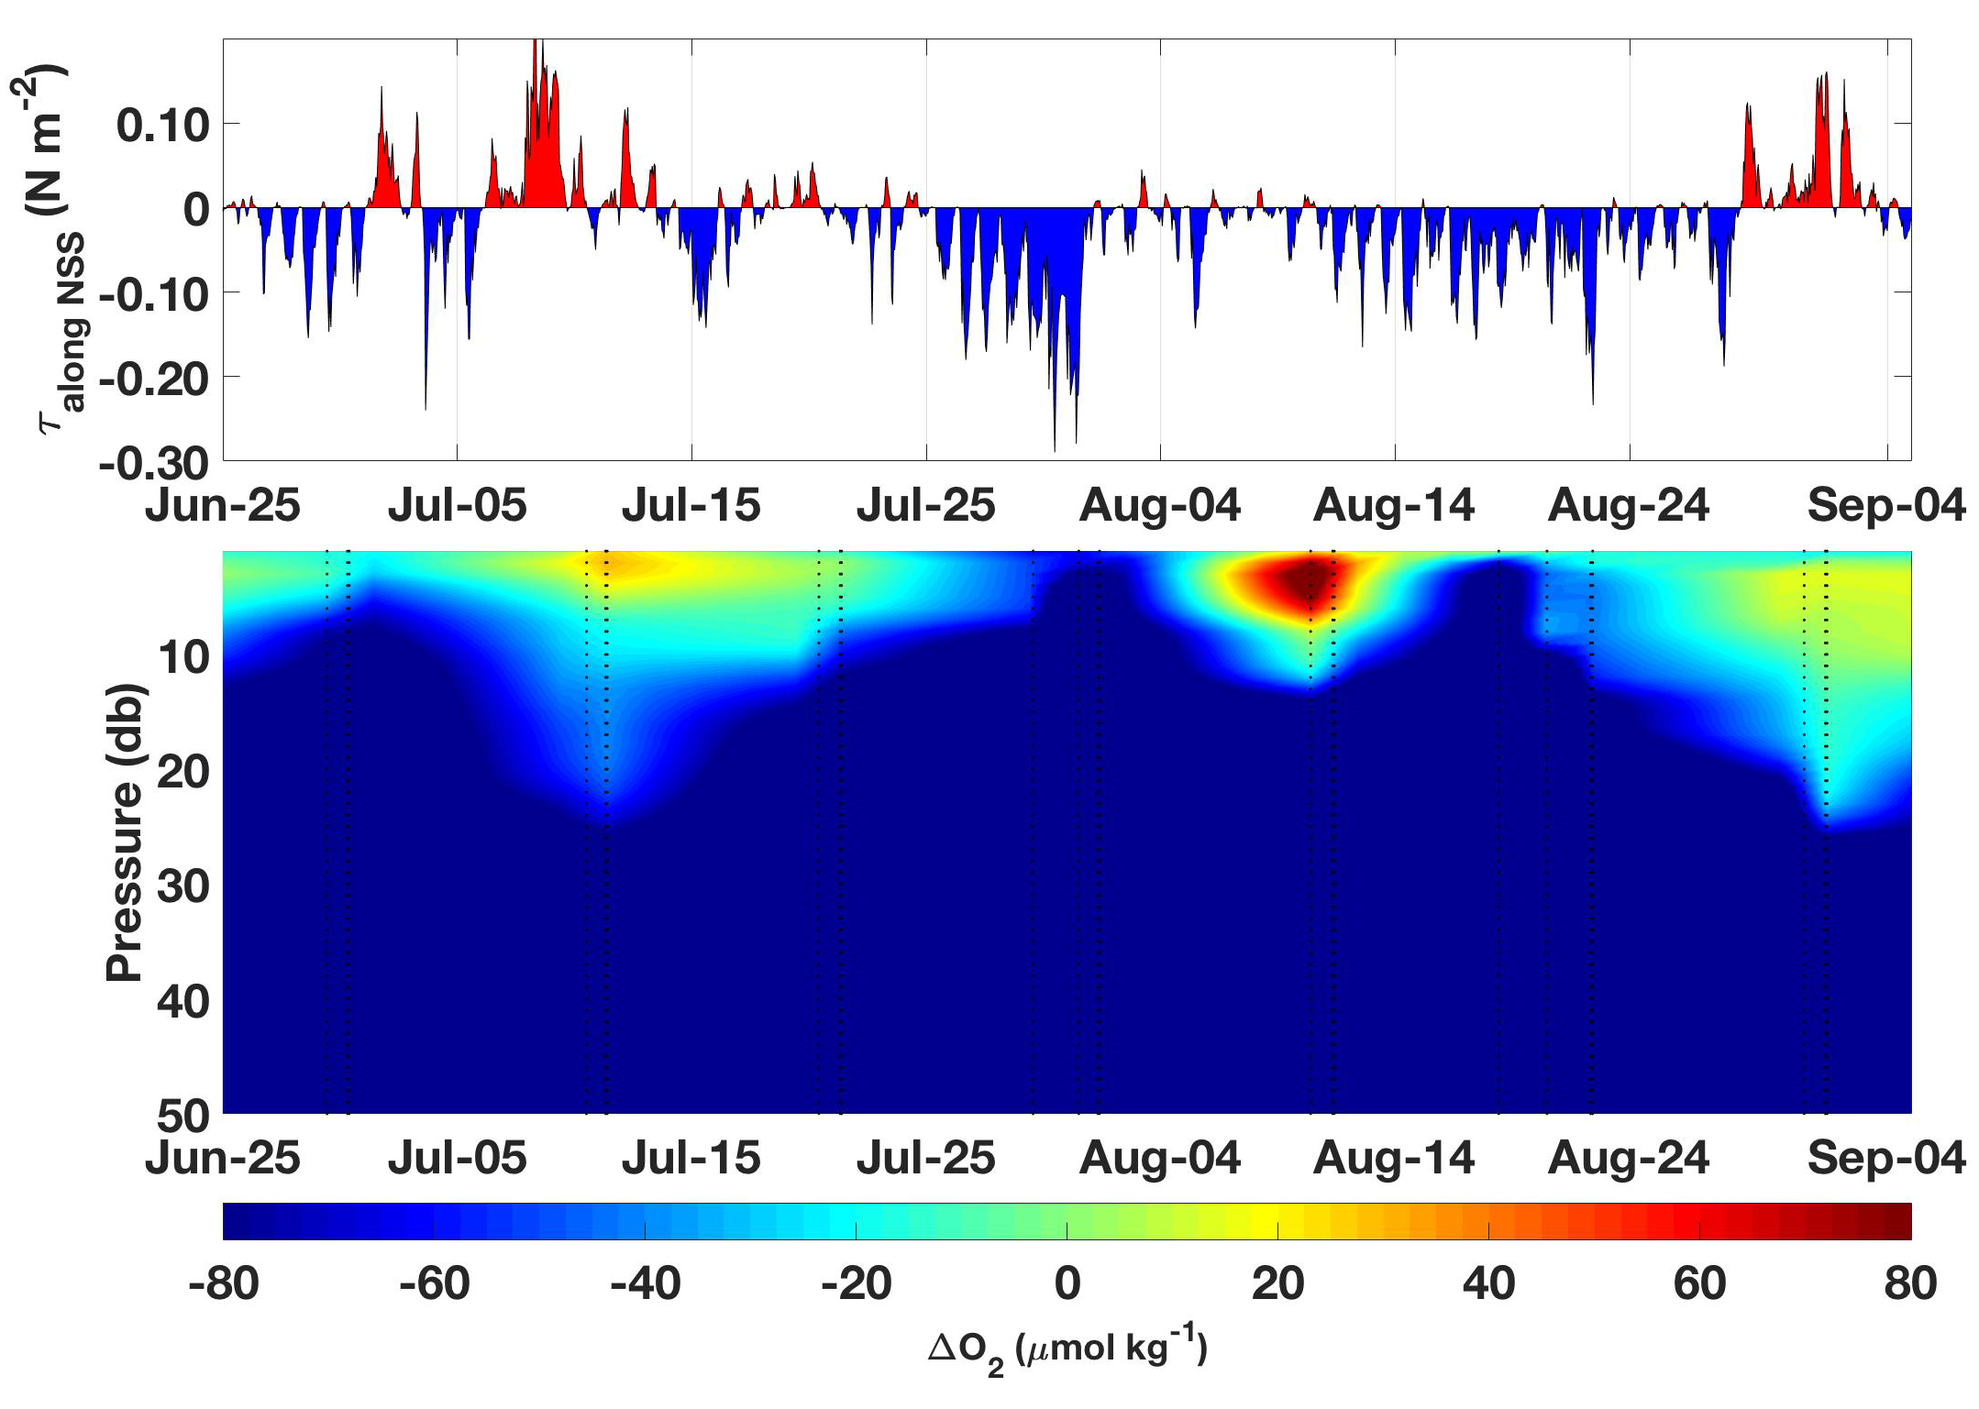
Supplemental Figure 4: Top panel is NSS along-axis wind stress ($τ_{along NSS};$N m⁻²) from Environment Canada weather buoy 46131, and the bottom panel is ∆O₂ (measured O₂ using a Sea-Bird Electronics SBE 63 oxygen optode– saturation; µmol kg⁻¹) for the upper 50 m of the water column measured at station QU39. Both records span June 25, 2016 to September 4, 2016, ± 1 month around the 2016 high-CO₂ event shown in Figure 5.

Supplemental Figure 5: Cumulative $τ_{along NSS}$ (N m⁻²) from Environment Canada weather buoy 46131 with spring and fall transitions defined for 2015 (black), 2016 (red), and 2017 (blue). Spring and fall transitions were defined based on the inflection points on cumulative $τ_{along NSS}$ curves that had been smoothed using a LOESS filter with a half power point equivalent to a 72-day running average. Gray lines are cumulative $τ_{along NSS}$from 1997 to 2018.

Supplemental Figure 6: The rate of energy transfer from the wind to the surface ocean (mJ m⁻² s⁻¹) between the spring and fall transitions (Figure 8) for 2015 (black), 2016 (red), and 2017 (blue) calculated using the daily average wind speeds measured from Environment Canada weather buoy 46131.

References:
Feely, R.A., Alin, S.R., Newton, J., Sabine, C.L., Warner, M., Devol, A., Krembs, C., and Maloy, C. (2010). The combined effects of ocean acidification, mixing, and respiration on pH and carbonate saturation in an urbanized estuary. Estuarine, Coastal and Shelf Science 88, 442-449.
Hauri, C., Winsor, P., Juranek, L.W., Mcdonnell, A.M.P., Takahashi, T., and Mathis, J.T. (2013). Wind-driven mixing causes a reduction in the strength of the continental shelf carbon pump in the Chukchi Sea. Geophysical Research Letters 40, 5932-5936.
Huyer, A., Sobey, J.C., and Smith, R.L. (1979). The Spring Transition in Currents Over The Oregon Continental Shelf. Journal of Geophyiscal Research 84, 6995-7011.
Miller, C.A., Pocock, K., Evans, W., and Kelley, A.L. (2018). An evaluation of the performance of Sea-Bird Scientific's SeaFET autonomous pH sensor: considerations for the broader oceanographic community. Ocean Science 14, 751-768.
Orr, J.C., Epitalon, J.-M., Dickson, A.G., and Gattuso, J.-P. (2018). Routine uncertainty propagation for the marine carbon dioxide system. Marine Chemistry, in press.
Pierce, S., Barth, J.A., Thomas, R.E., and Fleischer, G.W. (2006). Anomalously warm July 2005 in the northern California Current: Historical context and the significance of cumulative wind stress. Geophysical Research Letters 33, doi: 10.1029/2006GL027149.
Riahi, K., Rao, S., Krey, V., Cho, C., Chirkov, V., Fischer, G., Kindermann, G., Nakicenovic, N., and Rafaj, P. (2011). RCP 8.5 - A scenario of comparatively high greenhouse gas emissions. Climatic Change 109, 33-57.

