Supplementary data

SUPPLEMENTARY TABLE 1  Clinical characteristics vascular | Controls (n=21) | Patients (n=33) | P
Sex: male (%) | 10 (47.6) | 17 (50.0) | 1.0
Age (years) | 51.29 (12.99) | 57.47 (11.32) | 0.08
Length (m) | 1.74 (0.087) | 1.74 (0.11) | 0.98
Weight (kg) | 78.2 (64.1-129.8) | 81.95 (58.2-135.3) | 0.22
BMI (kg/m²) | 26.43 (21.43-46.04) | 26.97 (19.96-47.32) | 0.42
Waist-to-hip ratio | 0.94 (0.7-1.03) | 0.925 (0.77-1.08) | 0.88
Systolic BP (mmHg) | 120.71 (1.59) | 28.94 (16.14) | 0.08
Diastolic BP (mmHg) | 75.14 (8.16) | 80.03 (10.19) | 0.05
Heart rate (/min) | 60 (48-80) | 60 (44-76) | 0.76
Anti-hypertensives (%) | 1 (4.8) | 11 (32.4) | 0.02
Diabetes mellitus (%) | 0 | 3 (8.8) | 0.28
Smoker; current/past (%) | 4/2 (19/9.5) | 5/12 (14.7/35.3) | 0.10
Alcohol use (units/week) | 4 (0-20) | 1.5 (0-21) | 0.17
IGF-1 (nmol/l) | 17.16 (4.59) | 17.57 (4.11) | 0.74
Hormonal deficiency (%)  Estrogen depletion (%)  Hypothyroidism (%)  Hypogonadism (%)  Hypocortisolism (%)  GH deficiency (%)  Diabetes insipidus (%)  Hyperprolactinemia (%) | 2 (9.5)  5 (45.5)  2 (9.5)  0  0  0  0  0 | 1 (2.9)  12 (75)  0  0  0  0  1  0 | 0.551  0.224  0.141
Medical treatment (%)  SSA (%)  Dopamin agonist (%)  Pegvisomant (%) | 0  0  0  0 | 15 (44.1)  11 (32.4)  2 (5.9)  2 (5.9)
Surgery (%) | 0 | 29 (85.3)
Radiotherapy (%) | 0 | 3 (8.8)
Cholesterol (mmol/L)  HDL cholesterol (mmol/L)  LDL cholesterol (mmol/L)  Triglycerides (mmol/L)  Non-HDL cholesterol (mmol/L) | 5.37 (1.14)  1.53 (1.03-2.84)  3.03 (3.13)  1.46 (0.58-3.55)  3.8 (1.12) | 5.34 (1.13)  1.45 (0.77-2.88)  3.14 (1.01)  0.97 (.66-3.34)  3.74 (1.16) | 0.6  0.89  0.29  0.04  0.98
Supplementary table 1. Clinical characteristics in patients and controls – subgroup selected for vascular measurements.
Values are displayed as mean with SD (standard deviation) or as median with minimum and maximum, depending on the normality of the distribution, which was tested by the Shapiro-Wilk test. Categorical variables are displayed as numbers (percentage); BMI: body mass index in kg/m²; BP: blood pressure; IGF-1: Insulin-like Growth Factor 1; GH: Growth Hormone; Estrogen depletion (in women): postmenopausal women not using estrogen substitution; SSA: Somatostatin analogue; LDL: low-density lipoprotein; HDL: high-density lipoprotein. Differences between two groups were tested with the independent samples Mann-Whitney U test for non-normal data and the independent samples T-test for normal distributed data. Categorical variables were tested using the 2-sided Fisher exact test. P values of <0.05 were considered statistically significant.
SUPPLEMENTARY TABLE 2  Clinical characteristics | Controls (n=21) | Cured (n=19) | Biochemically controlled (n=14) | P | P*
Sex: male (%) | 10 (47.6) | 8 (42.1) | 9 (60) | 0.49 | 0.56
Age (years) | 52 (29-75) | 57 (42-70) | 53 (45-81) | 0.84 | 0.30
Length (m) | 1.74 (0.087) | 1.73 (0.11) | 1.75 (0.12) | 0.65 | 0.88
Weight (kg) | 78.2 (64.1-129.8) | 78.4 (58.2-135.3) | 88 (61.8-109) | 0.23 | 0.22
BMI (kg/m²) | 26.43 (21.43-46.04) | 26.91 (19.96-47.32) | 27.74 (22.98-34.02) | 0.56 | 0.51
Waist-to-hip ratio | 0.94 (0.7-1.03) | 0.9 (0.77-1.08) | 0.93 (0.87-1.06) | 0.32 | 0.74
Systolic BP (mmHg) | 120.7 (13.59) | 127.7 (18.55) | 130.53 (12.92) | 0.60 | 0.14
Diastolic BP (mmHg) | 75.14 (8.16) | 77.74 (11.86) | 82.93 (6.91) | 0.12 | 0.055
Heart rate (/min) | 60 (48-80) | 60 (44-76) | 64 (56-72) | 0.19 | 0.36
Anti-hypertensives (%) | 1 (4.8) | 6 (31.6) | 5 (33.3) | 1 | 0.02
Diabetes mellitus (%) | 0 | 1 (5.3) | 2 (13.3) | 0.57 | 0.18
Smoker; current/past (%) | 4/2(19/9.5) | 3/8 (15.9/42.1) | 2/4 (13.3/26.7) | 0.72 | 0.19
Alcohol use (units/week) | 4 (0-20) | 3 (0-20) | 0.5 (0-21) | 0.30 | 0.25
IGF-1 (nmol/l)  Disease duration (years) | 17.16 (4.59)  - | 16.98 (3.9)  6 (2-19) | 18.32 (4.37)  8.5 (4-35) | 0.36 | 0.35  0.123
Hormonal deficiency (%)  Estrogen depletion (%)  Hypothyroidism (%)  Hypogonadism (%)  Hypocortisolism (%)  GH deficiency (%)  Diabetes insipidus (%)  Hyperprolactinemia (%) | 2 (9.5)  5 (45.5)  2 (9.5)  0  0  0  0  0 | 1 (5.3)  8 (47.1)  0  0  0  0  1 (5.3)  0 | 0  4 (23.5)  0  0  0  0  0  0 | 1  0.38 | 0.77  0.64  0.62
Medical treatment (%)  SSA (%)  Dopamin agonist (%)  Pegvisomant (%) | 0  0  0  0 | 0  0  0  0 | 15 (100)  11 (73.3)  2 (13.3)  2 (13.3) |  | <0.001  <0.001  0.07  0.07
Surgery (%) | 0 | 19 (100) | 10 (66.7) |  | <0.001
Radiotherapy (%) | 1 (5.3) | 0 | 2 (13.3) |  | 0.18
Cholesterol (mmol/L)  HDL cholesterol (mmol/L)  LDL cholesterol (mmol/L)  Triglycerides (mmol/L)  Non-HDL cholesterol (mmol/L) | 5.37 (1.14)  1.53 (1.03-2.84)  3.03 (1.15)  1.46 (0.58-3.55)  3.80 (1.12) | 5.38 (1.31)  1.55 (1.02-2.83)  3.16 (1.22)  0.86 (0.66-2.77)  3.69 (1.4) | 5.28 (0.87)  1.45 (0.77-2.88)  3.13 (0.65)  1.25 (0.69-3.34)  3.79 (0.77) | 0.86  0.49  0.96  0.16  0.81 | 0.83  0.27  0.93  0.21  0.66

Supplementary table 2. Clinical characteristics in patients and controls – subgroup
selected for vascular measurements.
Values are displayed as mean with SD (standard deviation) or as median with minimum and maximum, depending on the normality of the distribution, which was tested by the Shapiro-Wilk test. Categorical variables are displayed as numbers (percentage); BMI: body mass index in kg/m²; BP: blood pressure; IGF-1: Insulin-like Growth Factor 1; GH: Growth Hormone; Estrogen depletion (in women): postmenopausal women not using estrogen substitution; SSA: Somatostatin analogue; LDL: low-density lipoprotein; HDL: high-density lipoprotein. Differences between two groups were tested with the independent samples Mann-Whitney U test for non-normal data and the independent samples T-test for normal distributed data. Categorical variables were tested using the 2-sided Fisher exact test. P values of <0.05 were considered statistically significant.
P*: P-values when comparing cured patients to patients in biochemical remission.
SUPPLEMENTARY TABLE 3 | Controls (N=21) | Patients (N=33) | Cured (n=19) | Biochemically controlled (n=14) | P | P*
Central Augmented Pressure (C_AP_HR75) (mmHg) | 7.75 (4.03) | 6.68 (6.12) | 7.59 (6.61) | 5.57 (5.5) | 0.04 | 0.019
Pulse wave velocity (m/s) | 9.14 (7.1-15.36) | 8.83 (6.63-13.46) | 9.09 (6.63-13.27) | 8.74 (7.24-13.46) | 0.002 | 0.008
Baseline diameter FMD (cm) | 0.39 (0.09) | 0.43 (0.07) | 0.42 (0.07) | 0.4457 (0.08) | 0.18 | 0.16
Peak diameter FMD (cm) | 0.41 (0.09) | 0.45 (0.07) | 0.44 (0.07) | 0.47 (0.07) | 0.3 | 0.27
Absolute FMD (cm) | 0.03 (0.01-0.07) | 0.02 (-0.01-0.05) | 0.02 (0-0.05) | 0.02 (-0.01-0.04) | 0.27 | 0.39
%FMD | 8.68 (4.87) | 5.22 (3.58) | 5.16 (3.59) | 5.29 (3.73) | 0.06 | 0.15
Shear rate (/min) | 26245 (14287-53297) | 15997 (4676-39954) | 18335 (7320-39954) | 10925 (4676-30588) | 0.002 | 0.07
Blood flow (ml/min) | 299.15 (50-935) | 304.11 (-3-663) | 323.2 (-3-663) | 302.17 (1-439) | 0.1 | 0.19
Baseline diameter NMD (cm) | 0.38 (0.0766) | 0.43 (0.07) | 0.43 (0.08) | 0.44 (0.05) | 0.17 | 0.37
Peak diameter NMD (cm) | 0.45 (0.07) | 0.52 (0.07) | 0.51 (0.09) | 0.53 (0.04) | 0.02 | 0.06
Absolute NMD (cm) | 0.07 (0.01-0.112) | 0.08 (0.04-0.15) | 0.077 (0.04-0.15) | 0.08 (0.04-0.14) | 0.39 | 0.11
%NMD | 19.8 (2-34.8) | 16.4 (8.4-34.5) | 16.3 (11-34.2) | 16.9 (8.4-34.5) | 0.74 | 0.92
FMD/NMD ratio | 0.42 (0.12-5.95) | 0.27 (-0.08-1.04) | 0.24 (-0.02-1.04) | 0.37 (-0.08-0.88) | 0.04 | 0.13
IMT (mm) | 0.8 (0.17) | 0.83 (0.10) | 0.83 (0.1) | 0.83 (0.11) | 0.48 | 0.76
Lumen (mm) | 6.78 (0.82) | 6.93 (0.79) | 6.76 (0.90) | 7.18 (0.52) | 0.73 | 0.28
IMT / lumen ratio | 0.12 (0.02) | 0.12 (0.02) | 0.13 (0.02) | 0.12 (0.02) | 0.57 | 0.49

Supplementary table 3. Vascular measurements
Values are displayed as mean with SD (standard deviation) or as median with minimum and maximum, depending on the normality of the distribution, which was tested by the Shapiro-Wilk test. Data were, when necessary, log-transformed prior to analysis. Differences between the subgroups were tested using ANCOVA with sex and systolic blood pressure as covariates for Augmented Pressure and age and systolic blood pressure for all other measures. Šidák correction for multiple testing was applied. P values of <0.05 were considered statistically significant. PWV: pulse wave velocity; IMT: intima-media thickness; FMD: flow-mediated dilatation; NMD: nitroglycerine-mediated dilatation.
P: p-values when comparing controls to the total group of patients.
P*: p-values when comparing controls to subgroups of patients.
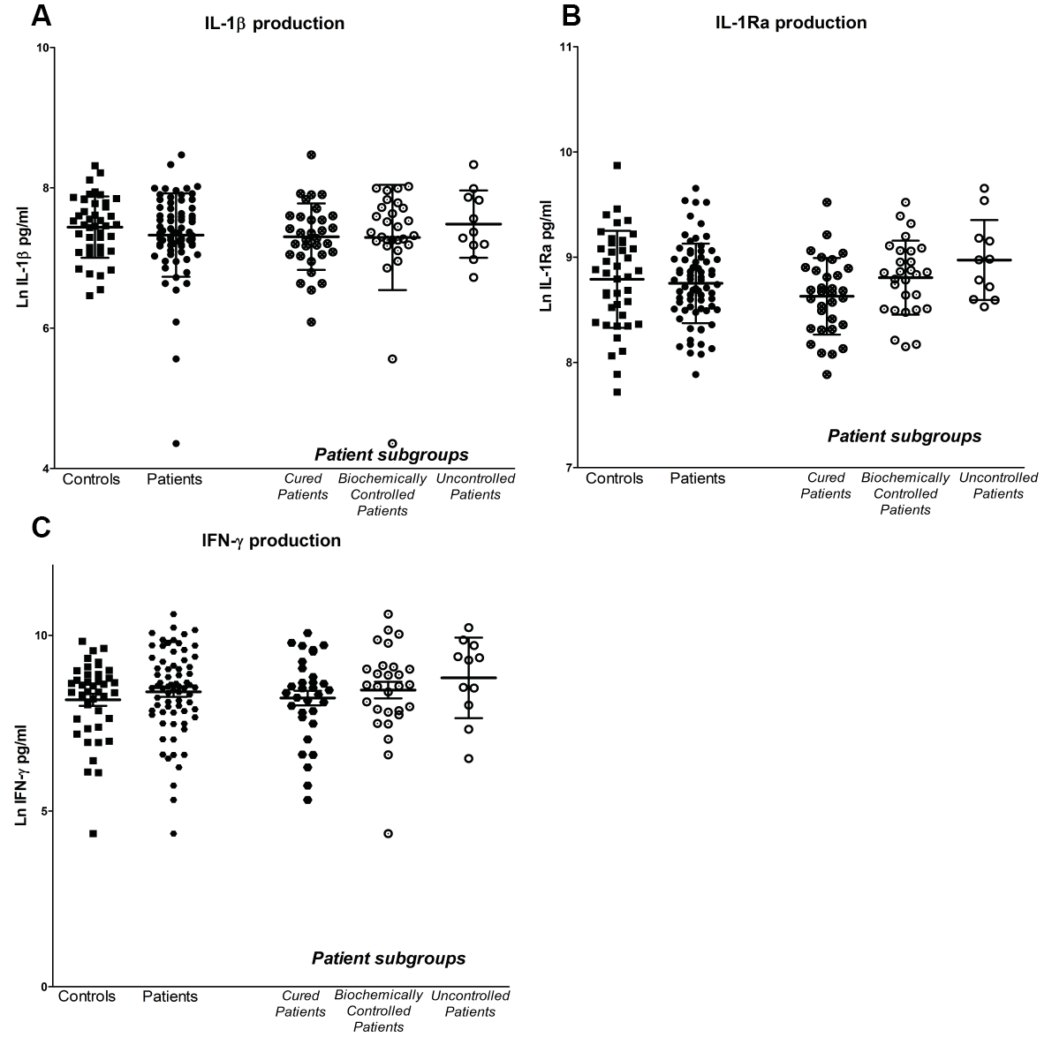
Supplementary Figure 1. LPS-stimulated IL-1β production (A) and LPS-stimulated IL-1Ra production (B) and PHA-stimulated IFN-γ production (C). Cytokine concentrations were measured by ELISA and displayed as mean ± SD. Data were log-transformed prior to analysis. Differences between the subgroups were tested using ANCOVA with BMI, age and leukocyte count as covariates. Šidák correction for multiple testing was applied. P values of <0.05 were considered statistically significant. LPS: lipopolysaccharide; PHA: Phytohemagglutinin; IL: interleukin; IFN-γ: interferon γ.

