**ONLINE SUPPLEMENTAL MATERIAL**

Potatoes and risk all cause, cancer and cardiovascular mortality in adults: a systematic review and dose response meta-analysis of prospective cohort studies

Running title: Potatoes and mortality

Manije Darooghegi Mofrad, Alireza Milajerdi, Ali Sheikhi, Leila Azadbakht

Department of Community Nutrition, School of Nutritional Science and Dietetics, Tehran University of Medical Sciences, Tehran, IR

Address reprint requests and correspondence to:

Leila Azadbakht,

PhD Department of Community Nutrition,

School of Nutritional Sciences and Dietetics,

Tehran University of Medical Sciences.

P. O. Box: 1416643931, Tehran Iran

Tel.: + 98/218/895 556,

Fax: + 98/218/8984 861

**ONLINE SUPPLEMENTAL MATERIAL**

**Content**

Supplemental Methods

* Online search strategy

Supplemental Results

* Supplemental Table 1. Quality assessment of included studies
* Supplemental Figure 1. Funnel plot for assessing publication bias in the studies reporting the potato intake and cancer mortality
* Supplemental Figure 2. Influence analysis of potato intake and cancer mortality
* Supplemental Figure 3. Funnel plot for assessing publication bias in the studies reporting the potato intake and all-cause mortality
* Supplemental Figure 4. Influence analysis of potato intake and all-cause mortality

**ONLINE SUPPLEMENTAL MATERIAL**

**Online Search Strategy**

The systematic search was based on the following search query and syntaxes:

PubMed (http://www.ncbi.nlm.nih.gov/pubmed/)

#1 ("Solanum tuberosum"[Mesh] OR "potato*" OR "French fries" OR “Fried *” OR “vegetable*”[Mesh] OR “vegetable*”[tiab] OR “Fast Food*”[Mesh] OR “Fast Food*”[tiab] OR “Food*”[Mesh] OR “Food*”[tiab] OR “Diet*”[Mesh] OR “Diet*”[tiab])

#2 ("Mortality"[Mesh] OR "Death"[Mesh] OR "mortality"[tiab] OR “death” [tiab])

#4 #1 AND #2

Limits English (language)

Search produced 45742 hits in PubMed.

SCOPUS (http://www.scopus.com)

#1 TITLE-ABS-KEY= ("Solanum tuberosum" OR"potato*" OR "French fries” OR “Fried *” OR “vegetable*” OR “Fast Food*” OR “Food*” OR “Diet*”)

#2 TITLE-ABS-KEY= ("Mortality” OR "Death")

#4 #1 AND #2

Limits English (language)

Search produced 109364 hits in SCOPUS .

**Supplemental Table 1.** The quality of included studies assessed by the Newcastle Ottawa Scale

|  |  |  |  |  |  |  |  |  |  |
| --- | --- | --- | --- | --- | --- | --- | --- | --- | --- |
|  | **Selection** | | | | **Comparability** | **Outcome** | | | **Total stars** |
|  | Representativeness of exposed cohort | Selection of the non- exposed  cohort | Ascertainment of exposure | Demonstration that outcome of interest was not present at start of study | Comparability  of cohorts on the basis of the design or analysis | Assessment of outcome | Was follow- up long enough for  outcomes to occur | Adequacy of follow up of cohorts |  |
| (Kahn et al., 1984) | 1 | 1 | 1 | 1 | 1 | 1 | 1 | 1 | 8 |
| (Pietinen et al., 1996) | 0 | 1 | 1 | 1 | 2 | 1 | 1 | 0 | 7 |
| (Huang et al., 2000) | 1 | 1 | 1 | 1 | 1 | 1 | 0 | 1 | 7 |
| (Khan et al., 2004) | 1 | 0 | 1 | 1 | 1 | 1 | 1 | 1 | 7 |
| (Kurozawa et al., 2004) | 1 | 1 | 1 | 1 | 1 | 1 | 0 | 1 | 7 |
| (Tokui et al., 2005) | 1 | 1 | 1 | 1 | 1 | 1 | 1 | 1 | 8 |
| (Trichopoulou et al., 2007) | 1 | 1 | 1 | 1 | 2 | 1 | 1 | 1 | 9 |
| (Iestra et al., 2006) | 1 | 0 | 1 | 1 | 1 | 1 | 1 | 1 | 7 |
| (Skuladottir et al., 2006) | 1 | 1 | 1 | 1 | 1 | 1 | 1 | 1 | 8 |
| (Sakauchi et al., 2007) | 1 | 1 | 1 | 1 | 1 | 1 | 1 | 1 | 8 |
| (Gonzalez et al., 2008) | 1 | 1 | 1 | 1 | 2 | 1 | 1 | 0 | 8 |
| (Guallar-Castillon et al., 2012) | 1 | 1 | 1 | 1 | 2 | 1 | 0 | 0 | 7 |
| (Wilson et al., 2012) | 1 | 1 | 1 | 1 | 2 | 1 | 1 | 1 | 9 |
| (Dilis et al., 2012) | 1 | 1 | 1 | 1 | 2 | 1 | 1 | 0 | 8 |
| (Sluik et al., 2014) | 1 | 1 | 1 | 1 | 1 | 1 | 1 | 1 | 8 |
| (Prinelli et al., 2015) | 1 | 1 | 1 | 1 | 2 | 1 | 1 | 0 | 8 |
| (Bongard et al., 2016) | 1 | 1 |  | 1 | 1 | 1 | 1 | 1 | 9 |
| (Larsson and Wolk, 2016) | 1 | 1 | 1 | 1 | 1 | 1 | 1 | 0 | 8 |
| (Veronese et al., 2017) | 1 | 1 | 1 | 1 | 2 | 1 | 1 | 1 | 9 |
| (Osella et al., 2018) | 1 | 1 | 1 | 1 | 2 | 1 | 1 | 1 | 9 |

**Selection**:

1. Representativeness of exposed cohort

Star assigned if cohort was truly or somewhat representative of the average potato-consumer in the community/population. Stars were not assigned where study population was sampled from a special population (e.g., participants of clinical trials or health examinations, nurses, health professionals).

1. Selection of non-exposed cohort

Star assigned where non-exposed persons were drawn from the same population as the exposed participants.

1. Ascertainment of exposure

Star assigned where diets were assessed using structured interviews or diet records, or where articles stated that the self-administered questionnaires had been validated.

1. Demonstration that outcome was not present at start of study:

Star assigned where participants with prevalent cardiovascular disease and/or cancer were excluded. For total mortality, stars assigned where both prevalent cardiovascular disease and cancer were excluded.

**Comparability**:

1. Comparability of cohorts on the basis of the design or analysis

One star assigned where aged and smoking was controlled for in analyses.

Second star assigned where other important potential confounders were controlled for in analyses.

**Outcome**:

1. Assessment of outcome

Star assigned where outcomes were identified through medical records/record linkage.

2) Was follow-up long enough for outcomes to occur

Star assigned where mean years of follow-up was >5 years.

3) Adequacy of follow up of cohorts

Star assigned where the follow-up rate was >80%. Stars were not assigned where these data were not reported.

**Supplementary Fig 1.** Funnel plot for assessing publication bias in the studies reporting the potato intake and all-cause mortality

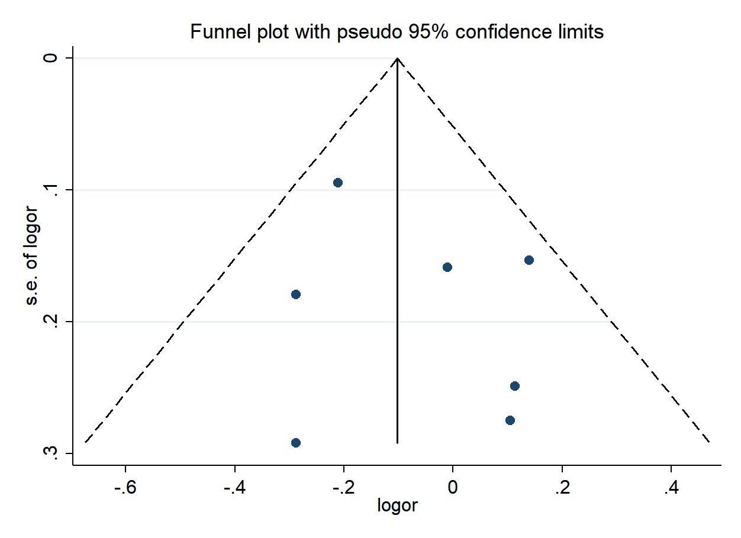

**Supplementary Fig 2.** Influence analysis of potato intake and all-cause mortality



**Supplementary Fig 3.** Funnel plot for assessing publication bias in the studies reporting the potato intake (Per 100 g/d increase) and all-cause mortality

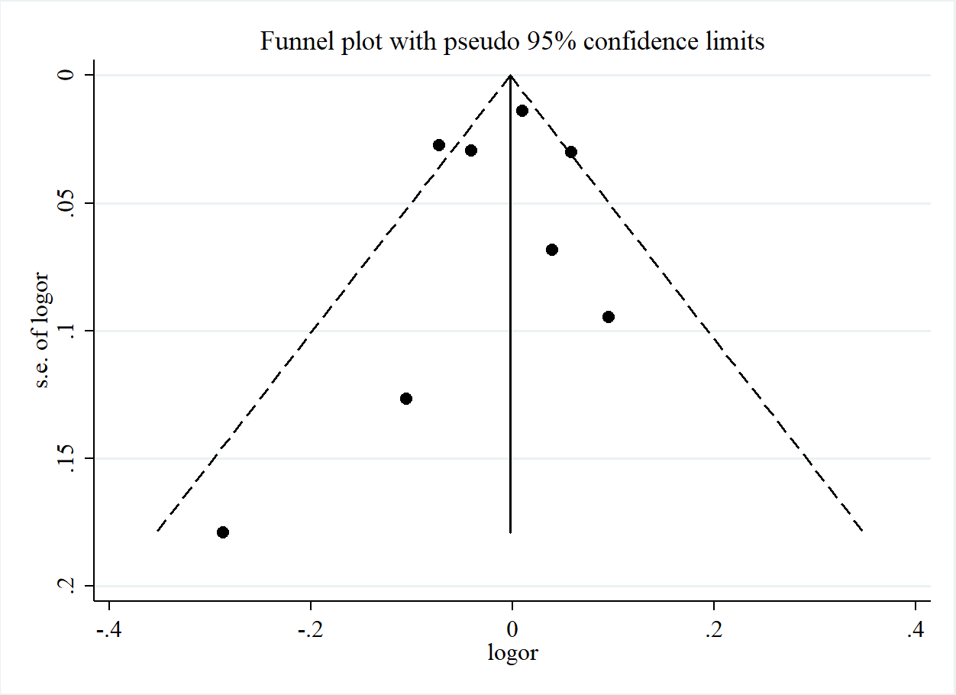

**Supplementary Fig 4.** Funnel plot for assessing publication bias in the studies reporting the potato intake and cancer mortality

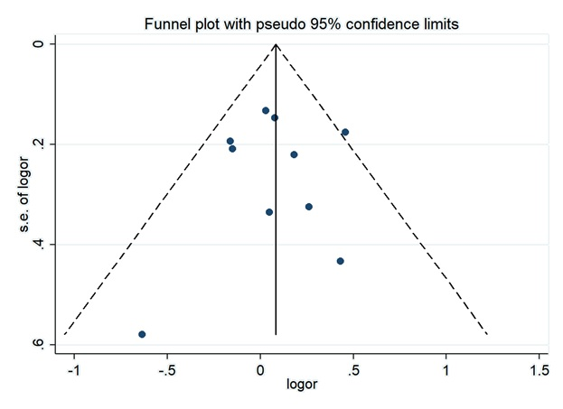

**Supplementary Fig 5.** Influence analysis of potato intake and cancer mortality



**Supplementary Fig 6.** Funnel plot for assessing publication bias in the studies reporting the potato intake (Per 100 g/d increase) and cancer mortality

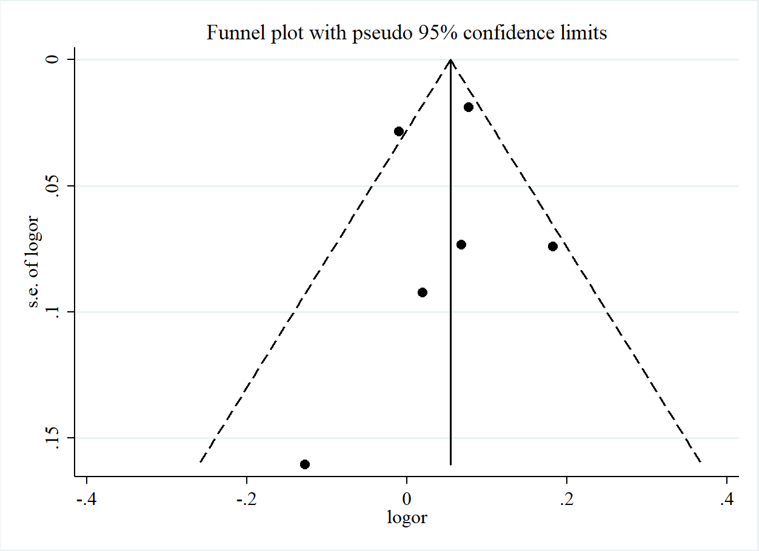

Bongard, V., Arveiler, D., Dallongeville, J., Ruidavets, J. B., Wagner, A., Simon, C., Marecaux, N., and Ferrieres, J. (2016). Food groups associated with a reduced risk of 15-year all-cause death. *Eur J Clin Nutr*.**70**: 715-722.

Dilis, V., Katsoulis, M., Lagiou, P., Trichopoulos, D., Naska, A., and Trichopoulou, A. (2012). Mediterranean diet and CHD: the Greek European Prospective Investigation into Cancer and Nutrition cohort. *Br J Nutr*.**108**: 699-709.

Gonzalez, S., Huerta, J. M., Fernandez, S., Patterson, A. M., and Lasheras, C. (2008). Differences in overall mortality in the elderly may be explained by diet. *Gerontology*.**54**: 232-237.

Guallar-Castillon, P., Rodriguez-Artalejo, F., Lopez-Garcia, E., Leon-Munoz, L. M., Amiano, P., Ardanaz, E., Arriola, L., Barricarte, A., Buckland, G., Chirlaque, M. D., Dorronsoro, M., Huerta, J. M., Larranaga, N., Marin, P., Martinez, C., Molina, E., Navarro, C., Quiros, J. R., Rodriguez, L., Sanchez, M. J., Gonzalez, C. A., and Moreno-Iribas, C. (2012). Consumption of fried foods and risk of coronary heart disease: Spanish cohort of the European Prospective Investigation into Cancer and Nutrition study. *Bmj*.**344**: e363.

Huang, X. E., Tajima, K., Hamajima, N., Kodera, Y., Yamamura, Y., Xiang, J., Tominaga, S., and Tokudome, S. (2000). Effects of dietary, drinking, and smoking habits on the prognosis of gastric cancer. *Nutr Cancer*.**38**: 30-36.

Iestra, J., Knoops, K., Kromhout, D., de Groot, L., Grobbee, D., and van Staveren, W. (2006). Lifestyle, Mediterranean diet and survival in European post-myocardial infarction patients. *Eur J Cardiovasc Prev Rehabil*.**13**: 894-900.

Kahn, H. A., Phillips, R. L., Snowdon, D. A., and Choi, W. (1984). Association between reported diet and all-cause mortality. Twenty-one-year follow-up on 27,530 adult Seventh-Day Adventists. *Am J Epidemiol*.**119**: 775-787.

Khan, M. M., Goto, R., Kobayashi, K., Suzumura, S., Nagata, Y., Sonoda, T., Sakauchi, F., Washio, M., and Mori, M. (2004). Dietary habits and cancer mortality among middle aged and older Japanese living in hokkaido, Japan by cancer site and sex. *Asian Pac J Cancer Prev*.**5**: 58-65.

Kurozawa, Y., Ogimoto, I., Shibata, A., Nose, T., Yoshimura, T., Suzuki, H., Sakata, R., Fujita, Y., Ichikawa, S., Iwai, N., Fukuda, K., and Tamakoshi, A. (2004). Dietary habits and risk of death due to hepatocellular carcinoma in a large scale cohort study in Japan. Univariate analysis of JACC study data. *Kurume Med J*.**51**: 141-149.

Larsson, S. C., and Wolk, A. (2016). Potato consumption and risk of cardiovascular disease: 2 prospective cohort studies. *Am J Clin Nutr*.**104**: 1245-1252.

Osella, A. R., Veronese, N., Notarnicola, M., Cisternino, A. M., Misciagna, G., Guerra, V., Nitti, A., Campanella, A., and Caruso, M. G. (2018). Potato Consumption Is not Associated with Higher Risk of Mortality: A Longitudinal Study among Southern Italian Older Adults. *J Nutr Health Aging*.**22**: 726-730.

Pietinen, P., Rimm, E. B., Korhonen, P., Hartman, A. M., Willett, W. C., Albanes, D., and Virtamo, J. (1996). Intake of dietary fiber and risk of coronary heart disease in a cohort of Finnish men. The Alpha-Tocopherol, Beta-Carotene Cancer Prevention Study. *Circulation*.**94**: 2720-2727.

Prinelli, F., Yannakoulia, M., Anastasiou, C. A., Adorni, F., Di Santo, S. G., Musicco, M., Scarmeas, N., and Correa Leite, M. L. (2015). Mediterranean diet and other lifestyle factors in relation to 20-year all-cause mortality: a cohort study in an Italian population. *Br J Nutr*.**113**: 1003-1011.

Sakauchi, F., Khan, M. M., Mori, M., Kubo, T., Fujino, Y., Suzuki, S., Tokudome, S., and Tamakoshi, A. (2007). Dietary habits and risk of ovarian cancer death in a large-scale cohort study (JACC study) in Japan. *Nutr Cancer*.**57**: 138-145.

Skuladottir, H., Tjoenneland, A., Overvad, K., Stripp, C., and Olsen, J. H. (2006). Does high intake of fruit and vegetables improve lung cancer survival? *Lung Cancer*.**51**: 267-273.

Sluik, D., Boeing, H., Li, K., Kaaks, R., Johnsen, N. F., Tjonneland, A., Arriola, L., Barricarte, A., Masala, G., Grioni, S., Tumino, R., Ricceri, F., Mattiello, A., Spijkerman, A. M., van der, A. D., Sluijs, I., Franks, P. W., Nilsson, P. M., Orho-Melander, M., Fharm, E., Rolandsson, O., Riboli, E., Romaguera, D., Weiderpass, E., Sanchez-Cantalejo, E., and Nothlings, U. (2014). Lifestyle factors and mortality risk in individuals with diabetes mellitus: are the associations different from those in individuals without diabetes? *Diabetologia*.**57**: 63-72.

Tokui, N., Yoshimura, T., Fujino, Y., Mizoue, T., Hoshiyama, Y., Yatsuya, H., Sakata, K., Kondo, T., Kikuchi, S., Toyoshima, H., Hayakawa, N., Kubo, T., and Tamakoshi, A. (2005). Dietary habits and stomach cancer risk in the JACC Study. *J Epidemiol*.**15 Suppl 2**: S98-108.

Trichopoulou, A., Bamia, C., Norat, T., Overvad, K., Schmidt, E. B., Tjonneland, A., Halkjaer, J., Clavel-Chapelon, F., Vercambre, M. N., Boutron-Ruault, M. C., Linseisen, J., Rohrmann, S., Boeing, H., Weikert, C., Benetou, V., Psaltopoulou, T., Orfanos, P., Boffetta, P., Masala, G., Pala, V., Panico, S., Tumino, R., Sacerdote, C., Bueno-de-Mesquita, H. B., Ocke, M. C., Peeters, P. H., Van der Schouw, Y. T., Gonzalez, C., Sanchez, M. J., Chirlaque, M. D., Moreno, C., Larranaga, N., Van Guelpen, B., Jansson, J. H., Bingham, S., Khaw, K. T., Spencer, E. A., Key, T., Riboli, E., and Trichopoulos, D. (2007). Modified Mediterranean diet and survival after myocardial infarction: the EPIC-Elderly study. *Eur J Epidemiol*.**22**: 871-881.

Veronese, N., Stubbs, B., Noale, M., Solmi, M., Vaona, A., Demurtas, J., Nicetto, D., Crepaldi, G., Schofield, P., Koyanagi, A., Maggi, S., and Fontana, L. (2017). Fried potato consumption is associated with elevated mortality: an 8-y longitudinal cohort study. *Am J Clin Nutr*.**106**: 162-167.

Wilson, K. M., Giovannucci, E., Stampfer, M. J., and Mucci, L. A. (2012). Dietary acrylamide and risk of prostate cancer. *Int J Cancer*.**131**: 479-487.