**Supplemental Materials for:**

**Reduced willingness to approach genuine smilers in social anxiety explained by potential for social evaluation, not misperception of smile authenticity**

Amy Dawel1*, Rachael Dumbleton2, Richard O’Kearney2, Luke Wright2, Elinor McKone1

1Research School of Psychology, and ARC Centre of Excellence in Cognition and its Disorders, The Australian National University, ACT 2600, Australia.

2Research School of Psychology, The Australian National University, ACT 2600, Australia.

*Corresponding author; e-mail: amy.dawel@anu.edu.au.

**Supplemental Material Contents**

Supplement S1 – Genuine happy stimuli used in previous studies 2

Supplement S2 – Extra Method Details 3

Supplement S3 – Detailed results for willingness to approach negative valence faces 7

Supplement S4 – Additional results showing similar outcomes for both social anxiety measures, and regardless of sex and viewpoint of the face stimuli 10

Supplement S5 – Bivariate correlations for variables included in multiple regressions 11

# Supplement S1 – Genuine happy stimuli used in previous studies

Of the nine studies Kivity and Huppert (2016) meta-analysed for approach ratings in social anxiety towards happy faces, eight used stimuli which we have previously shown to be mostly perceived as showing genuine happiness (Dawel et al., 2017). In particular, five studies used stimuli from Ekman’s lab, and another three used the KDEF (Karolinska Directed Emotional Faces; Lundqvist et al., 1998).

# Supplement S2 – Extra Method Details

**Session structure**

Participants completed all tasks in a single 2-hour session, including some additional tasks for a separate study which focused on psychopathic traits and is reported elsewhere (Dawel et al., in press). The order for all tasks (with tasks for **present article bolded** and tasks for the psychopathy study in normal font) completed by each participant was: arousal ratings; **approach-avoidance ratings;** intent-to-help ratings; **emotion labelling and genuineness ratings; face familiarity check (see end of this Supplement for details); demographic questionnaire;** Levenson Self Report Psychopathy Scale **(**LSRPS; Levenson, Kiehl, & Fitzpatrick, 1995) **SIAS;** Triarchic Psychopathy Measure **(**TriPM; Patrick, 2010); **SPAI-18; DASS-depression; STAI-state/trait;** Inventory of Callous Unemotional Traits **(**ICU; Frick, 2004).

**Additional details for social anxiety measures, and score distribution**

The*Social Phobia and Anxiety Inventory–brief version* (*SPAI-18*; Turner et al., 1989; De Vente et al., 2014)is a comprehensive measure of social anxiety that includes nine items assessing degree of distress in different social settings based on the presence of four different audience groups (strangers, authority figures, opposite sex, people in general) plus nine items assessing discomfort associated with being the centre of attention, cognitions, somatic reactions, and avoidance and escape behaviour. Items are rated on a 7-point scale from 0 (*never*) to 6 (*always*).

The *Social Interaction Anxiety Scale* (*SIAS*; Mattick & Clarke, 1998) provides a more focused measure of social interaction anxiety, and comprises 20 items describing cognitive, affective, and behavioural reactions to social interactions (e.g., “I am nervous mixing with people I don’t know well”) rated on a 5-point scale from 0 (*not at all characteristic or true of me*) to 4 (*extremely characteristic or true of me*).

Concerning suitability for correlation and regression analysis, Figure S1 shows an approximately normal distribution for both social anxiety measures.

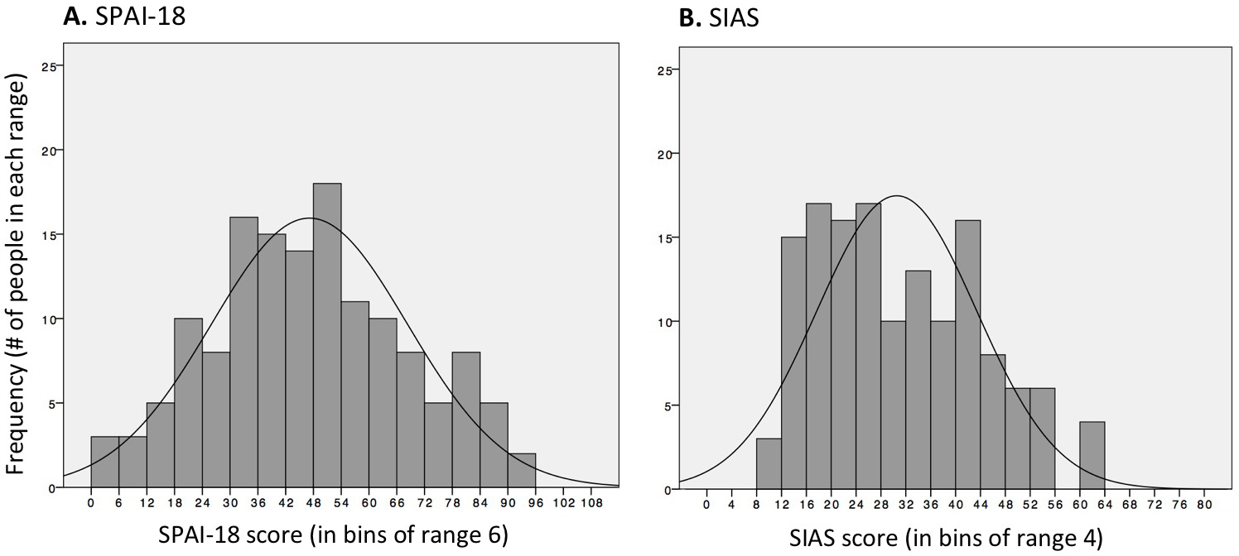

***Figure S2.*** Histograms illustrating the distribution of (A) SPAI-18 and (B) SIAS scores. The possible range of (A) SPAI-18 scores is 0-108, with each bar being a bin with a range of 6 (e.g., the bar between 90-96 has 2 people in it, meaning that 2 people had scores of 90 or more, but less than 96, with the bar below [84-90] containing the 5 people with scores above 84 and less than 90). The possible range of (B) SIAS scores is 0-80, with each bar being a bin with a range of 4 (e.g., the bar between 8-12 has 3 people in it, meaning that 3 people had scores of 8 or more, but less than 12, with the bar above [12-16] containing the 15 people with scores above 12 and less than 16).

**Additional stimulus details: Database origins, plus sex and viewpoint of faces**

Table S1 lists the individual stimuli used in the present study, which included 15 genuine and 15 polite smiles. We used all of the happy expressions from Dawel et al.’s (2017) genuine and posed sets, except for one posed stimulus that failed Dawel et al.’s (2017) validation procedure (see p. 1555 in Exp. 3 of that article) plus its viewpoint- and sex-matched counterpart from the genuine set. Table S1 also provides information on the sex and viewpoint of each face stimulus. Supplement S2 presents evidence establishing these variables did not affect results.

Table S2

*Stimulus items for the present study, including stimulus codes from original database sources*

|  |  |  |  |  |  |  |  |
| --- | --- | --- | --- | --- | --- | --- | --- |
|  |  |  | **Genuine smile items** | |  | **Polite smile items, matched to each genuine**  **smile item for sex-of-face and viewpoint** | |
| **Sex** | **View** |  | **Source** | **Stimulus code** |  | **Source** | **Stimulus code** |
| F | NF |  | FacePlace | CF0027_1110_HA |  | KDEF | AF05HAHR |
| F | NF |  | FacePlace | CF0025_1100_HA |  | KDEF | AF30HAHR |
| F | NF |  | FacePlace | CF0043_1100_HA |  | KDEF | AF29HAHR |
| F | NF |  | FacePlace | CF0023_1100_HA |  | KDEF | AF12HAHR |
| F | FR |  | GUR-M | 133_H2_006 |  | RaFD | Rafd090_61_Caucasian_female_happy_frontal |
| F | FR |  | GUR-M | 219_H6_xxx |  | RaFD | Rafd090_04_Caucasian_female_happy_frontal |
| F | FR |  | GUR-M | 130_H7_004 |  | RaFD | Rafd090_01_Caucasian_female_happy_frontal |
| F | FR |  | GUR-M | 102_H2_005 |  | GUR-E | 204_H5_xxx |
| F | FR |  | GUR-M | 145_H7_004 |  | GUR-E | 025_H3_008 |
| M | NF |  | News | FXJ283434b |  | KDEF | AM11HAHR |
| M | NF |  | News | FXJ283434a |  | KDEF | BM26HAHR |
| M | NF |  | News | FXT64665a |  | KDEF | BM08HAHR |
| M | NF |  | News | FXT64665b |  | RaFD | Rafd045_03_Caucasian_male_happy_left |
| M | NF |  | News | FXJ209317b |  | RaFD | Rafd045_05_Caucasian_male_happy_frontal |
| M | NF |  | News | FXJ209317a |  | KDEF | BM02HAHR |

*Notes.* F = female. M = male. NF = non-frontal (approximately three-quarter) viewpoint. FR = frontal viewpoint. FacePlace = from Righi, Peissig, & Tarr (2012). GUR-M = method-acted and GUR-E = English-acted (Gur et al., 2002). News = news media images (of professional sportsmen) from Fairfax Syndication, http://www.fairfaxsyndication.com/C.aspx?VP3=CMS3&VF=FXJO50_1. KDEF = Karolinska Directed Emotional Faces (Lundqvist et al., 1998). RaFD = Radboud Faces Database (Langner et al., 2010).

**Additional details for genuineness rating task**

The genuineness rating task was identical to that reported in Exp. 3 of Dawel et al. (2017), and included detailed explanations of the meaning of “genuine” (i.e., genuinely-felt by the displayer) and “fake” (i.e., pretended).

The exact instructions to participants for genuine ratings were as follows:

Sometimes people show facial expressions of emotions they genuinely feel, and sometimes they display expressions that are faked or posed (e.g., to be polite or because they are acting).

An example of a genuine expression is when somebody smiles and they really feel happy, like when they get a present or see something funny.

An example of a faked expression is when somebody smiles for a school photo, without feeling any emotion. Or a parent playing a game with their child may put on a ‘scared’ face to pretend fear, but is not actually feel the emotion displayed.

Your task is to decide whether faces are showing genuinely felt expressions or faked/posed/acted expressions.

All the expressions you will see were photographed in laboratories, but some of them are genuine and some are faked.

In **genuine expressions**, emotions were induced by showing people video clips, pictures or sounds, or by asking them to remember an emotional event. For example, some people showing genuine happy expressions were photographed while watching a funny video. Others showing genuine fear were photographed while watching a scary film.

In **faked expressions**, people were simply instructed to act different emotions. For example, some people showing faked happy expressions were photographed when instructed to pose for a photo. Others showing faked fear were photographed when instructed to ‘look scared’ or to move specific face muscles.

You will rate each face using the following scale:

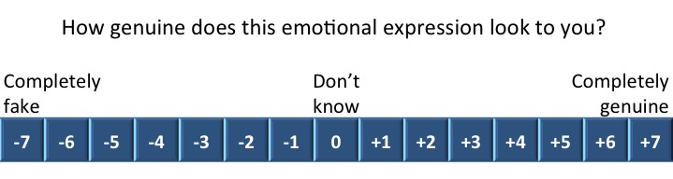

* **–7** means you think the expression is completely faked/posed/acted, and that the person does not feel the displayed emotion at all.
* **+7** means you think the expression is completely genuine, and that the person really feels the displayed emotion.
* **0** means that you can’t tell at all, and are just guessing.

Please don’t assume that half the faces you see will be genuine and half faked—this is not true of the face set you will see. We just want to know how genuine or fake you think the expressions are.

If you think that more of the faces you see are at the genuine end of the scale, please use this end more.

If you think that more of the faces you see are at the fake end of the scale, please use this end more.

If you think that they are spread across the scale, then please use the full length of the scale.

A final point: we want you to ***ignore the strength*** of the expressions when you rate how genuine or fake each expression is.

For example, an expression of sadness may be very subtle but be completely genuinely felt. Such an expression should be rated as completely genuine.

On the other hand, an expression of sadness may be very strong but be completely faked/posed/acted.

Such an expression should be rated as completely faked.

At the end of the face tasks, participants were given a comprehension check for the genuineness rating task. They were asked: “An example of a GENUINE expression is: (a) when somebody smiles and they really feel happy (e.g., like when they get a present they like) [correct answer], or (b) when somebody smiles without feeling any emotion (e.g., for a school photo)”; and “An example of a FAKED expression is: (a) when someone shows a fearful expression and they really feel afraid (e.g., when watching a scary film or hearing a creepy noise in the dark), or (b) when someone shows a fearful expression without feeling any emotion, or when feeling a different emotion to fear (e.g., a parent playing ‘tigers’ with their child might pretend a fearful expression, but feel no emotion or feel happy playing with their child) [correct answer].”All *n* = 141 participants included in analysis answered both questions correctly. Note, we also tested an additional seven participants who were excluded from analysis because they incorrectly answered at least one of these questions.

**Additional details for willingness-to-approach task**

The exact instructions to participants for the approach-avoid ratings were as follows:

We want you to imagine that you are on a street on your way to an appointment, and that you are lost and in a hurry, and need to ask someone for directions.

We want you to imagine that you walk past each face, and rate how likely you would be to approach or avoid this person to ask for directions.

Out of all the faces in the set, we want you to say which ones you are most likely to avoid and most likely to approach, using the following scale:

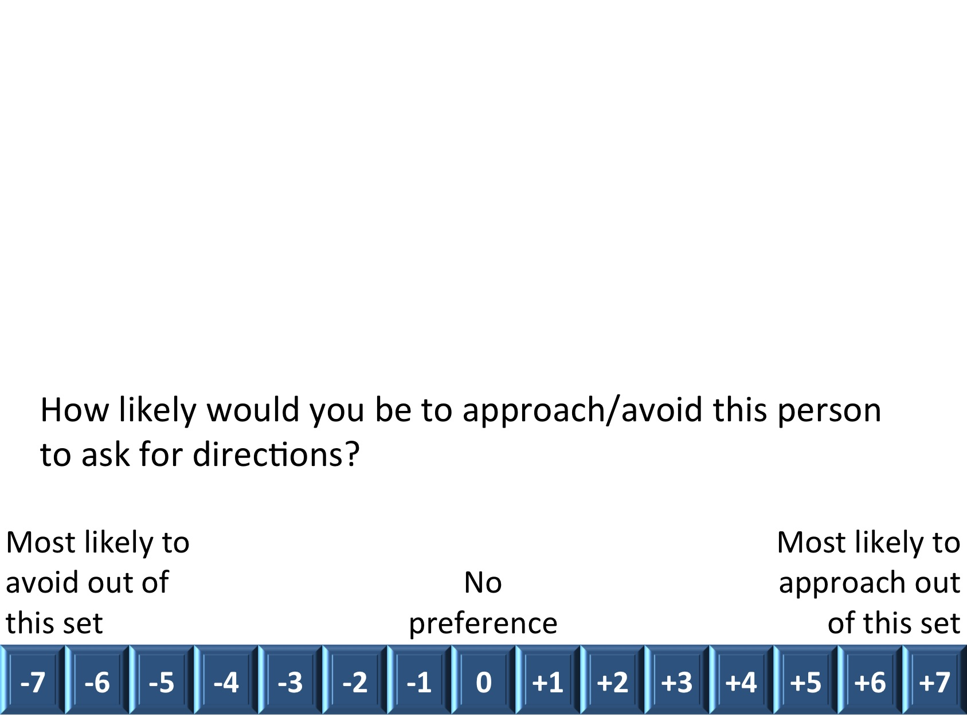

* -7 means that you would most want to avoid approaching this person to ask for directions.
* 0 means that you have no preference for either approaching or avoiding this person to ask for directions.
* +7 means that you would feel most comfortable approaching this person to ask for directions.

We are especially interested in how much you would want to approach or avoid each person relative to the other faces you are shown, so please try to use the full range of the scale.

Quite a number of the people you will see will be showing negative expressions, which means that in general you might choose to avoid these people. However, please do not rate every negative expression as -7. If you think you would avoid a person, but there are other people you would avoid more, please give them a less extreme rating.

Similarly, for positive expressions you might find that generally you would want to approach these people. Please do not rate every positive expression as +7. If you think you would approach a person, but there are other people you would approach more, please give them a less extreme rating.

There are no right or wrong answers, so please just answer as honestly as you can.

**Post-test check for face familiarity**

Our study aim was to measure genuineness percepts and willingness to approach for strangers; that is, people previously unfamiliar to the observers. Some of our genuine smile stimuli, however, came from news media (i.e., photographs of real events expected to induce happiness, such as winning a sporting grand final) and showed sportsmen who could have been familiar to some of our participants. Thus, after the face rating tasks were completed, we showed each of the news media stimuli again and asked participants to indicate if they recognised any of the people displaying the expressions. This familiarity check was used to exclude any rating trials that had shown faces recognised as familiar by that participant.

**Additional references**

Frick, P. J. (2004). *The inventory of callous-unemotional traits*. Unpub- lished rating scale, University of New Orleans: New Orleans, LA.

Levenson, M. R., Kiehl, K. A., & Fitzpatrick, C. M. (1995). Assessing psychopathic attributes in a noninstitutionalized population. *Journal of Personality and Social Psychology, 68,* 151–158. http://dx.doi.org/10 .1037/0022-3514.68.1.151

Patrick, C. J. (2010). *Operationalizing the triarchic conceptualization of psychopathy: Preliminary description of brief scales for assessment of boldness, meanness, and disinhibition*. Unpublished manuscript, Depart- ment of Psychology, Florida State University, Tallahassee, FL.

# Supplement S3 – Detailed results for willingness to approach negative valence faces

Negative valence faces (anger, disgust) were included to verify the validity of our approach-avoidance rating task (see main text Method), i.e., they allowed us to verify that participants showed the usual response of wanting to avoid negative expressions. However, ratings for these negative expressions can also be analysed for associations with social anxiety.

Past work has already established that, although social anxiety may be associated with reduced approach for negative expressions in some types of implicit measures (e.g., involving rate of moving a joystick towards or away from a face, Heuer et al., 2007; Lange et al., 2008), this is not the case for explicit rating measures (see Kivity and Hupperts’ [2016] meta-analysis of nine approach rating studies for “threat” expressions, anger, disgust, contempt).

This lack of social anxiety effect for negative emotions was replicated in the present study. Table S3 shows bivariate correlations between social anxiety and approach-avoidance ratings for genuine and posed anger and disgust expressions were all non-significant. Means in Figure S3 reveal our typical-SA and high-SA groups both simply wished to avoid the negative valence expressions, with no differences between groups, all *t*s <1.11, *p*s >.268. Finally, regression analysis including covariates (state and trait anxiety, and depression), following the same procedure as described for smiles in the main text Results, confirmed there was no independent effect of social anxiety on approach ratings for negative expressions (see Table S4, Step 2, where all *p*s >.314).



***Figure S3.*** Mean ratings of approach-avoidance, for typical SA (SPAI >48, *n*=65) and high-SA (SPAI ≤48, *n*=76) groups. Across genuine and posed anger and disgust, plus neutral expressions, the social anxiety groups did not differ on approach ratings. Error bars=±CI95.

Altogether, these results provide strong evidence of no effect of social anxiety on explicit willingness to approach ratings for negative valence expressions in our study, in agreement with Kivity and Hupperts’ (2016) meta-analytic evidence. We also note our findings extend the Kivity and Huppert evidence somewhat: the nine studies they analysed generally used posed expressions for their negative-valence emotions (e.g., *n*=5 studies used stimuli from Ekman and colleagues; and *n*=3 used the Karolinska Directed Emotional Faces set [KDEF]; Lundqvist et al., 1998), which are also perceived by the average observer as faking emotion (Dawel et al., 2017). The present study has generalised the conclusion of no social anxiety effect to genuine negative emotions (genuine disgust, genuine anger) as well as posed ones.

Finally, we also tested and analysed data for neutral expressions. As expected, and also verifying the validity of our task, participants did not show a strong tendency to want to approach or avoid neutral faces (Figure S3C). Also as for negative expressions, there was no evidence of association between social anxiety and approach-avoidance for neutral expressions.

Table S3a

*Pearson’s r correlations for each of the social anxiety measures (SPAI-18, SIAS) with approach-avoidance ratings*

|  |  |  |  |  |  |  |  |
| --- | --- | --- | --- | --- | --- | --- | --- |
|  | Anger | |  | Disgust | |  | Neutral  expressions |
|  | Genuine | Posed |  | Genuine | Posed |  |
| SPAI-18 | -.010 | .081 |  | -.051 | .049 |  | .011 |
| SIAS | .031 | .144† |  | -.058 | .055 |  | .077 |

*Notes.* All correlations are non-significant. †The single marked correlation has *p* = .089. All unmarked correlations have *p* > .340.

Table S3b

*Stepwise regressions testing whether social anxiety (Step 2) makes a unique contribution to predicting approach-avoidance ratings for expressions of anger and disgust, and neutral faces*

|  |  |  |  |  |  |  |  |
| --- | --- | --- | --- | --- | --- | --- | --- |
|  | | | *R* | *R*2 ch. | Beta | Part | *p*1 |
| **A. Genuine anger** | | |  |  |  |  |  |
|  | Step 1: STAI-state/trait, DASS-depression | | **.249** | **.062** |  |  | **.032** |
|  | Step 2: Social anxiety2 | | .251 | .001 |  |  | .695 |
|  | Final model: | Social anxiety |  |  | .045 | .033 | .695 |
|  |  | STAI-state |  |  | .136 | .100 | .231 |
|  |  | STAI-trait |  |  | **-.349** | **-.182** | **.030** |
|  |  | DASS-depression |  |  | **.312** | **.221** | **.009** |
| **B. Posed anger** | | |  |  |  |  |  |
|  | Step 1: STAI-state/trait, DASS-depression | | .118 | .014 |  |  | .591 |
|  | Step 2: Social anxiety | | .145 | .007 |  |  | .315 |
|  | Final model: | Social anxiety |  |  | .118 | .086 | .315 |
|  |  | STAI-state |  |  | .092 | .068 | .426 |
|  |  | STAI-trait |  |  | -.003 | -.001 | .987 |
|  |  | DASS-depression |  |  | -.076 | -.054 | .525 |
| **C. Genuine disgust** | | |  |  |  |  |  |
|  | Step 1: STAI-state/trait, DASS-depression | | .228 | .052 |  |  | .063 |
|  | Step 2: Social anxiety | | .232 | .002 |  |  | .571 |
|  | Final model: | Social anxiety |  |  | -.065 | -.047 | .571 |
|  |  | STAI-state |  |  | -.200 | -.147 | .080 |
|  |  | STAI-trait |  |  | -.042 | -.022 | .794 |
|  |  | DASS-depression |  |  | **.255** | **.181** | **.032** |
| **D. Posed disgust** | | |  |  |  |  |  |
|  | Step 1: STAI-state/trait, DASS-depression | | .173 | .030 |  |  | .240 |
|  | Step 2: Social anxiety | | .174 | <.001 |  |  | .884 |
|  | Final model: | Social anxiety |  |  | -.017 | -.012 | .884 |
|  |  | STAI-state |  |  | .044 | .033 | .770 |
|  |  | STAI-trait |  |  | -.057 | -.030 | .727 |
|  |  | DASS-depression |  |  | .193 | .137 | .107 |
| **E. Neutral faces** | | |  |  |  |  |  |
|  | Step 1: STAI-state/trait, DASS-depression | | **.247** | **.061** |  |  | **.034** |
|  | Step 2: Social anxiety | | .266 | .010 |  |  | .232 |
|  | Final model: | Social anxiety |  |  | .137 | .099 | .232 |
|  |  | STAI-state |  |  | **-.255** | **-.188** | **.024** |
|  |  | STAI-trait |  |  | -.127 | -.066 | .424 |
|  |  | DASS-depression |  |  | .221 | .157 | .060 |

*Notes. R*2 ch.=*R*2 change. 1*p* values for each step are for *F* change. 2Social anxiety=(*z*SIAS + *z*SPAI-18)/2. Bolded values are significant at *p* <.05.

**Additional references**

Heuer, K., Rinck, M., & Becker, E. S. (2007). Avoidance of emotional facial expressions

in social anxiety: The approach–avoidance task. *Behaviour Research and Therapy,*

*45*(12), 2990−3001.

Lange, W. G., Keijsers, G., Becker, E. S., & Rinck, M. (2008). Social anxiety and

evaluation of social crowds: Explicit and implicit measures. *Behaviour*

*Research and Therapy, 46*(8), 932-943.

# Supplement S4 – Additional results showing similar outcomes for both social anxiety measures, and regardless of sex and viewpoint of the face stimuli

Table S2 presents Pearson’s *r* correlations for social anxiety with ratings on each of our two tasks, separately for each social anxiety measure (SPAI-18, SIAS), and separately for subsets of face items divided by sex and viewpoint. Data show almost identical correlations for the SPAI-18 and SIAS measures, thus justifying combining these two measures in correlation and regression analyses in the main-text Results section. Data also show the same pattern of correlations regardless of face sex and viewpoint: in all cases, no significant correlations with social anxiety for genuineness ratings (Table S2A) and, for willingness-to-approach ratings (Table S2B), stronger correlations with social anxiety for genuine than polite smiles.

Table S4

*Correlations with (A) genuineness ratings and (B) approach ratings, for each social anxiety measure separately, and each sex/viewpoint of face separately*

|  |  |  |  |  |  |  |  |  |  |  |  |  |
| --- | --- | --- | --- | --- | --- | --- | --- | --- | --- | --- | --- | --- |
|  |  | All items (15 genuine, 15 polite smiles) | |  | Front view  female faces (5)1 | |  | Non-frontal  female faces (4) | |  | Non-frontal  male faces (6) | |
|  |  | Genuine | Polite |  | Genuine | Polite |  | Genuine | Polite |  | Genuine | Polite |
| A. Correlations with genuineness ratings | | | |  |  |  |  |  |  |  |  |  |
|  | SPAI-18 | -.039 | .100 |  | .005 | .127 |  | -.002 | .058 |  | -.108 | .030 |
|  | SIAS | -.049 | .045 |  | -.013 | .069 |  | -.025 | .008 |  | -.091 | .014 |
| B. Correlations with approach ratings | | | |  |  |  |  |  |  |  |  |  |
|  | SPAI-18 | **-.361\*\*\*** | **-.180\*** |  | **-.226\*\*** | -.022 |  | **-.290\*\*** | -.147† |  | **-.276\*\*** | **-.201\*** |
|  | SIAS | **-.354\*\*\*** | **-.194\*** |  | **-.216\*\*** | -.034 |  | **-.262\*\*** | -.132 |  | **-.282\*\*** | **-.224\*\*** |

*Notes.* 1Number of smiles of each type given in parentheses. Note, no face items showed front view males. Non-frontal viewpoints approximated three-quarter view. †*p* = .081. \**p* < .05. \*\**p* < .01. \*\*\**p* < .001. All unmarked correlations are non-significant and have *p* > .117.

# Supplement S5 – Bivariate correlations for variables included in multiple regressions

Table S5

*Bivariate correlations between variables included in multiple regressions*

|  |  |  |  |
| --- | --- | --- | --- |
|  | STAI-ST | STAI-TR | DASS-dep (*τ*) |
| Social anxiety1 | .423*** | .684*** | .319*** |
| STAI-ST |  | .672*** | .382*** |
| STAI-TR |  |  | .557*** |
| Approach ratings for genuine smiles | -.239** | -.384*** | -.198** |
| Approach ratings for polite smiles | -.291*** | -.218** | -.130* |

*Notes.* 1Social anxiety = (*z*SIAS + *z*SPAI-18)/2). Pearson’s *r* is reported where both measures are normally distributed; otherwise we report Kendall’s *τ* as indicated in the table. \**p* < .05. \*\**p* < .01. \*\*\**p* < .001.