Table S1. Primer sequences used for genes investigated by RT-PCR.
Gene name | Market | Symbol | Entrez  Gene ID | Primer (5’ → 3’) | Amplicon Size (pb)
Cu/Zn-Superoxide Dismutase | Oxidative Stress | SOD | XM_963191.2 | F: CCATGGAAAGGATCATGGAG  R: GGCTTCGATATTCCCCAAAT | 70
Glutathione Peroxidase |  | GPx | XM_964774.2 | F: GTTCTGAACCAGAGCCCTCA  R: TTTCTTCGCCCTCAATTGTC | 84
Glutathione S-Transferase | Metabolic detoxification | GST | XM_964053.1 | F: ATTCGATTGCCCGATATTTG  R: CGTTGAAGGTGTCCACAATG | 96
Cytochrome P450 6BQ8 |  | CYP6BQ8 | XM_970474.1 | F: CTATCCCCAACACTTCCATTC  R: CTGCGGTCAGTCCAACTTTAC | 237
Hypoxia-inducible factor 1 α | Stress responsive | HIF | XM_962334.2 | F: GTCGGATTTGGTGGCGAAAG  R: CTTTTCGCTGCTGCTCCACA | 100
Δ-9 Desaturase 1 | Repair of cellular membranes | Δ-9 Des | XM_965427.1 | F: CGGAGTCCATCGTTTATGGT  R: TGCCCATTCGTAAATGGAAT | 112
DNA Ligase IV | DNA repair | Lig | XM_963681.1 | F: CGGTGGAAGGCACTATTGTT  R: ACCGACGAATTCAAAGCATC | 82
Ribosomal protein S18 | Housekeeping | RpS18 | XM_968539.2 | F: CGAAGAGGTCGAGAAAATCG  R: CGTGGTCTTGGTGTGTTGAC | 235
F: Forward (5’ → 3’); R: Reverse (5’ → 3’).

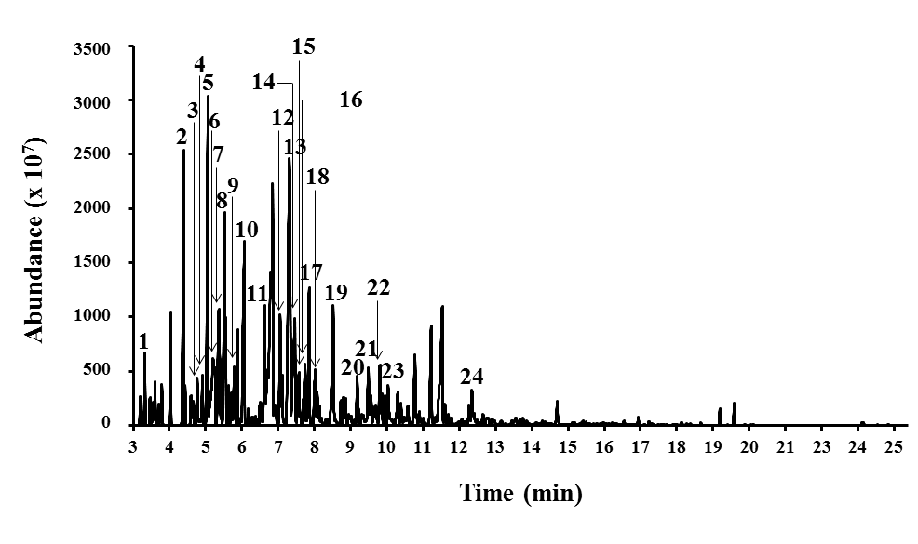
Fig S1. Typical GC/MS chromatograms of thinner. 1. Cyclohexane. 2. Methylcyclohexane. 3. 1,2,4-trimethylvyclopentane. 4. 1,2,3-trimethylCyclopentane. 5. Toluene. 6. 2-methylheptane. 7. 1,3-dimethylcyclohexane. 8. 1-ethyl-2-methylcyclopentane. 9. 1,2-dimethylcyclohexane. 10. 2,4-dimethylheptane. 11. ethylcyclohexane,. 12. Ethylbenzene. 13. p-Xylene. 14. Cyclohexanone. 15. 2-methyloctane. 16. 3-methyloctane. 17. o-Xylene. 18. cis-1-Ethyl-3-methyl-cyclohexane. 19. Nonane. 20. Propylcyclohexane,. 21. 2,6-dimethyloctane. 22. 1-ethyl-3-methylbenzene. 23. 1,2,3-trimethylbenzene,. 24. Butylcyclohexane.

