Supplementary Table 1. Characterization of tanshinoneIIA-loaded nanoparticles.
Size(nm) | PDI | ZP(mV) | EE(%) | DL(%)
120.9 ± 19.7 | 0.103 ± 0.06 | -7.12 ± 0.07 | 61.30 ± 1.96 | 1.48 ± 0.12
PDI, polydispersity indexes; ZP, zeta potential; EE, encapsulation efficiency; DL, drug loading capacity

Supplementary Table 2. Echocardiographic characteristics in mice after sham or coronary artery ligationoperation.
 | sham | MI | TanshinoneIIA-NP | TanshinoneIIA  (1 mg/kg) | Tanshinone IIA  (10 mg/kg)
SBP | 106±4.7 | 82±6.3 | 105.6±2.6 | 81±4.7 | 81±4.9
CO (mL/min) | 24.54±3.51 | 10.11±2.13 | 18.91±3.21 | 9.21±1.16 | 10.01±1.71
FS% | 46.55±1.91 | 20.24±1.23 | 39.24±2.12 | 21.48±1.32 | 39.24±2.44
EF% | 78.92±1.18 | 41.23±2.81 | 70.59±3.01 | 43.30±1.11 | 70.59±2.05
LVEDD(mm) | 3.48±0.15 | 4.99±0.21 | 3.67±0.32 | 5.12±0.19 | 4.87±0.16
LVESD (mm) | 1.86±0.11 | 3.98±0.15 | 2.23±0.12 | 4.02±0.13 | 3.99±0.14
SBP, systolic blood pressure; LVEDD, left ventricular end-diastolic diameter; LVESD, left ventricular end-systolic diameter; FS, fractional shortening; and EF, ejection fraction. All values are mean±SE.

Supplementary Figure 1. The synthesis mechanism and steps to make the mPEG-PLA-TPGS.
Supplementary Figure 2. The standard curve of tanshinoneIIA-loaded mPEG-PLA-TPGS.
Supplementary Figure 3. Cell viability.
After H2C9 cardiocytes were cultured at 37°C and 5% CO₂ in 96-well plates for 24 h. The designated dose of tanNP (0 μmol/L,0.1 μmol/L,0.5 μmol/L,1 μmol/L,5 μmol/L,10 μmol/L ) and MTT (5 mg/mL) were then added into each well, and cultured for an additional 24 h. Following culture, the cell supernatants were removed and discarded, and then the plates were shaken for 15 min to dissolve crystals, and the absorbance of each sample was detected at 570 nm (A570) by an ELISA microplate reader. The degree of cell viability in each sample was calculated by the following formula: cell viability (%) = (absorbance of the experimental group/absorbance of the control group) × 100%.
Supplementary Figure 4. Effects of tanshinoneIIA solution on cardiac function and structure after MI.
Masson trichrome staining and H&E staining at 4 weeks after ligation in mice treated with or without tanshinoneIIA solution(n=10).
Supplementary Figure 5. Effects of tanshinoneIIA-NP on IκB/NF-κB after MI.
Immunoblotting analysis for the activation of AR1, ERK, IκB, NFκB p65 on in ischemic border zone 4 weeks after explosion to coronary artery ligation. Quantitative analysis of these proteins, active form, relative to the value of sham-operated mice, is shown in lower panel (n=6). #P< 0.05 versus Sham; *P < 0.05 versus MI.

Supplementary Figure 1.

Supplementary Figure 2.

Supplementary Figure 3.

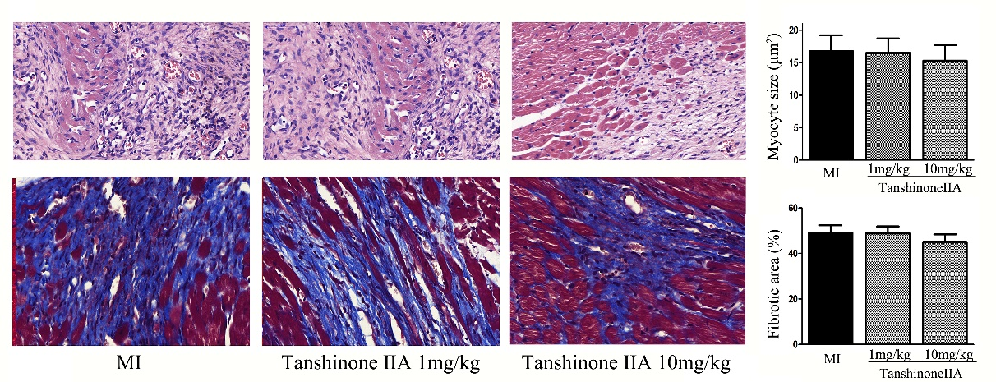
Supplementary Figure 4.

Supplementary Figure 5.

