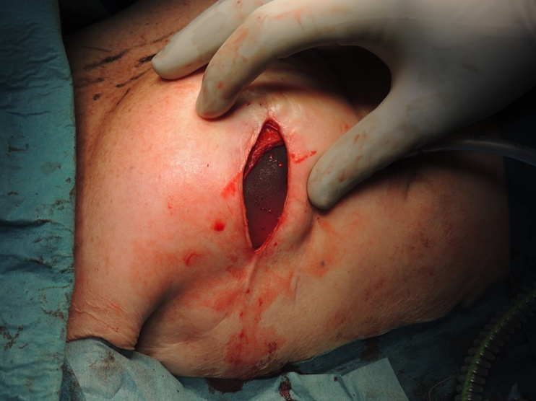
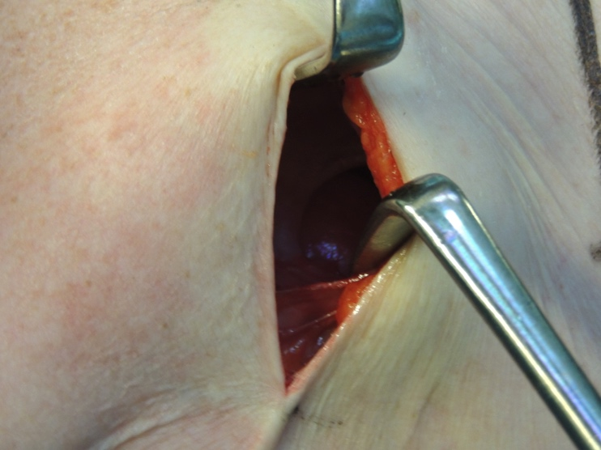
Picture 1: The pleural defect was found to be 4 x 4 centimeters, and clearly of older date.
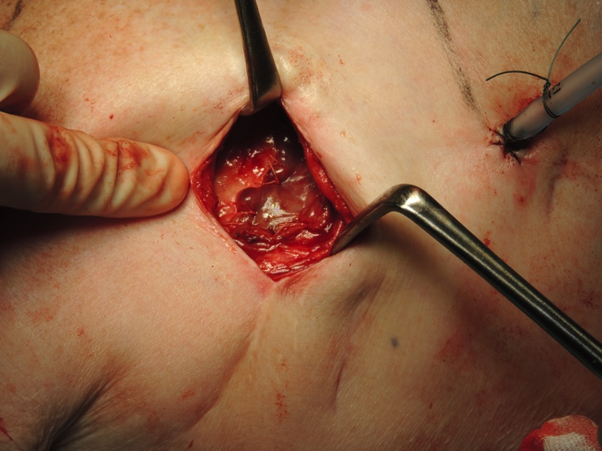

Picture 2 & 3: Creation of the flap

Picture 4: Placement of silicone implant

