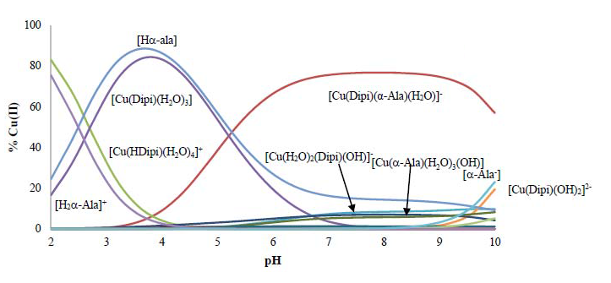
Species distribution diagram for the system Cu(II)-H₂Dipi- Hα-Ala [Cu(II)] = 3,0 mM, R = 1:1:1

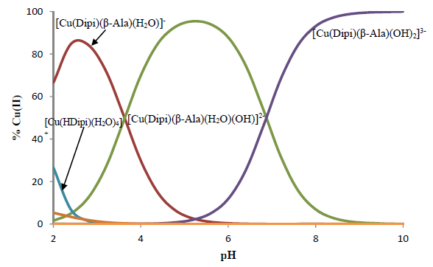
Species distribution diagram for the system Cu(II)- H₂Dipi - Hβ-Ala [Cu(II)] = 3,0 mM, R = 1:1:1

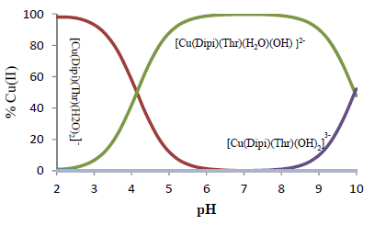
Species distribution diagram for the system Cu(II)- H₂Dipi - HThr[Cu(II)] = 3,0 mM, R = 1:1:1

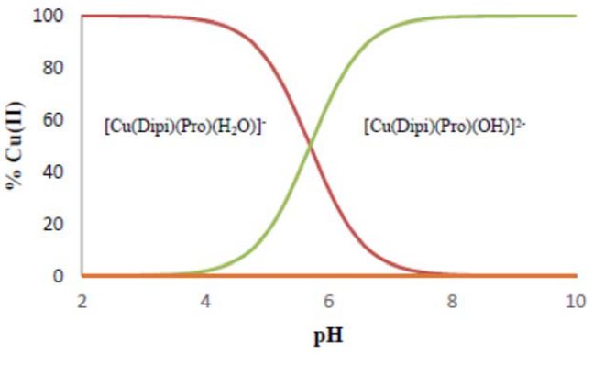
Species distribution diagram for the system Cu(II)- H₂Dipi - HPro[Cu(II)] = 3,0 mM, R = 1:1:1
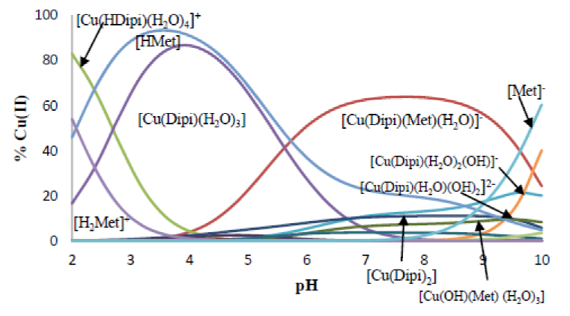
Species distribution diagram for the system Cu(II)- H₂Dipi - HMet[Cu(II)] = 3,0 mM, R = 1:1:1
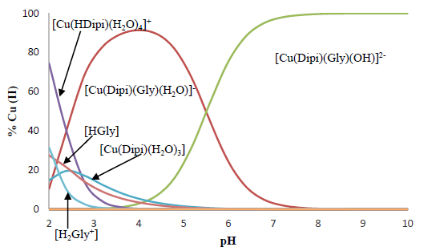
Species distribution diagram for the system Cu(II)- H₂Dipi - HGly [Cu(II)] = 3,0 mM, R = 1:1:1

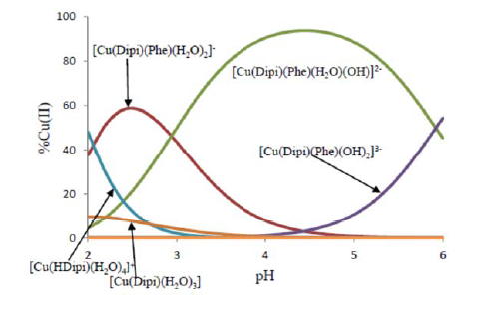
Species distribution diagram for the system Cu(II)- H₂Dipi - HPhe[Cu(II)] = 3,0 mM, R = 1:1:1
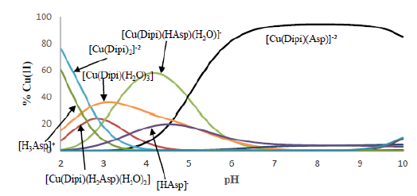
Species distribution diagram for the system Cu(II)- H₂Dipi - H₂Asp[Cu(II)] = 3,0 mM, R = 1:1:1

Comparison between voltammograms of [Cu(Dipi)(HHis)(H₂O)]⁺ and ligand [HHis]

Comparison between voltammograms of [Cu(Dipi)(Gly)(H₂O)]⁻ and ligand [HGly]

