Table A1 Descriptive statistics of crash data
Disaggregation | Before coordination |  |  | After coordination
 | N | % |  | N | %
Time of day
Peak hours | 211 | 27.4 |  | 218 | 28.8
Non-peak hours | 558 | 72.6 |  | 540 | 71.2
Crash type
Rear-end | 380 | 49.4 |  | 423 | 55.8
Angle | 165 | 21.5 |  | 174 | 23.0
Side-swipe | 79 | 10.3 |  | 93 | 12.3
Head on | 49 | 6.4 |  | 38 | 5.0
Miscellaneous Multiple Vehicle | 41 | 5.3 |  | 9 | 1.2
Others | 55 | 7.2 |  | 21 | 2.8
Speed limit
≥40 mi/h | 347 | 45.1 |  | 272 | 35.9
<40 mi/h | 422 | 54.9 |  | 486 | 64.1
Severity
Incapacitating injury | 1 | 0.1 |  | 3 | 0.4
Non-incapacitating injury | 24 | 3.1 |  | 20 | 2.6
Possible injury | 132 | 17.2 |  | 133 | 17.5
Property damage only | 612 | 79.6 |  | 602 | 79.4
Total | 769 | 100.0 |  | 758 | 100.0

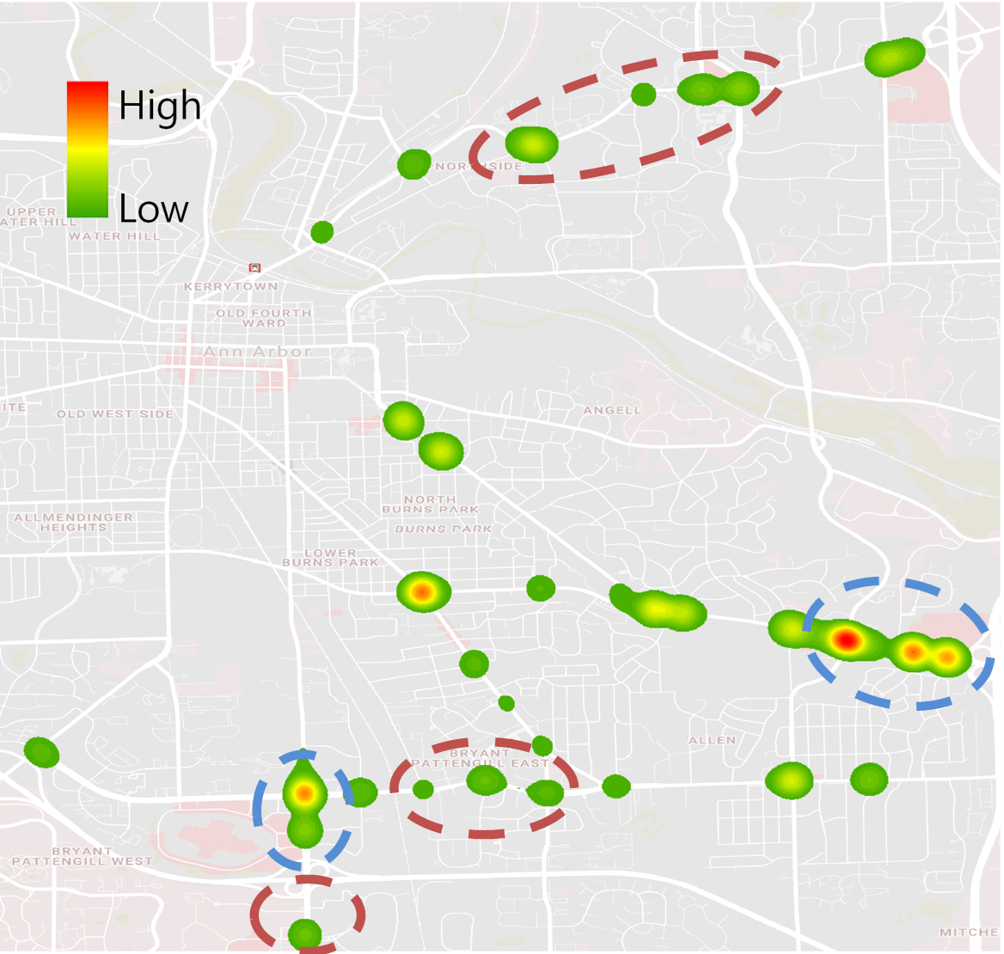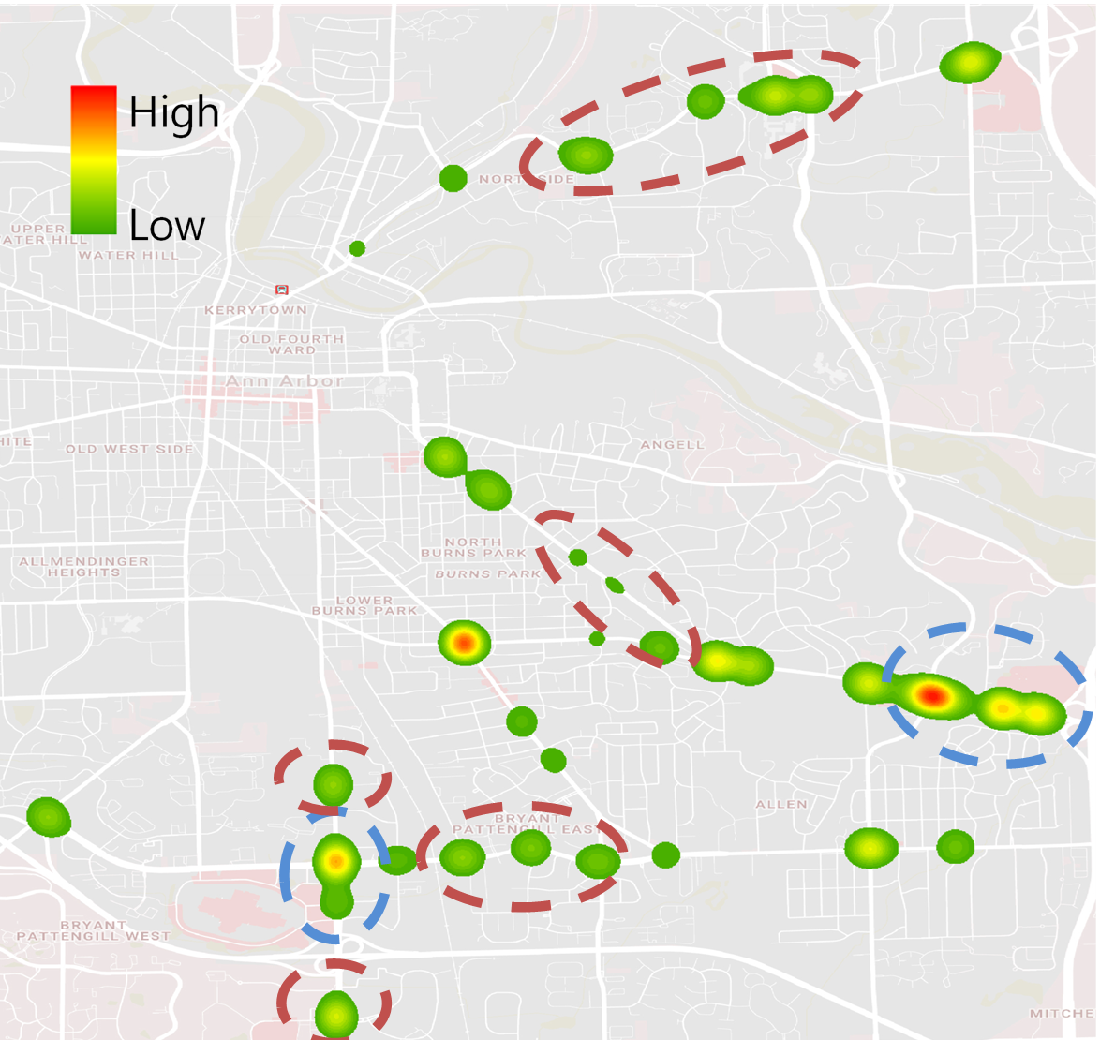
(a) before signal coordination (b) after signal coordination
Fig. A1 Crash distribution on the heat map

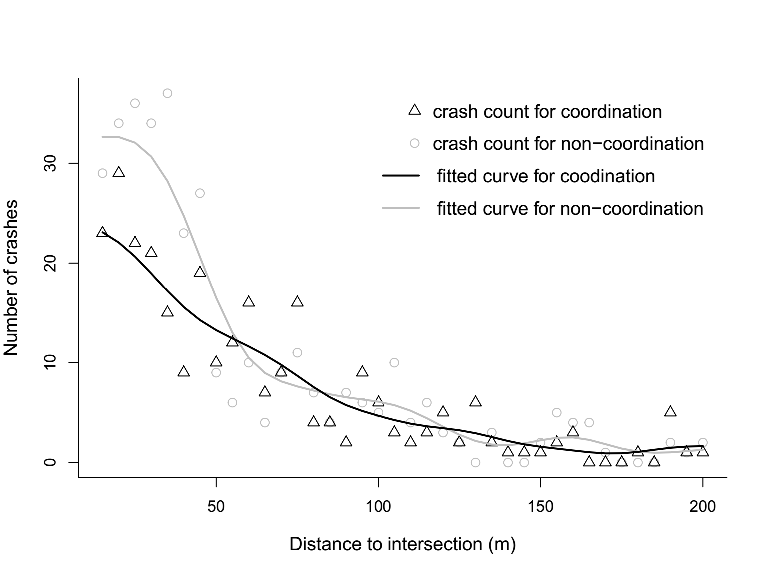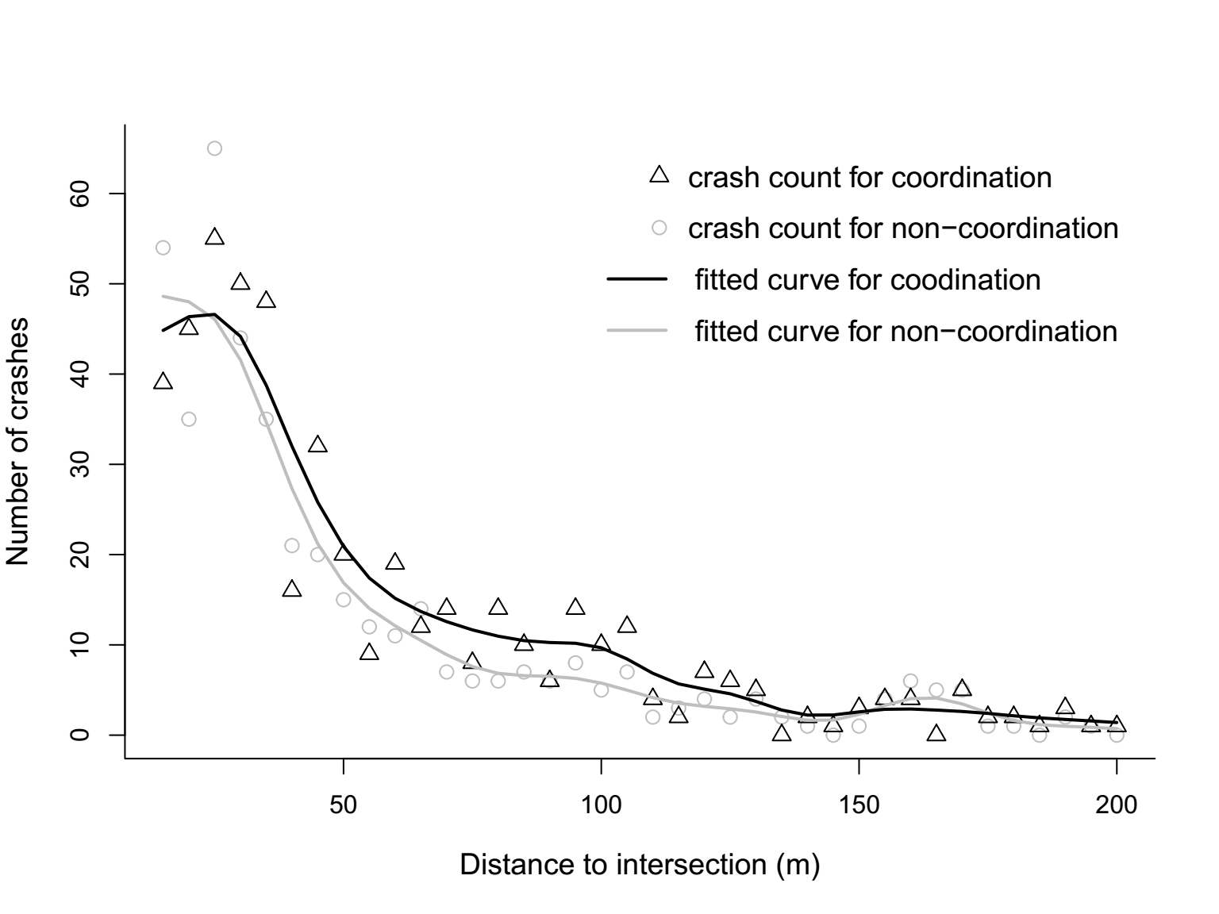
(a) ≥40 mi/h (b) <40 mi/h
Fig. A2 Kernel regression disaggregated by speed limit

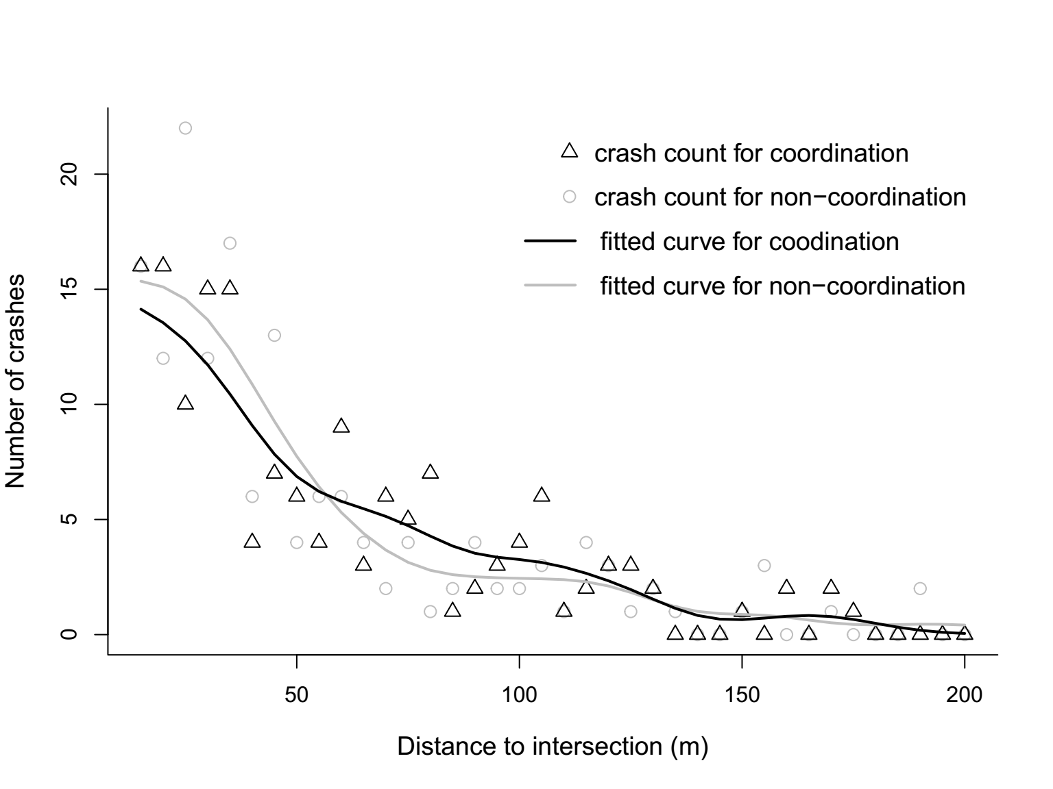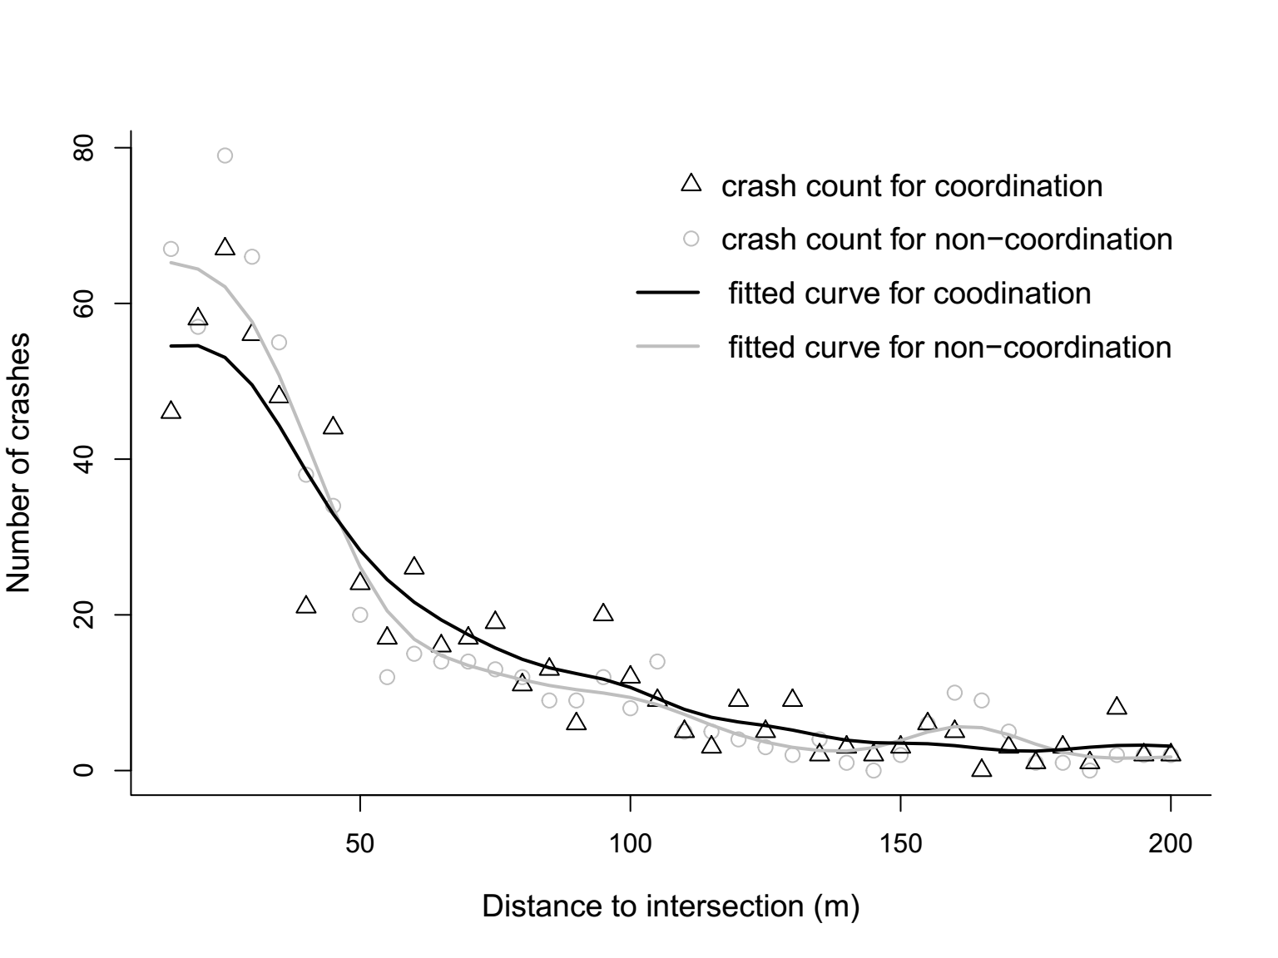
(a) injury (b) PDO
Fig. A3 Kernel regression disaggregated by injury severity

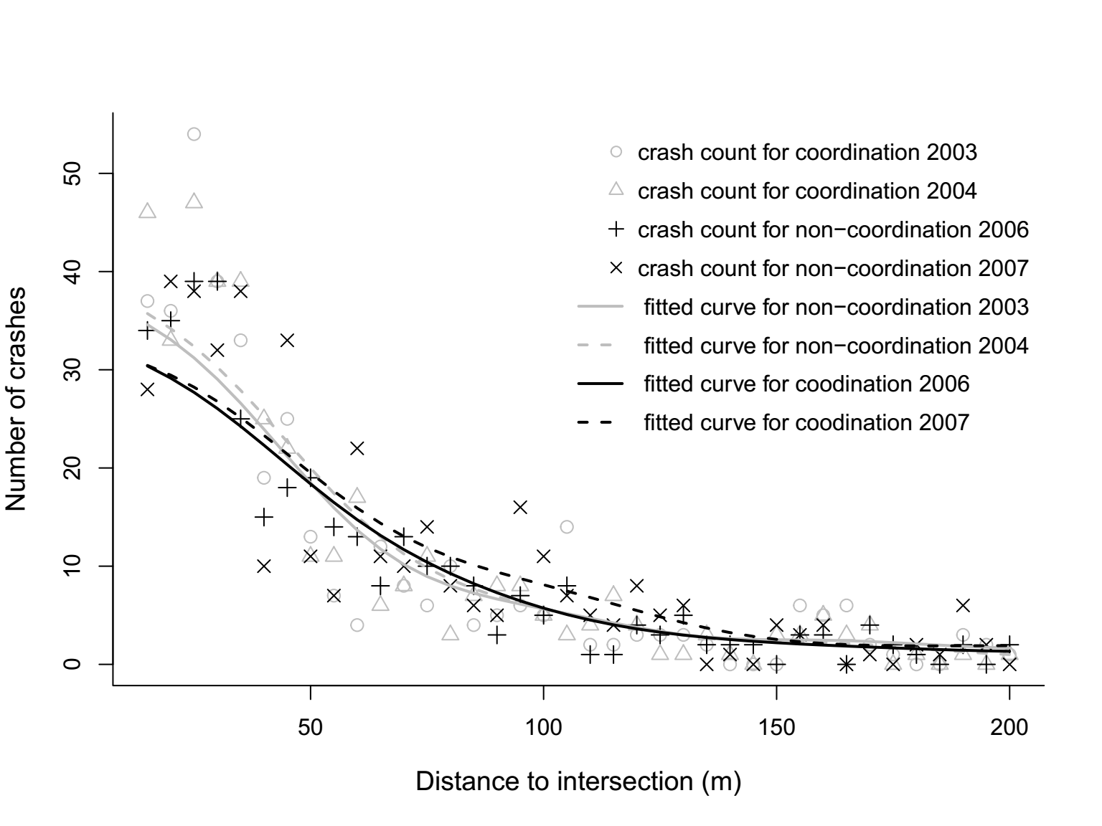
(a) overall crashes
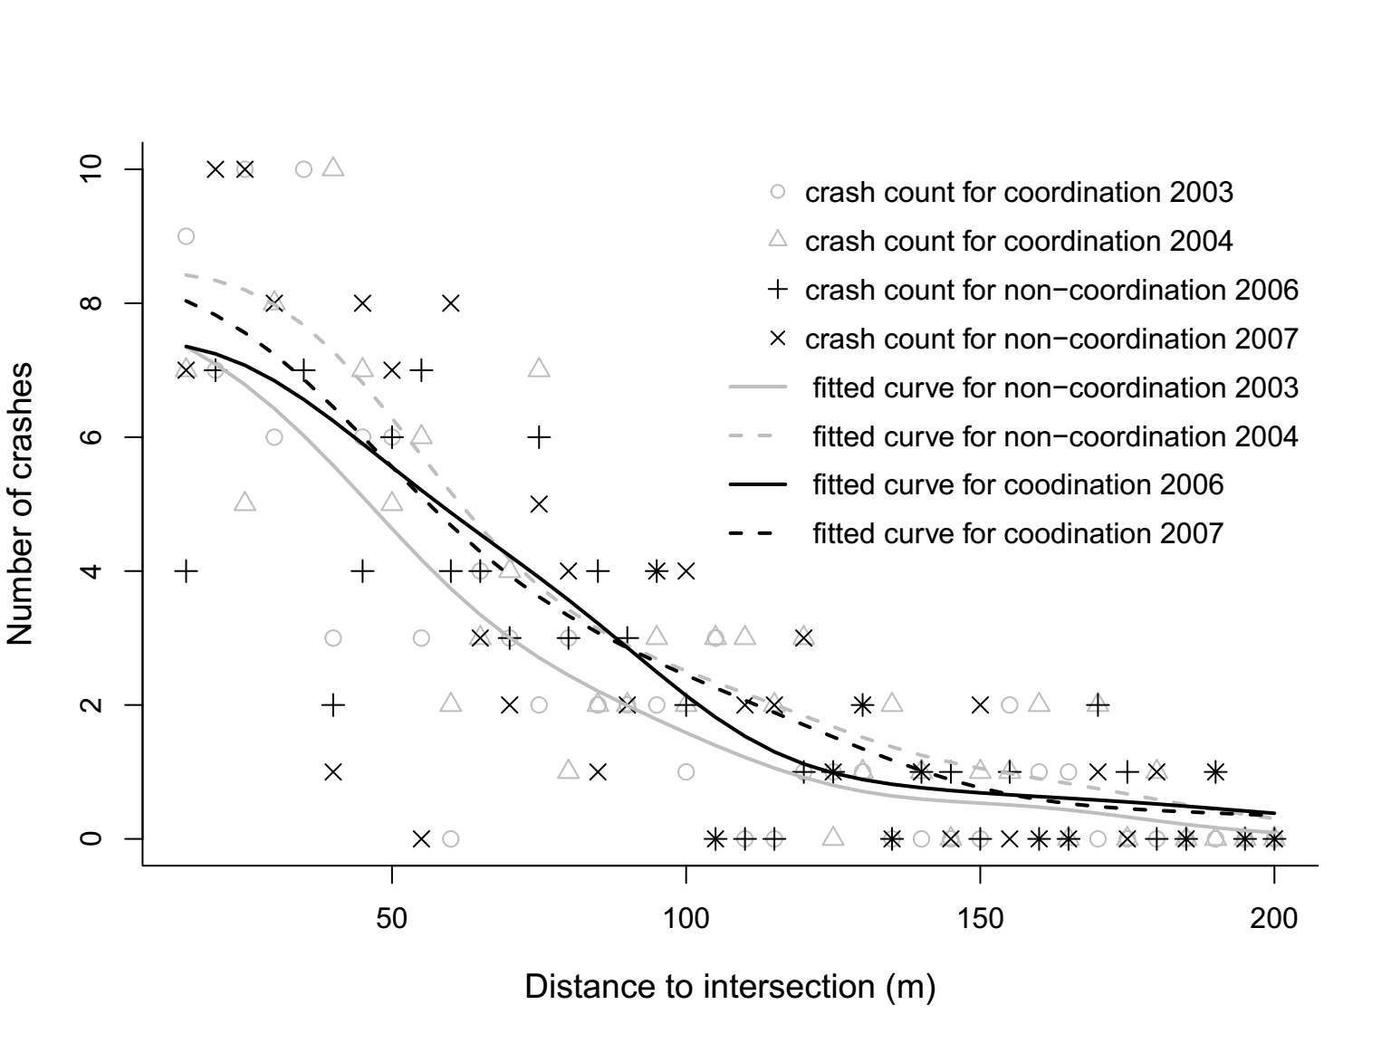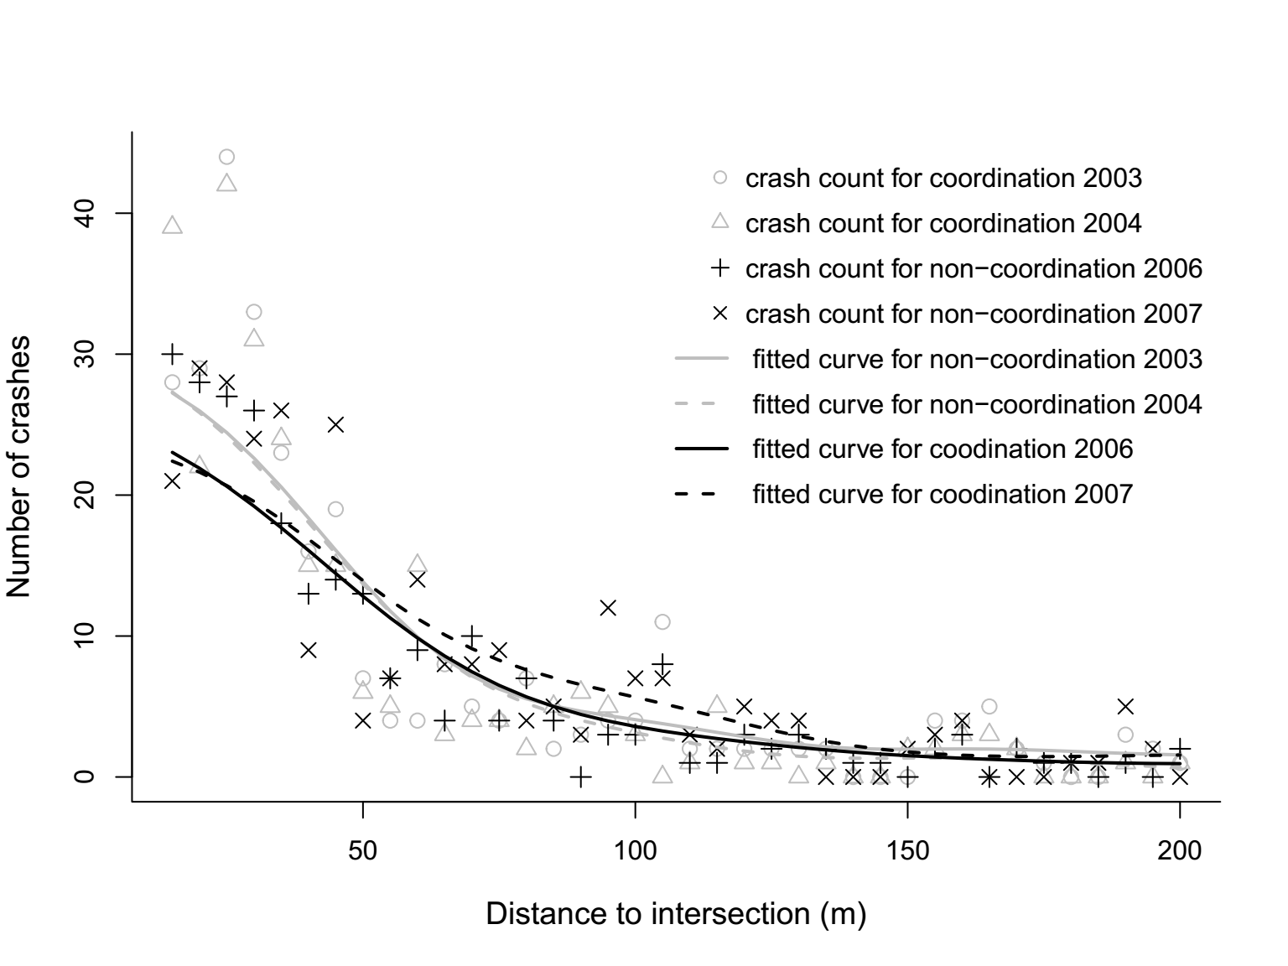
(b) peak hours (c) non-peak hours
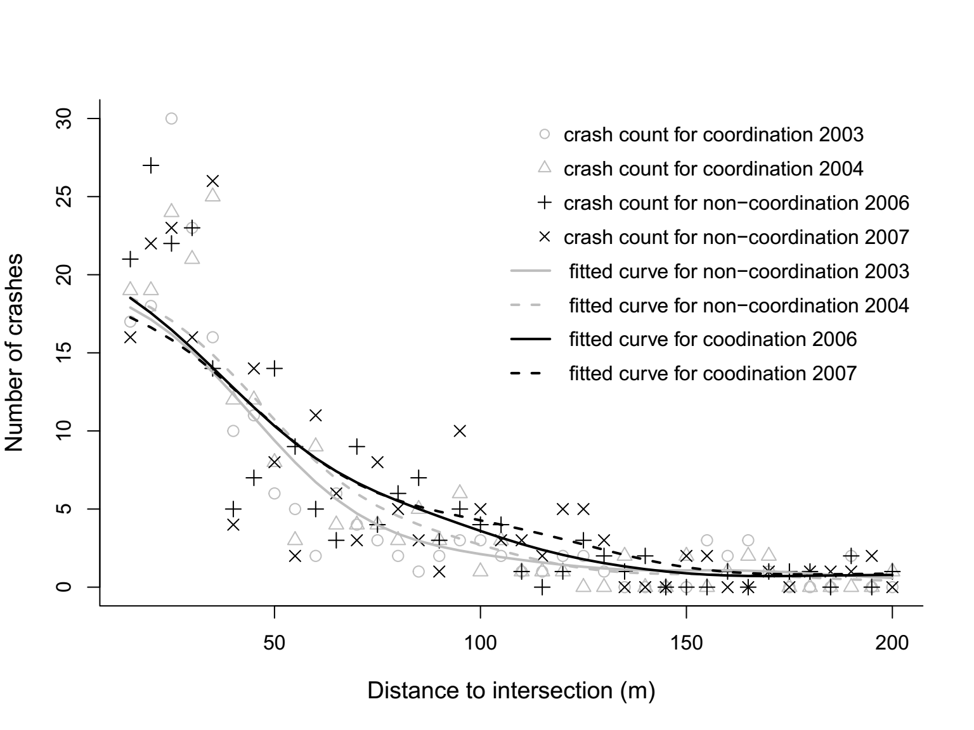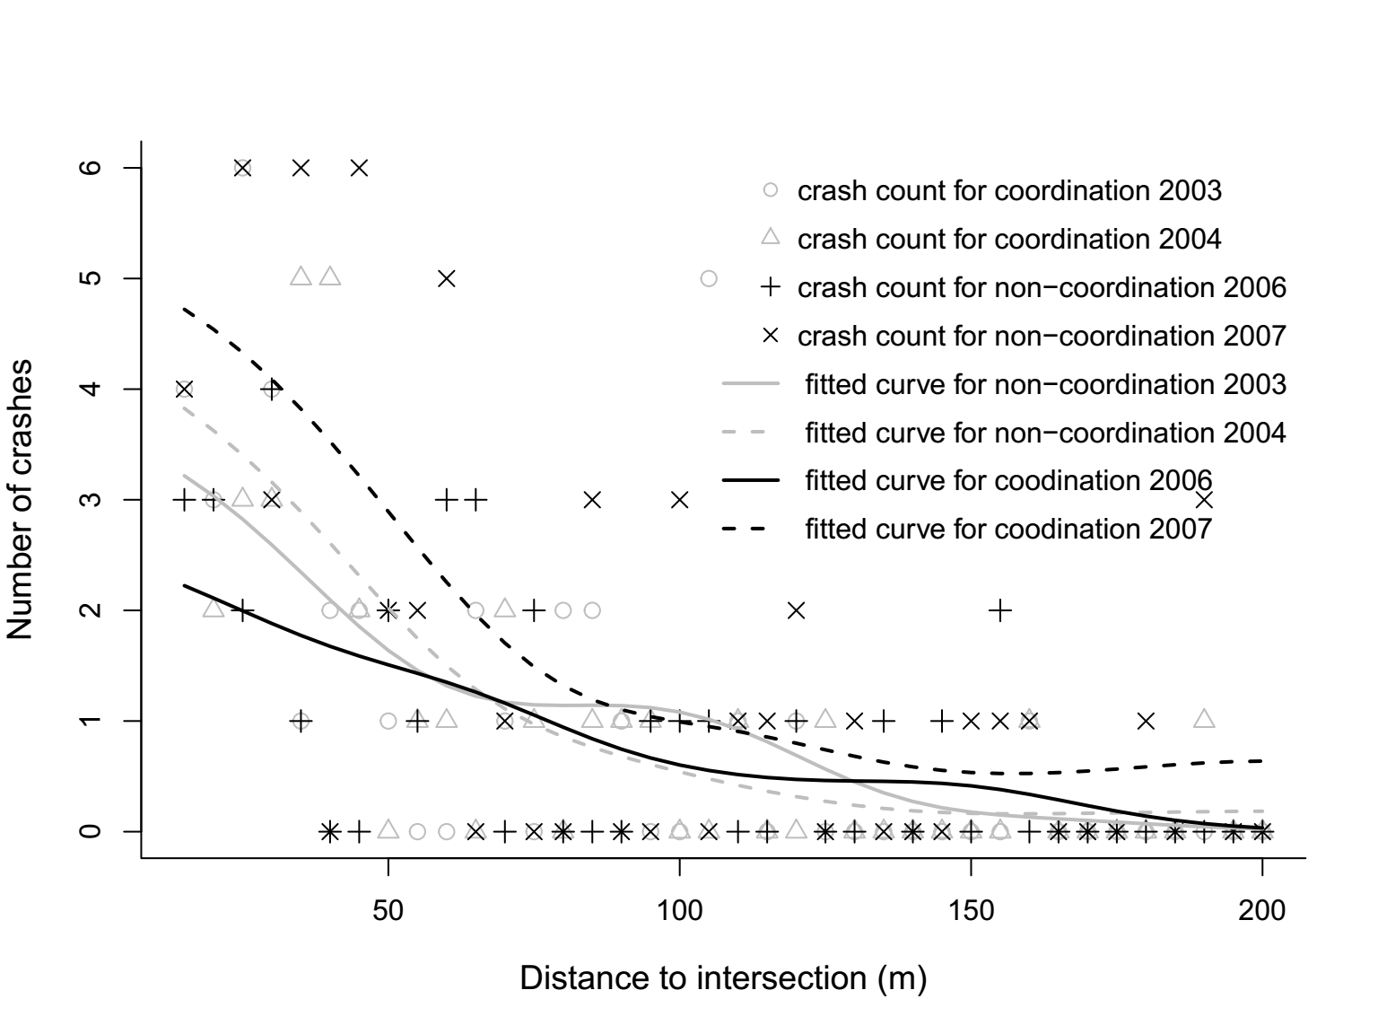
(d) rear-end crashes (e) side-swipe crashes
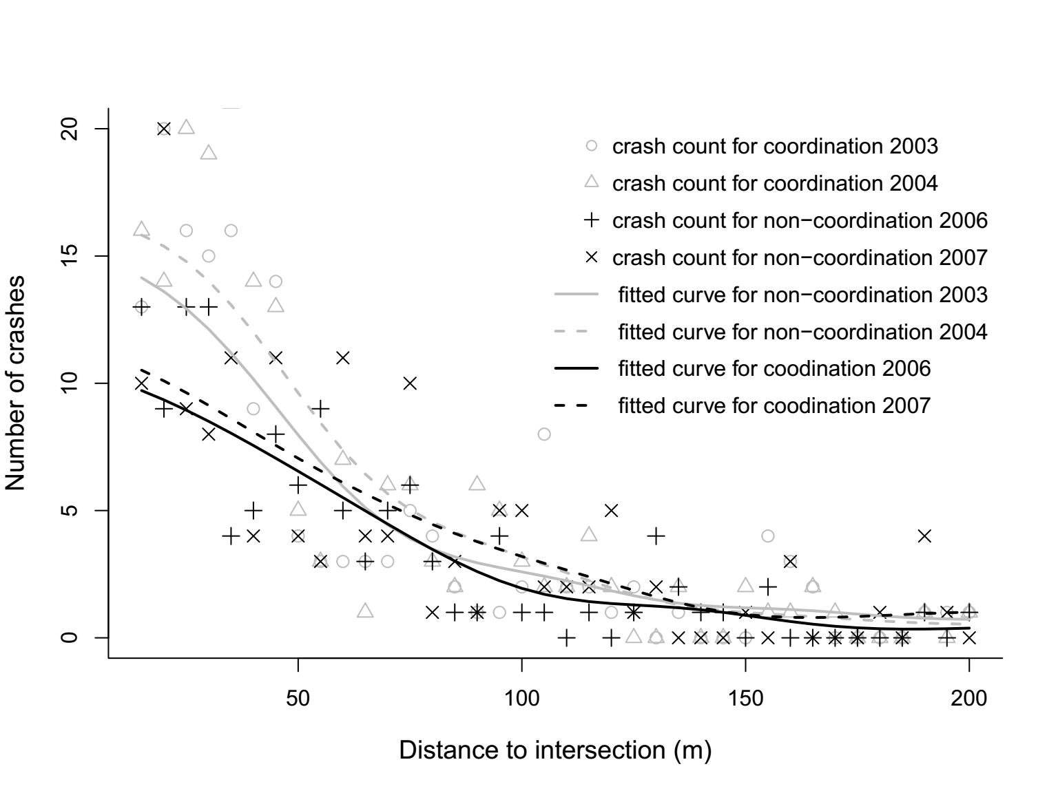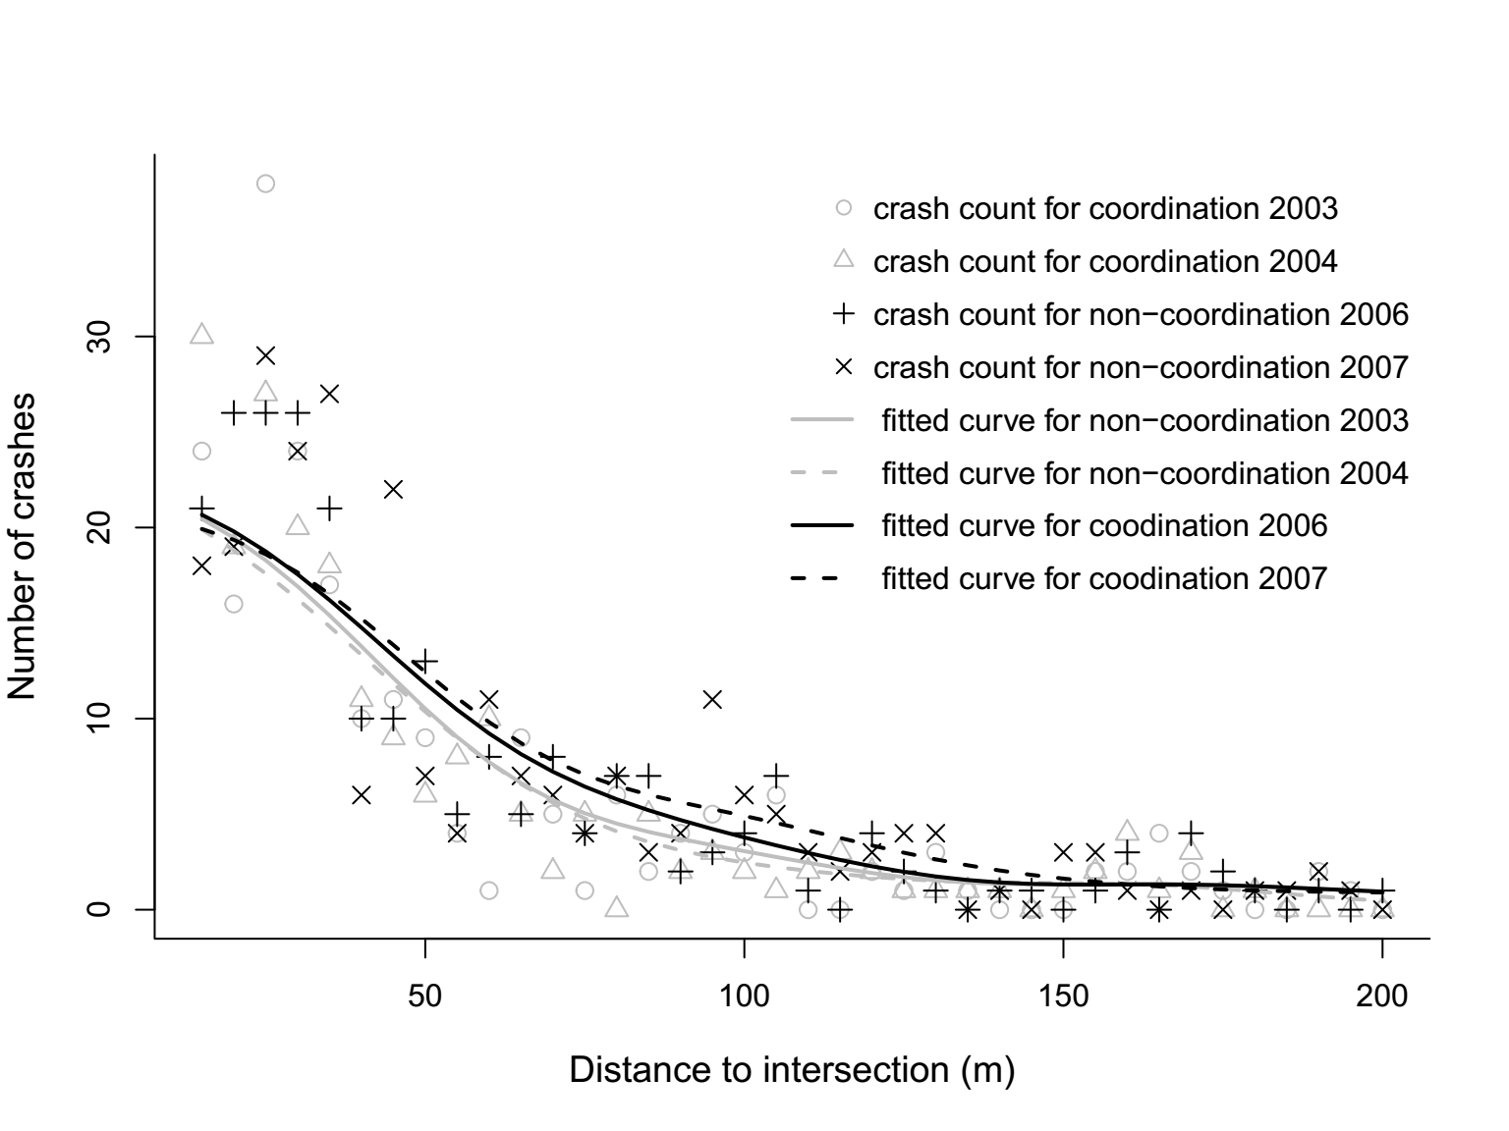
(f) ≥40 mi/h (g) <40 mi/h
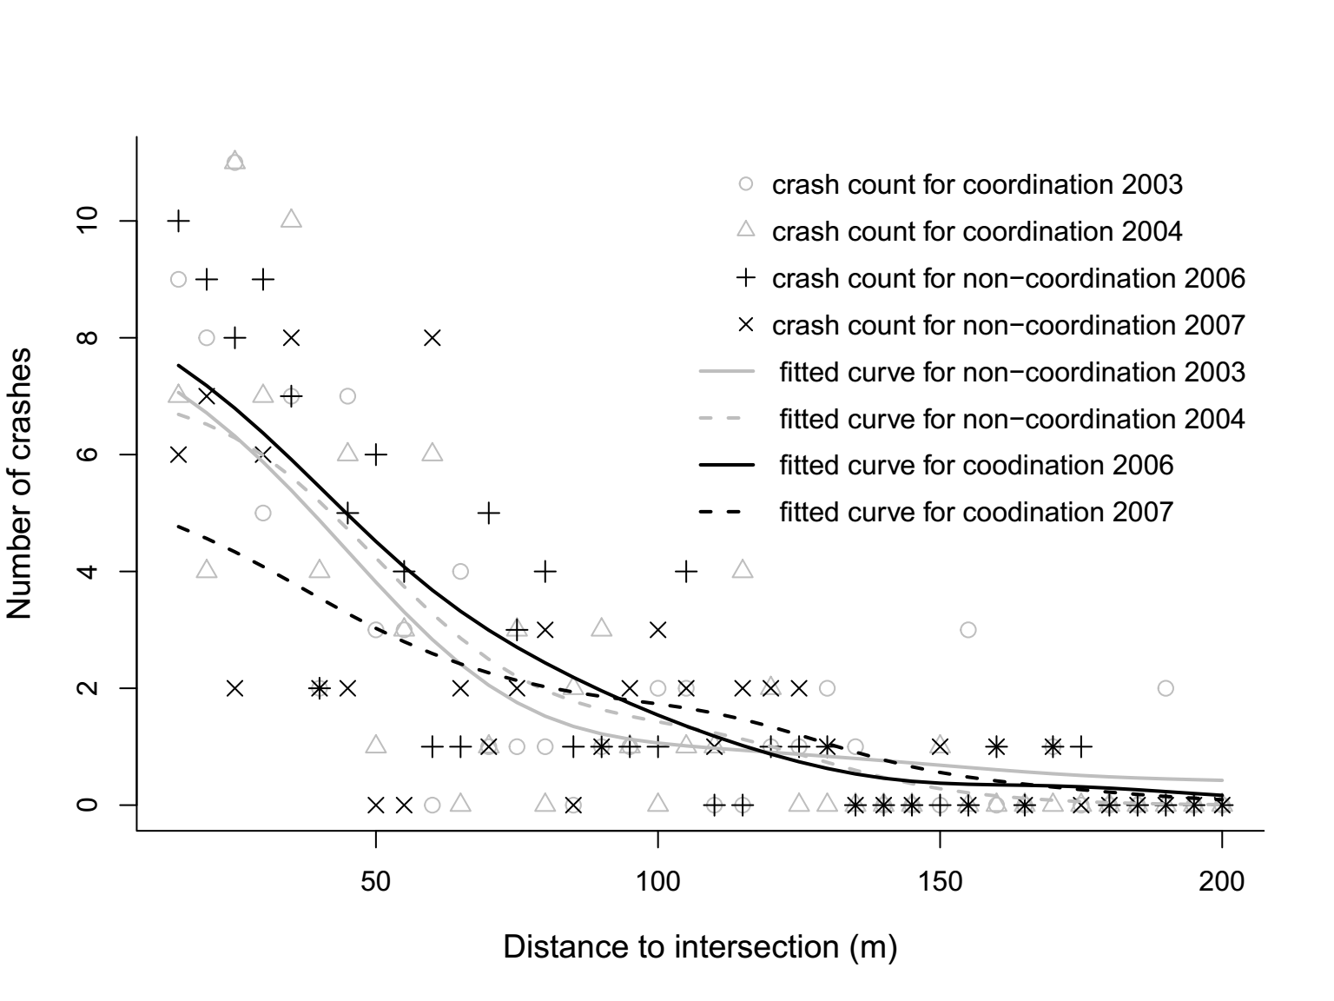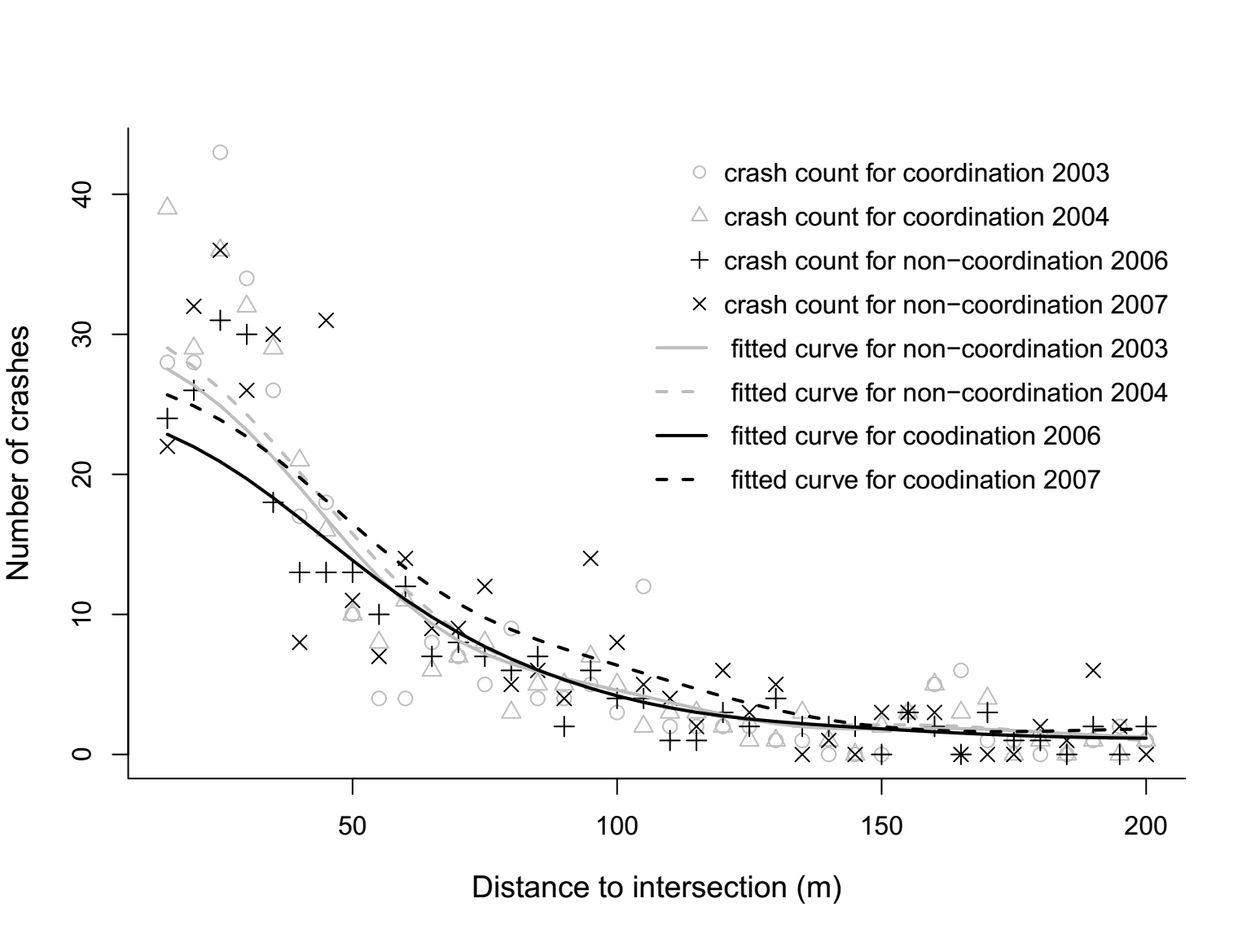
(h) injury crashes (i) PDO crashes
Fig. A4 Kernel regression disaggregated by year

