Appendix (Supporting Information)
Speed and reaction behaviour in different highway landscapes: A driving simulator study

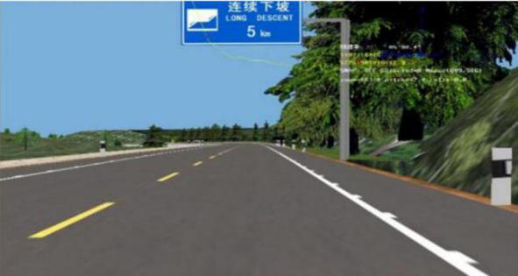
Fig.S1. Virtual scene in Experiment 1

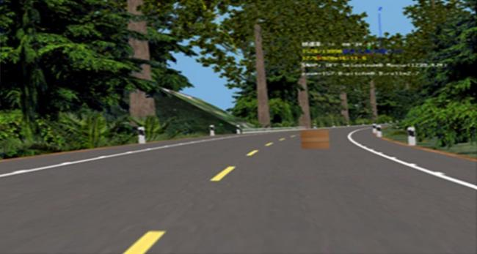
Fig.S2. Virtual scene in Experiment 2

Table S1. The details of the participants
The number of the participants |  |  | Age |  | Driving age
Experiment 1 | 20 |  | 20 ~ 47 years old |  | 3 ~ 20 years
 | 7 women | 13 men | M = 36.2 | S.D. = 9.7 |  | M = 7.2 | S.D. = 8.3
Experiment 2 | 24 |  | 29 ~ 54 years old |  |  | 5 ~ 18 years
 | 10 women | 14 men | M = 32.3 | S.D. = 10.9 |  | M = 12.1 | S.D. = 11.7

Table S2. Basic descriptive statistics of reaction time for different highway landscape
Landscape type | Statistic | Average value (s) | Standard deviation | Minimum value (s) | Median  (s) | Maximum value (s)
E₁A₈ | 22 | 1.425 | 0.294 | 0.801 | 1.436 | 1.932
E₁A₇ | 22 | 1.921 | 0.318 | 1.330 | 1.905 | 2.550
E₂A₈ | 22 | 1.075 | 0.248 | 0.589 | 1.036 | 1.694
E₂A₇ | 23 | 1.494 | 0.267 | 1.030 | 1.499 | 1.910
E₃A₈ | 23 | 0.862 | 0.193 | 0.455 | 0.870 | 1.299
E₃A₇ | 23 | 1.211 | 0.228 | 0.711 | 1.180 | 1.690
E₄A₈ | 22 | 0.593 | 0.155 | 0.360 | 0.557 | 0.941
E₄A₇ | 23 | 0.831 | 0.229 | 0.380 | 0.830 | 1.370

Table S3. Differences in the speed for different geometric alignments
Geometric alignment | F | F_{0.01(3.57)} | P
A₁ | 87.62 | 4.25 | <0.01
A₂ | 0.38 | 4.25 | >0.01
A₃ | 73.85 | 4.25 | <0.01
A₄ | 2.60 | 4.25 | >0.01
A₅ | 44.42 | 4.25 | <0.01
A₆ | 0.34 | 4.25 | <0.01

Table S4. Results of t-test for the reaction time in curved and straight sections
 |  | Levene test of variance equation |  | t-test of Mean value Equation
 |  | F | Sig. | T | df | Sig. (bilateral)
Reaction time | Assuming that the variance is equal | 3.770 | 0.054 | −5.780 | 178 | 0.000
 | Assuming that the variance is not equal |  |  | −5.794 | 171.707 | 0.000
- the speed is at 80 km/h
Table S5. Correlation analysis between the reaction time and either the alignment or the enclosure degree of the road
 |  |  | Reaction time | Road geometric alignment | Road enclosure degree
Spearman's Rho | Reaction time | Correlation coefficient | 1.000 | 0.443** | 0.693**
 |  | Sig.(bilateral) |  | 0.000 | 0.000
 |  | N | 448 | 448 | 448
- the speed is at 80 km/h

