APPENDIX
Test setup
The test fixture consisted of a rigid inclined seat in the rear-forward direction (designed to mimic the sagittal displacement of the occupant pelvis with that observed in a cushioned conventional vehicle seat, Pipkorn et al, 2016), a rigid footrest and an adjustable backrest made out of three segments of metal wire.
The motion of the occupant was arrested by a non-retractor, force-limited three-point passenger seat belt. The force-limiting characteristic was provided by a generic load-limiter device that provided a nominal constant force due to the controlled deformation of a set of calibrated metal strips that were pulled through a set of rollers. The obtained force magnitude was function of the thickness of the metal strips, the number of rollers engaged and how much the rollers deformed the strips, which was a continuously adjustable setting (Shaw et al., 2014) (Figure A.2)
The geometry and components of the test fixture and the restraint conditions were proposed based on preliminary numerical studies and experimental tests with the THOR-M dummy targeting a low-severity impact condition that would not cause above AIS 2 level chest fractures. The design objective was twofold: to facilitate the use of the test fixture so that additional test data produced by any other laboratory could be added to the experimental data included here and to facilitate the development of Finite Element (FE) models of the experiments.
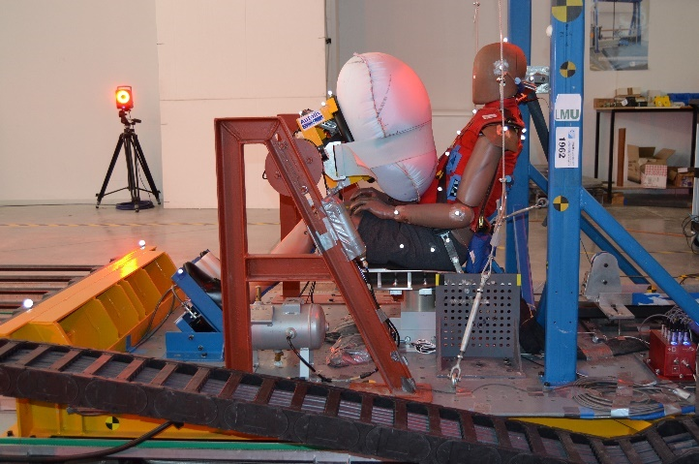 |  | 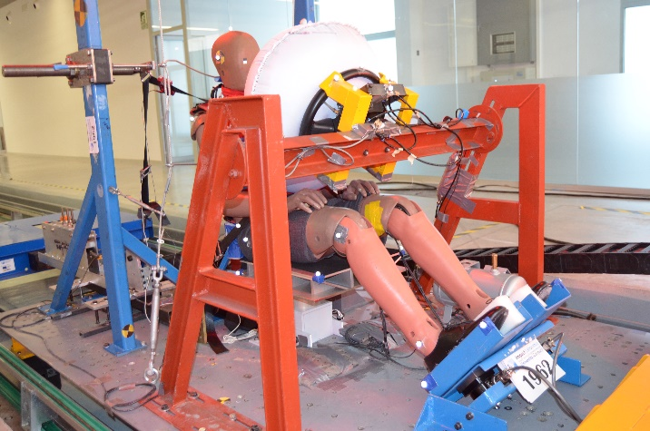
Figure A. 1 Generic oblique and lateral view of the test fixture and seating position of the THOR dummy (Cond. B). Notice the initial contact between the airbag and the dummy.
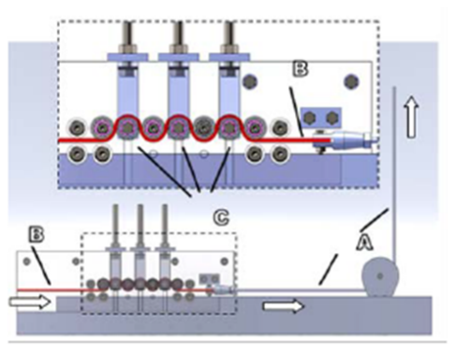 | 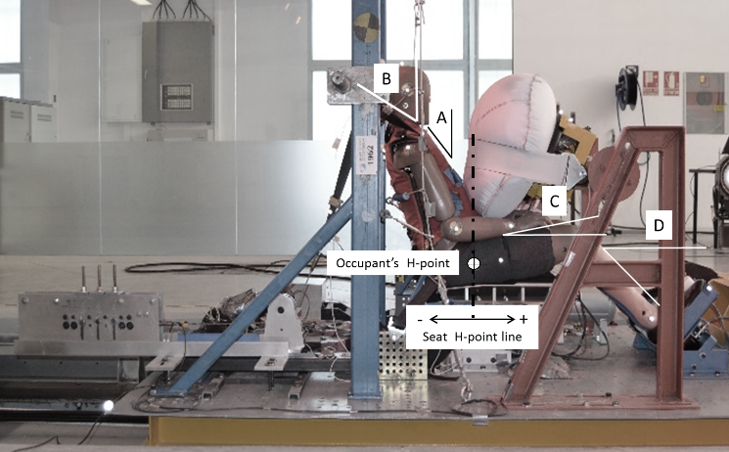
A- Sternal angle
B- Shoulder belt angle
C- Femur angle
D- Tibia angle
Figure A. 2 Illustration of the generic load limiting device and picture showing its position on the test fixture (red circle). Illustration of positioning parameters included in Table 1.

Occupant seating procedure
The overall seating procedure was similar for the ATD and PMHS in the two rounds of testing and consisted of the following steps:
- Position the occupant’s mid-sagittal plane of the pelvis on the midline of the seat.
- Ensure that the X position of the H-point (ATD) or greater trochanter of the occupant (PMHS) was aligned with the H-point defined in the seat.
- Adjust the position of the foot rest so that the femur angle was around 11 degrees and the tibia angle was around 50 degrees from the horizontal (illustrated in Figure A.2)
- Adjust the position and tension of the seat back wires so that the occupant torso angle measured over the sternum was about 30 degrees (illustrated in Figure A.2).
After the first round of ATD and PMHS tests, it was observed that the above seating procedure combined with the geometrical differences between the THOR ATD and the PMHS (or, correspondingly, the THUMS model), allowed for instances of uncontrolled variability in the initial position between the test surrogates (Figure A.7), including also inter-PMHS variability. Therefore, the second test series seating protocol included additional control points for the initial positioning of the THOR dummy and the PMHS. In particular, the forward position of the PMHS head (X_{EAM_PMHS}) and height of the airbag (Z_{Steering_wheel_PMHS}) coordinates were modified according to the following formulae (final values are provided in Table 1):
$$\frac{X_{EAM_THOR}-X_{H-point_THOR}}{{Sitting height}_{THOR}}=\frac{X_{EAM_PMHS}-X_{g_troch_PMHS}}{{Sitting height}_{PMHS}}$$
$$\frac{Z_{Top_THOR}-Z_{Steering_wheel_THOR}}{{Sitting height}_{THOR}}=\frac{Z_{Top_PMHS}-Z_{Steering_wheel_PMHS}}{{Sitting height}_{PMHS}}$$
Last, a more slouched initial position was provided to the PMHS in the second series to improve the overall visual comparison between the THOR initial position and the corresponding PMHS. This position was achieved by setting the angle measure between the spinous process of T1 and T12 to be around 10 degrees and was considered more reliable than measuring the sternum angle. Unfortunately, this angle was not measured in the initial test series.

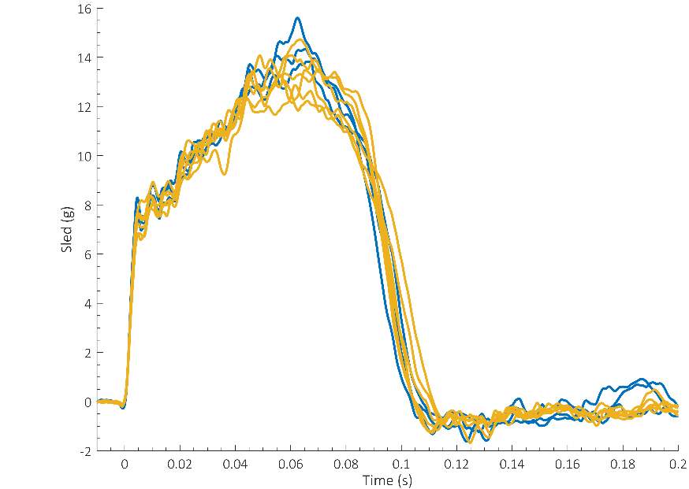
Figure A. 3 Time history of the sled acceleration pulse (blue: THOR tests; orange: PMHS tests)

Instrumentation
Upper shoulder and lower shoulder belt tension were measured at defined positions of the belt webbing using tension load cells (Model LAU300, Futek, Irvine, US) placed 15 cm away from the D-ring and 13 cm away from the buckle respectively. Lap belt tension was measured bilaterally. The THOR M dummy was equipped with the conventional instrumentation that included the IRTRACC sensors (IF-364-C-R3, Humanetics Innovative Solutions, Inc.) to measure the deformation of the ATD chest at four different locations. In the PMHS tests, triaxial accelerometers (Endevco 7264C, Meggitt, Irvine, US) were rigidly attached to the top of the head, two locations on the thoracic spine (upper and middle regions, nominally T1 and T8), lumbar spine (L2) and the pelvis using screws (Shaw et al, 2009; Lopez-Valdes et al, 2010). Triaxial Angular Rate Sensors (ARS PRO-18K, DTS, Seal Beach, US) were added to the head, upper spine (T1) and pelvis (approximately at the mid point between the two posterior superior iliac spines of the ilium). All sensor data were captured at 10,000 Hz with an external data acquisition system (PCI-6254, National Instruments; Austin, TX). Tests were recorded by a lateral and a frontal high-speed imagers at 1,000 Hz.
Marker position. Data processing
Retro-reflective spherical markers were attached to selected locations on the head; upper, mid and lower sections of the spine; acromion bilaterally; pelvis; hip joint bilaterally and on other selected landmarks (see Table A.1 for additional details). Corresponding locations of the ATD were also tracked during the tests. Marker clusters were used on the head, spine and pelvis of the PMHS. Clusters were attached using rigid, low-weight aluminum plates that were screwed to the corresponding anatomical structure. Other locations were tracked using single markers glued directly to the bandage covering the subject (see Figure A.4). Kinematic data were collected at 1,000 Hz using an optoelectric stereophotogrammetric system consisting of 10 cameras (Vicon, TS series, Oxford, UK). The system captured the position of the markers within a calibrated 3D volume. A calibration procedure, performed prior to testing, estimated the optical characteristics of each camera and established its position and orientation in a reference coordinate system. The trajectory of each marker was recorded and smoothed through a rigidity constraint using the least squares pose (LSP) estimator (Cappozzo et al., 2005; Chiari et al., 2005; Della Croce et al., 2005; Leardini et al., 2005). A global coordinate system (GCS) was defined at a laboratory fix location. A local coordinate system (LCS) moving with the test buck was defined with origin at the front central point of the sled platform. Local x axis pointed forward and it was coincident initially with the frontal anatomical axis of the occupant. The vertical z axis pointed upwards (opposite to ground) and the y axis was defined to form a right-hand oriented coordinate system. Unless otherwise indicated, displacement data are expressed with respect to this LCS. A photogrammetric algorithm within the Vicon Nexus software package (Nexus 1.8.5, Vicon, Oxford, UK) reconstructed the 3D position of each target for each video sample increment from the multiple 2D camera images.

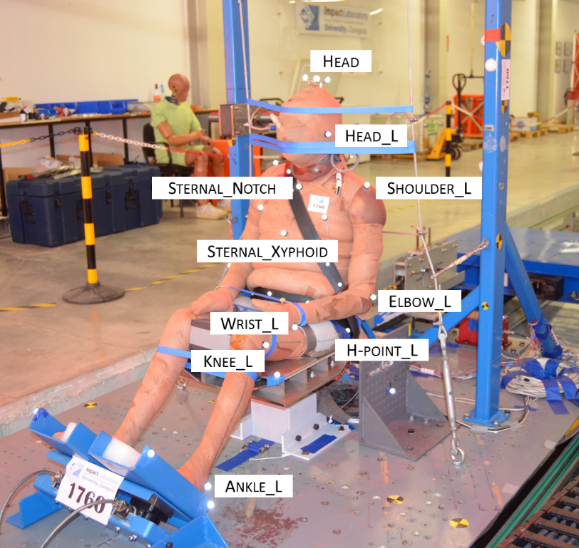 | 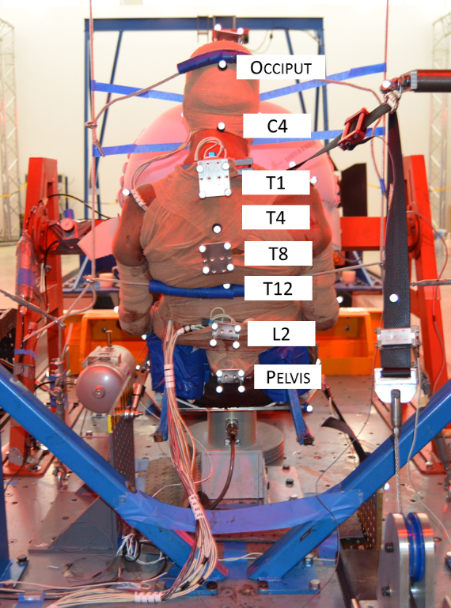
Figure A. 4 Position of the surface and rigidly attached markers (screwed plates) on one of the test subjects. Note that the index “_L” indicates left aspect and there is a corresponding right aspect marker not shown in the pictures.

Table A.1 List and locations of VICON markers used
Occupant single markers (glued to skin) |  |  |  | Test rig and seat belt markers
EAM bilaterally  Occiput  C4  T4  T12  Acromion bilaterally  Sternal notch  R4 bilaterally  Xyphoid process  Humerus lateral epicondyle bilaterally  Ulna styloid process bilaterally  Greater trochanter bilaterally  Tibia lateral condyle bilaterally  Lateral malleolus bilaterally |  |  |  | Seat platform (3 markers)  Sled platform (4 markers)  Shoulder belt (5 markers)  Lap belt (3 markers)  Belt webbing between D-ring and FL device  D-ring  Buckle bolt, buckle attachment  Belt anchor outer  Foot rest (4 markers)  Reaction mass, fixed reference (2 markers)
Marker plates rigidly attached to occupant
Location | 1761 | 1763 | 1765 |  | 1969 | 1970 | 1971
Head | Yes | Yes | Yes |  | Yes | Yes | Yes
Upper thoracic spine | T1 | T1 | T1 |  | T1 | T1 | T1
Mid thoracic spine | T8 | T8 | T8 |  | T8 | T8 | T8
Lumbar spine | L2 | L2 | L2 |  | L2 | L2 | L2
Pelvis | Yes | Yes | Yes |  | Yes | Yes | Yes

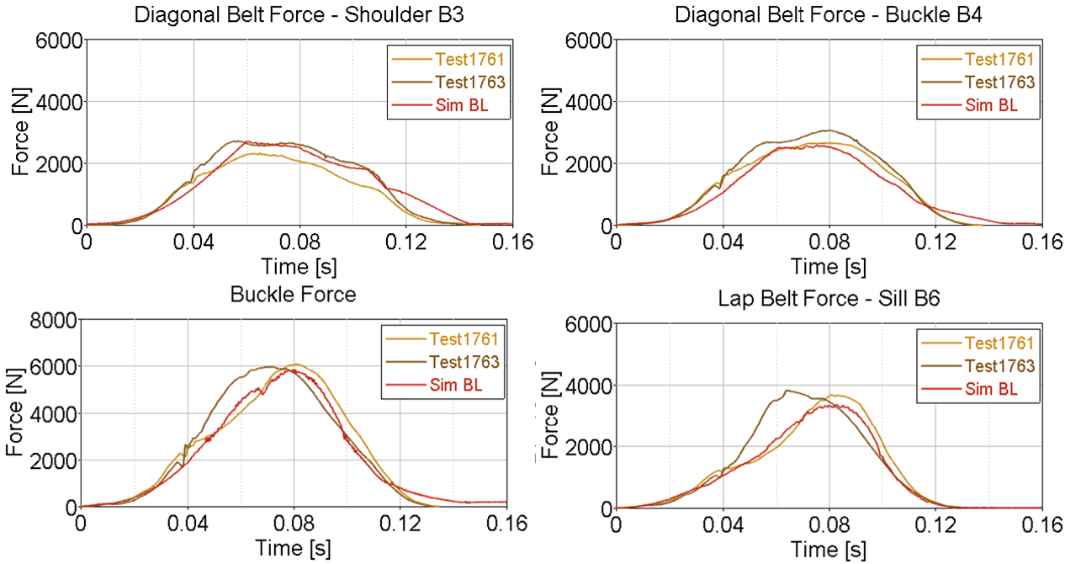
Figure A. 5 Comparison of the time history of seat belt forces between PMHS 1 and PMHS 2 and the THUMS model in test conditions 1.
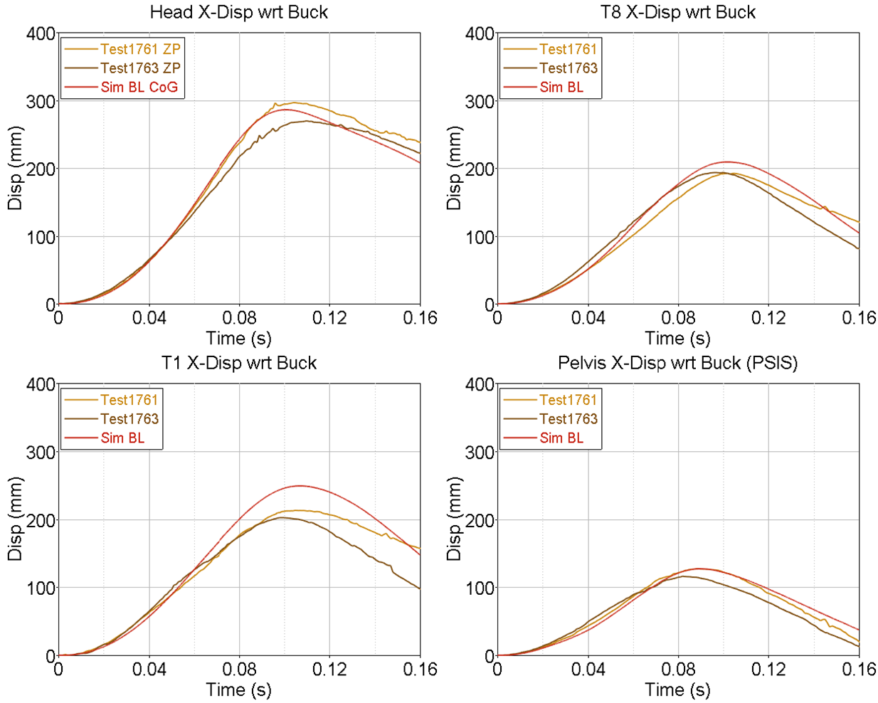
Figure A. 6 Comparison of the time history of the X displacement of selected anatomical landmarks between PMHS 1 and PMHS 2 and the THUMS model in test conditions 1.

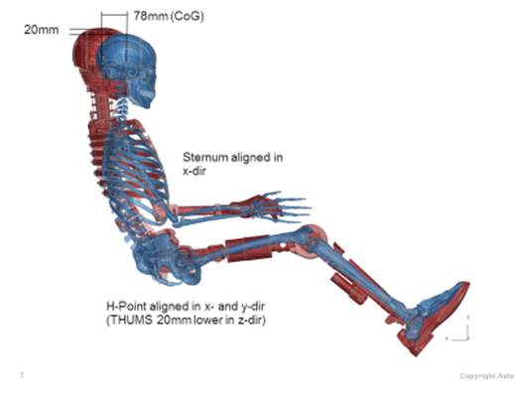
Figure A. 7 Comparison of the initial seating position between the THOR M dummy finite element model and the THUMS model
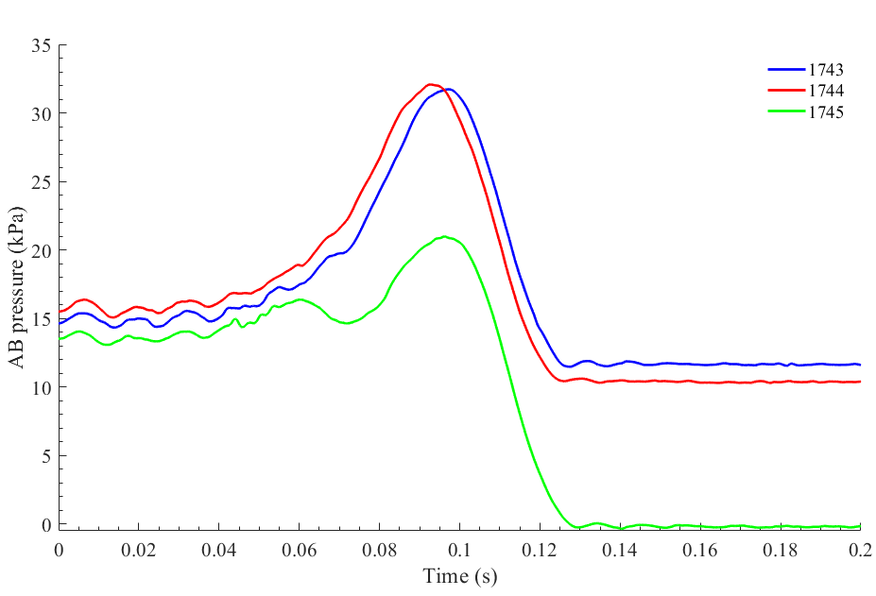 | 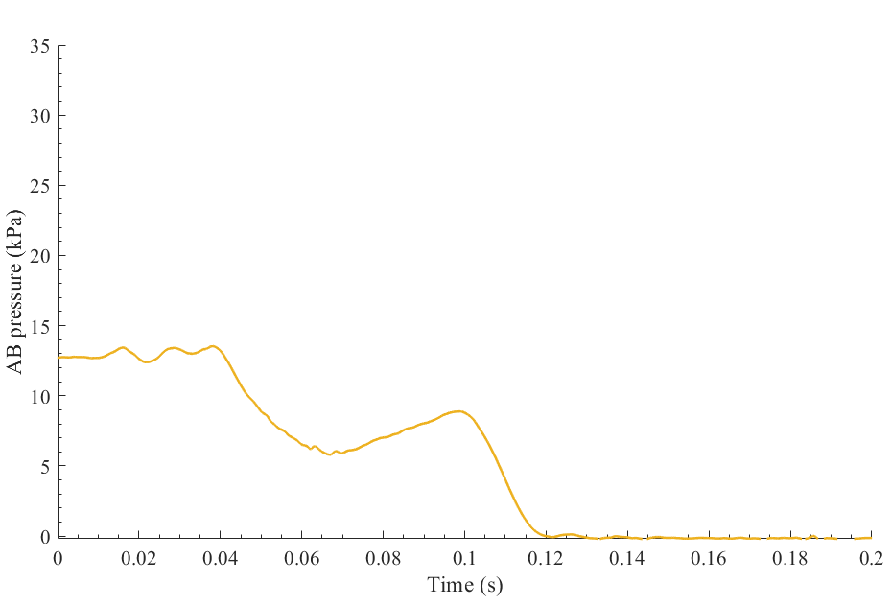
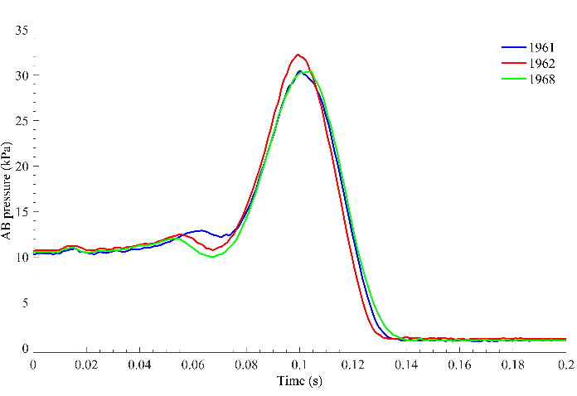 | 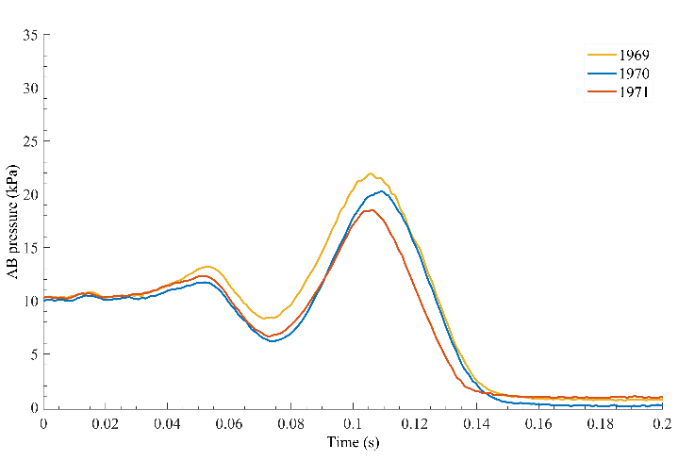
Figure A. 8 Comparison of the time history of airbag pressure of the THOR dummy (left) and PMHS (right) tests between series 1 (top) and series 2 (bottom). Note that only one valid measurement was taken in the series 1 of PMHS tests.

Sensor malfunction
Some of the instrumentation did not work correctly during the tests. In test 1743 (THOR), the motion capture system failed during the tests and the displacement results shown here include only the other two tests. The pressure sensor of the airbag malfunctioned in tests 1761 and 1763 and therefore the time history of the airbag pressure could not be measured. In case of test 1761, the initial pressure value was also affected by the sensor malfunctioning and was not recorded.

 | First round THOR | Second round THOR | First round PMHS | Second round PMHS
0 ms | 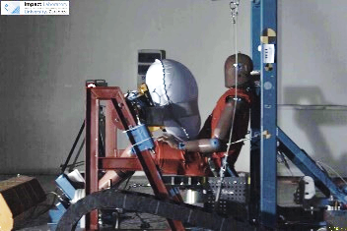 | 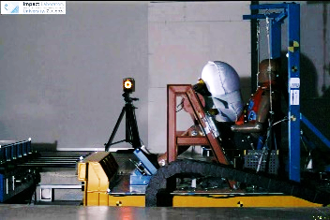 | 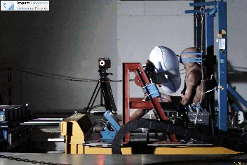 | 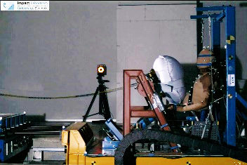
50 ms | 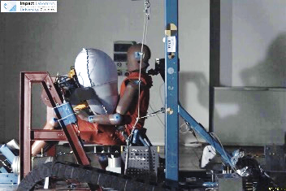 | 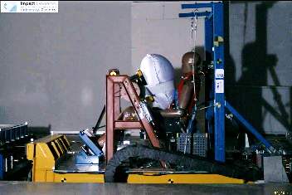 | 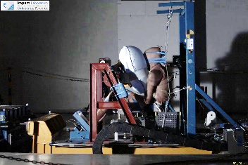 | 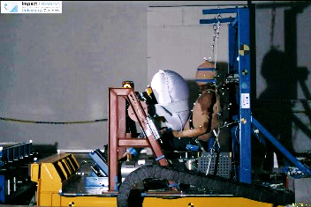
80 ms | 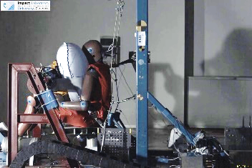 | 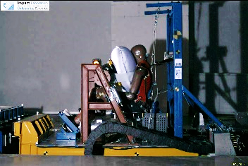 | 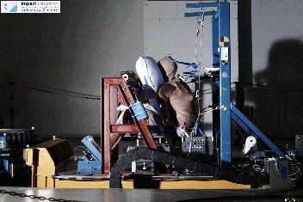 | 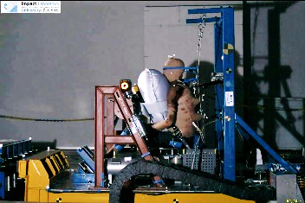
100 ms | 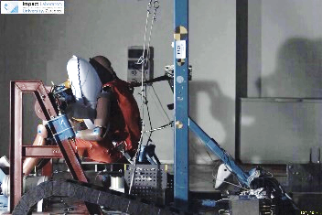 | 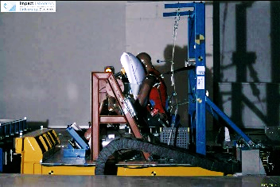 | 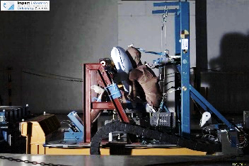 | 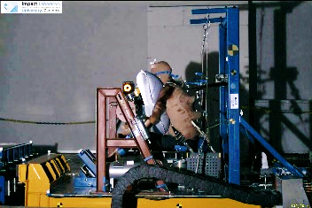
125 ms | 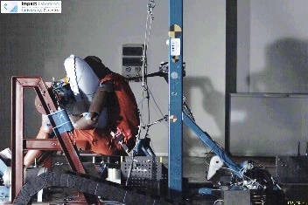 | 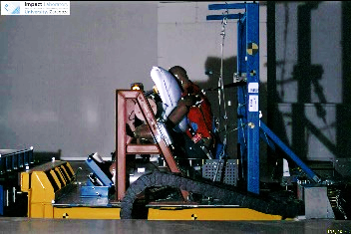 | 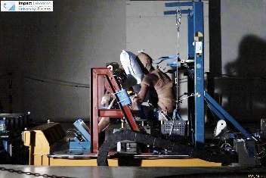 | 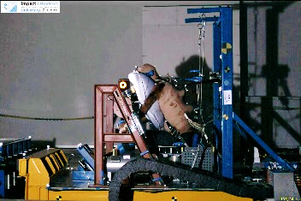
175 ms | 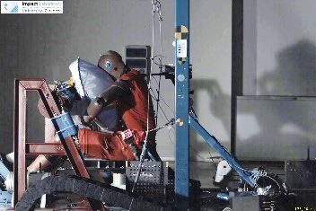 | 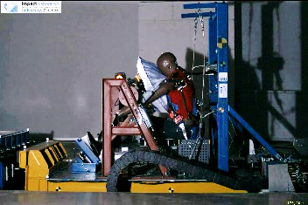 | 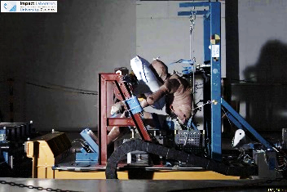 | 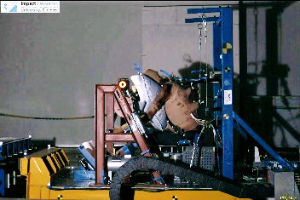
Figure A. 9 Kinematics of the THOR dummy and two selected PMHS showing the differences in torso pitch (especially in the PMHS tests) between the first and the second round of tests.

 | First round THUMS | Second round THUMS | First round PMHS | Second round PMHS
0 ms | 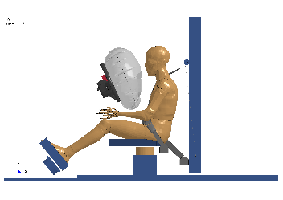 | 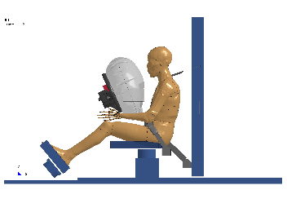
50 ms | 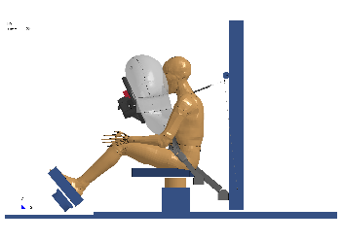 | 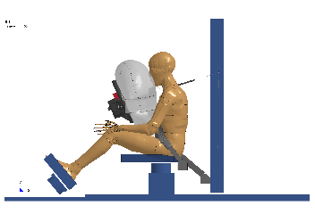
80 ms | 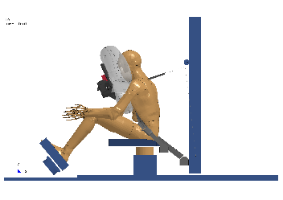 | 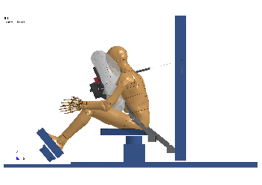
100 ms | 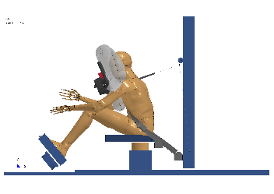 | 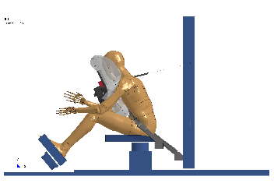
125 ms | 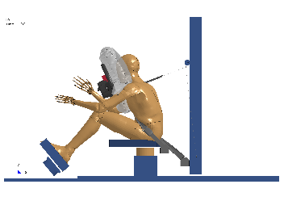 | 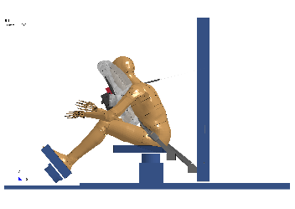
160 ms | 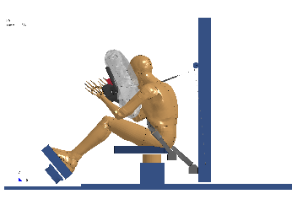 | 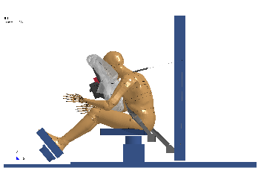 | 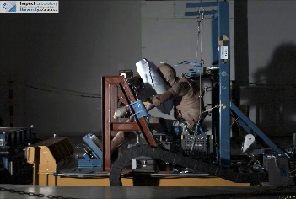 | 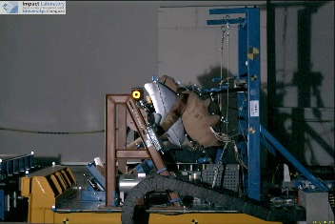
Figure A. 10 Kinematics of the THUMS human body model and two selected PMHS showing the differences in kinematics between the first and the second round of tests.

