APPENDIX
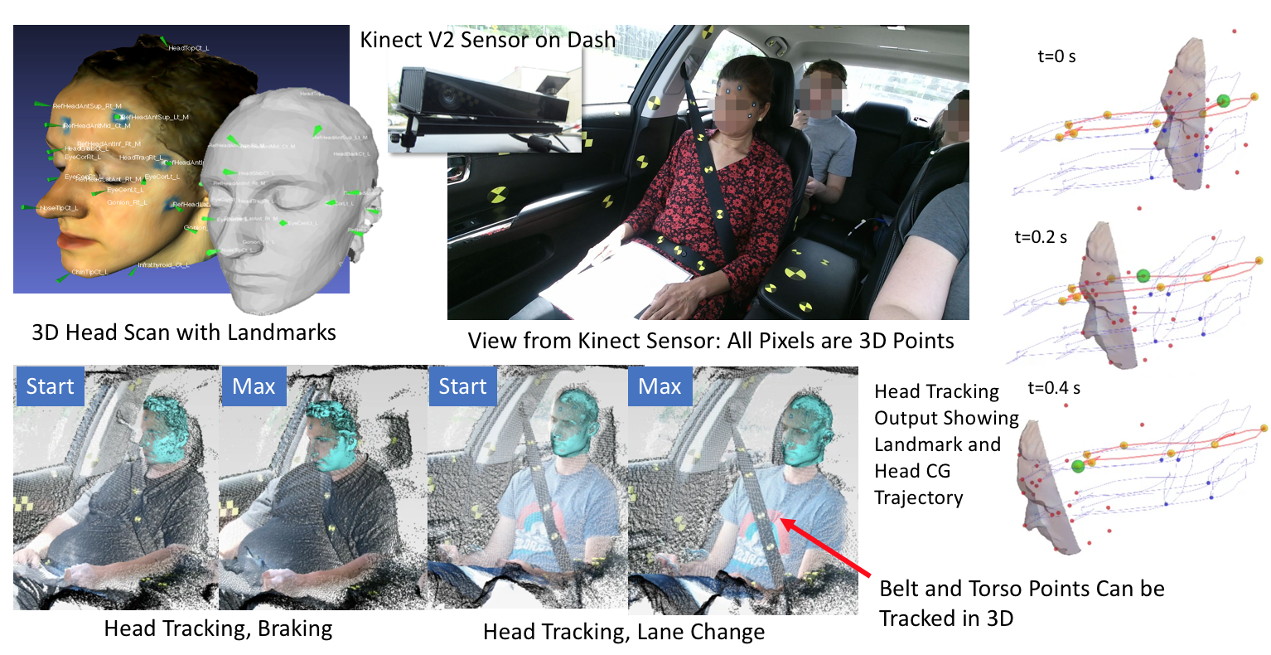Figure A1. Instrumentation and calculations for semi-automated head tracking.

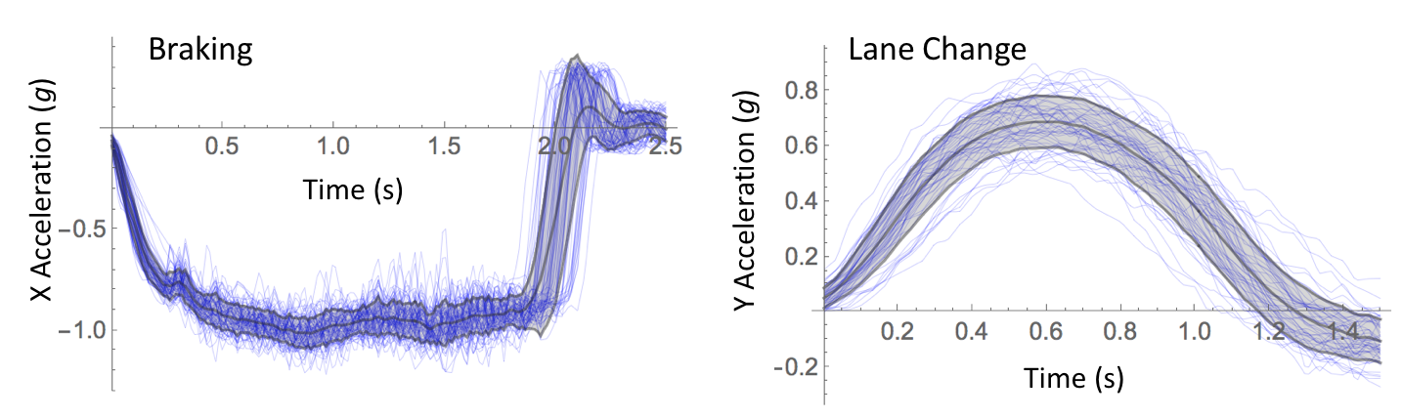
Figure A2. Overlay of longitudinal vehicle acceleration (g, s) from braking and lane-change trials. Corridors are mean ± sd.
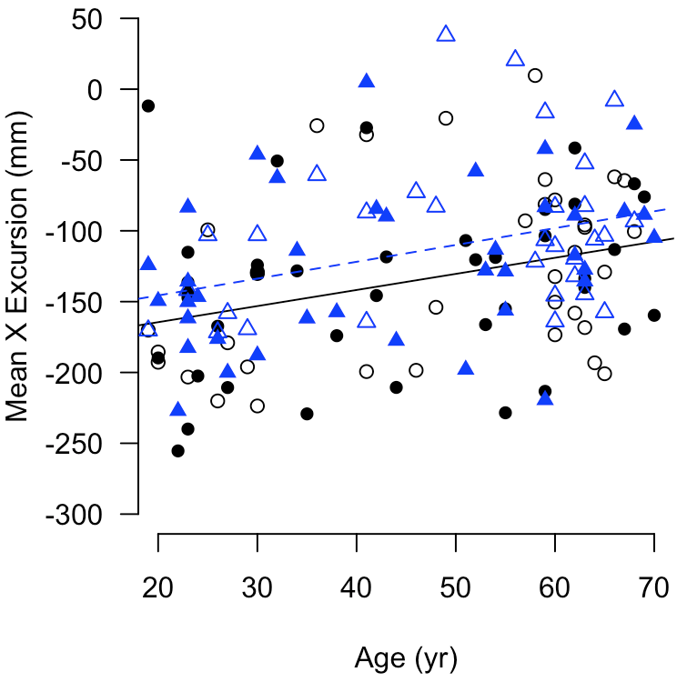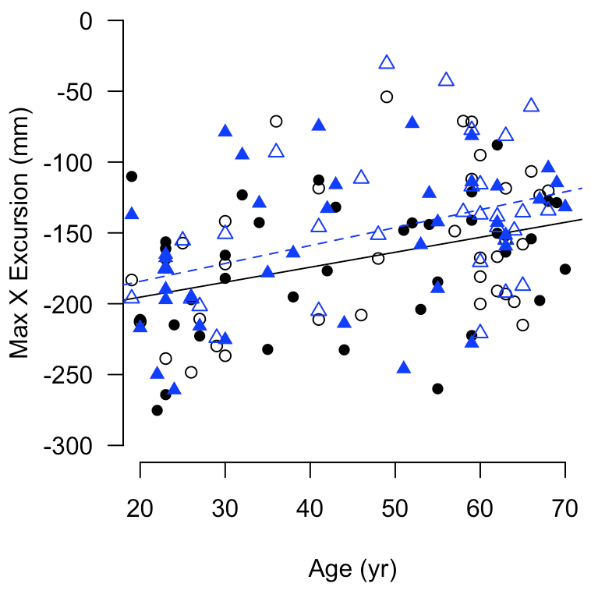
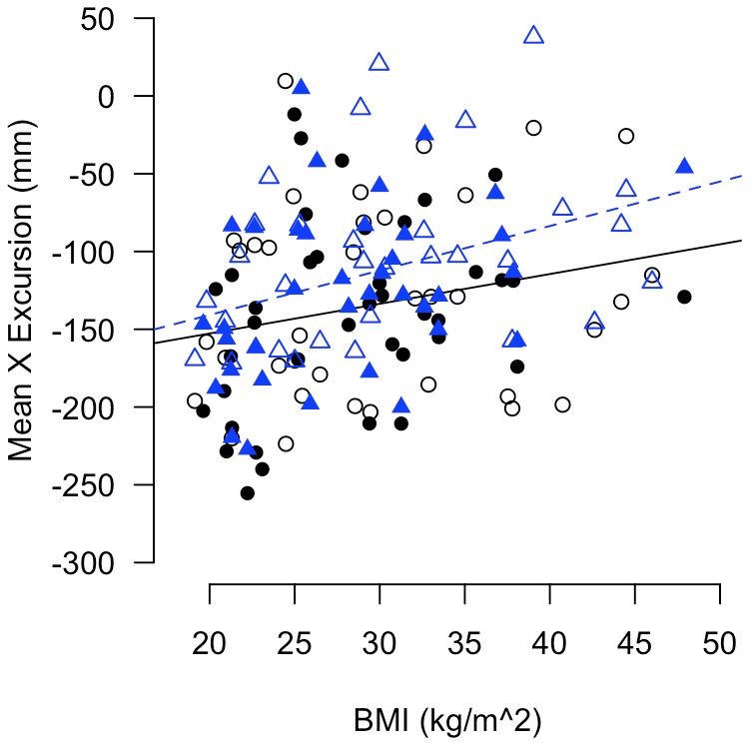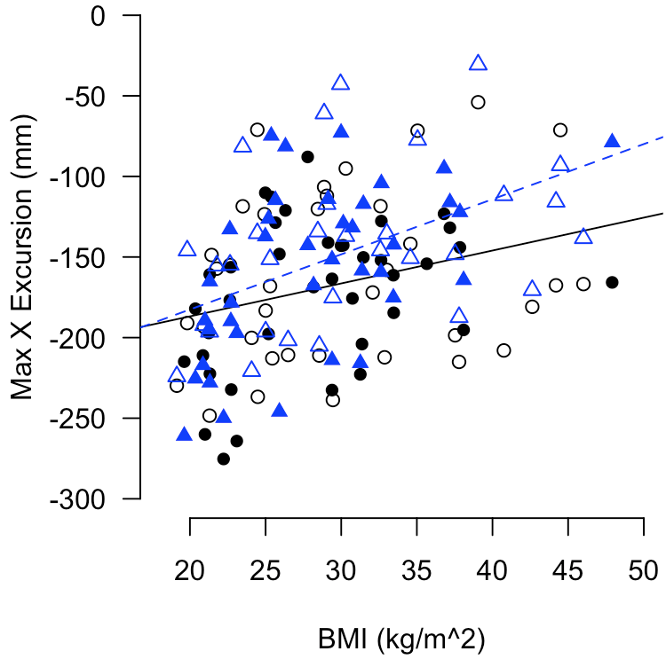
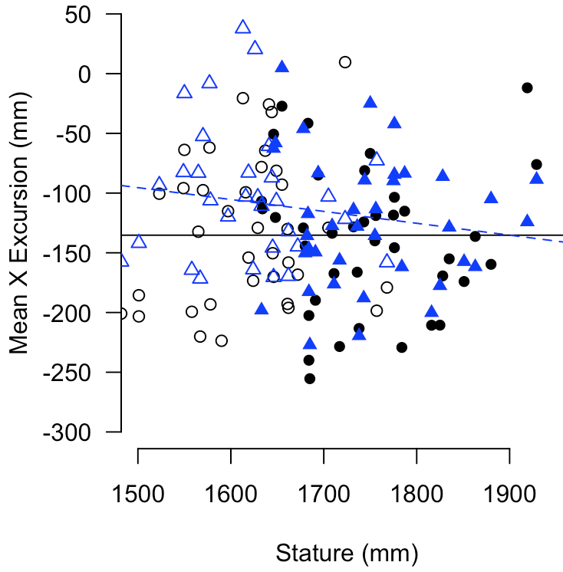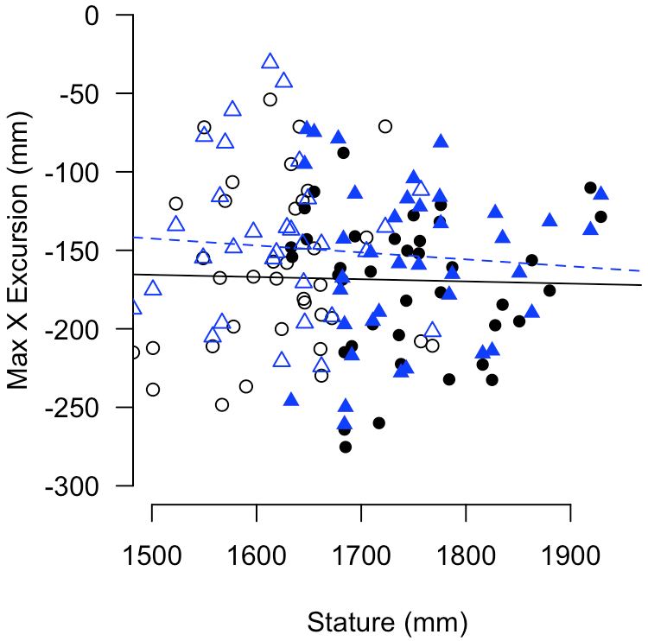

Figure A3. Effects of age and BMI on mean over the interval from 0.5 to 1.5 seconds (left) and maximum (right) forward excursion in braking trials. The first braking event is shown as circles and a solid regression line; the second event is triangles and a dashed line. Data from male and female participants are shown as filled and open symbols, respectively.

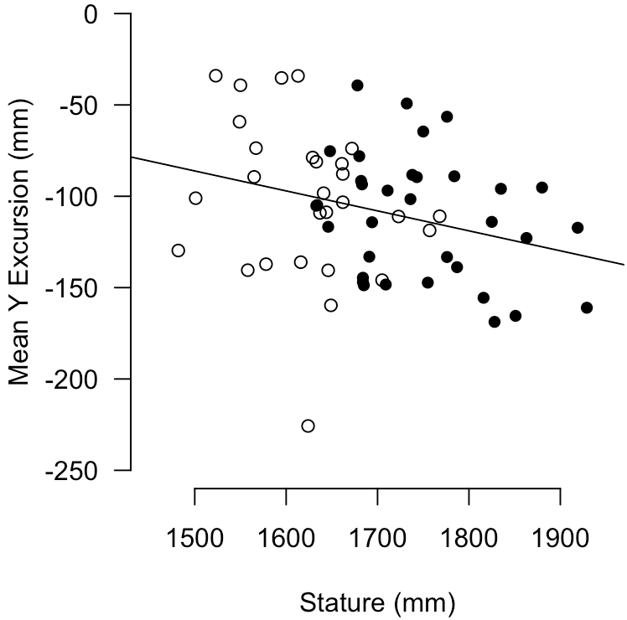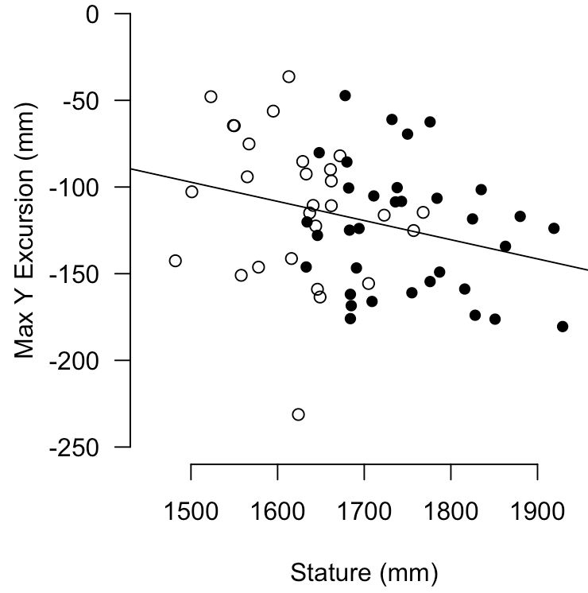
Figure A4. Association between stature and mean (left) and maximum (right) lateral head excursion in lane-change trials (negative = inboard). Data from male and female participants are shown as filled and open symbols, respectively.

