Submitted to:
Frontiers in Earth Science

Supplementary Material

Droughts over Amazonia in 2005, 2010 and 2015: a cloud cover perspective

Juan C. Jimenez^{1*}, Renata Libonati^{2,3}, Leonardo F. Peres^{2,4}

¹ GCU/IPL, University of Valencia,Valencia, Spain.

² Departamento de Meteorologia, Instituto de Geociências, Universidade Federal do Rio de Janeiro, Rio de Janeiro, Brazil.

³ Centro de Estudos Florestais, Instituto Superior de Agronomia, Universidade de Lisboa, Lisboa, Portugal.

⁴ Instituto Português do Mar e da Atmosfera, Lisboa, Portugal.

*Corresponding Author: jcjm@uv.es

COMMENTS ON THE ERA-INTERIM TOTAL CLOUD COVER DATASET

Although other CC products based on remote sensing and/or reanalysis exists, we selected ERA-interim because it provides a total CC data at global scale as the integration of CC at different time steps. In contrast, products generated from remote sensing data provide CC data at a given sensor overpass. Moreover, remote sensing product may require a gap-filling methodology to obtain a spatially homogeneous coverage. The CC product of the ERA-interim reanalysis has also been used in some studies and compared to other remote sensing based and reanalysis products. Liu et al. (2016) reported that ERA-interim CC product performed similarly to other reanalysis over the Arctic, it captured the main monthly and seasonal CC features over this region. A similar conclusion was drawn by Free et al. (2016) over the U.S. using visual weather station data, with reanalysis products (including ERA-interim) providing satisfactory results in the simulation of interannual variability of cloudiness and also for trend analysis. Naud et al. (2014) reported better performance of ERA-interim compared to other reanalysis using over the Southern Ocean using remote sensing data as a reference.

Most of these studies also found a bias (underestimation) of reanalysis products in total CC, although Naud et al. (2014) found that bias for the ERA-interim product was lower than biases found in other reanalysis products. Stengel et al. (2018) compared ERA-interim CC product to remote sensing data and suggested an incorrect detection of low clouds in the ERA-interim product as a cause for the bias, also corroborated by the study of Hill et al. (2016) over Africa. However, we suspect that computation of anomalies may reduce the bias, so we conclude that results presented in the above-mentioned references support the use of the ERA-interim dataset for this study.

References

Free, M., Sun, B., Yoo, H. L. (2016). Comparison between Total Cloud Cover in Four Reanalysis Products and Cloud Measured by Visual Observations at U.S. Weather Stations. J. Climate 29, 2015-2021. Doi: 10.1175/JCLI-D-15-0637.1
Hill, P. G., Allan, R. P., Chiu, J. C., Stein, T. H. M. (2016). A multisatellite climatology of clouds, radiation, and precipitation in southern West Africa and comparision to climate models. J. Geophys. Res. Doi: 10.1002/2016JD025246.
Liu, Y., and Key, J. R. (2016). Assessment of Arctic Cloud Cover Anomalies in Atmospheric Reanalysis Products Using Satellite Data. J. Climate 29, 6065-6083. Doi: 10.1175/JCLI-D-15-0861.1
Naud, C. M., Booth, J. F., and Del Genio, A. D. (2014). Evaluation of ERA-Interim and MERRA Cloudiness in the Southern Ocean. J. Climate 27, 2109-2124. Doi: 10.1175/JCLI-D-13-00432.1
Stengel, M., Schlundt, C., Stapelberg, S., Sus, O., Eliasson, U. W., and Meirink, J. F. (2018). Comparing ERA-Interim clouds with satellite observations using a simplified satellite simulator. Atmos. Chem. Phys. Discuss. Doi:10.5194/ACP-2018-258

SUPPLEMENTARY TABLES

Supplementary Table 1. Results of the trend analysis (1980-2016) at monthly level for total cloud cover over Northwestern (NW), Northeastern (NE), Southwestern (SW) and Southeastern (SE) Amazonia (see Supplementary Figure 1). Values of the slope (slp) are given in cloud cover percentage by decade (%/decade). Lower (slp₁) and upper (slp₂) limits for the trend at a confidence level of 95% are also given. The symbol * is used to provide information about the significance of the trend: *** for p<0.01, ** for p<0.05, and * for p<0.1. Values of slope are coloured in blue for an increasing trend and red for a decreasing trend. Values with a statistically significant trend are also marked in bold.

 | NW |  |  |  | NE |  |  |  | SW |  |  |  | SE
 | slp | slp₁ | slp₂ |  | slp | slp₁ | slp₂ |  | slp | slp₁ | slp₂ |  | slp | slp₁ | slp₂
JAN | 3.3 | 1.0 | 6.1 | *** | 1.1 | -1.6 | 3.0 |  | 3.0 | 1.7 | 4.4 | *** | 1.1 | -0.8 | 3.0
FEB | 3.1 | 1.1 | 5.0 | *** | 3.9 | 1.2 | 6.1 | *** | 3.1 | 1.9 | 4.3 | *** | 2.0 | 0.6 | 3.8 | ***
MAR | 3.1 | 1.8 | 4.4 | *** | 4.1 | 2.3 | 6.1 | *** | 2.8 | 1.8 | 4.1 | *** | 1.8 | 0.1 | 3.4 | **
APR | 1.8 | 0.5 | 3.1 | ** | 2.0 | -0.8 | 4.6 |  | 3.1 | 1.9 | 4.4 | *** | 2.5 | 0.5 | 4.5 | **
MAY | 1.9 | 1.1 | 2.9 | *** | 0.9 | -0.3 | 3.1 |  | 2.7 | 1.6 | 4.0 | *** | 3.3 | 1.0 | 5.7 | ***
JUN | 1.2 | 0.3 | 2.2 | *** | 0.7 | -1.8 | 3.4 |  | 2.1 | 0.5 | 3.5 | ** | 0.8 | -1.4 | 3.7
JUL | 2.4 | 1.4 | 3.3 | *** | 2.6 | -0.1 | 5.0 | * | 1.8 | 0.4 | 3.3 | ** | -0.9 | -2.8 | 1.2
AUG | 2.9 | 1.5 | 4.0 | *** | 1.4 | -1.3 | 4.0 |  | -0.2 | -1.5 | 1.4 |  | -2.1 | -3.4 | -0.5 | **
SEP | 2.6 | 1.2 | 3.7 | *** | 0.6 | -2.1 | 3.1 |  | 2.1 | 0.6 | 3.5 | *** | 0.7 | -1.1 | 2.7
OCT | 2.5 | 1.1 | 3.7 | *** | 0.8 | -1.4 | 3.1 |  | 3.6 | 2.2 | 5.1 | *** | 3.3 | 0.8 | 5.1 | ***
NOV | 3.4 | 2.2 | 4.5 | *** | 2.8 | -0.2 | 5.7 | * | 3.7 | 2.4 | 4.7 | *** | 4.0 | 2.0 | 5.7 | ***
DEC | 3.7 | 2.4 | 5.4 | *** | 0.9 | -1.6 | 3.6 |  | 3.5 | 2.3 | 4.6 | *** | 2.2 | -0.3 | 4.2 | *

SUPPLEMENTARY FIGURES

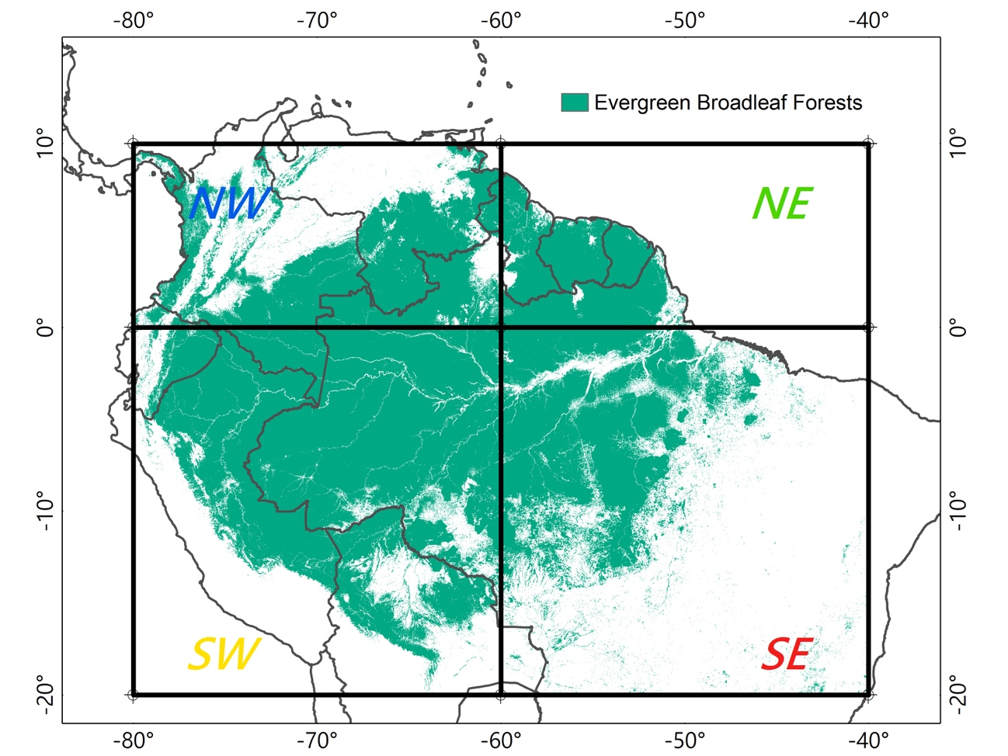

Supplementary Figure 1. Study area and regions considered for the cloud cover analysis. The study area was selected as the Evergreen Broadleaf Forests between geographical coordinates 10N-20S, 80W-40W. This includes mainly the Amazon Basin and adjacent tropical forests.

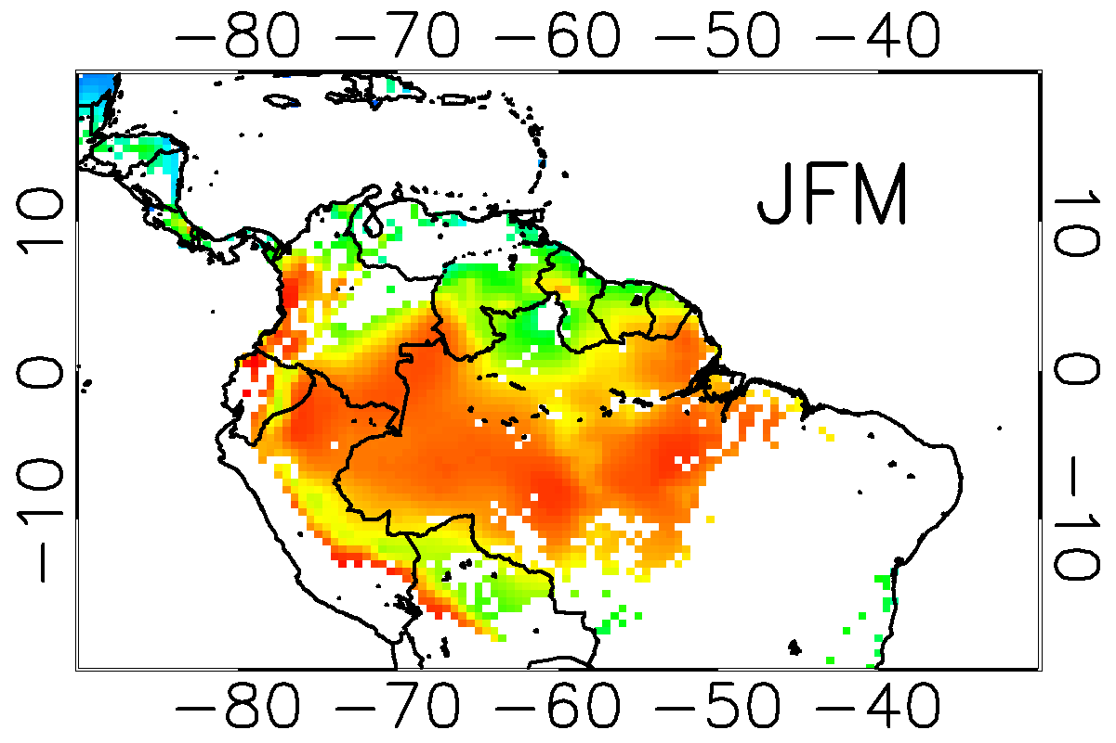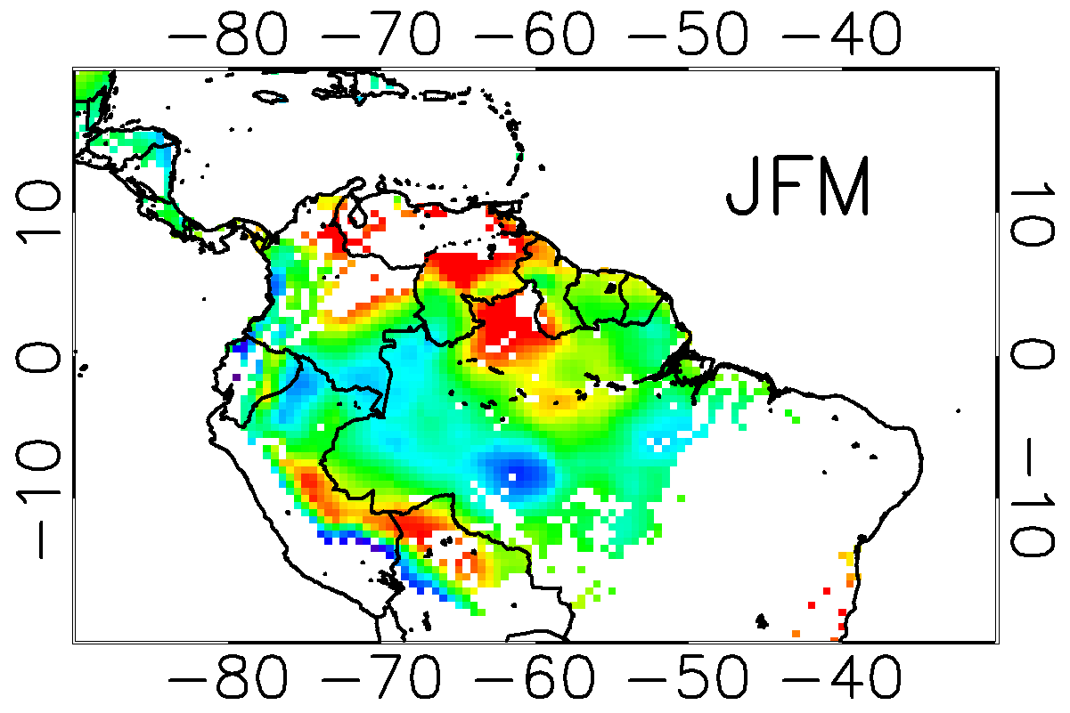

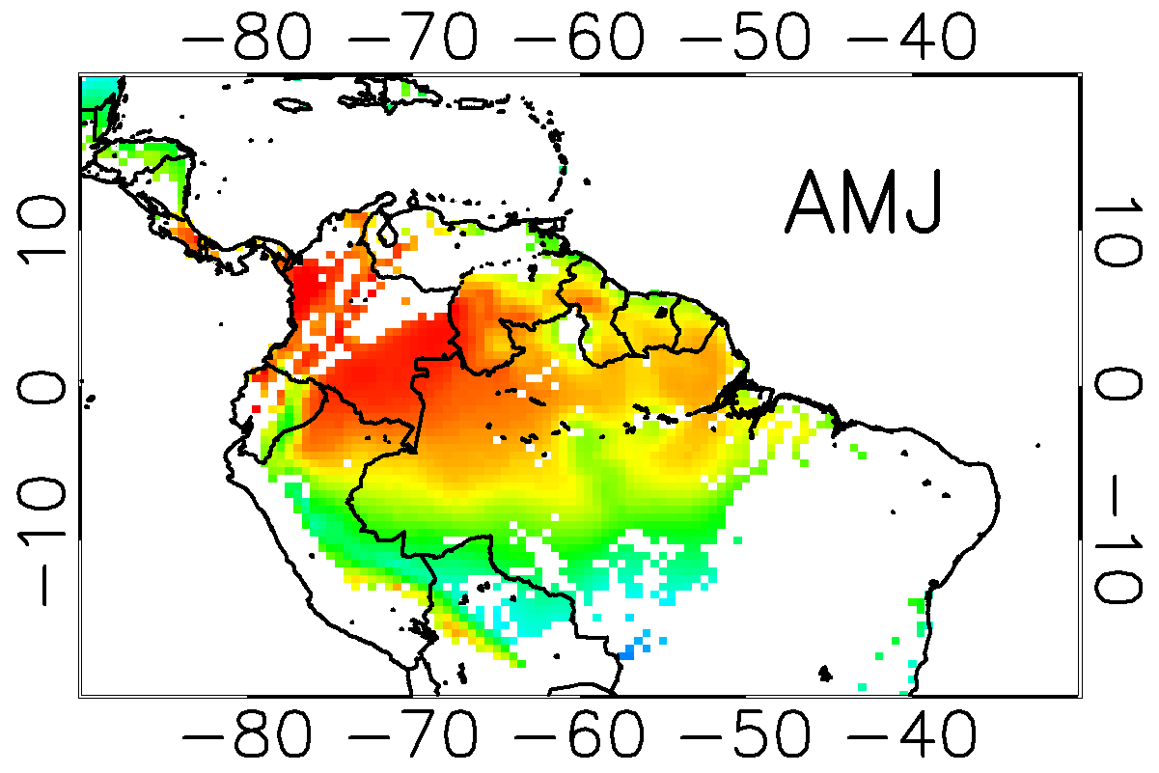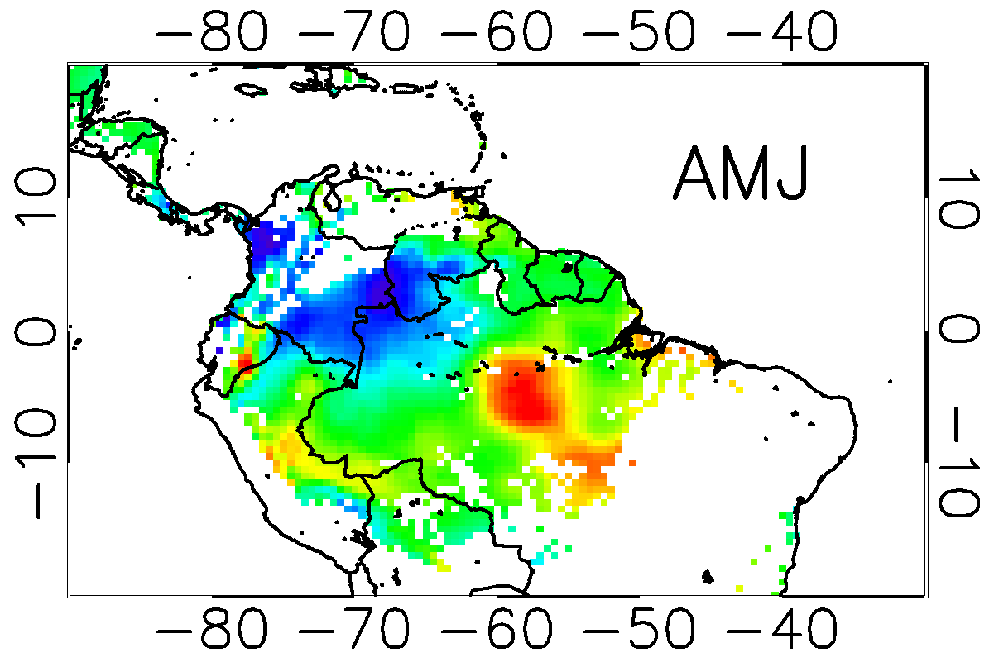

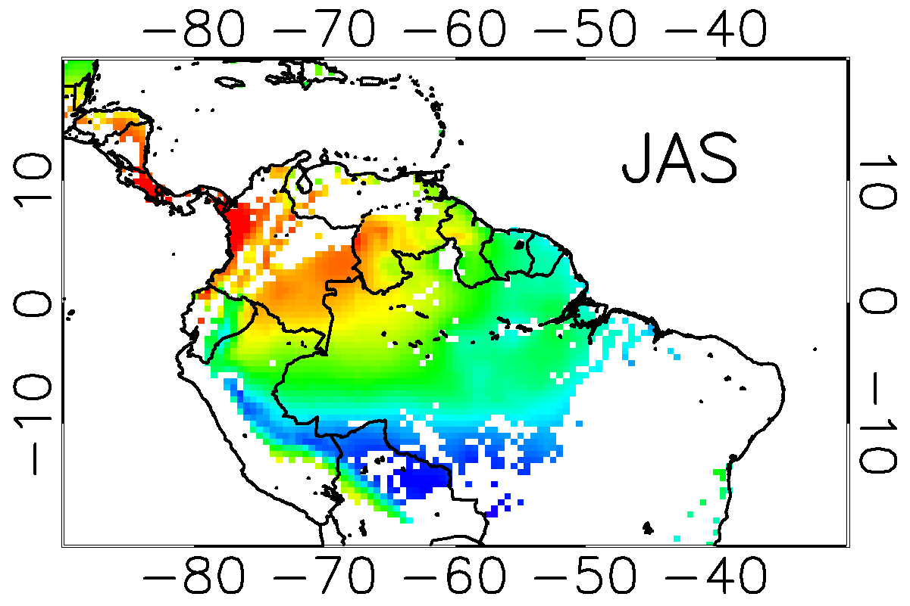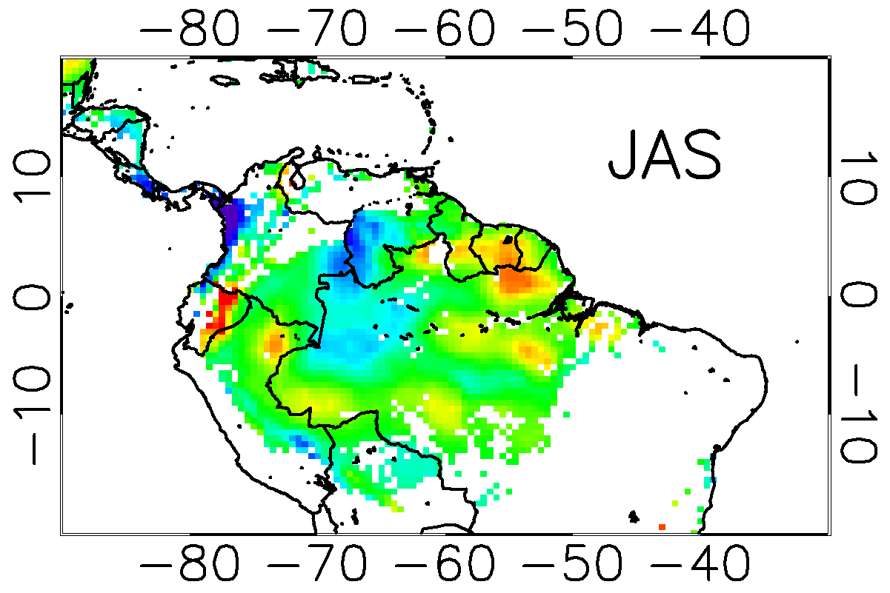

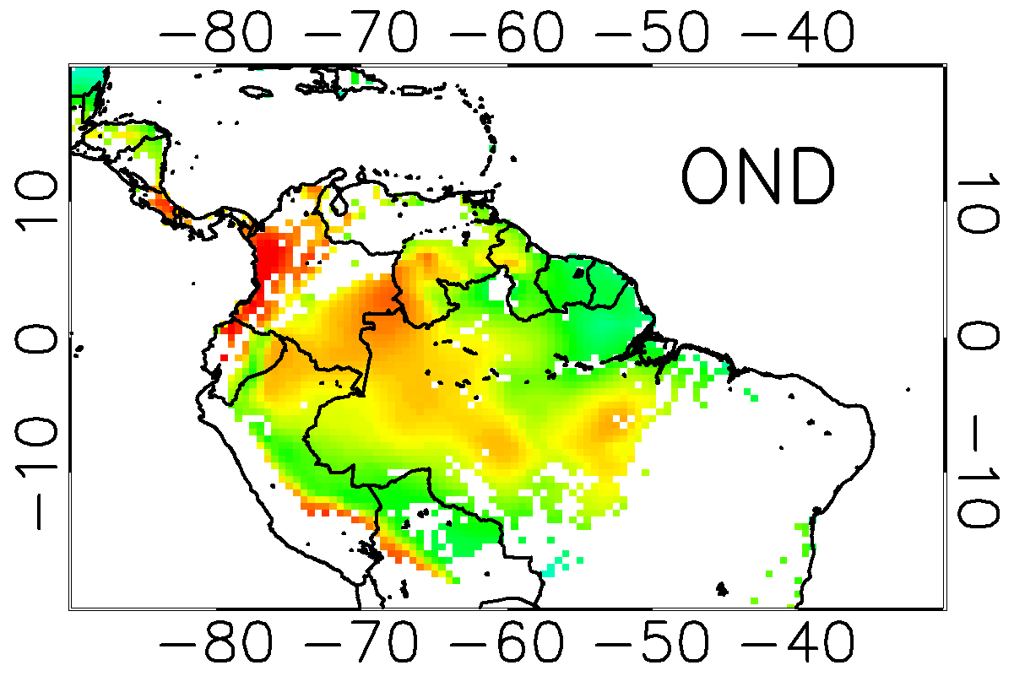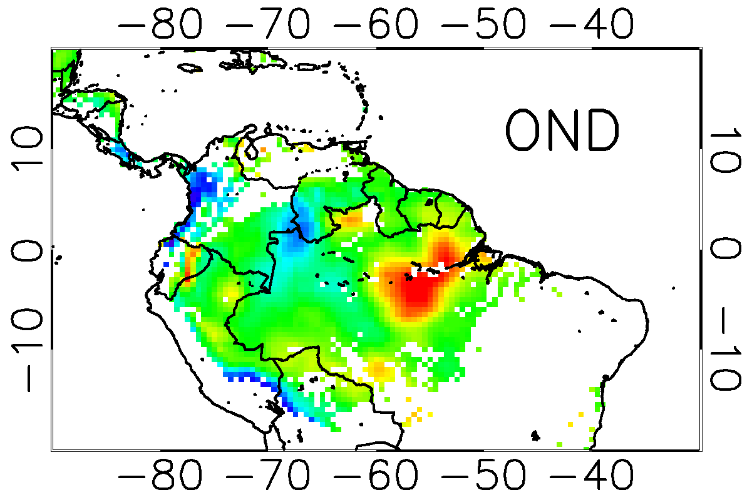
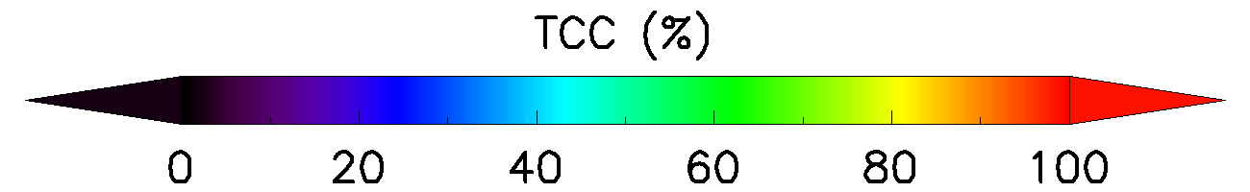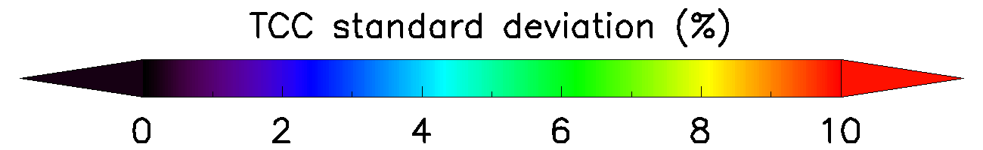

Supplementary Figure 2. Climatological mean (1981-2016) and standard deviation of the climatological mean for the Total Cloud Cover (TCC) over Amazonia for the four seasons JFM, AMJ, JAS, and OND.

1982-1983
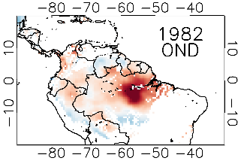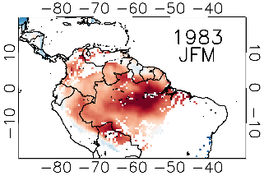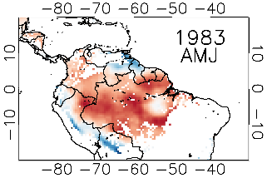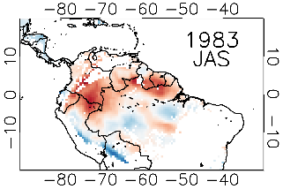

1997-1998
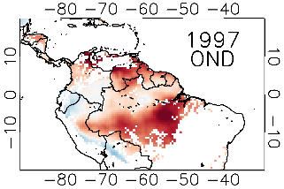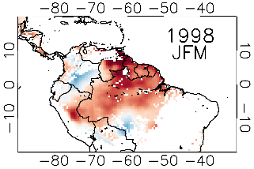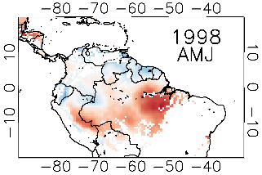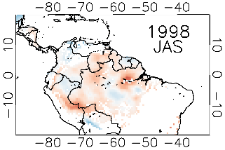

2004-2005
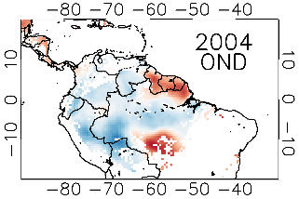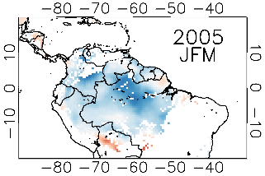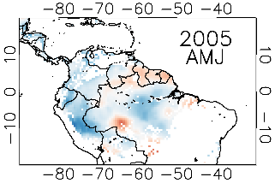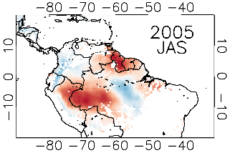

2009-2010
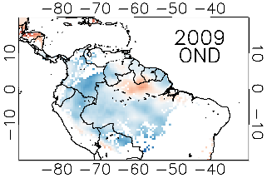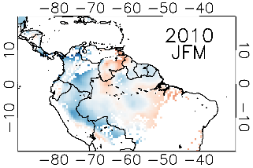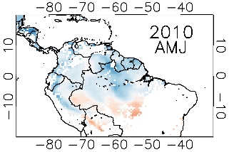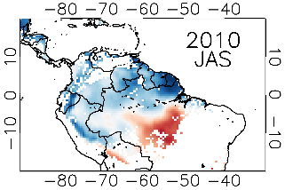

2015-2016
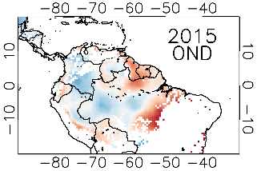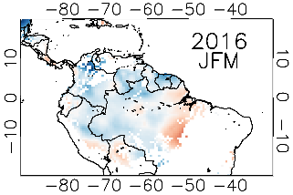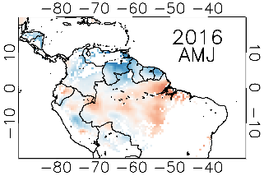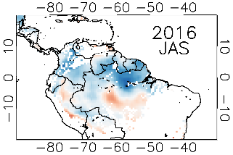

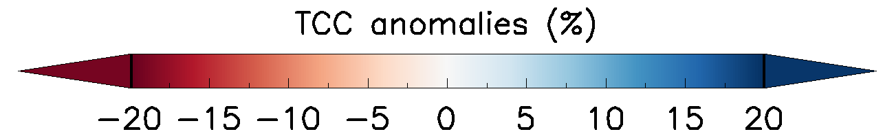

Supplementary Figure 3. Total cloud cover anomalies over Amazonia for strong EN events in 1982-83, 1997-98 and 2015-16, as well as for moderate EN events in 2004-05 and 2009-10. For each event, anomalies for the OND season of the first year are presented, and anomalies for seasons JFM, AMJ and JAS of the second year, are presented. Total cloud cover product was extracted from the ERA-Interim reanalysis resampled at 0.5º×0.5º. The reference period to compute the anomalies was 1981-2010. Results are only shown over pixels classified as Evergreen Broadleaf Forest.

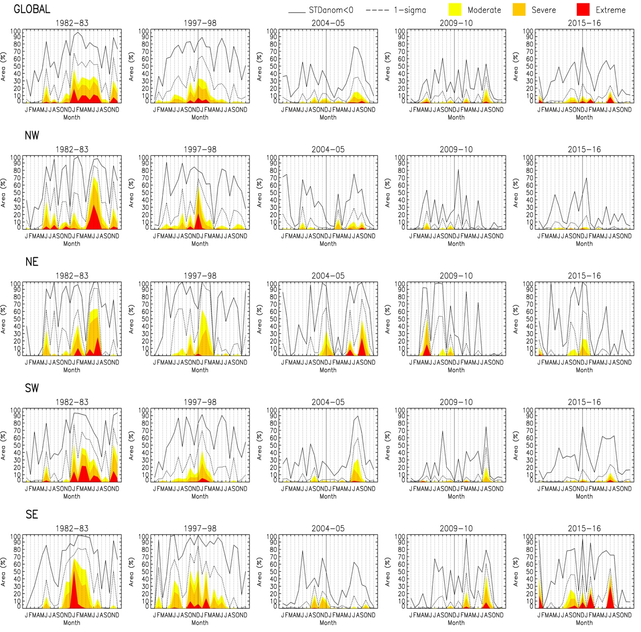

Supplementary Figure 4. Percentage of area (monthly values) for different levels of Total Cloud Cover declines over the entire Amazon region (Global), as well as for northwestern, northeasten, southwestern and southeastern Amazonia (see Supplementary Figure 1). Three levels based on standardized anomalies (SDanom) thresholds were considered: Yellow (SDanom ≤ -1.65), Orange (SDanom ≤ -1.96), and Red (SDanom ≤ -2.58), equivalent to confidence intervals of 90%, 95% and 99%, respectively. These levels are also refered to ‘moderate’, ‘severe’, and ‘extreme’ declines.

