Table 1. Classification of digital resources and materials.
Type | Authentic / Teaching-oriented | Examples used in CLIL
Hardware (physical devices) | Both | PCs, laptops, tablets, mobile phones, interactive whiteboards, scanners, cameras, etc.
Software (programmes for creating, running, managing and editing content) | Both | Browsers, office suits, media players, multimedia software, editors, etc.
Files (created, run, managed and edited by software) | Both | Books, music, films, podcasts, etc.
1.0 content websites and applications | Both | Of newspapers, institutions, companies and products; search engines; online reference material (databases, dictionaries…); games; virtual environments; etc.
2.0 content websites and applications | Both | Blogs, wikis, message boards, listing sites, video sharing sites, etc.
Social media | Both | Virtual communities, social networks, etc.
Communication services | Both | E-mailing, videoconferencing, instant messaging, etc.
Online learning environments | Teaching-oriented | Virtual Learning Environments (VLEs), webquests, online lesson plans, digital textbooks, educational apps, etc.

Table 2. Rotated component loadings
 | Teachers |  | Students
 | 1 | 2 | 1 | 2
1. Authetic materials for bilingual teaching are used | 0.323 | 0.780 | 0.626 | -0.053
2. Authetic materials for bilingual teaching are adapted | 0.729 | 0.152 | 0.629 | -0.100
3. Bilingual teaching materials are interesting and innovative | -0.007 | 0.896 | 0.722 | 0.155
4. Bilingual teachers work in collaboration to prepare and deliver the bilingual teaching materials in class | 0.545 | 0.532 | 0.745 | 0.038
5. The bilingual teaching materials used follow communicative principles | -0.175 | 0.694 | 0.571 | 0.467
6. Attention to diversity is always taken into account when bilingual teaching materials are being designed | 0.007 | 0.846 | 0.616 | 0.273
7. Multimedia software is used in class | 0.369 | -0.174 | 0.274 | 0.767
8. Online reference materials are used in class | 0.430 | 0.035 | 0.213 | 0.777
9. Blogs, wikis and webquest are used in class | 0.848 | 0.083 | -0.014 | 0.718
10. Interactive whiteboards are used in class | 0.850 | -0.109 | -0.051 | 0.425
11. Computer-mediated communication is used in class (e.g. e-Twinning) | 0.618 | 0.098 | 0.372 | 0.154

Figure 1. Component loadings plot (TEACHERS)

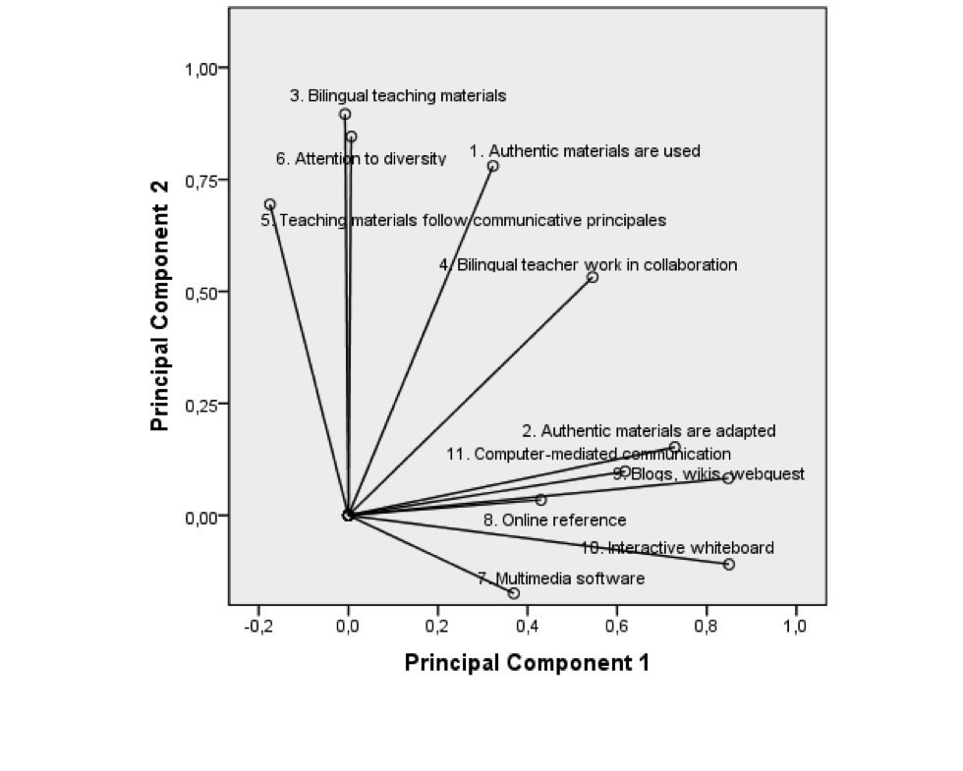

Figure 2. Component loadings plot (LEARNERS)

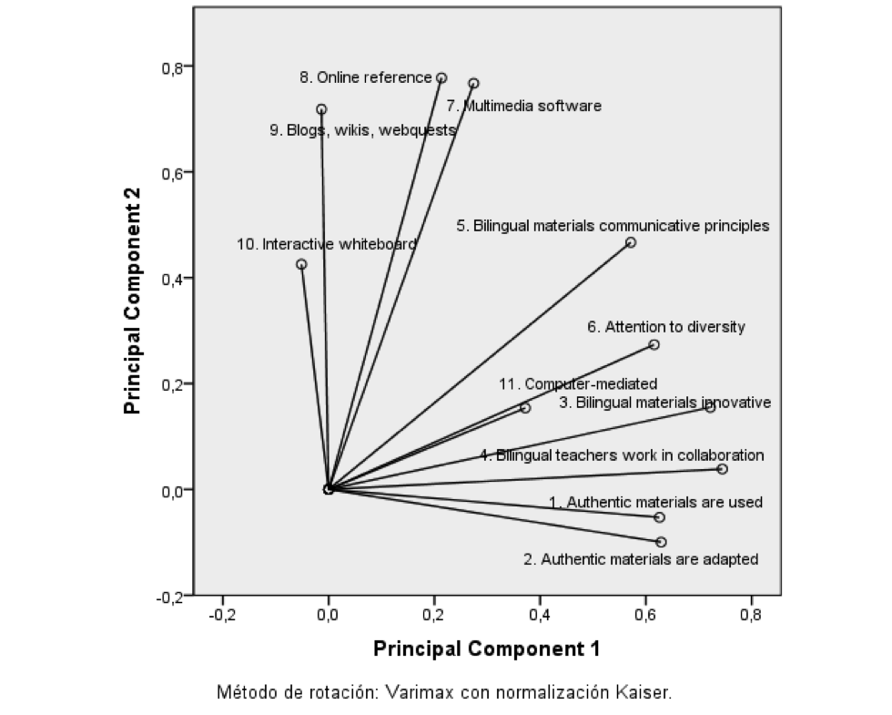

Table 3. Percentage of use of digital resources and materials.
 |  | Primary Education |  | Secondary Education
 |  | Teachers | Learners | Teachers | Learners
7. Multimedia software is used in class | Strongly disagree/ Disagree |  | 13,3 | 38,1 | 33.3
 | Agree/ Strongly agree | 100 | 86,9 | 61.9 | 66.7
8. Online reference materials are used in class | Strongly disagree/ Disagree |  | 26,5 | 4.8 | 11.6
 | Agree/ Strongly agree | 100 | 73,6 | 95.3 | 88.4
9. Blogs, wikis and webquests are used in class | Strongly disagree/ Disagree | 11,8 | 33,8 | 28.6 | 11.5
 | Agree/ Strongly agree | 88,2 | 66,2 | 71.4 | 88.4
10. Interactive whiteboards are used in class | Strongly disagree/ Disagree | 5,9 | 17,7 | 9.5 | 11.6
 | Agree/ Strongly agree | 94,2 | 82,4 | 90.4 | 88.4
11. Computer-mediated communication is used in class (e.g., e-Twinning) | Strongly disagree/ Disagree | 64,4 | 83,2 | 52.3 | 47.8
 | Agree/ Strongly agree | 35,3 | 16,2 | 47.6 | 52.3

Table 4. Mean, standard deviation and differences between primary and secondary students.
 | Year 6 in P.E. / Year 4 in S.E. | Mean | Standard deviation | Sign
1. Authetic materials for bilingual teaching are used | PE | 2.49 | 1.015 | 0.001
 | SE | 3.14 | 0.809
2. Authetic materials for bilingual teaching are adapted | PE | 2.81 | 0.868 | 0.841
 | SE | 2.84 | 0.980
3. Bilingual teaching materials are interesting and innovative | PE | 2.62 | 0.962 | 0.020
 | SE | 2.96 | 0.695
4. Bilingual teachers work in collaboration to prepare and deliver the bilingual teaching materials in class | PE | 2.54 | 1.177 | 0.001
 | SE | 3.20 | 0.719
5. The bilingual teaching materials used follow communicative principles | PE | 2.59 | 1.096 | 0.002
 | SE | 3.07 | 0.649
6. Attention to diversity is always taken into account when bilingual teaching materials are being designed | PE | 2.22 | 1.063 | 0.001
 | SE | 2.88 | 0.738
7. Multimedia software is used in class | PE | 3.29 | 0.734 | 0.011
 | SE | 3.59 | 0.626
8. Online reference materials are used in class | PE | 2.93 | 0.869 | 0.001
 | SE | 3.43 | 0.696
9. Blogs wikis and webquests are used in class | PE | 2.81 | 1.055 | 0.004
 | SE | 3.28 | 0.784
10. Interactive whiteboards are used in class | PE | 3.79 | 0.505 | 0.009
 | SE | 3.48 | 0.851
11. Computer-mediated communication is used in class (e.g.. e-Twinning) | PE | 1.44 | 0.870 | 0.001
 | SE | 2.52 | 1.093

Tabla 5. Cross matrix from class observation and semi-structured interviews.

 | Primary Education |  | Secondary Education
 | STUDENTS | TEACHERS | STUDENTS | TEACHERS
Authentic materials | - | They use both authentic and adapted materials | All kinds of materials are used
Adapted or hand-made materials | Non-linguistic-area worksheets and notebook
Books | In the foreign language class | In the foreign language class | In the foreign language class  Non-linguistic-area books if they find any
Online reference materials | Only 1 school | Some schools | All of them use online reference materials
Blogs | - | Some schools | Some of them have blogs, others use websites or wikis
Interactive whiteboard | 2 schools, but mainly as a projector | Mainly as a projector | All of them use interactive whiteboards but mainly as a projector

Table 6. Pearson correlations. Extramural activities (primary school level).
 | Books | Magazines | TV Shows | Films | Internet | Videogames | Songs
Books | 1 | -0.095 | 0.780** | 0.070 | 0.358** | 0.131 | 0.614**
Magazines |  | 1 | -0.082 | 0.204 | -0.199 | -0.125 | -0.087
TV Shows |  |  | 1 | 0.083 | 0.243 | 0.182 | 0.525**
Films |  |  |  | 1 | 0.342** | -0.102 | 0.258*
Internet |  |  |  |  | 1 | -0.097 | 0.480**
Videogames |  |  |  |  |  | 1 | 0.194
Songs |  |  |  |  |  |  | 1
** Significant correlation at 0.01 (bilateral).
* Significant correlation at 0.05 (bilateral).

Table 7. Pearson correlations. Secondary Education extramural activities.
 | Books | Magazines | TV Shows | Films | Internet | Video Games | Songs
Books | 1 | ,511** | ,252* | ,413** | ,308** | -,006 | -,015
Magazines |  | 1 | ,152 | ,365** | ,534** | ,302** | ,401**
TV Shows |  |  | 1 | ,096 | ,097 | ,182 | ,083
Films |  |  |  | 1 | ,185 | -,099 | -,052
Internet |  |  |  |  | 1 | ,427** | ,601**
Video games |  |  |  |  |  | 1 | ,416**
Songs |  |  |  |  |  |  | 1
** Significant correlation at 0.01 (bilateral).
* Significant correlation at 0.05 (bilateral).

