SUPPLEMENTARY INFORMATION
Silver incorporated Poly Vinylidene Fluoride (PVDF) Nanofibres for Bacterial Filtration
Felix Swamidoss V ^{a,*} , Mohan Bangaruª, Gobi Nalathambi^{b}, Dharmalingam Sangeethaª, Arun Karthick Selvam^{c}
Department of Mechanical Engineering ª, Department of Textile Technology ^{b}, Department of Biomedical Engineering ^{c}
Anna University, Chennai -600 025, India ^{a,b}
SSN College of Engineering, Chennai- 603110, India^{c}
Corresponding Author Email*: felixdj46@gmail.com Tel: +912235 7754

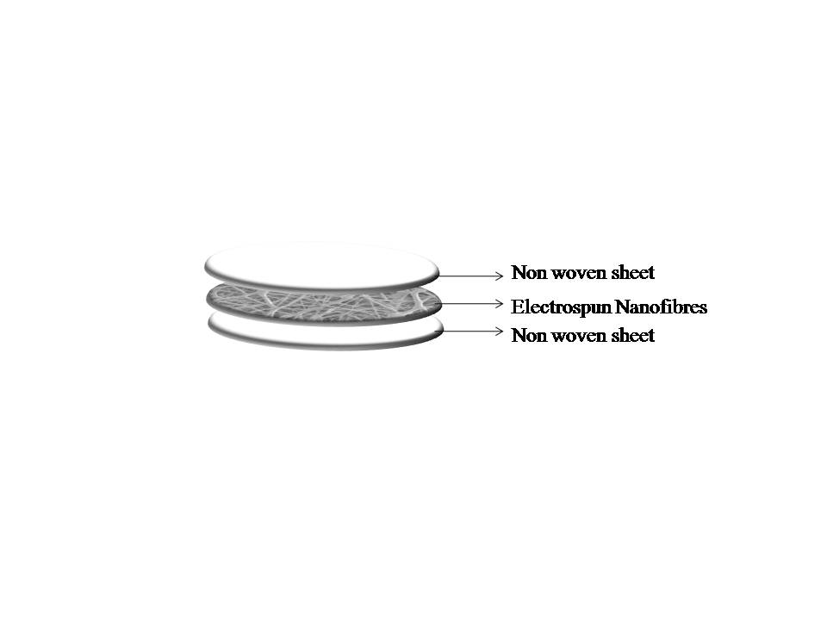
Fig S1 Cross sectional view of prepared filter
Table SI (i) Process Parameters obtained through Box Behnken design
(ii) Experimental runs obtained and sample id
(i)
Variables | Process parameters | Levels
 |  | -1 | 0 | +1
X₁ | Areal Density (grams sq. meter (GSM)) | 40 | 60 | 80
X₂ | Electrospinning time (hr) | 1 | 2 | 3
X₃ | Ag (wt %) | 5 | 10 | 15

(ii)
S.No | Areal Density (GSM) | Electrospinning Time (hr) | Ag  (wt%) | Sample ID
1 | 40 | 3 | 10 | STAT 1
2 | 40 | 2 | 5 | STAT 2
3 | 60 | 1 | 15 | STAT 3
4 | 60 | 2 | 10 | STAT 4
5 | 80 | 3 | 10 | STAT 5
6 | 60 | 2 | 15 | STAT 6
7 | 60 | 1 | 5 | STAT 7
8 | 40 | 1 | 10 | STAT 8
9 | 60 | 3 | 5 | STAT 9
10 | 60 | 3 | 15 | STAT 10
11 | 60 | 2 | 10 | STAT 11
12 | 80 | 1 | 10 | STAT 12
13 | 80 | 2 | 10 | STAT 13-
14 | 80 | 2 | 5 | STAT 14
15 | 60 | 2 | 15 | STAT 15
16 | 40 GSM PP non woven sheet |  |  | STAT 16
17 | 60 GSM PP non woven sheet |  |  | STAT 17
18 | 80 GSM PP non woven sheet |  |  | STAT 18

Table SII Average fibre diameter
S.No | Sample | Average Fibre Diameter(nm)
1 | PVDF + 0 wt% Ag | 286
2 | PVDF + 5 wt% Ag | 205
3 | PVDF + 10 wt% Ag | 186
4 | PVDF + 15 wt% Ag | 136

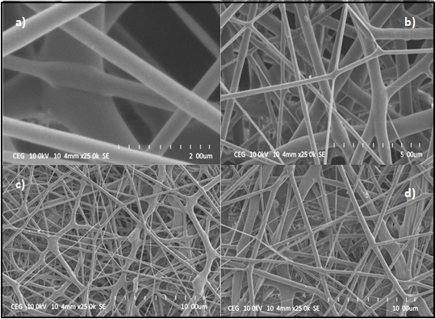
Fig S2 SEM images of (a) PVDF + 0 wt% Ag nanofibres, (b) PVDF + 15 wt% Ag, (c) PVDF + 10 wt% and (d) PVDF + 5 wt%

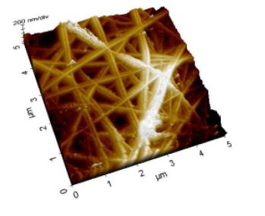
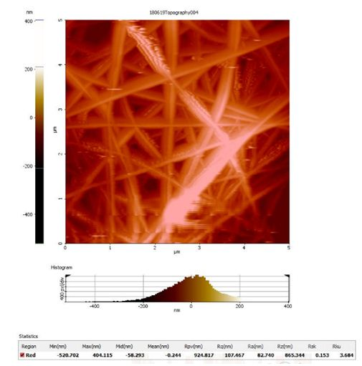
Fig S3 Surface Topology of the produced (a) PVDF+ 15 wt% Ag nanofibres, (b) 3D view of PVDF+ 15 wt% Ag nanofibres (c) PVDF+ 15 wt% Ag nanofibres with Ra and Rq values
Table SIII Surface roughness data
S.No | Membrane | Roughness
 |  | R_{a} (nm) | R_{q} (nm)
1 | PVDF- 0 wt% Ag | 22.57 | 39.86
2 | PVDF- 15 wt% Ag | 82.74 | 107.46

