Supplementary material:
Table S1: Extracted data from the included studies
Study | Adjusted /unadjusted | Complication | OCS dose | Measured outcome
Barry, 2017 | Unadjusted OR | Dyspepsia  Psychiatric complications  Sleep disorder  CKD  Hypertension  Lipid disorder  CVS complications  Diabetes mellitus  Obesity  Fracture  Osteoporosis  Osteopenia  Glaucoma  Cataract |  | 3.62 (95% CI 3.04-4.31)  1.38 (95% CI 1.18-1.61)  1.67 (95% CI 1.12-2.49)  1.67 (95% CI 1.33-2.11)  1.28 (95% CI 1.09-1.51)  1.10 (95% CI 0.89-1.36)  1.41 (95% CI 1.08-1.83)  1.48 (95% CI 1.15-1.92)  1.35 (95% CI 1.16-1.58)  1.53 (95% CI 1.07-2.19)  4.35 (95% CI 3.40-5.57)  4.89 (95% CI 3.56-6.71)  1.16 (95% CI 0.78-1.71)  1.84 (95% CI 1.38-2.44)
Broder, 2017 | Adjusted OR | Inpatient hospitalization  Emergency visits  Asthma related Hospitalization  Asthma related emergency visits  6 or more SABA fills |  | 1.81 (95% CI 1.25-2.62)  1.76 (95% CI 1.29-2.40)  4.95 (95% CI 1.98-12.4)  1.98 (95% CI 0.84-4.64)  2.36 (95% CI 1.66-3.35)
Cowie, 1987 | RR | Tuberculosis | NA | 2.30 (95% CI 0.59-9.17)
Dalal, 2016 | Adjusted OR  Adjusted IRR | Any complications  Acute complications  Chronic complications  Infections  GI complications  Psychiatric complications  CVS complications  Metabolic complications  Bone and muscle  Complications  Skin complications  Ocular complications  Inpatient visits  Outpatient visits  ER visits  Other visits  Pharmacy claims | < 5mg  5-10 mg  >10mg  < 5mg  5-10 mg  >10mg  < 5mg  5-10 mg  >10mg  < 5mg  5-10 mg  >10mg  < 5mg  5-10 mg  >10mg  < 5mg  5-10 mg  >10mg  < 5mg  5-10 mg  >10mg  < 5mg  5-10 mg  >10mg  < 5mg  5-10 mg  >10mg  < 5mg  5-10 mg  >10mg  < 5mg  5-10 mg  >10mg  < 5mg  5-10 mg  >10mg  < 5mg  5-10 mg  >10mg  < 5mg  5-10 mg  >10mg  < 5mg  5-10 mg  >10mg  < 5mg  5-10 mg  >10mg | 2.50 (95% CI 1.22-5.10)  2.95 (95% CI 2.60-3.35)  3.32 (95% CI 2.90-3.80)  1.72 (95% CI 1.34-2.19)  2.47 (95% CI 2.32-2.63)  2.76 (95% CI 2.51-3.03)  1.48 (95% CI 0.92-2.38)  2.19 (95% CI 1.98-2.42)  2.34 (95% CI 2.11-2.59)  1.70 (95% CI 1.34-2.16)  2.25 (95% CI 2.11-2.40)  2.43 (95% CI 2.17-2.71)  1.18 (95% CI 0.98-1.41)  2.02 (95% CI 1.89-2.15)  1.96 (95% CI 1.84-2.10)  1.16 (95% CI 0.95-1.41)  1.73 (95% CI 1.62-1.86)  1.74 (95% CI 1.62-1.86)  1.21 (95% CI 0.90-1.62)  1.77 (95% CI 1.62-1.93)  1.73 (95% CI 1.57-1.90)  0.87 (95% CI 0.72-1.07)  1.32 (95% CI 1.23-1.41)  1.35 (95% CI 1.25-1.45)  1.36 (95% CI 1.16-1.59)  2.28 (95% CI 2.16-2.40)  2.42 (95% CI 2.29-2.55)  1.37 (95% CI 1.18-1.59)  1.42 (95% CI 1.28-1.57)  1.66 (95% CI 1.51-1.83)  0.95 (95% CI 0.84-1.08)  1.09 (95% CI 1.02-1.17)  1.19 (95% CI 1.11-1.28  1.86 (95% CI 1.70-2.04)  2.40 (95% CI 2.26-2.56)  3.37(95% CI 3.18-3.59)  1.26 (95% CI 1.19-1.34)  1.33 (95% CI 1.28-1.38)  1.53 (95% CI 1.48-1.59)  1.57 (95% CI 1.39-1.78)  1.78 (95% CI 1.65-1.92)  2.17 (95% CI 2.00-2.35)  1.36 (95% CI 1.19-1.56)  1.56 (95% CI 1.40-1.73)  1.71 (95% CI 1.54-1.89)  1.57 (95% CI 1.50-1.65)  1.77 (95% CI 1.72-1.82)  1.93 (95% CI 1.88-1.98)
Daugerty, 2017 | Adjusted HR | Ulcer  Stroke  Myocardial infarction  Diabetes mellitus  Osteoporosis  Cataract | > 0  > 0  < 2.5  > 2.5  < 2.5  > 2.5  < 2.5  2.5-5.0  > 5.0  < 2.5  2.5-7.5  > 7.5 | 1.13 (95% CI 1.00-1.28)  1.11 (95% CI 0.97-1.27)  1.25 (95% CI 1.09-1.43)  2.15 (95% CI 1.67-2.77)  1.20 (95% CI 1.11-1.30)  1.70 (95% CI 1.44-2.01)  1.64 (95% CI 1.51-1.78)  6.79 (95% CI 5.98-7.73)  12.61 (95% CI 10.45-15.21)  1.07 (95% CI 1.00-1.15)  1.76 (95% CI 1.52-2.04)  3.38 (95% CI 2.41-4.73)
Lefebvre, 2017 | Adjusted OR  Adjusted IRR | Any complications  Infections  GI  Psychiatric  CVS  Metabolic  Bone and muscle  Ocular  Hematologic and oncologic complications  Inpatient visits  Outpatient visits  ER visits  Other visits  Pharmacy claims | < 6  6-12  >12  < 6  6-12  >12  < 6  6-12  >12  < 6  6-12  >12  < 6  6-12  >12  < 6  6-12  >12  < 6  6-12  >12  < 6  6-12  >12  < 6  6-12  >12  < 6  6-12  >12  < 6  6-12  >12  < 6  6-12  >12  < 6  6-12  >12  < 6  6-12  >12 | 2.03 (95% CI 1.00-4.14)  2.85 (95% CI 1.85-4.38)  3.64 (95% CI 2.43-5.46)  1.56 (95% CI 1.34-1.81)  2.53 (95% CI 2.27-2.82)  2.94 (95% CI 2.61-3.33)  1.50 (95% CI 1.28-1.76)  2.31 (95% CI 2.08-2.56)  2.55 (95% CI 2.28-2.84)  1.40 (95% CI 1.16-1.70)  1.62 (95% CI 1.42-1.84)  1.46 (95% CI 1.28-1.66)  1.14 (95% CI 0.87-1.48)  2.23 (95% CI 1.93-2.59)  2.06 (95% CI 1.76-2.41)  1.17 (95% CI 0.98-1.40)  1.56 (95% CI 1.38-1.76)  1.55 (95% CI 1.37-1.75)  1.09 (95% CI 0.94-1.26)  1.72 (95% CI 1.55-1.92)  1.89 (95% CI 1.68-2.12)  1.33 (95% CI 1.14-1.54)  1.63 (95% CI 1.43-1.87)  2.02 (95% CI 1.78-2.29)  1.58 (95% CI 1.24-2.01)  1.96 (95% CI 1.59-2.41)  1.69 (95% CI 1.35-2.12)  1.57 (95% CI 1.41-1.73)  1.92 (95% CI 1.75-2.11)  2.45 (95% CI 2.22-2.70)  1.05 (95% CI 0.91-1.21)  1.00 (95% CI 0.88-1.14)  1.15 (95% CI 1.01-1.31)  0.97 (95% CI 0.84-1.12)  1.25 (95% CI 1.07-1.47)  1.72 (95% CI 1.39-2.13)  1.24 (95% CI 1.05-1.47)  1.31 (95% CI 1.12-1.53)  1.44 (95% CI 1.22-1.71)  1.79 (95% CI 1.68-1.91)  1.77 (95% CI 1.72-1.82)  2.22 (95% CI 2.11-2.35)
Lefebvre, 2015 | Adjusted OR  Adjusted IRR | Infections  GI  Psychiatric  CVS  Metabolic  Bone and muscle  Ocular complications  Inpatient visits  Outpatient visits  ER visits  Other visits  Pharmacy claims. | 6-12  >12  6-12  >12  6-12  >12  6-12  >12  6-12  >12  6-12  >12  6-12  >12  6-12  >12  6-12  >12  6-12  >12  6-12  >12  6-12  >12 | 1.72 (95% CI 1.37-2.16)  1.91 (95% CI 1.51-2.43)  1.63 (95% CI 1.34-1.99)  1.81 (95% CI 1.46-2.24)  1.35 (95% CI 1.10-1.66)  1.28 (95% CI 1.03-1.60)  2.12 (95% CI 1.63-2.76)  1.96 (95% CI 1.48-2.58)  1.50 (95% CI 1.25-1.81)  1.51 (95% CI 1.23-1.85)  1.51 (95% CI 1.25-1.82)  1.59 (95% CI 1.29-1.96)  1.29 (95% CI 1.09-1.51)  1.55 (95% CI 1.32-1.83)  1.25 (95% CI 1.15-1.35)  1.59 (95% CI 1.44-1.76)  0.98 (95% CI 0.87-1.11)  1.13 (95% CI 0.97-1.32)  1.31 (95% CI 1.13-1.53)  1.78 (95% CI 1.47-2.17)  1.15 (95% CI 0.96-1.39)  1.33 (95% CI 1.01-1.74)  1.22 (95% CI 1.14-1.29)  1.35 (95% CI 1.26-1.44)
Lieberman, 1971 | Unadjusted OR | Tuberculosis  Heartburn  Ulcer  Psychosis  Fluid retention  Hypertension  Hypokalemia  Diabetes mellitus  Increased appetite  Weight gain  Bruising  Cataract | NA | 1.00 (95% CI 0.06-16.44)  6.71 (95% CI 1.80-25.00)  1.53 (95% CI 0.24-9.59)  1.00 (95% CI 0.06-16.44)  17.25 (95% CI 5.37-55.46)  2.67 (95% CI 1.09-6.52)  2.25 (95% CI 0.71-7.14)  6.71 (95% CI 1.80-25.00)  7.88 (95% CI 3.06-20.25)  12.25 (95% CI 4.65-32.26)  9.00 (95% CI 3.06-26.44)  3.13 (95% CI 0.31-31.14)
Luskin, 2016 | Unadjusted mean healthcare resource use in patients with OCS complications  Adjusted mean healthcare resource use in patients with OCS complications | Office visits  All cause  Asthma related  Inpatient hospitalization  All cause  Asthma related  Emergency department visit  All cause  Asthma related  Office visits  All cause  Asthma related  Inpatient hospitalization  All cause  Asthma related  Emergency department visit  All cause  Asthma related |  | 23.40 (95% CI 22.90-24.00)  3.10 (95% CI 2.90-3.30)  0.60 (95% CI 0.56-0.63)  0.11 (95% CI 0.10-0.12)  0.78 (95% CI 0.67-0.88)  0.03 (95% CI 0.02-0.05)  23.00 (95% CI 22.50-23.60)  3.20 (95% CI 3.00-3.40)  0.44 (95% CI 0.41-0.46)  0.07 (95% CI 0.06-0.09)  0.73 (95% CI 0.64-0.82)  0.02 (95% CI 0.01-0.02)
Spoendlin, 2015 | Adjusted OR | Achilles tendon rupture  Biceps tendon rupture |  | 1.20 (95% CI 1.10-1.31)  1.28 (95% CI 1.14-1.43)
Sullivan, 2017 | Adjusted OR | Any complication  Tuberculosis  Ulcer  Hypertension  Lipid disorder  Metabolic syndrome  Diabetes mellitus  Obesity  Fracture  Osteoporosis  Avascular necrosis  Glaucoma  Cataract |  | 1.29 (95% CI 1.20-1.37)  1.15 (95% CI0.94-1.41)  1.33 (95% CI 1.15-1.54)  1.32 (95% CI 1.20-1.46)  1.04 (95% CI 0.93-1.16)  0.84 (95% CI 0.54-1.31)  1.30 (95% CI 1.13-1.50)  1.28 (95% CI 1.13-1.45)  1.21 (95% CI 1.04-1.40)  1.44 (95% CI 1.28-1.63)  1.46 (95% CI 0.57-3.74)  1.04 (95% CI 0.82-1.32)  1.26 (95% CI 1.04-1.52)
Sweeney, 2016 | Adjusted OR | Dyspepsia  Psychiatric  Sleep disorder  Chronic kidney disease  Hypertension  Lipid disorder  Cardiovascular  Diabetes mellitus  Obesity  Fractures  Osteoporosis  Osteopenia  Glaucoma  Cataracts |  | 3.99 (95% CI 3.37-4.72) & 1.94 (95% CI 1.44-2.61)  1.43 (95% CI 1.22-1.69) & 2.39 (95% CI 1.64-3.49)  1.70 (95% CI 1.13-2.53) & 3.07 (95% CI 1.64-5.77)  1.80 (95% CI 1.39-2.32)  1.35 (95% CI 1.12-1.61) & 1.59 (95% CI 1.07-2.36)  1.15 (95% CI 0.92-1.44) & 2.64 (95% CI 1.60-4.37)  1.36 (95% CI 1.02-1.81) & 0.74 (95% CI 0.41-1.33)  1.46 (95% CI 1.11-1.91) &  3.5 (95% CI 1.94-6.24)  1.36 (95% CI 1.16-1.59) & 1.41 (95% CI 1.06-1.88)  1.54 (95% CI 1.06-2.22)  5.23 (95% CI 3.97-6.89) & 1.27 (95% CI 0.71-2.28)  5.26 (95% CI 3.75-7.37) & 1.23 (95% CI 0.79-1.92)  1.12 (95% CI 0.75-1.68) & 0.93 (95% CI 0.31-2.74)  1.89 (95% CI 1.39-2.56)
Zazzali, 2015 |  | Any complications  Infections  Pneumonia  Ulcer  Hypertension  Lipid disorder  Diabetes mellitus  Obesity  Glaucoma  Cataract  Fractures  Osteoporosis  Bone related complications |  | 1.16 (95% CI 1.06-1.27)  5.43 (95% CI 2.09-14.12)  3.73 (95% CI 2.96-4.69)  3.00 (95% CI 0.31-28.87)  1.20 (95% CI 1.08-1.33)  0.89 (95% CI 0.81-0.99)  1.26 (95% CI 1.10-1.44)  1.18 (95% CI 1.00-1.40)  1.12 (95% CI 0.72-1.43)  1.26 (95% CI 0.91-1.73)  2.33 (95% CI 1.36-4.00)  1.82 (95% CI 1.31-2.54)  1.91 (95% CI 1.43-2.55)
Zeiger | Unadjusted OR | Infections  Ulcer  Anxiety  Depression  Hypertension  Hypercortisolism  Diabetes mellitus  Fractures  Osteoporosis  Glaucoma  Cataract | <2.5  2.5-5.0  5.0-7.5  >7.5  <2.5  2.5-5.0  5.0-7.5  >7.5  <2.5  2.5-5.0  5.0-7.5  >7.5  <2.5  2.5-5.0  5.0-7.5  >7.5  <2.5  2.5-5.0  5.0-7.5  >7.5  <2.5  2.5-5.0  5.0-7.5  >7.5  <2.5  2.5-5.0  5.0-7.5  >7.5  <2.5  2.5-5.0  5.0-7.5  >7.5  <2.5  2.5-5.0  5.0-7.5  >7.5  <2.5  2.5-5.0  5.0-7.5  >7.5  <2.5  2.5-5.0  5.0-7.5  >7.5 | 1.58 (95% CI 1.41-1.77)  1.92 (95% CI 1.55-2.37)  1.67 (95% CI 1.12-2.51)  2.51 (95% CI 1.69-3.73)  2.64 (95% CI 1.06-6.56)  7.03 (95% CI 2.29-21.57)  5.02 (95% CI 0.62-40.44)  2.76 (95% CI 0.16-48.10)  1.44 (95% CI 1.25-1.65)  2.07 (95% CI 1.63-2.64)  1.56 (95% CI 0.97-2.52)  1.46 (95% CI 0.86-2.49)  1.38 (95% CI 1.21-1.58)  1.19 (95% CI 0.91-1.56)  1.14 (95% CI 0.69-1.89)  1.30 (95% CI 0.77-2.18)  1.26 (95% CI 1.15-1.39)  1.58 (95% CI 1.31-1.91)  1.44 (95% CI 1.02-2.04)  2.02 (95% CI 1.40-2.90)  5.11 (95% CI 1.36-19.29)  18.76 (95% CI 4.47-78.74)  54.79 (95% CI 12.15-247.11)  48.34 (95% CI 9.66-242.00)  1.02 (95% CI 0.89-1.18)  1.10 (95% CI 0.83-1.46)  1.03 (95% CI 0.61-1.74)  1.33 (95% CI 0.79-2.24)  1.26 (95% CI 1.03-1.54)  1.67 (95% CI 1.17-2.39)  1.44 (95% CI 0.73-2.87)  2.58 (95% CI 1.43-4.65)  1.11 (95% CI 0.86-1.44)  1.66 (95% CI 1.07-2.58)  1.74 (95% CI 0.80-3.78)  2.39 (95% CI 1.15-4.98)  1.02 (95% CI 0.75-1.39)  1.23 (95% CI 0.69-2.21)  1.37 (95% CI 0.50-3.75)  2.04 (95% CI 0.82-5.09)  1.38 (95% CI 1.12-1.71)  1.11 (95% CI 0.70-1.75)  1.74 (95% CI 0.88-3.47)  3.67 (95% CI 2.01-6.40)
Zhang, 2009 | Relative Risk | Myocardial infarction  MI hospitalization |  | 1.50 (95% CI 1.20-1.70)  1.80 (95% CI 1.30-2.60)

Table S2: Definition of system related complications:
Gastrointestinal | - Nausea/vomiting  - Gastrointestinal bleeds/ulcers  - Dyspepsia
Infections | - Fungal infections  - Pneumonia  - Sepsis  - Tuberculosis  - Urinary tract infection  - Varicella infection  - Bursitis
Bone- and  muscle-related | - Fractures  - Avascular necrosis  - Osteoporosis  - Muscle weakness  - Back pain
Cardiovascular | - Atrial fibrillation/flutter  - Hypertension  - Myocardial infarction
Metabolic | - Hyperglycemia  - Dyslipidemia  - Obesity  - Diabetes mellitus  - Metabolic syndrome
Ocular | - Cataracts  - Glaucoma
Psychiatric | - Bipolar disorder  - Depression  - Sleep disturbances  - Steroid psychosis

Table S3: Dose-response relationship of complications among different OCS dose ranges compared with non OCS users.
Adverse effect | OR | 95% CI
Any complication  - Low dose  - Medium dose  - High dose | 2.26  2.94  3.35 | (1.37-3.72)  (2.62-3.29)  (2.94-3.82)
Cardiovascular  - Low dose  - Medium dose  - High dose | 1.17  1.85  1.82 | (0.96-1.43)  (1.73-1.99)  (1.67-1.98)
Gastrointestinal  - Low dose  - Medium dose  - High dose | 1.36  2.09  2.06 | (1.21-1.52)  (1.99-2.20)  (1.96-2.17)
Infections  - Low dose  - Medium dose  - High dose | 1.60  2.30  2.68 | (1.40-1.82)  (2.18-2.43)  (2.46-2.91)
Psychiatric  - Low dose  - Medium dose  - High dose | 1.03  1.37  1.41 | (0.90-1.17)  (1.30-1.44)  (1.32-1.50)
Bone/muscle  - Low dose  - Medium dose  - High dose | 1.20  2.11  2.30 | (1.09-1.33)  (2.00-2.12)  (2.18-2.42)
Ocular  - Low dose  - Medium dose  - High dose | 1.08  1.21  1.40 | (0.98-1.18)  (1.13-1.29)  (1.31-1.49)

Table S4: Dose-response relationship of OCS use and healthcare utilization because of OCS related complications
Healthcare utilization | IRR | 95% CI
Inpatient visits  - Low dose  - Medium dose  - High dose | 1.71  2.27  3.09 | (1.59-1.83)  (2.16-2.39)  (2.94-3.25)
Emergency room visits  - Low dose  - Medium dose  - High dose | 1.28  1.66  2.10 | (1.17-1.40)  (1.55-1.78)  (1.95-2.26)
Outpatient visits  - Low dose  - Medium dose  - High dose | 1.22  1.31  1.50 | (1.16-1.29)  (1.26-1.36)  (1.45-1.56)
Other visits  - Low dose  - Medium dose  - High dose | 1.32  1.48  1.64 | (1.18-1.47)  (1.36-1.61)  (1.51-1.79)
Pharmacy claims  - Low dose  - Medium dose  - High dose | 1.63  1.79  1.96 | (1.58-1.69)  (1.76-1.83)  (1.93-2.00)

Table S5: Summary of collected cost data (a) studies reporting different cost data:
Study | Cost Category | Cost
Barry, 2017 (26) | Mean annual cost  Total cost  Clinical activity  Prescription | 4269-7434 US$ *  1494-4590 US$ *  2775-2844 US$ *
Broder, 2017 (27) | Mean total annual healthcare cost  Adjusted mean total annual healthcare cost excess | 40933 US$  17122 +/- 2395 US$
Luskin, 2016 (28) | Unadjusted mean annual healthcare cost in patients with complications  Adjusted mean cost in patients with complications  Annual total healthcare cost  Annual asthma related healthcare cost | 26355 US$ (95% CI 25264-27447)  25168 US$ (95% CI 24223-26133)  4213 US$ (95% CI 3990-4435)
*Adjusted to 2014 US$
(b) Comparison of studies reporting similar cost data:
Cost category | OCS dose | Dalal, 2016 (10)  Mean difference in US$ compared with non-OCS | Lefebvre, 2017 (11)  Mean difference in US$ compared with non-OCS | Lefebvre, 2015 (7)  Mean difference in US$ compared with low dose OCS
Pharmacy and medical costs  Pharmacy Cost  All medical cost  Inpatient visit  Outpatient visit  ER visit  Other visit costs  Annual increased cost of  Complications  Total cost of acute complications  Total cost of chronic complications | Low  Medium  High  Low  Medium  High  Low  Medium  High  Low  Medium  High  Low  Medium  High  Low  Medium  High  Low  Medium  High  Low  Medium  High  Low  Medium  High  Low  Medium  High | 667 (95% CI 257-937)  1160 (95% CI 1038-1427)  2291 (95% CI 2044-2532)  342 (95% CI 302-397)  422 (95% CI 393-460)  416 (95% CI 382-447)  390 (95% CI -33-629)  760 (95% CI 629-1013)  1872 (95% CI 1633-2096)  233 (95% CI -143-467)  467 (95% CI 331-683)  1433 (95% CI 1212-1635)  82 (95% CI 12-142)  182 (95% CI 150-230)  282 (95% CI 244-325)  24 (95% CI 11-45)  30 (95% CI 24-44)  76 (95% CI 49-72)  55 (95% CI 6-93)  75 (95% CI 52-103)  95 (95% CI 78-122)  2670  4639  9162 | 678 (95% CI 414-922)  1181 (95% CI 928-1397)  2140 (95% CI 1766-2391)  141 (95% CI 47-212)  356 (95% CI 253-429)  643 (95% CI 511-740)  521 (95% CI 291-755)  817 (95% CI 613-1009)  1497 (95% CI 1189-1719)  195 (95% CI 82-351)  427 (95% CI 340-548)  837 (95% CI 675-972)  -24 (95% CI -110-96)  91 (95% CI -17-197)  368 (95% CI 195-486)  1 (95% CI -1-3)  2 (95% CI 0-4)  4 (95% CI 2-7)  249 (95% CI 114-376)  253 (95% CI 137-363)  319 (95% CI 192-450)  2440  4516  8684  984  1880  4168  2424  4028  6816 | 478 (95% CI 256-733)  1370 (95% CI 1018-1720)  110 (95% CI 36-198)  307 (95% CI 208-417)  369 (95% CI 168-600)  1061 (95% CI 731-1402)  239 (95% CI 102-391)  620 (95% CI 403-848)  136 (95% CI 45-215)  398 (95% CI 250-514)  2 (95% CI 0-3)  4 (95% CI 2-6)  35 (95% CI -88-173)  116 (95% CI -30-291)  1914  5479  842  2953  1767  4492
Low dose: <5 mg in Dalal’s study and < 6 mg in Lefebvre’s studies
Medium dose: 5-10 mg in Dalal’s study and 6-12 mg in Lefebvre’s studies
High dose: >10 mg in Dalal’s study and >12 mg in Lefebvre’s studies

Figure S1: Search Strategy:
--------------------------------------------------------------------------------
1 exp Asthma/
2 asthma*.mp.
3 1 or 2
4 exp Prednisone/
5 prednisone.mp.
6 exp Prednisolone/
7 prednisolone.mp.
8 exp Dexamethasone/
9 dexamethasone.mp.
10 exp Betamethasone/
11 betamethasone.mp.
12 exp Glucocorticoids/
13 systemic corticosteroid*.mp.
14 or/4-13
15 "Drug-Related Side Effects and Adverse Reactions"/
16 adverse.mp.
17 (ae or si or to or co).fs.
18 (safe or safety).ti,ab.
19 side effect$.ti,ab.
20 ((adverse or undesirable or harm$ or serious or toxic) adj3 (effect$ or reaction$ or event$ or outcome$)).ti,ab.
21 (toxicity or complication$ or noxious or tolerability).ti,ab.
22 exp Hypertension/
23 Hypertension.mp.
24 exp Myocardial Infarction/
25 myocardial infarction.mp.
26 exp Osteoporosis/
27 osteoporosis.mp.
28 exp Cataract/
29 cataract*.mp.
30 exp Diabetes Mellitus/
31 diabetes.mp.
32 exp Adrenal Insufficiency/
33 adrenal insufficiency.mp.
34 exp Wound Healing/
35 wound healing.mp.
36 or/15-35
37 exp Hospitalization/
38 hospitalization*.mp.
39 economic*.mp.
40 ec.fs.
41 exp "Costs and Cost Analysis"/
42 cost*.mp.
43 exp Health Care Costs/
44 (health adj10 cost*).mp.
45 exp Emergency Service, Hospital/
46 (emergency adj5 visit*).mp.
47 or/37-46
48 exp Cost-Benefit Analysis/
49 cost effectiveness.mp.
50 48 or 49
51 3 and 14 and 36
52 3 and 14 and 47
53 3 and 14 and 50
54 (random$ or placebo$ or single blind$ or double blind$ or triple blind$).ti,ab. (1365546)
55 RETRACTED ARTICLE/
56 exp cohort analysis/
57 exp longitudinal study/
58 exp prospective study/
59 exp follow up/
60 cohort$.tw.
61 exp case control study/
62 (case$ and control$).tw.
63 exp case study/
64 (case$ and series).tw.
65 case report/
66 (case$ adj2 report$).tw.
67 (case$ adj2 stud$).tw.
68 or/54-67
69 51 and 68
70 52 and 68
71 53 and 68
***************************

Figure S2: The risk of development of any complications among different dose ranges of OCS compared with non-OCS users.
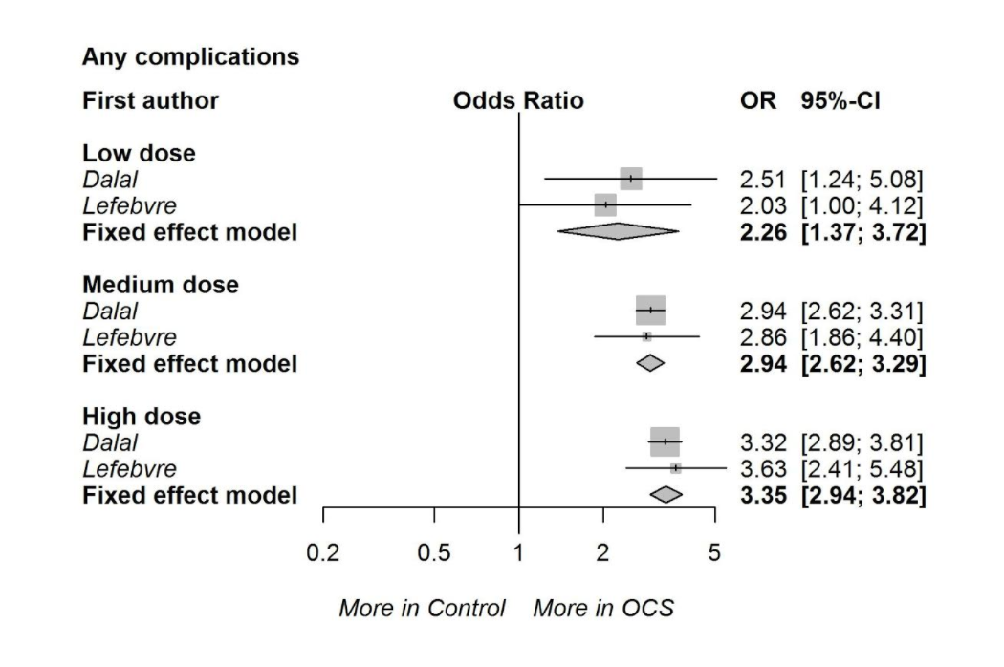
Figure S3: The risk of development of cardiovascular complications among different dose ranges of OCS compared with non-OCS users
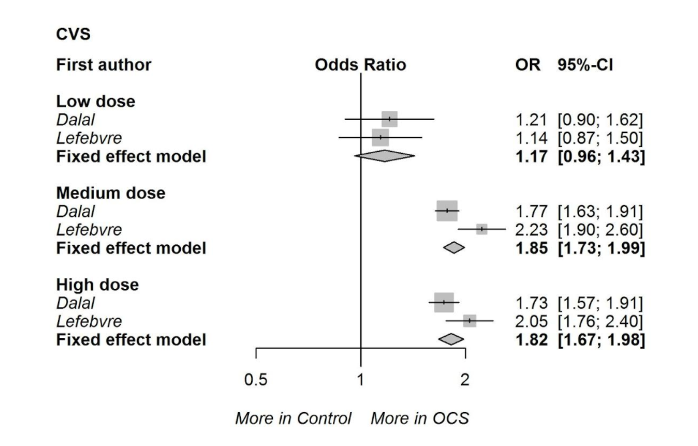
Figure S4: The risk of development of gastrointestinal complications among different dose ranges of OCS compared with non-OCS users.
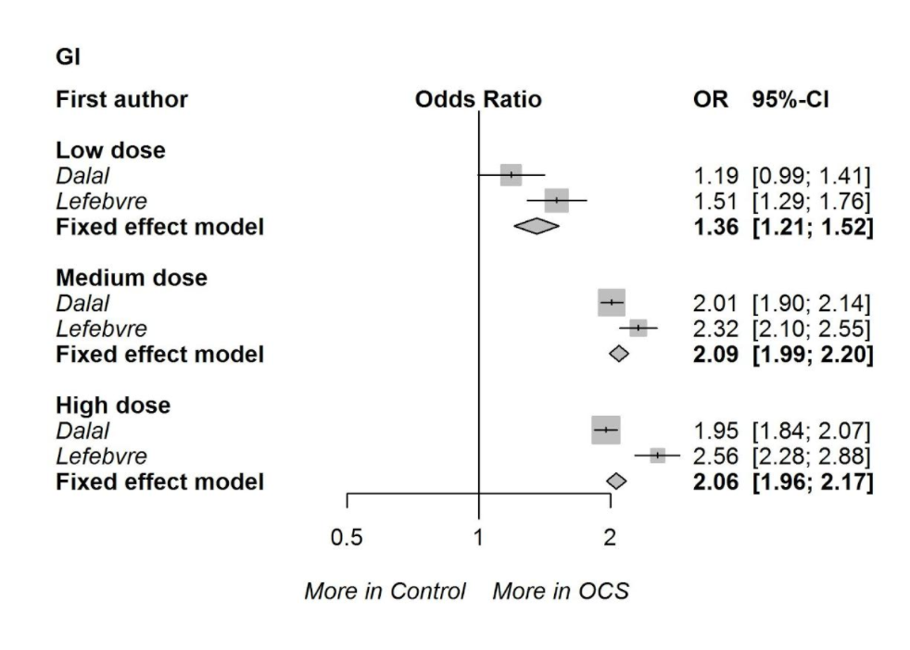
Figure S5: The risk of development of infections among different dose ranges of OCS compared with non-OCS users:
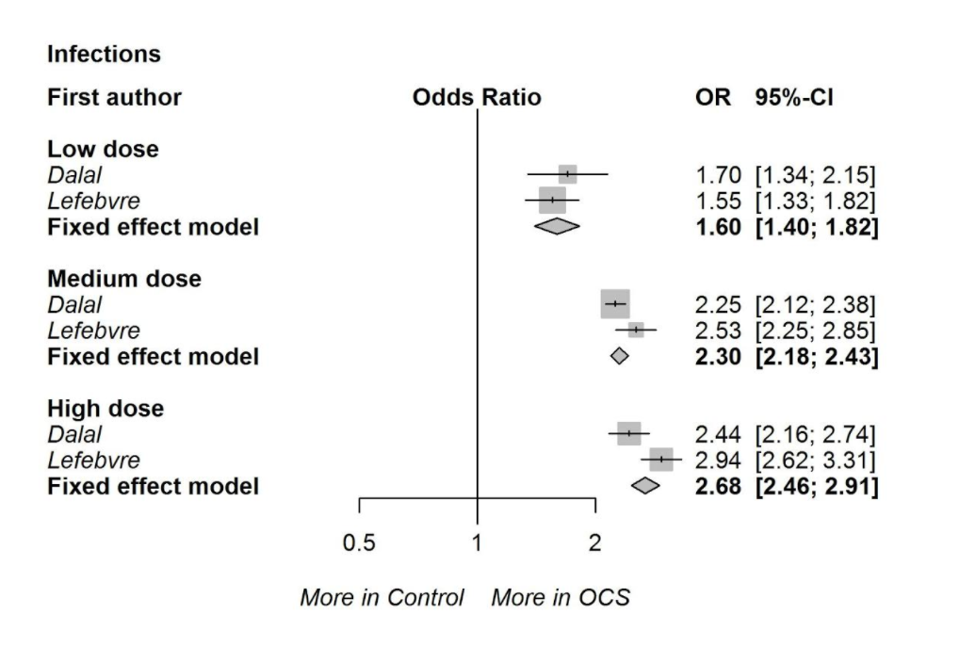

Figure S6: High dose OCS use and healthcare utilization because of OCS related complications compared with non-OCS users.
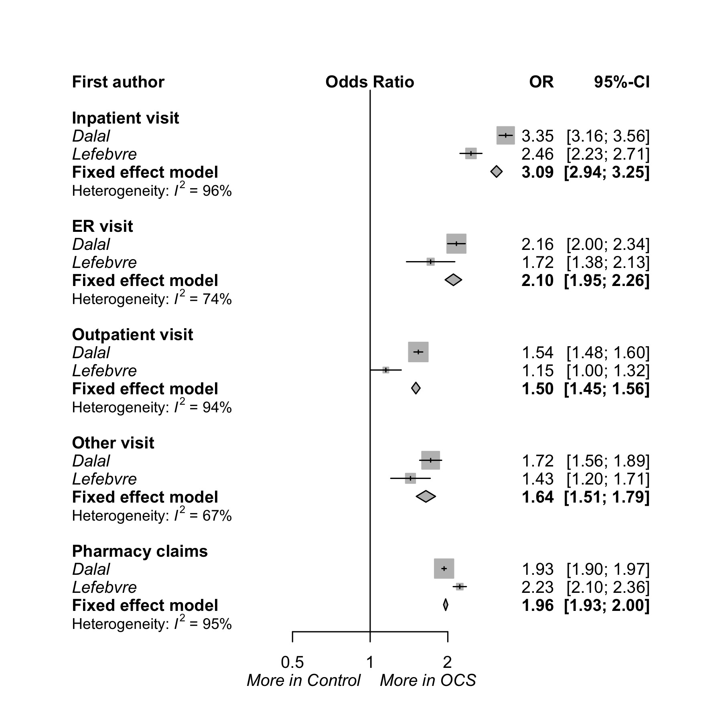
OR: Odds ratio, ER: emergency room

OCS use and healthcare utilization because of OCS related complications:
This study demonstrates higher rates of healthcare utilization as OCS dose increased. The adjusted OR of inpatients hospital admissions because of OCS related complications compared with non-OCS users, from the two studies that used regression modeling, was 1.71 (95% CI 1.59-1.83), 2.27 (95% CI 2.16-2.39), and 3.09 (95% CI 2.94-3.25) for low dose (< 6 mg), medium dose (5-12 mg) and high dose (>10 mg) respectively. As in supplementary file (table S4 and figure S5).

Healthcare cost of OCS related complications:
Six studies provided cost data. Although there are methodological limitations in terms of reporting these data we have included such data to provide a comprehensive overview. Upon individual study review, there was an increased cost difference of OCS related complications compared with non-OCS patients’ healthcare cost across the different dose ranges as demonstrated in table S5. We adjusted the cost to the same currency and year.

Discussion:

This study also showed that higher cumulative doses of OCS significantly increased all types of OCS-related healthcare resource utilization with a significant dose-response relationship with an increase in IRR for inpatient visits to 3.09 compared to non-OCS using asthmatics. This is higher than that reported by Broder et al. where the all cause hospitalization risk was 1.81 (95% CI 1.25-2.62), which included patients with 6 or more courses of OCS or intake of OCS for more than 30 days compared with 1 course or less or no OCS intake for more than 30 days (28). Zeiger et al study showed that patients with severe asthma on chronic OCS with a dose 2.5mg or more per day are more likely to have asthma exacerbations, including ED visits and hospitalizations when compared with non-OCS dependent asthma patients.⁽³³⁾

While there are methodological issues in pooling health care costs described earlier, the studies reporting cost in this review have also shown that the annual healthcare costs associated with AEs from OCS is increased with increasing doses. Three studies showed that the cost of inpatient care accounted for the greater proportion of the total cost (11, 12). On the other hand, two other studies published in the UK showed that pharmacy costs accounted for most of the total cost (27, 34). Barry et al. study also demonstrated higher costs for OCS related complications compared to matched asthmatics with an estimated annual cost for prescription drugs and healthcare activity of £1310 “US$2142” (£772 “US$ 1262” plus £538 “US$ 880”) and £224 “US$366” (£112 “US$183” plus £112 “US$183”) respectively (27).

