Supplementary Information
for
Shape-controllable synthesis of MnO₂ nanostructures from manganese-contained wastewater for phenol degradation by activating peroxymonosulfate: Performance and mechanism

Yaxiong Xiao, Yabo Wang, Yi Xie, Haixiang Ni, Xiang Li, Yongkui Zhang,
Tonghui Xie*

Department of Pharmaceutical & Biological Engineering, School of Chemical Engineering, Sichuan University, Chengdu 610065, P. R. China

Corresponding author:
Tonghui Xie
Department of Pharmaceutical & Biological Engineering, School of Chemical Engineering, Sichuan University, Chengdu 610065, P. R. China
Tel.: +86-28-85405221; Fax: +86-28-85405222
Email: xietonghui@scu.edu.cn

- Electrochemical measurement method
To prepare the working electrode, MnO₂ material, acetylene black and PVDF binder were mixed in a mass ratio of 8:1:1. The mixed sample was loaded on Ni foam and then dried at 60°C overnight under vacuum. The linear sweep voltammetry (LSV) was performed on a CHI660E electrochemical workstation with a typical three-electrode configuration, which consisted of a counter electrode (graphite electrode), a working electrode and a saturated calomel electrode. LSV curves were tested in a 0.1 mol/L K₂SO₄ and 1.5 g/L PMS solution.

Table. S1 Catalytic performance and activation energy of Mn-based catalysts with PMS for phenol removal
Catalyst | Initial phenol concentration (mg/L) | PMS dosage (g/L) | Catalyst dosage  (g/L) | Time  (min) | Degradation efficiency  (%) | Activation energy (kJ/mol) | Reference
Mn₂O₃ | 25 | 2.0 | 0.4 | 60 | 100% | 61.2 | [25]
Corolla-like MnO₂ | 20 | 2.0 | 0.2 | 30 | 100% | 25.3 | [26]
α-MnO₂ -140 | 30 | 2.0 | 0.4 | 15 | 100% | 21.9 | [35]
Mn₃O₄ | 25 | 2.0 | 0.4 | 30 | 100% | 38.5 | [36]
α-Mn₂O₃@α-MnO₂ | 25 | 2.0 | 0.4 | 20 | 100% | 32.1 | [37]
P-2 | 25 | 1.5 | 0.2 | 60 | 100% | / | This work
P-4 | 25 | 1.5 | 0.2 | 40 | 100% | / | This work
Mn-2 | 25 | 1.5 | 0.2 | 60 | 97% | / | This work
Mn-3 | 25 | 1.5 | 0.2 | 60 | 100% | / | This work
Mn-4 | 25 | 1.5 | 0.2 | 15 | 100% | 32.2 | This work

Fig. S1 XRD patterns of the MnO₂ materials prepared from manganese sulfate solution. P-2 and P-4 represent samples produced from commercial MnSO₄ solution with the hydrothermal hours of 2 h and 4 h respectively.

Fig. S2 EDS spectra of Mn-2 and Mn-4.

Fig. S3 TOC removal rate of Mn-2 and Mn-4 at 15 min and 30 min. Reaction conditions: [phenol]₀ = 25 mg/L, catalyst dosage = 0.2 g/L, PMS dosage = 1.5 g/L, initial pH = 3 and T = 25°C.

Fig. S4 Phenol removal curves versus time over Mn-3, P-2 and P-4 samples. Reaction conditions: [phenol]₀ = 25 mg/L, catalyst dosage = 0.2 g/L, PMS dosage = 1.5 g/L, initial pH = 3 and T = 25°C.

Fig. S5 Various pollutant removal curves versus time over Mn-4 samples. Reaction conditions: [phenol]₀ = 25 mg/L, catalyst dosage = 0.2 g/L, PMS dosage = 1.5 g/L, initial pH = 3 and T = 25°C.

Fig. S6 Leaching concentration of Mn²⁺ under various pH conditions.

Fig. S7 Influence of free Mn²⁺ on phenol degradation of Mn-4. Degradation reaction conditions: [phenol]₀ = 25 mg/L, catalyst dosage = 0.2 g/L, PMS dosage = 1.5 g/L, initial pH = 3 and T = 25°C.

Fig. S8 XRD patterns of Mn-4 before and after catalytic phenol degradation reaction as well as after calcination regeneration. Reaction conditions: [phenol]₀ = 25 mg/L, catalyst dosage = 0.2 g/L, PMS dosage = 1.5 g/L, initial pH = 3 and T = 25°C.

Fig. S9 SEM images of Mn-4 before and after catalytic phenol degradation reaction. Reaction conditions: [phenol]₀ = 25 mg/L, catalyst dosage = 0.2 g/L, PMS dosage = 1.5 g/L, initial pH = 3 and T = 25°C.

Fig. S10 N₂ adsorption curves of Mn-4 after catalytic phenol degradation reaction and after calcination regeneration.

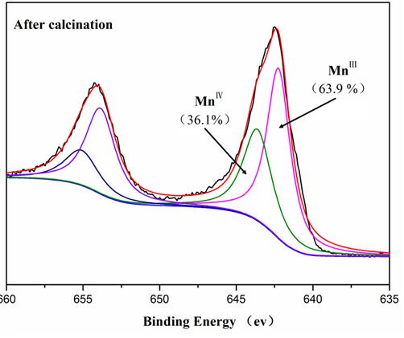
Fig. S11 XPS spectra of Mn 2p for Mn-4 after calcination regeneration.

