Effects of Different Oxygen-containing Anions on the Structure of Water Clusters
Fang Fang Jian, *E Liu, Junying Ma
School of Chemical Engineering and Pharmaceutics,
Henan University of Science and Technology, Luoyang, Henan, P. R. China.
E-mail: ffj2013@163.com

Supporting information

Table of contents Page

1. Crystallographic data for [Ni(Im)₆][SO₄(H₂O)₁₁] S-1 ~ S-4
2. Crystallographic data for [Ni(Im)₆][(NO₃)(Cl)(H₂O)₄] S-5 ~ S-7
3. Crystallographic data for [Ni(Im)₆][CO₃(H₂O)₅] S-8 ~ S-10
4. The distances of the adjacent 2D [Ni(Im)₆]²⁺ layers S-10 ~ S-11
5. The thickness of the sandwich construction for (1), (2) and (3) S-11-S-13
6. Other S-13

- Crystallographic data for [Cd(Im)₆][F·H₂O]₂

Table 1-1. Crystal data and structure refinement for [Ni(Im)₆][SO₄(H₂O)₁₁].
Empirical formula C18 H46 N12 Ni O15 S
Formula weight 761.34
Temperature 293(2) K
Wavelength 0.71073 A
Crystal system, space group Hexagonal, P-31c
Unit cell dimensions a = 8.9700(13) A alpha = 90 deg.
b = 8.9700(13) A beta = 90 deg.
c = 23.140(5) A gamma = 120 deg.
Volume 1612.4(5) A^3
Z, Calculated density 2, 1.729 Mg/m^3
Absorption coefficient 0.769 mm^-1
F(000) 896
Crystal size 0.1 x 0.1 x 0.2 mm
Theta range for data collection 1.76 to 28.25 deg.
Limiting indices -11<=h<=11, -11<=k<=11, -30<=l<=29
Reflections collected / unique 20666 / 1335 [R(int) = 0.0249]
Completeness to theta = 28.25 99.9 %
Refinement method Full-matrix least-squares on F^2
Data / restraints / parameters 1335 / 0 / 80
Goodness-of-fit on F^2 1.175
Final R indices [I>2sigma(I)] R1 = 0.0852, wR2 = 0.2550
R indices (all data) R1 = 0.0941, wR2 = 0.2743
Extinction coefficient 0.025(9)
Largest diff. peak and hole 1.634 and -0.596 e.A^-3

S-1
Table 1-2. Bond lengths [A] and angles [deg]for [Ni(Im)₆][SO₄(H₂O)₁₁].
_____________________________________________________________
Ni(1)-N(1)#1 2.126(3)
Ni(1)-N(1)#2 2.126(3)
Ni(1)-N(1)#3 2.126(3)
Ni(1)-N(1) 2.126(3)
Ni(1)-N(1)#4 2.126(3)
Ni(1)-N(1)#5 2.126(3)
N(1)-C(1) 1.308(4)
N(1)-C(3) 1.380(5)
N(2)-C(1) 1.338(5)
N(2)-C(2) 1.343(8)
C(3)-C(2) 1.342(6)
S(1)-O(1)#6 1.317(11)
S(1)-O(1) 1.317(11)
S(1)-O(2)#7 1.444(12)
S(1)-O(2)#8 1.444(12)
S(1)-O(2) 1.444(12)
S(1)-O(2)#6 1.444(12)
S(1)-O(2)#9 1.444(12)
S(1)-O(2)#10 1.444(12)
O(2)-O(2)#7 1.39(3)
O(2)-O(1)#6 1.501(14)
O(1)-O(2)#7 1.501(14)
O(1)-O(2)#6 1.501(14)
O(1)-O(2)#10 1.501(14)

N(1)#1-Ni(1)-N(1)#2 180.0(2)
N(1)#1-Ni(1)-N(1)#3 90.35(13)
N(1)#2-Ni(1)-N(1)#3 89.65(13)
N(1)#1-Ni(1)-N(1) 89.65(13)
N(1)#2-Ni(1)-N(1) 90.35(13)
N(1)#3-Ni(1)-N(1) 90.35(13)
N(1)#1-Ni(1)-N(1)#4 90.35(13)
N(1)#2-Ni(1)-N(1)#4 89.65(13)
N(1)#3-Ni(1)-N(1)#4 89.65(13)
N(1)-Ni(1)-N(1)#4 180.00(19)
N(1)#1-Ni(1)-N(1)#5 89.65(13)
N(1)#2-Ni(1)-N(1)#5 90.35(13)
N(1)#3-Ni(1)-N(1)#5 180.00(17)
N(1)-Ni(1)-N(1)#5 89.65(13)
N(1)#4-Ni(1)-N(1)#5 90.35(13)
C(1)-N(1)-C(3) 105.3(3)
C(1)-N(1)-Ni(1) 127.1(3)
C(3)-N(1)-Ni(1) 127.6(3)
C(1)-N(2)-C(2) 108.2(3)
N(1)-C(1)-N(2) 110.8(4)
C(2)-C(3)-N(1) 109.4(4)
C(3)-C(2)-N(2) 106.3(4)
O(1)#6-S(1)-O(1) 180.000(3)
O(1)#6-S(1)-O(2)#7 114.3(5)
O(1)-S(1)-O(2)#7 65.7(5)
O(1)#6-S(1)-O(2)#8 65.7(5)
O(1)-S(1)-O(2)#8 114.3(5)
O(2)#7-S(1)-O(2)#8 98.3(16)
O(1)#6-S(1)-O(2) 65.7(5)
O(1)-S(1)-O(2) 114.3(5)
O(2)#7-S(1)-O(2) 57.5(15)
O(2)#8-S(1)-O(2) 104.2(6)
O(1)#6-S(1)-O(2)#6 114.3(5)
O(1)-S(1)-O(2)#6 65.7(5)
O(2)#7-S(1)-O(2)#6 104.2(6)
O(2)#8-S(1)-O(2)#6 57.5(15)
O(2)-S(1)-O(2)#6 154.2(18)
O(1)#6-S(1)-O(2)#9 65.7(5)
O(1)-S(1)-O(2)#9 114.3(5)
O(2)#7-S(1)-O(2)#9 154.2(18)
O(2)#8-S(1)-O(2)#9 104.2(6)
O(2)-S(1)-O(2)#9 104.2(6)
O(2)#6-S(1)-O(2)#9 98.3(16)
O(1)#6-S(1)-O(2)#10 114.3(5)
O(1)-S(1)-O(2)#10 65.7(5)
O(2)#7-S(1)-O(2)#10 104.2(6)
O(2)#8-S(1)-O(2)#10 154.2(18)
O(2)-S(1)-O(2)#10 98.3(16)
O(2)#6-S(1)-O(2)#10 104.2(6)
O(2)#9-S(1)-O(2)#10 57.5(15)
O(2)#7-O(2)-S(1) 61.2(7)
O(2)#7-O(2)-O(1)#6 106.7(12)
S(1)-O(2)-O(1)#6 53.1(6)
S(1)-O(1)-O(2)#7 61.2(6)
S(1)-O(1)-O(2)#6 61.2(6)
O(2)#7-O(1)-O(2)#6 98.8(7)
S(1)-O(1)-O(2)#10 61.2(6)
O(2)#7-O(1)-O(2)#10 98.8(7)
O(2)#6-O(1)-O(2)#10 98.8(7)
_____________________________________________________________

Symmetry transformations used to generate equivalent atoms:
#1 -y,x-y,z #2 y,-x+y,-z #3 x-y,x,-z
#4 -x,-y,-z #5 -x+y,-x,z #6 -y+1,-x+1,-z+1/2
#7 -x+y+1,y,-z+1/2 #8 -y+1,x-y,z #9 -x+y+1,-x+1,z #10 x,x-y,-z+1/2

Table 1-3. Hydrogen bonds for [Ni(Im)₆][SO₄(H₂O)₁₁] [Å].
____________________________________________________________________________
D...A d(D...A) D...A d(D...A)
____________________________________________________________________________
O1w...O2w 2.829 O2w...O1w 2.880
O2w...O2w 2.486 O2w...O3(1)w 2.803
O2w...O3(2)w 2.048 O2w...O2 2.422
O3w...O2(1)w 2.803 O3w...O2(2)w 2.042
O3w...O2(3)w 2.049 O3w...O2(4)w 2.812
O1w...O2(1) 2.693 O1w...O2(2) 2.694
N-H...O2 3.019
____________________________________________________________________________
S-4

- Crystallographic data for the [Ni(Im)₆][(NO₃)(Cl)(H₂O)₄].
Table 2-1. Crystal data and structure refinement for [Ni(Im)₆][(NO₃)(Cl)(H₂O)₄].
Empirical formula C18 H32 Cl N13 Ni O7
Formula weight 636.71
Temperature 296.15 K
Wavelength 0.71073 Å
Crystal system Hexagonal
Space group P63/m
Unit cell dimensions a = 9.0035(13) Å α= 90°.
b = 9.0035(13) Å β= 90°.
c = 21.034(4) Å γ = 120°.
Volume 1476.6(5) Å3
Z 2.00004
Density (calculated) 1.432 Mg/m3
Absorption coefficient 0.807 mm-1
F(000) 664
Crystal size 0.35 x 0.28 x 0.21 mm³
Theta range for data collection 1.936 to 27.571°.
Index ranges -11<=h<=0, 0<=k<=11, -27<=l<=27
Reflections collected 1165
Independent reflections 1165 [R(int) = ?]
Completeness to theta = 25.242° 99.7 %
Absorption correction None
Refinement method Full-matrix least-squares on F2
Data / restraints / parameters 1165 / 0 / 67
Goodness-of-fit on F2 1.193
Final R indices [I>2sigma(I)] R1 = 0.0708, wR2 = 0.1703
R indices (all data) R1 = 0.1001, wR2 = 0.1833
Extinction coefficient n/a
Largest diff. peak and hole 0.443 and -1.106 e.Å-3

S-5
Table 2-2. Bond lengths [A] and angles [deg] for [Ni(Im)₆][(NO₃)(Cl)(H₂O)₄].
____________________________________________________________________________
Ni1-N1#1 2.125(3)
Ni1-N1#2 2.125(3)
Ni1-N1#3 2.125(3)
Ni1-N1#4 2.125(3)
Ni1-N1 2.125(3)
Ni1-N1#5 2.125(3)
N1-C0AA 1.388(7)
N1-C3 1.327(5)
N2-H2 0.8600
N2-C1AA 1.357(7)
N2-C3 1.333(6)
C0AA-C1AA 1.362(7)
C1AA-H1AA 0.9300
C3-H3 0.9300
O1-N3 1.290(5)
N1#1-Ni1-N1#4 89.81(12)
N1#5-Ni1-N1#2 90.19(12)
N1#3-Ni1-N1 89.81(12)
N1#1-Ni1-N1#5 90.19(12)
N1#1-Ni1-N1 180.0
N1#4-Ni1-N1#5 180.0
N1#4-Ni1-N1#2 89.81(12)
N1#1-Ni1-N1#3 90.19(12)
N1#3-Ni1-N1#2 180.00(14)
N1#4-Ni1-N1#3 90.19(12)
N1#5-Ni1-N1 89.81(12)
N1#5-Ni1-N1#3 89.81(12)
N1#2-Ni1-N1 90.19(12)
N1#1-Ni1-N1#2 89.81(12)
N1#4-Ni1-N1 90.19(12)
C0AA-N1-Ni1 127.9(3)
C3-N1-Ni1 127.6(3)
C3-N1-C0AA 104.5(4)
C1AA-N2-H2 125.7
C3-N2-H2 125.7
C3-N2-C1AA 108.6(4)
N1-C0AA-H0AA 125.0
C1AA-C0AA-N1 110.0(5)
C1AA-C0AA-H0AA 125.0
N2-C1AA-C0AA 105.5(5)
N2-C1AA-H1AA 127.3
C0AA-C1AA-H1AA 127.3
_____________________________________________________________
Symmetry transformations used to generate equivalent atoms:
#1 -x,-y,-z+1 #2 y,-x+y,-z+1 #3 -y,x-y,z
#4 x-y,x,-z+1 #5 -x+y,-x,z #6 x,y,-z+3/2
#7 -y+1,x-y+1,-z+3/2 #8 -x+y,-x+1,z #9 -y+1,x-y+1,z
#10 -x+y,-x+1,-z+3/2 #11 -y+1,x-y,z #12 -x+y+1,-x+1,z

Table 2-3. Hydrogen bonds for [Ni(Im)₆][(NO₃)(Cl)(H₂O)₄] [Å].
____________________________________________________________________________
D-H...A d(D-H) d(H...A) d(D...A) <(DHA)
____________________________________________________________________________
N2-H2...O1 0.86 1.93 2.780(5) 172.3
N2-H2...N3 0.86 2.68 3.488(4) 156.8
O2-H2A...Cl1#13 0.85 1.93 2.774(7) 179.8
O2-H2B...O1 0.85 2.01 2.682(8) 135.1
O3-H3A...O2 0.85 2.20 2.771(7) 124.5
____________________________________________________________________________
Symmetry transformations used to generate equivalent atoms:
#1 -x,-y,-z+1 #2 y,-x+y,-z+1 #3 -y,x-y,z
#4 x-y,x,-z+1 #5 -x+y,-x,z #6 x,y,-z+3/2
#7 -y+1,x-y+1,-z+3/2 #8 -x+y,-x+1,z #9 -y+1,x-y+1,z
#10 -x+y,-x+1,-z+3/2 #11 -y+1,x-y,z #12 -x+y+1,-x+1,z
#13 x+1,y+1,z

S-7

- Crystallographic data for the [Ni(Im)₆][CO₃(H₂O)₅]
Table 3-1. Crystal data and structure refinement for [Ni(Im)₆][CO₃(H₂O)₅].

Empirical formula C38 H68 N24 Ni2 O16
Formula weight 1116.92
Temperature 293(2) K
Wavelength 0.71073 A
Crystal system, space group Hexagonal, P63/m
Unit cell dimensions a = 8.977(6) A alpha = 90.000(11) deg.
b = 8.977(6) A beta = 90.000(10) deg.
c = 20.959(15) A gamma = 120.000(10) deg.
Volume 1462.7(18) A^3
Z, Calculated density 1, 1.418 Mg/m^3
Absorption coefficient 0.726 mm^-1
F(000) 662
Crystal size ? x ? x ? mm
Theta range for data collection 4.54 to 23.99 deg.
Limiting indices -8<=h<=10, -10<=k<=7, -23<=l<=23
Reflections collected / unique 4743 / 694 [R(int) = 0.0834]
Completeness to theta = 23.99 87.3 %
Refinement method Full-matrix least-squares on F^2
Data / restraints / parameters 694 / 5 / 82
Goodness-of-fit on F^2 1.085
Final R indices [I>2sigma(I)] R1 = 0.0566, wR2 = 0.1071
R indices (all data) R1 = 0.0791, wR2 = 0.1188
Largest diff. peak and hole 0.223 and -0.437 e.A^-3

S-8
Table 3-2. Bond lengths [A] and angles [deg] for [Ni(Im)₆][CO₃(H₂O)₅].
____________________________________________________________________________
Ni(1)-N(2) 2.126(4)
Ni(1)-N(2)#1 2.126(4)
Ni(1)-N(2)#2 2.126(4)
Ni(1)-N(2)#3 2.126(4)
Ni(1)-N(2)#4 2.126(4)
Ni(1)-N(2)#5 2.126(4)
N(1)-C(2) 1.332(5)
N(1)-C(1) 1.336(6)
N(2)-C(2) 1.313(5)
N(2)-C(3) 1.356(6)
C(1)-C(3) 1.359(7)
O(1)-C(4) 1.279(4)
C(4)-O(1)#6 1.279(4)
C(4)-O(1)#7 1.279(4)
O(1W)-O(1W)#8 0.93(2)

N(2)-Ni(1)-N(2)#1 180.0
N(2)-Ni(1)-N(2)#2 90.38(14)
N(2)#1-Ni(1)-N(2)#2 89.62(14)
N(2)-Ni(1)-N(2)#3 89.62(14)
N(2)#1-Ni(1)-N(2)#3 90.38(14)
N(2)#2-Ni(1)-N(2)#3 89.62(14)
N(2)-Ni(1)-N(2)#4 89.62(14)
N(2)#1-Ni(1)-N(2)#4 90.38(14)
N(2)#2-Ni(1)-N(2)#4 180.00(16)
N(2)#3-Ni(1)-N(2)#4 90.38(14)
N(2)-Ni(1)-N(2)#5 90.38(14)
N(2)#1-Ni(1)-N(2)#5 89.62(14)
N(2)#2-Ni(1)-N(2)#5 90.38(14)
N(2)#3-Ni(1)-N(2)#5 180.000(1)
N(2)#4-Ni(1)-N(2)#5 89.62(14)
C(2)-N(1)-C(1) 106.9(4)
C(2)-N(2)-C(3) 104.7(4)
C(2)-N(2)-Ni(1) 127.1(3)
C(3)-N(2)-Ni(1) 128.2(3)
N(1)-C(1)-C(3) 106.6(4)
N(2)-C(2)-N(1) 112.2(4)
N(2)-C(3)-C(1) 109.6(4)
O(1)#6-C(4)-O(1)#7 120.000(2)
O(1)#6-C(4)-O(1) 120.000(7)
O(1)#7-C(4)-O(1) 120.000(6)
_____________________________________________________________

Symmetry transformations used to generate equivalent atoms:
#1 -x+2,-y,-z+1 #2 -x+y+2,-x+1,z
#3 y+1,-x+y+1,-z+1 #4 x-y,x-1,-z+1
#5 -y+1,x-y-1,z #6 -y+2,x-y-1,z #7 -x+y+3,-x+2,z
#8 x,y,-z+3/2

Table 3-3. Hydrogen bonds for [Ni(Im)₆][CO₃(H₂O)₅] [Å].
____________________________________________________________________________
D...A d(D...A) D...A d(D...A)
____________________________________________________________________________
O1w...O2w 2.839 O2w...O3w 2.722
O2w...O1 2.704 N-H...O1 2.763
____________________________________________________________________________

- The distances of the adjacent 2D [Ni(Im)₆]²⁺ layers

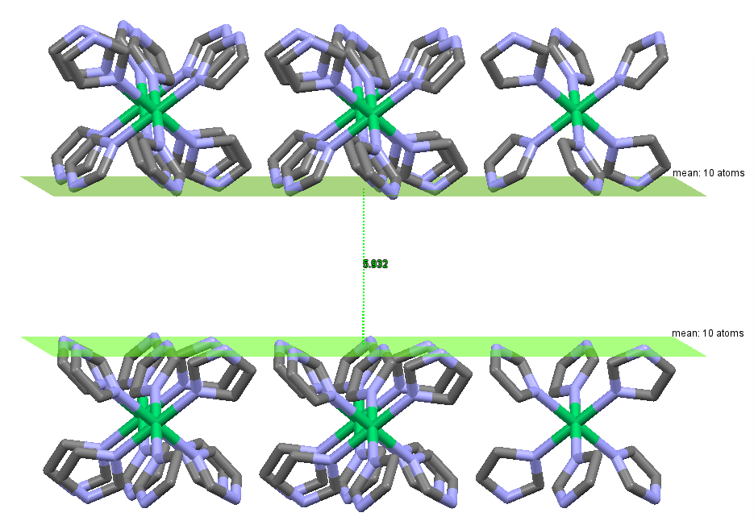

Fig. S4-1 Compound [Ni(Im)₆][SO₄(H₂O)₁₁] (1)

S-10

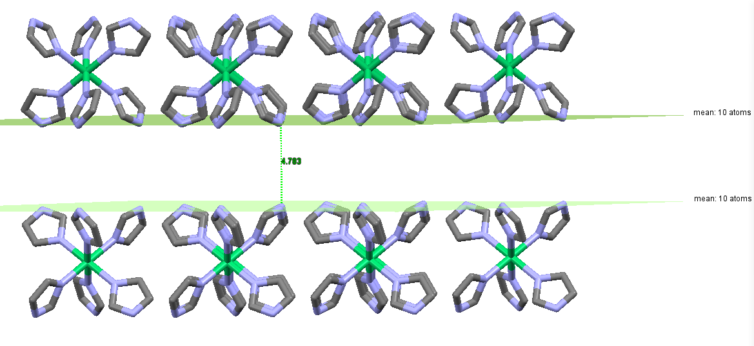
Fig. S4-2 Compound [Ni(Im)₆][(NO₃)(Cl)(H₂O)₄] (2)

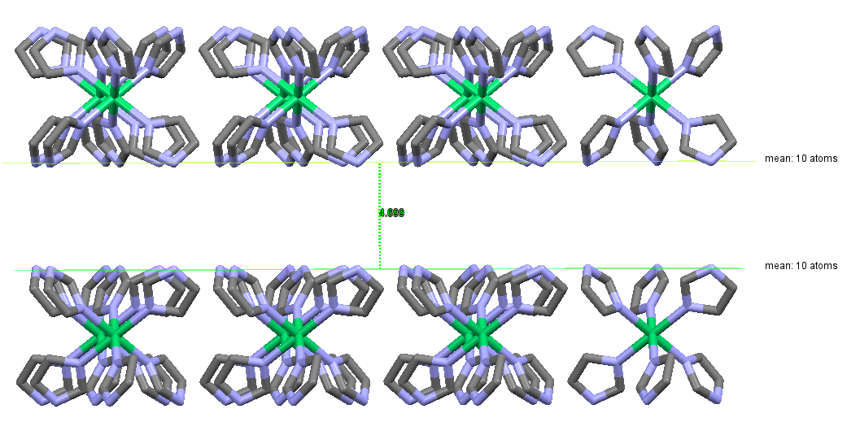

Fig. S4-3 Compound [Ni(Im)₆][CO₃(H₂O)₅] (3)

S-11

- The thickness of the sandwich construction for (1), (2) and (3)
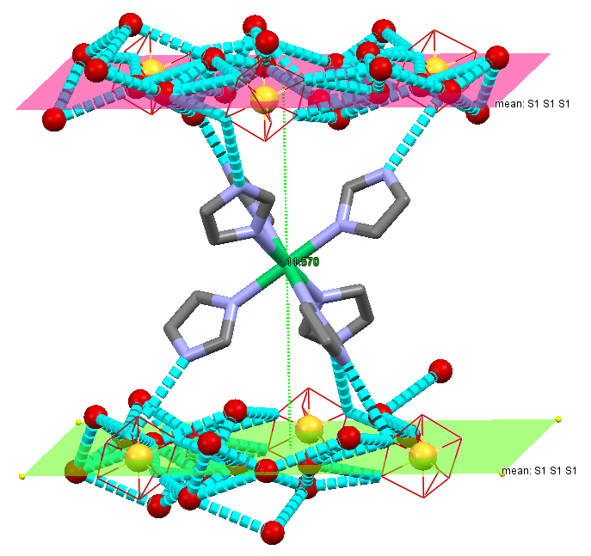
Fig. S5-1 Compound [Ni(Im)₆][SO₄(H₂O)₁₁] (1) d = 11.570Å.

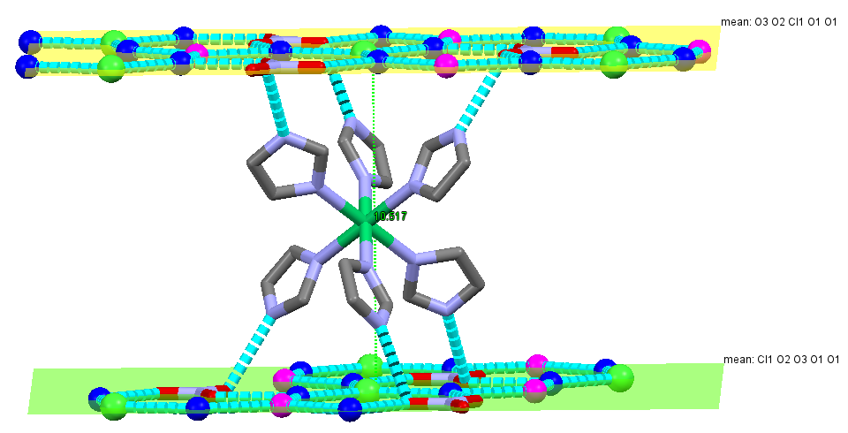
Fig. S5-2 Compound [Ni(Im)₆][(NO₃)(Cl)(H₂O)₄] (2) d = 10.517Å.

S-12
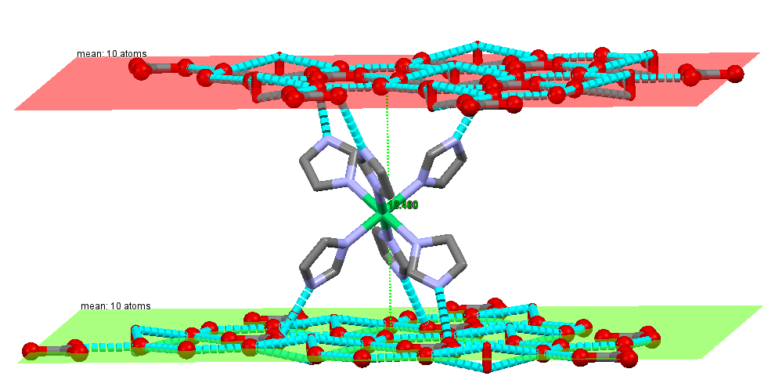

Fig. S5-3 Compound [Ni(Im)₆][CO₃(H₂O)₅] (3) d = 10.480 Å.
- Others

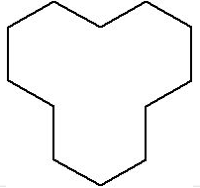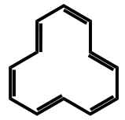
a b
Fig. S6-1. (a) Structure of cyclododecane; (b) Structure of [12]annulene.

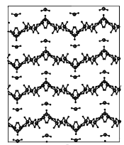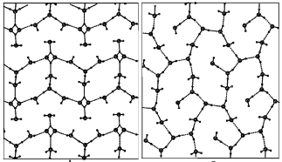

a b c
Fig. S6-2. Two-dimensional infinite water/ice layers of 6D₂O from a neutron diffraction study at (a) 278 K, (b) 263 K, and (c) 20 K.

S-13

