Circuit Training Protocol – Selected exercises descriptions
Mild Exercises -From 2nd to a 5th week

Upper body exercises
1.Supine position - Shoulder abduction with elbow flexion holding dumbbells | 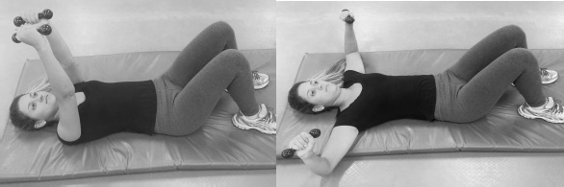
2. Standing position- Alternating punches without weight | 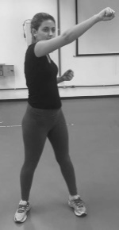  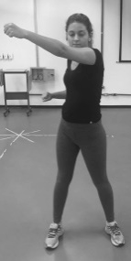
3. Standing position- Elbow flexion with 0.5 kg dumbbell | 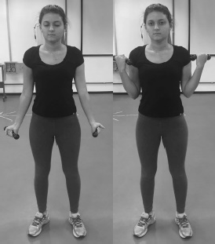
Lower body exercises
4. Sitting position – knee flexion light elastic band | 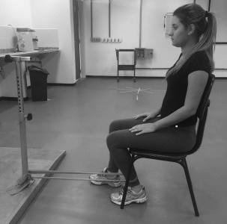  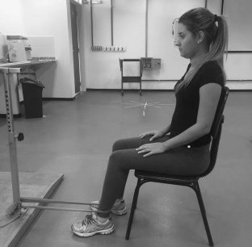
5. Standing position- Step-up and down | 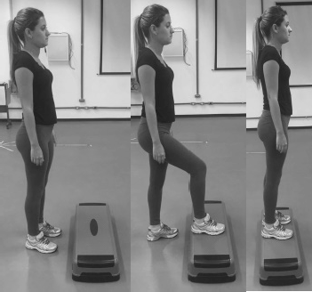
6. Standing position- Hip Abduction with 0.5kg ankle weight | 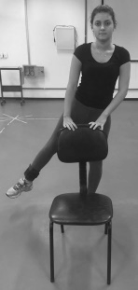
7. Standing position – Calf strengthening without extra weight | 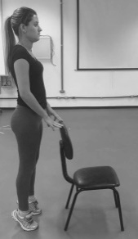
8. Supine position – Single leg raises with 0.5kg ankle weight | 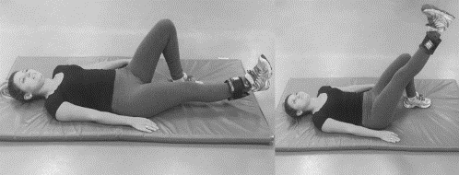
9. Supine position- Traditional Bridge | 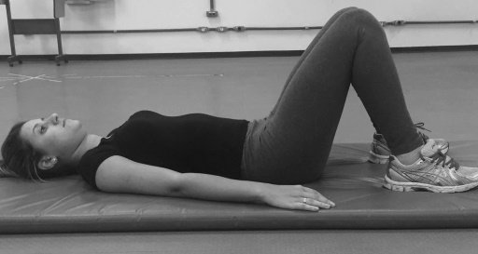
Trunk exercises
10. Ventral position – Knee Plank (isometric)
11. Knee Side Plank (isometric) | 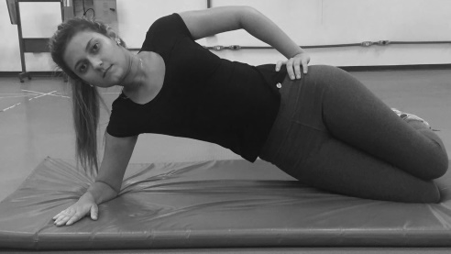
12. Supine position - Abdominal curl with legs leaning on the ball | 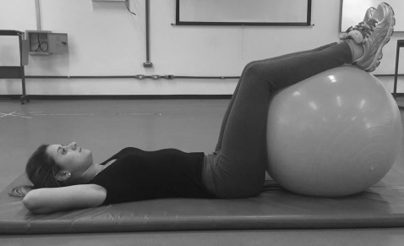
Global exercise
13. Standing position - Elbow flexion with 0.5kg dumbbell associated with hip and knee flexion contraleteral | 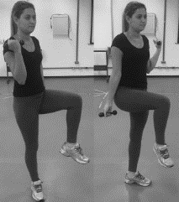
14. Standing position – Shoulders abduction with 0.5kg dumbbell associated with hip flexion | 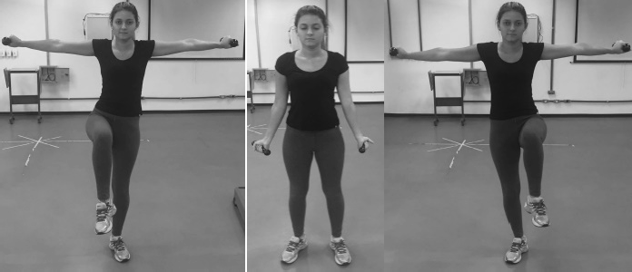
15. Standing position -Jumping Jack adapted (no jumping): starting with arms extended over the head and legs adducted. Progress the exercise to shoulders 90º abduction and legs abduction. | 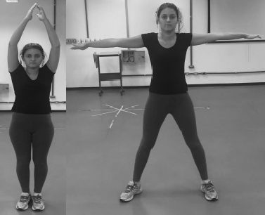

Moderate Exercises- From 6th to 10th week

Upper body exercises
- Standing position- Alternating punches | With 0.5kg dumbbell
- Standing position – Elbow flexion | With 0.5kg dumbbell
- Standing position – Shoulder flexion with light elastic band | 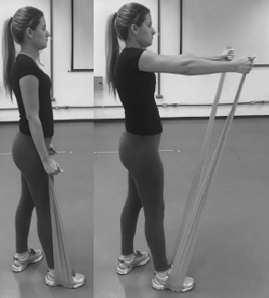
- Standing position – Elbow flexion with light elastic band
Lower body exercises
- Standing position- Hip Abduction with light elastic band | 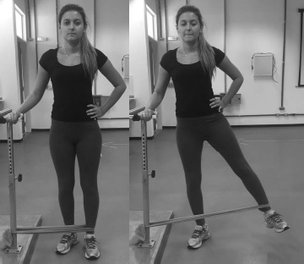
- Stand up position – Hip adduction with light elastic band | 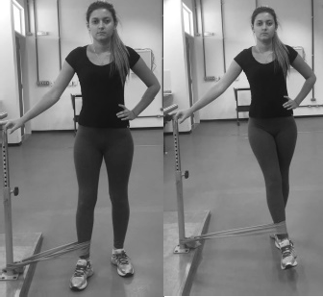
- Sit-to-stand | 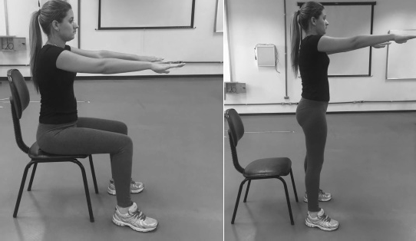
- Siting position – Knee extension with 0.5kg ankle weight | 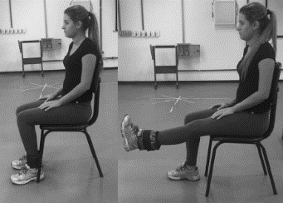
- Standing position – Knee flexion with 0.5kg ankle weight | 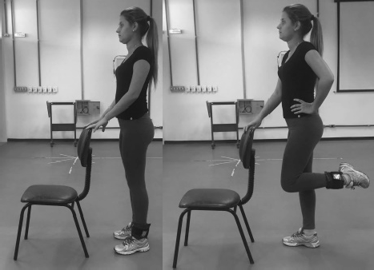
Trunk exercises
- Supine position – Abdominal curl up holding a small ball | 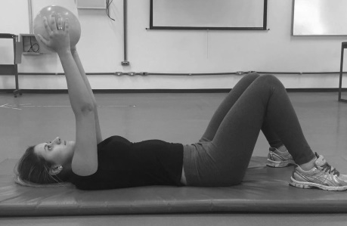  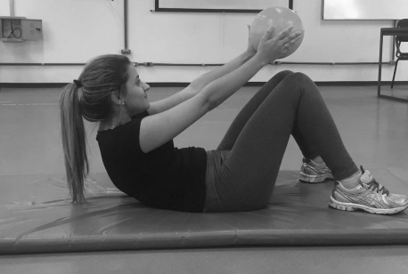
- Supine position – bridge exercise with hip adduction holding a small ball between the knees | 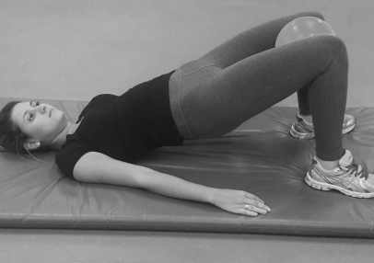
- Plank (isometric)
- Side Plank (isometric) | 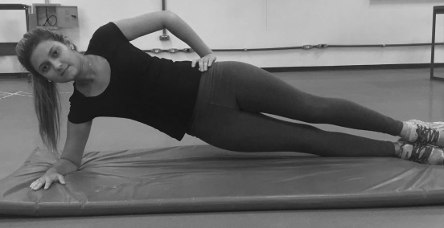
Global Exercises
- Standing position - Elbow flexion with 1.0kg dumbbell associated with hip and knee flexion contralateral
- Standing position – Shoulders abduction with 1.0kg dumbbell associated with hip and knee flexion | 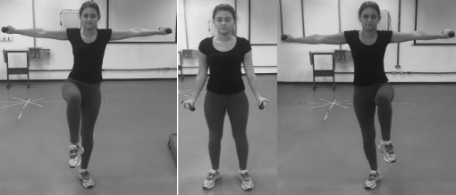
- Standing position -Jumping Jack adapted (no jumping) with 0.5kg dumbbell | 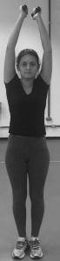  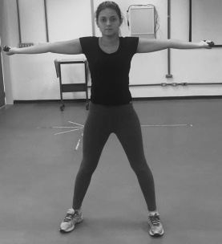
- Squat holding a small ball | 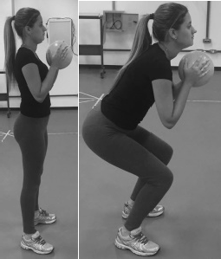

Intense Exercises - From 11th to 14th week
Upper body exercises
- Standing position- Alternating punches with 1.0kg dumbbell | With 1.0kg dumbbell
- Standing position – Shoulder flexion | With hard elastic band
- Standing position – Elbow flexion | With hard elastic band
Lower body exercises
- Standing position- Hip Abduction | With hard elastic band
- Stand up position – Hip adduction | With hard elastic band
- Standing position – Knee flexion | With 1.0 kg ankle weight
- Forward Lunge with elastic band medially traction. | 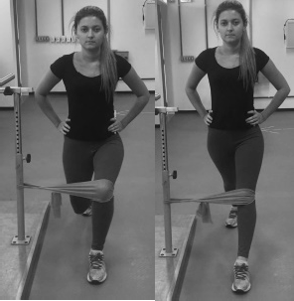
Trunk exercises
- Supine position – bridge with single leg static hold - one foot on the floor and contralateral limb with knee extension | 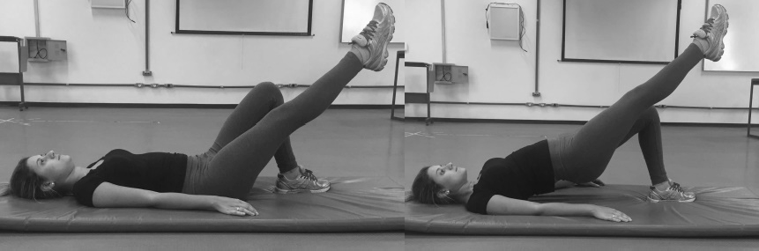
- Supine position – Oblique abdominal strengthening holding a small ball | 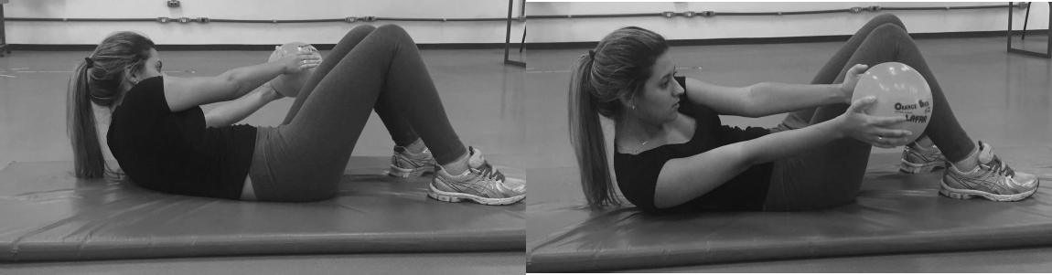
- Supine position – Bridge on bosu | 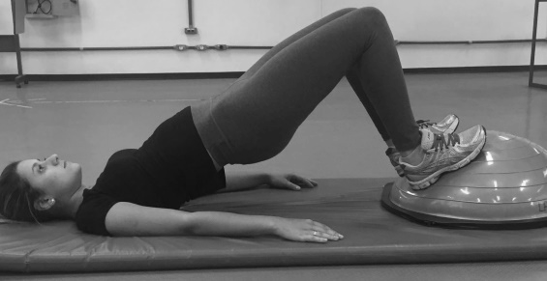
- Supine position – Abdominal curl with hip flexion and knee extension holding a small ball | 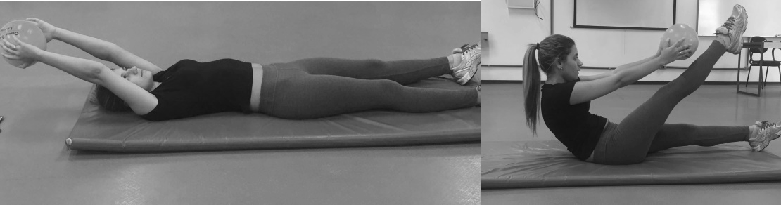
Global exercises
- Standing position – jumping Jack adapted (no jump) | With 1.0 kg dumbbell
- Standing position – Trunk flexion with hands touching the contralateral ankle (knee bended) | 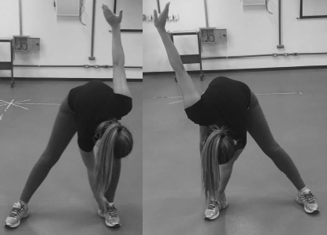
- Standing position – Criss cross with 1.0kg dumbbell | 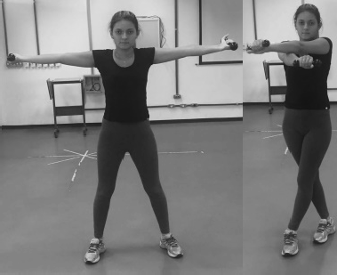
- Standing position – squat to overhead press with 0.5kg dumbbell | 