Supporting Information for
Organocatalyzed ring-opening copolymerization of α-bromo-γ-
butyrolactone with ε-caprolactone for the synthesis of functional aliphatic polyesters – pre-polymers for graft copolymerization

Chen Gao^{a,b}, Chi-Hui Tsou^{a,b}, Chun-Yan Zeng^{a,b}, Li Yuan^{a,b}, Rui Pengª, Xue-Mei Zhang^{a,b,}*

ªCollege of Materials Science and Engineering, Sichuan University of Science and Engineering, Zigong, Sichuan Province, China
^{b}Material Corrosion and Protection Key Laboratory of Sichuan Province, Zigong, Sichuan Province, China
* Corresponding author
E-mail address: 798538268@zju.edu.cn (Xue-Mei Zhang)

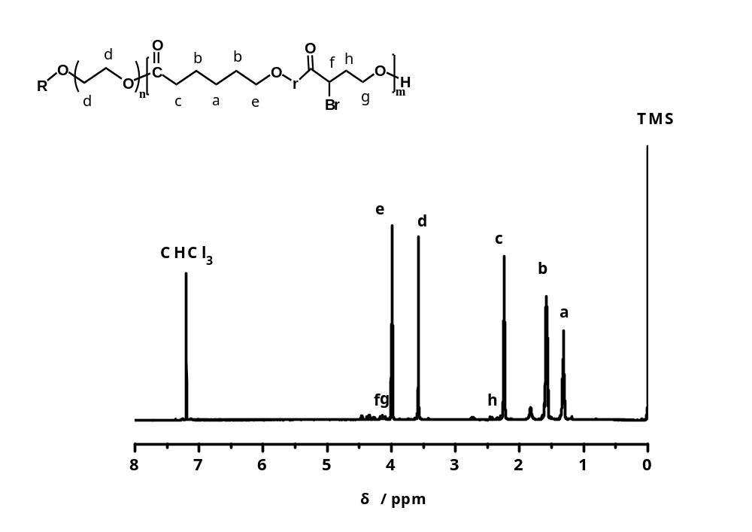
Fig. S1 ¹H NMR spectrum of PEGCB1.
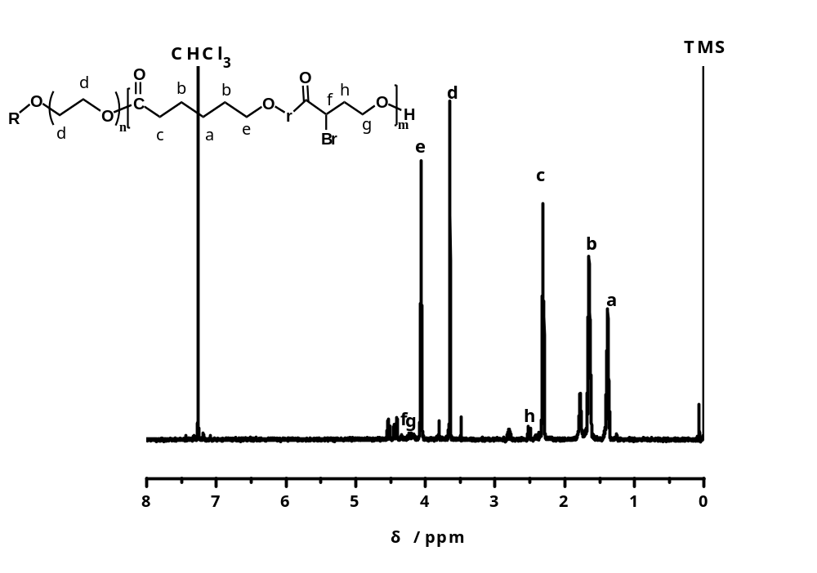
Fig. S2 ¹H NMR spectrum of PEGCB2.
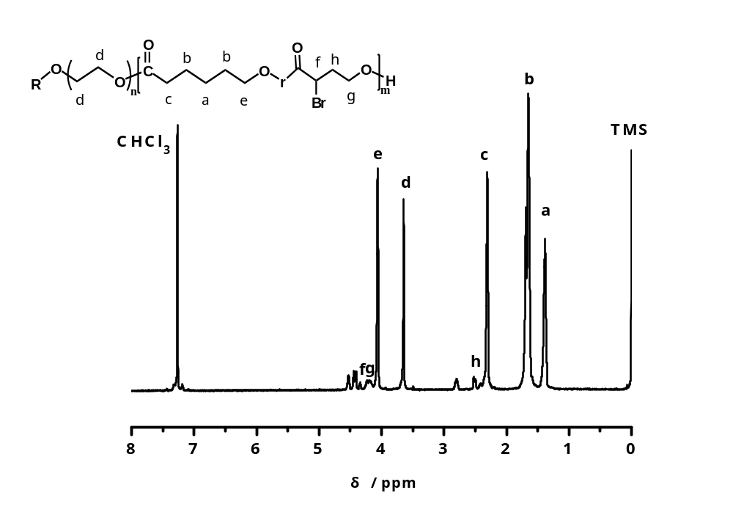
Fig. S3 ¹H NMR spectrum of PEGCB4.
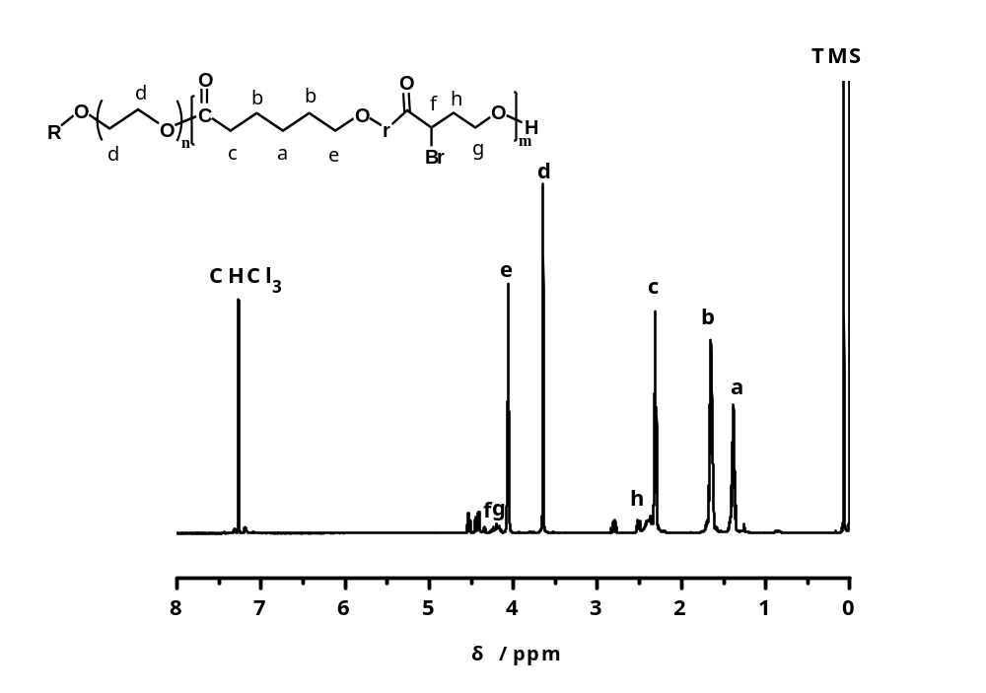
Fig. S4 ¹H NMR spectrum of PEGCB5.

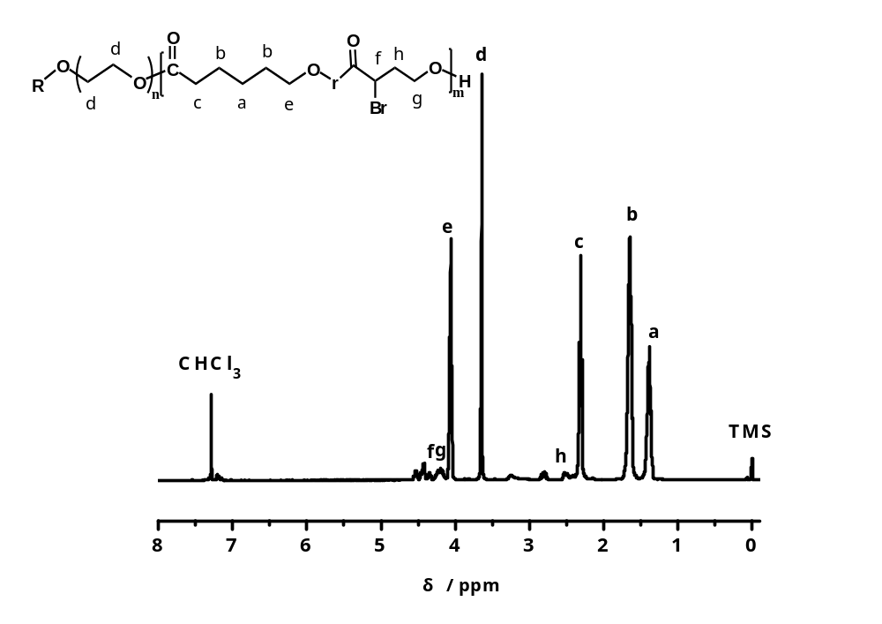
Fig. S5 ¹H NMR spectrum of PEGCB6.
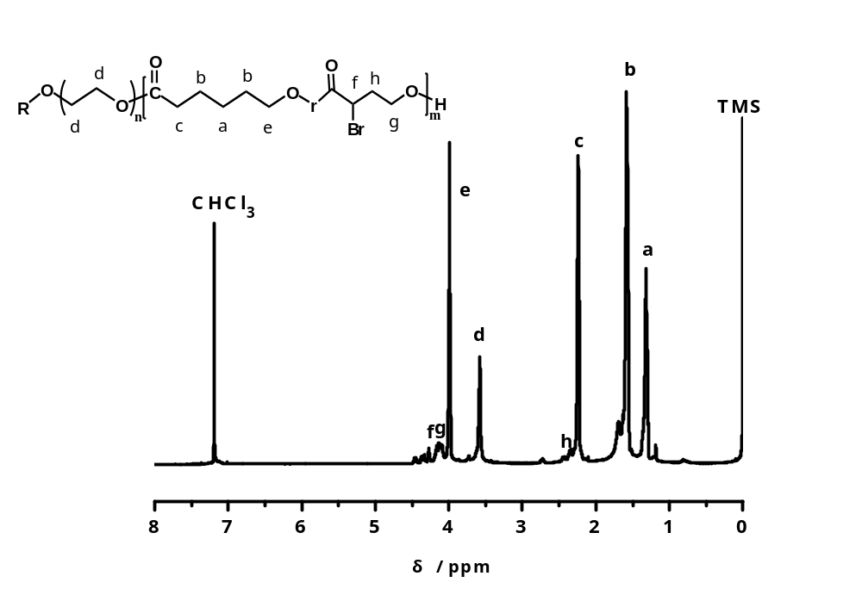
Fig. S6 ¹H NMR spectrum of PEGCB7.
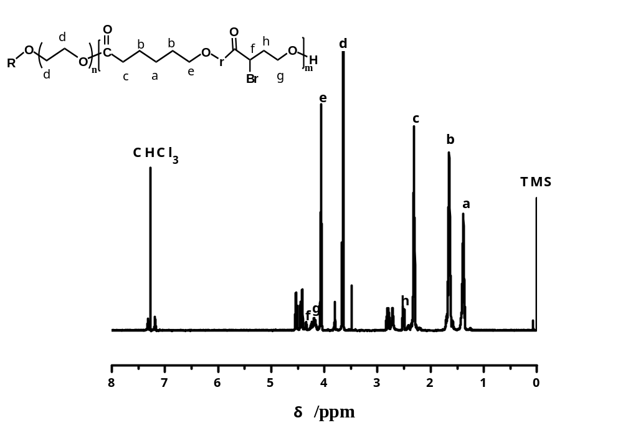
Fig. S7 ¹H NMR spectrum of PEGCB8.

