Supplemental material

Micellization Behavior of Anionic Gemini Surfactants--Templated Manufacture of Cerium Oxide Nanoparticles

***Xueming Liao,*** *†‡* ***Zhinong Gao,\**** *†‡* ***Yan Xia,*** *†‡* ***Wenzhong Zhai,*** *†‡* ***Xuesong Feng,Chenchen Pan,*** *†‡**†‡****Yingfang Zhang,*** *†‡* ***Saisai Yan,*** *†‡* ***Jia Han****†‡*

*†*College of Chemistry and Molecular Sciences, Wuhan University, Wuhan 430072, Hubei, P. R. China

*‡*Key Laboratory of Biomedical Polymers, Ministry of Education, Wuhan 430072, Hubei, P. R. China

1. **FTIR**

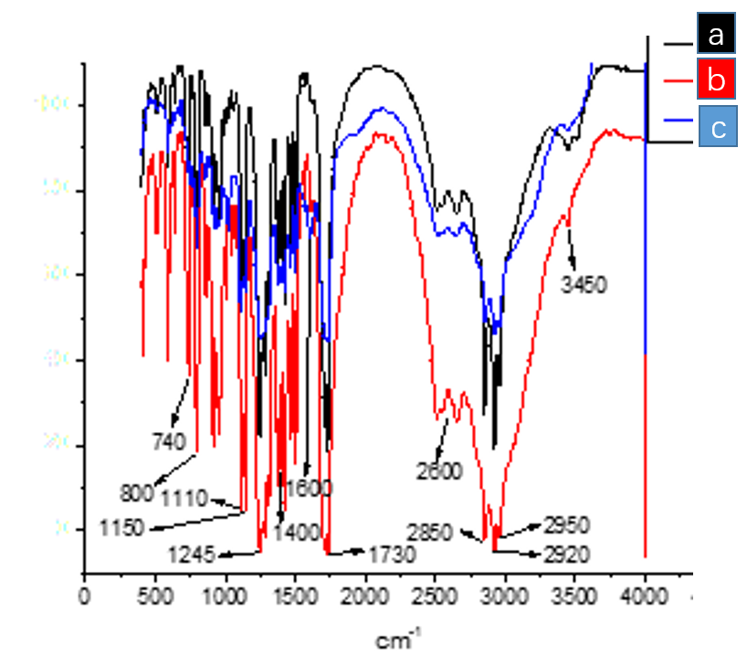

Fig.S1. The FTIR of GS (Cn-φ-Cn, n=8, 10, 12)

The infrared absorption peaks of gemini surfactants are listed in table below:

|  |  |  |
| --- | --- | --- |
| Vave number（cm-1） | Functiuonal group | Assignment |
| 3450 | -OH | O-H stretching vibration |
| 2950 | -CH3 | C-H asymmetrical stretching vibration |
| 2920、2850  2600 | -CH2- | C-H symmetrical stretching vibration  N-H symmetrical stretching vibration |
| 1730  1600 | -C=O | C=O stretching vibration  benzene skeleton vibration |
| 1400 | -CH2- | bending vibration |
| 1245、1150 | -COOCnH2n+1 | C-O-C symmetrical stretching vibration |
| 1110 | -C-O-H | C-O-H asymmetrical stretching vibration |
| 800、740 | -C6H2- | =C-H Outside surface swing |

1. **ESI-MS**



**C8-φ-C8**



**C10-φ-C10**



C12-φ-C12

Fig.S2. The ESI-MS of DS (Cn-φ-Cn, n=8, 10, 12)

**The ESI-MS peaks of dimeric surfactants are listed in table below.**

|  |  |  |
| --- | --- | --- |
| **GS** | **[M-H]-** | **[2M-H]-** |
| **C8-φ-C8** | **477.1** | **955.1** |
| **C10-φ-C10** | **533.2** | **1067.1** |
| **C12-φ-C12** | **589.3** | **1179.2** |

1. **1 H NRM**

As can be seen from Fig.S3, there are triple peaks during δ:7.75-8.25, which is clearly shown that two isomers co-existed in the system. By analysis, δ:7.95(s,1H) belongs to cis-isomer. Chemical shifts of δ:7.85(s,1H) and δ:8.15(s,1H) are trans-isomer. Isomers structures are shown below:

 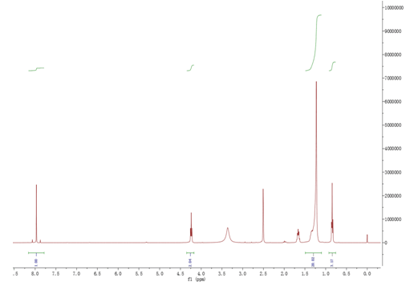

Fig.S3. The 1H NMR of C12-φ-C12.

1H NMR (300MHz, DMSO-d6,) of C12-φ-C12 is shown in Fig.S3, δ:2.5 and δ:3.4 are solvent peaks of DMSO-d6, δ:1.6 is the peak of H2O (The sample may absorb water when it was prepared and stored). The rest of 1H NMR peaks are shown below: δ:0.80–0.90(t,6H), 1.20–1.35(m,40H), 4.25(m,4H), 7.75-8.25[(t,3H): 7.85(s,1H), 7.95(s,1H), 8.15(s,1H)].

1H NMR of C8-φ-C8 and C10-φ-C10 are the same as C12-φ-C12, and shown below:

1H NMR (300MHz, DMSO-d6,) of C10-ϕ-C10: δ:0.80–0.90(t,6H), 1.20–1.35(m,32H), 4.25(m,4H), 7.75-8.25[(t,3H): 7.85(s,1H), 7.95(s,1H), 8.15(s,1H)].

1H NMR (300MHz, DMSO-d6,) of C8-ϕ-C8: δ:0.80–0.90(t,6H), 1.20–1.35(m,24H), 4.25(m,4H), 7.75-8.25[(t,3H): 7.85(s,1H), 7.95(s,1H), 8.15(s,1H)].

Gemini surfactants are also known as dimeric surfactants, which belong to oligomeric surfactants. According to the gemini surfactants described in the article, we were aware that the reaction of binary anhydride with long chain alkyl alcohol will generate isomers, but, 1) they were still gemini surfactants, 2) they all obtained the same spacer group, hydrophilic head groups and hydrophobic tail chains, 3) they all had the same functional groups, such as carboxylic acid ammonium salt, ester group, bezene ring spacer group and hydroxyls. According to the principle of structure determining performance, these isomers in the C12-ϕ-C12 system (same with C8-ϕ-C8 and C10-ϕ-C10) have a lot in commons, so it is more than reasonable for us to study them as a whole. We decided to study the integrated performance of composite system, rather than to split them and study separately. Test results show that the isomers coexisting system has very excellent surface active property, self-assemble behavior, and works well as template for shape-controllable synthesis of nano-CeO2, which can be the result of isomers synergy. The results also show that isomers being treated as a whole is a feasible and effective research method.

1. **Abbreviations:**

1). GS: Gimini surfactants

2). CMC: critical micelle concentration;

3). PMDA: pyromelliic dianhydride;

4). DMEA: dimethylaminoethanol

5). Cn-φ-Cn: anionic gemini surfactants,

C8-φ-C8: tail chain –COOC8H17;

C10-φ-C10: tail chain -COOC10H21;

C12-φ-C12: tail chain -COOC12H25.