Supplementary Table 1. Crystal structures and amino acid sequences used in molecular modeling.
CYP form | UniProt entry | PDB ID
1A1 | P04798-1 | 4I8V^{a,b} (Walsh et al. 2013)
1A2 | P05177-1 | 2HI4ª (Sansen et al. 2007)
1B1 | Q16678-1 | 3PM0ª (Wang et al. 2011)
2A6 | P11509-1 | 1Z10 (Yano et al. 2005)  2FDV^{a,b} (Yano et al. 2006)
2B6 | P20813-1 | 3QOA (Shah et al. 2011)  3UA5 (Shah et al. 2012)
2C8 | P10632-1 | 2VN0 (Schoch et al. 2008)
2C9 | P11712-1 | 1OG5 (Williams et al. 2003)  4NZ2 (Brändén et al. 2014)  1R9O (Wester et al. 2004)
2C19 | P33261-1 | 4GQSª (Reynald et al. 2012)
2D6 | P10635-1 | 3QM4ª (Wang et al. 2012)  4WNW (Wang et al. 2015)
2E1 | P05181-1 | 3T3Z (DeVore et al. 2012)
3A4 | P08684-1 | 3UA1 (Sevrioukova & Poulos 2012)  5TE8^{b} (Sevrioukova & Poulos 2017)
3A5 | P20815-1 | 5VEU (Hsu et al. 2018)
3A7 | P24462-1 | -
- Structures used in molecular docking
- Structures used in structure-based sequence pre-alignment

Supplementary Table 2. The absorbance properties of the coumarin derivatives.
Compound  number | Amax  [nm] | ε abs  [cm-1*M-1]
1 | 287 | 5 800
2 | 293 | 6 200
3 | 293 | 5 700
4 | 294  333 | 13 100  12 300
5 | 292 | 17 900
6 | 340 | 7 200
7 | 349 | 14 900
8 | 324 | 14 800
9 | 340 | 17 400
10 | 349 | 10 400
12 | 346 | 19 300

Supplementary Figure 1. Multiple sequence alignment of the CYP forms. The catalytic sites of the CYP1 family are very conserved (light pink) and have similar amino acids at the positions suggested to be involved in 3-phenylcoumarin binding (pink). CYP2A6 has a unique asparagine (teal) among the CYP2 family in addition to a well-positioned phenylalanine (teal) for possible π- π interactions alongside other hydrophobic amino acids (light blue) in the catalytic site. The catalytic site amino acids (light blue) and the suggested key residues in 3-phenylcoumarin binding (teal) differ among CYP2A6, CYP2D6 and CYP2C19. The amino acids present in either CYP3A4 or CYP3A5 binding sites (yellow) are conserved among the CYP3 forms. The conserved threonine in the helix I (black) and the heme-binding amino acids (grey) are aligned among all sequences. The alignment was built on top of structure-based pre-alignments of CYP2A6 and CYP3A4 to CYP1A1 from Vertaa in Bodil (Lehtonen 2004), and was performed with Malign (Johnson 1993) with structure-based matrix (STRMAT110) (Johnson & Overington 1993) and gap penalty of 30. The structure-based pre-alignments were left out of the figure for clarity. The used structures and sequences are listed in Supplementary Table 1.
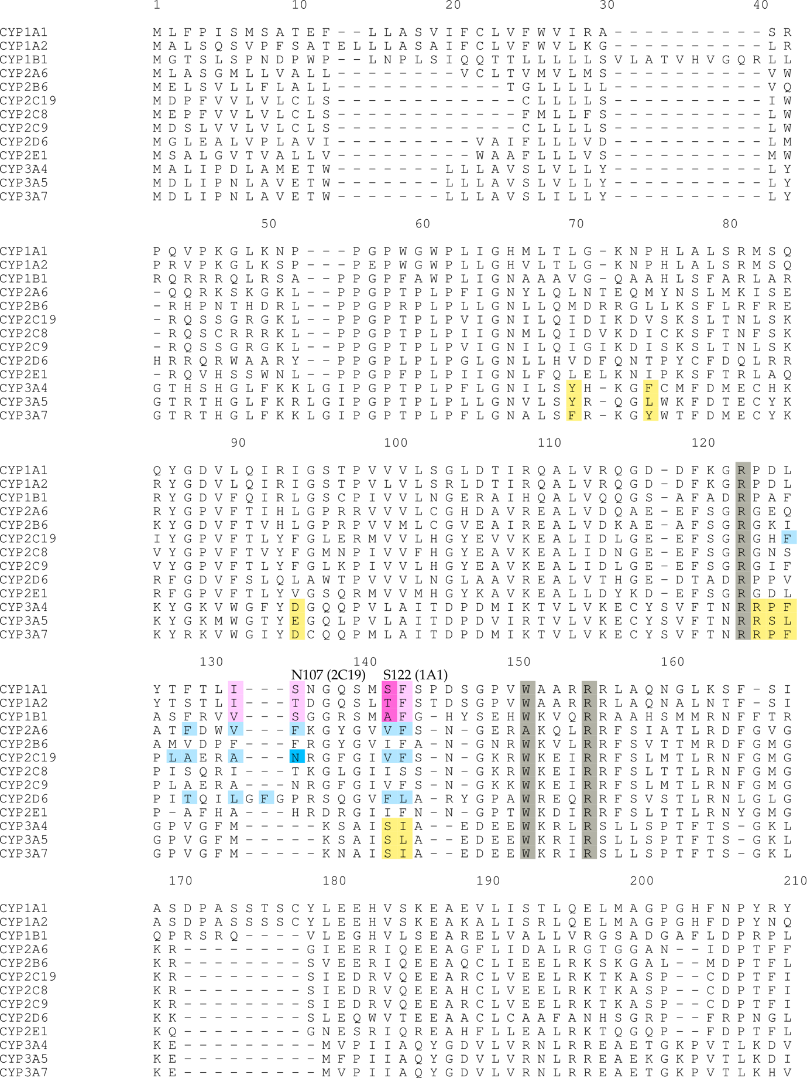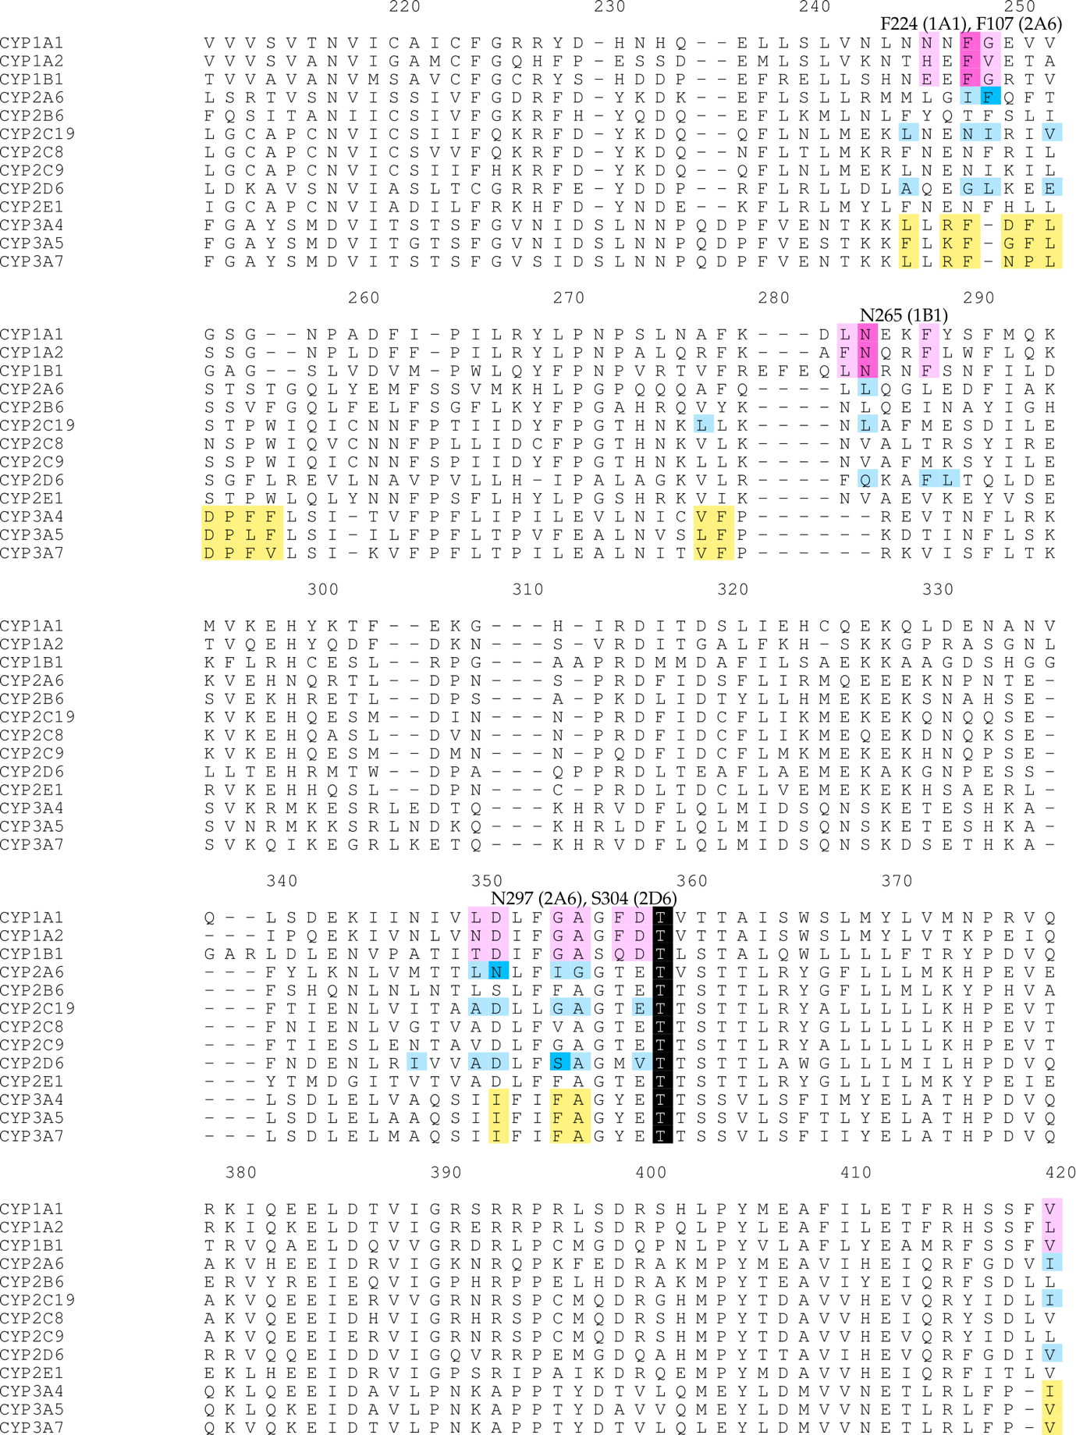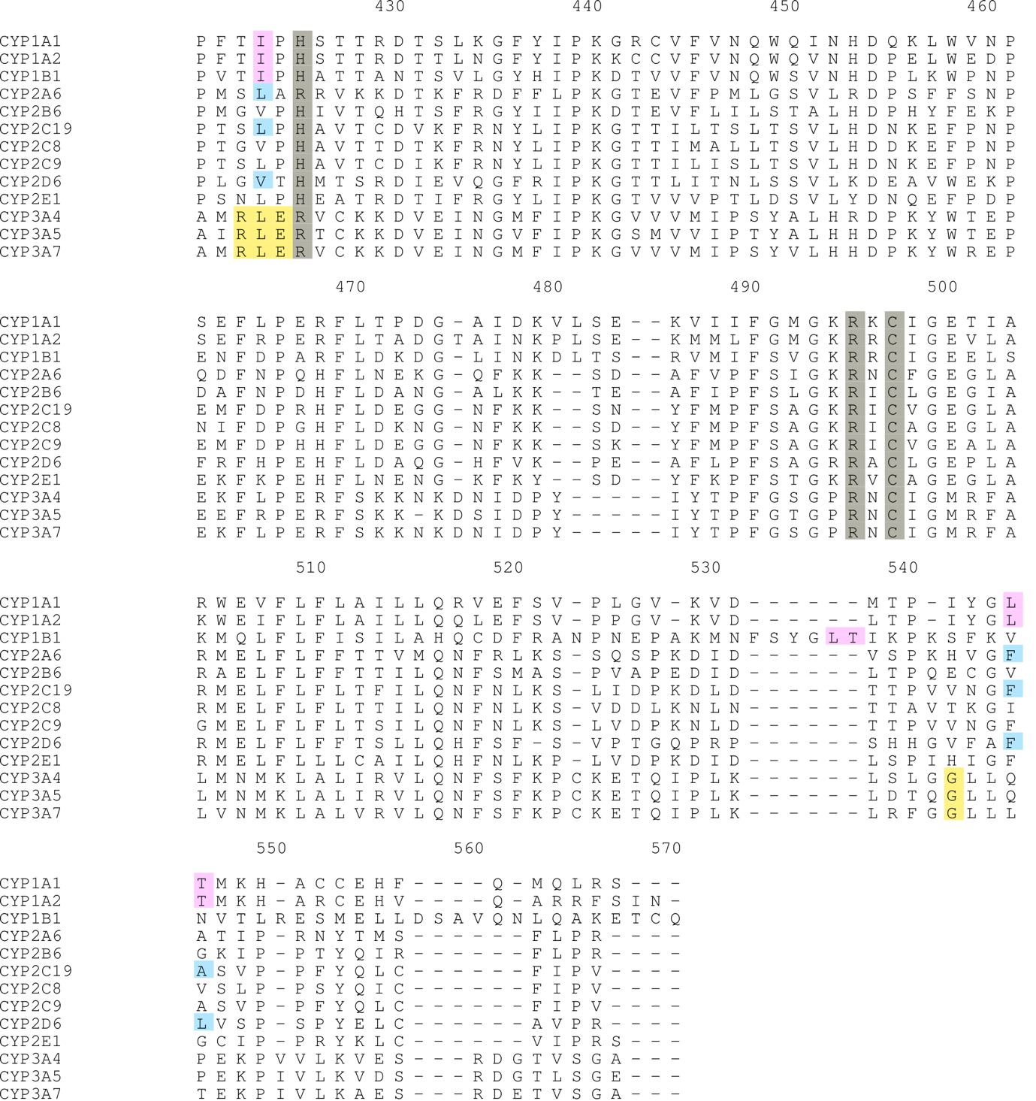

References
Brändén, G. et al., (2014). Structure-based ligand design to overcome CYP inhibition in drug discovery projects. Drug Discovery Today, 19: 905–911.
DeVore, N.M. et al., (2012). Structural comparison of cytochromes P450 2A6, 2A13, and 2E1 with pilocarpine. FEBS Journal, 279: 1621–1631.
Hsu, M.-H., Savas, U. & Johnson, E.F., (2018). The X-Ray Crystal Structure of the Human Mono-Oxygenase Cytochrome P450 3A5-Ritonavir Complex Reveals Active Site Differences between P450s 3A4 and 3A5. Molecular Pharmacology, 93: 14–24. Available at: http://molpharm.aspetjournals.org/lookup/doi/10.1124/mol.117.109744.
Johnson, M.S. & Overington, J.P., (1993). A structural basis for sequence comparisons: An evaluation of scoring methodologies. Journal of Molecular Biology, 233: 716–738.
Reynald, R.L. et al., (2012). Structural characterization of human cytochrome P450 2C19: Active site differences between P450s 2C8, 2C9, and 2C19. Journal of Biological Chemistry, 287: 44581–44591.
Sansen, S. et al., (2007). Adaptations for the oxidation of polycyclic aromatic hydrocarbons exhibited by the structure of human P450 1A2. Journal of Biological Chemistry, 282: 14348–14355.
Schoch, G.A. et al., (2008). Determinants of cytochrome P450 2C8 substrate binding: Structures of complexes with montelukast, troglitazone, felodipine, and 9-cis-retinoic acid. Journal of Biological Chemistry, 283: 17227–17237.
Sevrioukova, I.F. & Poulos, T.L., (2012). Structural and mechanistic insights into the interaction of cytochrome P4503A4 with bromoergocryptine, a type I ligand. Journal of Biological Chemistry, 287: 3510–3517.
Sevrioukova, I.F. & Poulos, T.L., (2017). Structural basis for regiospecific midazolam oxidation by human cytochrome P450 3A4. Proceedings of the National Academy of Sciences, 114: 486–491. Available at: http://www.pnas.org/lookup/doi/10.1073/pnas.1616198114.
Shah, M.B. et al., (2012). Conformational adaptation of human cytochrome P450 2B6 and rabbit cytochrome P450 2B4 revealed upon binding multiple amlodipine molecules. Biochemistry, 51: 7225–7238.
Shah, M.B. et al., (2011). Structures of cytochrome P450 2B6 bound to 4-benzylpyridine and. Molecular pharmacology, 80: 1047–1055.
Walsh, A.A., Szklarz, G.D. & Scott, E.E., (2013). Human cytochrome P450 1A1 structure and utility in understanding drug and xenobiotic metabolism. Journal of Biological Chemistry, 288: 12932–12943.
Wang, A. et al., (2015). Contributions of ionic interactions and protein dynamics to cytochrome P450 2D6 (CYP2D6) substrate and inhibitor binding. Journal of Biological Chemistry, 290: 5092–5104.
Wang, A. et al., (2012). Crystal Structure of Human Cytochrome P450 2D6 with Prinomastat Bound. Journal of Biological Chemistry, 287: 10834–10843. Available at: http://www.jbc.org/lookup/doi/10.1074/jbc.M111.307918.
Wang, A. et al., (2011). Structural characterization of the complex between ??-naphthoflavone and human cytochrome P450 1B1. Journal of Biological Chemistry, 286: 5736–5743.
Wester, M.R. et al., (2004). The structure of human cytochrome P450 2C9 complexed with flurbiprofen at 2.0-Å resolution. Journal of Biological Chemistry, 279: 35630–35637.
Williams, P. a et al., (2003). Crystal structure of human cytochrome P450 2C9 with bound warfarin. Nature, 424: 464–468. Available at: http://www.nature.com/nature/journal/v424/n6947/abs/nature01862.html.
Yano, J.K. et al., (2005). Structures of human microsomal cytochrome P450 2A6 complexed with coumarin and methoxsalen. Nature Structural and Molecular Biology, 12: 822–823.
Yano, J.K. et al., (2006). Synthetic inhibitors of cytochrome P-450 2A6: Inhibitory activity, difference spectra, mechanism of inhibition, and protein cocrystallization. Journal of Medicinal Chemistry, 49: 6987–7001.

