Supplemental Files
Supplemental Table 1. Presenting symptoms or findings for 82 subjects diagnosed with amyloidosis. Consistent with the difficulty and delay in making the diagnosis, many subjects had multiple symptoms at the time of initial presentation.

Presenting Symptom(s) or Finding(s) | Count
Fat., DOE, SOBª | 19
Carpal tunnel syndrome | 9
Fat., DOE, SOB, + LEE | 8
Fat., DOE, SOB + EKG or ECHO findings ± LEE | 8
Fat., DOE, SOB, + GI symptoms | 6
Carpal tunnel syndrome + 1 additional symptom | 4
Neuropathy^{b} | 3
EKG findings | 3
Fat., DOE, SOB + volume overload | 3
Presyncope ± additional symptoms | 3
Heart Failure ± DOE ± LEE | 3
Elevated Cardiac Markers ± ECHO or EKG findings | 3
Palpitations | 2
Cardiomyopathy and ECHO findings | 2
Cardiomyopathy and GI symptoms | 1
Cardiomyopathy | 1
GI symptoms | 1
Fat., DOE, SOB + LEE + neuropathy | 1
Fat., DOE, SOB, + neuropathy | 1
Fat., DOE, SOB + EKG or ECHO findings + LEE + neuropathy | 1
Total | 82

KEY: Fat. – Fatigue; DOE – dyspnea on exertion, SOB – shortness of breath; LEE – lower extremity edema; EKG – Electrocardiogram; ECHO – echocardiogram; GI – gastrointestinal. ªPatients could present with one or more of these closely related symptoms. ^{b}Neuropathy other than carpal tunnel syndrome.

Supplemental Figure 1. Cardiac Amyloidosis Grading Schema. Grade 1 <10% involvement by amyloid, Grade 2 10‐25%, Grade 3 25‐50%, and Grade 4 >50%.
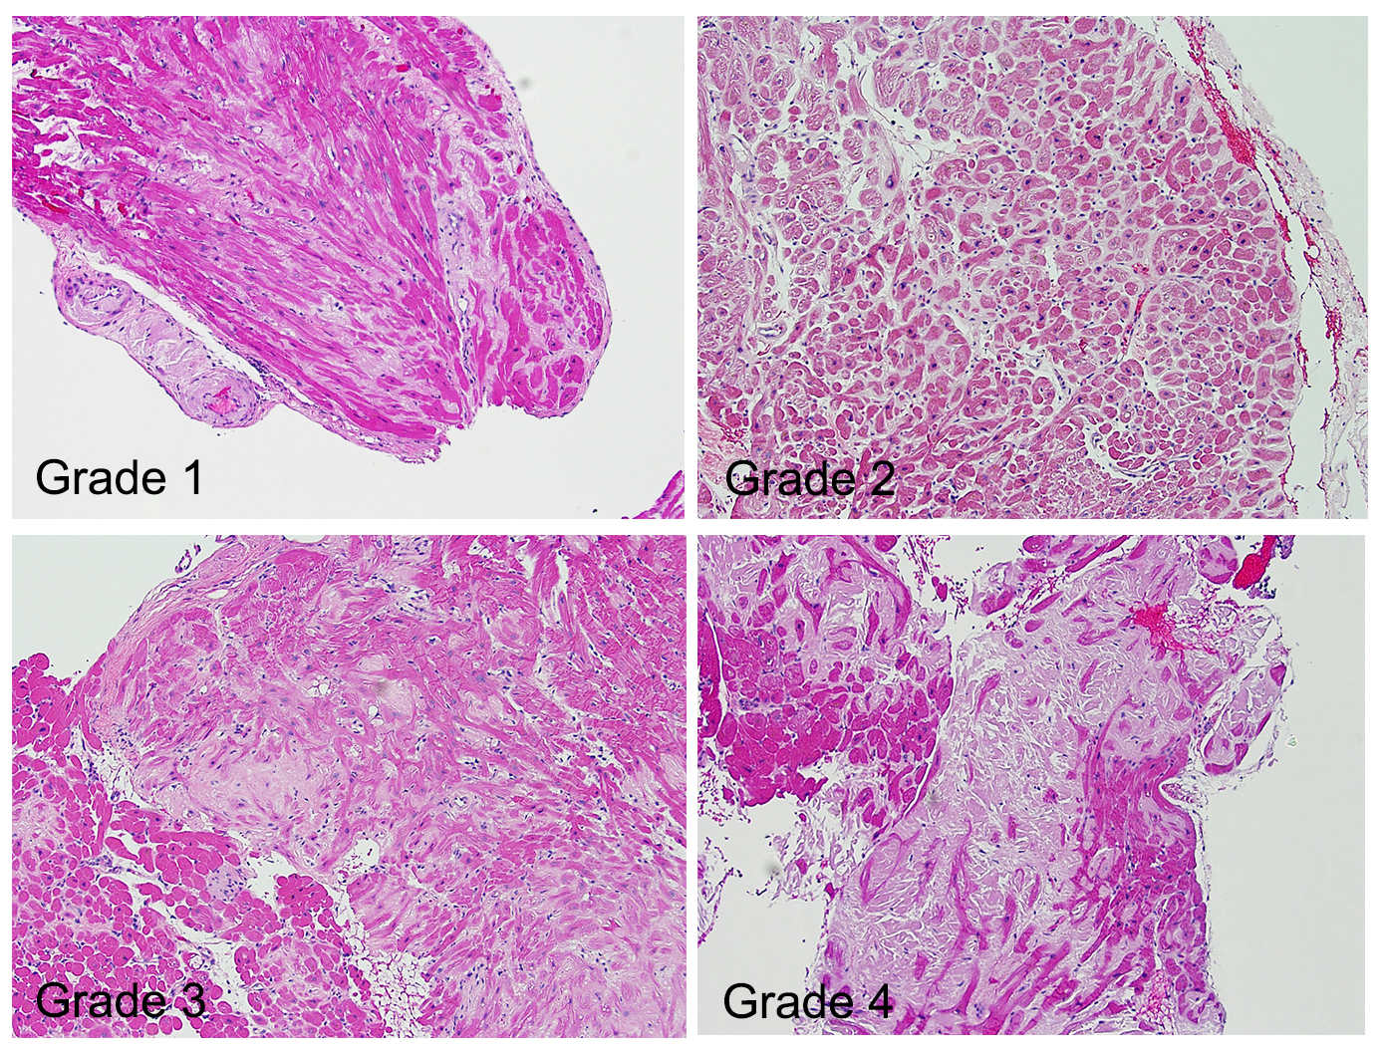

Supplemental Figure 2. Four Clinical Predictors of Delayed Diagnosis in the ATTR Subgroup, Ratio and 95% CI
