Supplementary Materials:
In the over 70 year-old male and female subjects, the trends of the switching SBP levels from AM to LM were similar with those of the 40 to 69 year-old subjects (Supplementary Table S3-S5).
Sensitivity analyses according to the different assumptions of the relationships between SBP and IR_{CVD} and the SBP frequency distributions
The representative natural log-normal frequency distributions of SBP and the representative quadratic relationship between SBP and IR_{CVD} were demonstrated in Supplementary Figure 1A and 1B, respectively.
Sensitivity analyses in the quadratic relationships between SBP and IR_{CVD} (Supplementary Table S6-S9) and in the right-skewed frequency distributions of SBP (Supplementary Table S10-S13) confirmed that the inferred SBP levels to switch from LM to AM were similar with the original simulations (Table 1, Supplementary Table S3-S5).

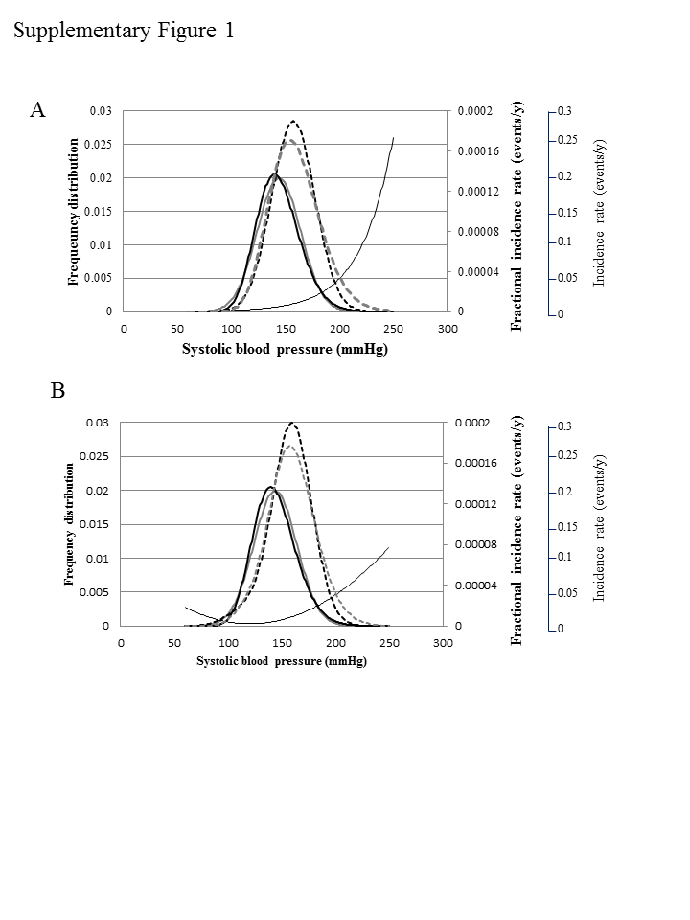
Supplementary Figure Legend
Relationships between systolic blood pressure (SBP) and incidence rates of cardiovascular disease (IR_{CVD}) without interventions in 60 to 69 year-old male subjects. (a) The thin black line represents an exponential relationship between SBP and IR_{CVD}. The solid thick black and grey lines represent the frequency normal and natural log-normal distributions of SBP, respectively. The broken thick black and grey lines represent IR_{CVD} under the frequency normal and natural log-normal distributions of systolic blood pressure, respectively. (b) The thin black line represents a quadratic relationship between SBP and IR_{CVD}. The solid thick black and grey lines represent the frequency normal and natural log-normal distributions of SBP, respectively. The broken thick black and grey lines represent IR_{CVD} under the normal and natural log-normal frequency distributions of SBP (Supplementary Table 6S and 10S), respectively.

Table S1. Constants used in the simulation
Constants of SBP frequency distributions |  |  |  |  |  | 40 - 69 M 40 – 69 F |  | 70-79 M |  |  | 80- M  70-79 F |  | 80 – F
Constants of IR_{CVD} |  |  |  |  |  | 40-69 M 40-69 F |  | 70-79 M |  |  | 80- M  70-79 F |  | 80- F
k | the slope of the exponential curves |  |  |  |  | 30  30 |  | 35 |  |  | 40  40 |  | 50
l | the absolute value of IR_{CVD} |  |  |  |  | 300-150  400-180 |  | 80 |  |  | 50  80 |  | 40
m | the rising point from exp(0) = 1 |  |  |  |  | 160-140  180-150 |  | 120 |  |  | 120  130 |  | 120
Constants of LM |  |  |  | Ideal |  |  | Optimistic |  |  | Realistic |  | Pessimistic
α (mmHg) |  |  |  | 28 |  |  | 15 |  |  | 8 |  | 5
β |  |  |  | 0.5 |  |  | 0.275 |  |  | 0.1375 |  | 0.075
Constants of AM |  |  |  |  | Strict |  | Realistic |  | Modest |  |  | Loose
a (mmHg) |  | Alarming SBP |  |  | 130 |  | 140 |  | 150 |  |  | 160
b |  | Accessibility factor |  |  | 0.05 |  | 0.03 |  | 0.02 |  |  | 0.01
c (mmHg) |  | Target SBP level |  |  | 130 |  | 140 |  | 140 |  |  | 150
d |  | Adherence factor |  |  | 0.8 |  | 0.7 |  | 0.6 |  |  | 0.5
Abbreviations: IR_{CVD}, the incidence rate of cardiovascular disease; M, male; F, female; LM, lifestyle modifications [16, 17, 25, 29, 31-33]; α, the total effects of successful LM on systolic blood pressure (SBP) (mmHg) including metabolic factors; β, proportion of participating LM; AM, antihypertensive medications [1, 2, 16, 17, 21, 30, 35, 36]; a, an alarming SBP, above which patients should be concerned about their SBP; b, an accessibility factor to a primary physician; c, the target SBP level; d, adherence for reaching the target SBP level [9, 16, 17, 37-40].
The constants, l and m, were deleted in the final differential equation (9, the lower line) although they had different values in the subpopulations according to sex and age.
Table S2. Representative SBP changes from 160 and 180 mmHg according to the various scenarios in 60 to 69 year-old male subjects
LM |  | Ideal | Optimistic | Realistic | Pessimistic
Average SBP level after successful and unsuccessful LM (mmHg) | from 160 | 143 | 154 | 158 | 159
 | from 180 | 163 | 174 | 178 | 179
AM |  | Strict | Realistic | Modest | Loose
Consultation rate | from 160 | 0.78 | 0.45 | 0.18 | 0
 | from 180 | 0.92 | 0.70 | 0.45 | 0.18
SBP lowering effect (mmHg) | from 160 | 24 | 14 | 12 | 10
 | from 180 | 40 | 28 | 24 | 15
Average SBP level after AM (mmHg) | from 160 | 141 | 154 | 158 | 160
 | from 180 | 143 | 160 | 169 | 177
Abbreviations: SBP, systolic blood pressure; LM, lifestyle modifications; AM, antihypertensive medications.
Table S3. Simulation-oriented switching SBP level in 70 to 79 year-old male subjects
Lifestyle modifications  supported by health nurses |  | Ideal | Optimistic | Realistic | Pessimistic
Antihypertensive medications
Consultation rate | SBP lowering effect
Strict | Strict | 158 | 146 | 139 | 137
 | Realistic | 168 | 154 | 147 | 144
 | Modest | 171 | 155 | 148 | 145
 | Loose | 185 | 165 | 157 | 154
Realistic | Strict | 169 | 155 | 148 | 145
 | Realistic | 176 | 155 | 153 | 149
 | Modest | 181 | 163 | 154 | 150
 | Loose | 192 | 171 | 161 | 157
Modest | Strict | 181 | 165 | 157 | 154
 | Realistic | 189 | 170 | 157 | 157
 | Modest | 192 | 172 | 162 | 158
 | Loose | 203 | 180 | 168 | 163
Loose | Strict | 205 | 181 | 170 | 166
 | Realistic | 212 | 186 | 174 | 168
 | Modest | 216 | 189 | 175 | 169
 | Loose | 227 | 196 | 180 | 173
Abbreviations: SBP, systolic blood pressure.

Table S4. Simulation-oriented switching SBP level in over 80 year-old male and 70 to 79 year-old female subjects
Lifestyle modifications  supported by health nurses |  | Ideal | Optimistic | Realistic | Pessimistic
Antihypertensive medications
Consultation rate | SBP lowering effect
Strict | Strict | 158 | 146 | 139 | 137
 | Realistic | 168 | 154 | 147 | 144
 | Modest | 172 | 155 | 148 | 145
 | Loose | 185 | 165 | 157 | 154
Realistic | Strict | 169 | 155 | 148 | 145
 | Realistic | 177 | 155 | 153 | 149
 | Modest | 181 | 163 | 154 | 150
 | Loose | 192 | 171 | 161 | 157
Modest | Strict | 181 | 165 | 158 | 155
 | Realistic | 188 | 170 | 161 | 157
 | Modest | 192 | 172 | 162 | 158
 | Loose | 203 | 180 | 168 | 163
Loose | Strict | 204 | 181 | 170 | 166
 | Realistic | 211 | 185 | 173 | 168
 | Modest | 215 | 188 | 175 | 169
 | Loose | 227 | 195 | 180 | 173
Abbreviations: SBP, systolic blood pressure.

Table S5. Simulation-oriented switching SBP level in over 80 year-old female subjects
Lifestyle modifications  supported by health nurses |  | Ideal | Optimistic | Realistic | Pessimistic
Antihypertensive medications
Consultation rate | SBP lowering effect
Strict | Strict | 158 | 146 | 139 | 137
 | Realistic | 168 | 153 | 147 | 144
 | Modest | 172 | 155 | 148 | 145
 | Loose | 185 | 165 | 157 | 154
Realistic | Strict | 169 | 155 | 148 | 145
 | Realistic | 177 | 161 | 153 | 149
 | Modest | 181 | 163 | 154 | 150
 | Loose | 192 | 171 | 161 | 157
Modest | Strict | 181 | 165 | 157 | 154
 | Realistic | 188 | 170 | 157 | 157
 | Modest | 192 | 172 | 162 | 158
 | Loose | 203 | 180 | 168 | 163
Loose | Strict | 201 | 181 | 170 | 164
 | Realistic | 209 | 185 | 173 | 168
 | Modest | 213 | 188 | 175 | 169
 | Loose | 224 | 195 | 180 | 173
Abbreviations: SBP, systolic blood pressure.

Table S6. Simulation-oriented switching SBP level in 40 to 69 year-old male and female subjects under the quadratic relationship between SBP and IR_{CVD}
Lifestyle modifications  supported by health nurses |  | Ideal | Optimistic | Realistic | Pessimistic
Antihypertensive medications
Consultation rate | SBP lowering effect
Strict | Strict | 158 | 146 | 139 | 137
 | Realistic | 168 | 154 | 147 | 144
 | Modest | 172 | 155 | 148 | 145
 | Loose | 185 | 165 | 157 | 154
Realistic | Strict | 169 | 155 | 148 | 145
 | Realistic | 177 | 161 | 153 | 149
 | Modest | 181 | 163 | 154 | 150
 | Loose | 193 | 171 | 161 | 157
Modest | Strict | 180 | 165 | 157 | 154
 | Realistic | 188 | 170 | 161 | 157
 | Modest | 192 | 172 | 162 | 158
 | Loose | 203 | 180 | 168 | 163
Loose | Strict | 201 | 180 | 170 | 166
 | Realistic | 208 | 185 | 173 | 168
 | Modest | 213 | 188 | 174 | 169
 | Loose | 224 | 195 | 180 | 173
Abbreviations: SBP, systolic blood pressure; IR_{CVD}, incidence rate of cardiovascular disease.
Table S7. Simulation-oriented switching SBP level in 70 to 79 year-old male subjects under the quadratic relationship between SBP and IR_{CVD}
Lifestyle modifications  supported by health nurses |  | Ideal | Optimistic | Realistic | Pessimistic
Antihypertensive medications
Consultation rate | SBP lowering effect
Strict | Strict | 158 | 146 | 139 | 137
 | Realistic | 168 | 154 | 147 | 144
 | Modest | 172 | 155 | 148 | 145
 | Loose | 185 | 165 | 157 | 154
Realistic | Strict | 169 | 155 | 148 | 145
 | Realistic | 177 | 161 | 153 | 149
 | Modest | 181 | 161 | 154 | 150
 | Loose | 193 | 163 | 161 | 158
Modest | Strict | 180 | 165 | 157 | 154
 | Realistic | 188 | 170 | 161 | 157
 | Modest | 192 | 172 | 162 | 158
 | Loose | 203 | 180 | 168 | 163
Loose | Strict | 201 | 180 | 170 | 166
 | Realistic | 208 | 185 | 173 | 168
 | Modest | 213 | 188 | 174 | 169
 | Loose | 224 | 195 | 180 | 173
Abbreviations: SBP, systolic blood pressure; IR_{CVD}, incidence rate of cardiovascular disease.
Table S8. Simulation-oriented switching SBP level in over 80 year-old male and 70 to 79 year-old female subjects under the quadratic relationship between SBP and IR_{CVD}
Lifestyle modifications  supported by health nurses |  | Ideal | Optimistic | Realistic | Pessimistic
Antihypertensive medications
Consultation rate | SBP lowering effect
Strict | Strict | 158 | 146 | 139 | 137
 | Realistic | 168 | 154 | 147 | 144
 | Modest | 172 | 155 | 148 | 145
 | Loose | 185 | 165 | 157 | 154
Realistic | Strict | 169 | 155 | 148 | 145
 | Realistic | 177 | 161 | 153 | 149
 | Modest | 181 | 163 | 154 | 150
 | Loose | 193 | 171 | 161 | 157
Modest | Strict | 180 | 165 | 157 | 154
 | Realistic | 188 | 170 | 161 | 157
 | Modest | 192 | 172 | 162 | 158
 | Loose | 203 | 180 | 168 | 163
Loose | Strict | 201 | 180 | 170 | 166
 | Realistic | 208 | 185 | 173 | 168
 | Modest | 213 | 188 | 174 | 169
 | Loose | 224 | 195 | 180 | 173
Abbreviations: SBP, systolic blood pressure; IR_{CVD}, incidence rate of cardiovascular disease.
Table S9. Simulation-oriented switching SBP level in over 80 year-old female subjects under the quadratic relationship between SBP and IR_{CVD}
Lifestyle modifications  supported by health nurses |  | Ideal | Optimistic | Realistic | Pessimistic
Antihypertensive medications
Consultation rate | SBP lowering effect
Strict | Strict | 158 | 146 | 139 | 137
 | Realistic | 168 | 154 | 147 | 144
 | Modest | 172 | 155 | 148 | 145
 | Loose | 186 | 166 | 157 | 154
Realistic | Strict | 168 | 154 | 148 | 145
 | Realistic | 177 | 161 | 152 | 149
 | Modest | 181 | 162 | 153 | 150
 | Loose | 193 | 171 | 161 | 157
Modest | Strict | 180 | 165 | 157 | 154
 | Realistic | 188 | 170 | 161 | 157
 | Modest | 191 | 172 | 162 | 158
 | Loose | 203 | 179 | 168 | 163
Loose | Strict | 200 | 180 | 170 | 166
 | Realistic | 208 | 185 | 173 | 168
 | Modest | 213 | 187 | 174 | 169
 | Loose | 224 | 195 | 180 | 173
Abbreviations: SBP, systolic blood pressure; IR_{CVD}, incidence rate of cardiovascular disease.

Table S10. Simulation-oriented switching SBP level in 40 to 69 year-old male and female subjects in the log-normal distribution of SBP under the quadratic relationship between SBP and IR_{CVD}
Lifestyle modifications  supported by health nurses |  | Ideal | Optimistic | Realistic | Pessimistic
Antihypertensive medications
Consultation rate | SBP lowering effect
Strict | Strict | 158 | 146 | 139 | 137
 | Realistic | 168 | 153 | 147 | 144
 | Modest | 172 | 155 | 148 | 145
 | Loose | 185 | 165 | 157 | 154
Realistic | Strict | 169 | 155 | 148 | 145
 | Realistic | 177 | 161 | 153 | 149
 | Modest | 181 | 163 | 154 | 150
 | Loose | 193 | 171 | 161 | 157
Modest | Strict | 181 | 165 | 158 | 155
 | Realistic | 188 | 170 | 161 | 157
 | Modest | 192 | 172 | 162 | 158
 | Loose | 203 | 180 | 168 | 163
Loose | Strict | 201 | 180 | 170 | 166
 | Realistic | 208 | 185 | 173 | 168
 | Modest | 213 | 188 | 175 | 169
 | Loose | 224 | 195 | 180 | 173
Abbreviations: SBP, systolic blood pressure; IR_{CVD}, incidence rate of cardiovascular disease.
Table S11. Simulation-oriented switching SBP level in 70 to 79 year-old male subjects in the log-normal distribution of SBP under the quadratic relationship between SBP and IR_{CVD}
Lifestyle modifications  supported by health nurses |  | Ideal | Optimistic | Realistic | Pessimistic
Antihypertensive medications
Consultation rate | SBP lowering effect
Strict | Strict | 158 | 146 | 139 | 137
 | Realistic | 168 | 153 | 147 | 144
 | Modest | 172 | 155 | 148 | 145
 | Loose | 185 | 165 | 157 | 154
Realistic | Strict | 169 | 155 | 148 | 145
 | Realistic | 177 | 161 | 153 | 149
 | Modest | 181 | 163 | 154 | 150
 | Loose | 192 | 171 | 161 | 157
Modest | Strict | 181 | 165 | 158 | 155
 | Realistic | 188 | 170 | 161 | 157
 | Modest | 192 | 172 | 162 | 158
 | Loose | 203 | 180 | 168 | 163
Loose | Strict | 201 | 181 | 170 | 166
 | Realistic | 208 | 185 | 173 | 168
 | Modest | 213 | 188 | 175 | 169
 | Loose | 224 | 195 | 180 | 173
Abbreviations: SBP, systolic blood pressure; IR_{CVD}, incidence rate of cardiovascular disease.
Table S12. Simulation-oriented switching SBP level in over 80 year-old male and 70 to 79 year-old female subjects in the log-normal distribution of SBP under the quadratic relationship between SBP and IR_{CVD}
Lifestyle modifications  supported by health nurses |  | Ideal | Optimistic | Realistic | Pessimistic
Antihypertensive medications
Consultation rate | SBP lowering effect
Strict | Strict | 158 | 146 | 140 | 137
 | Realistic | 168 | 153 | 147 | 144
 | Modest | 171 | 155 | 148 | 145
 | Loose | 185 | 165 | 157 | 154
Realistic | Strict | 169 | 155 | 148 | 145
 | Realistic | 177 | 161 | 153 | 149
 | Modest | 181 | 163 | 154 | 150
 | Loose | 192 | 171 | 161 | 157
Modest | Strict | 181 | 165 | 158 | 155
 | Realistic | 188 | 170 | 161 | 157
 | Modest | 192 | 172 | 162 | 158
 | Loose | 203 | 180 | 168 | 163
Loose | Strict | 201 | 181 | 170 | 166
 | Realistic | 209 | 185 | 173 | 168
 | Modest | 213 | 188 | 175 | 169
 | Loose | 224 | 195 | 180 | 173
Abbreviations: SBP, systolic blood pressure; IR_{CVD}, incidence rate of cardiovascular disease.
Table S13. Simulation-oriented Switching SBP level in over 80 year-old female subjects in the log-normal distribution of SBP under the quadratic relationship between SBP and IR_{CVD}
Lifestyle modifications  supported by health nurses |  | Ideal | Optimistic | Realistic | Pessimistic
Antihypertensive medications
Consultation rate | SBP lowering effect
Strict | Strict | 158 | 146 | 140 | 137
 | Realistic | 168 | 153 | 147 | 144
 | Modest | 171 | 155 | 148 | 145
 | Loose | 185 | 165 | 157 | 154
Realistic | Strict | 169 | 155 | 148 | 145
 | Realistic | 177 | 161 | 153 | 149
 | Modest | 181 | 163 | 154 | 150
 | Loose | 192 | 171 | 161 | 157
Modest | Strict | 181 | 165 | 158 | 155
 | Realistic | 188 | 170 | 161 | 157
 | Modest | 192 | 172 | 162 | 158
 | Loose | 203 | 180 | 168 | 163
Loose | Strict | 201 | 181 | 170 | 166
 | Realistic | 209 | 185 | 173 | 168
 | Modest | 213 | 188 | 175 | 169
 | Loose | 224 | 195 | 180 | 173
Abbreviations: SBP, systolic blood pressure; IR_{CVD}, incidence rate of cardiovascular disease.

