Supplemental Tables and Figures
Table S1. eRpL22-like knockout phenotypes after heat shock (HS)
Genotype | Time of HS after egg laying | # of heat-shocked embryos | Phenotypes
CKO; HS-FLP/+ | 1 hour | 16 | Embryonic lethality
 |  | 2 | L1 lethality
 |  | 1 | Developmental arrest in L1-like stage, defects in tracheal branching and growth, comparatively smaller Malpighian tubules
 |  | 1 | Midpupal lethality, male genitalia deformation, gut development defects
 |  | 1 | Early adult lethality (within 24h post-eclosure), tissue (bristles, midgut, eye) death, larval mobility defects
 |  | 1 | Eye bristle defects in adult female
 | 24-36 hours | 15 | Lethality
 |  | 1 | Severe testis/seminal vesicle defects; sterile
 |  | 1 | Ovary defects including egg chamber polarity defects; not sterile
 |  | *3 | Normal gonad development
 | 48-60 hours | 12 | Normal gonad development; sporadic rough eye
Wildtype | 1 hour | 35 | Embryonic lethality
 |  | 16 | Wildtype
 | 24-36 hours | 35 | Lethality
 |  | 62 | Wildtype
- *Timing of HS was likely later in the 24-36 hour window.

Genotype | Length measurements (μm) | Average length (μm)
Wildtype (3 larvae) | 2398.2, 2564.6, 3021.2 | 2661.3
Wildtype with heat shock (1 larva) | 3525.9
CKO (2 larvae) | 2493.5, 2341.6 | 2417.5
CKO with heat shock (1 larva) | 707.1
Table S2. Larval length measurements for Figure 2

Table S3. Primer Table
Primer Name | Sequence (5’ -> 3’) | Use
F_Act5C | 5’-GAGCGCGGTTACTCTTTCAC-3’ | qRT-PCR
R_Act5C | 5’-GCCATCTCCTGCTCAAAGTC-3’ | qRT-PCR
F_eRpL22 | 5’-TGCTGAGGATAGCATCATGG-3’ | qRT-PCR
R_eRpL22 | 5’-AAAAGTGAACGTCGGAGCTG-3’ | qRT-PCR
F_eRpL22-like | 5’-CAAAAAGAAGGCTTGGCAAC-3’ | qRT-PCR
R_eRpL22-like | 5’-TCCTTCAGCTGGTTGAGCTT-3’ | qRT-PCR
F_eRpL22-like_pENTR | 5’-CACCGCGAGATCTATGAGTTC  CCAGACGCAG-3' | Creation of eRpL22-like-FLAG transgenic
R_eRpL22-like_FLAG | 5’-GTCACGGATCCTTACTTGTCATCGTCATCCTT GTAGTCGCCGCGGCCGATGGCAAAGGTTTTTC  CGCCATTGTCGTCGGCAA-3' | Creation of eRpL22-like-FLAG transgenic
F_pENTR_FLAG | 5’-CACCATGATCGGCCGCGGCGACTAC  AAGGATGAC GATGACAAG-3' | Creation of FLAG-eRpL22 transgenic
R_eRpL22 | 5’-GCCCTGAGGCTCTTGGGAGCAGCGGCAGC-3' | Creation of FLAG-eRpL22 transgenic
F_DsRed | 5' - gctcttcaagggagtgaaatacatc - 3' | Genotype for DsRed
R_DsRed | 5' - gatccacaaggccctgaagc - 3' | Genotype for DsRed
F_Dmel_Hsp70 | 5'- gcctcgaatgttcgcgaaaagagc - 3' | Genotype for HSp70-Fippase
RFLP1 | 5’- CTGACGAACAAGCACCTTAGGTGGTG – 3’ | Genotype for HSp70-Flippase
F_Flank | 5’- GCCTTGTTTGCTCTTGGCAG - 3’ | Genotype for eRpL22-like locus / flanking sequence
R_Flank | 5’- AATTAAGCCGCCTGGCATCG- 3’ | Genotype for eRpL22-like locus / flanking sequence
F_Actin_Gal4 | 5’-catgatgaaataacataaggtggtccc-3’ | Genotype for Actin-Gal4
R_Actin_Gal4 | 5’-CTCCAGTCACAGCTTTGCAGC-3’ | Genotype for Actin-Gal4
F_DmL22likeBamHI | 5′-GTCACGGATCCATGAGTTCCCAGACGCAGAAAAAG  AATGCTTCCAA-3′ | Genotyping for eRpL22-L22-like-FLAG construct
R_DmL22likeBamHI | 5′-GTCACGGATCCTTAGGCAAAGGTTTTT  CCGCCATTGTCGTCGGCAA-3′ | Genotyping for eRpL22-L22-like-FLAG construct

Figure S1
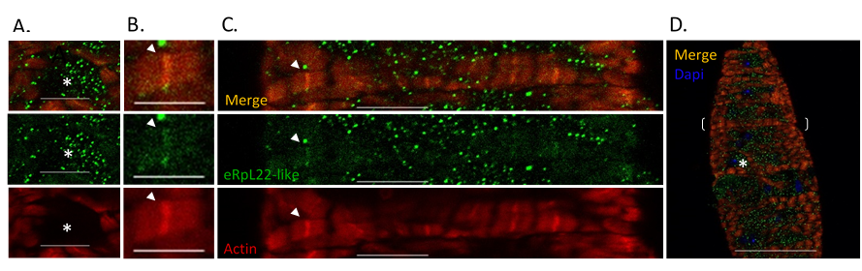

Figure S2
Figure S3
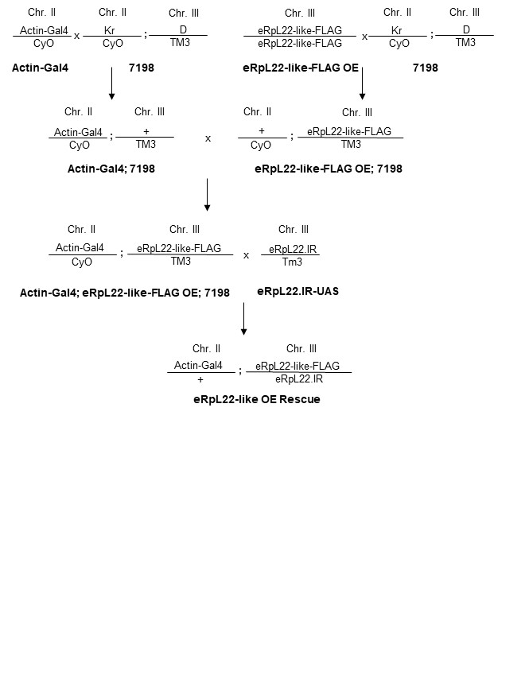
Supplemental Information
Figure S1. IHC of wildtype first instar larva gut. IHC of wildtype first instar larva gut. eRpL22-like (green) co-localizes with actin (red) in muscle (arrows) (B-C), does not co-localize in non-muscle regions of gut (asterisks) (A). Magnification: A) scale bar 10µm, B) scale bar 5µm, C) scale bar 10µm, D) scale bar 50µm.

Figure S2. Complete germline development is retained in eRpL22-like-depleted testes. A) Phase contrast microscopy of light (top) and heavy (bottom) testis squashes shows various stages of germline development in control (bam>GFP) and eRpL22-like-depleted tissue, including mitotic cells and primary spermatocytes (bracket), elongating spermatids (short open arrow), sperm bundles (long open arrow), and individual mature sperm (closed arrow). Asterisk denotes the apical tip, where germline stem cells are located and germline development begins. (10X magnification) B) IHC of eRpL22-like-depleted testis. eRpL22 (red) shows increased cytoplasmic co-localization with eRpL22-like (green) compared to eRpL22 in the control (wildtype). Degenerating cysts (arrowhead) are also evident in eRpL22-like-depleted testes. Asterisks denote apical tips. (20x magnification). Images in A and B are representative from numerous examples.

Figure S3. Schematic of eRpL22-like rescue cross strategy. Genotypes are listed on each chromosome and name of parent fly is shown in bold below genotypes.

