Sensitive Electrochemical Determination of Hydrogen Peroxide using Copper Nanoparticles in a Polyaniline Film on a Glassy Carbon Electrode
Jing Liangª, Maochao Weiª, Qiang Wang^{b}, Zongshan Zhao^{a,*}, Aifeng Liuª, Zhuanni Yu,^{b} and Yong Tianª
ªCAS Key Laboratory of Biobased Materials, Qingdao Institute of Bioenergy and Bioprocess Technology, Chinese Academy of Sciences, Qingdao 266101, China.
^{b} College of Chemistry and Pharmaceutical Sciences, Qingdao Agricultural University, Qingdao 266109, China.
*Corresponding author. Fax/Tel: +86 532-80662709, E-mail: zhaozs@qibebt.ac.cn.
SUPPLEMENTARY MATERIAL

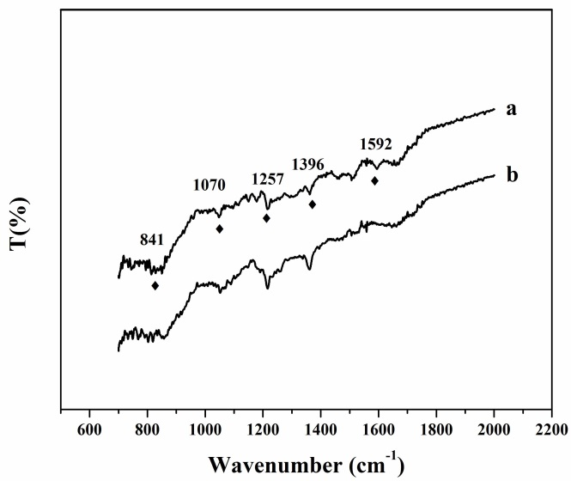
Figure S1. Fourier transform infrared spectra of polyaniline and polyaniline/Cu particles

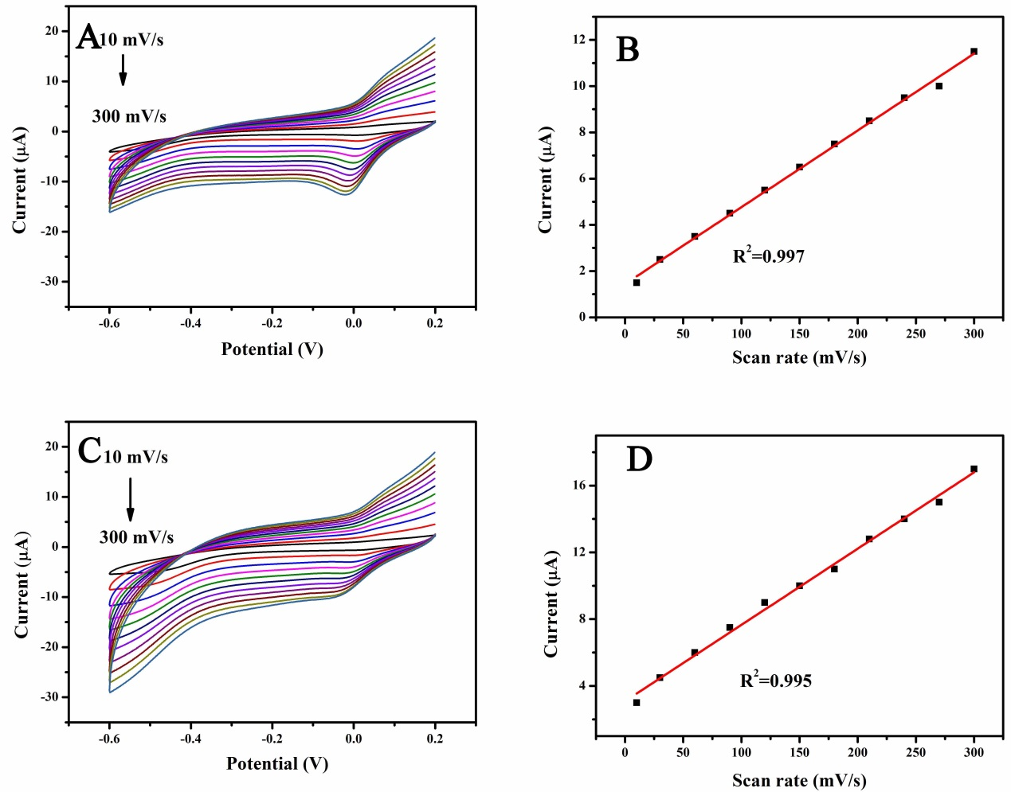
Figure S2. Cyclic voltammograms and plot of peak current versus scan rate.of H₂O₂ (0.1 M ) on polyaniline electrode (A, B) in buffer (pH 6.5) and polyaniline/Cu electrode (C, D) in H₂O₂ solution at scan rates of 10, 50, 100, 150, 200, 250 and 300 mV/s, respectively.

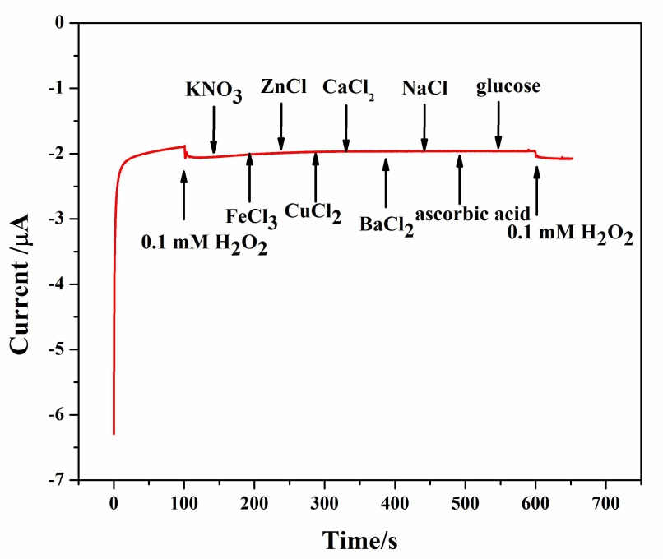
Figure S3. Influence of the potential co-existing species on polyaniline/Cu electrode.

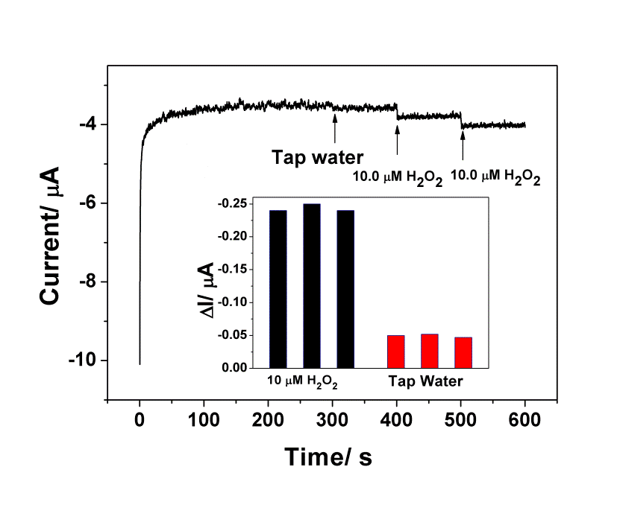
Figure S4. Amperometric responses of polyaniline/Cu electrode for detecting H₂O₂ in tap water samples

