Supporting information

Dipeptide-Modified Nanoparticles to Facilitate Oral Docetaxel Delivery: New Insights into PepT1-Mediated Targeting Strategy
Yuqian Duª, Chutong Tianª, Menglin Wangª, Di Huang^{b}, Wei Weiª, Yan Liuª, Lin Liª, Bingjun Sunª, Longfa Kouª, Qiming Kan^{c}, Kexin Liu^{b}, Cong Luoª, Jin Sun^{a,*}, Zhonggui He^{a,*}

a. Department of Pharmaceutics, Wuya College of Innovation, Shenyang Pharmaceutical University, Shenyang, P.R. China
b. Department of Clinical Pharmacology, School of Pharmacy, Dalian Medical University, Dalian, P.R. China
c. School of Life Science and Biopharmaceutics, Shenyang Pharmaceutical University, Shenyang, 110016, P. R. China

*Corresponding author:
Prof. Zhonggui He, PhD and Prof. Jin Sun, PhD
No. 59 Mailbox, Department of Pharmaceutics, Wuya College of Innovation, Shenyang Pharmaceutical University, 103 Wenhua Road, Shenyang 110016, China
Tel: +86-024-23986321; Fax: +86-024-23986321
E-mail address: hezhonggui@vip.163.com; sunjin@syphu.edu.cn
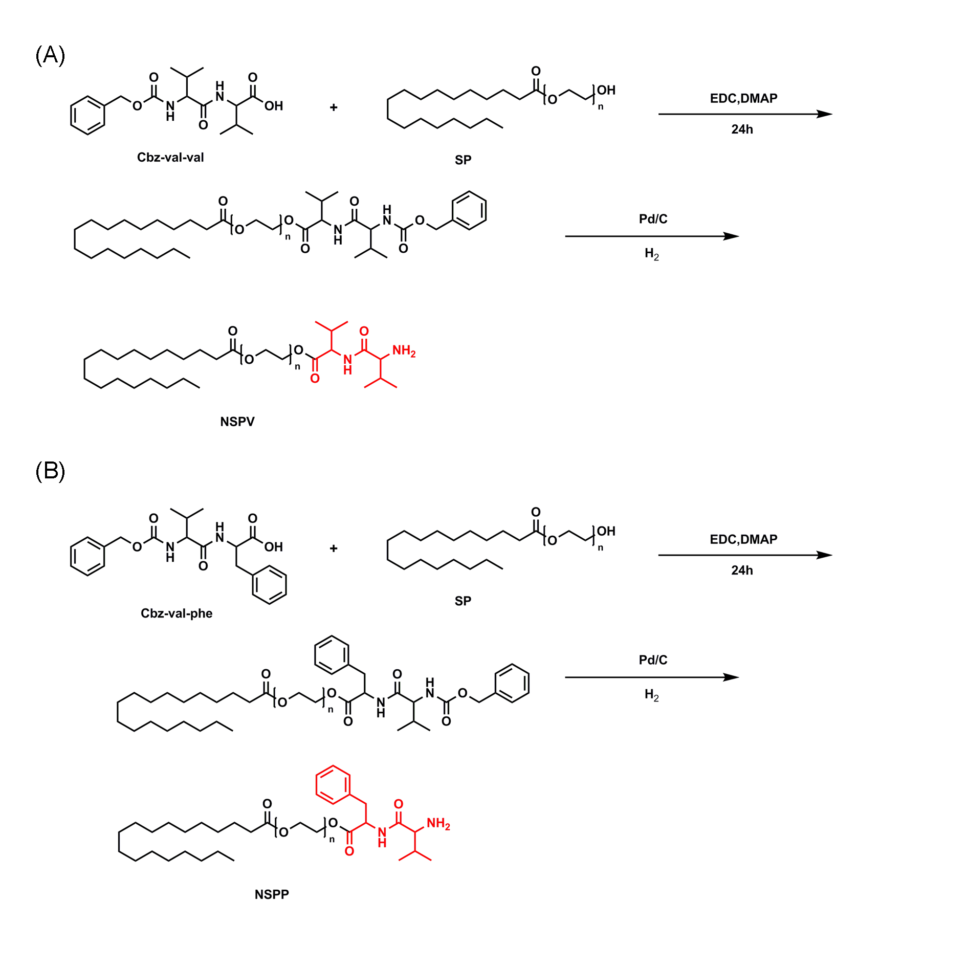
Figure S1. The synthesis routes of dipeptides (L-valine-valine, L-valine-phenylalanine) and polyoxyethylene n stearate (SPn) conjugates (n=25 or 40, representing PEG Mw: 1000 or 2000, respectively).

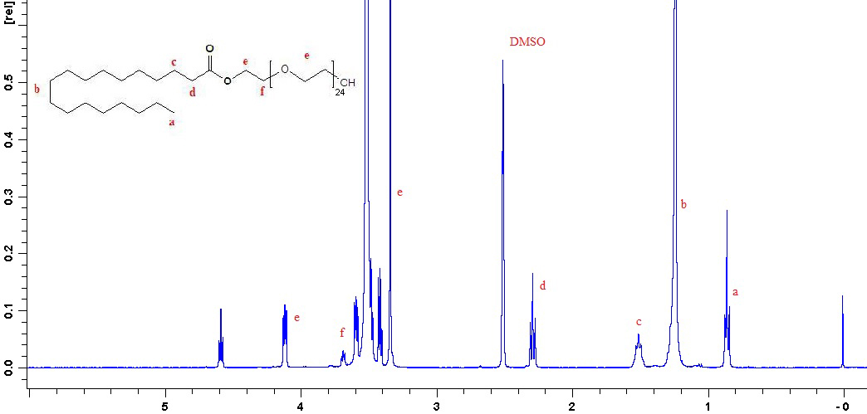
Figure S2. ¹H NMR spectrum of polyoxyethylene25 stearate (SP25).

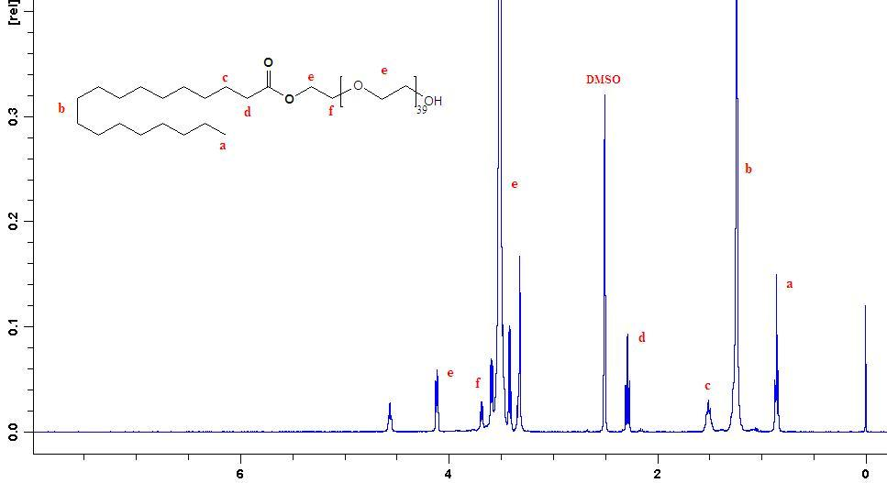
Figure S3. 1H NMR spectrum of polyoxyethylene40 stearate (SP40).

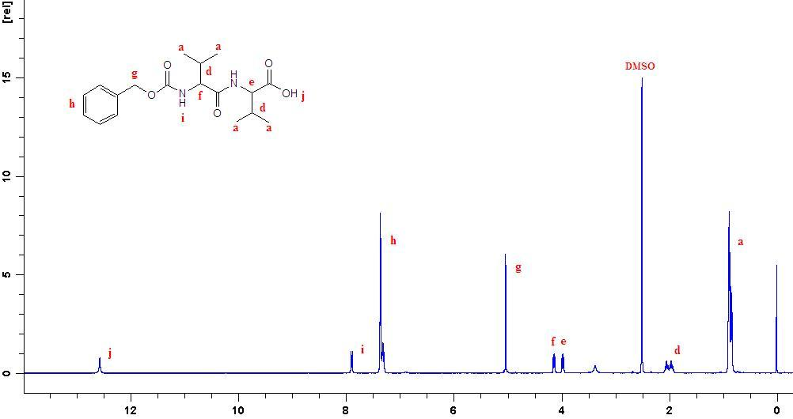
Figure S4. 1H NMR spectrum of Cbz-L-valine-valine.

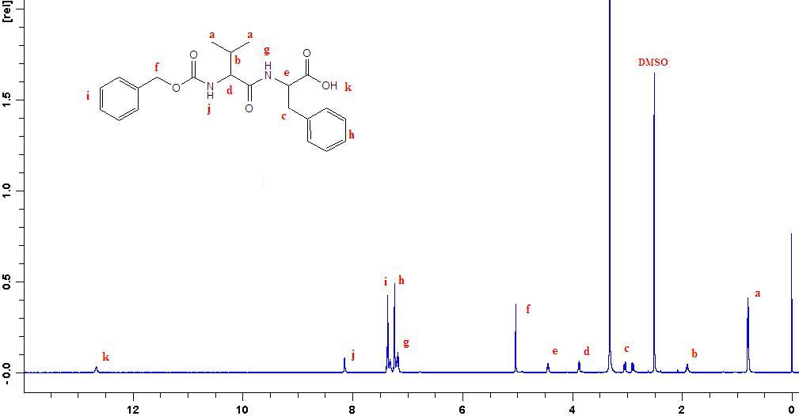
Figure S5. 1H NMR spectrum of Cbz-L-valine-phenylalanine.

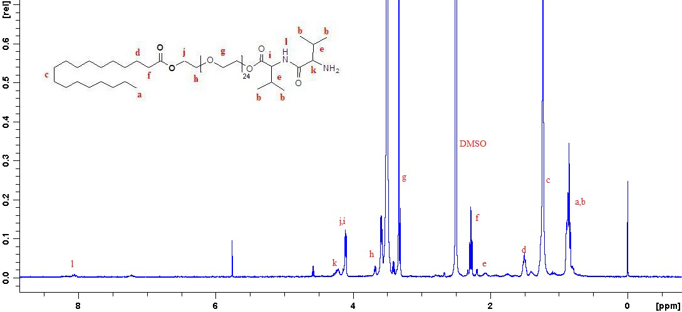
Figure S6. 1H NMR spectrum of NSPV1000 polymer (L-valine-valine and polyoxyethylene25 stearate conjugate, PEG Mw:1000).

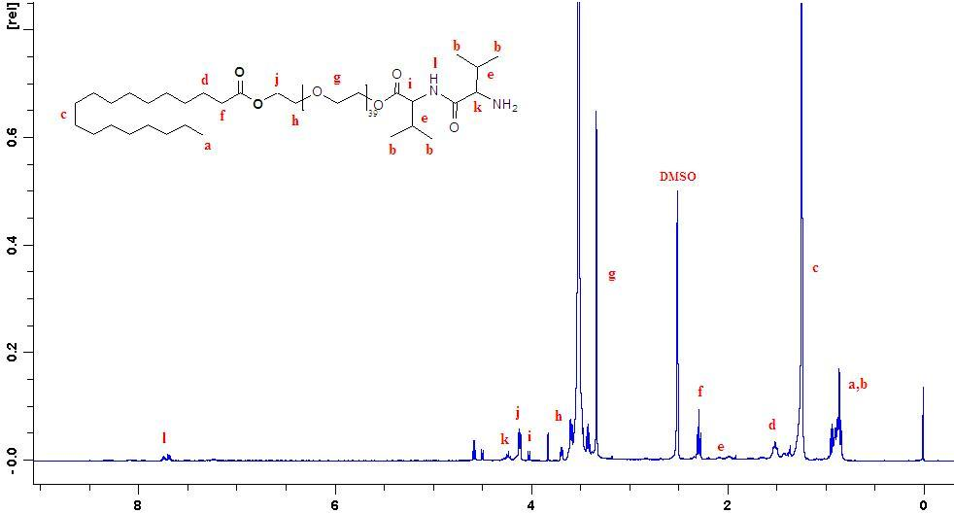
Figure S7. 1H NMR spectrum of NSPV2000 polymer (L-valine-valine and polyoxyethylene40 stearate conjugate, PEG Mw:2000).

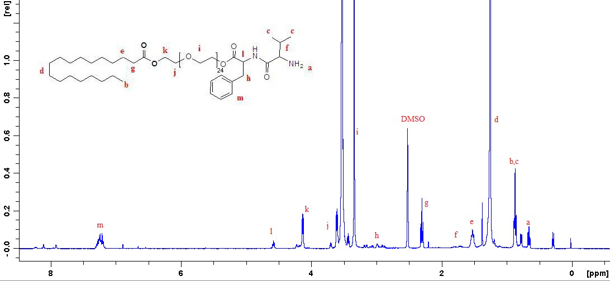
Figure S8. 1H NMR spectrum of NSPP1000 polymer (L-valine-phenylalanine and polyoxyethylene25 stearate conjugate, PEG Mw:1000).

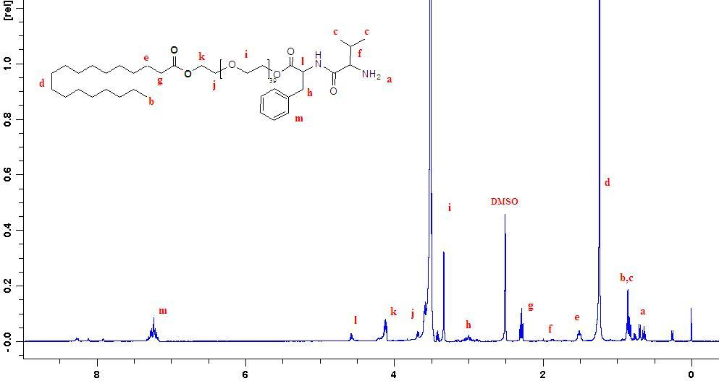
Figure S9. 1H NMR spectrum of NSPP2000 polymer (L-valine-phenylalanine and polyoxyethylene40 stearate conjugate, PEG Mw:2000).

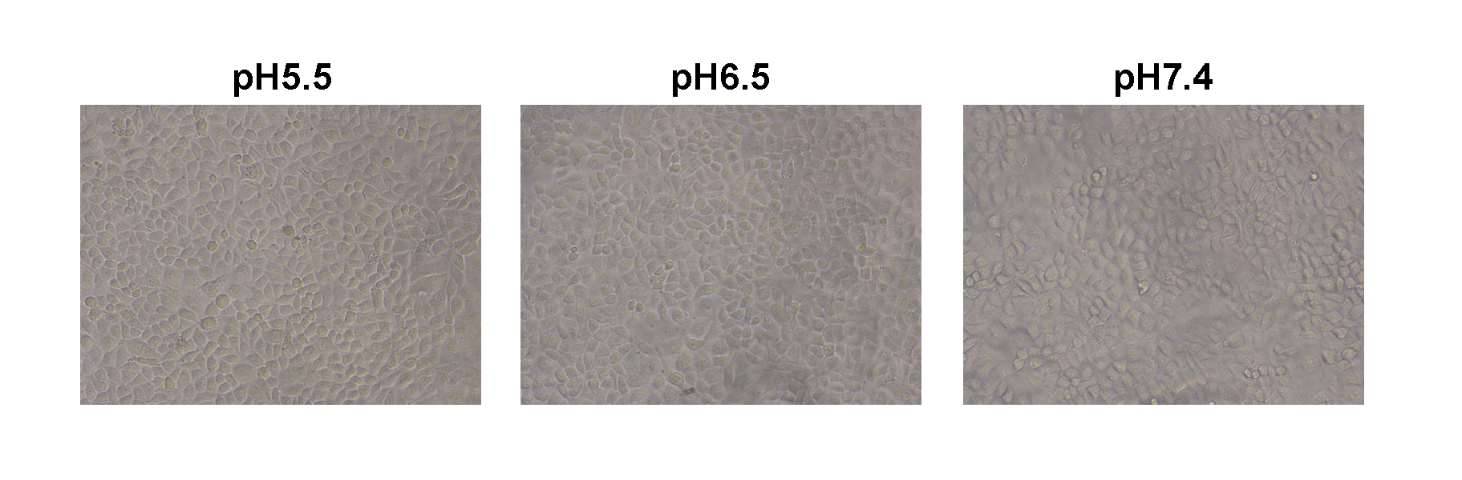
Figure S10. Cell morphology monitored by microscope under different pH conditions (pH 5.5, 6.5 and 7.4) after the experiments (Original magnification: ×100).
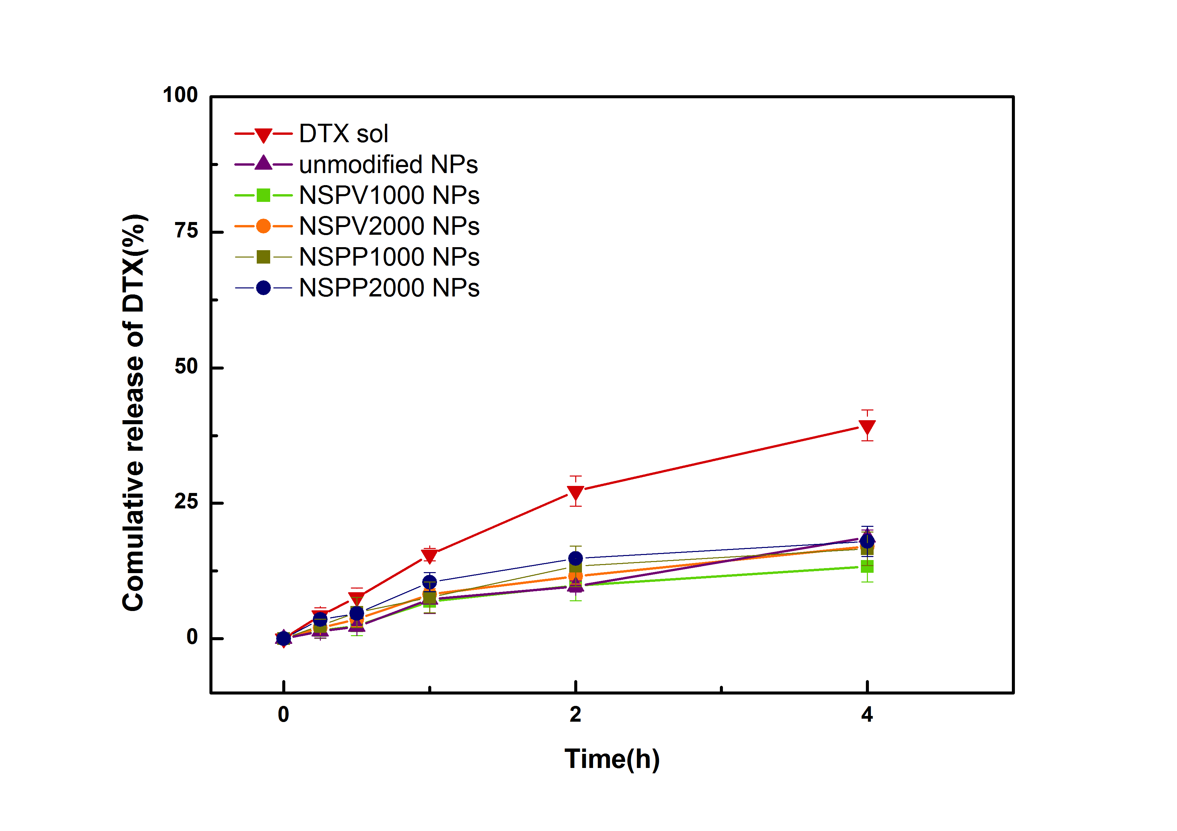
Figure S11. In vitro release of DTX solution, DTX-loaded unmodified NPs, NSPV1000 NPs, NSPV2000 NPs, NSPP1000 NPs and NSPP2000 NPs in pH 1.0 medium for 4 h. (Data are shown as mean ± SD, n=3).
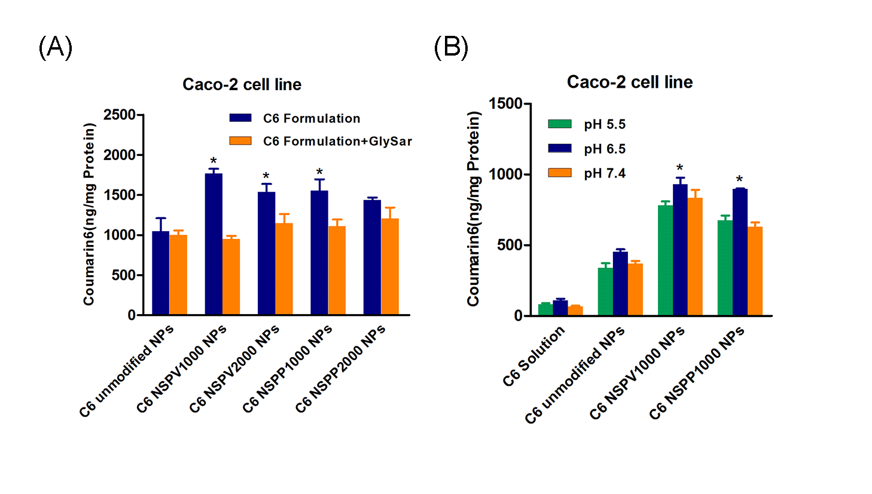
Figure S12. (A) Competitive study in Caco-2 cells in the presence of typical substrate GlySar (GS); (B) Influence of proton in the culture medium on the cellular uptake of dipeptide modified NPs in Caco-2 cells.
Table S1. Physical characterizations of DTX-loaded NPs (n=3)
NPs | Size (d.nm) | PDI | Zeta potential (mV) | DL (%) | EE (%)
Unmodified NPs | 159.7±4.9 | 0.046±0.028 | -4.05±0.25 | 5.01±0.35 | 92.45±1.52
NSPV1000 NPs | 165.6±4.4 | 0.030±0.029 | -2.79±0.16 | 5.58±0.25 | 89.90±0.53
NSPV2000 NPs | 169.4±4.5 | 0.027±0.027 | -2.44±0.25 | 4.94±0.15 | 85.50±1.34
NSPP1000 NPs | 167.8±5.6 | 0.016±0.016 | -3.77±0.24 | 5.46±0.34 | 88.57±1.57
NSPP2000 NPs | 170.6±2.4 | 0.054±0.038 | -2.23±0.11 | 4.84±0.08 | 83.65±2.47
Table S2. Pharmacokinetic parameters of DTX solution and DTX-loaded NPs
PK parameters | C_{max}(ng/mL) | T_{max}(h) | AUC₀₋₂₄(ng×h/mL) | t_{1/2}(h) | F_{R}(100%)
DTX solution | 38.14±6.14 | 0.31±0.13 | 44.72±15.87 | 2.05±0.99 | 100
Unmodified NPs | 24.53±16.84 | 1.60±0.89 | 100.67±33.88 | 5.25±2.42 | 225.11
NSPV1000 NPs | 46.09±19.53 | 1.75±1.50 | 196.15±30.55 | 10.58±3.28 | 438.62

