Electronic supplementary material - 3

Robust quantification of fish early life CO₂ sensitivities via serial experimentation Hannes Baumann, Emma L. Cross, and Christopher S. Murray

Reevaluation of experimental data using Hedges d instead of log-transformed response ratios as a metric for effect size

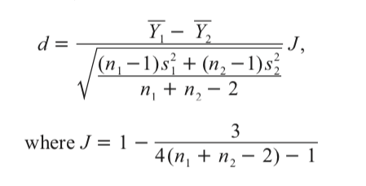
We computed effect sizes for all six traits and each of 20 experiments, using Hedges d following Prezlawski et al. (2015) as advocated for by Koricheva et al. (2013):
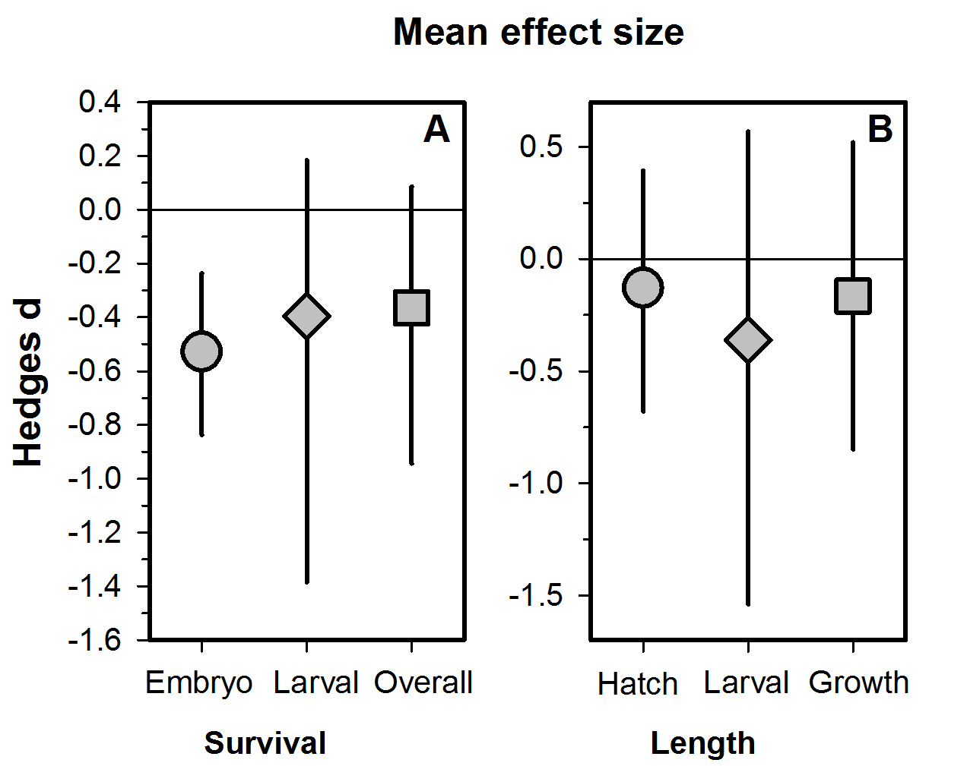
We then averaged all d and calculated bias-corrected, bootstrapped 95% confidence intervals. Using this metric resulted in qualitatively consistent results, i.e., we observed consistently negative mean d values, with the confidence intervals suggesting significant overall reductions in embryo survival (Fig.1).

Koricheva, J., Gurevitch, Jessica, & Mengersen, K. (2013). Handbook of meta-analysis in ecology and evolution. Princeton, NJ: Princeton University Press.
Przeslawski, Rachel, Byrne, Maria, & Mellin, Camille. (2015). A review and meta-analysis of the effects of multiple abiotic stressors on marine embryos and larvae. Global Change Biology, 21(6), 2122-2140. doi: 10.1111/gcb.12833

