Table S1: The effects of different concentration of apyrase on the level of extracellular ATP of the wounded and systemic leaves of the wound plants.
 |  | Application to the wounded leaves
apyrase (units/mL) | 1 |  | 5 | 10 | 20
 | ns |  | ns | 67.7%* | 52.9%* | Local leaves
 | ns |  | ns | ns | ns | Systemic leaves

The leaves were pre-treated with different concentration of apyrase as described in Materials and methods, and the level of extracellular ATP was measured at 0.5 h after wounding. The values of extracellular ATP in either the wounded or systemic leaves in the absence of apyrase was denoted as the 100% value. One leaf each obtained from different seedlings were used for one independent repeat of the experiment. Each value represents the mean of four independent experiments. ns- no significant effect. *–statistically significant difference from the treatment of apyrase ( P <0.05).

Table S2: The effects of different concentration of either DMTU or DPI on H₂O₂ content of the wounded and systemic leaves of the wound plants.
 | Application to the wounded leaves  ----------------------------------------------------- ---  ----------------------------------- |  |  |  | Application to leaf petiole of the wounded leaves  ----------------------------------------------------------------  -----------------------------------------------  -----------------------------------------------
DMTU(mmol/L) | 0.1 | 0.5 | 1 | 5 | 0.1 | 0.5 | 1 | 5
 | ns | ns | 71.1%* | 57.9%* | ns | ns | ns | ns | Local leaves
 | ns | ns | 74.3%* | 54.3%* | ns | ns | 65.7%* | 51.4%* | Systemic leaves
DPI(μmol/L) | 1 | 5 | 50 | 100 | 1 | 5 | 50 | 100
 | ns | ns | 76.2%* | 61.9%* | ns | ns | ns | ns | Local leaves
 | ns | ns | 81.6%* | 65.8%* | ns | ns | 57.9%* | 50.0%* | Systemic leaves
The values of the H₂O₂ content in either the wounded or systemic leaves in the absence of DMTU and DPI was denoted as the 100% value. Two to 3 leaves each obtained from different seedlings were pooled as one sample for one independent repeat of the experiment. Each value represents the mean of four independent experiments. ns- no significant effect. *–statistically significant difference from the treatment of either DMTU or DPI ( P <0.05).

Table S3: The effects of different concentration of either DMTU or DPI on H₂O₂ content of the ATP-treated and systemic leaves of the ATP-treated plants.
 | Application to the ATP-treated leaves  --------------------------------------------------- ---  ----------------------------------- |  |  |  | Application to leaf petiole of the  ATP-treated leaves  ----------------------------------------------------------------  -----------------------------------------------  -----------------------------------------------
DMTU(mmol/L) | 0.1 | 0.5 | 1 | 5 | 0.1 | 0.5 | 1 | 5
 | ns | ns | 77.4%* | 67.7%* | ns | ns | ns | ns | Local leaves
 | ns | ns | 82.1%* | 71.4%* | ns | ns | 75.0%* | 64.3%* | Systemic leaves
DPI(μmol/L) | 1 | 5 | 50 | 100 | 1 | 5 | 50 | 100
 | ns | ns | 73.5%* | 61.8%* | ns | ns | ns | ns | Local leaves
 | ns | ns | 70.4%* | 59.3%* | ns | ns | 66.7%* | 55.6%* | Systemic leaves

The values of the H₂O₂ content in either the ATP-treated or systemic leaves in the absence of DMTU and DPI was denoted as the 100% value. Each value represents the mean of four independent experiments. ns- no significant effect. *–statistically significant difference from the treatment of either DMTU or DPI ( P <0.05).

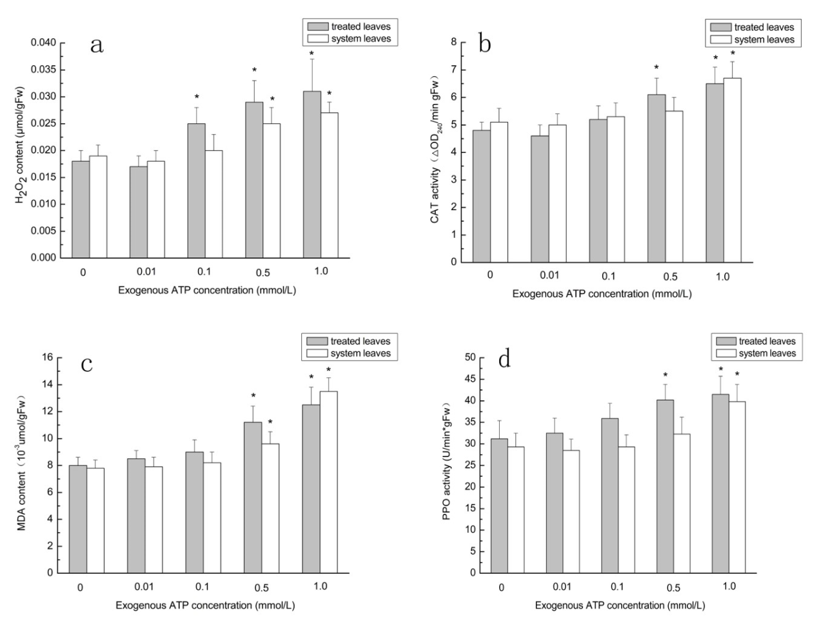

Fig S1. The effects of the treatment with different concentration of exogenous ATP on the H₂O₂ content(a), CAT activity(b), MDA content(c), and PPO activity(d) of the ATP-treated leaves and systemic leaves.
The H₂O₂ content, CAT activity, MDA content, and PPO activity were measured, respectively, at 0.5 h, 1 h, 2 h, 1 h after the exogenous ATP treatment. Two to 3 leaves each obtained from different seedlings were pooled as one sample for one independent repeat of the experiment. The values represent means of at least four individual experiments. * - statistically significant differences between the controls (0 mM ATP) and the ATP-treated plants (P < 0.05).

