SUPPLEMENTARY MATERIAL
Isoquinoline Alkaloids from Asimina triloba
Taghreed A. Majrashi^{a,b,c}, Fazila Zulfiqarª, Amar G. Chittiboyinaª, Zulfiqar Aliª, and Ikhlas A. Khan^{a,b*}
ªNational Center for Natural Products Research, School of Pharmacy, University of Mississippi, University, MS 38677, USA
^{b}Department of Biomolecular Sciences, Research Institute of Pharmaceutical Sciences, School of Pharmacy, University of Mississippi, University, MS 38677, USA
^{c}College of Pharmacy, King Khalid University, Abha, Saudi Arabia
*Email: ikhan@olemiss

ABSTRACT
A new aporphine glycoside, (-)-anolobine-9-O-β-D-glucopyranoside was isolated from the twigs of pawpaw (Asimina triloba) along with 7 known alkaloids including five aporphine alkaloids (anolobine, nornuciferine, norushinsunine, liriodenine, and lysicamine), a proaporhine alkaloid (stepharine) and a tetrahydrobenzylisoquinoline alkaloid (coclaurine). Among these compounds, nornuciferine, lysicamine, stepharine, and coclaurine are reported for the first time from this plant. The structure of the new compound was elucidated by spectroscopic methods, including 1D, 2D NMR, and HRESI-​MS. The absolute configuration of compounds 1, 2, 7 and 8 was determined by CD experiment.

Keywords: Annonaceae, Asimina triloba, Anolobine-9-O-β-D-glucopyranoside, Aporphine, Alkaloids, NMR.

Figure S1: Key HMBC (→) and COSY (▬) correlations of 1

Figure S2: CD spectra of anolobine-9-O-β-D-glucopyranoside 1 and its aglycone (anolobine 2)

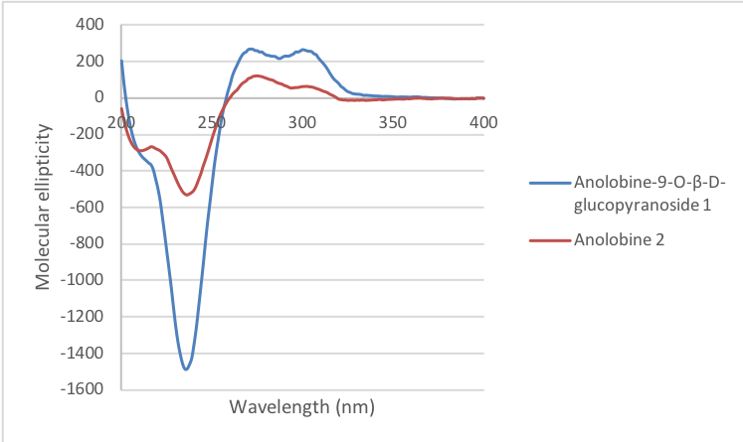

Figure S3: CD spectrum of stepharine (7)
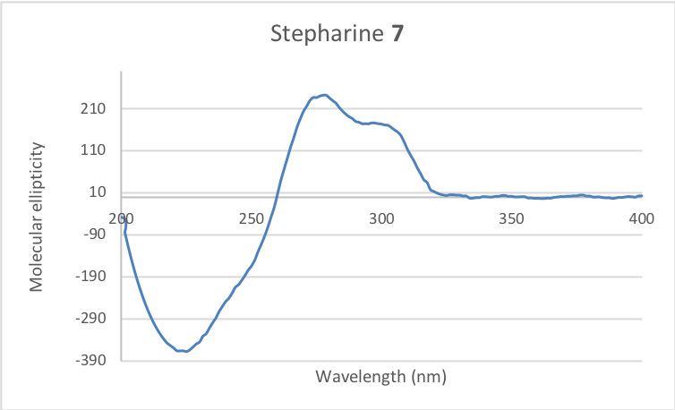

Figure S4: CD spectrum of coclaurine (8)
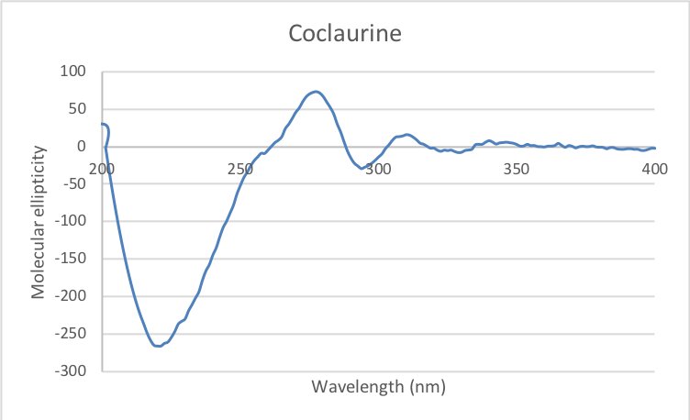

Table S1: ¹H and ¹³C NMR data of anolobine-9-O-β-D-glucopyranoside (1) (DMSO-d₆, 500 MHz/150 MHz)
No. | Mult. | δ ¹³C [ppm] | δ ¹H [ppm]
1 | C | 141.7 | -
2 | C | 146.5 | -
3 | CH | 107.7 | 6.60 (s)
3a | C | 127.6
4 | CH₂ | 29.5 | 2.53 (m)  2.79 (m)
5 | CH₂ | 43.3 | 2.77 (m)  3.15 (m)
6a | CH | 53.5 | 3.69 (overlapped)
7 | CH₂ | 37.1 | 2.57 (t, J = 14.5, H-7α),  2.83 (dd, J = 14.5, 4.8 Hz, H-7β)
7a | C | 137.7 | -
8 | CH | 116.3 | 6.97 (d, J = 2.3 Hz)
9 | C | 157.1 | -
10 | CH | 115.6 | 6.98 (dd, J = 9.4, 2.3 Hz)
11 | CH | 128.1 | 7.90 (d, J = 9.4 Hz)
11a | C | 125.0 | -
11b | C | 115.0 | -
11c | C | 128.5 | -
OCH₂O | CH₂ | 100.8 | 5.96, 6.09 (each brd. s)
1' | CH | 100.9 | 4.90 (d, J = 7.5 Hz)
2' | CH | 73.7 | 3.23 - 3.31 (overlapped)
3' | CH | 77.1 | 3.23 - 3.31 (overlapped)
4' | CH | 70.2 | 3.18 (t, J = 9.1 Hz)
5' | CH | 77.6 | 3.35 (ddd, J = 9.1, 5.8, 2.1 Hz)
6' | CH₂ | 61.1 | 3.69 (overlapped)  3.48 (dd, J =11.9, 5.8 Hz)

Original spectra for compound 1
¹H NMR (500 MHz, DMSO-d₆):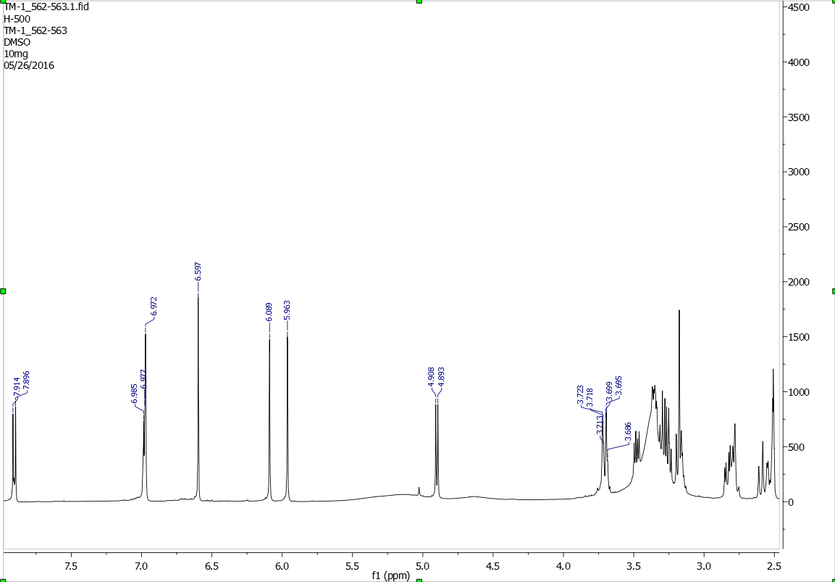

¹³C NMR (125 MHz, DMSO-d6):
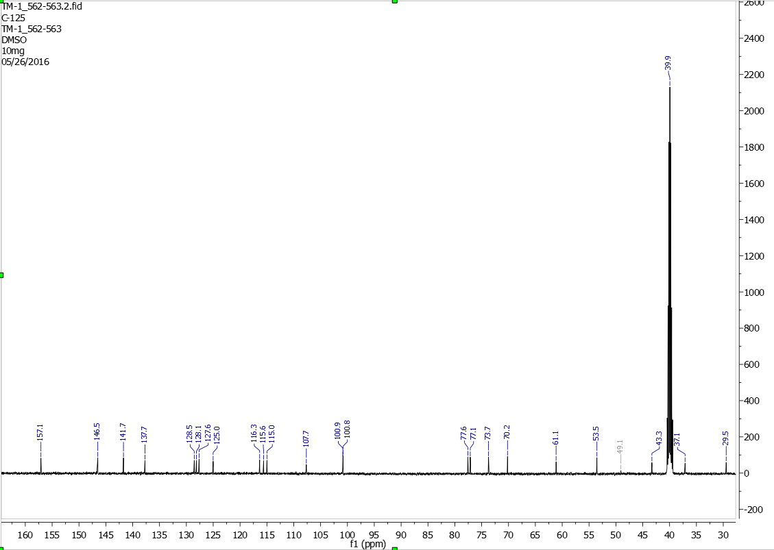

DEPT 135:
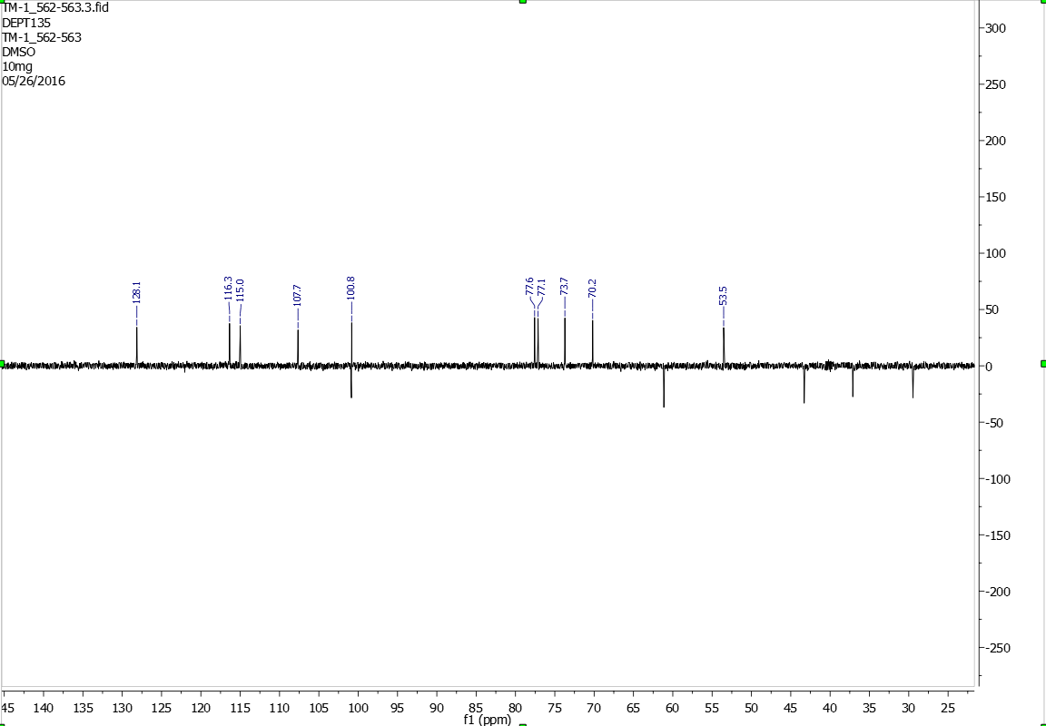

HSQC:
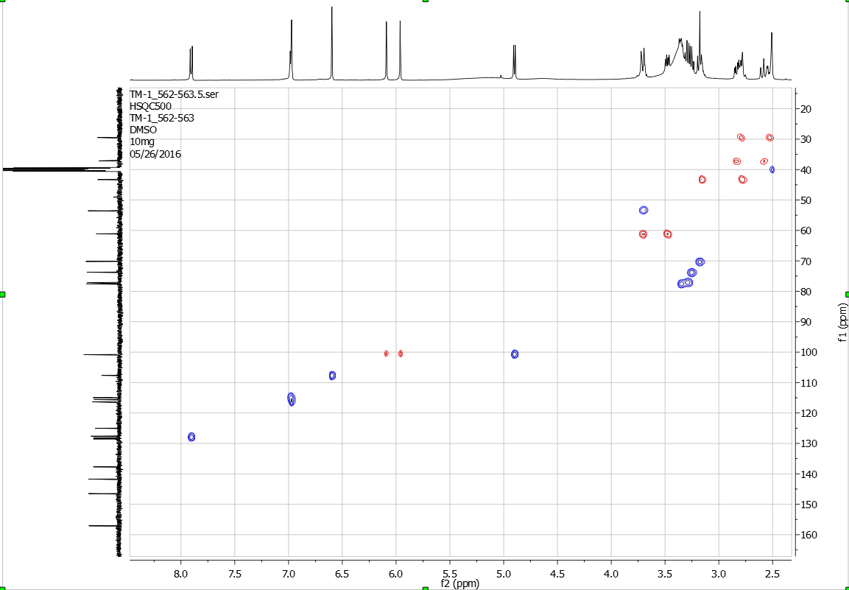

H-H COSY:
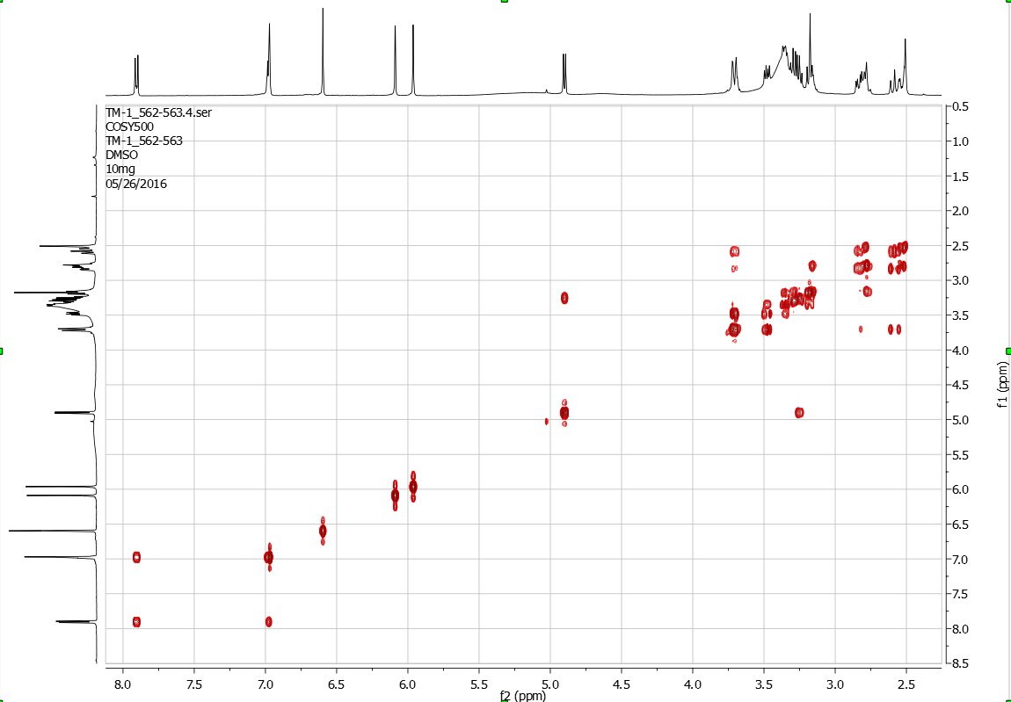

HMBC:
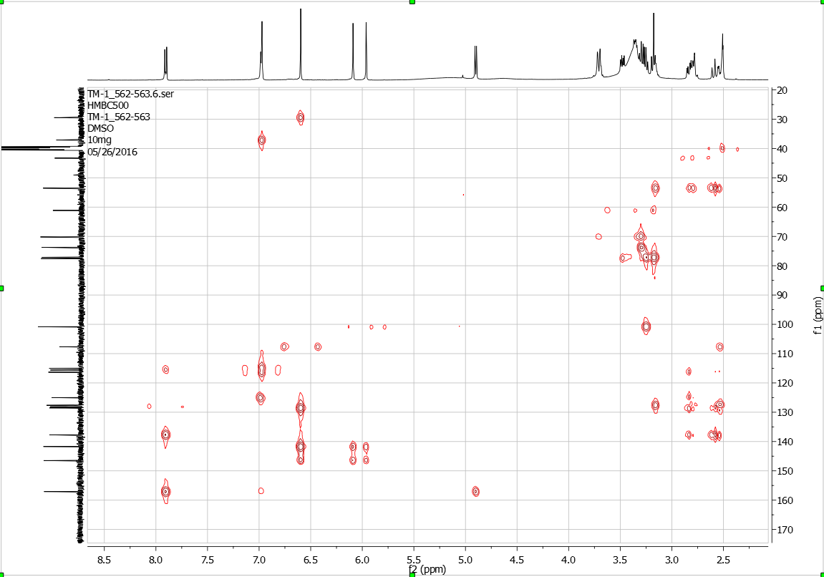

IR (KBr):
