Supplementary file nestedness

Equations 1-4



(1)

J= H/ln(S)

**(**2)

R=(S-1)/ln N (3)

$$D=\sum_{i=1}^{s}{{\left(\frac{N_{i}}{N}\right)}^{2}}$$ (4)

Where

n- Importance value for each species

N-Total importance values

S- Total number of species in the community

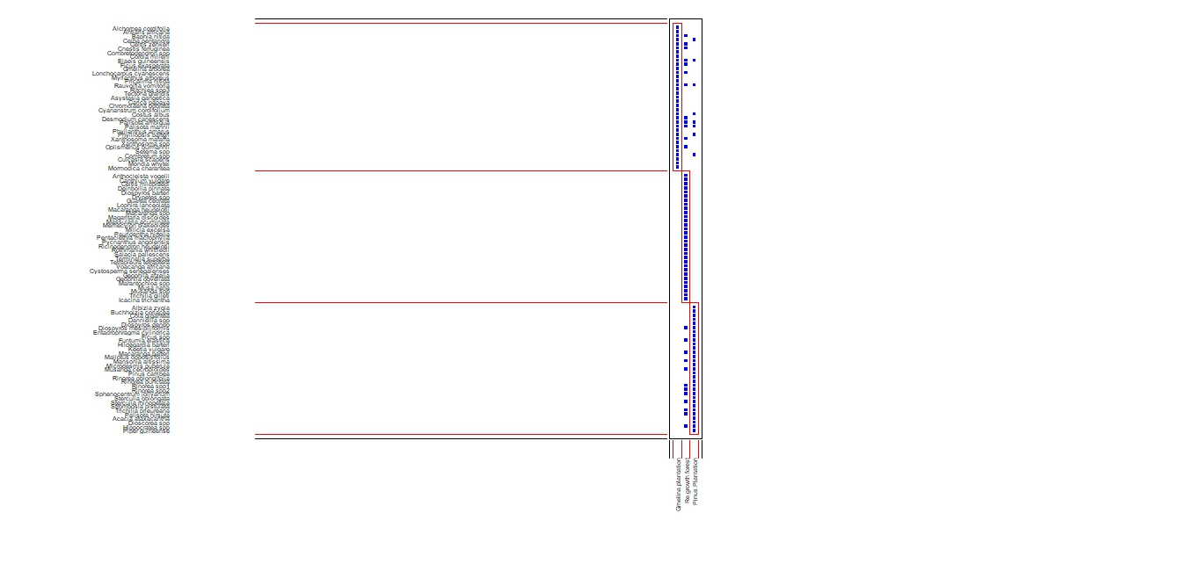

Modules Images