Supplementary Materials for

Ductility by shear band delocalization in the nano-layer of gradient structure
Fuping Yuan^{a,b}, Dingshun Yanª, JiangDa. Sunª, Lingling Zhou ª, Yuntian. Zhu^{c,d*}, and Xiaolei Wu^{a,b*}

ªState Key Laboratory of Nonlinear Mechanics,
Institute of Mechanics, Chinese Academy of Science,
15 Beisihuan West Road, Beijing 100190, China

^{b}School of Engineering Science, University of Chinese Academy of Sciences,
19A Yuquan road, Beijing 100049, China

^{c}Nano Structural Materials Center, School of Materials Science and Engineering,
Nanjing University of Science and Technology,
200 Xiaolingwei, Nanjing 210094, China

^{d}Department of Materials Science and Engineering, North Carolina State University,
Campus Box 7919, Raleigh, NC 27695, USA

Digital image correlation imaging

The digital image correlation (DIC) imaging was attached to provide a large optical field-of-view with representative statistics on the top NS surface of GS samples. The DIC tensile tests were also conducted in CG samples for comparison. The specific commercial VIC-2D software was utilized for DIC data analysis and strain-field calculation. The longitudinal (axial) strains ($ε_{L}$) in the gauge section were recorded continuously with increasing applied tensile strain ($ε_{app}$). The localized strain rate (${\dot{ε}}_{L}$) was also calculated in terms of ${{\dot{ε}}_{L}=∂ε}/{∂t}$. Also, the interrupted DIC tensile tests were conducted for the microstructural observations, texture analysis, and Vickers micro-hardness (Hv) measurements in the NS surface layer.

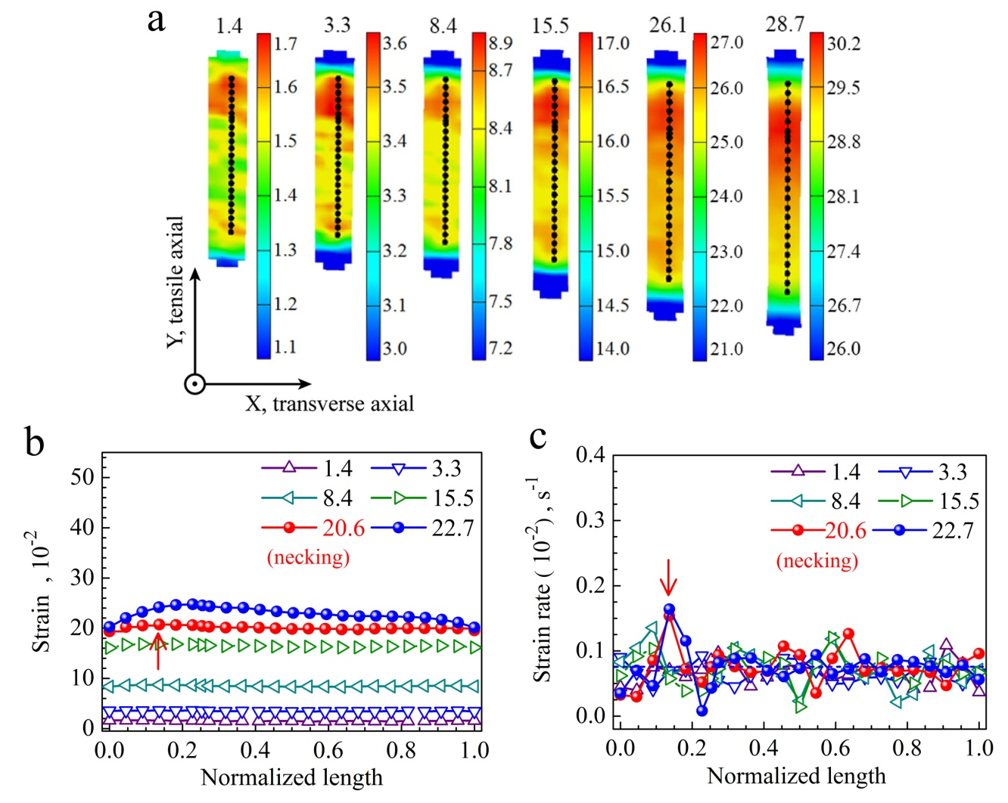
Fig. S1 Tensile deformation in homogeneous CG sample. (a) Longitudinal strain ($ε_{L}$) contour maps at varying applied strains ($ε_{app}$). Number above each contour: $ε_{app}$, %. Scale bar: the range of $ε_{L}$ inside each contour. Two numbers at both ends: maximum and minimum of $ε_{L}$. (b) and (c) Distribution of both $ε_{L}$ and ${\dot{ε}}_{L}$. Horizontal dashed line in (C) applied strain rate of 8×10⁻⁴ s⁻¹.

During uniform tensile deformation, $ε_{L}$ is almost uniform, even more or less waved (Fig. 2d), and equal to $ε_{app}$ everywhere along the line in the gauge section. ${\dot{ε}}_{L}$ is also uniform, equal to ${\dot{ε}}_{app}$. Upon diffused necking at E_{U} of 26% ( in Fig. 2b), $ε_{L}$ rises moderately (indicated by an arrow in Fig. 2b) at the place where the neck is (arrow in Fig. 2b), but with an evident rise of ${\dot{ε}}_{L}$.

