Appendix A
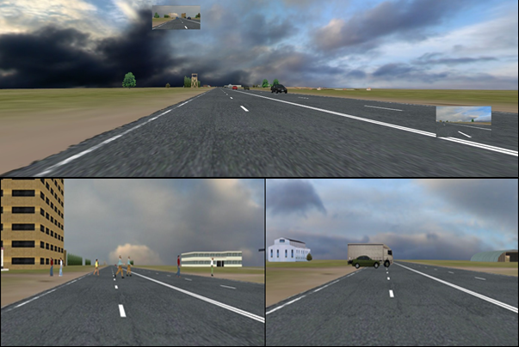
Figure I Illustration of scenario and the sudden events: Pedestrian crossing and road crossing by parked vehicles (Choudhary and Velaga, 2017c).

Table I Pairwise comparisons for pre-detection phase with respect to driving conditions.
Driver Category | Driving Conditions |  | Mean Difference (I-J) | S. E. | p-value | 95% Confidence Interval for Difference
 | I | J |  |  |  | Lower Bound | Upper Bound
Professional | BL | ST | -1.73* | 0.30 | <0.001 | -2.49 | -0.98
 |  | LT | -1.93* | 0.23 | <0.001 | -2.49 | -1.37
 | ST | BL | 1.73* | 0.30 | <0.001 | 0.98 | 2.49
 |  | LT | -0.20 | 0.31 | 1.00 | -0.97 | 0.58
 | LT | BL | 1.93* | 0.23 | <0.001 | 1.37 | 2.49
 |  | ST | 0.20 | 0.31 | 1.00 | -0.58 | 0.97
Young | BL | ST | -1.70* | 0.30 | <0.001 | -2.44 | -0.97
 |  | LT | -1.75* | 0.22 | <0.001 | -2.30 | -1.20
 | ST | BL | 1.70* | 0.30 | <0.001 | 0.97 | 2.44
 |  | LT | -0.05 | 0.31 | 1.00 | -0.80 | 0.71
 | LT | BL | 1.75* | 0.22 | <0.001 | 1.20 | 2.30
 |  | ST | 0.05 | 0.31 | 1.00 | -0.71 | 0.80
Note: *. The mean difference is significant at 0.05 level; BL=Baseline; ST=Short text; LT=Long text; S.E.=Standard Error.

