**Supporting Information**

**PEG-400 promoted a simple, efficient and recyclable catalyst for the one-pot eco-friendly synthesis of functionalized isoxazole substituted pyrroles in aqueous medium**

Rajasekhar Ponduri*a,b, Pramod Kumara, and Lakshmana Rao Vadalib

aJNTU-H College of Engineering, CCST, IST, Kukatpally, Hyderabad-500085, Telangana State, India; bMylan Laboratories Limited, Bollaram, Jinnaram (Mandal), Medak (Dist), Hyderabad, Telangana State, India

*E-mail:* [rajasekharponduri333@gmail.com](mailto:rajasekharponduri333@gmail.com)

**Contents**

**Characterization Data for the Products S12-S113**

**Copies of** **1H and 13C NMR spectra of products S114-S134**

**(*E*)-Ethyl-1-(5-(4-chlorostyryl)-3-methylisoxazol-4-yl)-2-methyl-4-phenyl-1*H*-pyrrole-3-carboxylate (3b):**



Yield: 80%, mp 152-154 oC. IR (KBr): 3058, 2960, 1645, 1472, 1078 cm-1, 1H NMR (300 MHz, CDCl3): *δ* 7.64-7.21 (m, 9H), 6.85 (s, 1H), 6.72 (d, *J* = 12 Hz, 1H), 6.61 (d, *J* = 12 Hz, 1H), 4.19 (q, *J* = 7.2 Hz, 2H), 2.42 (s, 3H), 2.20 (s, 3H), 1.14 (t, *J* = 7.2 Hz, 3H); 13C NMR (75 MHz, CDCl3): *δ* 164.7, 158.2, 154.1, 138.8, 137.6, 135.5, 134.5, 132.3, 129.8, 128.8, 128.3, 127.5, 126.3, 123.0, 122.5, 118.5, 113.1, 100.2, 59.7, 15.5, 13.2, 11.6. HRMS (ESI-MS) calcd for C26H23ClN2NaO3 (M+Na)+ 469.1295,found 469.1295.

**(*E*)-Ethyl-1-(5-(2-chlorostyryl)-3-methylisoxazol-4-yl)-2-methyl-4-phenyl-1*H*-pyrrole-3-carboxylate (3c):**



Yield: 75%, mp 157-159 oC. IR (KBr): 3065, 2958, 1649, 1470, 1080 cm-1, 1H NMR (300 MHz, CDCl3): *δ* 7.64-7.22 (m, 9H), 6.90 (s, 1H), 6.70 (d, *J* = 12 Hz, 1H), 6.61 (d, *J* = 12 Hz, 1H), 4.20 (q, *J* = 7.2 Hz, 2H), 2.38 (s, 3H), 2.21 (s, 3H), 1.12 (t, *J* = 7.2 Hz, 3H); 13C NMR (75 MHz, CDCl3): *δ* 164.9, 158.6, 154.2, 138.3, 137.1, 135.6, 134.1, 133.2, 129.8, 129.2, 128.6, 128.2, 127.8, 127.2, 126.1, 123.3, 122.2, 118.7, 113.3, 100.3, 60.2, 15.2, 13.5, 11.4. HRMS (ESI-MS) calcd for C26H23ClN2NaO3 (M+Na)+ 469.1295,found 469.1299.

**(*E*)-Ethyl-1-(5-(4-bromostyryl)-3-methylisoxazol-4-yl)-2-methyl-4-phenyl-1*H*-pyrrole-3-carboxylate (3d):**



Yield: 85%, mp 160-162 oC. IR (KBr): 3051, 2958, 1648, 1478, 1082 cm-1, 1H NMR (300 MHz, CDCl3): *δ* 7.62-7.20 (m, 9H), 6.89 (s, 1H), 6.70 (d, *J* = 12 Hz, 1H), 6.62 (d, *J* = 12 Hz, 1H), 4.24 (q, *J* = 7.2 Hz, 2H), 2.41 (s, 3H), 2.25 (s, 3H), 1.28 (t, *J* = 7.2 Hz, 3H); 13C NMR (75 MHz, CDCl3): *δ* 164.4, 157.5, 154.7, 138.7, 136.5, 135.4, 134.4, 131.4, 129.8, 128.9, 128.5, 127.4, 126.3, 123.5, 122.8, 118.2, 113.5, 100.1, 60.1, 15.3, 13.6, 11.1. HRMS (ESI-MS) calcd for C26H23BrN2NaO3 (M+Na)+ 513.0790,found 513.0790.

**(*E*)-Ethyl-1-(5-(2-bromostyryl)-3-methylisoxazol-4-yl)-2-methyl-4-phenyl-1*H*-pyrrole-3-carboxylate (3e):**



Yield: 74%, mp 165-167 oC. IR (KBr): 3065, 2955, 1643, 1472, 1081 cm-1, 1H NMR (300 MHz, CDCl3): *δ* 7.63-7.21 (m, 9H), 6.80 (s, 1H), 6.72 (d, *J* = 12 Hz, 1H), 6.60 (d, *J* = 12 Hz, 1H), 4.23 (q, *J* = 7.2 Hz, 2H), 2.41 (s, 3H), 2.19 (s, 3H), 1.16 (t, *J* = 7.2 Hz, 3H); 13C NMR (75 MHz, CDCl3): *δ* 165.2, 157.2, 154.7, 138.1, 136.6, 135.3, 134.4, 132.6, 129.9, 129.1, 128.8, 128.4, 127.6, 127.1, 126.8, 123.2, 122.4, 118.4, 113.6, 100.1, 60.1, 15.8, 13.2, 11.8. HRMS (ESI-MS) calcd for C26H23BrN2NaO3 (M+Na)+ 513.0790,found 513.0798.

**(*E*)-Ethyl-1-(5-(4-fluorostyryl)-3-methylisoxazol-4-yl)-2-methyl-4-phenyl-1*H*-pyrrole-3-carboxylate (3f):**



Yield: 80%, mp 148-150 oC. IR (KBr): 3065, 2957, 1648, 1470, 1085 cm-1, 1H NMR (300 MHz, CDCl3): *δ* 7.62-7.22 (m, 9H), 6.88 (s, 1H), 6.70 (d, *J* = 12 Hz, 1H), 6.62 (d, *J* = 12 Hz, 1H), 4.31 (q, *J* = 7.2 Hz, 2H), 2.41 (s, 3H), 2.24 (s, 3H), 1.11 (t, *J* = 7.2 Hz, 3H); 13C NMR (75 MHz, CDCl3): *δ* 165.6, 161.1, 157.3, 154.4, 138.3, 136.7, 135.7, 134.3, 129.9, 128.9, 128.5, 127.3, 123.5, 122.0, 119.3, 116.7, 113.9, 100.3, 61.5, 15.7, 13.1, 11.3. HRMS (ESI-MS) calcd for C26H23FN2NaO3 (M+Na)+ 453.1590,found 453.1599.

**(*E*)-Ethyl-2-methyl-1-(3-methyl-5-(4-nitrostyryl)isoxazol-4-yl)-4-phenyl-1*H*-pyrrole-3-carboxylate (3g):**



Yield: 75%, mp 151-153 oC. IR (KBr): 3073, 2963, 1645, 1470, 1081 cm-1, 1H NMR (300 MHz, CDCl3): *δ* 7.64-7.20 (m, 9H), 6.87 (s, 1H), 6.71 (d, *J* = 12 Hz, 1H), 6.61 (d, *J* = 12 Hz, 1H), 4.20 (q, *J* = 7.2 Hz, 2H), 2.41 (s, 3H), 2.19 (s, 3H), 1.13 (t, *J* = 7.2 Hz, 3H); 13C NMR (75 MHz, CDCl3): *δ* 164.4, 158.2, 154.6, 144.6, 139.4, 137.8, 136.8, 135.4, 134.3, 129.6, 128.6, 127.7, 126.5, 123.3, 122.8, 118.5, 113.7, 100.1, 59.6, 15.6, 13.3, 11.4. HRMS (ESI-MS) calcd for C26H23N3NaO5 (M+Na)+ 480.1535,found 480.1540.

**(*E*)-Ethyl-2-methyl-1-(3-methyl-5-(4-methylstyryl)isoxazol-4-yl)-4-phenyl-1*H*-pyrrole-3-carboxylate (3h):**



Yield: 92%, mp 144-146 oC. IR (KBr): 3061, 2964, 1649, 1470, 1081 cm-1, 1H NMR (300 MHz, CDCl3): *δ* 7.63-7.22 (m, 9H), 6.90 (s, 1H), 6.70 (d, *J* = 12 Hz, 1H), 6.62 (d, *J* = 12 Hz, 1H), 4.25 (q, *J* = 7.2 Hz, 2H), 2.43 (s, 3H), 2.33 (s, 3H), 2.23 (s, 3H), 1.12 (t, *J* = 7.2 Hz, 3H); 13C NMR (75 MHz, CDCl3): *δ* 164.6, 158.4, 154.6, 138.7, 137.3, 136.6, 135.7, 134.3, 129.6, 128.5, 128.3, 127.6, 126.4, 123.7, 122.4, 118.6, 113.7, 100.0, 60.4, 24.8, 15.4, 13.6, 11.2. HRMS (ESI-MS) calcd for C27H26N2NaO3 (M+Na)+ 449.1841,found 449.1847.

**(*E*)-Ethyl-2-methyl-1-(3-methyl-5-(2-methylstyryl)isoxazol-4-yl)-4-phenyl-1*H*-pyrrole-3-carboxylate (3i):**



Yield: 80%, mp 141-143 oC. IR (KBr): 3070, 2961, 1645, 1473, 1079 cm-1, 1H NMR (300 MHz, CDCl3): *δ* 7.63-7.21 (m, 9H), 6.88 (s, 1H), 6.71 (d, *J* = 12 Hz, 1H), 6.61 (d, *J* = 12 Hz, 1H), 4.20 (q, *J* = 7.2 Hz, 2H), 2.44 (s, 3H), 2.36 (s, 3H), 2.21 (s, 3H), 1.14 (t, *J* = 7.2 Hz, 3H); 13C NMR (75 MHz, CDCl3): *δ* 164.6, 158.1, 154.7, 138.4, 137.1, 136.2, 135.4, 134.5, 129.7, 128.9, 128.2, 127.8, 127.3, 126.4, 125.4, 123.3, 122.4, 118.1, 113.3, 100.1, 59.7, 24.1, 15.6, 13.2, 11.5. HRMS (ESI-MS) calcd for C27H26N2NaO3 (M+Na)+ 449.1841,found 449.1841.

**(*E*)-Ethyl-1-(5-(4-methoxystyryl)-3-methylisoxazol-4-yl)-2-methyl-4-phenyl-1*H*-pyrrole-3-carboxylate (3j):**



Yield: 90%, mp 149-151 oC. IR (KBr): 3072, 2960, 1645, 1473, 1080 cm-1, 1H NMR (300 MHz, CDCl3): *δ* 7.64-7.20 (m, 9H), 6.89 (s, 1H), 6.71 (d, *J* = 12 Hz, 1H), 6.61 (d, *J* = 12 Hz, 1H), 4.34 (q, *J* = 7.2 Hz, 2H), 3.52 (s, 3H), 2.39 (s, 3H), 2.21 (s, 3H), 1.14 (t, *J* = 7.2 Hz, 3H); 13C NMR (75 MHz, CDCl3): *δ* 165.4, 158.7, 156.5, 154.8, 138.4, 135.2, 134.6, 131.7, 129.6, 128.6, 128.4, 127.1, 124.1, 122.3, 118.8, 116.7, 113.3, 100.4, 60.2, 58.1, 15.8, 13.3, 11.6. HRMS (ESI-MS) calcd for C27H26N2NaO4 (M+Na)+ 465.1790,found 465.1795.

**(*E*)-Ethyl-1-(5-(2-methoxystyryl)-3-methylisoxazol-4-yl)-2-methyl-4-phenyl-1*H*-pyrrole-3-carboxylate (3k):**



Yield: 82%, mp 153-155 oC. IR (KBr): 3070, 2965, 1644, 1472, 1078 cm-1, 1H NMR (300 MHz, CDCl3): *δ* 7.64-7.20 (m, 9H), 6.83 (s, 1H), 6.71 (d, *J* = 12 Hz, 1H), 6.61 (d, *J* = 12 Hz, 1H), 4.23 (q, *J* = 7.2 Hz, 2H), 3.58 (s, 3H), 2.43 (s, 3H), 2.19 (s, 3H), 1.12 (t, *J* = 7.2 Hz, 3H); 13C NMR (75 MHz, CDCl3): *δ* 164.3, 158.6, 155.8, 154.4, 138.2, 135.1, 134.8, 131.2, 129.4, 128.8, 128.3, 127.7, 123.3, 122.7, 120.5, 118.4, 116.1, 114.5, 112.3, 100.2, 60.4, 57.2, 15.7, 13.1, 11.3. HRMS (ESI-MS) calcd for C27H26N2NaO4 (M+Na)+ 465.1790,found 465.1799.

**(*E*)-Ethyl-1-(5-(3,4-dimethoxystyryl)-3-methylisoxazol-4-yl)-2-methyl-4-phenyl-1*H*-pyrrole-3-carboxylate (3l):**



Yield: 84%, mp 158-160 oC. IR (KBr): 3075, 2964, 1645, 1477, 1083 cm-1, 1H NMR (300 MHz, CDCl3): *δ* 7.62-7.21 (m, 8H), 6.82 (s, 1H), 6.71 (d, *J* = 12 Hz, 1H), 6.62 (d, *J* = 12 Hz, 1H), 4.18 (q, *J* = 7.2 Hz, 2H), 3.62 (s, 3H), 3.48 (s, 3H), 2.42 (s, 3H), 2.20 (s, 3H), 1.12 (t, *J* = 7.2 Hz, 3H); 13C NMR (75 MHz, CDCl3): *δ* 164.2, 158.5, 154.4, 150.2, 148.6, 138.3, 136.6, 134.1, 131.2, 129.3, 128.9, 128.3, 127.2, 123.5, 122.1, 118.5, 115.4, 113.6, 110.7, 100.2, 60.5, 58.1, 56.4,15.7, 13.8, 11.3. HRMS (ESI-MS) calcd for C28H28N2NaO5 (M+Na)+ 495.1896,found 495.1896.

**(*E*)-Ethyl-1-(3-methyl-5-styrylisoxazol-4-yl)-2,4-diphenyl-1*H*-pyrrole-3-carboxylate (3m):**



Yield: 88%, mp 161-163 oC. IR (KBr): 3058, 2955, 1644, 1472, 1081 cm-1, 1H NMR (300 MHz, CDCl3): *δ* 7.64-7.19 (m, 15H), 6.86 (s, 1H), 6.72 (d, *J* = 12 Hz, 1H), 6.61 (d, *J* = 12 Hz, 1H), 4.19 (q, *J* = 7.2 Hz, 2H), 2.24 (s, 3H), 1.10 (t, *J* = 7.2 Hz, 3H); 13C NMR (75 MHz, CDCl3): *δ* 164.7, 158.8, 154.2, 138.2, 137.1, 135.8, 134.4, 133.4, 131.9, 130.3, 129.9, 129.8, 128.8, 128.6, 127.9, 127.8, 126.3, 123.8, 122.5, 118.4, 113.3, 100.1, 60.2, 15.7, 11.4. HRMS (ESI-MS) calcd for C31H26N2NaO3 (M+Na)+ 497.1841,found 497.1848.

**(*E*)-Ethyl-2-(4-chlorophenyl)-1-(5-(2-chlorostyryl)-3-methylisoxazol-4-yl)-4-phenyl-1*H*-pyrrole-3-carboxylate (3n):**



Yield: 78%, mp 168-170 oC. IR (KBr): 3073, 2959, 1645, 1479, 1080 cm-1, 1H NMR (300 MHz, CDCl3): *δ* 7.63-7.20 (m, 13H), 6.88 (s, 1H), 6.71 (d, *J* = 12 Hz, 1H), 6.62 (d, *J* = 12 Hz, 1H), 4.19 (q, *J* = 7.2 Hz, 2H), 2.18 (s, 3H), 1.12 (t, *J* = 7.2 Hz, 3H); 13C NMR (75 MHz, CDCl3): *δ* 165.2, 157.6, 154.3, 138.8, 136.2, 135.7, 134.6, 132.1, 131.4, 130.2, 129.6, 129.1, 128.9, 128.5, 128.3, 127.7, 127.2, 126.8, 126.4, 123.2, 122.1, 118.6, 113.4, 100.3, 59.7, 15.2, 11.4. HRMS (ESI-MS) calcd for C31H24Cl2N2NaO3 (M+Na)+ 565.1062,found 565.1062.

**(*E*)-Ethyl-2-(4-bromophenyl)-1-(5-(2-methoxystyryl)-3-methylisoxazol-4-yl)-4-phenyl-1*H*-pyrrole-3-carboxylate (3o):**



Yield: 80%, mp 173-175 oC. IR (KBr): 3078, 2952, 1642, 1475, 1078 cm-1, 1H NMR (300 MHz, CDCl3): *δ* 7.65-7.21 (m, 13H), 6.85 (s, 1H), 6.72 (d, *J* = 12 Hz, 1H), 6.62 (d, *J* = 12 Hz, 1H), 4.17 (q, *J* = 7.2 Hz, 2H), 3.54 (s, 3H), 2.21 (s, 3H), 1.14 (t, *J* = 7.2 Hz, 3H); 13C NMR (75 MHz, CDCl3): *δ* 164.6, 158.2, 156.7, 154.3, 138.3, 135.7, 134.6, 132.5, 131.5, 130.4, 129.8, 129.4, 128.9, 128.2, 128.1, 127.7, 127.1, 126.4, 123.6, 122.1, 118.8, 115.5, 113.2, 100.4, 60.6, 58.5, 15.2, 11.1. HRMS (ESI-MS) calcd for C32H27BrN2NaO4 (M+Na)+ 605.1052,found 605.1052.

**(*E*)-Ethyl-2-(4-chlorophenyl)-1-(5-(2,4-dichlorostyryl)-3-methylisoxazol-4-yl)-4-phenyl-1*H*-pyrrole-3-carboxylate (3p):**



Yield: 76%, mp 172-174 oC. IR (KBr): 3078, 2951, 1648, 1473, 1078 cm-1, 1H NMR (300 MHz, CDCl3): *δ* 7.64-7.21 (m, 12H), 6.84 (s, 1H), 6.72 (d, *J* = 12 Hz, 1H), 6.61 (d, *J* = 12 Hz, 1H), 4.21 (q, *J* = 7.2 Hz, 2H), 2.25 (s, 3H), 1.16 (t, *J* = 7.2 Hz, 3H); 13C NMR (75 MHz, CDCl3): *δ* 164.7, 158.2, 154.6, 138.2, 136.6, 135.3, 134.3, 132.4, 131.2, 130.5, 129.8, 129.2, 128.7, 128.4, 128.1, 127.8, 127.3, 126.6, 125.1, 123.5, 122.6, 118.4, 113.2, 100.1, 60.3, 15.5, 11.2. HRMS (ESI-MS) calcd for C31H23Cl3N2NaO3 (M+Na)+ 599.0672,found 599.0672.

**(*E*)-Ethyl-1-(5-(2-(furan-2-yl)vinyl)-3-methylisoxazol-4-yl)-2-methyl-4-phenyl-1*H*-pyrrole-3-carboxylate (3q):**



Yield: 85%, mp 147-149 oC. IR (KBr): 3072, 2955, 1644, 1470, 1081 cm-1, 1H NMR (300 MHz, CDCl3): *δ* 7.52-6.95 (m, 8H), 6.86 (s, 1H), 6.71 (d, *J* = 12 Hz, 1H), 6.62 (d, *J* = 12 Hz, 1H), 4.02 (q, *J* = 7.2 Hz, 2H), 2.42 (s, 3H), 2.19 (s, 3H), 1.17 (t, *J* = 7.2 Hz, 3H); 13C NMR (75 MHz, CDCl3): *δ* 164.2, 158.1, 154.7, 148.1, 142.8, 138.5, 135.7, 134.6, 129.0, 128.7, 127.9, 123.3, 122.0, 118.4, 115.0, 113.5, 107.6, 100.2, 60.4, 15.7, 13.5, 11.5. HRMS (ESI-MS) calcd for C24H22N2NaO4 (M+Na)+ 425.1477,found 425.1483.

**(*E*)-Ethyl-2-methyl-1-(3-methyl-5-(2-(thiophen-2-yl)vinyl)isoxazol-4-yl)-4-phenyl-1*H*-pyrrole-3-carboxylate (3r):**



Yield: 82%, mp 150-152 oC. IR (KBr): 3068, 2952, 1646, 1478, 1079 cm-1, 1H NMR (300 MHz, CDCl3): *δ* 7.63-7.11 (m, 8H), 6.82 (s, 1H), 6.71 (d, *J* = 12 Hz, 1H), 6.62 (d, *J* = 12 Hz, 1H), 4.24 (q, *J* = 7.2 Hz, 2H), 2.40 (s, 3H), 2.18 (s, 3H), 1.15 (t, *J* = 7.2 Hz, 3H); 13C NMR (75 MHz, CDCl3): *δ* 165.5, 157.3, 154.8, 144.6, 138.4, 135.9, 134.8, 130.4, 129.8, 129.0, 128.4, 128.2, 127.3, 123.5, 122.7, 118.3, 113.5, 100.2, 60.2, 15.7, 13.3, 11.5. HRMS (ESI-MS) calcd for C24H22N2NaO3S(M+Na)+ 441.1249,found 441.1258.

**(*E*)-Ethyl-2-methyl-1-(3-methyl-5-(2-(pyridin-3-yl)vinyl)isoxazol-4-yl)-4-phenyl-1*H*-pyrrole-3-carboxylate (3s):**



Yield: 80%, mp 155-157 oC. IR (KBr): 3064, 2950, 1645, 1475, 1077 cm-1, 1H NMR (300 MHz, CDCl3): *δ* 9.08 (s, 1H), 8.36 (d, *J* = 8.2 Hz, 1H), 7.58-7.22 (m, 7H), 6.83 (s, 1H), 6.72 (d, *J* = 12 Hz, 1H), 6.59 (d, *J* = 12 Hz, 1H), 4.24 (q, *J* = 7.2 Hz, 2H), 2.42 (s, 3H), 2.18 (s, 3H), 1.10 (t, *J* = 7.2 Hz, 3H); 13C NMR (75 MHz, CDCl3): *δ* 164.6, 158.6, 154.6, 146.3, 142.4, 138.7, 135.7, 134.7, 132.1, 130.3, 129.0, 128.9, 128.0, 125.6, 123.4, 122.0, 118.3, 113.9, 100.2, 60.6, 15.7, 13.5, 11.5. HRMS (ESI-MS) calcd for C25H23N3NaO3 (M+Na)+ 436.1637,found 436.1637.

**(*E*)-Ethyl-2-methyl-1-(3-methyl-5-styrylisoxazol-4-yl)-4-(*p*-tolyl)-1*H*-pyrrole-3-carboxylate (3t):**



Yield: 90%, mp 142-144 oC. IR (KBr): 3073, 2958, 1645, 1476, 1078 cm-1, 1H NMR (300 MHz, CDCl3): *δ* 7.63-7.21 (m, 9H), 6.86 (s, 1H), 6.72 (d, *J* = 12 Hz, 1H), 6.61 (d, *J* = 12 Hz, 1H), 4.19 (q, *J* = 7.2 Hz, 2H), 2.44 (s, 3H), 2.32 (s, 3H), 2.19 (s, 3H), 1.14 (t, *J* = 7.2 Hz, 3H); 13C NMR (75 MHz, CDCl3): *δ* 165.6, 157.1, 154.6, 138.0, 137.5, 136.6, 135.2, 134.5, 129.7, 128.8, 128.6, 127.6, 126.9, 123.2, 122.4, 118.3, 113.1, 100.1, 60.6, 24.3, 16.3, 13.7, 11.8. HRMS (ESI-MS) calcd for C27H26N2NaO3 (M+Na)+ 449.1841,found 449.1850.

**(*E*)-Ethyl-4-(4-methoxyphenyl)-2-methyl-1-(3-methyl-5-styrylisoxazol-4-yl)-1*H*-pyrrole-3-carboxylate (3u):**



Yield: 85%, mp 146-148 oC. IR (KBr): 3069, 2954, 1643, 1475, 1085 cm-1, 1H NMR (300 MHz, CDCl3): *δ* 7.62-7.20 (m, 9H), 6.83 (s, 1H), 6.70 (d, *J* = 12 Hz, 1H), 6.60 (d, *J* = 12 Hz, 1H), 4.17 (q, *J* = 7.2 Hz, 2H), 3.56 (s, 3H), 2.46 (s, 3H), 2.22 (s, 3H), 1.12 (t, *J* = 7.2 Hz, 3H); 13C NMR (75 MHz, CDCl3): *δ* 164.2, 157.5, 155.5, 153.4, 138.5, 135.8, 134.2, 131.6, 129.7, 128.7, 128.1, 127.6, 123.9, 122.0, 118.5, 116.2, 113.2, 100.2, 60.9, 58.0, 15.8, 13.7, 11.8. HRMS (ESI-MS) calcd for C27H26N2NaO4 (M+Na)+ 465.1790,found 465.1797.

**(*E*)-Ethyl-4-(4-chlorophenyl)-2-methyl-1-(3-methyl-5-styrylisoxazol-4-yl)-1*H*-pyrrole-3-carboxylate (3v):**



Yield: 80%, mp 154-156 oC. IR (KBr): 3072, 2957, 1644, 1475, 1081 cm-1, 1H NMR (300 MHz, CDCl3): *δ* 7.61-7.22 (m, 9H), 6.88 (s, 1H), 6.71 (d, *J* = 12 Hz, 1H), 6.61 (d, *J* = 12 Hz, 1H), 4.14 (q, *J* = 7.2 Hz, 2H), 2.40 (s, 3H), 2.19 (s, 3H), 1.11 (t, *J* = 7.2 Hz, 3H); 13C NMR (75 MHz, CDCl3): *δ* 164.8, 158.3, 154.3, 138.6, 137.3, 136.6, 134.9, 132.2, 129.7, 128.9, 128.3, 127.3, 126.6, 123.4, 122.2, 118.9, 113.3, 100.1, 60.4, 15.4, 13.5, 11.2. HRMS (ESI-MS) calcd for C26H23ClN2NaO3 (M+Na)+ 469.1295,found 469.1299.

**(*E*)-Ethyl-4-(4-bromophenyl)-2-methyl-1-(3-methyl-5-styrylisoxazol-4-yl)-1*H*-pyrrole-3-carboxylate (3w):**



Yield: 78%, mp 159-161 oC. IR (KBr): 3065, 2954, 1645, 1472, 1080 cm-1, 1H NMR (300 MHz, CDCl3): *δ* 7.61-7.22 (m, 9H), 6.86 (s, 1H), 6.71 (d, *J* = 12 Hz, 1H), 6.61 (d, *J* = 12 Hz, 1H), 4.21 (q, *J* = 7.2 Hz, 2H), 2.43 (s, 3H), 2.18 (s, 3H), 1.14 (t, *J* = 7.2 Hz, 3H); 13C NMR (75 MHz, CDCl3): *δ* 165.2, 158.1, 154.7, 138.6, 136.3, 135.2, 134.1, 131.6, 129.3, 128.9, 128.1, 127.7, 126.4, 123.1, 122.6, 118.4, 113.1, 100.2, 60.6, 15.3, 13.1, 11.3. HRMS (ESI-MS) calcd for C26H23BrN2NaO3 (M+Na)+ 513.0790,found 513.0798.

**(*E*)-Ethyl-2-methyl-1-(3-methyl-5-styrylisoxazol-4-yl)-4-(4-nitrophenyl)-1*H*-pyrrole-3-carboxylate (3x):**



Yield: 72%, mp 162-164 oC. IR (KBr): 3069, 2961, 1645, 1474, 1079 cm-1, 1H NMR (300 MHz, CDCl3): *δ* 7.63-7.21 (m, 9H), 6.83 (s, 1H), 6.72 (d, *J* = 12 Hz, 1H), 6.62 (d, *J* = 12 Hz, 1H), 4.23 (q, *J* = 7.2 Hz, 2H), 2.44 (s, 3H), 2.22 (s, 3H), 1.12 (t, *J* = 7.2 Hz, 3H); 13C NMR (75 MHz, CDCl3): *δ* 165.5, 158.1, 154.7, 144.1, 139.5, 137.1, 136.3, 135.3, 134.5, 129.1, 128.5, 127.8, 126.3, 123.5, 122.2, 118.1, 113.3, 100.3, 60.6, 15.1, 13.5, 11.4. HRMS (ESI-MS) calcd for C26H23N3NaO5 (M+Na)+ 480.1535,found 480.1535.

**(*E*)-Ethyl-4-(furan-2-yl)-2-methyl-1-(3-methyl-5-styrylisoxazol-4-yl)-1*H*-pyrrole-3-carboxylate (3y):**



Yield: 80%, mp 138-140 oC. IR (KBr): 3075, 2952, 1646, 1474, 1080 cm-1, 1H NMR (300 MHz, CDCl3): *δ* 7.54-6.96 (m, 8H), 6.84 (s, 1H), 6.71 (d, *J* = 12 Hz, 1H), 6.60 (d, *J* = 12 Hz, 1H), 4.22 (q, *J* = 7.2 Hz, 2H), 2.39 (s, 3H), 2.21 (s, 3H), 1.10 (t, *J* = 7.2 Hz, 3H); 13C NMR (75 MHz, CDCl3): *δ* 165.6, 158.4, 154.4, 148.3, 142.5, 138.8, 135.5, 134.7, 129.8, 128.7, 127.5, 123.1, 122.5, 118.6, 115.9, 113.3, 107.1, 100.1, 60.6, 15.3, 13.7, 11.8. HRMS (ESI-MS) calcd for C24H22N2NaO4 (M+Na)+ 425.1477,found 425.1485.

**(*E*)-Ethyl-2-methyl-1-(3-methyl-5-styrylisoxazol-4-yl)-4-(thiophen-2-yl)-1*H*-pyrrole-3-carboxylate (3z):**



Yield: 78%, mp 139-141 oC. IR (KBr): 3065, 2955, 1642, 1473, 1083 cm-1, 1H NMR (300 MHz, CDCl3): *δ* 7.62-7.12 (m, 8H), 6.85 (s, 1H), 6.72 (d, *J* = 12 Hz, 1H), 6.62 (d, *J* = 12 Hz, 1H), 4.23 (q, *J* = 7.2 Hz, 2H), 2.39 (s, 3H), 2.19 (s, 3H), 1.16 (t, *J* = 7.2 Hz, 3H); 13C NMR (75 MHz, CDCl3): *δ* 164.6, 158.3, 154.6, 144.2, 138.6, 135.5, 134.4, 130.4, 129.9, 129.1, 128.9, 128.2, 127.5, 123.5, 122.1, 118.4, 113.9, 100.1, 59.5, 15.2, 13.6, 11.4. HRMS (ESI-MS) calcd for C24H22N2NaO3S(M+Na)+ 441.1249,found 441.1249.

**(*E*)-Ethyl-2,5-dimethyl-1-(3-methyl-5-styrylisoxazol-4-yl)-4-phenyl-1*H*-pyrrole-3-carboxylate (3aa):**



Yield: 68%, mp 140-142 oC. IR (KBr): 3070, 2955, 1645, 1476, 1081 cm-1, 1H NMR (300 MHz, CDCl3): *δ* 7.65-7.22 (m, 10H), 6.71 (d, *J* = 12 Hz, 1H), 6.61 (d, *J* = 12 Hz, 1H), 4.21 (q, *J* = 7.2 Hz, 2H), 2.46 (s, 3H), 2.35 (s, 3H), 2.18 (s, 3H), 1.13 (t, *J* = 7.2 Hz, 3H); 13C NMR (75 MHz, CDCl3): *δ* 164.2, 158.5, 154.7, 138.7, 137.2, 135.8, 134.8, 129.6, 128.7, 128.5, 127.8, 127.2, 126.2, 123.6, 122.4, 118.5, 113.8, 100.2, 60.5, 18.9, 15.3, 13.5, 11.4. HRMS (ESI-MS) calcd for C27H26N2NaO3 (M+Na)+ 449.1841,found 449.1846.

**(*E*)-Ethyl-2-methyl-1-(3-methyl-5-styrylisoxazol-4-yl)-4,5-diphenyl-1*H*-pyrrole-3-carboxylate (3ab):**



Yield: 70%, mp 163-165 oC. IR (KBr): 3071, 2952, 1645, 1475, 1078 cm-1, 1H NMR (300 MHz, CDCl3): *δ* 7.65-7.20 (m, 15H), 6.72 (d, *J* = 12 Hz, 1H), 6.55 (d, *J* = 12 Hz, 1H), 4.28 (q, *J* = 7.2 Hz, 2H), 2.42 (s, 3H), 2.14 (s, 3H), 1.12 (t, *J* = 7.2 Hz, 3H); 13C NMR (75 MHz, CDCl3): *δ* 164.5, 159.0, 154.7, 138.2, 137.0, 135.6, 134.4, 133.0, 132.9, 131.3, 130.2, 129.6, 129.3, 128.8, 128.7, 127.9, 127.7, 126.8, 125.5, 123.3, 122.2, 113.3, 100.1, 60.6, 15.9, 11.7. HRMS (ESI-MS) calcd for C32H28N2NaO3 (M+Na)+ 511.1998,found 511.1998.

**Ethyl-1-(3,5-dimethylisoxazol-4-yl)-2-methyl-4-phenyl-1*H*-pyrrole-3-carboxylate (5a):**



Yield: 82%, mp 130-132 oC. IR (KBr): 3072, 2955, 1644, 1471, 1080 cm-1, 1H NMR (300 MHz, CDCl3): *δ* 7.59-7.38 (m, 5H), 6.83 (s, 1H), 4.21 (q, *J* = 7.2 Hz, 2H), 2.42 (s, 3H), 2.23 (s, 3H), 2.14 (s, 3H), 1.09 (t, *J* = 7.2 Hz, 3H); 13C NMR (75 MHz, CDCl3): *δ* 164.4, 158.9, 154.1, 138.3, 135.4, 129.4, 128.2, 127.8, 123.5, 118.9, 113.5, 100.2, 60.3, 13.4, 12.8, 11.9, 10.2. HRMS (ESI-MS) calcd for C19H20N2NaO3 (M+Na)+ 347.1372,found 347.1379.

**Ethyl-2-methyl-1-(5-methyl-3-phenylisoxazol-4-yl)-4-phenyl-1*H*-pyrrole-3-carboxylate (5b):**



Yield: 78%, mp 135-137 oC. IR (KBr): 3070, 2952, 1645, 1475, 1078 cm-1, 1H NMR (300 MHz, CDCl3): *δ* 7.63-7.21 (m, 10H), 6.87 (s, 1H), 4.19 (q, *J* = 7.2 Hz, 2H), 2.41 (s, 3H), 2.22 (s, 3H), 1.12 (t, *J* = 7.2 Hz, 3H); 13C NMR (75 MHz, CDCl3): *δ* 165.7, 158.8, 154.2, 138.9, 135.7, 132.5, 129.8, 129.2, 128.6, 128.4, 127.8, 127.5, 123.8, 118.6, 113.3, 100.1, 60.5, 15.6, 13.5, 10.5. HRMS (ESI-MS) calcd for C24H22N2NaO3 (M+Na)+ 409.1528,found 409.1528.

**Ethyl-1-(3,5-diphenylisoxazol-4-yl)-2-methyl-4-phenyl-1*H*-pyrrole-3-carboxylate (5c):**



Yield: 80%, mp 166-168 oC. IR (KBr): 3071, 2953, 1646, 1479, 1084 cm-1, 1H NMR (300 MHz, CDCl3): *δ* 7.62-7.22 (m, 15H), 6.83 (s, 1H), 4.24 (q, *J* = 7.2 Hz, 2H), 2.39 (s, 3H), 1.12 (t, *J* = 7.2 Hz, 3H); 13C NMR (75 MHz, CDCl3): *δ* 164.6, 158.7, 154.2, 138.5, 135.5, 133.1, 132.4, 130.2, 129.9, 129.1, 128.8, 128.5, 128.3, 127.7, 127.3, 126.5 123.1, 118.5, 113.2, 100.4, 60.1, 15.3, 13.3. HRMS (ESI-MS) calcd for C29H24N2NaO3 (M+Na)+ 471.1685,found 471.1689.

**Ethyl-1-(3-(4-chlorophenyl)-5-phenylisoxazol-4-yl)-2-methyl-4-phenyl-1*H*-pyrrole-3-carboxylate (5d):**



Yield: 75%, mp 170-172 oC. IR (KBr): 3076, 2955, 1645, 1473, 1081 cm-1, 1H NMR (300 MHz, CDCl3): *δ* 7.65-7.22 (m, 14H), 6.85 (s, 1H), 4.19 (q, *J* = 7.2 Hz, 2H), 2.42 (s, 3H), 1.25 (t, *J* = 7.2 Hz, 3H); 13C NMR (75 MHz, CDCl3): *δ* 165.7, 158.8, 154.9, 138.6, 135.4, 134.2, 132.4, 131.3, 129.9, 129.4, 128.9, 128.7, 128.2, 127.7, 127.3, 126.3 123.2, 118.2, 113.2, 100.1, 60.4, 15.5, 13.4. HRMS (ESI-MS) calcd for C29H23ClN2NaO3 (M+Na)+ 505.1295,found 505.1295.



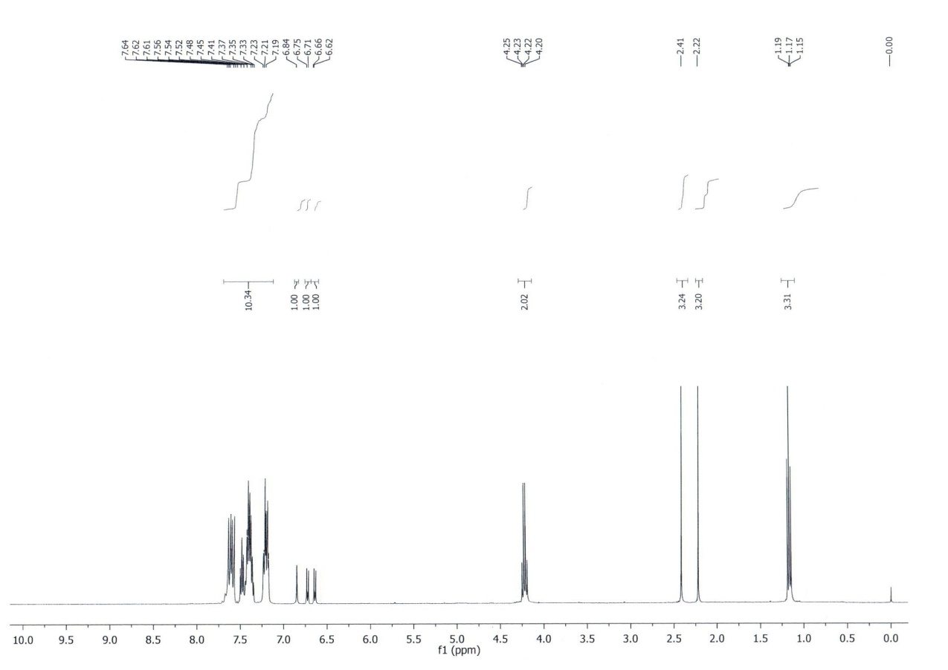



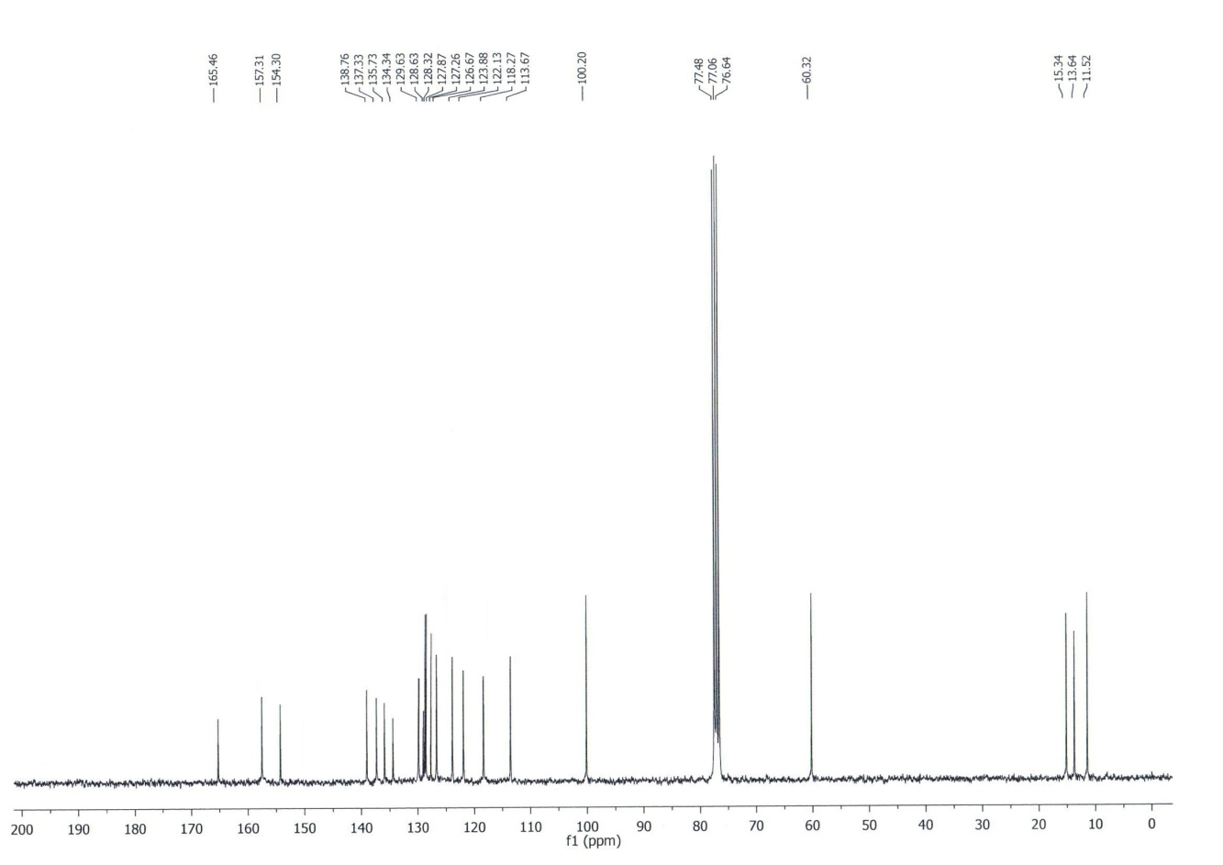**1H NMR of compound 3a**



**13C NMR of compound 3a**

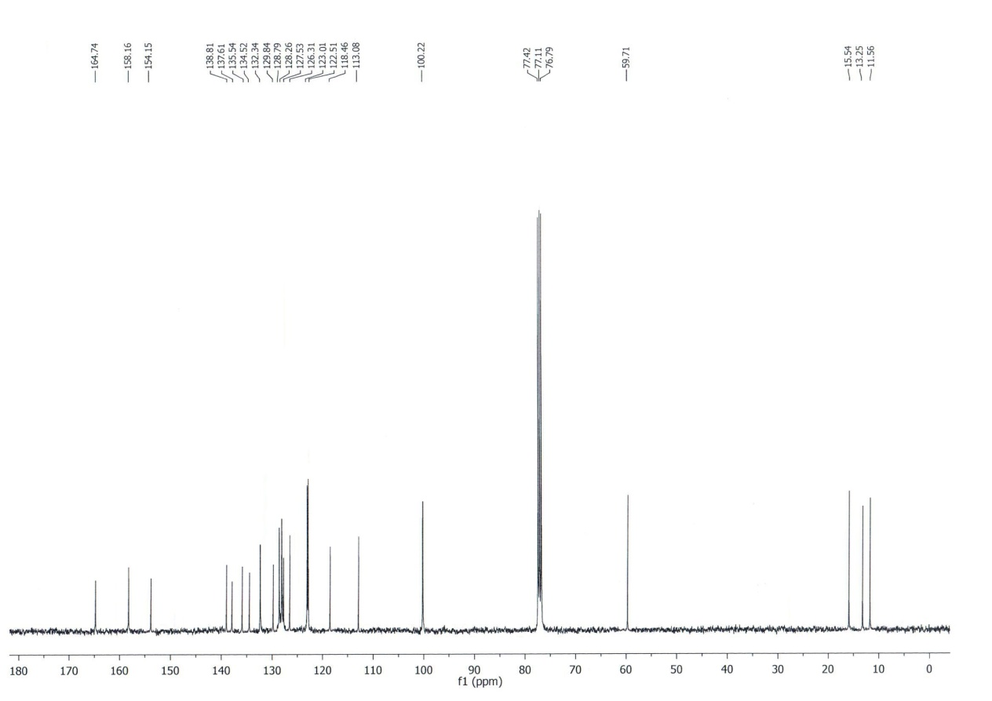**1H NMR of compound 3b**



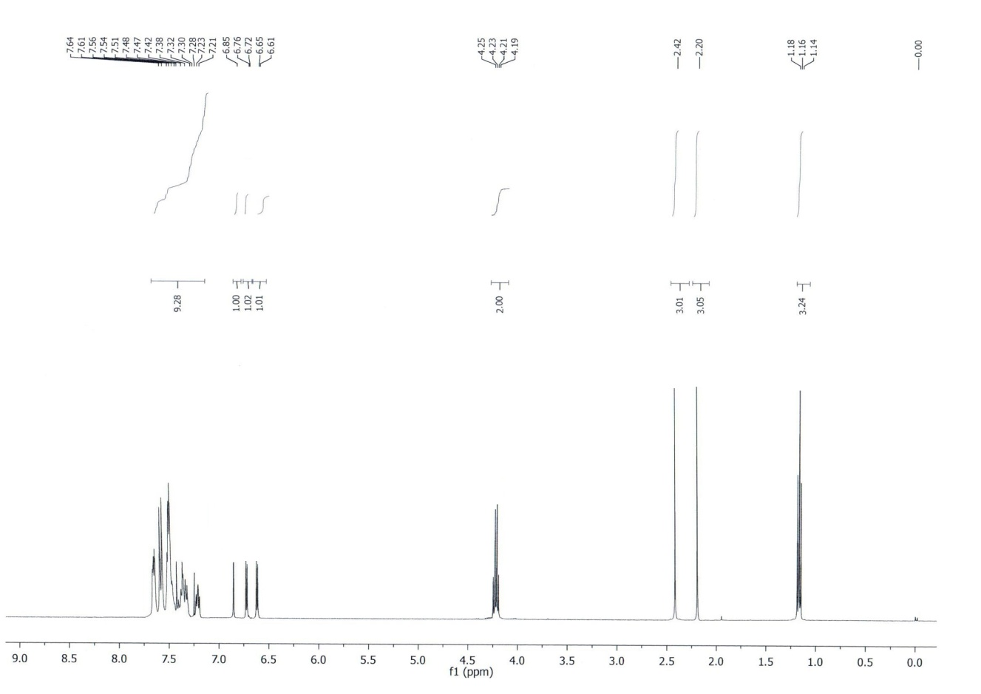



**13C NMR of compound 3b**

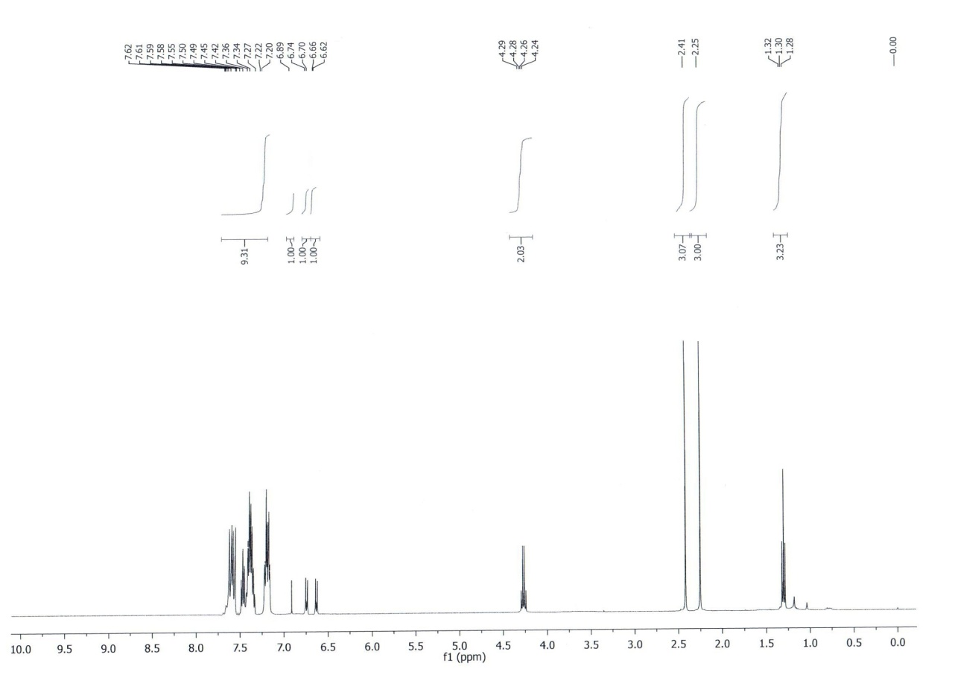



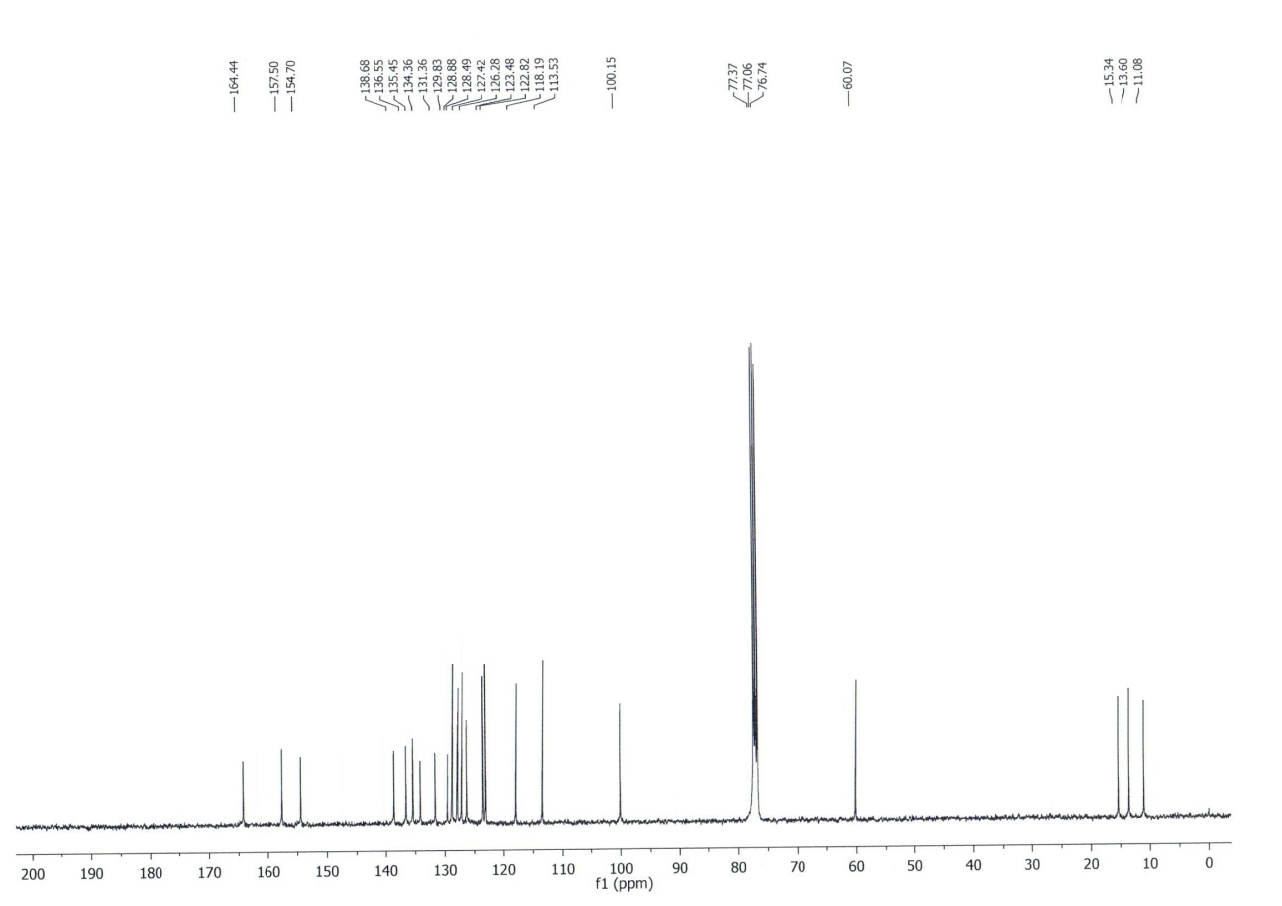**1H NMR of compound 3d**



**13C NMR of compound 3d**

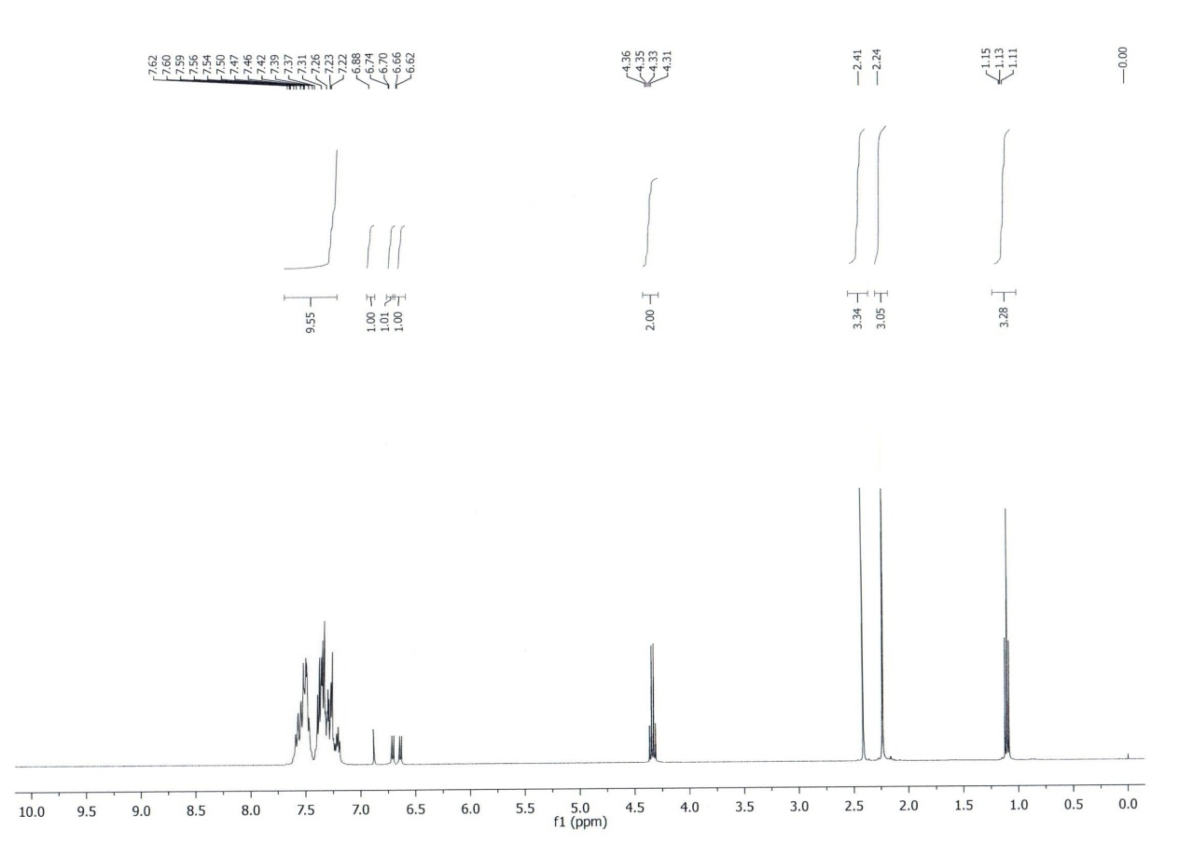



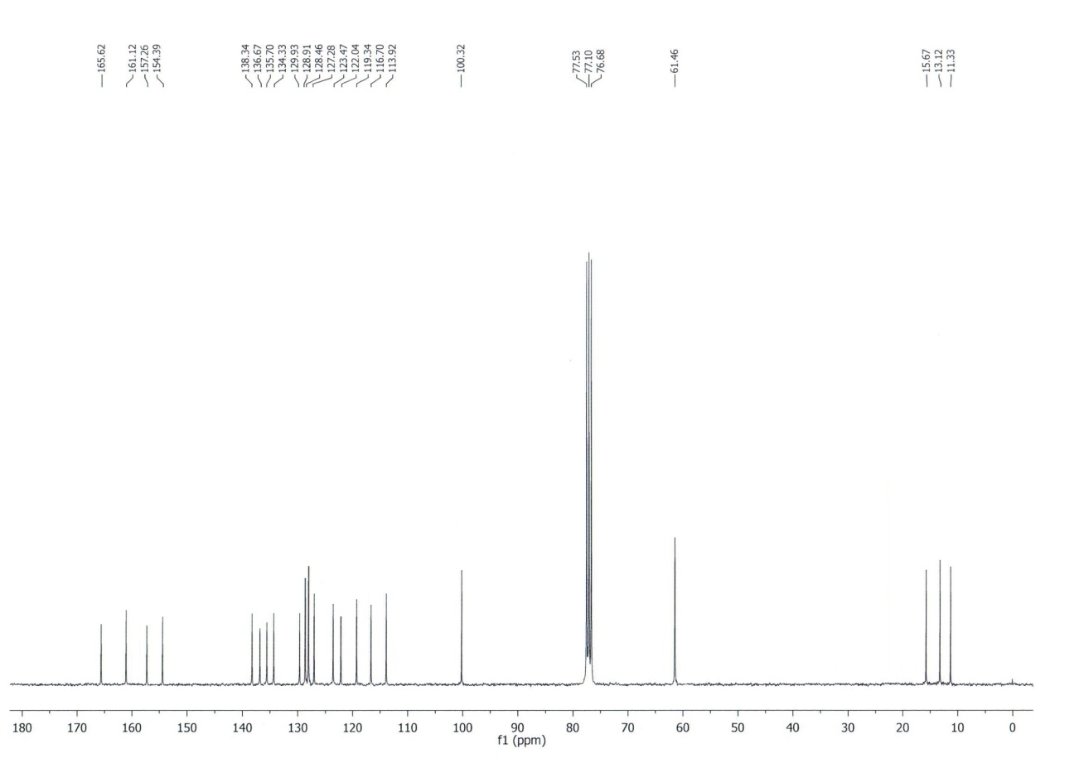**1H NMR of compound 3f**



**13C NMR of compound 3f**

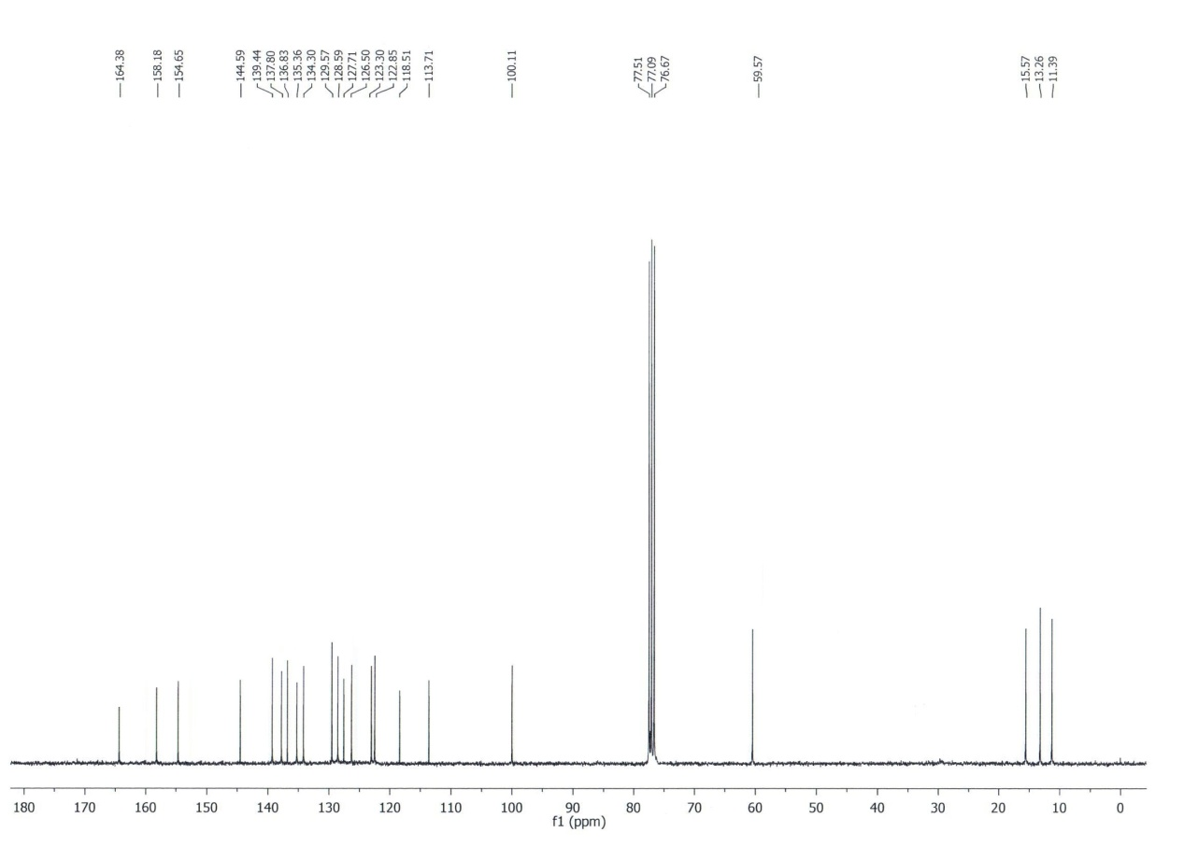**1H NMR of compound 3g**



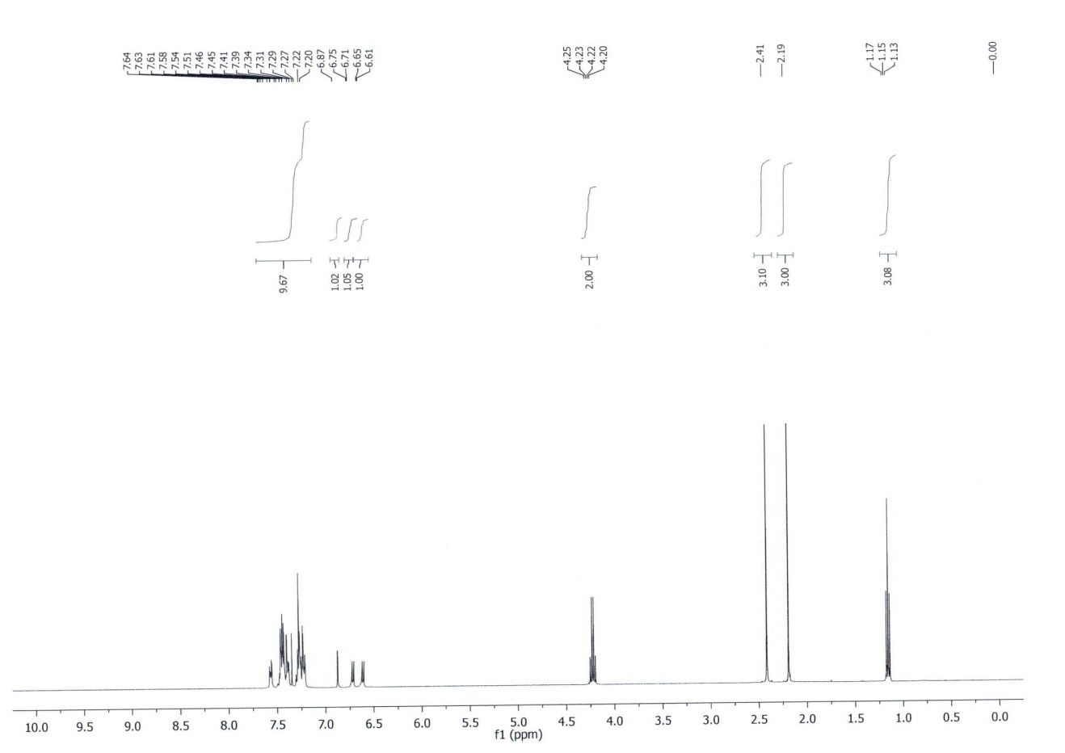



**13C NMR of compound 3g**

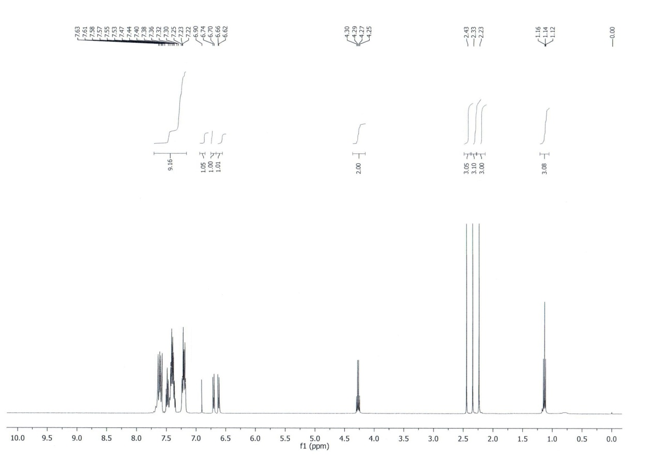



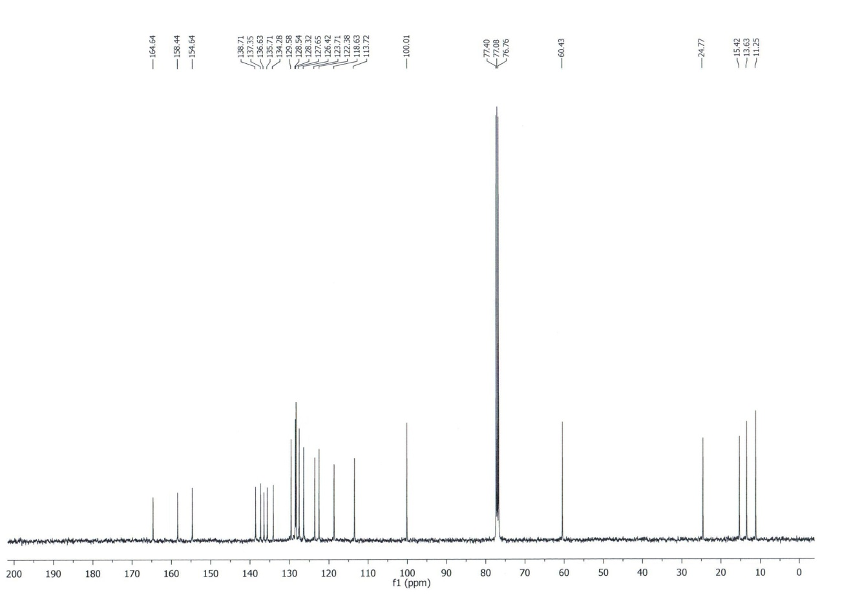**1H NMR of compound 3h**



**13C NMR of compound 3h**

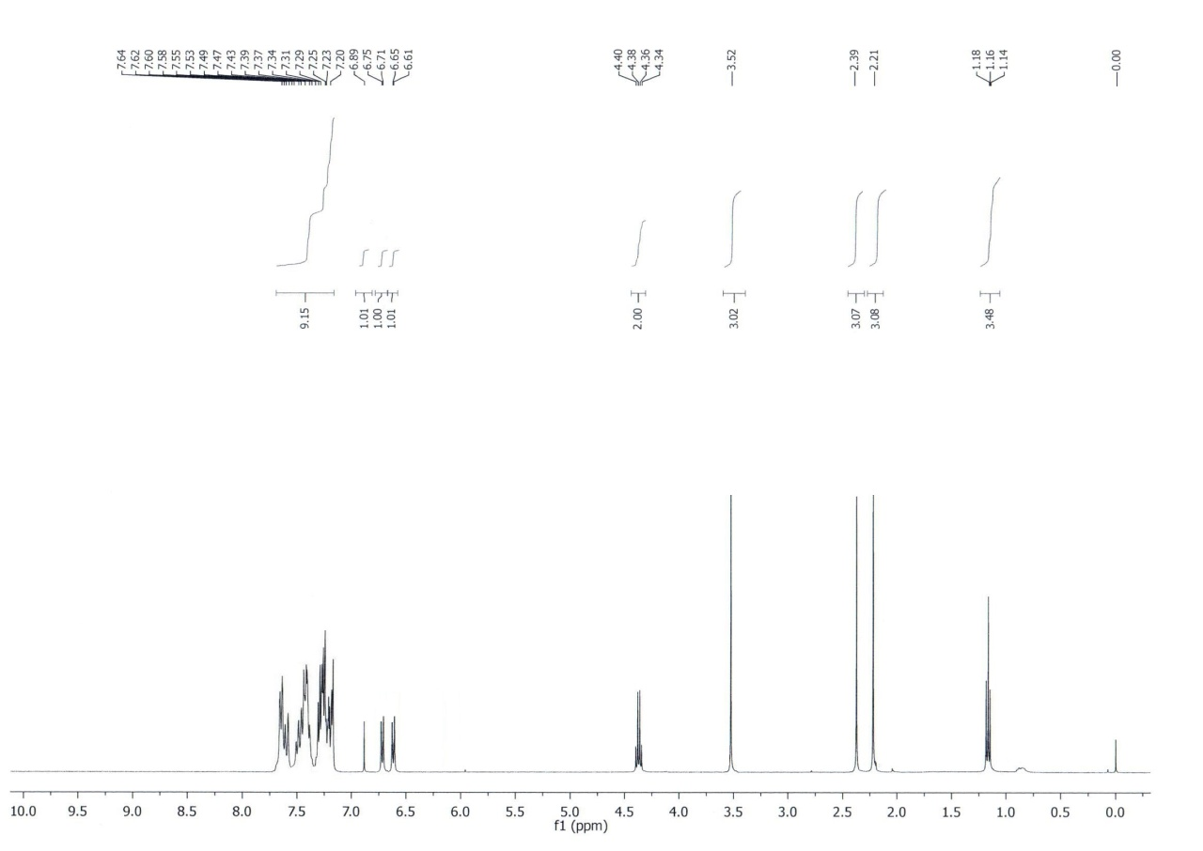



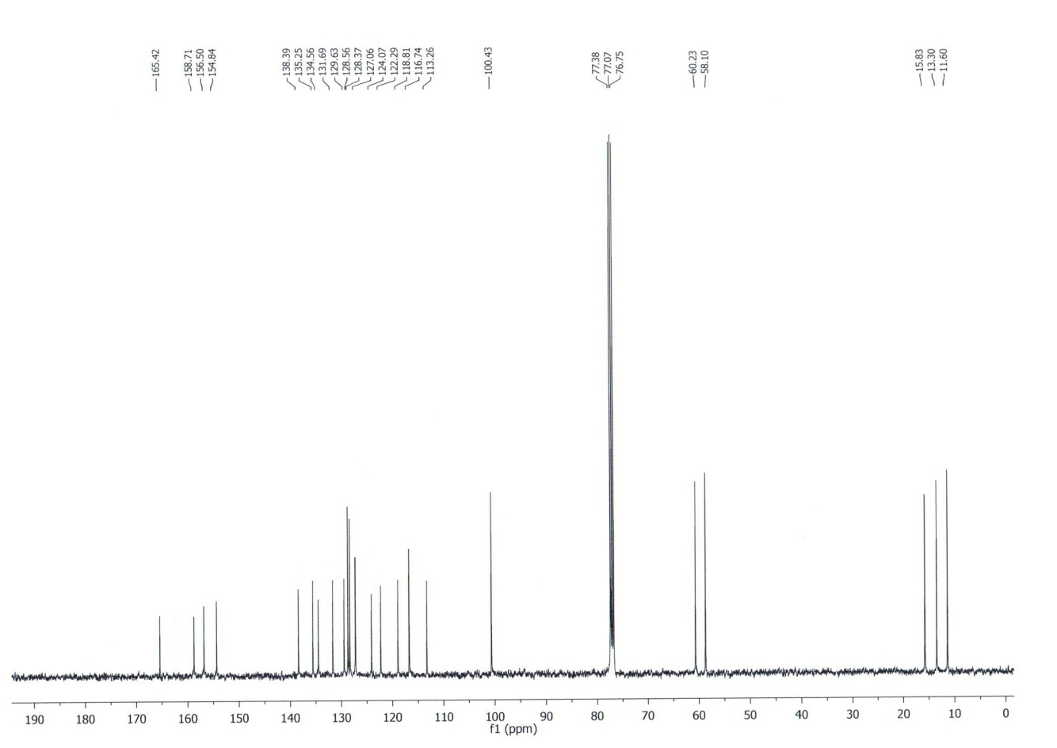**1H NMR of compound 3j**



**13C NMR of compound 3j**

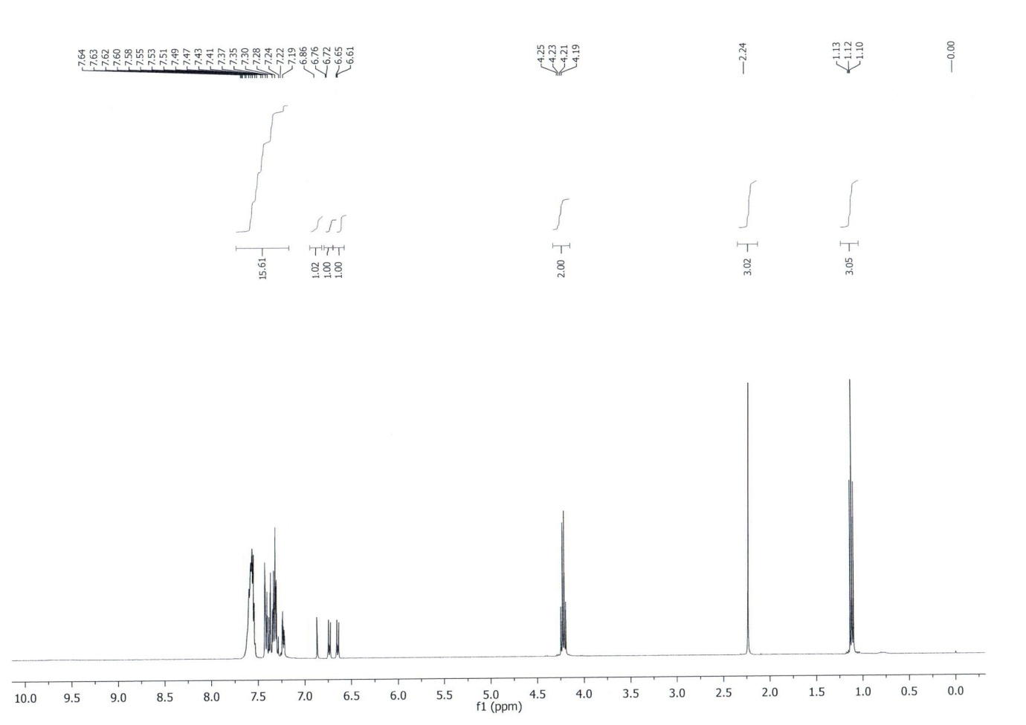



**1H NMR of compound 3m**

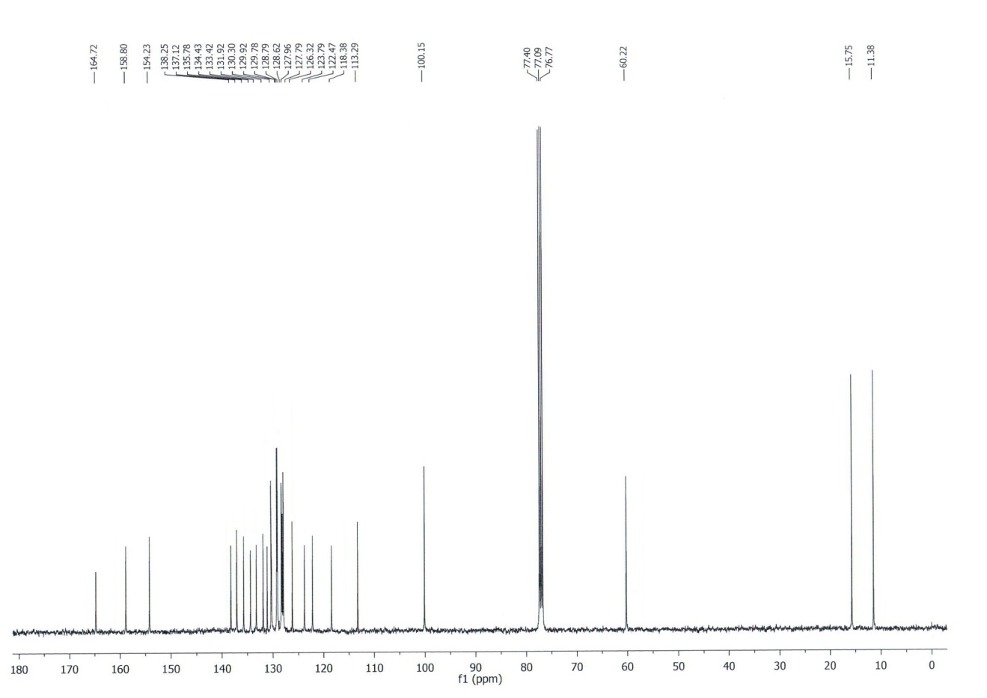



**13C NMR of compound 3m**

**1H NMR of compound 3o**



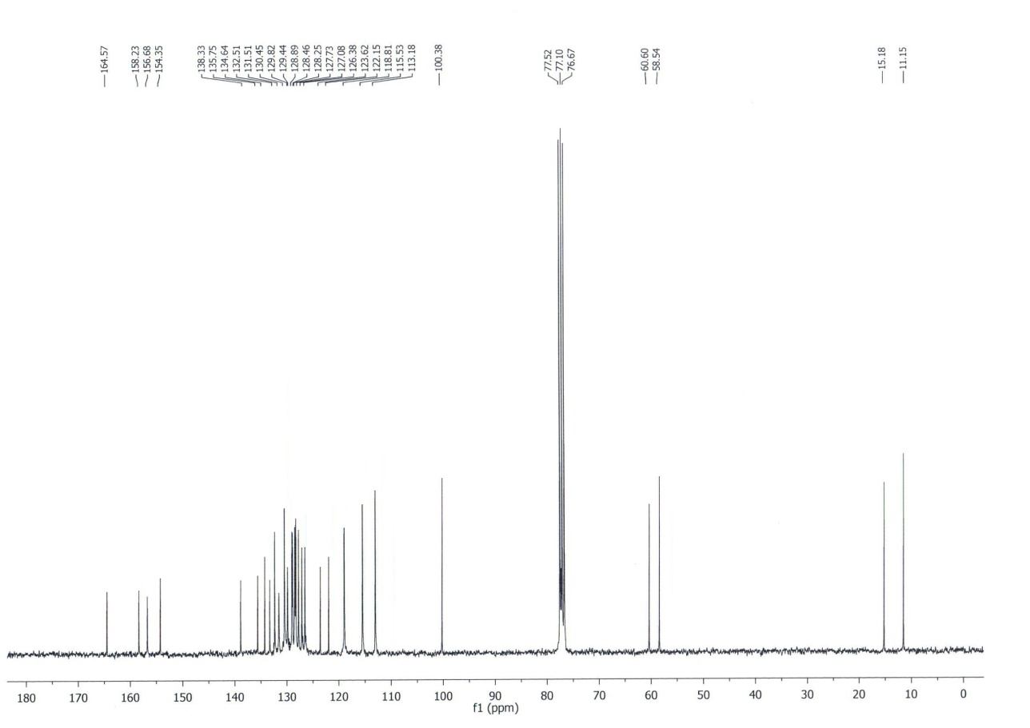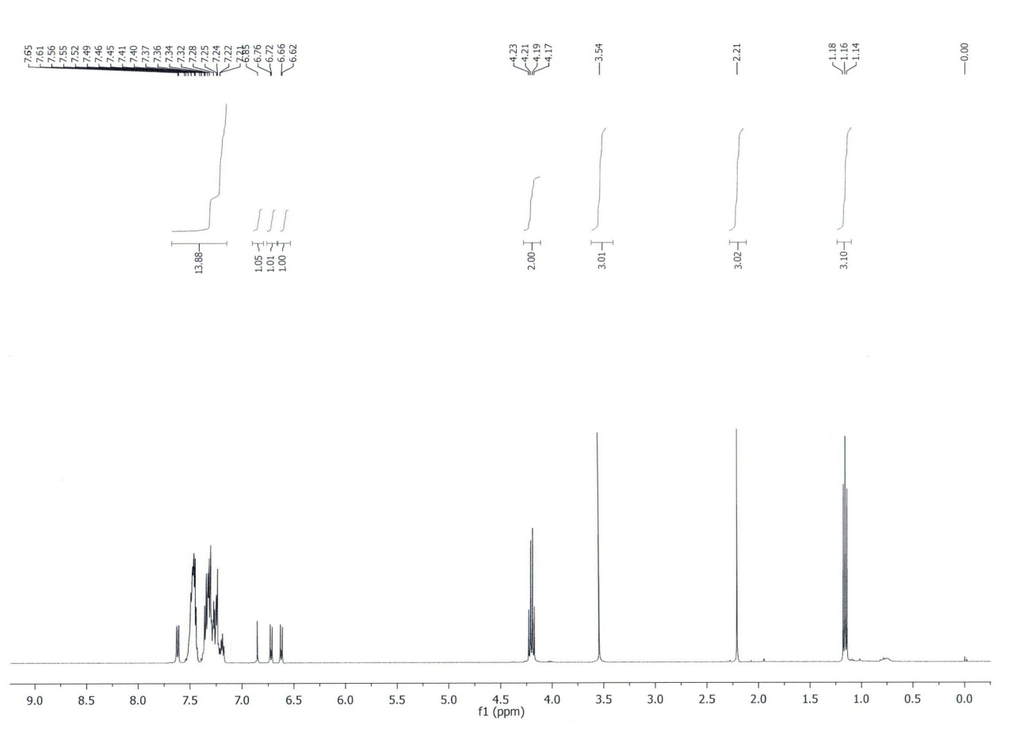



**13C NMR of compound 3o**

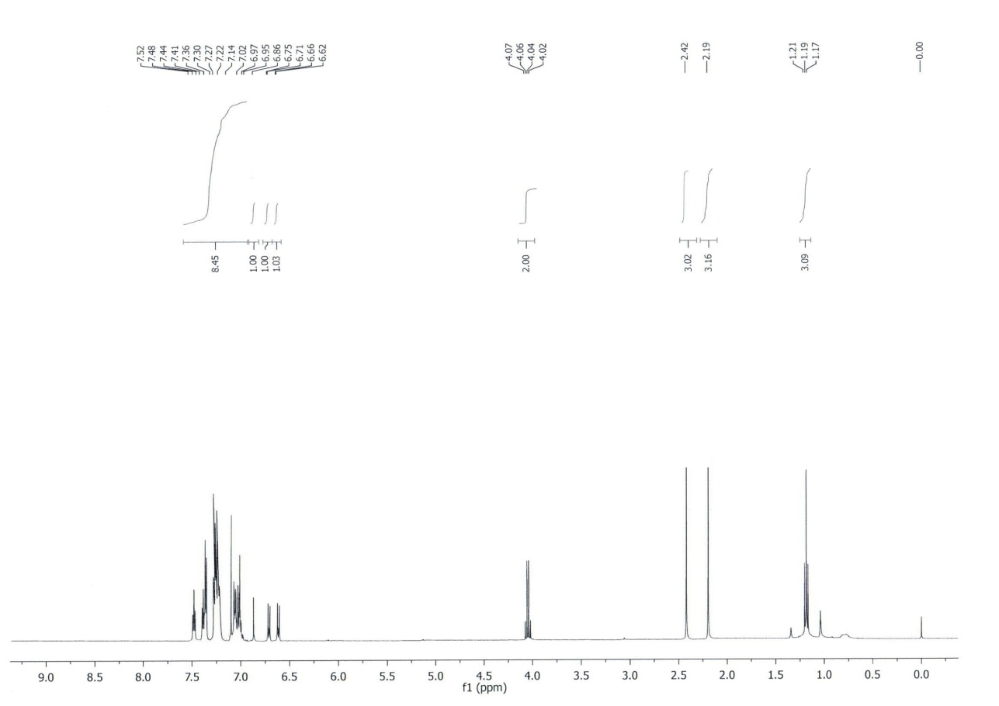



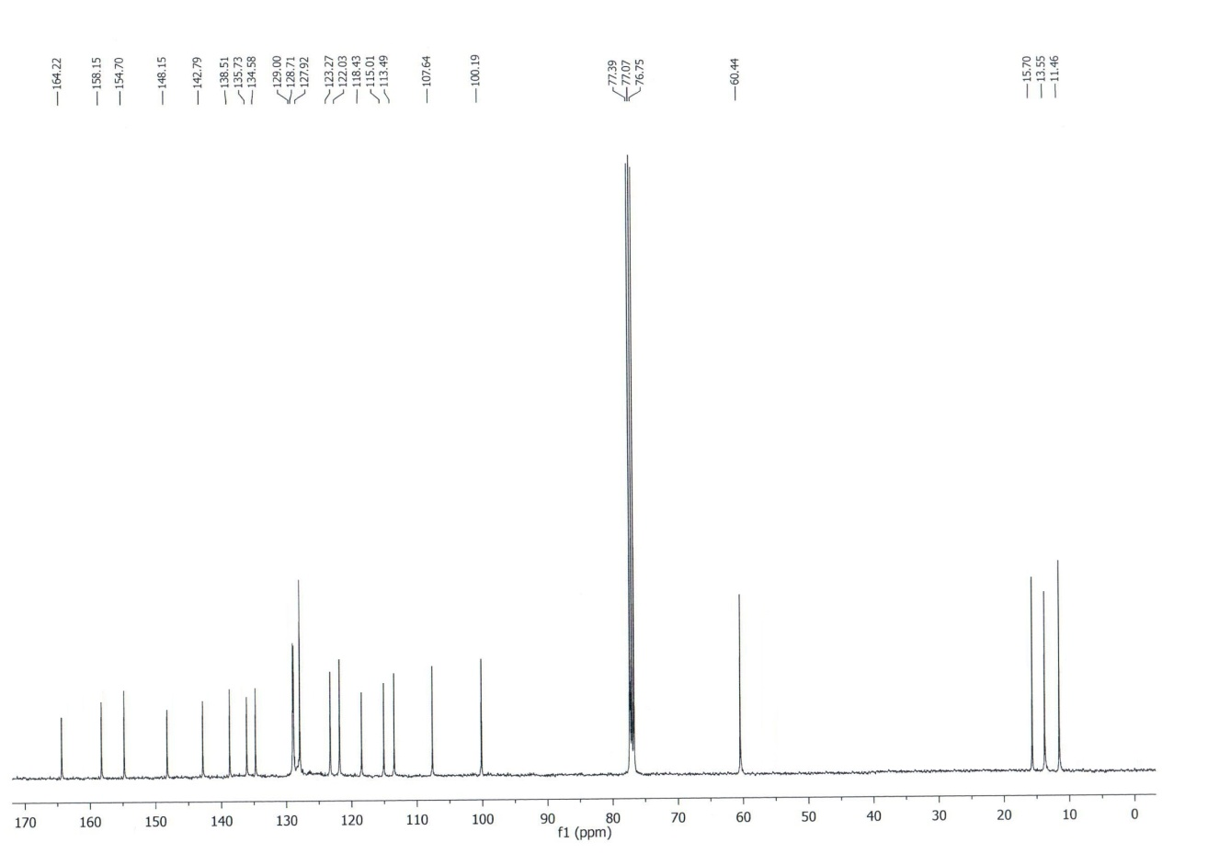**1H NMR of compound 3q**



**13C NMR of compound 3q**

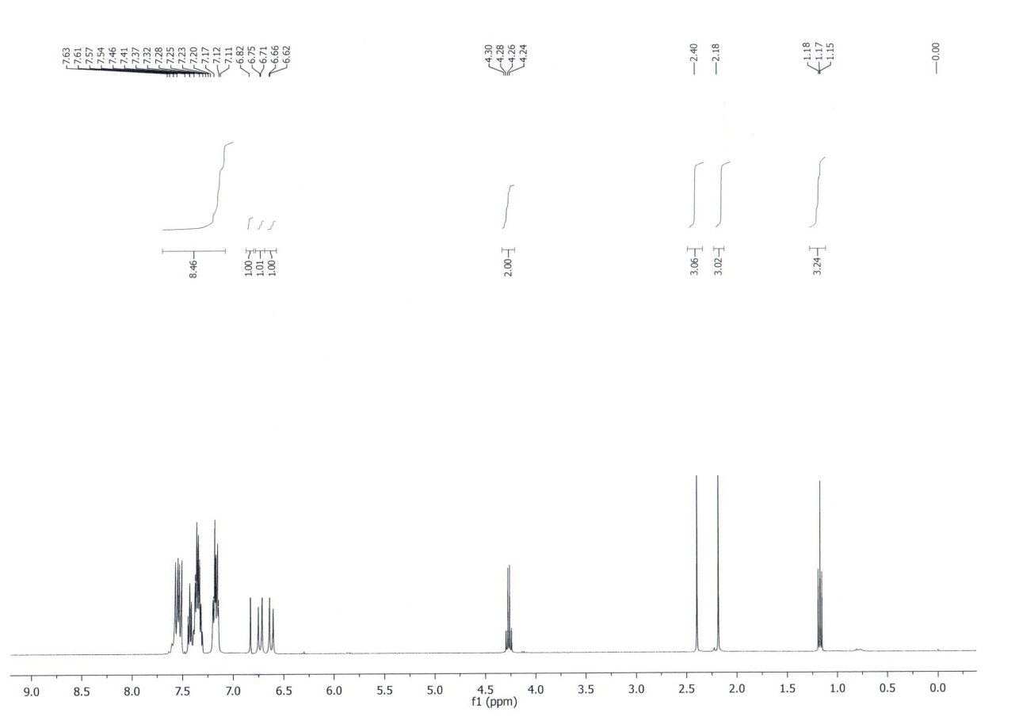



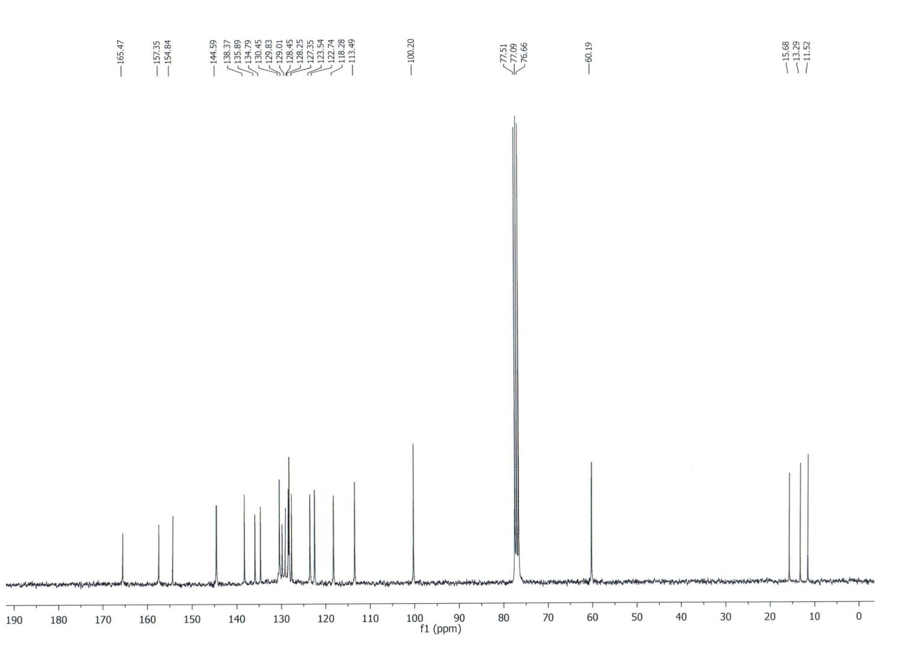**1H NMR of compound 3r**



**13C NMR of compound 3r**

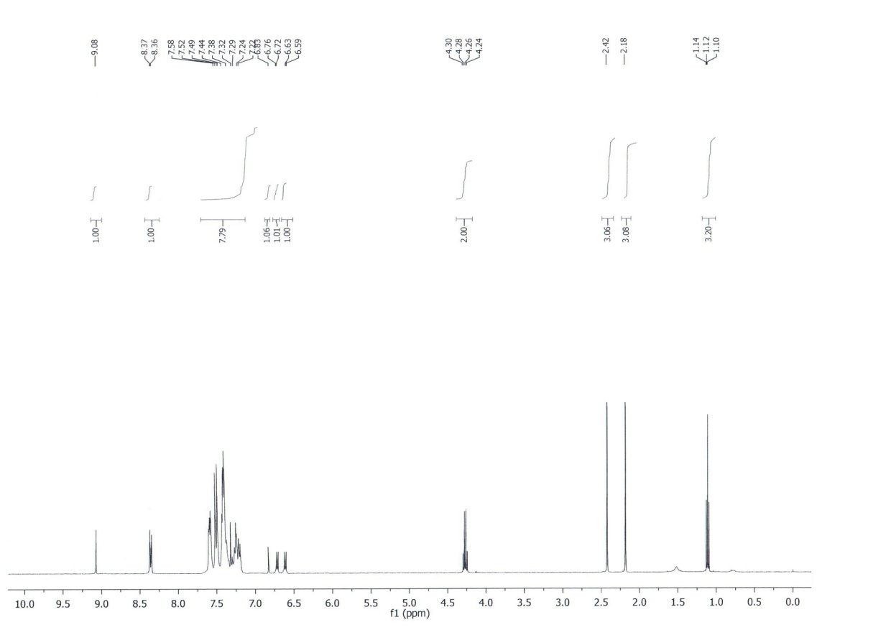



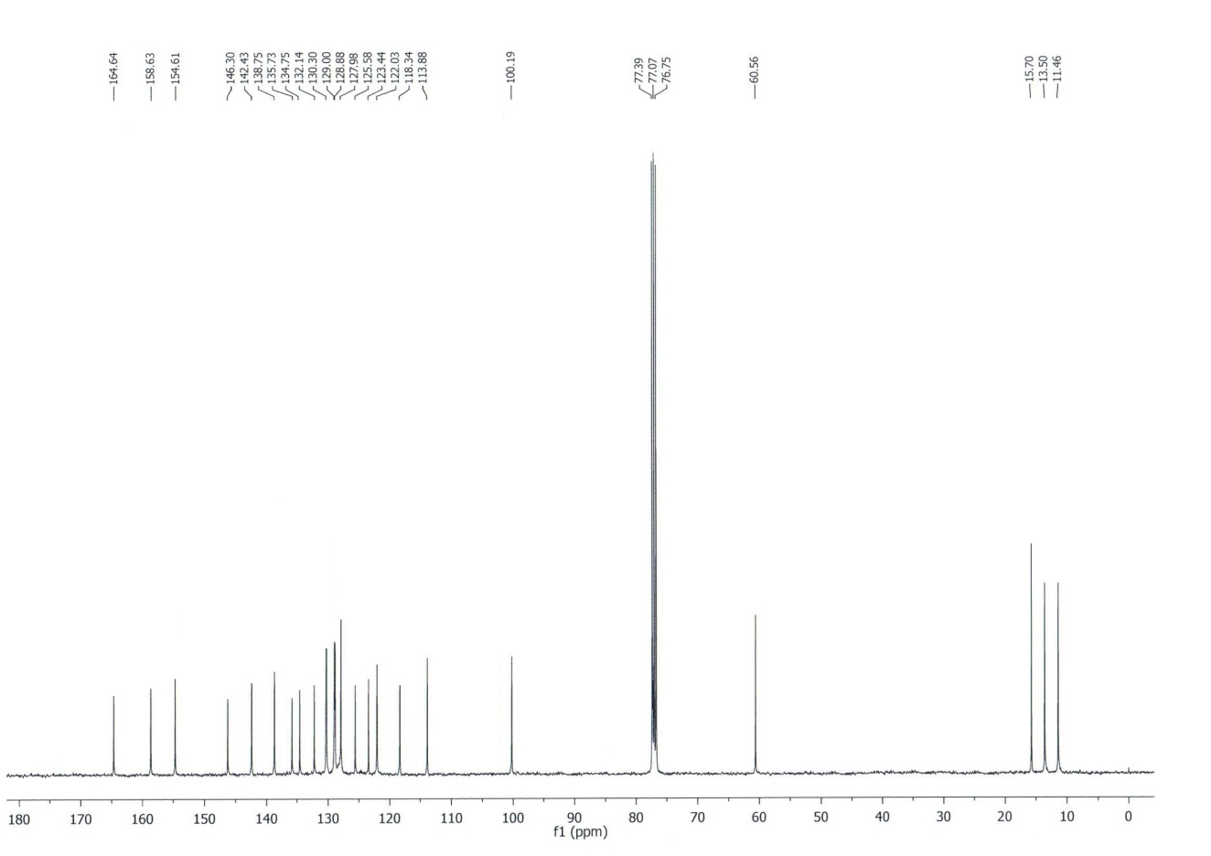**1H NMR of compound 3s**



**13C NMR of compound 3s**

**1H NMR of compound 3t**



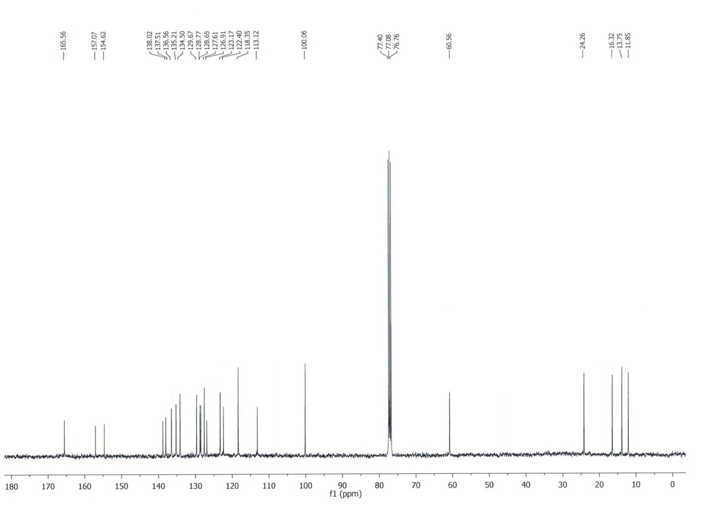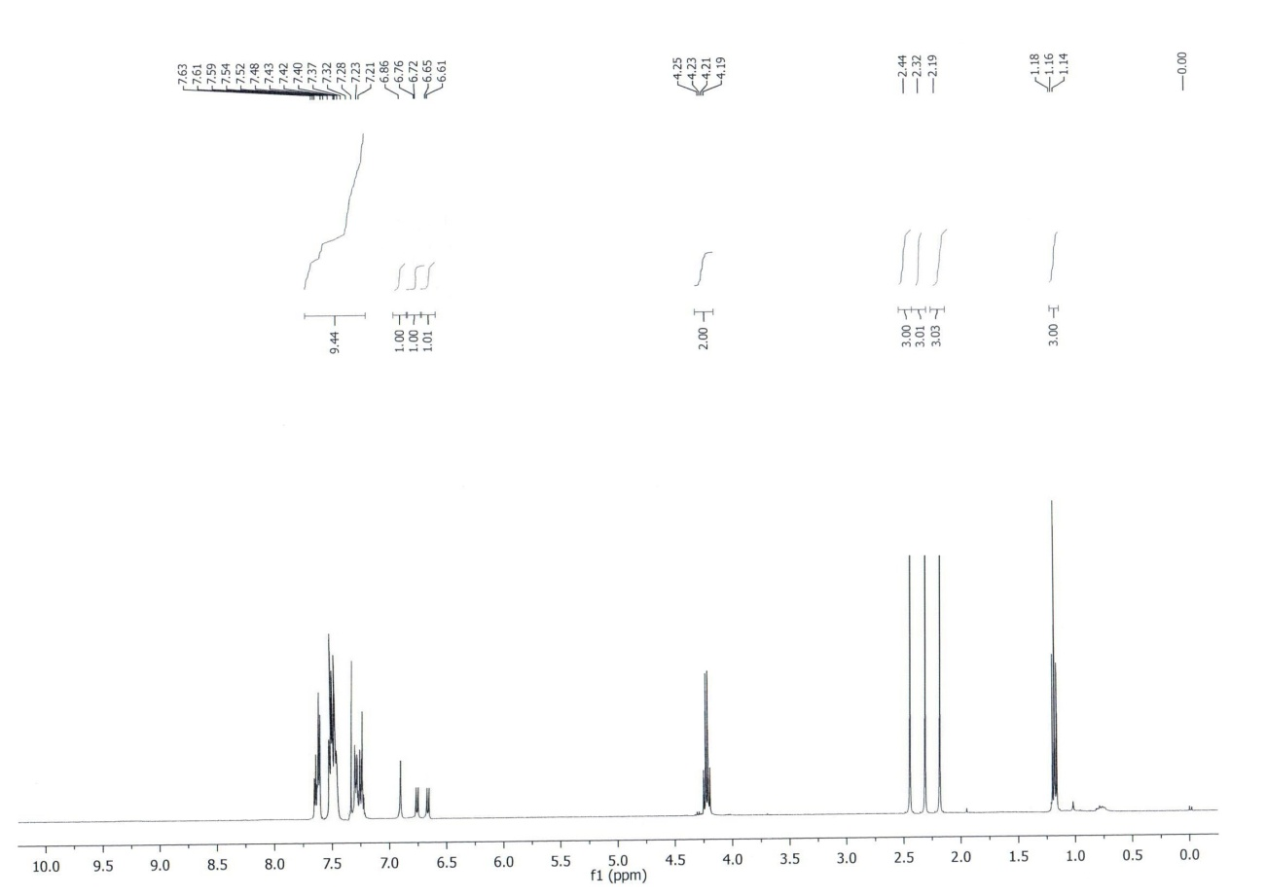



**13C NMR of compound 3t**

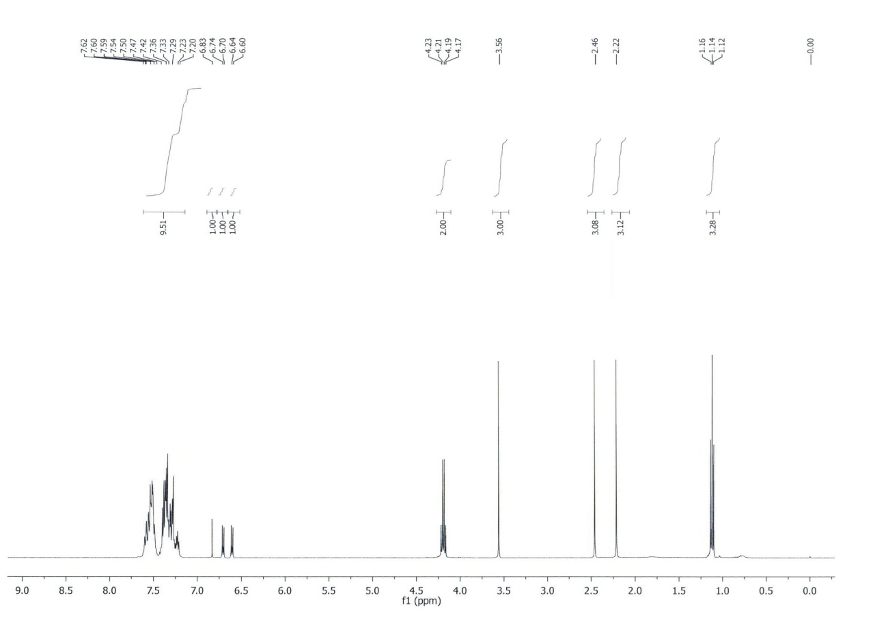



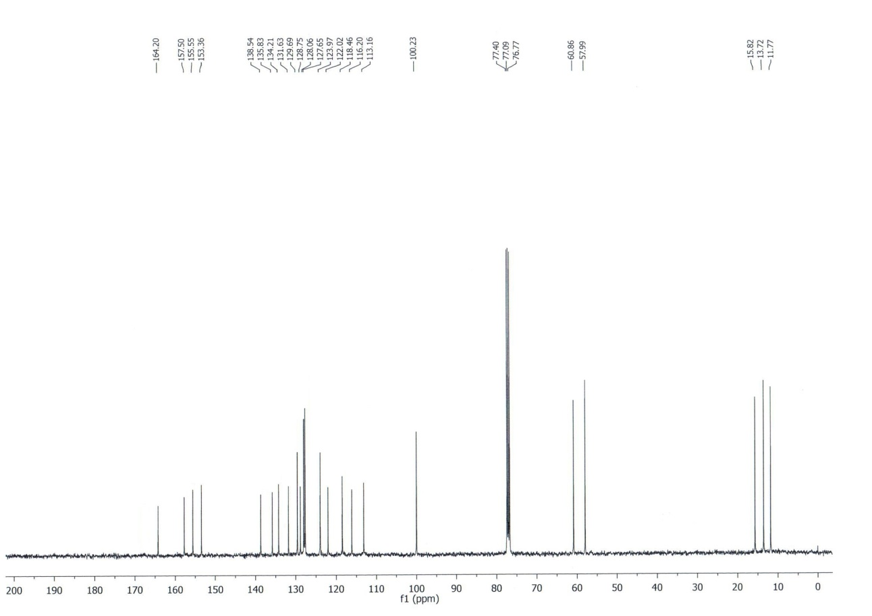**1H NMR of compound 3u**



**13C NMR of compound 3u**

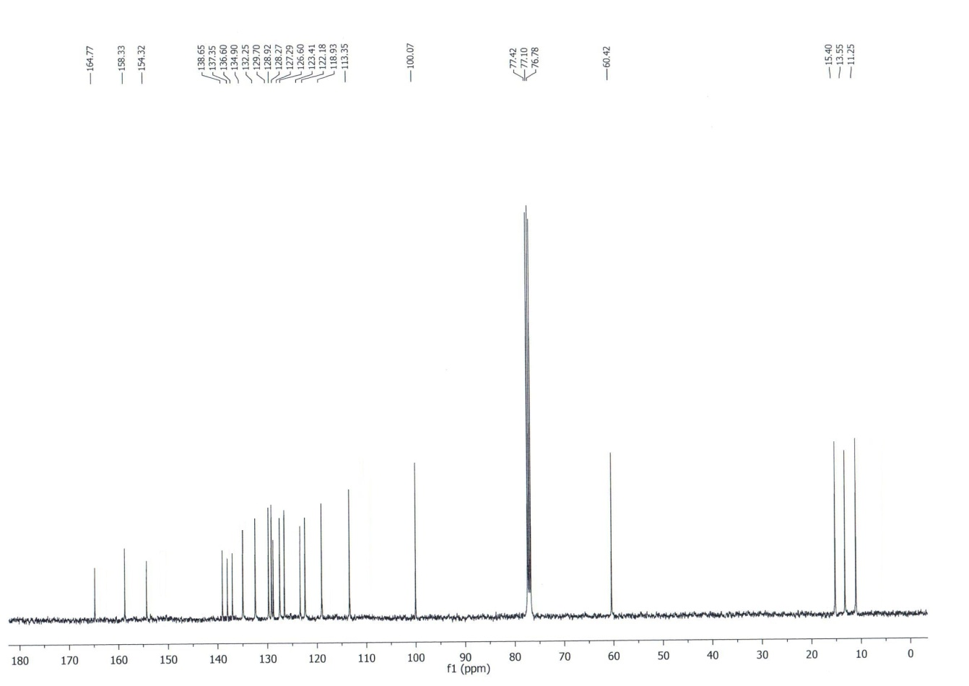**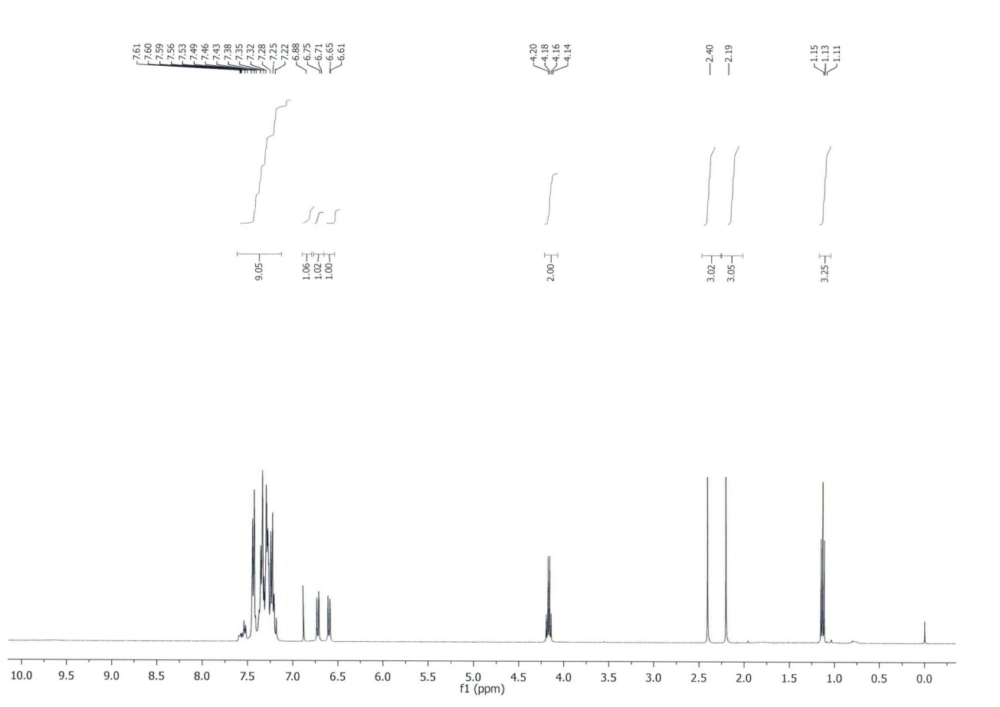1H NMR of compound 3v**



**13C NMR of compound 3v**

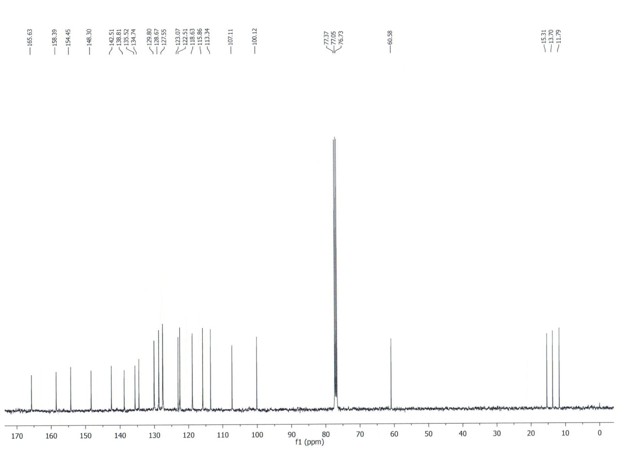**1H NMR of compound 3y**



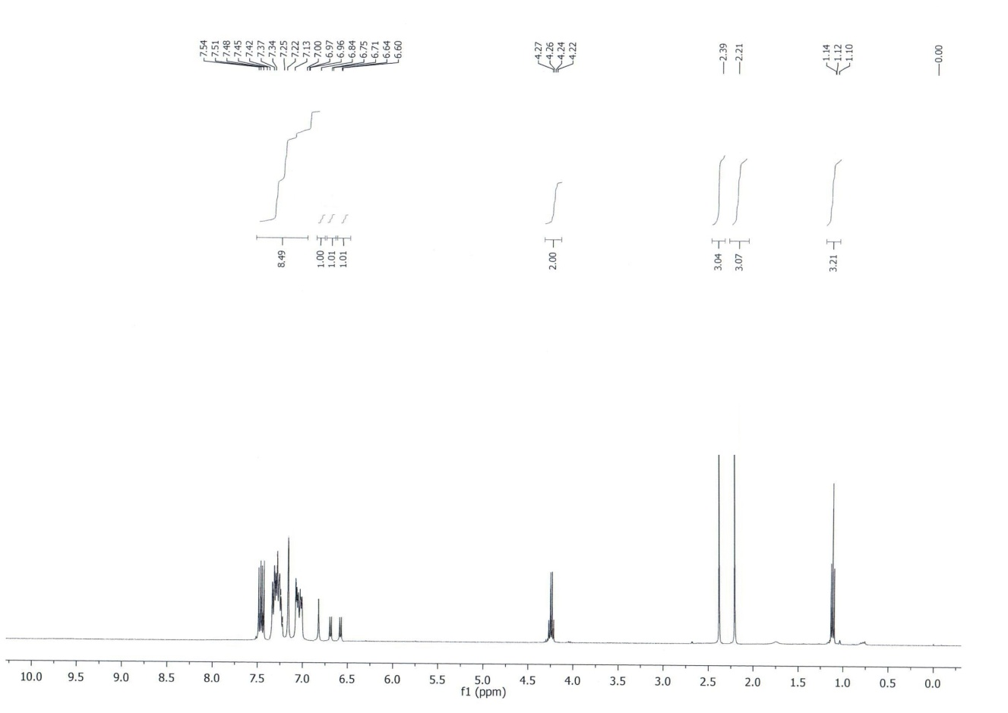

**13C NMR of compound 3y**

**1H NMR of compound 3aa**



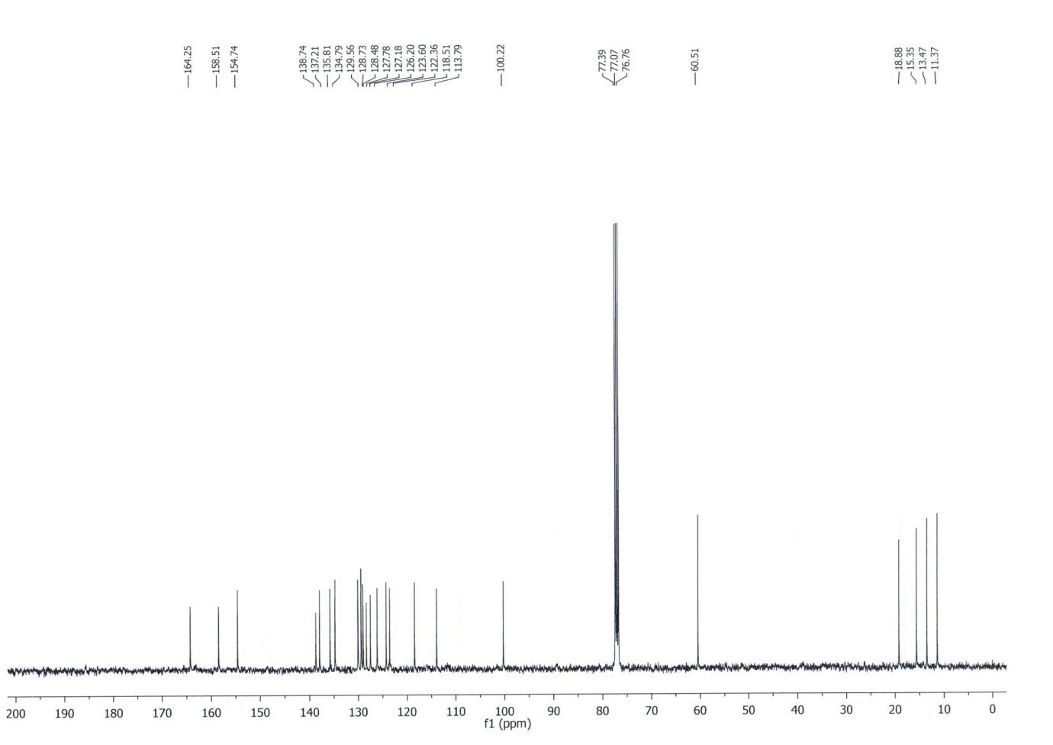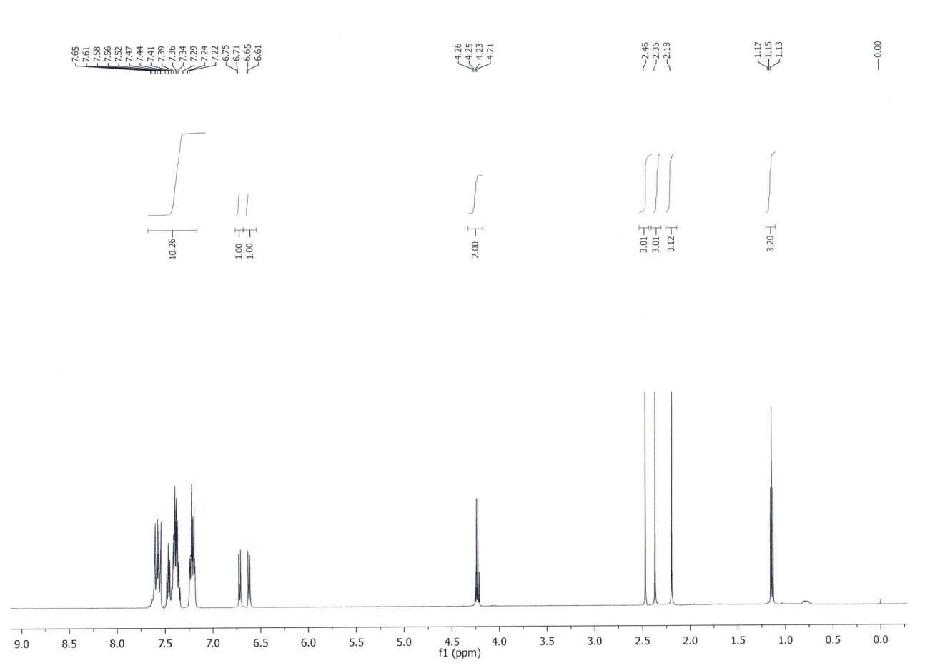



**13C NMR of compound 3aa**

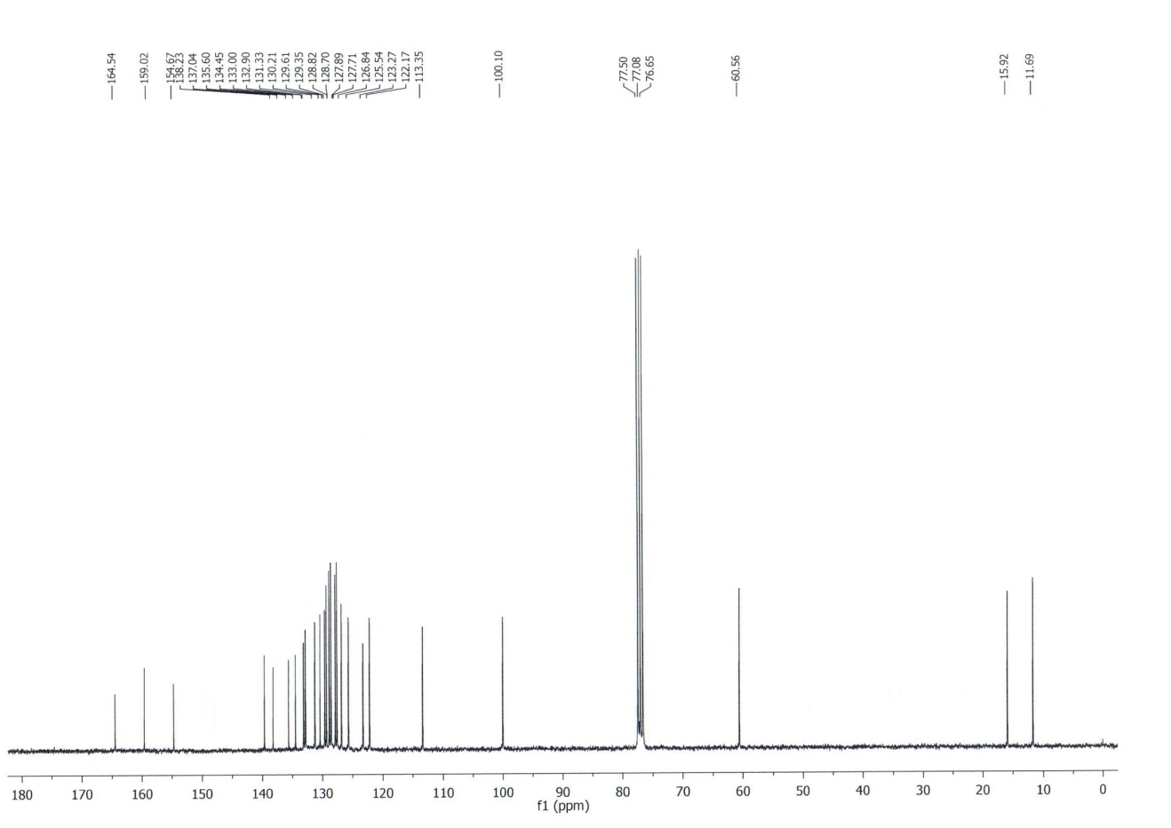**1H NMR of compound 3ab**



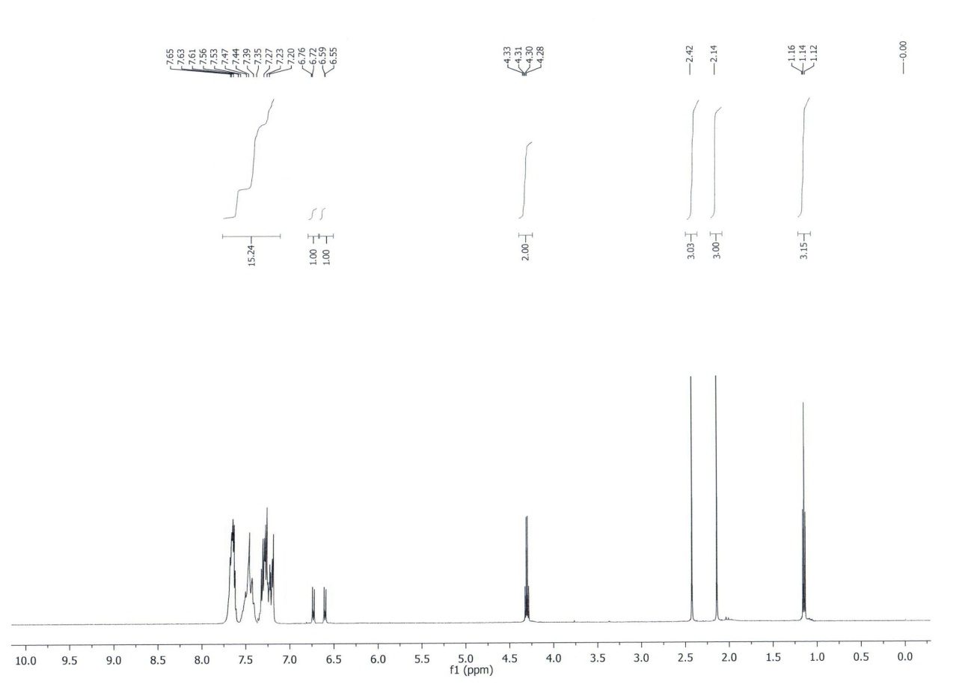



**13C NMR of compound 3ab**

**1H NMR of compound 5a**



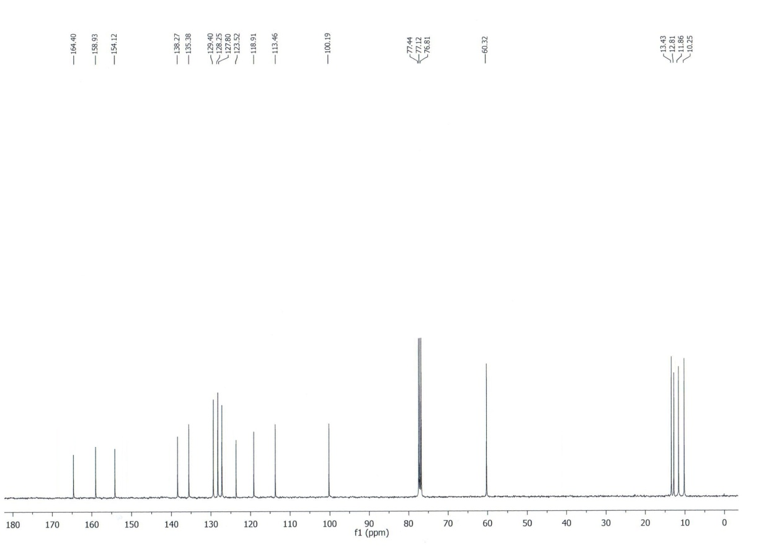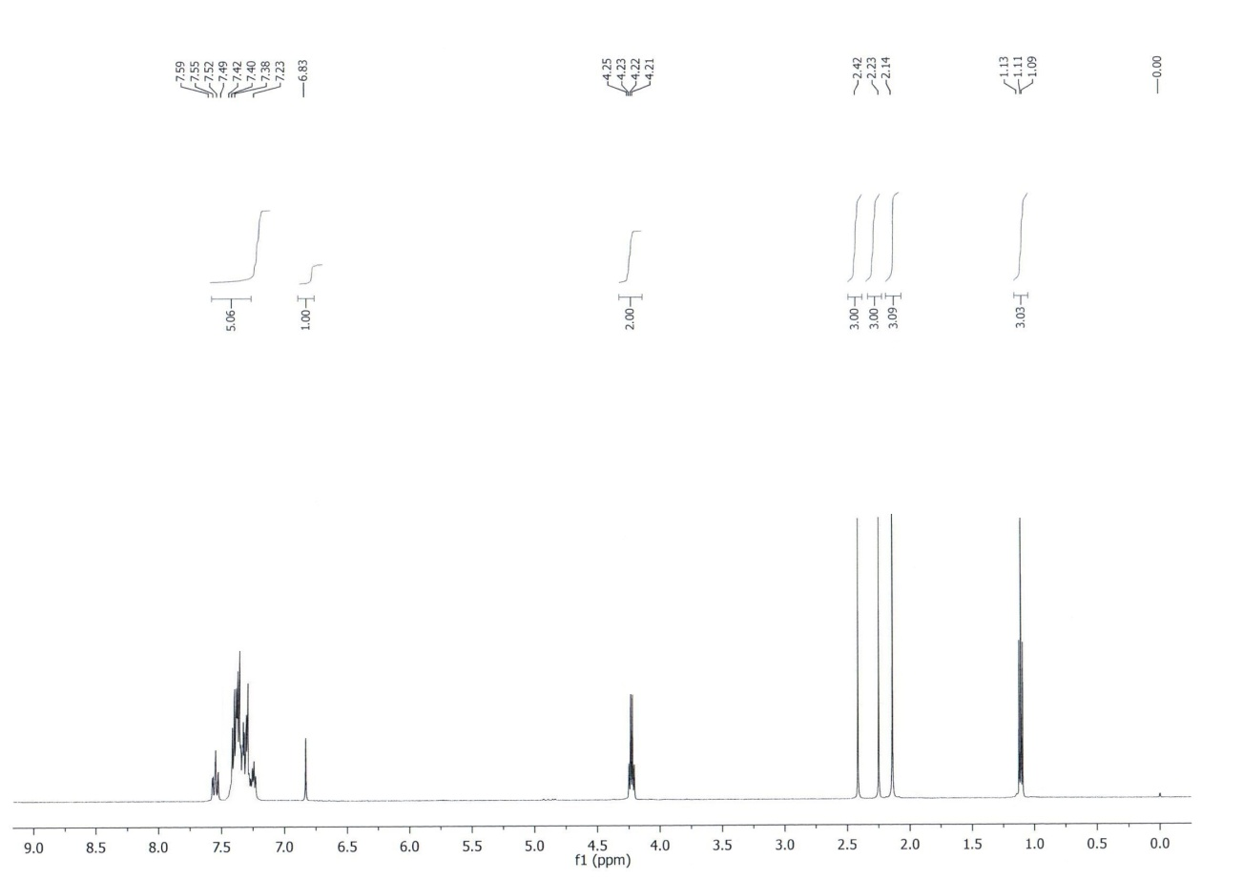

**13C NMR of compound 5a**

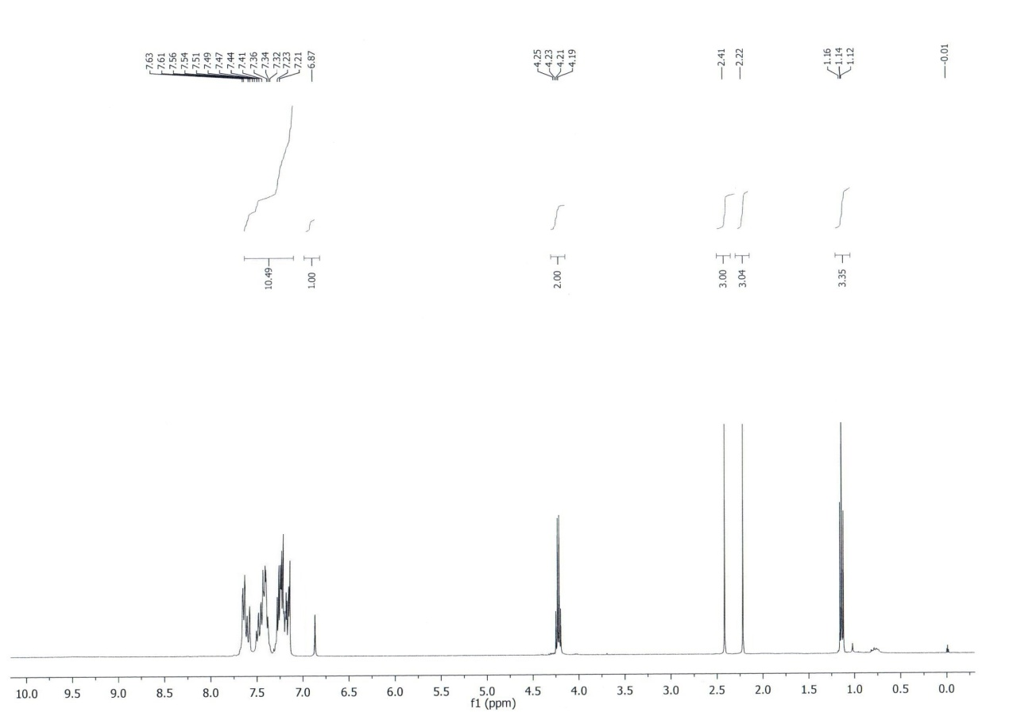



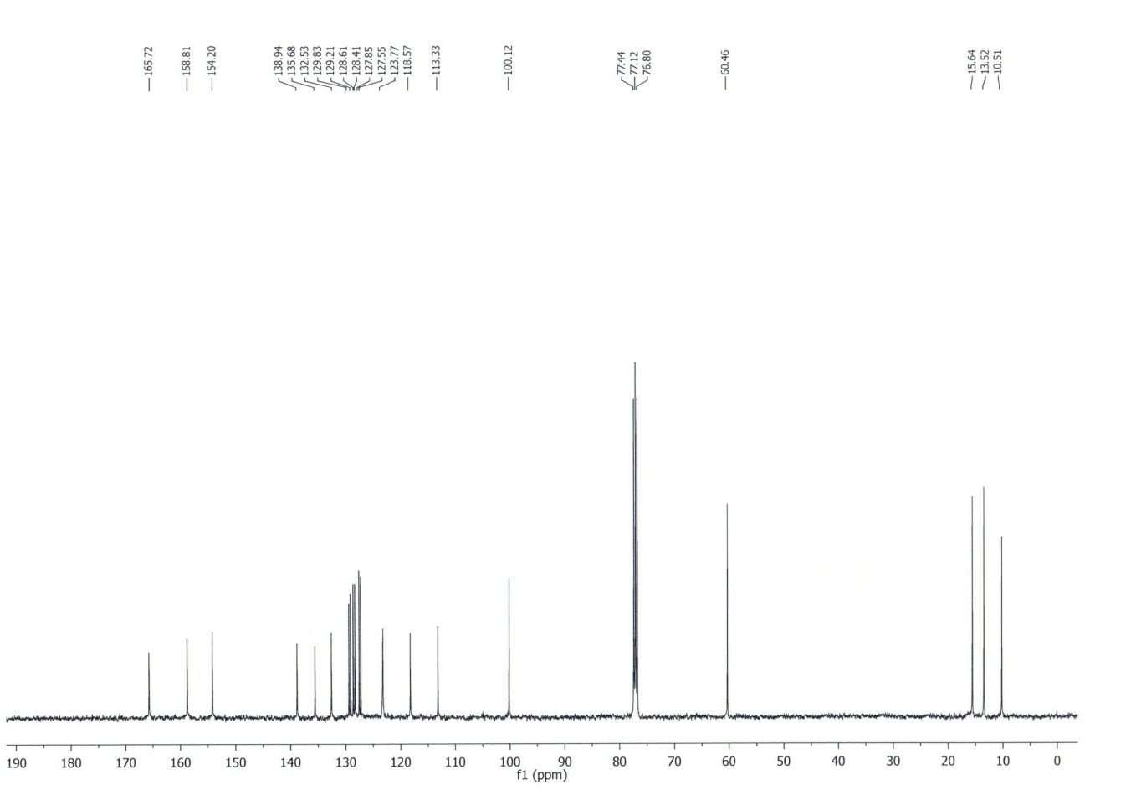**1H NMR of compound 5b**



**13C NMR of compound 5b**

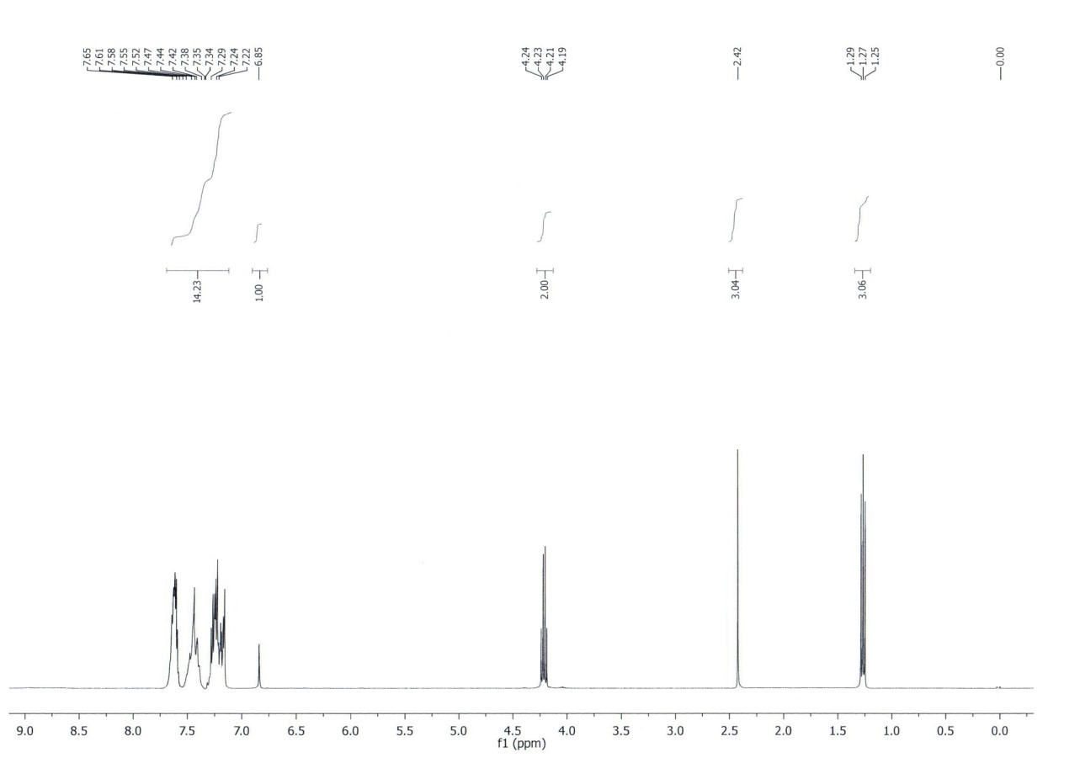



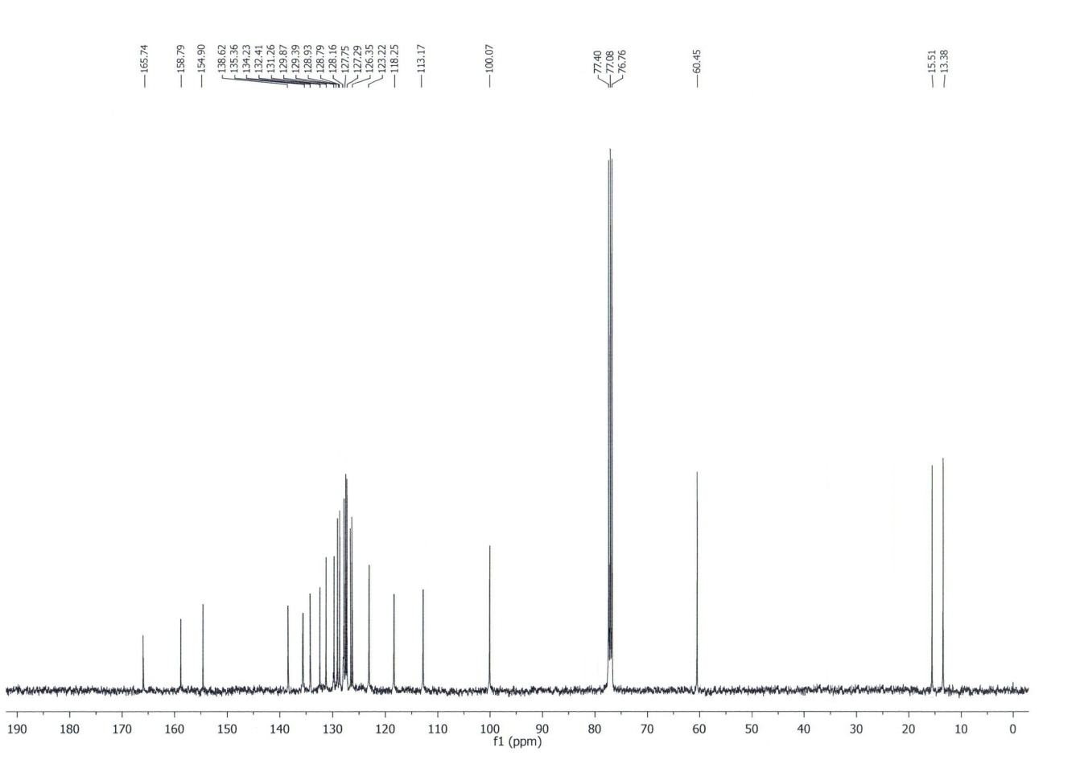**1H NMR of compound 5d**



**13C NMR of compound 5d**