SUPPLEMENTARY MATERIAL
Neoclerodane Diterpenoids from Scutellaria barbata with cytotoxic activities
Maolin Wang¹, Yayun Chen¹, Peng Hu¹, Junyang Ji¹, Xiang Li^{,3*}, Jianwei Chen^{1,2}

¹College of Pharmacy, Nanjing University of Chinese Medicine, Nanjing 210046, China
²Jiangsu Key Laboratory for TCM Formulae Research, Nanjing 210046, China
³Jiangsu Key Laboratory for Chinese Material Medica Processing, Nanjing 210029, China

Abstract Two new neoclerodane diterpenoids, barbatin F (1), barbatin G (2)together with four known compounds, scutebata A (3)，scutebata B (4), scutebata C (5) and scutebata P (6) were isolated from the whole plant of Scutellaria barbata D.Don. Their structures were elucidated on the basis of spectroscopic studies. In vitro cytotoxicity of selected compounds against cancer cell lines LoVo, SMMC-7721, HCT-116, and MCF-7 were evaluated, compound 1 and 2 showed weak cytotoxic activities against HCT-116 colon cancer cell lines with IC₅₀ value of 44.3μM, 32.3μM respectively, while compound 3 and 4 exhibited moderate cytotoxic activities against four tested human cancer cell lines with IC₅₀ values of 5.31～28.5μM.
Key words: Scutellaria barbata; neoclerodane diterpenoids; barbatin F-G; cytotoxicity activities

Figure S1. The HMBC correlations spectrum of compound 1
Figure S2. The HMBC correlations spectrum of compound 2

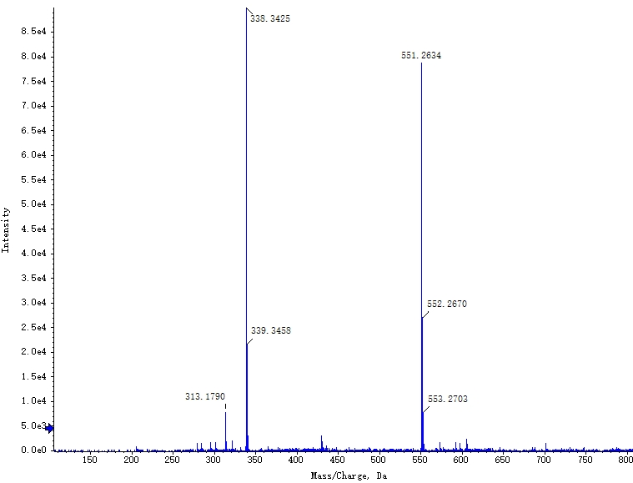
Figure S3. HR-ESI-MS spectrum of compound 1
Figure S4. ¹H-NMR spectrum of compound 1
Figure S5. ¹³C-NMR spectrum of compound 1
Figure S6. The HSQC correlations spectrum of compound 1
Figure S7. The IR spectrum of compound 1
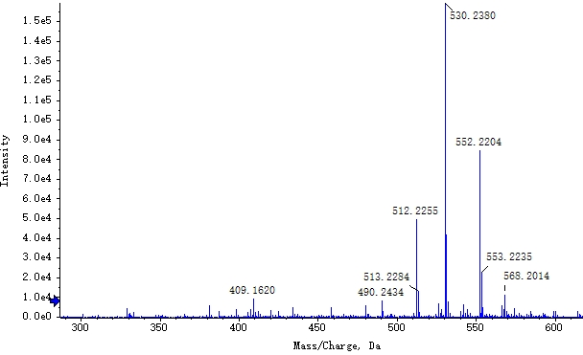
Figure S8. The HR-ESI-MS spectrum of compound 2
Figure S9. The ¹H-NMR spectrum of compound 2
Figure S10. The ¹³C-NMR spectrum of compound 2
Figure S11. The HSQC spectrum of compound 2
Figure S12. The IR spectrum of compound 2
Figure S13. Key HMBC correlations of compound 1 and 2

Table S1. ¹H and ¹³C-NMR data of compounds 1 and 2 (in DMSO-d6).
Position | 1 |  |  | 2
 | δH | δC |  | δH | δC
1 | 1.74（m,Ha）  2.03（m,Hb） | 19.1 |  | 1.70(m,Ha)  2.04(m,Hb) | 19.4
2 | 1.08（m,2H） | 26.0 |  | 2.07(m,2H) | 26.0
3 | 5.24（br s） | 123.8 |  | 5.17(br s) | 121.8
4 |  | 140.7 |  |  | 144.4
5 |  | 43.3 |  |  | 43.6
6 | 5.64（d,10.0） | 77.7 |  | 3.81(dd,10.0,6.5) | 71.5
7 | 5.51（d,10.0） | 75.3 |  | 5.25(d,10.0) | 78.8
8 |  | 76.2 |  |  | 77.1
9 |  | 48.8 |  |  | 47.3
10 | 2.27（br d,12.5） | 42.5 |  | 2.17(br d,11.5) | 40.2
11 | 6.35（d,17.0） | 148.1 |  | 5.36(br d,6.0) | 75.8
12 | 6.53（d,17.0） | 122.1 |  | 3.18(d,10.0,Ha)  2.69(dd,10.0,6.0,Hb) | 28.7
13 |  | 164.3 |  |  | 130.6
14 | 6.10（s） | 114.1 |  |  | 138.7
15 |  | 174.2 |  |  | 170.2
16 | 5.05（Ha,d,16.5）  5.22（Hb,d,16.5） | 71.1 |  | 4.67(d,16.0,Ha)  4.57(d,16.0,Hb) | 69.2
17 | 0.93（s,3H） | 21.4 |  | 1.12(s,3H) | 21.4
18 | 1.52（s,3H） | 20.1 |  | 1.77(s,3H) | 22.8
19 | 1.27（s,3H） | 17.5 |  | 1.09(s,3H) | 16.8
20 | 1.16（s,3H） | 15.5 |  | 0.80(s,3H) | 16.5
1’ |  | 166.1 |  |  | 165.5
2’ |  | 129.3 |  |  | 126.6
3’ | 8.01（d,7.5） | 130.2 |  | 9.34(s) | 151.4
4’ | 7.53（t,7.5） | 129.3
5’ | 7.67（t,7.5） | 134.1 |  | 8.80(d,5.4) | 153.8
6’ | 7.53（t,7.5） | 129.3 |  | 7.60(dd,7.5,5.4) | 124.0
7’ | 8.01（d,7.5） | 130.2 |  | 8.49(d,7.5) | 140.0
1’’ |  | 161.3 |  |  | 171.0
2’’ |  | 197.9 |  | 1.98(s,3H) | 21.2
3’’ | 2.85（m） | 36.6
4’’ | 0.64（d,9.0,3H） | 17.0
5’’ | 0.83（d,9.0,3H） | 17.2
6-OH |  |  |  | 4.88(d,6.5)

Correspondence to: Professor Xiang Li, College of Pharmacy, Nanjing Universityof Chinese Medicine, 138 Xian Lin Road, Nanjing, P.R. China Tel.: +86 2585811512; fax: +86 2585811524 E-mail address: lixiang_8182@163.com

