





GC- MS of FAMEs

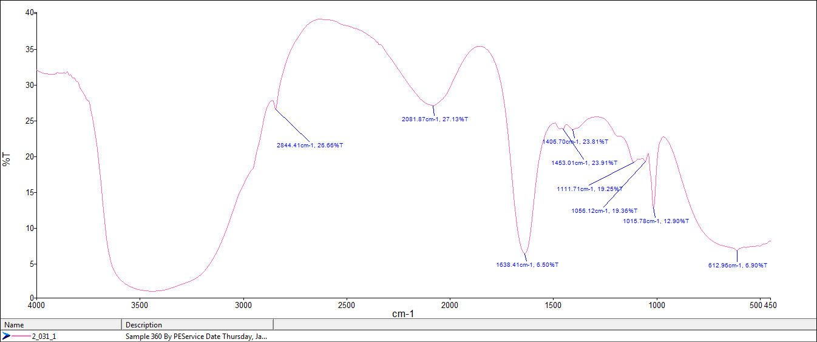

FT-IR of Pure Glycerol